Travel Award Request Form
2024 –2025

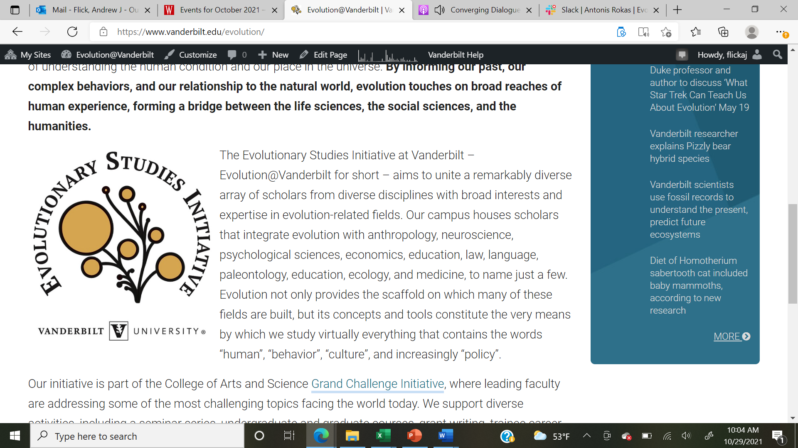
Name: __________________________ Email Address: _______________________________

Please submit this award request and other required documents (see below) to Dr. Andy Flick (andrew.j.flick@vanderbilt.edu).

Eligibility
- Must attend more than ½ of the upcoming Evolutionary Studies seminars and journal club meetings
- Research or travel must occur during current fiscal year (i.e., before June 1st, 2025)
- Only one award per trainee in current fiscal year

** Awards must be requested prior to the meeting. Requested funds (maximum of $500) must be applied directly to the costs associated with presenting to the meeting.

I certify that I will abide by the terms stated in this form and in my application:

Trainee’s signature: ___________________________________________ Date: __________

I certify that I have read over the application and find it true to the best of my knowledge:

Advisor’s signature: ___________________________________________ Date:__________
Advisor’s name: ___________________________________________
Please submit the following:
- This form signed by both you and your advisor.
- Meeting justification:
  - One or two sentence justification on how this meeting fits into the evolutionary studies theme.
  - One or two sentence justification on how presentation relates to evolutionary studies
- Budget with justification.
- Proof of Evolutionary Studies Initiative acknowledgement (e.g., acknowledgement slide).
- Written statement agreeing to attend majority of upcoming Evolutionary Sciences events

*** SPECIAL ADDENDUM for 2024-2025 ***
If you volunteer at the Evolutionary Studies booth for 2 hours during the conference in Athens, GA, you will be eligible for an additional $500 in travel funds. Please note this conference is likely in fiscal year 25/26 unless you use funds for registration costs and other charges that can occur before June 1st.

