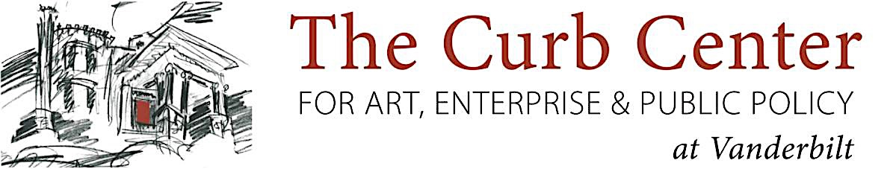

2017-2018 Curb Center Faculty Fellowship in Arts Policy Application

Name:

Title:

Department:

Project Title:

Research Team:
For each investigator, list their name, affiliation, email address, no more than one sentence about their role in the project, and link to lab/personal website.

Abstract:
(limit 100 words)

Research Plan:
(including Background/significance, Research aims and hypotheses, and Methods. Limit 500-1000 words)

References:
(limit 400 words)

Timeline for project:
(limit 100 words and/or one figure)

Budget Justification:
(limit 250 words)
Allowable budget items include: student stipends (graduate or undergraduate students, research supplies, small equipment, and travel expenses to collect data or meet with off-site collaborators (no conference travel).
Faculty salary coverage is not allowable.
Research teams and their unit administrators will be responsible for tracking expenditures.
Funds must be utilized by June 30, 2018; no extensions are permitted.

