I’ve
Updated: March 2022

Getting Started in the Lab

Sterility & Aseptic Technique

Written by: Kaeli Bryant, Vanderbilt University

Project Guide

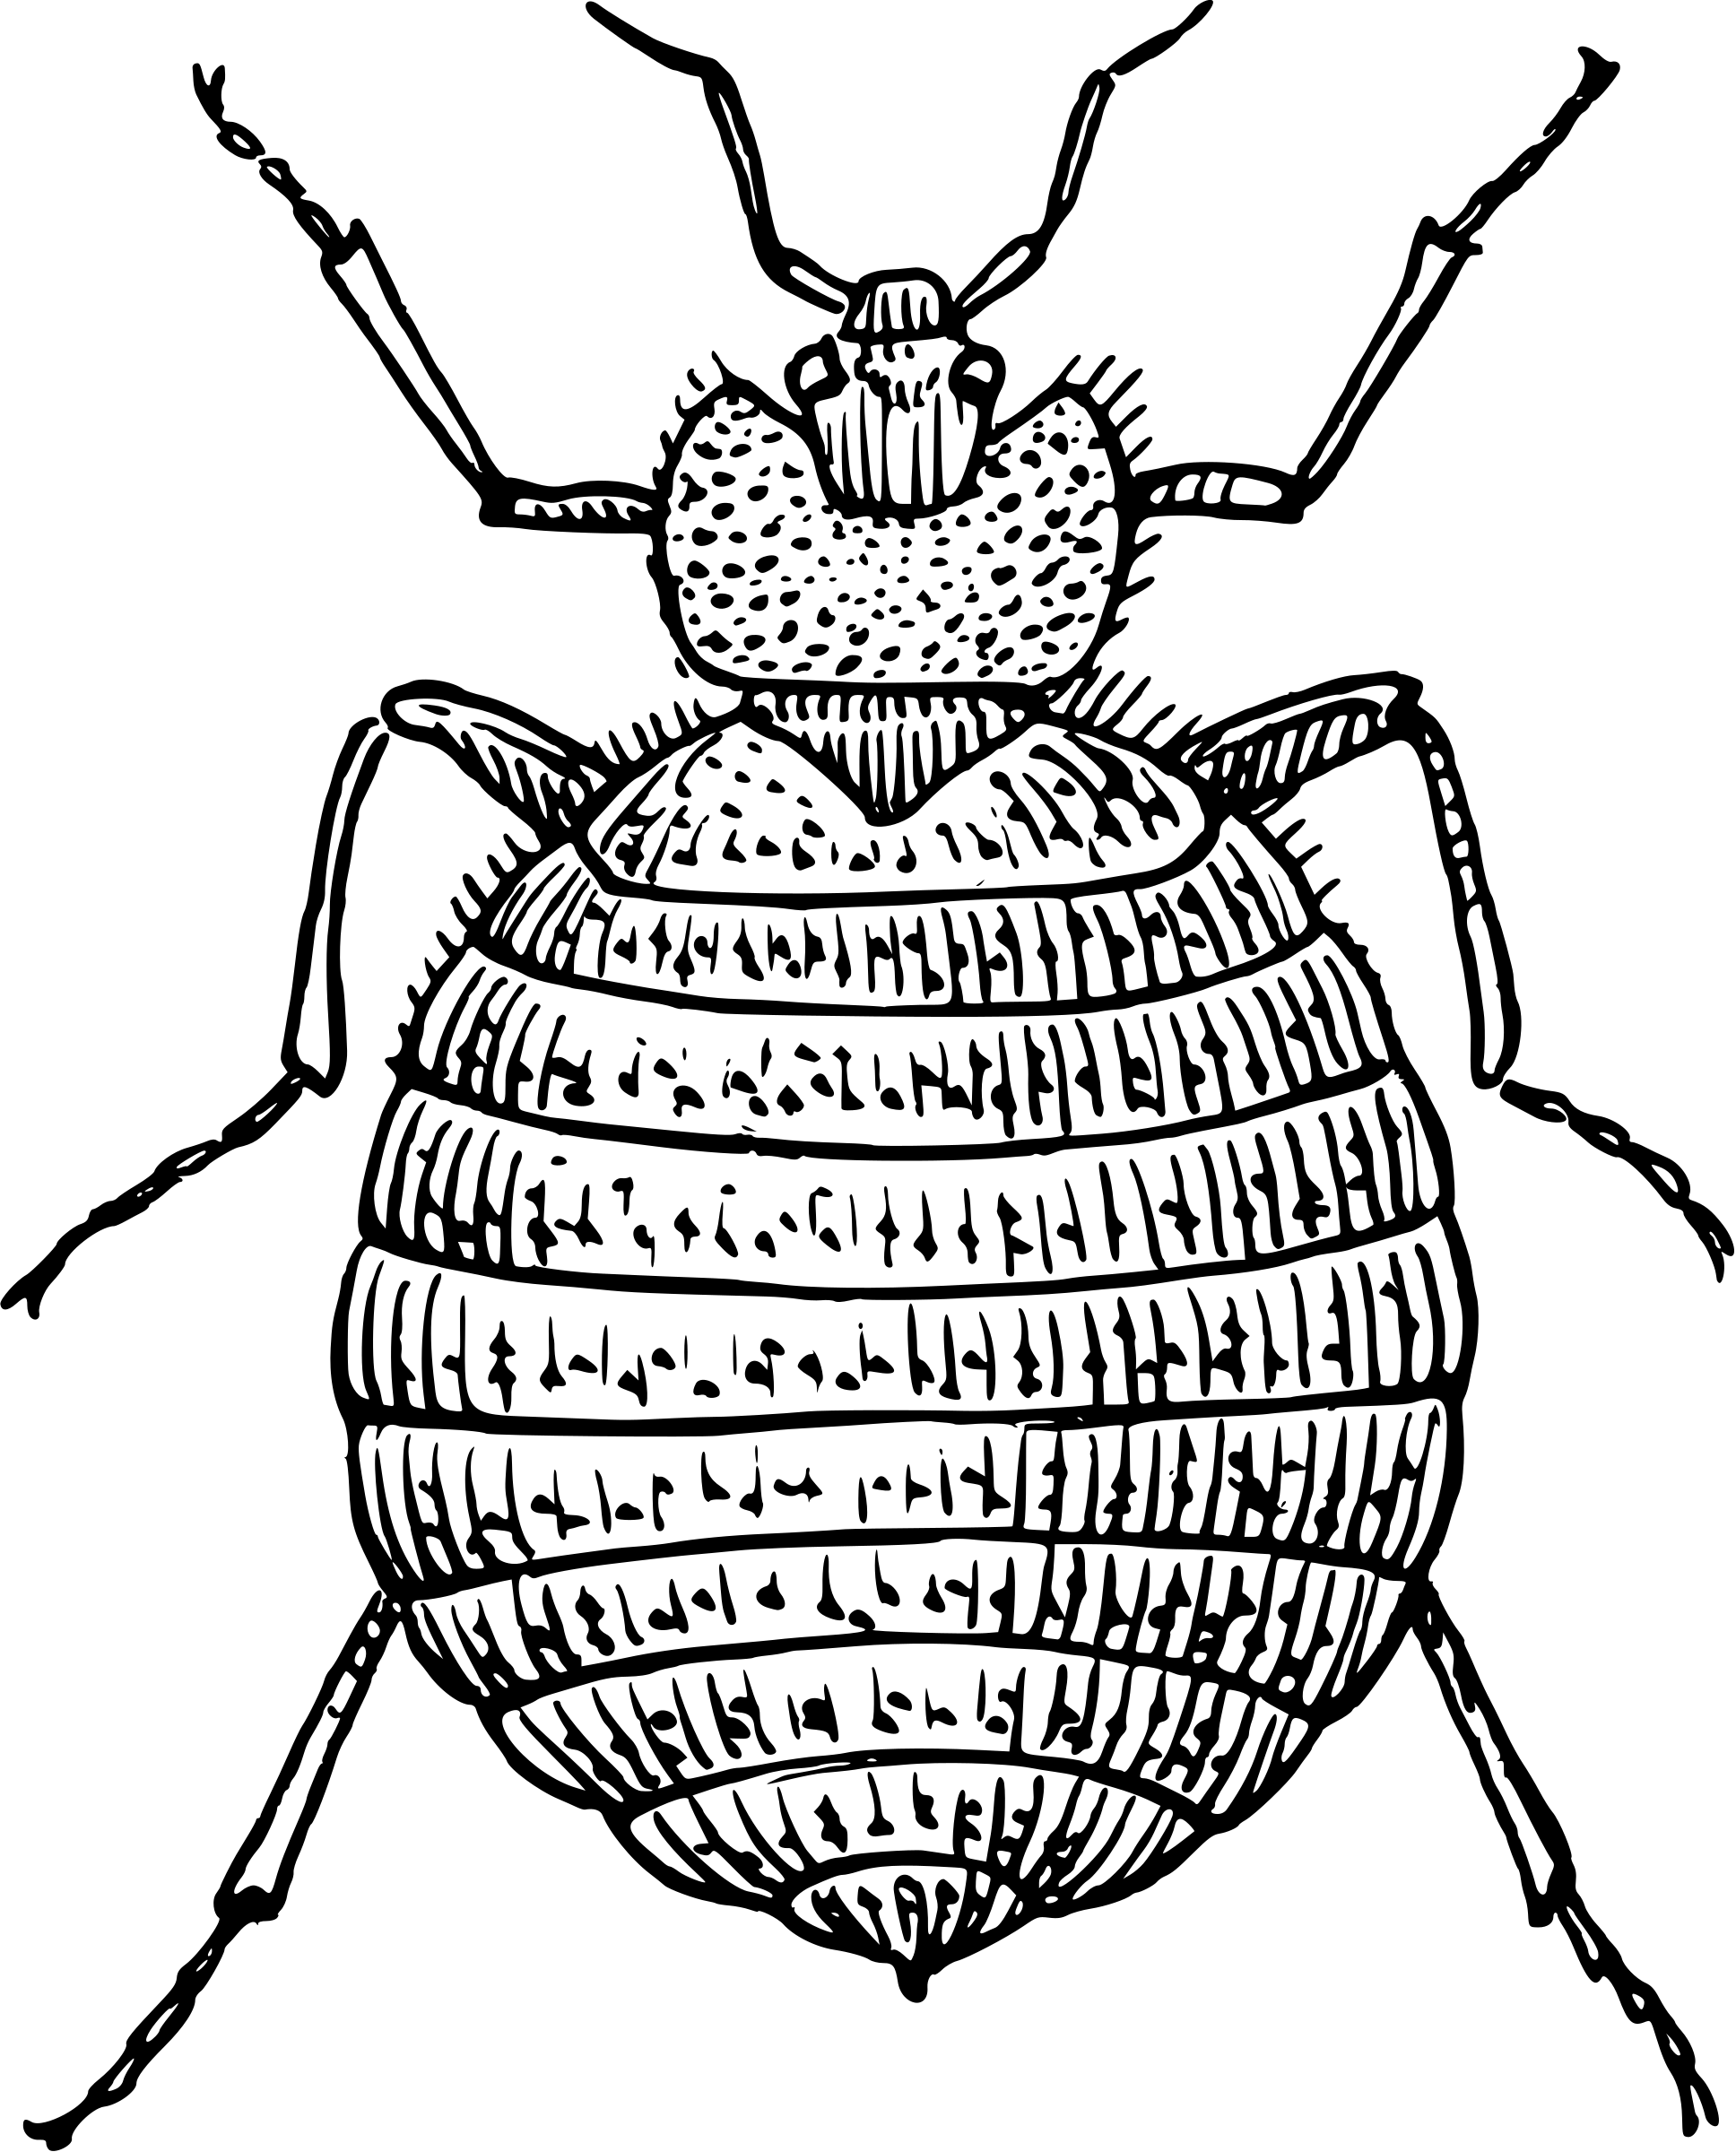
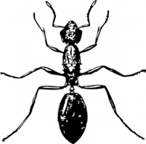
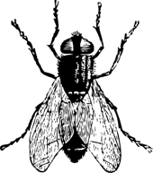
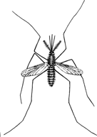
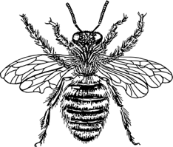
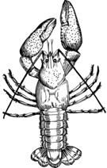

The Wolbachia Project

Page | Contents
 | Introduction
3-4 | --Where do Bacteria Live?
5-6 | --Sterility
6 | --Sterility Checklist
7-8 | --Pre-Lab Questions
 | Lab Activity
9-10 | --Visual Supplies Checklist
11-13 | --Pre-Lab Activity: Designing Your Experiment
14-15 | --Lab Activity: Plating Environmental Samples
16-18 | --Plate Observation Sheets
19 | --Post-Lab Activity: Colony Morphology
20-21 | --Post-Lab Questions
22 | Glossary
Content is made available under the Creative Commons Attribution-NonCommercial-No Derivatives International License. Contact (wolbachiaproject@vanderbilt.edu) if you would like to make adaptations for distribution beyond the classroom.

The Wolbachia Project: Discover the Microbes Within! was developed by a collaboration of scientists, educators, and outreach specialists. It is directed by the Bordenstein Lab at Vanderbilt University.
https://www.vanderbilt.edu/wolbachiaproject

Where Do Bacteria Live?

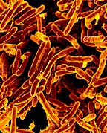
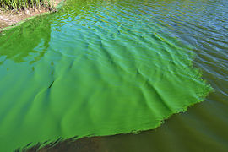
We live in a microbial world. Bacteria have spent millions of years adapting to almost every environmental niche possible. For example, microbes belonging to the genus Cyanobacteria are found in a wide range of habitats from terrestrial to marine. Normally beneficial, they break down waste, fix atmospheric nitrogen, and detoxify heavy metals. In warm, nutrient-rich environments, however, they can cause toxic algae blooms that poison animals and block sunlight to other organisms in the water column (Figure 1). Agrobacterium tumefacians, a soil microbe, is an important genetic engineering tool in biotechnology research where it is used to transfer genes into plant and fungi. Another soil bacterium, Mycobacterium tuberculosis has adapted to its environment by developing a thick waxy coat that retains moisture in dry environments (Figure 2). However, this waxy coat also causes great harm for humans, as it prevents degradation by immune cells and leads to the development of one of the deadliest infections on the planet—tuberculosis. Some bacteria can only survive if they’re inside of a host, like Wolbachia. These are classified as endosymbionts, meaning they live in symbiosis within another organism. Wolbachia can be found in many different arthropods and nematodes—in fact, it is the most common intracellular infection on the planet!
Figure 2. Scanning electron microscopy image of Mycobacterium tuberculosis
Figure 1. An algae bloom in a lake caused by Cyanobacteria (in green)

While bacteria can live in countless different environments, each of these environments provide specific nutrient and physiological conditions that may not be met if a microbe is moved to a different environment. However, by understanding what conditions need to be met for bacteria to grow, we can recapitulate these in an artificial environment to study the bacteria. In the lab, bacteria are most commonly grown on agar plates, round Petri dishes that are filled with agar. Agar is a combination of the sugar agarose and the carbohydrate mixture agaropectin and is typically derived from algae and seaweed. The addition of agar to a liquid will result in a thick, gelatinous substance. Indeed, agar can even be used in cooking applications as a vegan substitute for gelatin. Agar can be combined with different nutrients, depending on the requirements of the bacterium you want to study, to provide a solid surface where bacteria can grow and be studied (Figure 3). Nutrient agar refers to agar plates that contain a standard concentration of specific nutrients and are used as a baseline for standard bacterial growth.

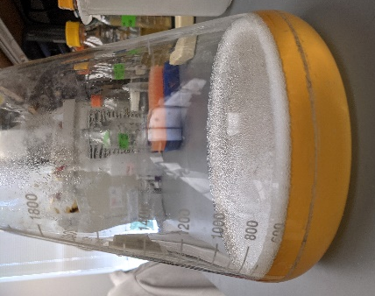
Different bacteria will grow better or worse depending on the type of agar plate you use. Some bacteria synthesize most of the nutrients they need on their own and can be grown on agar plates with minimal agar, which means there are very few nutrients added to the agar. However, other microbes need lots of nutrients from the environment and are plated on rich agar, which is media that contains supplements like amino acids, nucleotides, and carbohydrates. Some bacteria grow well inside of a host and can be plated on blood agar plates. These are agar plates that contain a small amount of mammalian blood to provide some of the unique nutrients that are required for these bacteria to grow in other organisms. Bacteria can also be grown without the use of agar plates. Liquid media contains all the components one might find in an agar plate, except the agar, which results in the media staying as a liquid and not thickening. Liquid media can be used to grow a greater amount of bacteria than what can be done on a plate. The same species can be grown on an agar plate or in liquid media, like Helicobacter pylori, as seen in Figures 4 and 5. Finally, there are some bacteria that scientists have not yet defined the conditions necessary for growth, meaning they cannot be grown on agar plates and must be studied in their native environment—this includes Wolbachia. Wolbachia is therefore considered an “unculturable bacterium”, meaning we are unable to culture, or grow, it in the lab outside of its native host.
Figure 3. Escherichia coli on a nutrient agar plate
Figure 5. H. pylori growing in liquid media
Figure 4. Helicobacter pylori on a blood agar plate

Sterility & Aseptic Technique

Sterility is the concept of removing any and all sources of contamination from an environment. Types of contamination that can exist on everyday surfaces include viruses, bacteria, fungi, and certain enzymes like DNases, RNases, and proteases that degrade DNA, RNA, and proteins, respectively (Figure 6). These can come from touching surfaces with bare hands, breathing onto surfaces, or placing contaminated objects onto a once-clean surface. It is absolutely imperative to keep your samples sterile and free of contaminants; otherwise, it can affect the results of your experiment and potentially ruin the sample altogether. Therefore, keeping your work environment contamination-free is of the highest importance in order to keep your experiment sailing smoothly.
Figure 6. DNase degrading a DNA molecule

Aseptic technique is the employment of practices that are used to minimize the risk of contamination. There are several ways that aseptic technique can be applied to keep the environment sterile. Certain chemicals can be used to remove contaminants from a surface before you begin working. 70% ethanol is commonly used to sterilize surfaces and equipment before beginning an experiment. Other reagents, or any substance used to cause a chemical reaction, like RNaseZap for example, are specialized for removing enzymes from a surface to prevent the degradation of important samples.

Personal protective equipment (PPE) is used to protect both you and your samples from contamination. Latex or nitrile gloves are always necessary when working with microbes. Additionally, you can wear a face mask to prevent aerosolized contaminants from getting on your sample. You may also wear a lab coat to prevent your clothes from contaminating the sample, and vice versa. When working with extremely dangerous microbes like Ebola virus, scientists wear a positive pressure personnel suit to reduce the risk of becoming infected.

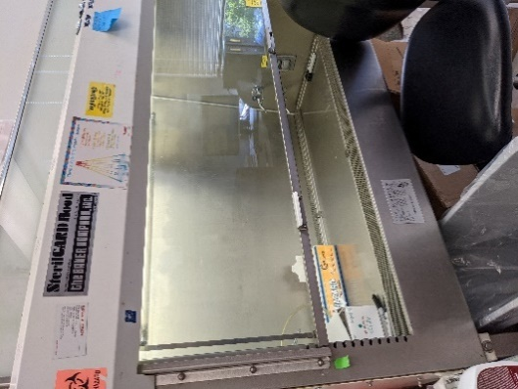
Scientists use specialized equipment dedicated to maintaining sterility. An autoclave is a machine that works similar to a pressure cooker—it creates a high temperature and high pressurized environment to kill microbes that are on the surface of supplies or present in media. In professional lab environments, scientists may use a biosafety cabinet to work with microbes. A biosafety cabinet (Figure 7) circulates air away from the sample to remove airborne contaminants and allows you to work with the sample exposed to air for a longer period of time. In other settings, a Bunsen burner can be used in a similar manner to remove airborne contaminants when a microbial sample must be exposed to air for a short period of time, like when spreading bacteria on a plate. When working with plates, be sure to minimize the amount of time that the agar is exposed to the air or use a biosafety hood, if available.
Figure 7. A biosafety cabinet in a research lab

Checklist for Creating a Sterile Workspace

- Autoclave all materials, including media, pipette tips, and tubes. You may also purchase these items pre-sterilized.
- Clear your workspace to remove potentially contaminating objects, such as your phone or backpack.
- Put on gloves and additional PPE if necessary.
- Use a spray bottle to spray the surface and equipment with 70% ethanol.
- Move samples and equipment to a biosafety hood, if available.
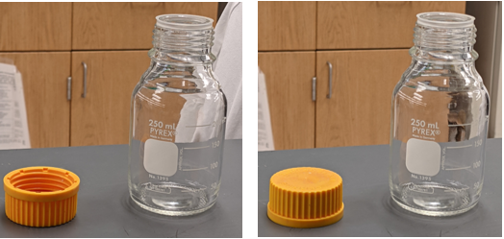
- When working with samples, minimize the amount of time they are exposed to air. If you are removing a lid (from sample or reagent), always place it upside down on the bench (Figure 8). If a lid is placed on the benchtop, it can transfer contaminants back to the source.

Pre-Lab Questions
Figure 8. Properly placing a lid upside down (left image) vs improperly placing a lid right side up (right image)

- Explain how the following reagents and equipment contribute towards sterility.
  - Autoclave

  - Gloves

  - 70% ethanol

- Mix and match definitions with the following terms:

Nutrient agar Liquid media Rich agar
Blood agar Minimal agar

a. | ____________________ | this type of media can be used when working with microbes that are able to infect mammals
b. | ____________________ | this type of media can be used for bacteria that are able to synthesize most of the nutrients they need
c. | ____________________ | this type of media can be used for bacteria that are unable to synthesize most of the nutrients they need
d. | ____________________ | this type of media can be used when a scientist needs a large volume of bacteria
e. | ____________________ | this type of media can be used for general bacteria growth

Pre-Lab Questions

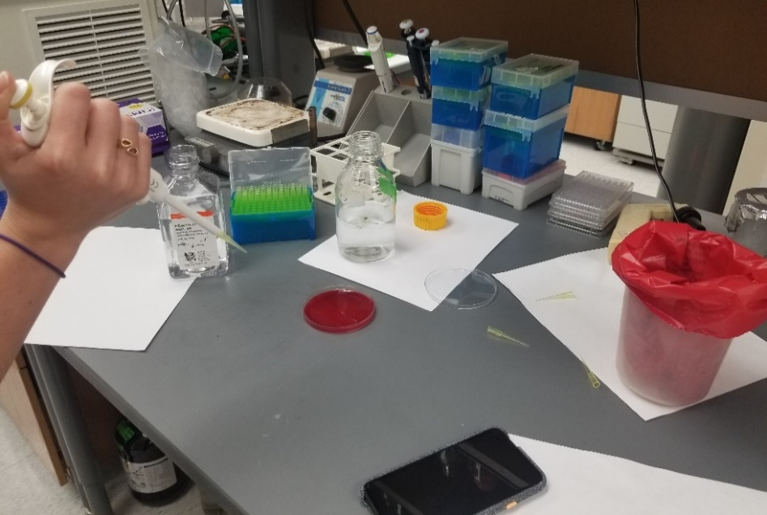
- Looking at the picture on the right, identify one of the possible errors in aseptic technique, why it is improper, and what should be done instead.

- You have isolated an unknown bacterium from a patient. What type of agar would you use to try and grow the bacteria, and why? Would you use the same type if the bacteria had been isolated from a soil sample?

Visual Supplies Checklist
 | Name | Picture | Purpose
 | Colored pencils |  | Learning Tool  Colored pencils can be used to accurately portray the color of the bacteria that you are observing.
 | Computer with Internet access | 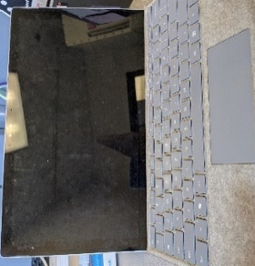 | Learning Tool  A computer allows you to access a wide range of information that may help to identify observed microbial growth.
 | Agar and  Petri dishes |  | Supplies  Agar is melted and poured into Petri dishes to make Agar plates, media that provides nutrients for bacterial growth.
 | Microwave | 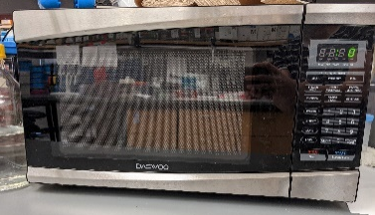 | Equipment  A microwave can be used to quickly melt materials such as agar.
 | Hot gloves | 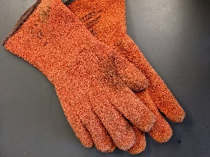 | Personal Protective Equipment  (PPE)  Hot gloves are used to protect your skin when handling hot objects. Use gloves if preparing agar in a glass container.
 | Nitrile gloves | 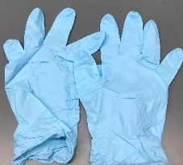 | PPE  Nitrile loves are used to protect both the scientist and sample from contamination.
 | Squirt bottle or spray bottle with 70% ethanol |  | Cleaning  70% ethanol is used to clean the workspace before and after experiments.
 | Sterile  cotton swabs | 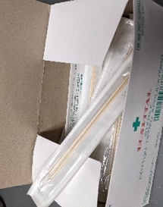 | Supplies  Sterile cotton swabs are used to lift bacteria from one surface and move to another surface, usually a plate of agar.
 | Sharpie |  | Organization  It is extremely important to label all plates correctly.
 | Parafilm |  | Safety  Parafilm is used to seal the agar plates after plating microbes.
Optional Supplies
 | Prepared  agar plates | 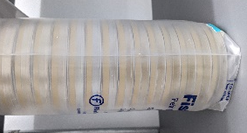 | Supplies  Agar plates are used to provide nutrients to bacteria to allow for growth. If using prepared agar plates, you do not need a microwave, hot gloves, agar, or Petri dishes.
 | Incubator |  | Equipment  An incubator is used to provide optimal growing conditions for bacteria by modifying the temperature, humidity, and/or CO₂ levels.

Pre-Lab Activity: Designing Your Experiment

In this activity, you will learn how to design a hypothesis and fill out the Plate Observation Sheets.
The goal of this module is to sample your environment for the presence of microbes. First, you will identify a surface from which you want to test microbial growth. Then, you will measure microbial growth by using a cotton swab to sample that surface and transferring the sample to an agar plate, which will allow the bacteria to grow and become visible.

Before you can begin, however, you must come up with a hypothesis. A hypothesis is a testable idea that explains a currently unknown phenomenon. For your experiment, there are several different hypotheses that you can test regarding the amount of microbial growth on a surface.
Example: If there are culturable bacteria on my hand, then I will be able to grow them on an agar plate.

Another type of idea for which you can make a hypothesis is to compare two different conditions.
Example: If I wash my hands with soap and water, then I will see reduced bacterial growth due to removing the microbes from my skin.

There is a plethora of ideas that could be tested in this module, so be creative! Another aspect to consider when designing your experiment is if it’s possible to include any controls. A control is a part of the experiment that you’re not modifying in order to compare the effects of the variable, or experimental, condition. For instance, in the experiment described above where you observe bacterial growth on a plate that has antibiotics, your variable condition would be plating unknown microbes on a plate with antibiotics. You could even include multiple variables represented by multiple plates featuring different antibiotics. One control you could include would be to plate the same unknown microbes on a plate without antibiotics. This would be a negative control, as you’re showing what happens without the variable of antibiotics. Another control you could include would be to plate bacteria that are known to be sensitive to the antibiotic on the antibiotic plate. This would be a positive control, as you’re showing what you might expect to happen if your variable is sensitive to antibiotics. Including controls in your experiments is very important to confirm that your variable condition is actually responsible for the phenomenon that you’re testing.

During this module, you will test at least one hypothesis. For each hypothesis, you need to fill out a Plate Observation Sheet for each sample and any controls you are including. Prior to doing the experiment, you will fill out what you will test, what your hypothesis is, and what the Plate ID # is. The Plate ID # should be unique to your group (2-4 people). Initials and a number are recommended.

Answer the following question and use the Pre-Lab Activity 1 Example Page to plan out your experiment.

- If you are unable to obtain sterile cotton swabs, you may substitute over-the-counter Q-tips. To control for unsterilized cotton swabs, it is recommended that you streak one plate – or portion of a plate - using just the Q-tip as a control. Would this be a positive or negative control? Explain.

Pre-Lab Activity Example Page
Brainstorming  List three questions that you could explore in this lab activity. They could pertain to specific environments or treatments. | Question 1:  Can I culture bacteria from my hand?
Question 2:
Can I culture bacteria from the surface of my desk?
Question 3:
Does the use of a cleaning agent affect the amount of bacteria I can culture from a door knob?
Hypothesis  Formulate a testable hypothesis. | If there are culturable bacteria living on my hand, then I will be able to grow them on an agar plate.
Variables  List the variables for your experiment. These are the unknown and testable components of your experiment. | The surface of my hand.
Controls  Does your experiment have controls? If so, list the controls and indicate if they are positive or negative controls. | (+) Control:  A plate of E. coli that my teacher will provide.
(-) Control:
A cotton swab that has not been used to swab for bacteria.

Brainstorming  List three questions that you could explore in this lab activity. They could pertain to specific environments or treatments. | Question 1:
 | Question 2:
 | Question 3:
Hypothesis

Formulate a testable hypothesis.
Variables

List the variables for your experiment. These are the unknown and testable components of your experiment.
Controls  Does your experiment have controls? If so, list the controls and indicate if they are positive or negative controls. | (+) Control:
 | (-) Control:

Lab Activity: Plating Environmental Samples

In this lab activity, you will observe microbial growth from three different environments.

Prepare lab space
- Remove all unnecessary items from your lab station
  - If possible, use a biosafety cabinet
- Put on nitrile gloves and clean all surfaces by wiping down with 70% Ethanol

Prepare the agar plates (optional, you may also purchase pre-made plates)
- Follow manufacturer’s instructions. General steps are listed below:
  - Loosen the cap on the agar bottle and microwave on low power in 60 second intervals or until the liquid begins to boil
  - Gently swirl the bottle to ensure that all agar is melted. If needed, microwave additional time in 30 second intervals
  - Wearing hot gloves, remove the container from the microwave and let cool for about 10 minutes or until you can hold the container without burning your hand
  - With the agar still warm, pour it into an empty Petri dish until the bottom is 2/3 covered. Gently swirl the plate, avoiding air bubbles, to coat the entire bottom of the plate
  - Cover the plate and let cool for one hour
  - Once agar has solidified, use immediately or store the plates upside down in a 4°C fridge

Swab and plate samples
- Place agar plates and sealed cotton swabs onto your sterile surface
- Label the bottom of each plate with the Plate ID #, the date, and brief description of the surface or control
  - If plating multiple samples on the same plate, use a Sharpie to draw a line on the bottom of the plate and label each side appropriately
- Remove the cotton swab from the packaging
  - Open packaging from the “stick end” to ensure the cotton swab does not touch anything
- For the surface that you’re testing, carefully rub the cotton swab against the surface for 5 seconds
  - Prepare your controls first, then test your samples
- Use the cotton swab to place the sample on the agar plate by gently swabbing the side used to touch the sample to the plate
  - For samples that may have a lot of bacteria or a lot of different types, like your cheek or hand, refer to Figure 9 for how to plate
  - For other samples, refer to Figure 10 for how to plate
- Place the lid back onto the agar plate and place plate upside down once sample has dried.
- Seal the lid with Parafilm by stretching a thin strip of Parafilm around the plate, such that there are no gaps between the top and bottom
- Discard the cotton swab in the trash
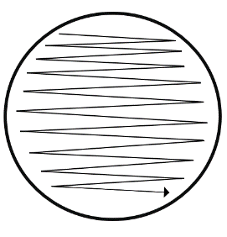
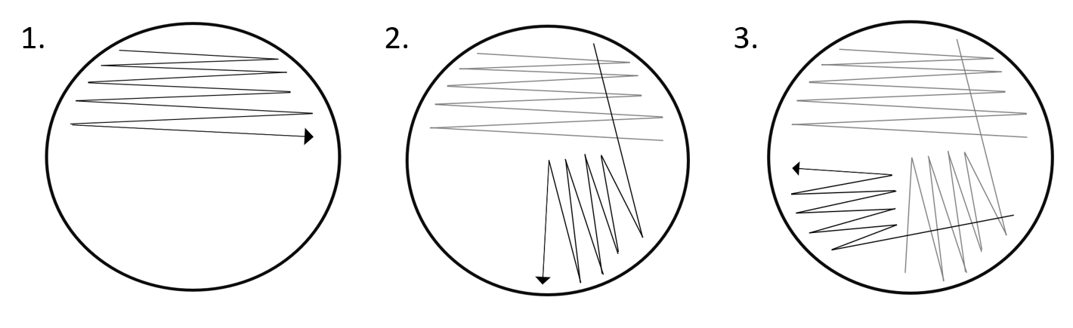
- Repeat steps 7-11 for each sample that you will be testing
Figure 9. Method for swabbing highly concentrated samples
- Once completed, store the plates in an incubator or in a warm location
- Check plates every 24 hours and record growth over the next 3-5 days. Leave the plate sealed with parafilm; do not open the lid
  - Use the Plate Observation Sheets on pages 17-19 to record growth characteristics

Plate Observation Sheet
Figure 10. Method for swabbing samples that are not highly concentrated

Record observations for each date. Use the chart from page 16 to include notes about colony morphology and growth rate. Use colored pencils to illustrate characteristics for each day.
Plate ID # _____
Collection Sheet
Surface:
Hypothesis:
Day ___ Observation:
Day ___ Observation:
Day ___ Observation:
Date:

Plate Observation Sheet

Record observations for each date. Use the chart from page 16 to include notes about colony morphology and growth rate. Use colored pencils to illustrate characteristics for each day.
Plate ID # _____
Collection Sheet
Surface:
Hypothesis:
Day ___ Observation:
Day ___ Observation:
Day ___ Observation:
Date:

Plate Observation Sheet

Record observations for each date. Use the chart from page 16 to include notes about colony morphology and growth rate. Use colored pencils to illustrate characteristics for each day.
Plate ID # _____
Collection Sheet
Surface:
Hypothesis:
Day ___ Observation:
Day ___ Observation:
Day ___ Observation:
Date:

Post-Lab Activity: Colony Morphology

In this activity, use online guides to research the basics of colony morphology, a method that scientists use to describe and identify microbes growing on agar plates.

- Use colored pencils to complete the following chart. (use the QR code above as a way to get started!)

Microbiology Colony Morphology
Form | Margin | Elevation | Color
Circular | Entire (even) | Flat | Opaque or white
Irregular | Undulate (wavy) | Raised | Milky
Filamentous | Filamentous | Convex | Orange
Rhizoid | Lobate (lobes) | Pulvinate | Red/pink
Punctiform | Erose (serrated) | Umbonate | Black
Spindle | Curled | Crateriform | Brown

- List at least 3 examples of colony texture.

Post-Lab Questions

- Compared to your hypothesis for each of the samples, were the results what you were expecting to see? Why or why not?

Plate 1:

Plate 2:

Plate 3:

- Describe what you observed from each of the swabs. What color are the different bacteria? What morphology? How dense? Use these characteristics and where the sample came from to attempt to guess what bacteria species you have growing

Plate 1:

Plate 2:

Plate 3:

Post-Lab Questions

- Based on what you’ve learned, do you have recommendations for optimizing your assay? If so, how would you modify the original protocol?

- Design a new experiment to test bacterial growth. What source are you going to sample? Are you going to include a positive or negative control? What type of plates would you use? What would you expect to happen?

Glossary

Aseptic technique: the employment of practices that are used to minimize the risk of contamination.
Bleach: a chemical used to sterilize materials and lyse microbes.
Blood agar: a type of growth media that is enriched with blood to allow for the growth of certain strains of bacteria.
Control: a part of the experiment that you’re not modifying in order to compare the effects of the variable condition.
Culture: to grow bacteria.
DNase: an enzyme that degrades DNA.
Endosymbiont: an organism that lives inside another organism, will often have a mutualistic or beneficial relationship.
Ethanol: a chemical used to sterilize materials and surfaces.
Hypothesis: a testable idea that explains a currently unknown phenomenon.
Incubator: a device used to grow and maintain microbes at specific conditions.
Liquid media: a type of growth media that does not solidify and can be used for various experiments; particularly useful for growing large amounts of bacteria.
Minimal agar: a type of growth media that contains very little nutrients.
Negative control: Ensures the process and samples are not contaminated, it is designed to produce a negative result.
Nutrient agar: a type of growth media that contains a standard amount of nutrients.
Petri dish: a small, plastic or glass plate that can be filled with agar to grow and sustain microbes.
Positive control: a well-understood variable; should result in an expected positive result.
Protease: an enzyme that degrades other proteins.
Reagent: any substance used to cause a chemical reaction.
Rich agar: a type of growth media that contains a high level and variety of nutrients.
RNase: an enzyme that degrades RNA.
Sterility: the concept of removing any and all sources of contamination from an environment.
Variable: the unknown condition that you are testing in your experiment

