I’ve
Updated: October 2021

Lab 5: Bioinformatics I

Sanger Sequence Analysis

Project Guide

Table of Contents

Page | Contents
3 | Activity at a Glance
4 | Technical Overview
5-6 | Part 1: Analyze a Sanger Sequence
7 | Part 2: Generate a Consensus Sequence
8 | Illustrated BLAST Alignment
9 | Part 3: Analyze a “Less than Perfect” Sanger Sequence
10 | Database Entry

Content is made available under the Creative Commons Attribution-NonCommercial-No Derivatives International License. Contact (wolbachiaproject@vanderbilt.edu) if you would like to make adaptations for distribution beyond the classroom.

The Wolbachia Project: Discover the Microbes Within! was developed by a collaboration of scientists, educators, and outreach specialists. It is directed by the Bordenstein Lab at Vanderbilt University.
https://www.vanderbilt.edu/wolbachiaproject

Activity at a Glance

Goals
To analyze and interpret the quality of Sanger sequences
To generate a consensus DNA sequence for bioinformatics analyses

Learning Objectives
Upon completion of this activity, students will (i) understand the Sanger method of sequencing, also known as the chain-termination method; (ii) be able to interpret chromatograms; (iii) evaluate sequencing Quality Scores; and (iv) generate a consensus DNA sequence based on forward and reverse Sanger reactions.

Prerequisite Skills
While no computer programming skills are necessary to complete this work, prior exposure to personal computers and the Internet is assumed.

Teaching Time: One class period

Recommended Background Tutorials
- DNA Learning Center Animation: Sanger Method of DNA Sequencing (https://www.dnalc.org/view/15479-sanger-method-of-dna-sequencing-3d-animation-with-narration.html)
- YouTube video: The Sanger Method of DNA Sequencing (https://www.youtube.com/watch?v=FvHRio1yyhQ)
- Khan Academy: DNA Sequencing (https://www.khanacademy.org/science/high-school-biology/hs-molecular-genetics/hs-biotechnology/a/dna-sequencing)

Required Resources
- Computer with internet browser, such as Firefox or Chrome
- DNA analysis software, such as SnapGene Viewer* - https://www.snapgene.com/snapgene-viewer/
- DNA Sequence Files: https://www.vanderbilt.edu/wolbachiaproject/lab-5-dna-sequences/

* Multiple software options are available for DNA sequence analysis. SnapGene Viewer is highlighted here due to its user-friendly interface and cross-platform accessibility. Another highly recommended tool is MEGA X (https://www.megasoftware.net/home).

Technical Overview

File Extensions
- .ab1 (ABI sequencer data file): Known as the trace file, it includes raw data that has been output from Applied Biosystems’ Sequencing Analysis Software. .ab1 files include quality information about the base calls, the chromatogram (also called the electropherogram), and the DNA sequence.
- .scf (Standard Chromatogram Format): Like .ab1 files, .scf files are also trace files that include quality information about the base calls, the chromatogram (also called the electropherogram), and the DNA sequence.
- .seq: Known as the sequence file, it is a plain text file containing the DNA sequence.
- .fasta: A text-based format for representing either nucleotide or peptide sequences. The file often starts with a description or header line that begins with ‘>’ and provides information about the sequence.

Quality Scores
Quality scores indicate the probability that an individual base is called incorrectly during DNA sequencing. For this lab, we recommend a Q score ≥ 40.

Q score | Probability of incorrect base call | Base call accuracy
10 | 1 in 10 | 90%
20 | 1 in 100 | 99%
30 | 1 in 1,000 | 99.9%
40 | 1 in 10,000 | 99.99%

Consensus Sequence
Recall that DNA is double-stranded. Therefore, sequencing a region of DNA involves two Sanger reactions: forward and reverse. Sanger sequencing the forward strand uses only the forward primer (the same forward primer used for PCR) while sequencing the reverse strand uses only the reverse primer (the same reverse primer used for PCR). This lab activity will walk through the analysis of each sequence separately and then illustrate how to generate a consensus sequence. To generate the consensus, you will perform an alignment of both the forward and reverse sequences to confirm that bases are complementary. If the alignment is not 100% homologous, you should investigate the discrepancy in the original chromatogram files.

Is sequencing both strands required? No. Oftentimes, only one direction is sequenced because it is much more cost-effective. If the Sanger sequencing run was successful and quality scores are >40, this DNA sequence can be trusted. Most Wolbachia Project participants sequence only the forward strand.

Part 1: Analyze a Sanger Sequence

MATERIALS

Example Sanger sequence:
- Example-WSpecF.ab1

Computer with:
- SnapGene Viewer Software
- Internet Access (NCBI)

Getting Started
- Download Example Sanger sequences to a folder on your desktop.
  - https://www.vanderbilt.edu/wolbachiaproject/lab-5-dna-sequences/
- Download SnapGene Viewer to your computer:
  - https://www.snapgene.com/snapgene-viewer/
- Open SnapGene Viewer.

Edit a Forward Trace File
  - Select Open >> Open Files >> Example-WSpecF.ab1.

  - Select File >> Save As >> Mod.WSpecF.scf (or name of your preference). Rename the sequence to create a copy of the original .ab1 file. Since SnapGene Viewer does not have an .ab1 option, use the comparable .scf extension.
Note: Always make a copy of raw data prior to editing. Keep the originals in case you make a mistake along the way or need to refer to the raw sequences in the future.

  - Select “Show quality values” in the lower right-hand corner. The bars correlate to quality score. Hover the cursor over each bar to visualize the quality score.

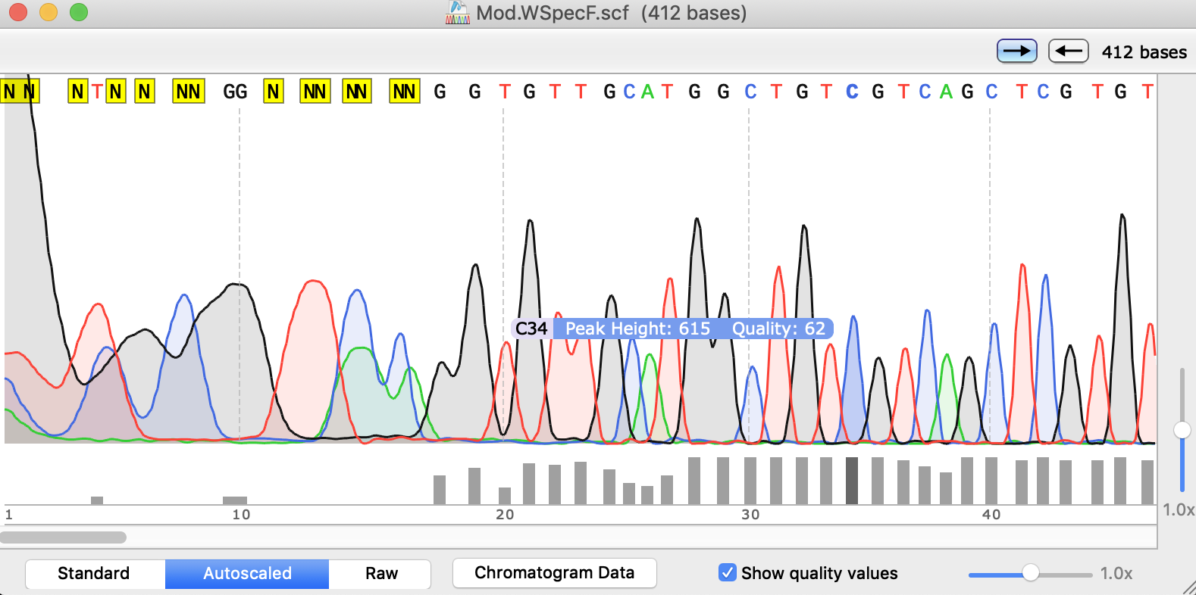

The Quality Score for this base call is 62.
Turn on Quality Values

  - Use the bottom scroll bar to scan the sequence. Confirm that the majority of the sequence contains unique peaks with quality values ≥ 40.

  - The ends of the sequence will likely be low-quality (as seen above). Therefore, it is necessary to trim/delete poor base calls. Beginning at the 5’-end (left), identify the beginning of the “high quality sequence.”
Note: Determining where to trim based on the chromatogram and quality scores requires some personal judgement. For example, scroll to base 54. It has a distinct ’T’ peak, but the Quality Score is only 21. According to our ≥ 40 cutoff, there are three possible options ranging from most to least conservative:
- Trim everything before base 55.
- Include this region, but change to ‘T’ to ‘N’
- Perform an alignment (see Part 2); if the complementary strand is ‘A’, keep the ‘T’ base call.
Most importantly, maintain consistency throughout your analysis. Define guidelines, record them in your lab notebook, and apply them to all sequences.

  - Using the cursor, highlight ALL bases prior to this sequence.
For this example, we will apply the most conservative guidelines and select for the contiguous sequence with ≥ 40 quality scores. Therefore, we will trim the first 54 bases.

- Hit ‘Delete.’
ONLY trim from the ends; NEVER trim the interior portion of the sequence!

- Repeat steps #8-10 for the 3’-end (right).
Applying the most conservative guideline, we will trim the last 17 bases.

- Scroll through the sequence. Are all quality scores ≥ 40?
If there is a low-value base call in the middle of the sequence, DO NOT DELETE. Use your judgment here. Does the peak look unique? Is the value near 40 (i.e., 37-39)? If yes, you can leave as is. If you are not confident with this base call, highlight with your cursor and type ‘N’. This will replace the base call with ‘N’, indicating that the exact base is unknown.

- Select File >> Export >> FASTA Format.

- Check your folder. You should now have 3 files for this sequence: the original trace file (.ab1), the modified trace file (.scf), and the FASTA file.

Part 2: Generate a Consensus Sequence

MATERIALS

Example Sanger sequences:
- Example-WSpecF.ab1
- Example-WSpecR.ab1

Computer with:
- SnapGene Viewer Software
- Internet Access (NCBI)
Edit the Forward Trace File
Download Example Sanger sequences to a folder on your desktop.
  - https://www.vanderbilt.edu/wolbachiaproject/lab-5-dna-sequences/
Complete Part 1 to generate a WSpecF forward FASTA file.

Edit the Reverse Trace File – repeat the same steps from Part 1
  - In SnapGene Viewer, select Open >> Open Files >> Example-WSpecR.ab1.
  - Select File >> Save As >> Mod.WSpecR.scf (or name of your preference).
  - Select “Show quality values” in the lower right-hand corner.
  - Use the bottom scroll bar to scan the sequence. Confirm that the majority of the sequence contains unique peaks with quality values ≥ 40.
  - Beginning at the left, identify the beginning of the “high quality sequence.”
  - Using the cursor, highlight ALL bases prior to this sequence.
  - Hit ‘Delete.’
  - Repeat steps #19-21 for the right end of the sequence.
  - Scroll through the sequence. Are all quality scores ≥ 40?
  - Select File >> Export >> FASTA Format.
  - Check your folder. You should now have 3 files for this sequence: the original trace file (.ab1), the modified trace file (.scf), and the FASTA file.

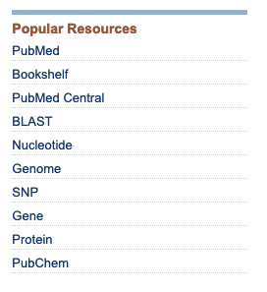
Generate a Consensus Sequence
- Open NCBI in your web browser: https://www.ncbi.nlm.nih.gov/
- Select “BLAST” from the right-hand ‘Popular Resources’ menu
- Select “Nucleotide BLAST.”
- (optional) Enter a Job Title.
- Click “ Align two or more sequences” at the bottom of the first box.
- Load your forward FASTA file in the top box and the reverse FASTA file in the second box. Hit BLAST.
  - The lower box shows the alignment of the two sequences.
  - Bases that are gray and lower case indicate low complexity regions.
- Check the % Identity. It should be 100%. If not, refer to the trace files and investigate the discrepancy.
- If your identity is 100%, select the Arrow next to “Download” and download FASTA (aligned sequences). Save. You have now generated a Consensus Sequence.
Illustrated BLAST Alignment

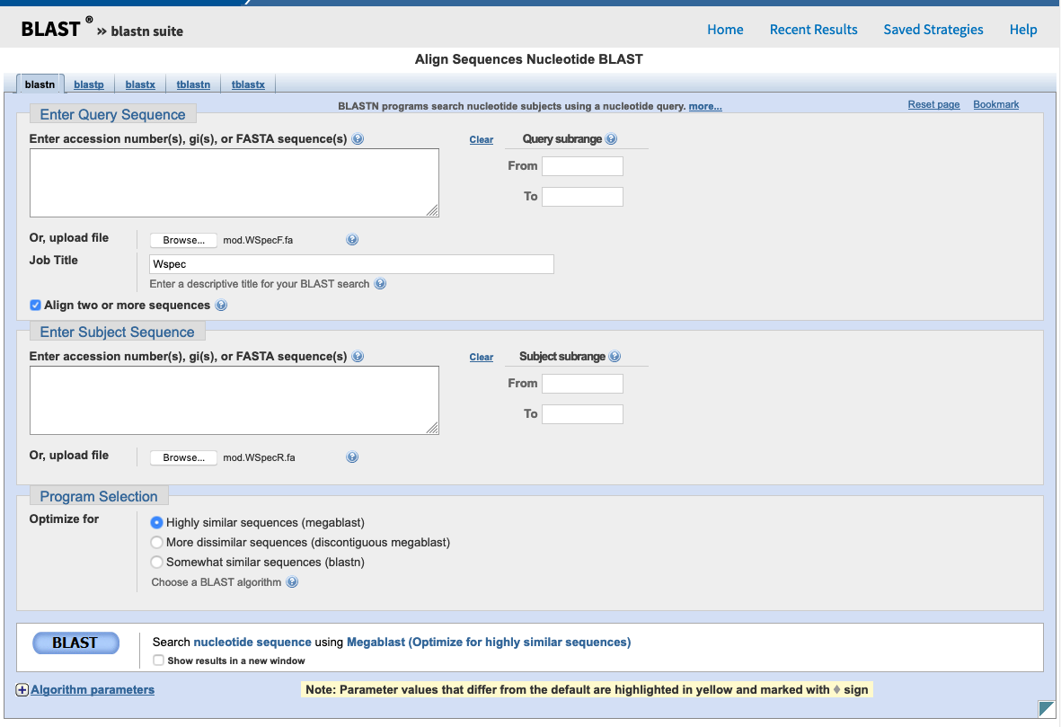
QUERY
1. Enter “Job Title”
(optional)
2. Check “Align two or more sequences"
3. Upload .fasta files or manually enter nucleotide sequences.
4. Select “BLAST”

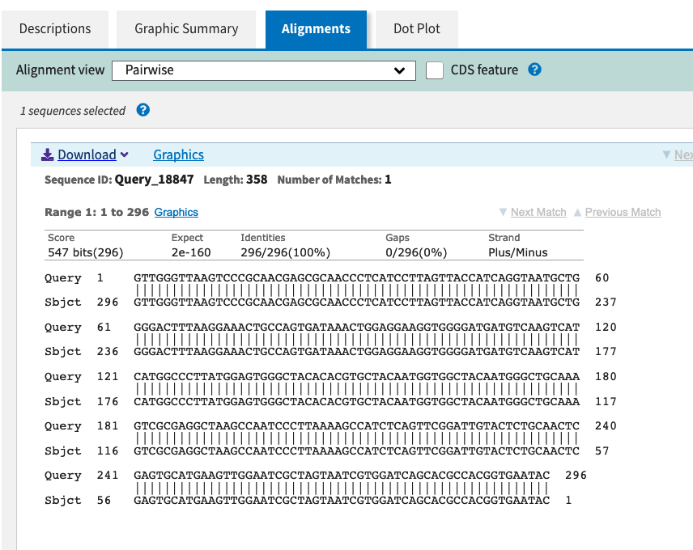
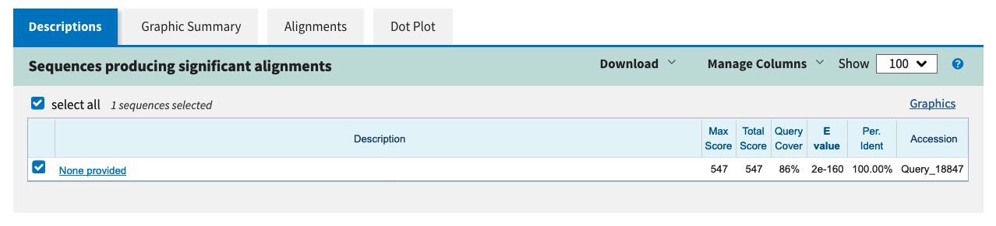
RESULTS
6. Confirm that identity is 100%
7. Download “FASTA (aligned sequence)” and “Save”
8. The “Consensus Sequence” is the aligned 296 bases that are shared between forward and reverse strands.
5. Select “Alignments” tab

Part 3: Analyze a “Less than Perfect” Sanger Sequence

MATERIALS

Example Sanger sequences:
- Example-CO1R.ab1
- Example-CO1F.ab1

Computer with:
- SnapGene Viewer Software
- Internet Access (NCBI)
Getting Started
Download Example Sanger sequences to a folder on your desktop.
  - https://www.vanderbilt.edu/wolbachiaproject/lab-5-dna-sequences/

- In SnapGene Viewer, select Open >> Open Files >> Example-CO1R.ab1.
- Select File >> Save As >> Mod.CO1R.scf (or name of your preference).
- Select “Show quality values” in the lower right-hand corner. Notice the low Q scores.
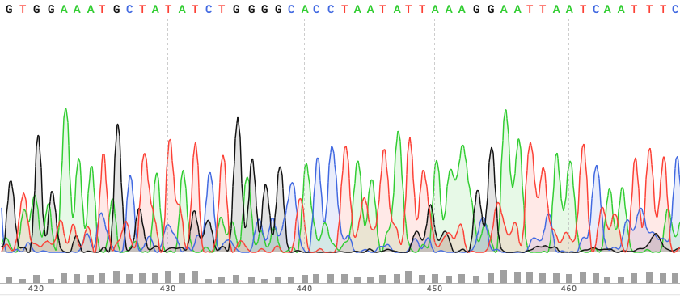
- Not only are Q scores < 40, but there are also multiple peaks for each base call. This is a low-quality sequencing run and base calls should not be trusted.
- Because the Sanger sequence is poor quality, we will need to perform Sanger sequencing using the other PCR primer (in this case, use the forward primer).
- Open the complementary (forward) strand In SnapGene Viewer: select Open >> Open Files >> Example-CO1F.ab1.
- Select File >> Save As >> Mod.CO1F.scf (or name of your preference).
- Select “Show quality values” in the lower right-hand corner.
This sequence is a better run and can be trusted.
- Follow the steps in Part 1 for this sequence.

Many variables can cause a low-quality run including, but not limited to:
- Non-specific primer binding
- Contamination with other samples during DNA extraction and/or PCR
- Arthropod-specific: Amplification of both the COI gene and nuclear mitochondrial pseudogenes (numts)
- Wolbachia-specific: The arthropod is infected with more than one Wolbachia strain (co-infection)
- Not enough DNA template
- DNA degradation
- Inhibitory contaminants (salts, enzymes)

Database Entry
After completing this lab, analyze your own Sanger sequences and complete corresponding entries in The Wolbachia Project Database. A comprehensive guide is located under the Resources tab.
https://wolbachiaprojectdb.org/
Database fields to review and update
  - Wolbachia positive?
  - Confidence level
  - Explain your confidence level

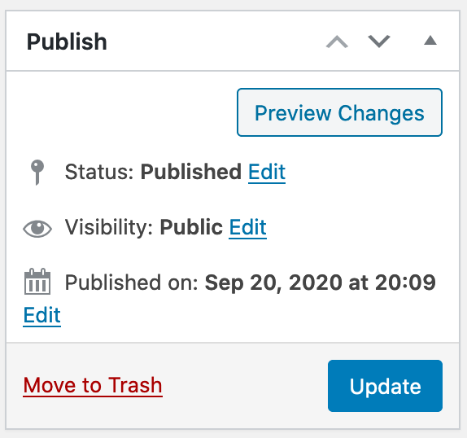
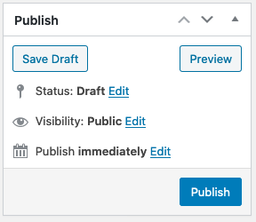
If Wolbachia-positive and DNA was sequenced:
  - Wolbachia 16S .fasta upload
  - Wolbachia 16S .ab1 upload
  - Wolbachia 16S sequence (text)
If Arthropod DNA was sequenced:
  - Arthropod 16S .fasta upload
  - Arthropod 16S .ab1 upload
  - Arthropod 16S sequence (text)
Database fields to complete
Publish
or
Update
Share with the world

