I’ve
Updated: October 2021

Lab 5: Bioinformatics III

Wolbachia Identification & Naming

Project Guide

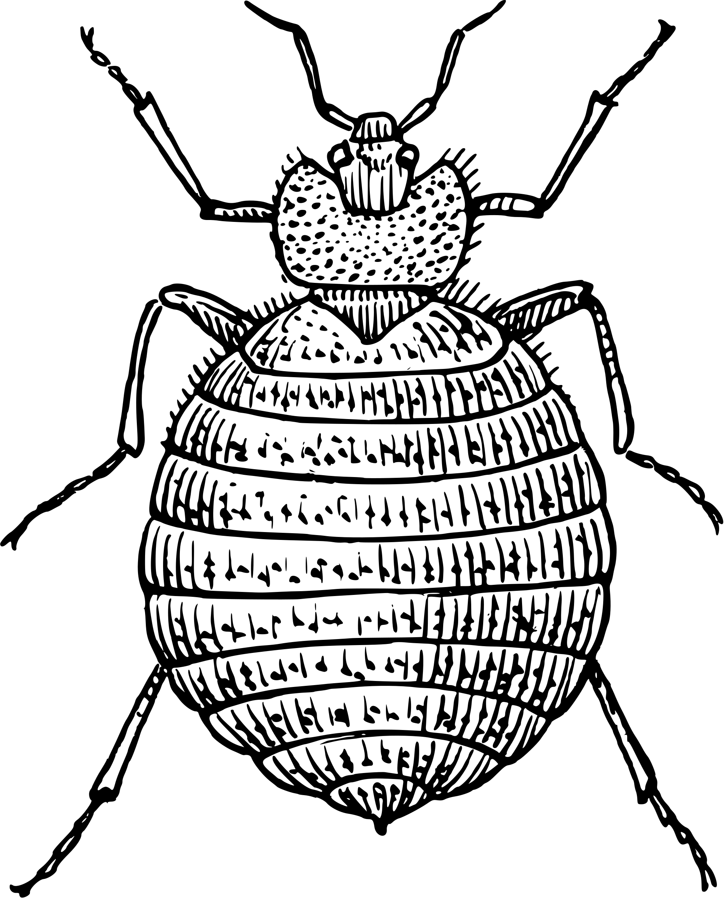
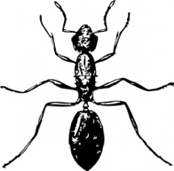
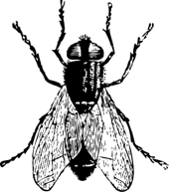
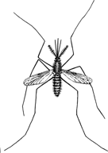
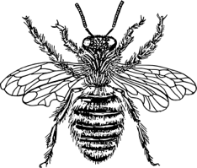
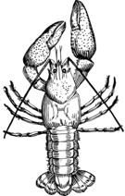

The Wolbachia Project

Page | Contents
 | Introduction
3 | -- Wolbachia Identification
4 | -- Wolbachia Naming
5 | -- Wolbachia Supergroups
6 | -- Pre-Lab Question
 | Lab Activity
7 | -- Activity 1: Wolbachia Discovery
8 | -- Activity 2: Wolbachia Naming
Content is made available under the Creative Commons Attribution-NonCommercial-No Derivatives International License. Contact (wolbachiaproject@vanderbilt.edu) if you would like to make adaptations for distribution beyond the classroom.

The Wolbachia Project: Discover the Microbes Within! was developed by a collaboration of scientists, educators, and outreach specialists. It is directed by the Bordenstein Lab at Vanderbilt University.
https://www.vanderbilt.edu/wolbachiaproject

Wolbachia Identification

Wolbachia is a bacterial genus that was first identified in 1924 by entymology student Marshall Hertig and his advisor, S. Burt Wolbach, as Rickettsia-like microorganisms that infect insects (Hertig & Wolbach, 1924). In 1936, Hertig officially proposed the name Wolbachia pipientis because it was found to be present in every germ cell of both male and female Culex pipiens mosquitoes throughout all stages of development (Hertig, 1936). It has since been detected in numerous arthropods (including insects, spiders, mites, and crustaceans), filarial nematodes, and plant-parasitic nematodes. Wolbachia are obligate intracellular endosymbionts, meaning they live within the cells of other organisms. Unlike free-living bacteria, such as E. coli, they cannot be cultured on a petri dish or studied in cell-free media. In order to determine morphology and distinguishing characteristics, scientists rely on tools such as transmission electron microscopy (Fig 5.1), scanning electron microscopy (Fig 5.2) and, most commonly, DNA sequencing and genetic analysis.

Figure 5.2. Scanning electron micrograph shows a Wolbachia cell, purified from an insect host, that is in the process of dividing.
Image credit: Dennis Kunkel and Sarah Bordenstein
Figure 5.1. Transmission electron micrograph shows a single Wolbachia cell enclosed by multiple eukaryotic-derived membranes within an insect host.
Image credit: Sarah Bordenstein

One of the most widespread genetic tools to identify Wolbachia is the 16S rRNA gene marker. This phylogenetic marker is commonly used to identify bacteria at the species level and to differentiate between closely related species. While 16S rRNA provides an introductory level of classification, additional genes such as wsp and a set of multilocus sequence typing (MLST) genes - ftsZ, gatB, coxA, hcpA, and fbpA - have also been used to further resolve evolutionary relationships.

References
Hertig, M., & Wolbach, S. B. (1924). Studies on Rickettsia-Like Micro-Organisms in Insects. The Journal of Medical Research, 44(3), 329–374.7.
Hertig, M. (1936). The Rickettsia, Wolbachia pipientis (gen. et sp.n.) and Associated Inclusions of the Mosquito, Culex pipiens. Parasitology, 28(4), 453-486.
Wolbachia Naming

As discussed in Lab 1, the Linnean system of taxonomy classifies all organisms into genus and species. Beyond this, many species are further classified into subcategories. Using domestic dogs as an analogy, we know that they are all classified as one taxonomic species - Canis familiaris - yet there are dramatic differences between a German Shepherd and a Dalmatian (Fig 5.3). Society therefore categorizes domestic dogs into breeds. If you’ve ever watched an AKC dog show, you’ll notice that individual breeds can also be organized based on the historical work associated with each type: sporting group, hound group, working group, terrier group, toy group, herd group, and non-sporting group.
Canis familiaris
Breed: German Shepherd
Group: Herding group

Wolbachia are currently classified into one species: Wolbachia pipientis. Within this species designation, they are further categorized into strains. Strains are generally written as a lower-case w (to indicate Wolbachia) followed by a two to three letter abbreviation of the host species. The first letter following w is always capitalized. Below, the three letters are derived from just the species name.
Canis familiaris
Breed: Dalmatian
Group: Non-sporting group
- wMel is the Wolbachia endosymbiont of Drosophila melanogaster
- wKue is the Wolbachia endosymbiont of Ephestia kuehniella
- wMeg is the Wolbachia endosymbiont of Chrysomya megacephala
Figure 5.3

Alternatively, the capitalized letter may refer to genus and the following letters identify the species.
- wCle is the Wolbachia endosymbiont of Cimex lectularius
- wBm is the Wolbachia endosymbiont of Brugia malayi
- wOv is the Wolbachia endosymbiont of Onchocerca volvulus

In many cases, multiple Wolbachia strains might be associated with a single host species. Rather than have wSim1 and wSim2 for Wolbachia endosymbionts of Drosophila simulans, for example, standardized strain designations can be replaced by an abbreviation for the geographic location of its host.
- wRi is the Wolbachia endosymbiont of Drosophila simulans from Riverside, CA
- wAu is the Wolbachia endosymbiont of Drosophila simulans from Australia
While both strains infect Drosophila simulans and share high genetic similarity, it is important to differentiate between the two because wRi induces cytoplasmic incompatibility whereas wAu is not associated with a reproductive phenotype in its host.

In addition, abbreviated descriptors might be added to the end of a strain name.
- wCobs-BR is the Wolbachia endosymbiont of Cardiocondyla obscurior from Brazil
- wCobs-JP is the Wolbachia endosymbiont of Cardiocondyla obscurior from Japan

Wolbachia Supergroups

In 1998, Supergroups were proposed in order to group genetically related strains of Wolbachia (Zhou et al., 1998). The designation often, but not always, correlates with host type. The first described Supergroups A and B are associated with arthropods whereas Supergroups C and D are associated with filarial nematodes; Supergroup E has only been described in springtails; Supergroup F is found in both termites and filarial nematodes; and so on. Because different Wolbachia strains can co-infect the same host, Supergroup designations are often added to the end of the strain name:
- wVitA is the Supergroup A-Wolbachia endosymbiont of Nasonia vitripennis
- wVitB is the Supergroup B-Wolbachia endosymbiont of Nasonia vitripennis
- wAlbA is the Supergroup A-Wolbachia endosymbiont of Aedes albopictus
- wAlbB is the Supergroup B-Wolbachia endosymbiont of Aedes albopictus
- wCauA is the Supergroup A-Wolbachia endosymbiont of Cadra cautella
- wCauB is the Supergroup B-Wolbachia endosymbiont of Cadra cautella

Figure 5.4. Unrooted phylogenetic tree of Wolbachia Supergroups based on 2 genetic markers, ftsZ and coxA.
Image credit: Lefoulon et al., 2020

Supergroups were originally based on DNA sequence homology of the wsp (Wolbachia surface protein) gene and have since been expanded to encompass multi-locus phylogenies, where a phylogenetic tree is constructed from more than one genetic marker (Fig 5.4). Using multiple markers across the genome allows for resolution of closely related species and helps to delineate Supergroups. For the purpose of this lab activity, we will construct a tree based solely on a short segment of the 16S rRNA gene marker.
Pros: This method is easy and affordable. For less than $5 per sequence, we can determine a putative Supergroup designation. A phylogenetic tree of one gene can be created using freely available software with no required background experience in bioinformatics.
Cons: Using only a small segment (i.e., about 300-400 bp) of a single 16S rRNA gene (>1,400 bp) may not resolve closely related strains and/or clearly differentiate between some Wolbachia Supergroups. More advanced phylogenomic assays (involving genome data and evolutionary reconstructions) may be required to definitively identify proper grouping.

References
Lefoulon, E., Clark, T., Borveto, F. et al. (2020). Pseudoscorpion Wolbachia symbionts: diversity and evidence for a new supergroup S. BMC Microbiol 20, 188.
Zhou, W., Rousset, F., & O'Neil, S. (1998). Phylogeny and PCR-based classification of Wolbachia strains using wsp gene sequences. Proceedings. Biological Sciences, 265(1395), 509–515.

Pre-Lab Question

Complete the following table to match each Wolbachia strain name to the corresponding host species.

wAlbB
wAna_India
wAu
wBif
wBt
wCauA
wCauB
wFex
wKue
wMel
wNfe
wNfla
wPipJHB
wRec
wVitA

Host species (Wolbachia Supergroup) | Wolbachia strain name
Drosophila recens
Drosophila bifasciata
Drosophila melanogaster
Cadra cautella (Supergroup A)
Cadra cautella (Supergroup B)
Bemisia tabaci
Nomada ferruginata
Nomada flava
Culex pipiens Johannesburg
Ephestia kuehniella
Drosophila simulans from Australia
Drosophila ananassae from India
Aedes albopictus (Supergroup B)
Formica exsecta
Nasonia vitripennis (Supergroup A)

Lab Activity 1: Wolbachia Discovery

Lab Pre-requisite - Before beginning this lab, complete the following modules:
    - Bioinformatics I: Sanger Sequencing Analysis
    - Bioinformatics II: NCBI Taxonomy & BLAST Searching

If your arthropod did not have a Wolbachia infection, select one of the
“Example Wolbachia Sequences” from Module III:
https://www.vanderbilt.edu/wolbachiaproject/lab-5-dna-sequences

The goal of this activity is to assess your Wolbachia discovery in context of previous research. Follow the steps below to see if Wolbachia has been identified in your arthropod(s).

Wolbachia Project Database
- Open a browser window and go to: https://wolbachiaprojectdb.org/
- Select ‘Database >> Browse by Taxonomy’ from the navigation menu.
- Scroll through the available taxa – is yours listed?

- Is your arthropod (or a closely related species) represented in the Wolbachia Project Database? If so, how do your results compare to previous results?

NCBI
- Open a browser window and go to: https://www.ncbi.nlm.nih.gov/taxonomy
- Enter Wolbachia in the top Taxonomy search bar and select Search.
- Select Wolbachia.
- Scroll through the alphabetized list to see if Wolbachia has been described in your arthropod.
- Optional - If your arthropod is present, click on the link. The taxonomy page links all NCBI records (see upper right-hand corner for nucleotide and protein links).

- Is Wolbachia listed for your arthropod?

Google Scholar
- Open a browser window and go to: https://scholar.google.com
- In the search bar, enter Wolbachia and your arthropod name. This will provide a list of journal articles and books that discuss your arthropod. Be careful, some papers report negative (uninfected) data. To the best of your ability, scroll through the article to determine status.

- Has anyone previously detected Wolbachia in your arthropod?

Lab Activity 2: Wolbachia Naming

The goal of this activity is to follow standard Wolbachia nomenclature in order to name your strain. This name will be used as the taxon label for phylogenetic trees. Refer to page 5 for more information.

YES
NO
NO
YES

- What is your Wolbachia strain name? _____________________

- Open a browser window and search for “Wolbachia wXXX” (insert strain name). Has this name already been used?

- If your name has already been used by scientists, revise the name by adding a descriptor at the end of the strain. For example, if your name is wSim (for Wolbachia of Drosophila simulans) and you collected the fly from the city of Forest Hills, you might use wSimFH (for Wolbachia of Drosophila simulans from Forest Hills).

It is very possible that your Wolbachia strain could be identical to one that has already been described. Unfortunately, we are not able to conclusively assess exact genomic identity with just a partial 16S rRNA sequence. More detailed analyses, such as genome sequencing, are required. However, contributing the 16S rRNA sequence will inform scientists about the strain infecting your particular arthropod.

