Lab 5: Bioinformatics III
QUICK SHEET: Build an Arthropod Phylogenetic Tree

MATERIALS

- Arthropod sequence(s):
Use your FASTA sequence(s) from Module I. If you do not have your own sequences, download one or more Unknown Arthropod Sequence(s):
https://www.vanderbilt.edu/wolbachiaproject/lab-5-dna-sequences/#moduleiii

- FASTA Reference Sequences for Arthropod Phylogenetics:
https://www.vanderbilt.edu/wolbachiaproject/lab-5-dna-sequences/#moduleiii

- Computer with Internet Access

Background Information
- Use NCBI BLASTN to determine the putative identity of your Arthropods. Complete the table below.

Sample  ID # | Top BLASTN Hit  (Scientific Name) | NCBI Accession Number | Common Name(s) | Subphylum | Class | Order

- Review the Appendix: Reference Arthropod Sequences. Based on the above taxonomic classification, which organisms are most closely related to your Arthropods? Check the box(es).

Create the Arthropod FASTA file
- Reference arthropod sequences are provided using either Scientific Name or Common Name. Download the preferred FASTA file and save to your Desktop.
  - Common Name (recommended): https://tinyurl.com/u2e4w95c
  - Scientific Name: https://tinyurl.com/2xzudwtv
- Open the FASTA file using TextEdit (Mac), Notepad (Windows), Text (Chromebook), or similar.
  - Review the FASTA file format. Each individual sequence must have a top line that begins with ‘>’ and includes a sequence name and/or short description. The actual DNA sequence comprises the rest of the file.
- Manually add your sequence(s) to the end of the file.
  - First line: >Sequence ID or >Arthropod name
  - Second line: copy/paste your DNA sequence
  - Save the FASTA file. Make sure the extension is ‘.fasta’ (similar to .doc for a Word document)
Generate the Arthropod Phylogenic Tree
- Open https://ngphylogeny.fr/
- Use the “One Click Workflow”
- Upload your FASTA file
- Use default parameters and click “Submit”
- Optional: Enter email address at the top of the page to receive results by email
- Click the green “Viewer” button next to #12 Output Tree
- Identify Tardigrade (Hypsibius pallidoides) as the root by clicking on the name and selecting “Reroot on the node”
- Optional: Format your tree
  - To highlight your sequence, click the taxon label and select “All incident branches”
  - To highlight an entire clade, click the node (dot) and select “All descendant branches”
  - To rotate at the node, click the node (dot) and select “Swap subtree”
  - To align labels, click Tree settings >> “align text”
- Download the phylogenetic tree or take a screenshot.

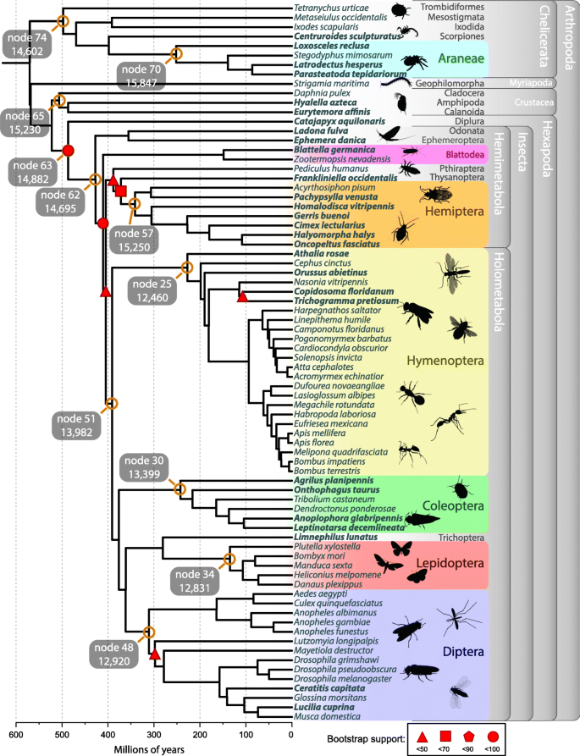
Advanced Option: Enhance the Phylogenetic Tree
- When publishing phylogenetic trees, it is helpful to add biological relevance to each clade. For example, see Figure 2 (right) from the following article:

Thomas, G.W.C., Dohmen, E., Hughes, D.S.T. et al. Gene content evolution in the arthropods. Genome Biol 21, 15 (2020). https://doi.org/10.1186/s13059-019-1925-7

The authors highlight major clades by Order, add icons to represent major taxa, and list higher taxonomic information to the right of the tree. This adds meaningful data to the tree and allows readers to correlate each clade with taxonomic classification.

How would you illustrate your tree? You may print out a copy and manually label or shade clades; or import your tree into an editing program (i.e., PowerPoint, Slides, Photoshop, etc.) and add color, shading, and labels.

Appendix: Reference Arthropod Sequences

Taxonomic relatives | Scientific Name | NCBI Accession Number | Common Name(s) | Subphylum | Class | Order
 | Aedes aegypti | KC970269 | Yellow fever mosquito | Hexapoda | Insecta | Diptera
 | Anopheles gambiae | MG930868 | African malaria mosquito | Hexapoda | Insecta | Diptera
 | Apis mellifera | MW428261 | Honey bee | Hexapoda | Insecta | Hymenoptera
 | Armadillidium vulgare | MF752177 | Roly poly | Crustacea | Malacostraca | Isopoda
 | Blattella germanica | KC407709 | German cockroach | Hexapoda | Insecta | Blattodea
 | Bombus impatiens | GU806825 | Bumblebee | Hexapoda | Insecta | Hymenoptera
 | Bombyx mori | AB649194 | Domestic silkworm | Hexapoda | Insecta | Lepidoptera
 | Camponotus sericeus | KY000669 | Carpenter ant | Hexapoda | Insecta | Hymenoptera
 | Cimex lectularius | MF680527 | Bed bug | Hexapoda | Insecta | Hemiptera
 | Culex quinquefasciatus | MH423504 | Southern house mosquito | Hexapoda | Insecta | Diptera
 | Daphnia pulex | LC215468 | Water flea | Crustacea | Branchiopoda | Diplostraca
 | Dendroctonus ponderosae | JF888167 | Mountain pine beetle | Hexapoda | Insecta | Coleoptera
 | Drosophila melanogaster | MG605130 | Fruit fly | Hexapoda | Insecta | Diptera
 | Halyomorpha halys | KP898259 | Stink bug | Hexapoda | Insecta | Hemiptera
 | Ixodes scapularis | MN357814 | Deer tick | Chelicerata | Arachnida | Ixodida
 | Latrodectus hesperus | MK420122 | Black widow spider | Chelicerata | Arachnida | Araneae
 | Manduca sexta | JN678236 | Tobacco hornworm | Hexapoda | Insecta | Lepidoptera
 | Musca domestica | KX230684 | Housefly | Hexapoda | Insecta | Diptera
 | Parasteatoda tepidariorum | KY269043 | Common house spider | Chelicerata | Arachnida | Araneae
 | Solenopsis invicta | KP730067 | Red imported fire ant | Hexapoda | Insecta | Hymenoptera
 | Strigamia maritima | AY288753 | Coastal centipede | Myriapoda | Chilopoda | Geophilomorpha
 | Tribolium castaneum | JQ350711 | Red flour beetle | Hexapoda | Insecta | Coleoptera
 | Zootermopsis nevadensis | EU253855 | Nevada termite | Hexapoda | Insecta | Blattodea

