I’ve
Updated: August 2021

Lab 2: DNA Extraction
Qiagen DNeasy

Project Guide

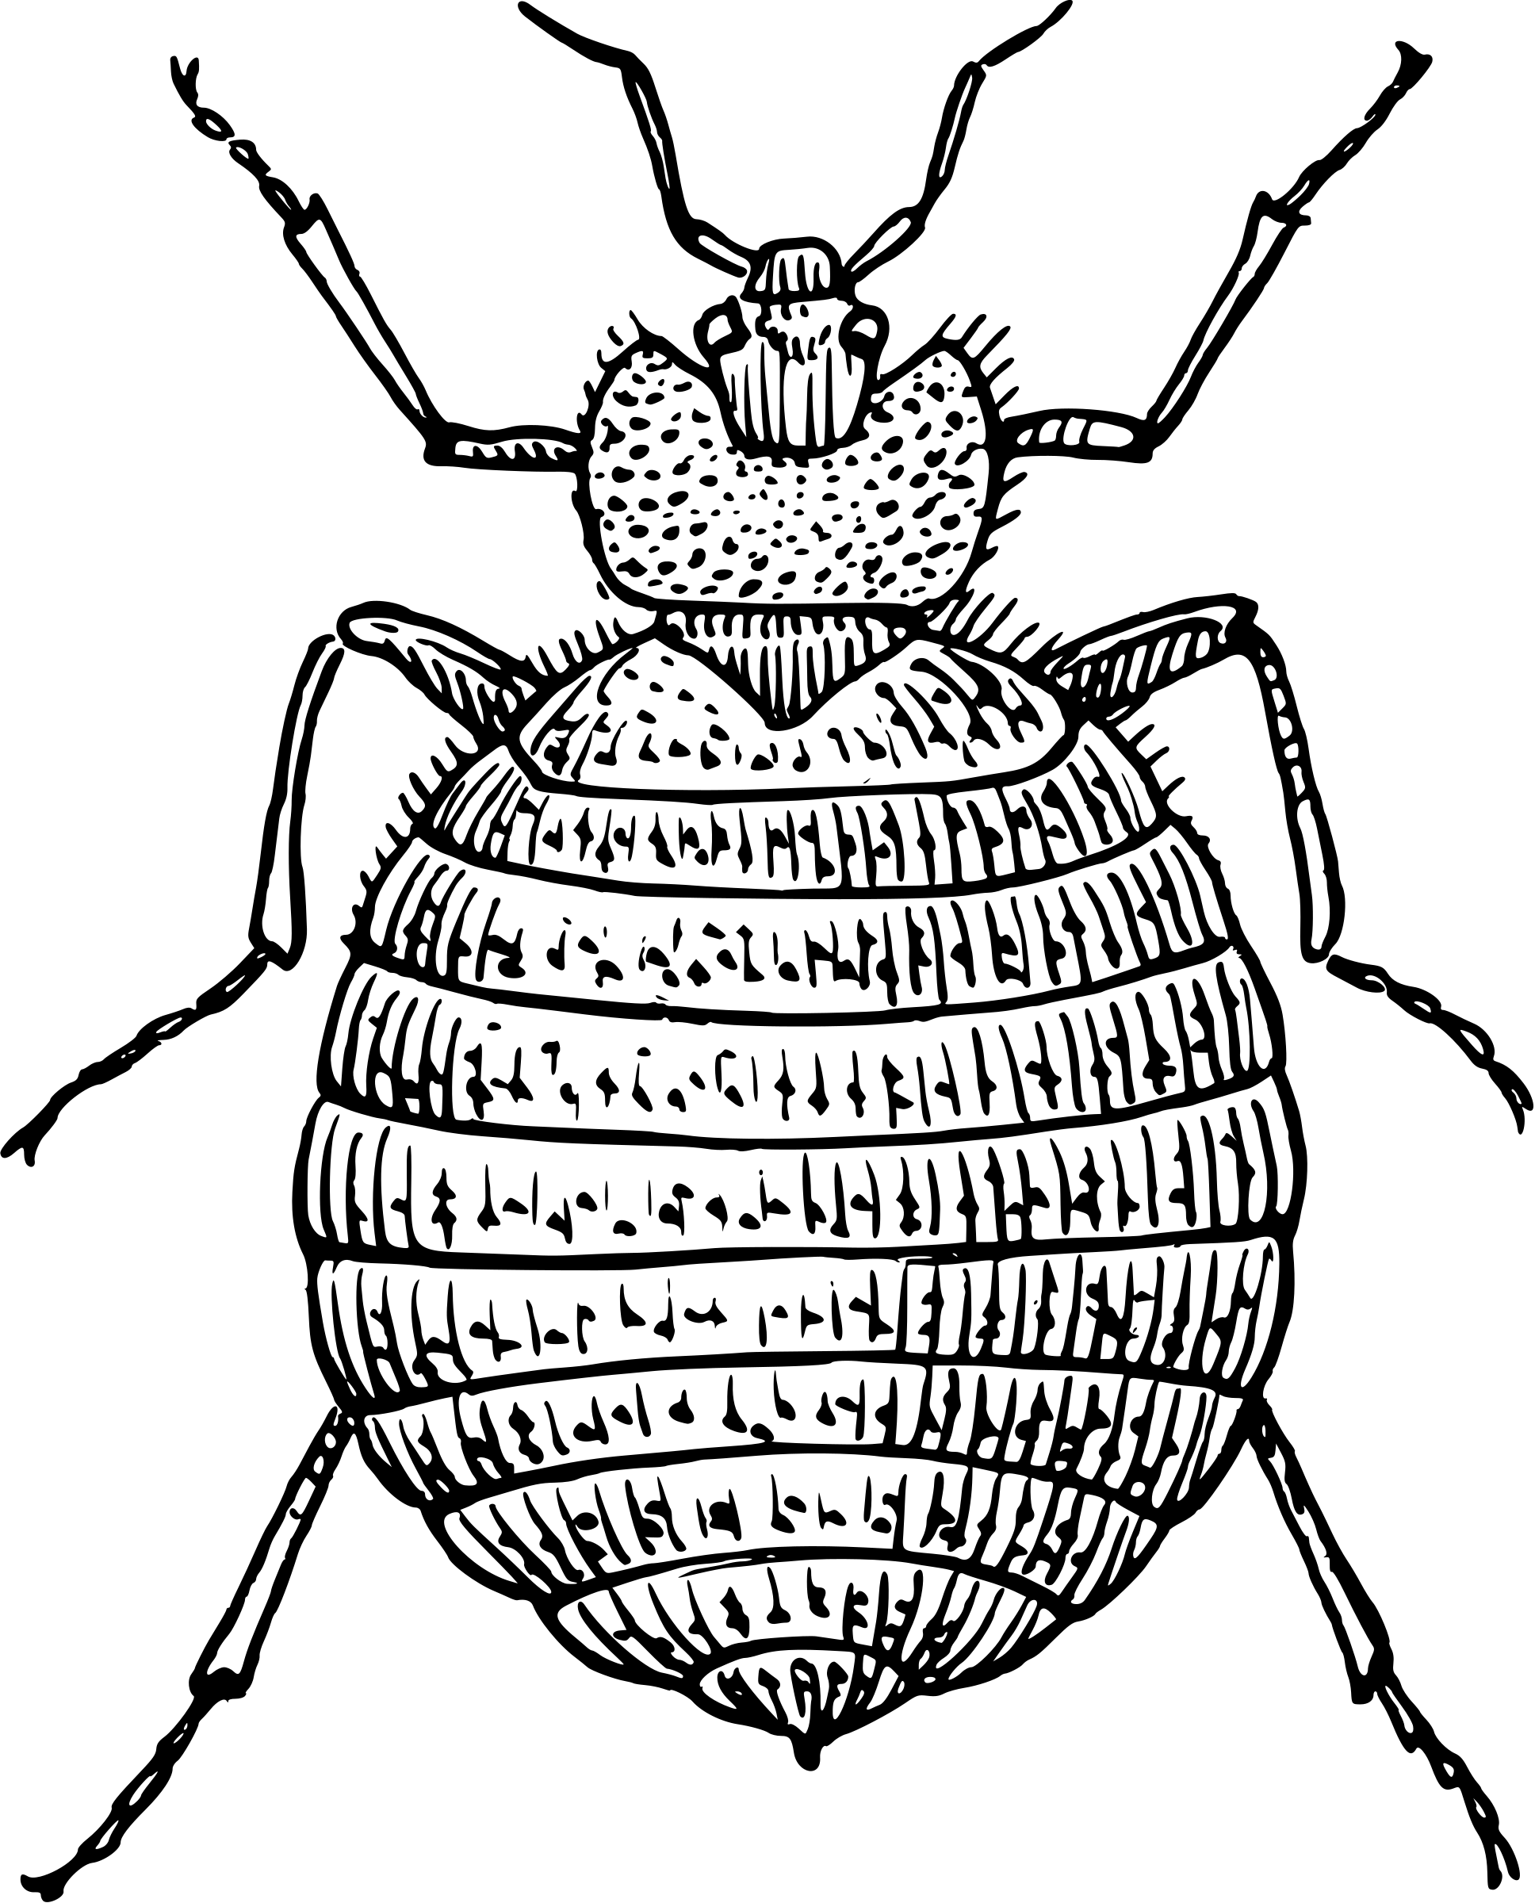
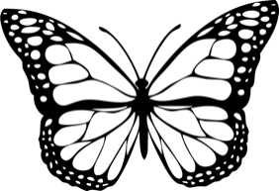
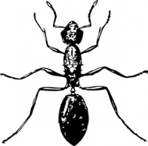
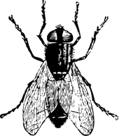
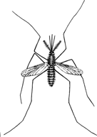
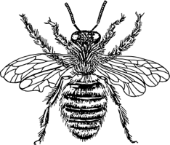
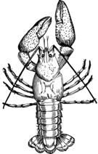

Table of Contents

Page | Contents
 | Introduction
3 | Introduction to DNA
4 | Cellular DNA
5 | Wolbachia Localization
6 | Technical Overview
 | Lab Activity
7-8 | Pre-Lab Questions
9-11 | DNA Extraction Protocol
12 | DNA Extraction Bench Protocol
13 | Post-Lab Questions
14 | Database Entry Checklist

Content is made available under the Creative Commons Attribution-NonCommercial-No Derivatives International License. Contact (wolbachiaproject@vanderbilt.edu) if you would like to make adaptations for distribution beyond the classroom.

The Wolbachia Project: Discover the Microbes Within! was developed by a collaboration of scientists, educators, and outreach specialists. It is directed by the Bordenstein Lab at Vanderbilt University.
https://www.vanderbilt.edu/wolbachiaproject

Introduction

DNA Composition

Deoxyribonucleic acid, or DNA, is a self-replicating molecule that encodes the genetic information for nearly all living organisms. DNA is comprised of monomers, called nucleotides. Each nucleotide consists of (i) a five-carbon sugar (deoxyribose), (ii) a phosphate group, and (iii) a nitrogenous base (Figure 2.1). Nucleotides are differentiated by their attached nitrogenous base: adenine (A), thymine (T), guanine (G) or cytosine (C). Adenine and guanine are classified as purines; cytosine and thymine are classified as pyrimidines. The nucleotides are linked together via phosphodiester bonds to form long strands of DNA, where the order of nucleotides along the sugar-phosphate backbone determines the DNA sequence.

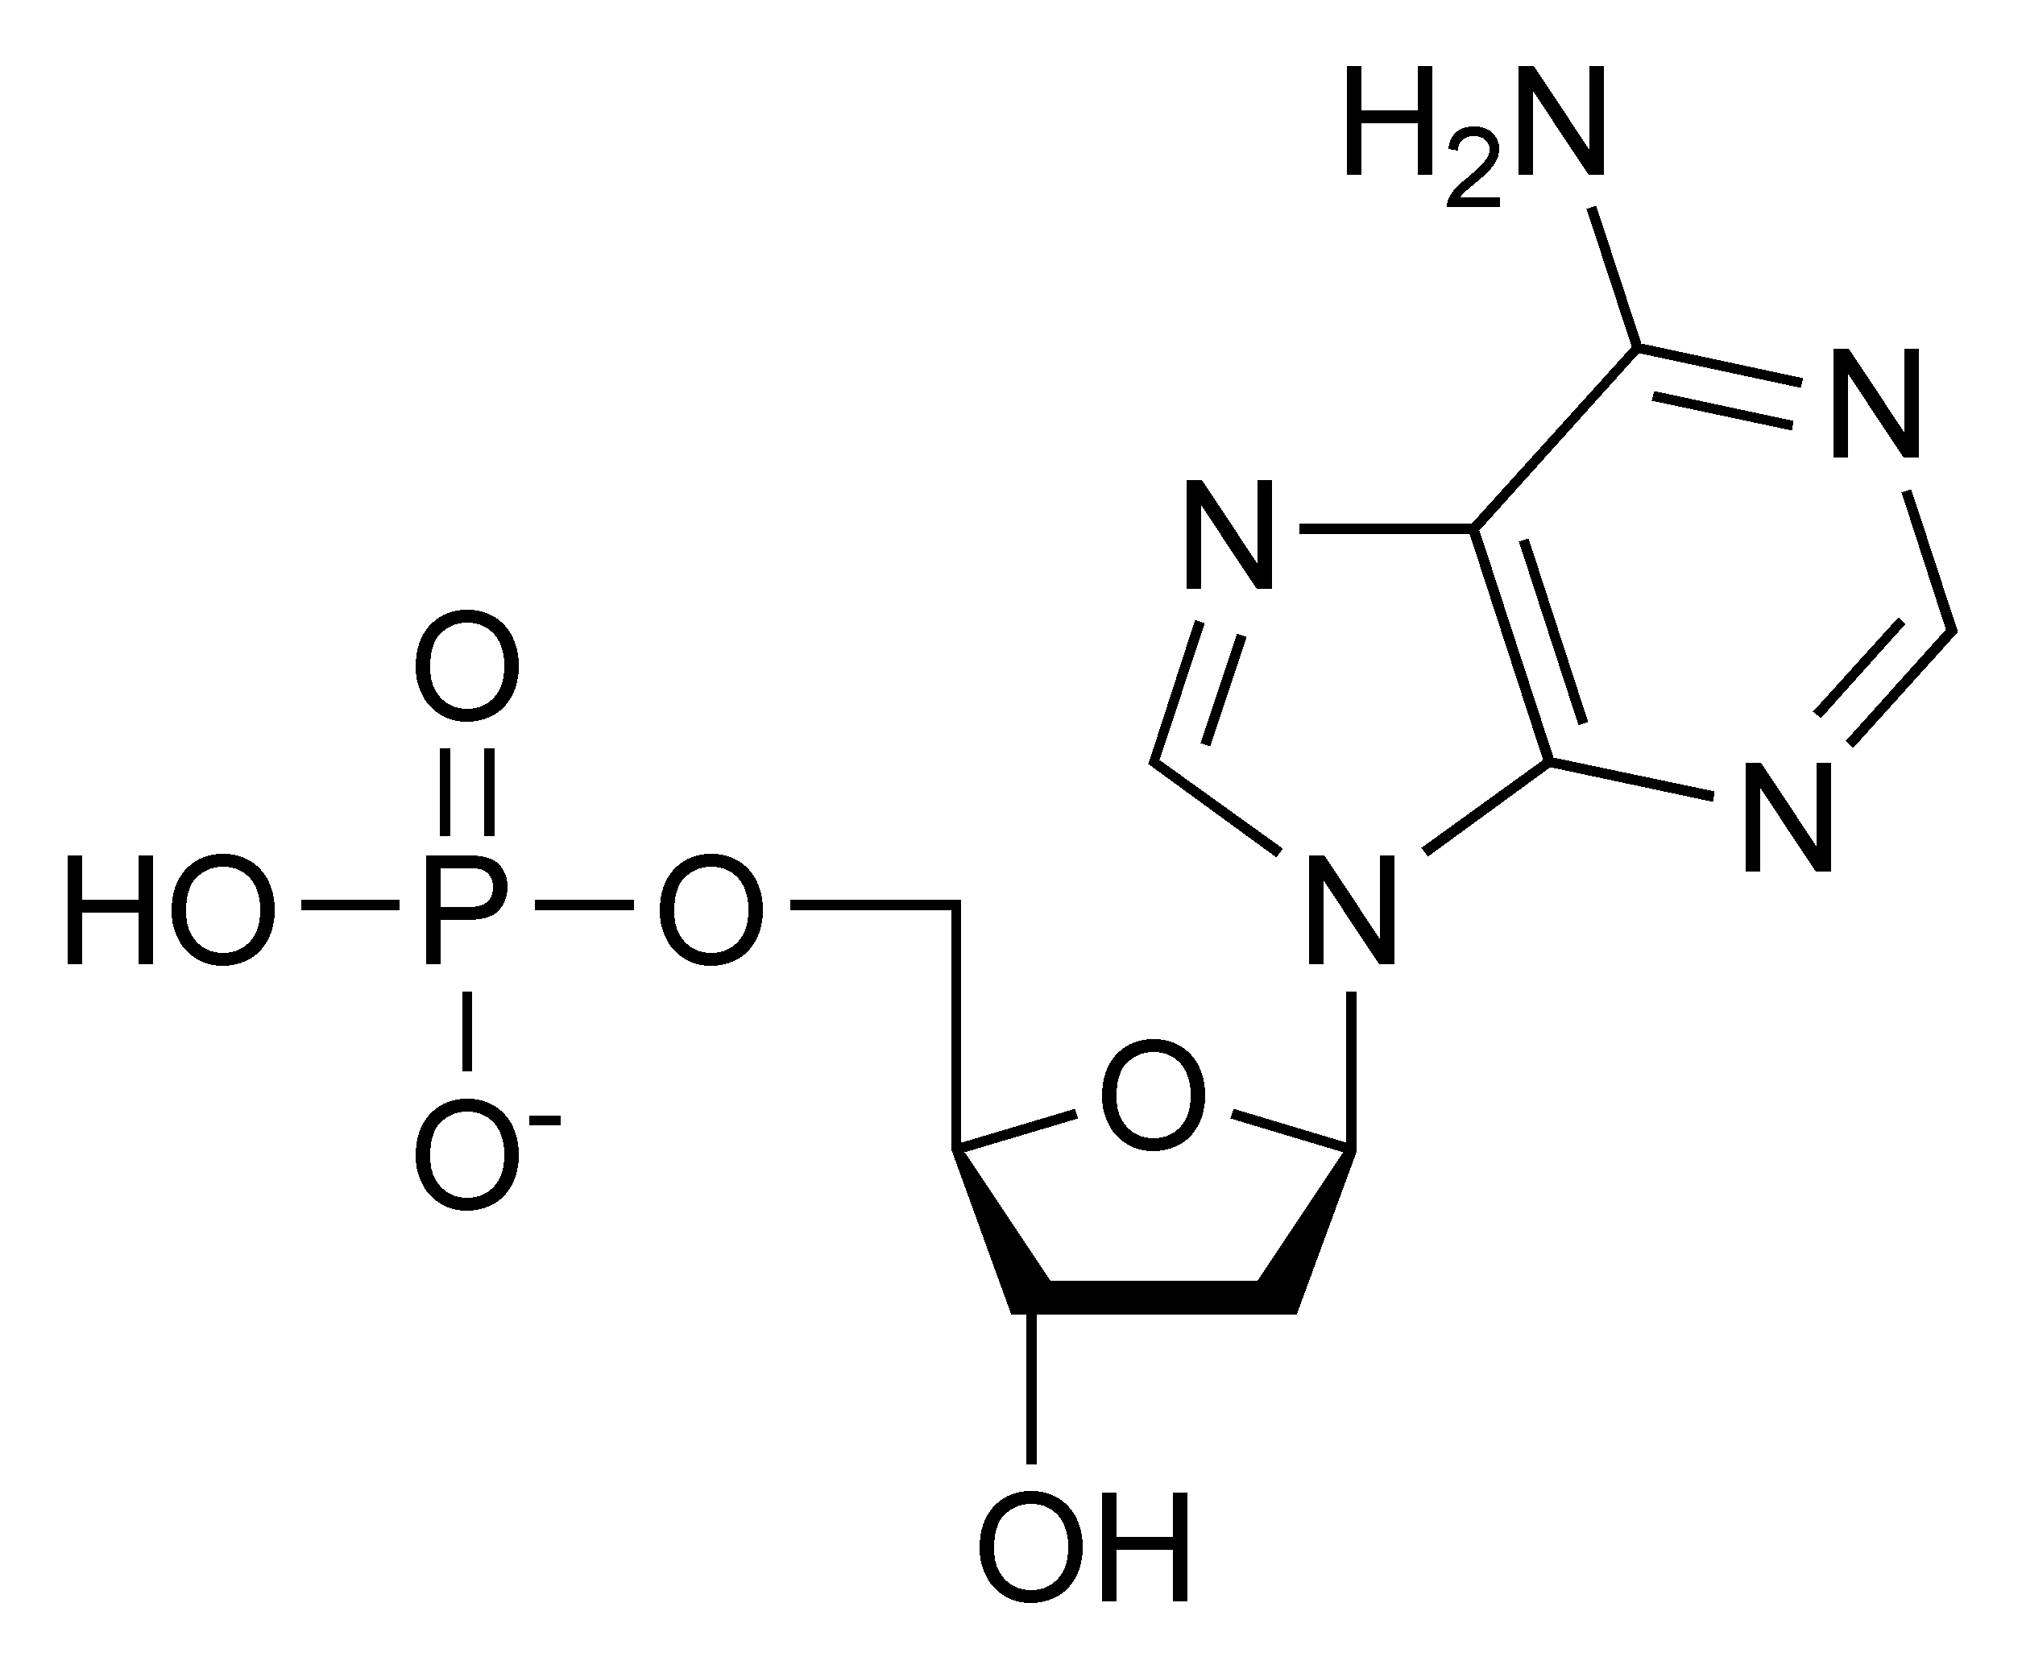
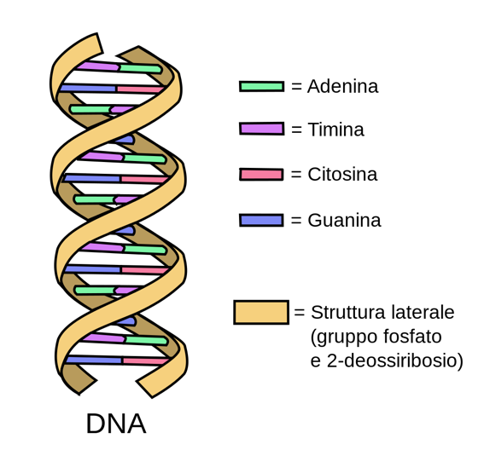
Phosphate group
5-carbon Sugar (Deoxyribose)
Nitrogenous base
(Adenine)
Image from Wikimedia Commons; available in public domain.
Image modified from Wikimedia Commons/Forluvoft; available in public domain.
Adenine (A)
Thymine (T)
Cytosine (C)
Guanine (G)
Sugar- phosphate backbone
Left: Nucleotide structure consisting of phosphate group, sugar (deoxyribose), and nitrogenous base.
Right: DNA double helix structure consisting of a hydrophilic sugar-phosphate backbone and hydrophobic nitrogenous base pairs.
Figure 2.1

DNA Structure

A single strand of DNA is asymmetrical and therefore has a specific method of combining with a second strand of DNA. The sugar and phosphate group are both hydrophilic and will readily come into contact with water molecules within a cell, whereas the nitrogenous bases are hydrophobic and will aggregate together. Two strands of DNA can satisfy their hydrophilic and hydrophobic constraints by orienting their nitrogenous bases to the inside and their hydrophilic sugars and phosphate groups to the outside. The nitrogenous bases are held together by hydrogen bonds, which maintain the shape of the DNA ladder. These base pairs are formed when a pyrimidine binds with a purine. Specifically, adenine forms a base pair only with thymine via two hydrogen bonds, and cytosine forms a base pair with only guanine via three hydrogen bonds (Figure 2.1). A skew and a twist of the strands of DNA lets in as little water as possible between the nitrogenous bases, forming the well-known double helix shape of the double stranded DNA (dsDNA) molecule.

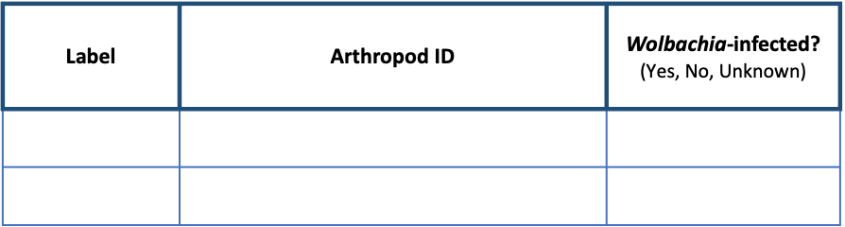
Cellular DNA
https://theminione.com/minione-resource-center/

Nucleus
Wolbachia
Bacterial chromosome
Phage WO DNA
Mitochondria
Mitochondrial DNA
Phage WO DNA
Eukaryotic chromosomes

Figure 2.2. A eukaryotic cell containing nuclear DNA (gold), mitochondrial DNA (teal), bacterial DNA (blue) and bacteriophage DNA (red).

Arthropod cells may contain multiple types of DNA (Figure 2.2).

- Nuclear DNA: Eukaryotic DNA is coiled and condensed around nuclear proteins, called histones, to form chromosomes. Chromosomes are stored in the nucleus of each cell and encode the arthropod’s genetic information.
- Mitochondrial DNA: Mitochondria, the organelle responsible for cellular respiration and energy production, contains its own DNA. Mitochondrial DNA is circular and, like its encoding organelle, is passed down from mother to offspring.
- Bacterial DNA: Wolbachia and other bacterial endosymbionts contain a single, circular, supercoiled DNA molecule called the bacterial chromosome.
- Bacteriophage DNA: Phage WO, the bacteriophage that infects Wolbachia, carries its own genome. Phage WO is a temperate phage, meaning it can integrate its genome into the bacterial chromosome. When active, WO packages its DNA into phage capsids and lyses the Wolbachia cell to infect new hosts. Therefore, phage DNA can be found in both the Wolbachia chromosome and in phage particles.

In addition to the DNA shown above, an arthropod cell may also contain eukaryotic viruses and other intracellular bacteria (e.g., Rickettsia, Spiroplasma, Cardinium).

Wolbachia Localization
https://theminione.com/minione-resource-center/

In most cases, whole body DNA extractions are sufficient to obtain Wolbachia DNA. If a specimen is particularly large and/or has a tough exoskeleton, abdominal dissections are recommended. A general rule of thumb is to dissect specimens that are larger than a grain of rice, such as a fruit fly, small ant, or mosquito. Because Wolbachia is maternally transmitted, it is commonly localized in the reproductive organs (ovaries and testes); however, increasing studies have also detected the symbiont in somatic, non-reproductive tissue. For the purpose of this lab activity, we recommend dissecting the reproductive areas. Make sure the arthropod is not still alive; freezing overnight and/or preserving in alcohol should be done prior to dissections and DNA extraction.

General guidelines for Wolbachia DNA extractions:
- Small arthropods: If the specimen is about the size of a grain of rice (such as a fruit fly or small ant ~2 mm), extract DNA from the entire body.
- Large arthropods: If the specimen is larger than ~2 mm, use a scalpel or razor blade to cut off the abdomen. In many cases, such as grasshoppers and cockroaches, the abdomen may still be larger than 2 mm. If so, use the scalpel to extract an internal portion of the abdomen most likely to contain reproductive tissue. The anatomy of a Dipteran fly is shown below for reference (Figure 2.3). Research the anatomy of each arthropod prior to dissections.
- Tough arthropods: If the specimen has a particularly tough exoskeleton, such as a tick, use a scalpel or razor blade to carefully cut open the abdomen and expose internal organs. This will ensure that the cell lysis buffer has access to reproductive tissues.
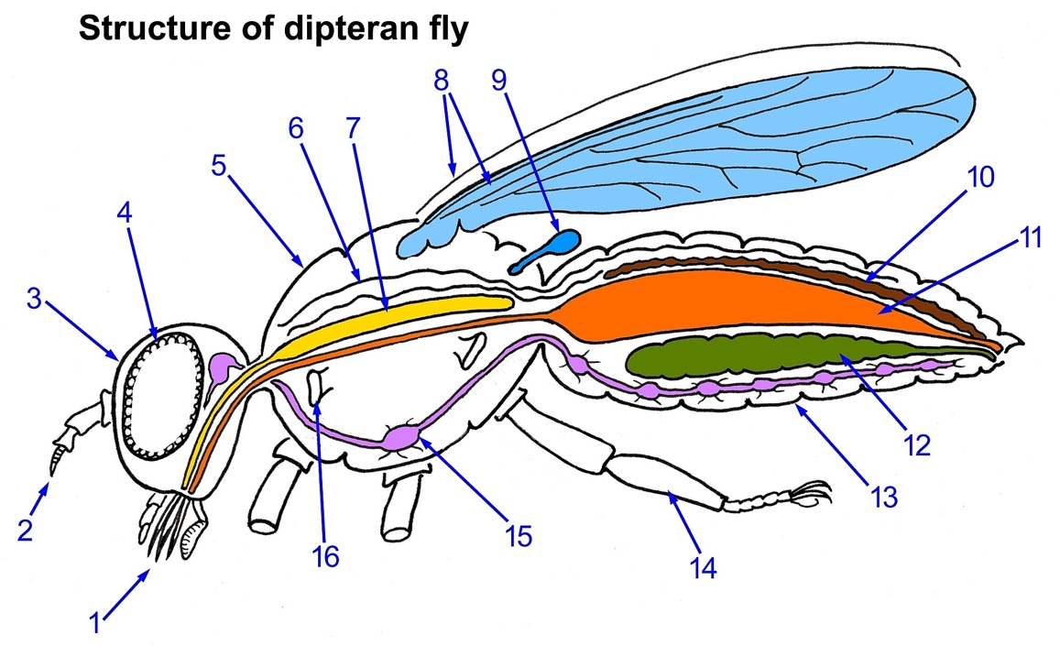
Image by Daktaridudu; available in Wikipedia under CC BY-SA 4.0 license
Paired antennae
Complex mouthparts
Head
Compound eye
Thorax
Open heart tube
Salivary gland
Wings
Halter
Excretory (Malpighian) tube
Gut
Ovary (or Testis)*
Abdomen
Legs
Thoracic ganglion of nervous system
Spiracle opening to respiratory tube (trachea)
* Wolbachia-enriched

Figure 2.3. Dipteran fly anatomy

Technical Overview
https://theminione.com/minione-resource-center/

This DNA extraction protocol is based on the insect adaptation of Qiagen’s DNeasy Blood & Tissue kit (Product # 69504).

Sample Preparation
Each specimen will be rinsed with water to remove alcohol preservative. If larger than a fruit fly, the abdomen will be dissected to obtain the reproductive tissues. If the specimen contains a particularly tough exoskeleton, abdominal tissue can be exposed using a scalpel or razor blade.

Cell Lysis & DNA Precipitation
Each specimen will be macerated in a cell lysis solution to break open the cellular and nuclear membranes. As a result, DNA is exposed to proteases, such as nucleases, in the host tissue. Therefore, the enzyme Proteinase K must be added to denature the proteins and keep the DNA intact. The solution is heated to ~ 56°C for enhanced lysis. Finally, ethanol will be added to bring the DNA out of solution.

DNA Purification
Once the proteases are destroyed and DNA is precipitated, the DNA must be purified. All cellular components, including DNA, will be placed into a spin column. Upon centrifugation, the material will pass through the filter, which attracts DNA but allows cellular debris to pass through. This will be followed by two wash steps with two separate buffers, AW1 and AW2.

DNA Elution
The activity will be completed by removing the DNA from the filter. This is called eluting the DNA and is done by adding the elution Buffer AE. DNA is more attracted to the elution buffer than the filter, and finally passes through the filter. Spinning the tube with the DNA embedded in the filter will pull the elution buffer through the matrix, thus collecting the DNA into the 1.5 ml tube.

Pre-Lab Questions
https://theminione.com/minione-resource-center/

Read through the entire lab activity and answer the questions below.

- Based on your knowledge of DNA structure, what is the complementary strand of this DNA sequence?
5’ – ATG CCG GAA TCG TTA GCA – 3’

- Is it possible for your DNA extraction to contain only Wolbachia DNA? Explain why or why not.

- List the two controls used in this experiment. Why do we need controls at this stage?

- Which centrifuge rotor(s) is properly balanced?

1
2
3
4
5
6
7
8
7
6
5
4
3
1
5
4
1
C
B
A
2
8
2
8
7
3

6

- How would you properly balance the other rotor(s)?

- What would happen if you used the same pipet tip throughout the entire protocol?

Pre-Lab Questions, Part 2
https://theminione.com/minione-resource-center/

- Based on background research, formulate a hypothesis about the frequency of Wolbachia endosymbionts in your specimens.

- Read through the entire protocol. What is the purpose of each reagent?
Proteinase K:

Buffer AL:

Ethanol:

Buffer AW1:

Buffer AW2:

Buffer AE:

- Which centrifugation step will transfer DNA to the spin column membrane (or filter)?

- Which centrifugation step will remove, or elute, DNA from the spin column?

DNA Extraction Protocol
https://theminione.com/minione-resource-center/
Class Materials
Materials per Group
* Only needed if using water bath

- Mini-centrifuge
- Float rack *
- Metal tongs *
- Incubator, heat block, or water bath, 56 °C
- Vortex mixer

* Only needed if using water bath

- P200 and P1000 pipettes
- P200 and P1000 tips
- Waste cup for tips
- Waste cup for liquids
- Sharpie
- Kimwipes
- Tube rack

- Qiagen DNeasy Kit aliquots
- Buffer ATL (1.1 ml)
- Proteinase K (120 ul)
- Buffer AL (1.2 ml)
- Buffer AW1 (2 x 1.5 ml)
- Buffer AW2 (2 x 1.5 ml)
- Buffer AE (600 ul)
- Ethanol (95-100%, 1.2 ml)
- 4 spin columns
- 4 collection tubes

- 2 Arthropod specimens
- +/- Drosophila controls
- Gloves
- Tweezers / Scalpel
- Petri dish
- Water
- Transfer pipette
- 4 Microtube pestles
- 8-1.5 ml tubes

Sample Preparation
- Label the contents of each tube in the chart below.

Tube # | Contents
1
2
3 | Positive (+) Arthropod Control
4 | Negative (-) Arthropod Control

- Use tweezers to carefully transfer the first arthropod to a Petri dish.
- Rinse with water using either a transfer pipette or squirt bottle and blot dry excess liquid. Take 1-2 pictures for the The Wolbachia Project Database.
- Remove the abdomen of the arthropod and cut off a small piece (roughly ~2 mm, or small enough to fit in the bottom of a microcentrifuge tube). If the specimen is smaller than a grain of rice, use the entire body.
Remove as much preservative and water as possible. If the arthropod is large or has a thick/tough exoskeleton, dissect out the reproductive tissues (Refer to page 5). Arthropods with a thick exoskeleton should be cut into multiple pieces.
- Place the specimen in a labeled 1.5 ml microcentrifuge tube and repeat for remaining arthropods.
(continued)

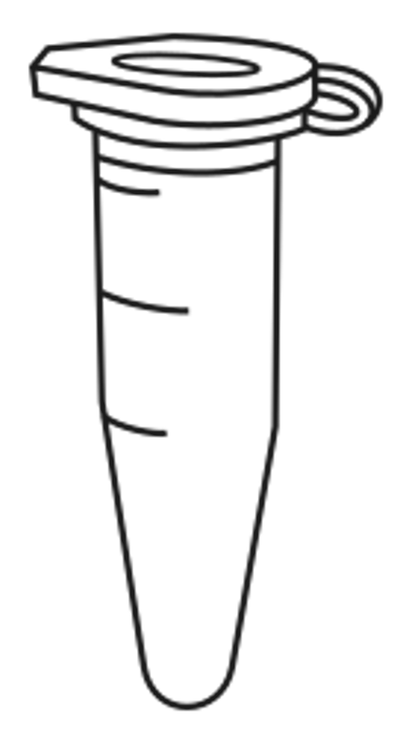
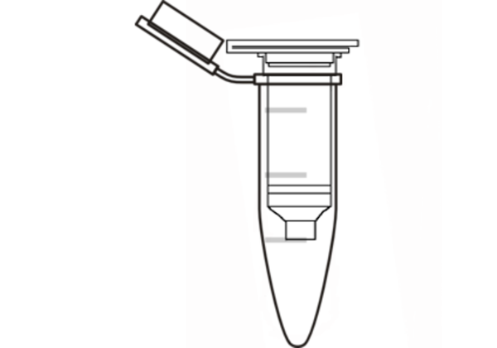
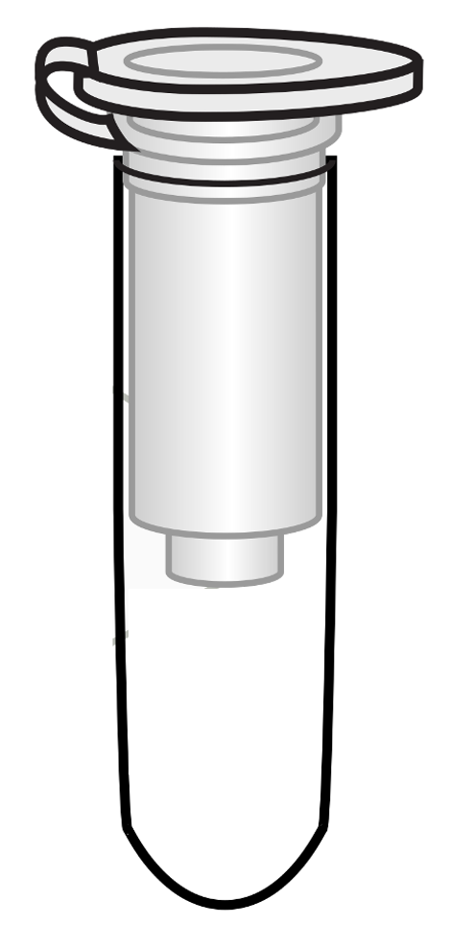
1.5 mL microcentrifuge tube
DNA Purification
Cell Lysis & DNA Precipitation
DNA Elution
1.5 mL
microcentrifuge
tube
Spin column
2.0 mL collection
tube
Spin column

Cell Lysis & DNA Precipitation
- Add 180 ul Buffer ATL to the first tube.
- Use a sterile pestle to grind the sample for 1 minute.
This is the most critical step of the entire protocol. Thorough grinding is necessary in order to obtain high DNA yield. Use muscle power and grind each sample thoroughly.
- Add 20 ul Proteinase K. This will destroy DNases that break down DNA.
- Add 200 ul Buffer AL and immediately mix by vortexing for 10 seconds or pipetting up and down. Buffer AL lyses open cells.
- Using a new pestle; repeat Steps 6-9 with remaining samples.
- Incubate for at least 15 minutes @ 56 °C. Longer incubation times (i.e., 2-3 hours) are most effective for cellular lysis.
- If arthropod debris is present, do a quick spin (about 30 seconds) to pellet debris as this could clog the filter of the spin column. Using a new tip for each sample, transfer the supernatant to a labeled 1.5 ml tube. Discard the old tube of cellular debris and repeat for other samples, as needed.
- Add 200 ul ethanol (96-100%) to each tube and mix by vortexing for 10 seconds or pipetting up and down. Ethanol precipitates DNA.

This is an optional STOPPING POINT. Store DNA in in refrigerator (4 °C) until next class period.

(continued)

DNA Purification
- Collect four DNeasy spin columns fitted with four 2.0 ml collection tubes and label the lids of the spin columns 1-4 with your initials.
- Pipet the liquid from Tube 1 of the above steps (including any precipitate) into the DNeasy Mini column #1. Using a new pipette tip for each transfer, repeat this process with the three other tubes. Make sure to keep the tube numbers consistent.
Throughout the protocol, be careful not to touch the filter or get liquid around the rim of the column.
- Centrifuge for 1 minute at ≥6,000 x g (8,000 rpm). The DNA is now caught in the filter of the spin column. Discard the flow through from the 2.0 ml collection tubes into the waste cup.
If using a mini-centrifuge, you may not be able to fit all columns in the rotor. Spin 2-3 at once, ensuring that the centrifuge is properly balanced at all times. If your centrifuge does not have an adjustable speed, use the default speed throughout the protocol.
- Place the spin column containing the DNA from Tube 1 in the same emptied 2.0 ml collection tube.
- Repeat for the other three tubes, remembering to label.
- To each, add 500 ul of Buffer AW1. This buffer washes the DNA.
- Centrifuge for 1 minute at ≥6,000 x g (8,000 rpm).
- Again, discard the flow through waste from the 2.0 ml collection tubes into the waste cup and place the DNeasy Mini Spin Columns back into the same emptied 2.0 ml collection tubes.
- Add 500 ul Buffer AW2 (a second wash buffer) to each of the four tubes and centrifuge for 3 minutes at 20,000 x g (14,000 rpm), or max speed of your centrifuge if it doesn’t go that high, to dry the DNeasy membrane.
If the centrifuge you are using cannot attain this speed, allow the tube to air dry for 5 minutes. This will evaporate the ethanol. It is important to air dry the membrane so that ethanol does not interfere with PCR.

DNA Elution
- Place your spin columns into 1.5 ml microcentrifuge tubes. Be sure to label the lids of each tube #1-4 and include your initials. These will contain your purified DNA samples.
Carefully remove the DNeasy column so that it does not make contact with residual ethanol in the tube. If ethanol is still present on the membrane, empty the collection tube and spin again.
At this point, you will have two sets of lids. When you place them in the rotor, rotate the column such that its lid is not directly on top of the 1.5 ml tube lid. Keep lids down against the rotor, not sticking out, and face them in the direction of motion. If a lid breaks off, transfer DNA to a new labeled 1.5 ml tube.
- Pipet 100 ul of Buffer AE directly onto the spin column membrane. This is an elution buffer that rinses the DNA off the spin column filter and into the 1.5 ml tube.
- Incubate at room temperature for 1 minute.
- Centrifuge at ≥6,000 g or 8,000 rpm for 1 minute. The eluted DNA will be collected in the 1.5 ml tube.
- Discard the spin column and KEEP the labeled 1.5 ml tube. The DNA is now in the 1.5 ml microcentrifuge tube.
- Optional: incubate the DNA for 1 hour @ 65 °C or overnight at room temperature.
- Store the eluted DNA frozen at -20 °C until PCR.

DNA Extraction Bench Protocol
https://theminione.com/minione-resource-center/

This is an abbreviated protocol. Make sure to label all tubes and change pipette tips between samples.

Sample Preparation
  - Remove the abdomen of the arthropod and cut off a small piece (roughly ~2 mm, or small enough to fit in the bottom of a microcentrifuge tube). If the specimen is smaller than a grain of rice, use the entire body.
  - Place the specimen in a labeled 1.5 ml microcentrifuge tube.

Cell Lysis & DNA Precipitation
  - Add 180 ul Buffer ATL and use a sterile pestle to grind the sample for 1 minute.
  - Add 20 ul Proteinase K.
  - Add 200 ul Buffer AL and immediately mix by vortexing for 10 seconds or pipetting up and down.
  - Incubate for at least 15 minutes @ 56 °C. Longer incubation times (i.e., 2-3 hours) are most effective for cellular lysis.
  - If arthropod debris is present, do a quick spin (~30 seconds) to pellet debris. Use a pipette to carefully transfer the supernatant to a new labeled 1.5 ml microcentrifuge tube. Discard the tube of cellular debris.
  - Add 200 ul ethanol (96-100%) and mix by vortexing for 10 seconds or pipetting up and down.

Optional stopping point: store DNA in refrigerator (4 °C)

DNA Purification
  - Label a DNeasy spin column fitted with a 2.0 ml collection tube.
  - Pipet the liquid containing ethanol-precipitated DNA into the DNeasy spin column.
  - Centrifuge for 1 minute at ≥6,000 x g (8,000 rpm). Discard the flow through from the 2.0 ml collection tube.
  - Add 500 ul of Buffer AW1 and centrifuge for 1 minute at ≥6,000 x g (8,000 rpm). Discard the flow through.
  - Add 500 ul Buffer AW2 and centrifuge for 3 minutes at 20,000 x g (14,000 rpm).

DNA Elution
  - Transfer the spin columns to a labeled 1.5 ml microcentrifuge tube. Discard the 2.0 ml collection tube.
  - Pipet 100 ul of Buffer AE directly onto the spin column membrane.
  - Incubate at room temperature for 1 minute.
  - Centrifuge at ≥6,000 g or 8,000 rpm for 1 minute.
  - Discard the spin column and KEEP the labeled 1.5 ml tube.
  - Optional: incubate the DNA for 1 hour @ 65 °C or overnight at room temperature.
  - Store the eluted DNA frozen at -20 °C until PCR.

Post-Lab Questions
https://theminione.com/minione-resource-center/

- Illustrate the contents of each tube upon completion of the following steps. Below, label where the DNA is located.

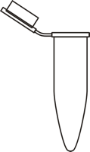
Sample Preparation
Cell Lysis
Cellular Debris Removal
DNA Elution

- After completion of the DNA extraction, what did the DNA look like?

- Where is Wolbachia generally located within an arthropod? Why?

- What is the purpose of isolating the DNA? What is your next step in determining the frequency of Wolbachia?

- Imagine that there is an E. coli outbreak in your state and you would like to test the lettuce from your local grocery store. How could you modify this protocol in order to extract DNA from the lettuce (to identify the species) and check for presence/absence of E. coli. ? Keep in mind that (i) E. coli is free-living and not an endosymbiont, and (ii) plant cells are encased in both a cell membrane and cell wall.

Database Entry
https://theminione.com/minione-resource-center/

After completing the DNA Extraction, open your entries in The Wolbachia Project Database and record Methods and protocol notes. A comprehensive guide is located under the Resources tab.

https://wolbachiaprojectdb.org/

Database Fields to Complete

Methods
- DNA extraction kit
- DNA extraction location
- Update protocol notes

