I’ve
Updated: June 2021

Lab 1: Arthropod Collection
& Identification

Project Guide

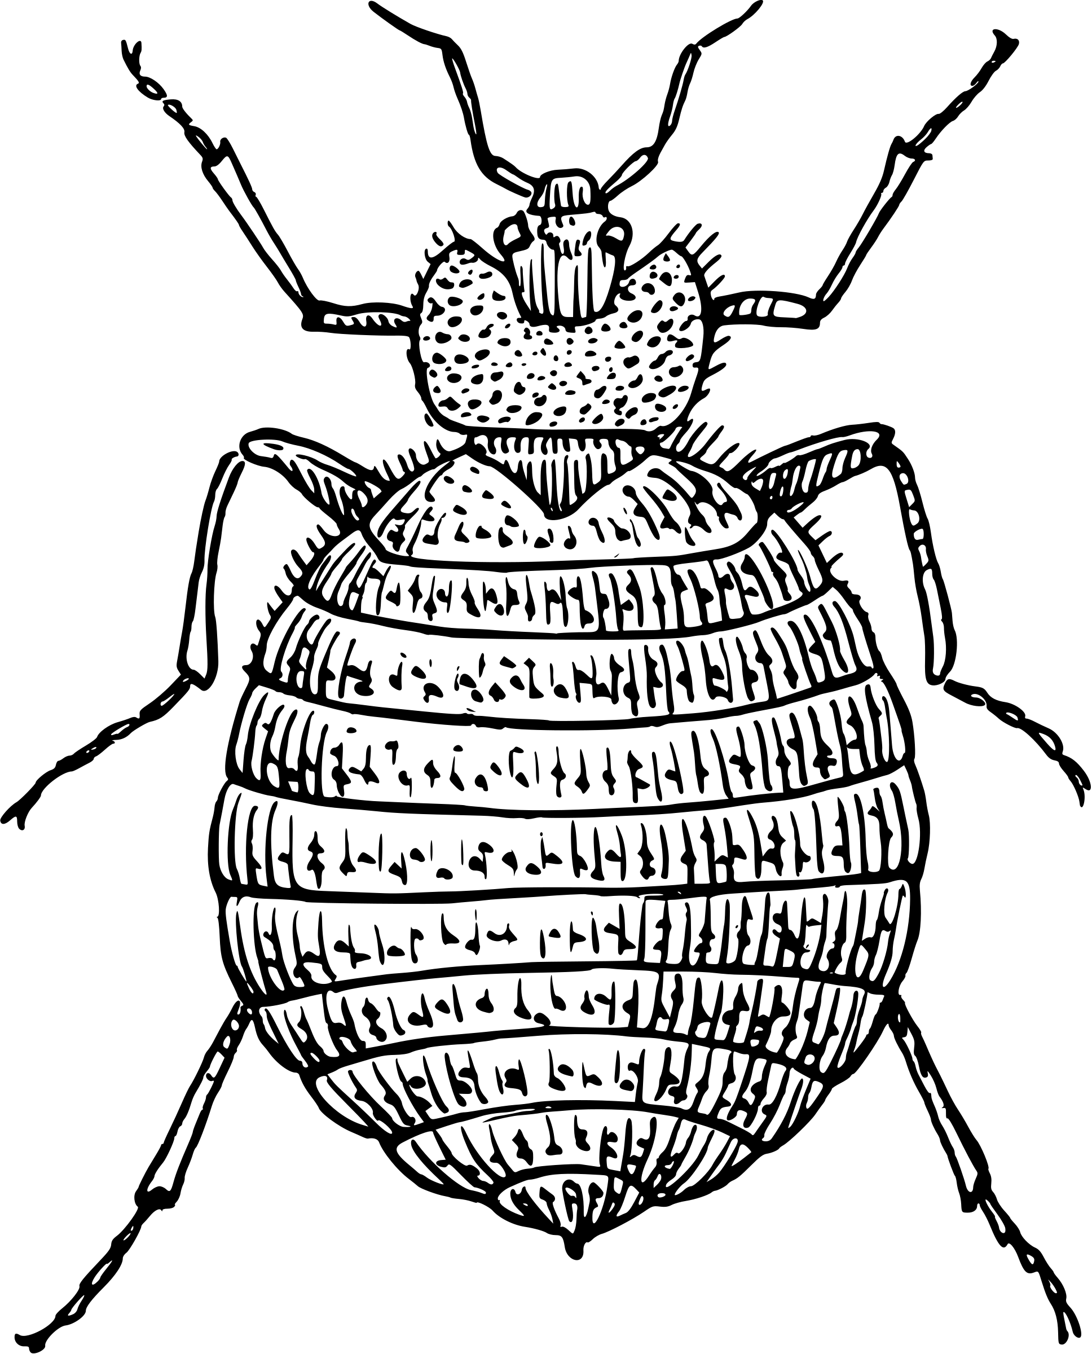
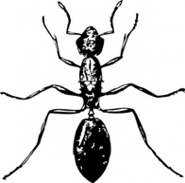
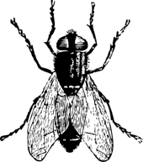
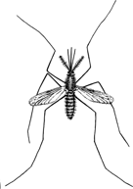
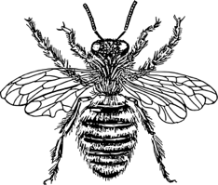
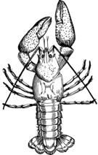

Table of Contents

Page | Contents
3 | Introduction
4 | Taxonomy
5 | Arthropods
6 | Insects
7 | Review Key Concepts
 | Lab Activity
8 | Pre-Lab Questions
9 | Part 1: Arthropod Collection
10-11 | Arthropod Collection Forms
12 | Part 2: Arthropod Identification
13 | Post-Lab Questions
14 | Extension Opportunities
15 | Database Entry Checklist
Content is made available under the Creative Commons Attribution-NonCommercial-No Derivatives International License. Contact (wolbachiaproject@vanderbilt.edu) if you would like to make adaptations for distribution beyond the classroom.

The Wolbachia Project: Discover the Microbes Within! was developed by a collaboration of scientists, educators, and outreach specialists. It is directed by the Bordenstein Lab at Vanderbilt University.
https://www.vanderbilt.edu/wolbachiaproject

Unless noted, figures created with BioRender.com
Introduction

In this activity, you will embark on an expedition to collect arthropods from local fauna, the animals present in a particular region, habitat, or time. Prior to the activity, review the scientific method and develop a hypothesis with a sampling scheme for determining which organisms (individual life forms such as plants, animals, and bacteria) may or may not harbor the bacterial endosymbiont, Wolbachia. An endosymbiont is an organism that lives within the body or cells of another organism; Wolbachia is one of the most successful endosymbionts on the planet and infects up to 60% of all arthropods. Sampling locations should be coordinated with your group and could include your home, nearby nature park, schoolyard, or carefully selected habitats that differ in temperature, location, etc.

A testable hypothesis can be proved or disproved based on scientific research. If you are performing a biodiversity or discovery-based experiment, first think about why, when, and where you are sampling. What do you expect to find? Do you expect all arthropods to be infected with Wolbachia? Develop a testable hypothesis prior to your experiment. For example:
- XX% of the arthropods on my school campus are infected with Wolbachia.
- Arthropods collected from leaf litter are more likely to be infected than freshwater arthropods.
- There is no difference between the Wolbachia infection prevalence of Coccinellidae (ladybird beetles) in the spring and fall seasons.
- Ants nesting in the soil are Wolbachia-positive, but tree-dwelling ants are not.

After arthropods are preserved in ethanol or rubbing alcohol, you will identify each specimen to taxonomic order and create an entry in The Wolbachia Project Database. This will enable further exploration of new questions, such as:
- Why do species in some insect groups have few or no endosymbionts while insect species in other groups have these microorganisms in every species examined to date?
- Suppose you find that a collection of ants nesting in soil have Wolbachia, whereas the ants that live in the trees above do not. Does this indicate that soils in some way contribute to how Wolbachia transmits itself among species of ants? Can this hypothesis be supported if both soil-dwelling and tree-dwelling ants have Wolbachia?

Without knowing the identity of the arthropod host these ideas may never be explored, and certainly could not be tested. Therefore, it is essential to (i) upload a high-quality picture for each arthropod that will be screened for Wolbachia, (ii) provide clear and concise observation notes in the database, and, if possible, (iii) include DNA sequence data.

Recommended Resources
iNaturalist (https://www.inaturalist.org/) is a crowdsourced species identification app that is used to record biodiversity observations and help naturalists identify organisms in their local environment. The software will suggest options for identifying your arthropod and, after submission, citizen scientists will provide feedback on the classification.
OpenStax (https://openstax.org/) is a free online textbook. Chapter 28.6 of the Biology 2e textbook provides an overview of the phylum Arthropoda, including descriptions for each of the subphyla discussed in this lab activity.
https://openstax.org/books/biology-2e/pages/28-6-superphylum-ecdysozoa-arthropods

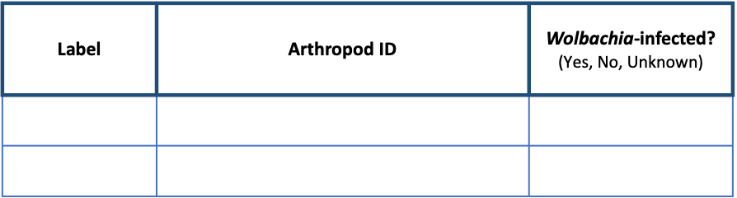
Taxonomy
https://theminione.com/minione-resource-center/

Taxonomy is the classification of organisms based on relatedness. Developed by Swedish botanist Carl Linnaeus in the 1700’s, scientists across the world use taxonomy to organize all living things in a hierarchical structure. Because there are over one million named species of arthropods, it can be difficult to classify beyond order based solely on visual observation; therefore, DNA sequence similarity is often used alongside morphology (form and structure) and ecology (the study of the relationships between organisms and their physical environment) to determine classification. The scientific name for an organism is based on binomial nomenclature, a unique two-word name combining the genus and species. It is written in italics and the genus is always capitalized. This name can be shortened by only including the first initial of the genus, as shown in the table below.

Domain * | Eukarya | Eukarya | Bacteria
Kingdom | Animalia | Animalia | Eubacteria
Phylum | Chordata | Arthropoda | Firmicutes
Class | Mammalia | Insecta | Bacilli
Order | Primates | Lepidoptera | Bacillales
Family | Hominidae | Nymphalidae | Listeriaceae
Genus | Homo | Danaus | Listeria
Species | Homo sapiens | Danaus plexippus | Listeria monocytogenes
Abbreviated name | H. sapiens | D. plexippus | L. monocytogenes

* The above classification is based on the three-domain system of taxonomy (Archaea, Bacteria, Eukarya). However, increasing evidence supports a two-domain system. First proposed as the eocyte hypothesis by James A. Lake and colleagues in 1984 (doi: 10.1073/pnas.81.12.3786), Eukarya are included with the Archaea.
Arthropods

Arthropods, the most diverse and abundant animals on earth, are characterized as invertebrates with a hard covering called an exoskeleton, segmented body, and jointed appendages. They represent about 85% of all described animal species and there are an estimated 10 quintillion (10,000,000,000,000,000,000) individual arthropods inhabiting the planet on any given day. If the services these animals provide everyday (for free) suddenly disappeared, humans would soon disappear. They clean water, pollinate flowers that produce about 1/3 of the food we eat, break down waste, and decompose plants and animals. Given their importance, why are they so little appreciated and poorly understood? Perhaps the single largest factor is their small size. Most of the one million described species are less than 1/3” long, the size of this line:
This entire world of small creatures exists literally under your feet.

The phylum Arthropoda is classified into five subphyla (plural of subphylum, a taxonomic category that ranks below phylum and above class):
- Chelicerata: spiders, scorpions, mites, ticks, horseshoe crabs, and relatives
- Crustacea: crabs, lobsters, crayfish, shrimps, krill, barnacles, prawns, woodlice, and relatives
- Hexapoda: insects, springtails, and relatives
- Myriapoda: millipedes, centipedes, and relatives
- Trilobita: trilobites (extinct)

What is the difference between an arthropod, spider, insect, or bug? Taxonomy. True bugs belong to the order Hemiptera and include bedbugs, assassin bugs, and stinkbugs. All bugs belong to the class Insecta, which are characterized by three body segments (head, thorax, abdomen) and six legs. Spiders, on the other hand, belong to the class Arachnida and have two body parts (cephalothorax and abdomen) and eight legs. All insects and arachnids belong to the phylum Arthropoda.
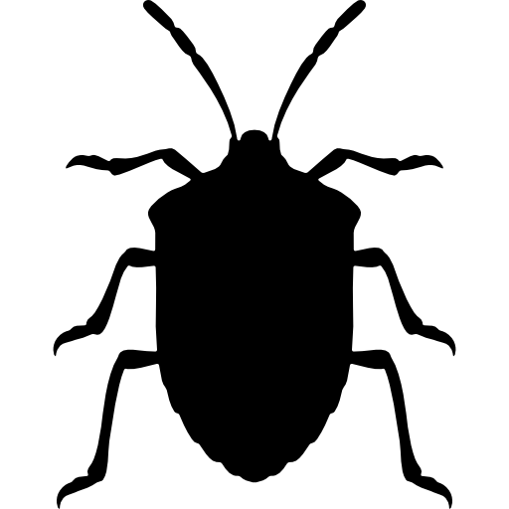
Kingdom: Animalia
Phylum: Arthropoda
Subphylum: Hexapoda
Class: Insecta
Order: Hemiptera

Insects

Most arthropods are insects, members of class Insecta and subphylum Hexapoda. Hexa and poda both originate from Latin (from Greek) meaning six and those having feet, respectively. All insects have three body segments.

  - The head features conspicuous eyes, mouthparts, and antennae.
  - The thorax contains wings and legs.
  - The abdomen contains the reproductive organs, where many of the endosymbiotic bacteria reside.

Of course, it is common for there to be exceptions to the body plan. Many insects lack wings or legs (particularly in the larval stage), some are eyeless, etc. These features allow for classification into groups. Order is the most familiar taxonomic grouping.
Common examples are:
Orthoptera
Coleoptera
Hemiptera
  - Order: Blattodea – cockroaches and termites
  - Order: Coleoptera – beetles
  - Order: Diptera – flies
  - Order: Hemiptera – true bugs
  - Order: Hymenoptera – bees, wasps and ants
  - Order: Lepidoptera – moths and butterflies
  - Order: Mantodea – praying mantids
  - Order: Odonata – dragonflies and damselflies
  - Order: Orthoptera – grasshoppers and crickets
  - Order: Phasmatodea – stick insects and leaf insects
  - Order: Phthiraptera – biting and sucking lice
  - Order: Siphonaptera – fleas

Notice that most, but not all, insect orders end with the suffix “-ptera.” Ptera is the plural form of the Ancient Greek pterón, which means wing or feather. Wings are one of the most conspicuous ways orders of insects are differentiated.

For the purpose of this lab, it is recommended to study smaller species because they are easier to dissect and preserve better. Larger insects rot more quickly, thus degrading DNA and making it more difficult to examine bacterial endosymbionts.

Review Key Concepts

1. Define the following keywords.

- Arthropod:
- Binomial nomenclature:
- Ecology:
- Endosymbiont:
- Exoskeleton:
- Fauna:
- Morphology:
- Organism:
- Subphylum:
- Taxonomy:

2. Use the word bank to label the images below.
Abdomen Arachnida Head Thorax
Abdomen Cephalothorax Insecta Wings
Asian Fruit Fly (male)
Tarantula

3. List at least three morphological differences between the above organisms.

Pre-Lab Questions

Read through the entire lab activity and answer the questions below.

- Why is it important to take pictures and label each arthropod?

- Are spiders classified as arthropods? Are they insects? Why or why not?

- Use an online taxonomic key (see page 10) to complete the chart.
The pillbug represents an example where you may not be able to confidently identify genus/species. In this case, classify down to the most reliable taxonomic category (Family).

Kingdom |  |  | Animalia
Phylum | Arthropoda
Class |  | Insecta |  | Alphaproteobacteria
Order |  |  | Diptera
Family | Armadillidiidae
Genus | ? | Drosophila |  | Wolbachia
Species | ? | Drosophila melanogaster
Scientific name | ? |  |  | W. pipientis
Common name | Pillbug |  | Yellow fever mosquito | N/A

- This charismatic arthropod has many common names throughout the English-speaking world. Research and list a few of the common names below. Based on its taxonomic classification (specifically order), which name is most accurate?

Part 1: Arthropod Collection

Preparation
- State your hypothesis, collection method, and materials needed.
- Review the arthropod collection plan with your instructor. Avoid arthropods that are poisonous, venomous, and/or sting. If you have a history of allergic reactions to bites or stings, consult with your teacher prior to this lab.
Hypothesis

Collection Method

Materials Needed

Arthropod Collection
- Document each arthropod in its natural habitat by taking pictures and recording specific Observation Data in the Arthropod Collection Forms. Fill out as much information as possible – note specific details about the collection location, seasonal conditions, and arthropod behavior. Complete one form per specimen. If unable to capture a good image of the arthropod, you may draw a sketch or take a picture after it has been stored in alcohol for at least 24 hours.
- Collect each arthropod according to the specific protocol detailed above.
- Preserve each specimen by transferring to a small tube or vial of alcohol. This can be 80% or greater ethanol (ethyl alcohol) or over-the-counter rubbing alcohol (isopropanol or isopropyl alcohol). Alcohol preserves DNA for later studies. If the arthropod is moving too quickly to preserve in alcohol, first slow it down by placing into a collection jar at cold temperature: refrigerator (20 min) or freezer (10 minutes).
- Carefully label each tube to correlate with the ID number from the Arthropod Collection Form. Make sure the cap is tightly sealed as the alcohol can wipe off the label. For extra reassurance (optional), place each individual tube in a plastic Ziploc bag along with a labeled notecard.
- Store in the freezer overnight, or until ready to proceed with the lab.
Arthropod Collection Form

 | Collector name
Arthropod ID
Initials and number
 | Collection date
Observation Data | Location  description
 | Latitude
 | Longitude
 | Season
 | Temperature
 | Habitat | Terrestrial / Aquatic / Urban / Other
Arthropod
observation
notes
Arthropod Identification | Arthropod  description
 | Arthropod order
 | Scientific name
 | Common name
iNaturalist Record #
Only submit to iNaturalist if
you took a picture of the live
arthropod in its natural
habitat.

Arthropod Collection Form

 | Collector name
Arthropod ID
Initials and number
 | Collection date
Observation Data | Location  description
 | Latitude
 | Longitude
 | Season
 | Temperature
 | Habitat | Terrestrial / Aquatic / Urban / Other
Arthropod
observation
notes
Arthropod Identification | Arthropod  description
 | Arthropod order
 | Scientific name
 | Common name
iNaturalist Record #
Only submit to iNaturalist if
you took a picture of the live
arthropod in its natural
habitat.

Part 2: Arthropod Identification

Materials per Group

- Insect collection
- Gloves, 2 pair
- 2 safety goggles
- Bent probe and/or forceps
- 2-3 Petri dishes (100 x 15 mm or 150 x 20 mm)
- Transfer pipette (eye dropper)
- Small squirt bottle of 70% ethanol
- Paper towels
- Computer or mobile device
- Dissecting microscope or macro lens
- Colored pencils
- Field guides (optional)

Arthropod Identification
- Remove the arthropod from your alcohol-filled tube in the freezer, and place in a petri dish. Carefully squirt enough ethanol into the dish to properly cover. Ethanol preserves DNA for future molecular studies, such as PCR.
- Use forceps or a probe to carefully position the arthropod.
- Capture morphology with digital pictures and/or hand drawn illustrations. If illustrating, make large sketches using colored pencils to correctly portray the color. Use a dissecting microscope, if needed, to visualize fine details. If you were unable to take a picture of the arthropod in its natural habitat, you may quickly and carefully remove the sample from alcohol to image it. Place on a solid color background, such as a paper towel, for best results.
- Once imaged, immediately place your arthropod back into ethanol, if removed.
- Record a written observation of each specimen on the Arthropod Collection Form. Include specific notes about body segmentation (e.g., head, thorax, and abdomen for insects), number of legs, presence of wings and antennae, etc.
- Use one or more of the following resources to identify each arthropod at least to order. When using online keys, answer only the questions in which you are confident. Compare the possible identification with your notes and images.
  - iNaturalist: https://www.inaturalist.org/
  - Insect Identification: https://www.insectidentification.org/
  - Discover Life: https://www.discoverlife.org/20/q?guide=Insect_orders
  - Field Guides (check with your local library)
- Clean up your lab station.

Post-Lab Questions

- Complete an Arthropod Collection Form for each of your specimens.

- Research the habitat and life of your identified arthropods. Record notes in the chart below.

 | Arthropod 1  #_________________ | Arthropod 2  #_________________
Common name
Habitat
(trees, soil, etc.)
Diet
Life cycle
Geographic
location
Interesting facts

- Does your research match the actual collection site and observed behaviors? Why or why not?

- Were you able to identify down to order? Genus and species? If not, why?

- Based on your research of each arthropod, do you expect them to be Wolbachia-infected?

Extension Opportunities

- Taxonomy, like all of science, is constantly evolving to accommodate new discoveries and scientific data. Research the following classification systems and provide an overview of each in the form of a short essay or PowerPoint/Google Slides presentation. Conclude with a personal recommendation of what you believe to be the best system.
  - Two- empire system
  - Three-domain system
  - Two-domain system

- Research the five subphyla of Arthropoda. Prepare a PowerPoint or Google Slides presentation summarizing key characteristics and representative taxa of each group.

- Insects are fundamental to life as we know it. Select one of the general categories below and provide a comprehensive review of their contribution and importance.
  - Agriculture
  - Ecology
  - Economy
  - Forensics
  - Food
  - Medicine

- Create an EOL Biodiversity Card Deck featuring at least 10 taxa related to your hypothesis. If you are only studying one specific organism, such as Culex pipiens mosquitoes, you may broaden the scope to include ten different mosquito species of your local environment.
  - EOL Biodiversity Cards: https://education.eol.org/card_resources
  - Example card decks: https://education.eol.org/card_maker

- Research or design two arthropod traps: a trap that is designed to only capture one arthropod class, and another arthropod trap that can trap multiple arthropod classes. What are the similarities and differences between the traps? Write a protocol for how to build one of your traps, then build it at home and test it. Write a report on what you observed, and if your trap was successful.

Database Entry

After completing Arthropod Collection & Identification, create an entry in The Wolbachia Project Database and record observation and protocol notes. A comprehensive guide is located under the Resources tab.
https://wolbachiaprojectdb.org/

Database Fields to Complete

Observations
- Picture
- Photo credit
- Location
- Collection date
- Captive/Cultivated?
- Observations
- Putative Identification

