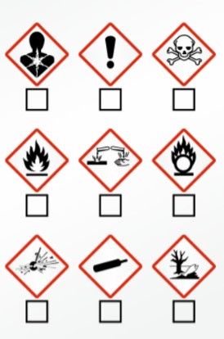  Product ID:  _______________________________________________  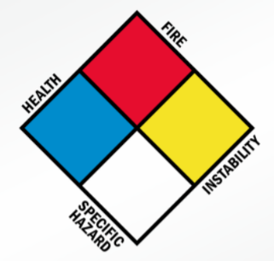  Signal Word:  - Danger  - Warning  - N/A  Precautionary Information:  PPE:  PPE: |  | Product ID:  _______________________________________________  Signal Word:  - Danger  - Warning  - N/A  Precautionary Information:  PPE:  PPE:
Product ID:  _______________________________________________  Signal Word:  - Danger  - Warning  - N/A  Precautionary Information:  PPE:  PPE: |  | Product ID:  _______________________________________________  Signal Word:  - Danger  - Warning  - N/A  Precautionary Information:  PPE:  PPE:
Product ID:  _______________________________________________  Signal Word:  - Danger  - Warning  - N/A  Precautionary Information:  PPE:  PPE: |  | Product ID:  _______________________________________________  Signal Word:  - Danger  - Warning  - N/A  Precautionary Information:  PPE:  PPE:
Product ID:  _______________________________________________  Signal Word:  - Danger  - Warning  - N/A  Precautionary Information:  PPE: |  | Product ID:  _______________________________________________  Signal Word:  - Danger  - Warning  - N/A  Precautionary Information:  PPE:
Product ID:  _______________________________________________  Signal Word:  - Danger  - Warning  - N/A  Precautionary Information:  PPE: |  | Product ID:  _______________________________________________  Signal Word:  - Danger  - Warning  - N/A  Precautionary Information:  PPE:
  Department: Maintenance and Operations  Building Services  Office: Occupational Health and Safety  Book Print Date: 3/18/2024  Reviewed by: Jennifer Burke (Senior Safety Officer) |  |   Department: Maintenance and Operations  Paint Services  Office: Occupational Health and Safety  Book Print Date: 3/18/2024  Reviewed by: Jennifer Burke (Senior Safety Officer)
Department: Maintenance and Operations  Grounds Maintenance  Office: Occupational Health and Safety  Book Print Date: 3/18/2024  Reviewed by: Jennifer Burke (Senior Safety Officer) |  |   Department: Maintenance and Operations  Supply Room Ops  Office: Occupational Health and Safety  Book Print Date: 3/18/2024  Reviewed by: Jennifer Burke (Senior Safety Officer)

