SUSTAINABLE BUILDING STANDARDS
January 2020

Table of Contents
Table of Contents 1
I. Overview 1
II. Building Design 4
A. General Design Principles 4
B. Integrated Design 5
1) LEED and Other Certifications 5
2) Renewable Energy Assessment 6
C. Commissioning 6
D. Life Cycle Cost Analysis 7
III. Energy Use and Performance 7
A. Energy Modeling 7
B. Metering and Ongoing Verification of Performance 10
C. Energy Use Intensity (EUI) 10
D. Energy Conservation 10
IV. Materials, Resources, and Waste 12
A. Construction and Demolition Waste Prevention 13
B. Waste Management 14
V. Water Management 14
A. Indoor Potable Water 15
B. Outdoor Potable Water 16
VI. Indoor Environmental Quality 16
A. Indoor Air Quality 16
B. Daylighting & Visual Comfort 17
C. Indoor Thermal Comfort 17
D. Natural Ventilation & Occupant Controls 18
E. Acoustic Control 18
F. Ergonomics 19
G. Materials of Concern 19
H. Sustainable Materials 20
VII. Landscaping and Outdoor Spaces 20
A. Light Pollution and Energy Reduction Measures 21
B. Outdoor Noise Reduction Measures 22
VIII. Glossary of Terms and Acronyms 24
Appendix A: Sustainable Building Standards Compliance Checklist 27
Appendix B: BlueSky Vision Energy Use Intensity (EUI), Renewable Energy and WUI Reduction Targets 31
Appendix C: BlueSky Energy Conservation Measure Recommendations, in order of benefit-cost ratio 33
Appendix D: Sustainable Checklist for Products and Furniture 35
Appendix E: VU-Specific Emissions Factors for Fiscal Year 2018-2019 37

Overview
In September 2015, Vanderbilt embarked on a strategic planning process FutureVU, in an effort to create a holistic and sustainable long-term vision for the physical development of the campus over the next thirty years. Emphasis was placed on green spaces, connectivity, inclusion, and sustainability. On Earth Day 2019, Vanderbilt publicly declared a Carbon Neutrality goal and net positive energy goal for 2050 for Scope 1, 2 and 3 greenhouse gas emissions. These Sustainable Building Standards (“Standards”), developed using FutureVU Sustainability Guidelines, Vanderbilt’s carbon neutrality goal, BlueSky Vision, Zero Waste goal, ASHRAE 90.1-2016, and other references, apply to all capital projects and should be addressed in all Requests for Proposals issued for new projects and referenced in contracts for architects, design consultants, and construction managers.
Vanderbilt has been building facilities with sustainable and green features for some time to ensure environmentally responsible, long-lasting, and efficient buildings that will foster healthier and productive learning and working environments. Sustainable building entails design and construction practices that meet specified efficiency, environmental and wellness standards for both indoor and outdoor spaces, resolving much of the negative impact of buildings on their occupants and the environment. A well-designed green building combines reducing environmental impacts, safeguarding and even improving health of building occupants, and improving economic performance while supporting Vanderbilt’s academic mission and strategic goals. Such triple-bottom-line thinking translates into energy savings, financial savings, verified improved building performance, enhanced productivity, increased building value, reduced liability and improved risk management. For Vanderbilt, it means moving into a future where our buildings have a net positive impact.
Vanderbilt’s goal is to continuously improve our buildings and building standards to achieve increasing levels of performance, sustainability and positive environmental and health impacts. These Standards include targets for energy use and greenhouse gas emissions, water conservation, indoor environmental quality, outdoor lighting and noise, and materials, resources & waste.
The scope and impact of Vanderbilt’s building projects can be grouped into four tiers with each having specific guidelines. Each of the four tiers are outlined below for project teams.
Tier 1 includes all new buildings, major building additions, and full building renovations with a comprehensive scope that includes room configuration modifications, installation of new HVAC systems, envelope modifications, and new lighting projects. All sections of the Standards pertain to Tier 1, and all Tier 1 projects should seek a minimum of LEED Gold certification with an evaluation of possible Living Building petal, Net Zero, WELL, Fitwel and/or Zero Waste certification, where possible.
Tier 2 includes partial renovations or fit outs of existing facilities in which systems within the renovated spaces are largely replaced (e.g. lighting, finishes, plumbing, and/or HVAC), but base building HVAC systems and the building envelope remain unaffected. This tier is designed to cover projects in which only a part of an existing building is being renovated, but most or all major systems serving the space (e.g. lighting, HVAC, furniture, fixtures and finishes) are within the scope of the project. Examples might include build-out of a new office or classroom space, renovations to a laboratory or other space, or other renovations that might require occupants to temporarily relocate. Any system or equipment that is installed new or as a replacement for existing equipment should be commissioned. The project team will determine if the commissioning agent should be internal or external. Projects that are only addressing one or a few systems serving the space are more likely to fall under Tier 3 or Tier 4 of these Standards. Although formal LEED certification is not mandatory for Tier 2 projects, some LEED requirements are still included in this tier and LEED certification should be sought where practical.
Tier 3 includes renovations to systems with an energy impact but are focused only on those systems (e.g. controls upgrades, major plumbing retrofits, AHU replacement, lighting replacement, etc.). This tier focuses on projects that may have an energy impact, but otherwise do not involve the renovation of a space in its entirety. Typical examples include the replacement of an air handling unit, boiler, or elevator or bathroom renovations in dorms. LEED certification is generally not possible for Tier 3 projects as there is not enough scope to earn enough points to meet LEED requirements. Instead, project teams should look at energy conservation measures (ECMs) recommended in the Blue Sky Final Report as shown in Appendix C to determine if any recommended ECMs can be incorporated. Details on ECMs performed during the project should be documented and provided to the VU project manager.
Teams are required to research the energy efficiency and greenhouse gas reduction benefits of any replacement energy system using Vanderbilt’s annual standard GHG conversion factors (Appendix E) and provide alternatives for consideration. Included in the analysis should be estimates of potential financial and greenhouse gas emission savings, costs, available incentives, etc. Any system or equipment that is installed new or as a replacement for existing equipment should be commissioned. The project team will determine if the commissioning agent should be internal or external.
Tier 4 includes landscape projects, replacement of carpets, repainting, roof replacements, etc. that do not go through LEED certification but can benefit from application of green building concepts. Projects in Tier 4 have a negligible impact on energy and GHGs but might have significant material, waste or water impacts. This tier of project usually involves renovation of interior finishes or furnishings, landscape projects or roof replacement. Project teams should address the materials, waste, and indoor quality portions of the Standards before each project to ensure advancement of Vanderbilt’s sustainability goals.
Table 1: Areas Covered Under Specific Project Tiers  Area of Concern | Tier 1 | Tier 2 | Tier 3 | Tier 4
 | New Construction and Major Additions or Renovations | Existing Buildings, Partial Building Interior Fit-Outs, HVAC, Lighting and Materials | Existing Buildings, Limited Scope Projects with Energy and GHG Impacts | Limited Scope Projects with no Energy or GHG Impacts
REQUIRED ELEMENTS
Site Design and Planning
Integrated design, including OPR development
LEED and other certifications
Renewable energy assessment
Commissioning
Life cycle cost analysis
Energy Use and Performance
Energy modeling
Metering and ongoing verification of performance
EUI
Energy use and conservation
Materials, Resources, and Waste
Construction & demolition waste prevention
Waste management
DESIRED ELEMENTS
Water Management
Indoor potable water use
Outdoor potable water use
Indoor Environmental Quality
Indoor air quality
Daylighting and visual comfort
Indoor thermal comfort
Natural ventilation and occupant controls
Acoustic control
Ergonomics
Materials of Concern
Sustainable materials
Landscape and Outdoor Spaces
Light pollution and energy use reduction measures
Outdoor noise reduction measures

Building Design

General Design Principles
FutureVU provides architectural and sustainability guidelines and strategies that are critical in guiding VU’s building projects. Below are general principles that Vanderbilt requires teams to follow in designing and constructing buildings.
- Ensure first and foremost that buildings are designed to support Vanderbilt’s unique academic mission and strategic goals.
- Look to existing architectural vocabulary and visual structure for scale, proportion, character, configuration and exterior materials.
- Look to contemporary architectural expression in terms of character, function, building, construction technologies, interior materials and technology.
- Maintain existing and desired built densities (in terms of footprint and volume) within campus neighborhoods, with the goal of a maximum neighborhood footprint density in the range of 21% to 33%, targeting 25%.
- Design and orient new buildings to shape and create open spaces rather than be isolated objects in space.
- Consider street frontages and consistent setbacks.
- Context should inform appropriate scale and proximity to other buildings.
- Orient building entrances to support primary pedestrian paths, relationships with other buildings and green spaces, and the Greenway.
- Buildings should be sited, oriented and configured to maximize outdoor and indoor comfort, in keeping with the strategies outlined in the Standards.
- In order to ensure adequate light and ventilation among buildings, consider appropriate proportions of built to open space.
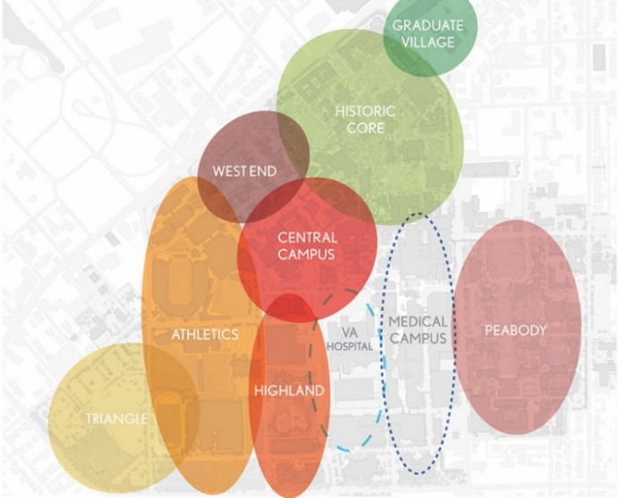
- Respect the need for equal and accessible sequences and spaces in buildings and exterior spaces. (please refer to Vanderbilt’s Accessibility Master Plan for further details on accessibility requirements).
In addition to general architectural guidelines and strategies, Vanderbilt has developed specific neighborhood-related guidelines for its eight neighborhoods: Historic Core, West End, Central, Highland, Peabody, Graduate and Professional Student Village, Triangle and Athletics.
Figure 1: Vanderbilt Campus Neighborhoods Map

Integrated Design
Integrated design is a process that begins with assembling a multi-stakeholder and multi-discipline team that should include, at a minimum, the following functions: project manager, design and construction, academic administration, building occupants, operations and maintenance, sustainability, energy modeling, finance and commissioning. The team will develop a plan and design that adheres to academic goals and sustainable design principles, looking comprehensively at climate impact, use, building design, and systems, while adhering to timeline and budgetary constraints. This collaborative approach looks at the entire life cycle of the project. Integrated design process should include:
Early performance-based energy modeling and analysis (refer to Vanderbilt’s A&E Guidelines, Division 1.19.00.01);
Sustainability charette
Determination of an EUI target
Renewable energy assessment to determine options for the site (see below); and
Development of the Owner’s Project Requirements (OPR).
Teams should refer to LEED IP Credit 1: Integrated Process for guidance on this process.

LEED and Other Certifications
All Tier 1 projects will pursue LEEDv4 (or newest) Gold (or higher) certification. Tier 2 projects will seek LEED certification where practical. LEED is typically not achievable for Tier 3 and 4 projects, but water use, materials, waste, and indoor quality sustainability strategies should still be incorporated. Each project will be reviewed to determine which level of LEED or other certifications the University wishes to pursue.
- As early as possible in the design phase, in support of Vanderbilt’s carbon neutrality and FutureVU goals, the team should evaluate the feasibility of pursuing other certifications in addition to LEED relating to energy efficiency, wellness and green building, including providing projected cost estimates. The evaluation should include:
Net Zero and Resilience: An analysis of meeting requirements to achieve Net Zero certification, including an assessment of on-site energy storage potential for resiliency.
Living Building Challenge: An analysis of possible credits (petals) in the Living Building Challenge certification that could be potentially pursued for a given building project, regardless of whether full certification is pursued.
Fitwel and/or WELL: A review of Fitwel and WELL certification requirements and feasibility/necessity for including some or all of these goals in the project.
Zero Waste: A review of GBCI’s TRUE Zero Waste certification requirements related to C&D waste, particularly relating to diversion rates and waste minimization and feasibility to achieve.
- Projects must complete an annotated LEED scorecard at the end of each project phase and should keep a record of final LEED documentation for each project.

Renewable Energy Assessment
- On-site Solar: For new buildings, determine if solar photovoltaic or solar thermal hot water heating installations could be implemented. Installations should be considered for roof tops and parking structures that have appropriate roof style, orientation, available sunlight and ease of installation. If solar is not an option initially, all Tier 1 projects must, at a minimum, be made “solar ready” for installation in the future, including additional space for equipment in the building (e.g. technology, inverters, energy storage, conduit) and proper roof areas (minimize mechanical and other equipment on roofs). Teams should provide a complete analysis of the full solar potential for the building project.
- Other On-site Renewables: Analyze other renewable potential such as geothermal, heat recovery, microturbines, etc., if applicable.
- Resilience: Assess optimization of on-site energy storage potential to address VU’s net positive energy goal.
3) Energy Performance Goals in the OPR
- The integrated design process and development of the OPR should include development of energy performance goals, per ANSI/ASHRAE standard 209-2018, Section 5.6.

A feasibility analyses/study should be presented illustrating the consideration of each certification and sustainable building approaches above and resulting recommendations. Project teams should demonstrate that all feasible options have been considered and ruled in or out. The resulting Owner’s Project Requirements (OPR) document should include all options that can be reasonably carried out, from a cost and a site perspective.

Commissioning
All projects on Vanderbilt’s campus will be commissioned, following Vanderbilt’s internally developed commissioning process (refer to A&E Guidelines, Division 1.19.00). The project team will determine the level of commissioning and whether an outside firm will be selected. Commissioning ensures that buildings and systems function according to design intent. It also provides needed training to ensure that buildings and new systems are operated at maximum efficiency. Ultimately, commissioning reduces resource consumption (energy and water), reduces operational costs, reduces environmental impact, and increases comfort, health and productivity. As such, it is critical to achievement of Vanderbilt’s academic and FutureVU goals.

D. Life Cycle Cost Analysis
Life Cycle Cost Analyses (LCCA) will be performed to quantify the 30-year impacts on initial costs, GHG emissions, energy costs, maintenance costs, etc. The scope of each LCCA will vary depending on project, but should typically include building envelope, HVAC, electrical, plumbing, other major building systems, and renewable energy systems. Requirements by design phase include:
Table 2: LCCA Requirements by Design Phase
Design Phase | Requirements
Planning/Conceptual Design | Initial LCCA for optional design elements and certification levels with major budget implications
Schematic Design | LCCA for options of major energy-consuming systems and to document the financial criteria for decision making as part of the energy modeling exercise, per ANSI/ASHRAE 209-2018.
Value Engineering (Any Phase) | Quantification of impacts beyond initial capital outlay

Energy Use and Performance

Energy Modeling
Teams should perform energy modeling to aid Vanderbilt in its pursuit of Blue Sky energy efficiency and carbon neutrality goals. Energy modeling should be completed according to ANSI/ASHRAE Standard 209-2018 Energy Simulation Aided Design for Buildings Except Low-Rise Residential Buildings. Specifically, energy modeling will be used to inform the design, selection and construction of Vanderbilt facilities and facility infrastructure in support of and in conjunction with Vanderbilt FutureVU standards and A&E Guidelines. The scope for energy modeling services, including the modeling cycles (as defined in ASHRAE 209-2018 Sections 4, 5 and 6) will be outlined in the OPR. (Refer to A&E Guidelines, Division 01.19.00.01).

Metering and Ongoing Verification of Performance
Applicable sections of Vanderbilt’s A&E guidelines relating to metering should be followed. Tier 1 projects should separately meter and install smart meters for all utilities coming into the building. When appropriate to project scope, there should be a team discussion about separately sub-metering significant use types within the building including large kitchens, data centers, and large data closets.
Water Metering
Steps should be taken to ensure that accurate real-time sub-metering is in place in order to separate building fixture consumption from irrigation, domestic hot water use, process water, cooling tower make-up water, and boiler make-up water. Sub-metering should be installed for non-potable sources of water used to offset water demands on campus such as stormwater, dewatering water, greywater from sinks and showers, HVAC cooling coil condensate, and black water.

Energy Use Intensity (EUI)
Vanderbilt’s FutureVU BlueSky Vision aims to align the EUI of various building types with industry accepted AIA 2030 Challenge targets (Appendix B). Teams should determine how best to meet EUI goals within project budget and scope while considering strategies to exceed EUI goals wherever possible.

Energy Conservation
Vanderbilt’s FutureVU launched the BlueSky Energy Vision Study (BlueSky Vision) in January 2018 to re-envision the campus energy infrastructure and to identify effective strategies for reducing carbon emissions on campus from the 2016 Greenhouse Gas (GHG) emissions baseline. Design decisions regarding technology, equipment, lighting, heating and cooling should be made with the goals of employing GHG emissions reduction strategies, attaining Blue Sky EUI targets (Appendix B), and implementing ECM recommendations (Appendix C) in the forefront. Energy conservation should not just focus on system efficiency, renewable energy production, etc., but also incorporating occupant use reduction strategies such as passive strategies, daylighting, feedback, automated setbacks, etc.
Strategies :
- Implement energy conservation measures (ECMs) as outlined in BlueSky Vision that have a favorable benefit-cost ratio (Appendix C) and provide maximum opportunities for GHG emissions reductions.
- Provide flexible building systems that can connect to future technologies and innovations in infrastructure.
- Install central automated control systems to ensure control of each building for maximum energy efficiency and GHG emissions reductions.
- Develop feedback loops for occupants to conserve energy with behavior improvements and with measurement technology for on-going commissioning and operational improvements.
- Use energy modeling to help with an optimal design, ensure the team is optimizing building performance, energy efficiency and GHG emissions reductions potential, ensure the correct group of strategies for a given project are being employed, and after completion to ensure ECMs are working using post-occupancy evaluation of metered data.
- Reduce heating, cooling and electricity demand by using passive strategies wherever practical, including climate-responsive design, daylighting, and conservation practices.
- Specify efficient and high-performance water and energy-conserving equipment and lighting systems.
- Ensure the engagement of the commissioning agent at every project phase.
- Create high performance façades with double paned, low-e glazing; 40% or lower window-to-wall ratios; thermally broken window frames; continuous air barriers; and ASHRAE 90.1-2016 compliant wall insulation to improve thermal comfort.
- Design projects to meet or exceed targets for R value, U factor, and Solar Heat Gain Coefficient (SHGC) found in Table 5.5-3 Building Envelope Requirements for Climate Zone 3 (A,B,C) in ASHRAE 90.1-2016, Energy Standard for Buildings Except Low-Rise Residential Buildings (I-P Edition).
- Increase insulation in existing buildings to comply with ASHRAE 90.1-2016 levels.
- Provide operable windows for natural ventilation and cooling where possible, considering the HVAC system type and controls being used.
- Assess high-energy users within the building to maximize energy efficiency and GHG emissions reduction opportunities.
  - High energy and high heat-generation equipment should be co-located and isolated within spaces to allow use of high-efficiency heat rejection systems.
  - Teams should reference ASHRAE 90.4-2016 – Energy Standard for Data Centers to calculate anticipated energy use in data centers. ASHRAE Standard 90.4 “establishes the minimum energy efficiency requirements of data centers for design, construction, and operation and maintenance, and utilization of on-site or off-site renewable energy resources.”
- Where possible, install occupancy sensors, photo sensors, and continuous daylight dimming controls to ensure that lights do not illuminate vacant or naturally lit spaces.
- Implement demand-controlled ventilation in all new construction.
- Install sensors in non-laboratory buildings to monitor carbon dioxide concentration and modulate ventilation air accordingly.
- Use variable air volume exhaust systems in laboratories and add glycol run-around heat recovery to laboratory ventilation systems.
- Convert CAV to VAV and include adding enthalpy wheel energy recovery in non-laboratory HVAC systems.

Materials, Resources, and Waste
Vanderbilt’s Zero Waste strategy prioritizes waste avoidance and reduction over creation of waste streams, even those that are diverted to recycling, composting and reuse. Zero Waste also aids in the university’s efforts to reduce GHG emissions and attain carbon neutrality by 2050. The waste hierarchy below should guide waste management for all building projects on Vanderbilt’s campus.
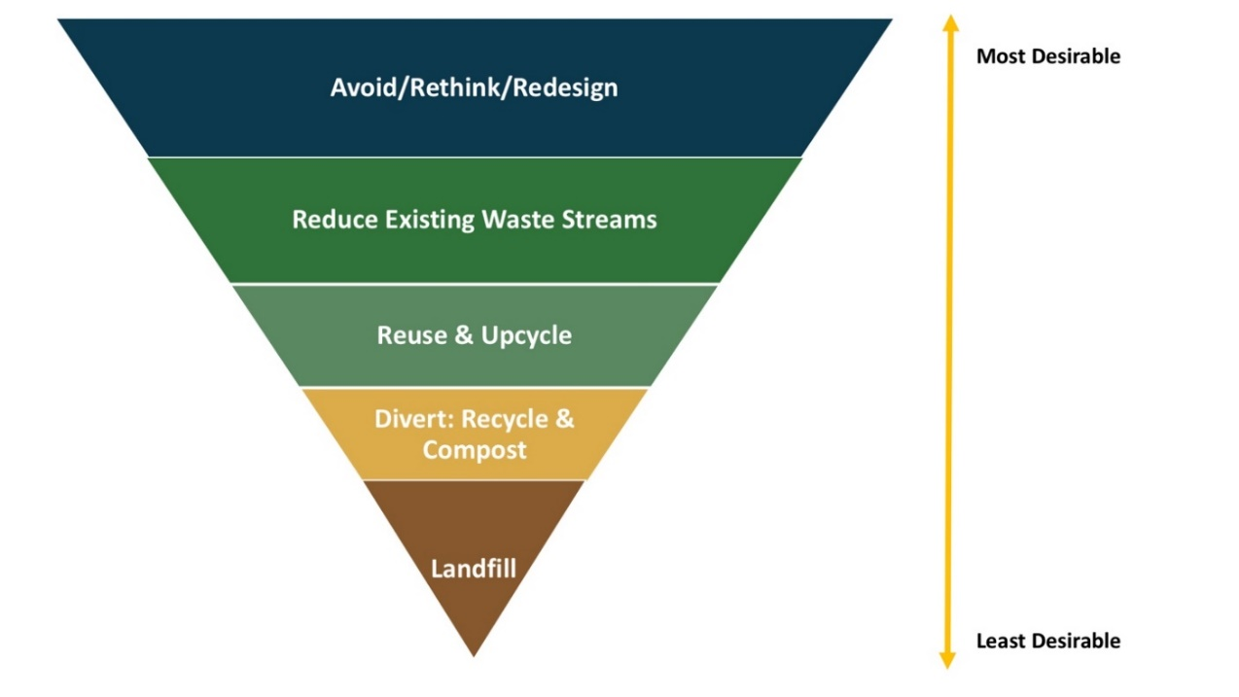
Figure 4: Waste Hierarchy

Construction and Demolition Waste Prevention
Project teams should consider waste prevention at the material level, giving preference to materials that can be salvaged and reused, easily repaired and maintained, or recycled at the end of their service life. Facilities should be designed for easy disassembly and reuse of building components to accommodate potential future growth while also saving on materials and reducing waste streams. Design teams should consider each of the following strategies and report on which they are or are not incorporating.
Strategies
- Design with flexible, simplified building layouts, eliminating complex framing conditions that require excessive structure wherever possible (like transfer beams, for example). Standardize elements throughout building.
- Design with deconstruction or disassembly in mind.
- Design story heights to reduce waste (right-size for 4’X8’ drywall pieces, or typ. lumber lengths, etc.).
- Design facilities to be multi-use. Can serve multiple purposes and therefore eliminate redundancies and renovation waste.
- Have more exposed structures and fewer unnecessary finishes.
- Design for ease of replacement in mind (replacing one carpet tile where needed rather than an entire floor of carpet).
- Use BIM coordination between all trades to eliminate errors and unnecessary waste.
- When building on existing building site, reuse existing materials to greatest extent possible.
- Reuse excavation material and balance cut and fill material on-site.
- When using finish materials, make them multi-purpose (pin board that also dampens sound, for example).
- Use reclaimed materials (like wood).
- Inventory large waste pieces on site for future use.
- Design with a focus on occupant recycling and organics collection, rather than on trash collection.
- Incorporate demountable partitions and movable walls that can be reconfigured within spaces.
- Incorporate accessible ceiling and floor systems.
- Incorporate flexible power and lighting distribution systems (plug-and-play) to accommodate for redistribution of interior programs.
- Design HVAC systems to allow for future rezoning of spaces.
- Prioritize prefabricated, unitized, and recycled building components that can be easily disassembled or deconstructed for replacement, reuse or can be returned to the manufacturer. Prefabricated, modular design provides higher quality control with lower cost, less waste, and quicker assembly on-site.
- Develop tracking methods for material procurement to ensure buildings are designed with healthy, low-impact materials.

Waste Management
When waste is generated, systems should be in place that encourage recycling, reuse and composting of this waste. Vanderbilt has determined that reducing, to the maximum extent practicable, the amount of waste disposed of is a high priority to assist in achievement of VU’s zero waste goal of 90% diversion by 2030. The Contractor and subcontractors shall take steps to generate the least amount of waste possible by minimizing waste due to error, poor planning, breakage, mishandling, contamination, or other factors. Of the inevitable waste that is generated, as many of the waste materials as economically feasible shall be segregated for reuse, salvage, or recycling, or recycled as mixed debris. In no case shall material be disposed of in a landfill or incinerator where an approved and less costly recycling or reuse alternative exists. Waste disposal in landfills and incinerators shall be minimized and shall be considered the alternative of last resort.
Strategies
- Adhere to LEED v4 Construction and Demolition Waste Management credit, making sure selection option and path for waste diversion is approved by the Vanderbilt PM.
- Provide for collection and storage of recyclables on site, both inside and outside the building.
- Provide for collection and storage of organic and compostable materials on site, both inside and outside the building.

Water Management
Water is a valuable resource that should be conserved whenever possible. The history of development in Metro Nashville is closely connected to local hydrological conditions and the Nashville area has had significant flooding events in the past. Vanderbilt University aims to minimize the demand for potable water in addition to reducing both stormwater runoff and sewage conveyance by implementing effective stormwater management areas, efficient fixtures, installing weather-based irrigation controllers, and reusing water on campus where possible.

Indoor Potable Water
Strategies
- Meet campus-wide potable water reduction target of 30% by 2030 and 50% by 2050 from current use. These reduction targets will likely require stormwater collection around campus to be used at chiller plants for cooling tower makeup water and at the main power plant for boiler makeup water.
- For all Tier 1-4 projects, specify fixtures that follow a minimum of LEED prescriptive path/EPA Water Sense labelled bathroom and kitchen fixtures with the use of high efficiency fixtures wherever possible (Table 3). Deviations to minimum requirements must receive advance approval.
Academic/Admin Buildings | Standard Fixtures Flowrate | LEED Prescriptive Path Flowrate | High Efficiency Fixtures Flowrate | Residence Halls | Standard Fixtures  Flowrate | LEED Prescriptive Path  Flowrate | High Efficiency Fixtures  Flowrate
Lavatory  Faucets | 0.5 Gallons per minute (gpm) | 0.4 gpm | 0.35 gpm | Lavatory  Faucets | 2.2 gpm | 1.5 gpm | 0.35 gpm
Toilets | 1.6 Gallons per flush (gpf) | 1.28 gpf | Dual Flush 1.6/1.1 gpf or 1.28 gpf | Toilets | 1.6 gpf | 1.28 gpf | Dual Flush  1.6/1.1 gpf or 1.28 gpf
Urinals  Showers  Kitchen Faucets | 1.0 gpf  2.5 gpm  2.2 gpm | 0.5 gpf  2.00 gpm  1.75 gpm | 0.125 gpf  1.25 gpm  1.5 gpm | Urinals  Showers  Kitchen Faucets | 1.0 gpf  2.5 gpm  2.2 gpm | 0.5 gpf  2.00 gpm  1.75 gpm | 0.125 gpf  1.25 gpm  1.5 gpm
Table 3: Fixture Flow Rate Requirements

- Refer to the water use intensity (WUI) reduction targets shown by building type in Appendix B.
- For Tier 1 projects, achieve 40-50% water savings in LEED NCv4 WE indoor Water Use Reduction credit.
- For Tier 2 projects and major plumbing retrofits, also target 30-40% water savings from the LEED v4 baseline.
- Consider stormwater and greywater collection and reuse systems early in the building design process by identifying sources including roof, lavatories and showers for reuse in flushing or process and make-up water.
- Assess potential for incorporating sub-metering for building fixture use, process water, and cooling tower make-up water.
- Collect and filter black water from toilet fixtures and kitchen sinks for use in toilet flushing where feasible.

Outdoor Potable Water
The use of potable water for non-potable water demands should be minimized by leveraging alternative sources of water, including greywater and collected stormwater. Stormwater provides a large potential water resource for non-potable uses. For more detailed information on stormwater and irrigation requirements, please refer to the Landscape Strategic Plan.
Strategies
- Comply with the LEED-NCv4 Outdoor Water Use Reduction Credit, including a reduction of water use by at least 50%.
- Sub-meter irrigation separately from other potable water use.
- Consider stormwater and greywater collection and reuse systems early in the building design process by identifying sources including roof, lavatories and showers for reuse in irrigation.
- Establish stormwater collection systems to collect water for cooling tower and boiler make-up water. Excess water should be directed to building non-potable water use or irrigation.
- Establish systems for collection and reuse of HVAC condensate water for cooling tower and boiler make-up water. Excess water should be directed to building non-potable water use or irrigation.
        - Install water meters with automatic data logging to provide real-time water consumption data should be installed.

Indoor Environmental Quality
Indoor environmental quality significantly impacts building occupants’ health, wellbeing, and productivity. This section outlines recommended strategies for improving both indoor environmental quality and material procurement procedures, highlighting the benefits for students, faculty, and staff at Vanderbilt.

Indoor Air Quality
Indoor air can be of lower quality than outdoor air, due to the off gassing of building materials, the presence of microbial pathogens, and high concentrations of carbon dioxide. Research over the last several years regarding the effects of toxic ingredients in materials has resulted in a wide range of new standards and guidelines for material procurement practices to provide better indoor air quality. LEED Version 4, for example, requires product testing to verify VOC emissions.
Strategies
- Specify building materials which contain low or no VOCs and ultra-low-emitting formaldehyde (ULEF) resins or no-added-formaldehyde (NAF) resins. (See related section “Healthy Materials”).
- Limit space absolute humidity to 54F dew point to reduce the risk of condensation, mold, and dust mites. This corresponds to 50% RH at 74F.
- Set ventilation rates to comply with all requirements of ASHRAE 62.1-2016 Ventilation for Acceptable Indoor Air Quality.
- Incorporate demand-controlled ventilation systems for all spaces with occupant densities greater than 25 people per 1000 sf to keep CO2 levels below 800 ppm.

Daylighting & Visual Comfort
Vanderbilt places a high priority on providing high-quality, highly functional spaces for students, staff, and faculty. Balancing natural and artificial light with a preference for daylight and outdoor views is critical. Harvesting daylight for use in interior spaces enhances this access and can reduce lighting energy consumption. Research also suggests that natural daylight improves wellness, cognitive performance, and productivity.
Strategies
- Implement LEED v4.1 requirement for achieving daylight levels to, as much as possible, reduce the use of electrical lighting by introducing daylight into the space.
- Include appropriate solar controls, such as low e-coatings, shades, or interior blinds to mitigate the potential for glare and excessive daylight.
- Specify high quality and high efficiency LEDs with a color rendering index (CRI) greater than 80. Higher CRI values render more accurate colors.
- Use daylight dimming controls in all perimeter spaces.
- Provide task lights for all workstations for enhanced lighting controllability.
- Incorporate Circadian Lighting Design principles according to the WELL Building Standard V2 requirements.
- Assess illuminance levels through a daylight simulation study.

Indoor Thermal Comfort
Vanderbilt requires that indoor spaces meet ASHRAE Standard 55, Thermal Environmental Conditions for Human Occupancy, which specifies requirements for air temperature, mean radiant temperature, air velocity, and relative humidity in order to maintain ideal occupant thermal comfort. The key is to mitigate temperature asymmetries to keep the variance under 10^{O}F in either direction.
Strategies
- Limit the window-to-wall ratio to 40%.
- Specify high performance glazing.
- Increase wall insulation to the latest ASHRAE 90.1-2016 levels.
- Create continuous air barriers to reduce air leakage and maintain indoor temperature set points.

Natural Ventilation & Occupant Controls
Natural ventilation reduces fan and cooling energy and offers occupants thermal control of their space, increasing space satisfaction.
Strategies
- Floor plate depth should be optimized based on window opening area and floor to ceiling height.
- Size window openings appropriately for natural ventilation and include airflow control mechanisms in the building management system.
- Reduce mechanical energy use by creating single-sided ventilation for individual offices, stack effect ventilation for atrium spaces and cross ventilation for large open classrooms and workspaces.
- To maximize air movement and individual control of temperature, use adjustable thermostats, underfloor ventilation outlets, ceiling fans, and operable windows.
- Provide automatic or manually operated interior blinds in all regularly occupied spaces for glare control.

Acoustic Control
Acoustics play a large role in occupant satisfaction. Proper acoustic control measures should be implemented to provide a high level of occupant satisfaction and productivity and to avoid costly design fixes. The WELL Building Standard recommends limiting exterior noise intrusion to less than 50 dBA.
Strategies
- Develop noise criteria early in design process to determine level of acoustic isolation necessary for different areas of the building.
- Provide acoustical insulation or sound baffling systems to limit reverberation time (RT60) to less than 0.5 seconds.
- Use sound dampening materials with high noise reduction coefficients (NRC) for walls, ceilings, and floors.
- Employ active sound masking systems.
- Limit background noise from HVAC equipment to less than 40 dBA.

Ergonomics
Design teams should consider how ergonomics will impact the layout of spaces. Ergonomic design impacts occupant health and productivity. Students, faculty, and staff with static furniture and equipment are more likely to experience discomfort and be more susceptible to repetitive strain injuries. Additionally, static furniture and a one-size-fits-all design approach does not serve Vanderbilt’s diversity and inclusion goals, so designs should incorporate a variety of ergonomically correct furniture, equipment, and layouts.
Strategies
- Provide adjustable computer screens, sit-stand desks, and flexible chairs (compliant with HFES 100 Standard or BIFMA G1 guidelines) can greatly improve working conditions and be inclusive of diverse populations.
- Study areas for students should have a mix of desk heights, standing desks to accommodate different study group working preferences and differing abilities and sizes.
- Implementing ergonomic design recommendations in the WELL Building Standard is preferred.

Materials of Concern
Vanderbilt is working to create healthier and more sustainable environments in all our buildings. Teams should use the Sustainable Checklist for Products and Furniture found in Appendix D. Teams should also meet requirements for addressing specific chemical classes of concern in furniture, carpet, wall base, and non-blackout window shades. Specifically, the university aims to phase out the following classes of chemical compounds from facilities in the near-term: halogenated flame retardants (HRFs), highly fluorinated chemicals (stain repellents), heavy metals (mercury, chromium, lead and cadmium), and added formaldehyde. Other chemical compounds to avoid in building materials include antimicrobials, bisphenols and phthalates, and organic solvents.
Strategies
- Select no- or low-VOC products.
- Select products with natural rubber coatings and other non-chemical flame retardants.
- Select products without highly fluorinated chemicals, instead using natural water-repellent coatings.
- Select products, equipment, and lighting fixtures with low- or no-mercury content, lead-free paint, and cadmium-free products.
- Select products with no added urea-, phenol-formaldehyde, melamine resin, nor methylene diphenyl diisocyanate (MDI).
- Select products without added antimicrobials.
- Avoid PVC. Use metal piping or high-density polyethylene, wood/metal window framing, fabric-backed carpet, non-vinyl or natural flooring materials, natural siding, thermoplastic polyolefin (TPO) roof membranes.

Sustainable Materials
All projects must use sustainable materials to the maximum extent possible. As materials can weigh heavily on natural resources, Vanderbilt’s FutureVU goals specify that projects should consider the full environmental impact of products used from extraction of raw materials to end-of-use disposal methods.
Strategies
- Incorporate use of materials, building products (e.g. synthetic gypsum drywall, iron, recycled aluminum, copper, and steel, dimension stone, ashcrete, recycled glass tiles, recycled cork panels and flooring, etc.), furniture, benches, recycling containers, finishes, partitions, etc. with recycled content, referring to LEED v4 for specific requirements on amounts and calculations.
- Per LEED v4, use locally sourced products, building materials, equipment, furniture and finishes (within a 100-mile radius) where possible and/or those with manufacturer take back programs.
- Evaluate the full life-cycle impact of products used in terms of environmental, health, and social contributions of a product.
- Incorporate demountable partitions and movable walls that can be reconfigured within spaces.
- Prioritize prefabricated, unitized, and recycled building components that can be easily disassembled or deconstructed for replacement, reuse or can be returned to the manufacturer.
- Prioritize the purchase of products with third-party verified life cycle assessments including EPDs.

Landscaping and Outdoor Spaces
Just as teams must apply sustainable building strategies to the interior of buildings constructed on campus or for large renovations, Vanderbilt requires that as much concerted attention be paid to outdoor spaces and landscaping. Vanderbilt’s FutureVU strategy highlights landscaping and green spaces as vital to Vanderbilt’s historical legacy and the arboretum and plays a critical role in sustainability by providing both humans and wildlife with numerous ecological interactions. A campus with an engaging and sustainable landscape design can improve student and employee health, manage stormwater runoff, and create habitat for local flora and fauna. Vanderbilt’s strategy is designed to encourage engagement with the outdoors and reap the environmental benefits of sustainable landscapes. Towards that end, the focus is on strategies to better activate the outdoor environment for use by students, faculty and staff by improving outdoor thermal comfort as well as those that emphasize protecting and restoring plants, trees and natural habitat on campus, as well as incorporating sustainable landscape materials and reducing light pollution. Strategies in this section cover outdoor light and noise pollution and outdoor lighting energy efficiency. Refer to the Landscape Strategic Plan for further details on addressing all aspects of outdoor spaces.

Light Pollution and Energy Reduction Measures
While site and exterior building facade lighting is necessary to provide security and wayfinding at night, it can exacerbate light pollution and use more energy than needed if not designed correctly. This environmental issue must be mitigated wherever possible because of its harmful effects on both human activity and wildlife, (i.e., disrupting circadian rhythms and migratory patterns while impairing night vision and wasting energy). Outdoor lighting should be designed in a manner to ensure maximum sustainability, efficiency and safety while still providing aesthetic value.
Strategies
- Isolate outdoor lighting to areas needed for pedestrian safety.
- Select outdoor lighting features with low backlight-uplight-glare (BUG) potential and energy efficiency.
- Adhere to LEED v4 Light Pollution Reduction credit.
- Adhere to International Dark Sky Association outdoor lighting basics including selected lighting minimizing blue light emissions and being fully shielded (pointing downward).
- Adhere to LEED v4 Exterior Lighting credit, which controls light pollution from buildings.
- Exterior lighting must be Dark Sky qualified and have motion sensor controls, integrative photovoltaic cells, photo sensors, or astronomic time-clock operation.
  - Exemptions: emergency lighting, lighting required by code for health and safety purposes, and lighting used for eye adaptation near covered vehicle entrances or exits.
- In environmentally sensitive areas, use LPS, which emits orange-colored light but is very energy efficient and not as bright.
- In areas where it’s necessary to use white light, LEDs may be used, one advantage of LED lighting being that it can be dimmed when not needed. This feature both saves on energy and reduces light pollution during the night. If LEDs are selected, follow the following guidelines from IDA that will aid in selection of energy and cost-efficient lighting that ensures safety and security while also promoting the goal of dark night skies:
  - Always choose fully shielded fixtures that emit no light upward.
  - Use “warm-white” or filtered LEDs (CCT < 3,000 K; S/P ratio < 1.2) to minimize blue emission.
  - Look for products with adaptive controls like dimmers, timers, and motion sensors.
  - Consider dimming or turning off the lights during overnight hours.
  - Avoid the temptation to over-light because of the higher luminous efficiency of LEDs.
  - Only light the exact space and in the amount required for tasks.
- Select lighting that meets IDA standards, based on products that have received IDA’s “Fixture Seal of Approval” and can be found in IDA’s database of certified products.

Outdoor Noise Reduction Measures
FutureVU outlines Vanderbilt’s desire to ensure that future development reinforces, rather than detracts from, the park setting via green open spaces and pathways.

Strategies

- Conduct a site noise assessment. Perform qualitative assessments of nearby noise sources and noise-sensitive receivers, and/or a quantitative measurement of site noise in at least one location for at least 24-hours.
- Design and locate exterior noise sources, including building equipment (mounted on the rooftop, inside building but exterior venting, or located at grade), transformers, traffic associated with the building, and other sources. Ensure that the following project noise levels are not exceeded at the project boundary:
  - For boundaries adjacent to residential buildings:
    - Maximum exterior noise level (Lmax) does not exceed existing ambient levels and does not exceed 60 dBA.
    - Average exterior noise level (Leq, 8h) of 45 dBA.
  - For boundaries not adjacent to residential buildings:
    - Outdoor Day-Night Equivalent Level (Ldn) or Community Noise Equivalent Level (CNEL) of 60 dBA.

Glossary of Terms and Acronyms
AIA – American Institute of Architects.
ASHRAE – American Society of Heating, Refrigeration, and Air Conditioning Engineers.
BUG rating – Backlight, Uplight, and Glare are considered to gauge the amount of light trespass that a light fixture produces from behind (backlight), above (uplight) and in front (glare).
EUI – Energy Use Intensity – A building’s total annual energy use in kBTU divided by its gross square footage.
EPD - Environmental Product Declarations are internationally accepted, verified and published reports on the ways in which a product affects the environment throughout its life cycle, from material extraction through production, shipping, consumption and disposal.
Fitwel – Fitwel Wellness Certification includes design and operational strategies to address a broad range of health behaviors and risks to positively impact occupant health.
FSC - The Forest Stewardship Council. The Forest Stewardship Council sets voluntary standards for responsible forest management.
FutureVU – A framework for the development of Vanderbilt’s campus over the next 20 to 30 years. The initiative considers core themes such as connectivity and community enhancement, diversity and inclusion, accessibility, environmental sustainability, and preservation of the university’s historic, park-like setting – in support of Vanderbilt’s Academic Strategic Plan.
GHG – Greenhouse Gases are gases that trap heat in the atmosphere causing overall temperatures to rise over time. The main greenhouse gases VU quantifies are: Carbon Dioxide (CO₂), Methane (CH₄), Nitrous Oxide (N₂O), and fluorinated gases, including hydrofluorocarbons, perfluorocarbons, and Sulfur Hexafluoride.
GPF – gallons per flush
GPM – gallons per minute
International Dark Sky Association (IDA) - IDA’s mission is to preserve and protect the nighttime environment and our heritage of dark skies through environmentally responsible outdoor lighting.
LCC – Life cycle costing assesses total cost incurred throughout a specific period of facility ownership. is “a method that allows you to assess the total cost you’ll incur throughout your period of facility ownership. LCC includes acquisition, operational, and disposal expenses and allows decisions to be made with an idea of full costs of a building, not just first cost.
LCCAs – Life cycle cost analyses. Assessments using life cycle costing methodology.
LEED – U.S. Green Building Council’s Leadership in Energy and Environmental Design (LEED) certification program.
LID – Low-impact development. LID includes systems and practices that use or mimic natural processes to enhance water infiltration and use of stormwater to protect water quality and habitat.
Living Building or Living Building Challenge (LBC) – Living Building Challenge is a “green building certification program and sustainable design framework that visualizes the ideal for the built environment, using the metaphor of a flower because the ideal built environment should function as cleanly and efficiently as a flower.
M&V – measurement and verification.
MDI – Methylene Diphenyl Diisocyanate is a chemical used primarily in the production rigid polyurethane foams used for insulation.
Net Zero Energy and Net Positive Energy Building – Achieving Net Positive Energy means producing, from renewable resources, more energy on site than is used over the course of a year.” According to USGBC, a net zero building achieves a source energy use balance of zero over a period of 12 months.
NRC - Noise reduction coefficients provide a measure of the level of noise reduction achieved by sound dampening materials used for walls, ceilings, and floors.
PBTs – persistent bio accumulative toxins include 16 chemicals and 5 chemical compound categories that are subject to the Toxics Release Inventory (TRI) reporting under Section 313 of the Emergency Planning and Community Right to Know Act (EPCRA).
PVC – Polyvinyl Chloride is a common, lightweight, strong plastic used in construction.
SITES - Sustainable Sites Initiative, a rating system designed to measure landscapes’ performance and create innovative and sustainable landscape design.
SHGC – Solar Heat Gain Coefficient is “the ratio of the solar heat gain entering the space through the fenestration area to the incident solar radiation. Solar heat gain includes directly transmitted solar heat and absorbed solar radiation, which is then reradiated, conducted, or convected into the space.”
SRI – Solar Reflectance Index is “a measure of the constructed surface’s ability to stay cool in the sun by reflecting solar radiation and emitting thermal radiation.
SWMM – Stormwater Management Manual for Metro Nashville establishes the regulations and technical guidelines developed by Metro Public Works to enforce the city’s Stormwater Management Ordinance.
Thermal resistance (R-value) – the reciprocal of the time rate of heat flow through a unit area induced by a unit temperature difference between two defined surfaces of material or construction under steady-state conditions (h·ft2·°F/Btu).
Thermal transmittance (U-factor) – heat transmission in unit time through unit area of a material or construction and the boundary air films, induced by unit temperature difference between the environments on each side (Btu/h·ft2·°F).
USGBC – U.S. Green Building Council.
VOC – Volatile Organic Compounds are gases emitted from solids or liquids and include a variety of chemicals, some of which may have short- or long-term adverse health effects.
VRF – Variable Refrigerant Flow is a mechanical system in which a refrigerant liquid is used as a heating/cooling medium as opposed to chilled water. It leads to significant energy savings, up to 55% over comparable HVAC systems.
WELL – Performance-based system for measuring, certifying, and monitoring features of the built environment that impact human health and wellbeing, through air, water, nourishment, light, fitness, comfort, and mind.
WUI – Water use intensity. A building’s annual water usage in kgal divided by its gross square footage.
Zero Waste Certification – GBCI’s TRUE Zero Waste Certification involves meeting seven minimum program requirements, including 90% or greater diversion from landfill, documenting waste diversion, and not exceeding 10% contamination for any materials leaving the site.

Appendix A: Sustainable Building Standards Compliance Checklist
Vanderbilt Sustainable Building Standards Checklist
Updated 5.24.19
Please use applicable sections of this worksheet to document sustainability strategies and targets met. Please use the results summary box to 1) explain any areas of non-compliance with the Standards or the required deliverables, and 2) highlight any areas of innovation or unexpected results.
What Tier is this Project?
Project Elements | Results Summary
BUILDING DESIGN
LEED and Other Certifications
LEED, Net Zero, Living Building Challenge (LBC), Fitwel, WELL, and/or Zero Waste certification analyses | Example: “LEED Gold and Fitwel achievable;  LEED platinum, LBC, WELL unachievable”
Integrated Design
Early performance-based modeling and analysis
Renewable energy assessment (on-site solar, other on-site renewables, resilience)
OPR development
Design charrette meetings done and notes, with sustainability goals, completed
LEED documentation to meet LEED IP credit: Integrated Process
Commissioning
Commissioning agent or internal
Life Cycle Costing Assessment
Planning/conceptual design phase – optional design elements and certification levels with major budget implications
Schematic design phase – options for major energy-consuming systems
Value engineering – quantification of impacts beyond initial capital outlay
Energy Use and Performance
Energy Modeling - Model results comparing potential options, with a summary of assumptions, inputs and outputs provided to PM
Metering and ongoing verification of performance
- Metering and sub-metering as appropriate for both energy and water set up and verified by PM
- Measurement & Verification Plan created and provided to PM
- If a BAS exists, meters are tied into it
Energy use intensity targets identified and met in design
Energy conservation measures and strategies employed
Vanderbilt Sustainable Building Standards Checklist
Updated 5.24.19
Please use applicable sections of this worksheet to document sustainability strategies and targets met. Please use the results summary box to 1) explain any areas of non-compliance with the Standards or the required deliverables, and 2) highlight any areas of innovation or unexpected results.
Water Management
Completed LEED v4 Indoor Water Use Reduction Calculator showing at least a 50% reduction submitted to and reviewed by PM
Completed analysis showing at least a 50% reduction in water use and verification of separately metered irrigation provided to PM
Materials, Resources, and Waste
Construction and Demolition Waste prevention measures determined and outlined

Waste management measures and systems determined and outlined

Indoor Environmental Quality
Indoor air quality strategies

Daylighting and visual comfort strategies

Indoor thermal comfort strategies

Natural ventilation and occupant control strategies

Acoustic control strategies

Ergonomics strategies

Materials of Concern strategies

Sustainable materials strategies

Landscaping and Outdoor Spaces
Light pollution and energy use reduction strategies

Outdoor noise pollution prevention/reduction strategies
Closeout Documentation and O&M Readiness
Digital as-built energy model, with summary of inputs/outputs
Narrative on sustainability lessons learned provided to PM
Vanderbilt Sustainable Building Standards Checklist
Updated 5.24.19
Please use applicable sections of this worksheet to document sustainability strategies and targets met. Please use the results summary box to 1) explain any areas of non-compliance with the Standards or the required deliverables, and 2) highlight any areas of innovation or unexpected results.
Additional Strategies Employed and Notes

Appendix B: BlueSky Vision Energy Use Intensity (EUI), Renewable Energy and WUI Reduction Targets 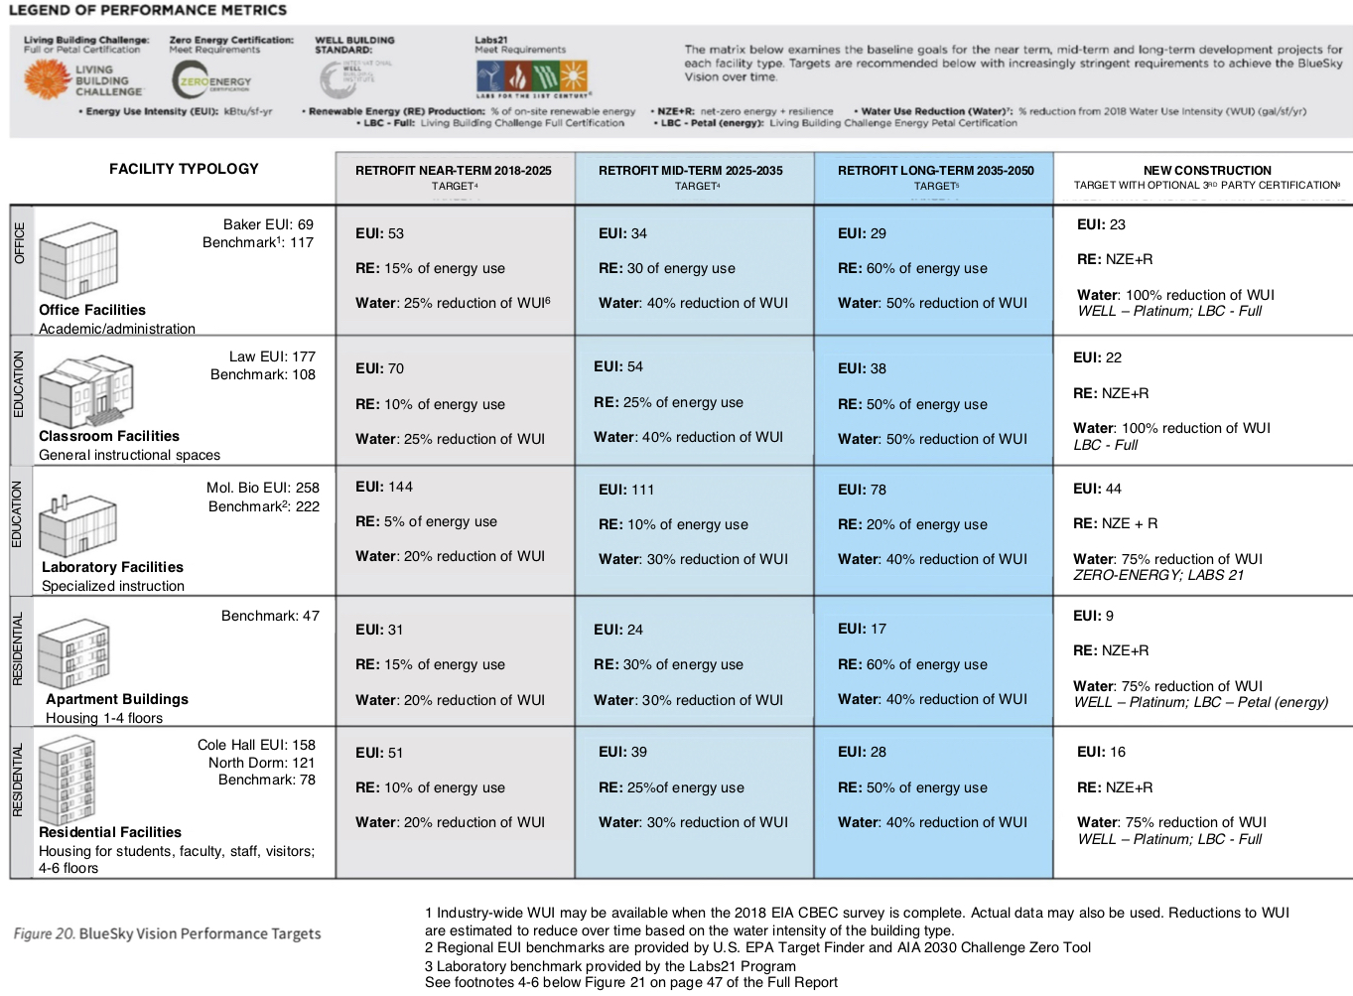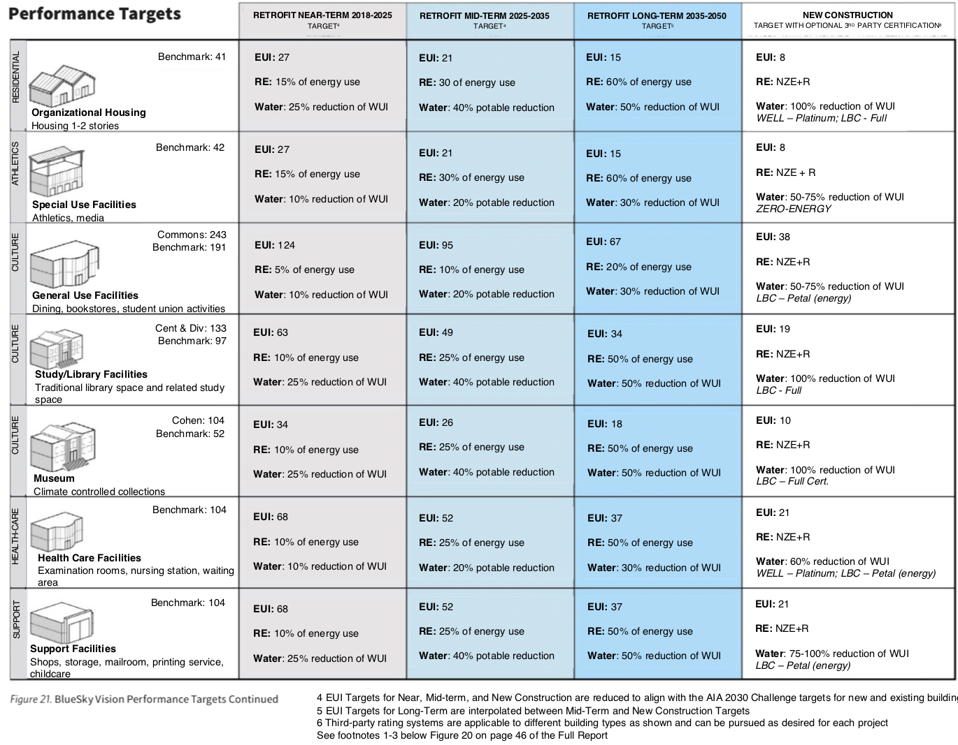
Appendix C: BlueSky Energy Conservation Measure Recommendations, in order of benefit-cost ratio

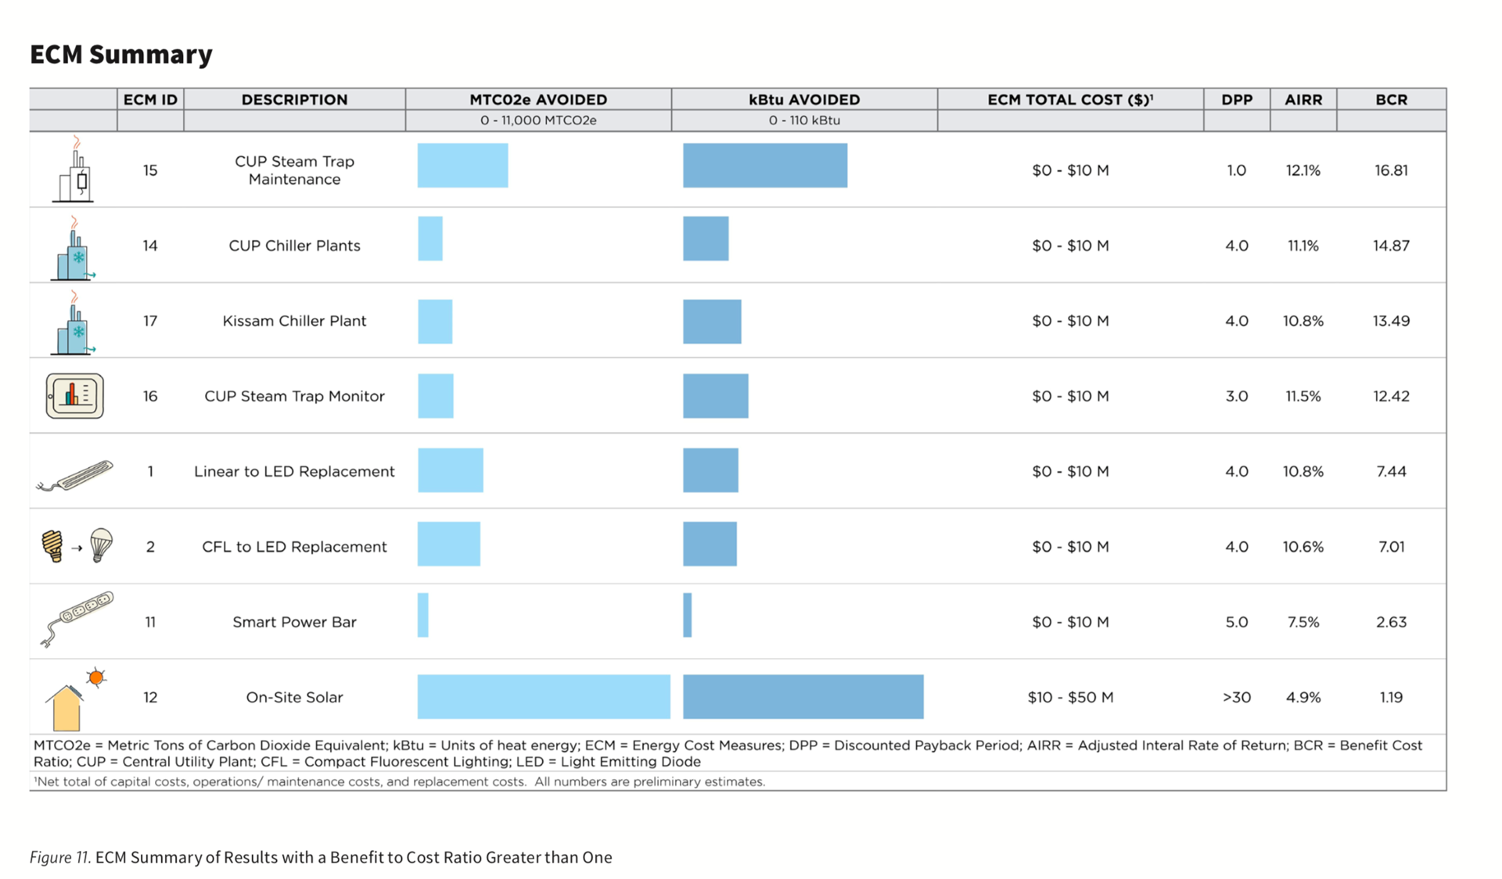

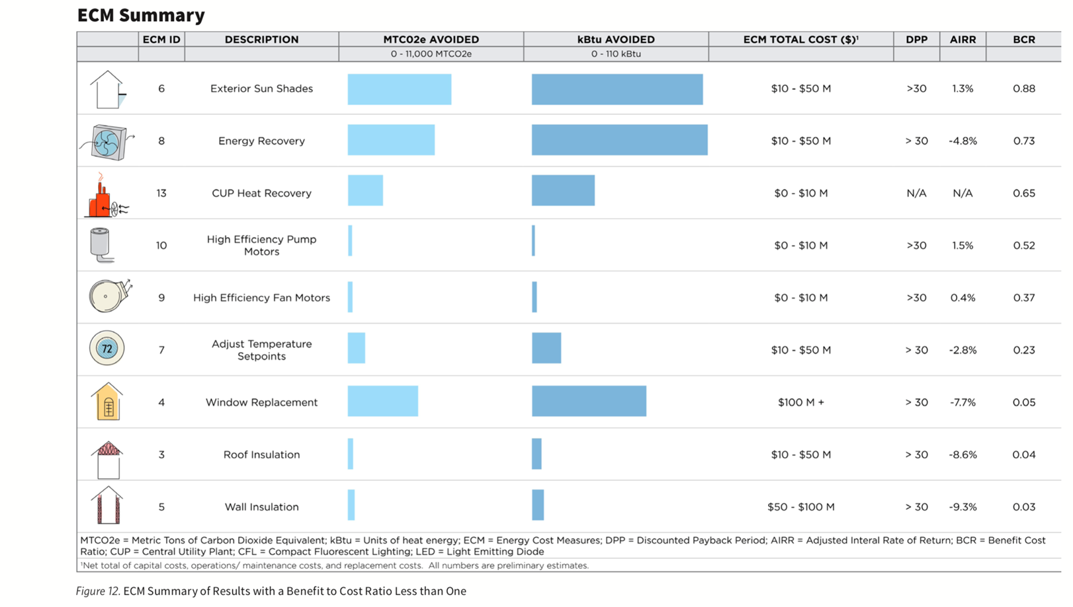

Appendix D: Sustainable Checklist for Products and Furniture
When comparing products, choose product with most checkmarks

Criteria | Description |  | Reason criteria not met
Recycled Content | - Contains at least 25% recycled content  - Is salvaged or reused
Renewable Resource Content | - Contains at least 25% rapidly renewable material such as bamboo, acacia, etc.  - Contains at least 50% FSC certified wood
Locally Sourced | - Is sourced within 100 miles of University (purchased, manufactured, or extracted)  - Is Made in the USA if not locally sourced
Reduced Environmental Footprint | - Contains a Type III Environmental Product Declaration (ISO 14025) or a self-reported Live-Cycle Assessment (ISO 14040 or 14044)  - Cradle to Cradle certification  - BIFMA level certified  - SMaRT certified  - Other footprint reduction methods: _____________
Content Disclosure | - Contains a publicly available Manufacturer Inventory or Health Product Declaration report disclosing the product’s chemical ingredients to at least 0.1%  - Living Building Challenge Certified Declare label
When comparing products, choose product with most checkmarks

Criteria | Description |  | Reason criteria not met
Non-Hazardous Ingredients | - GreenGuard Gold certification  - SCS Indoor Advantage Gold Achieves credits 7.6.1-3 in BIFMA Level certification  - Contains general emission evaluation report  - Living Building Challenge Certified Red List Compliant  - For furniture: meet all limits set by ANSI/BIFMA Furniture Sustainability Standard for VOC content (WELL Air Quality Standard Part 5)  - Use low or no-VOC paints and varnishes
Durability | - Product will last for an extended period  - Product can be repaired if damaged  - Product can be reused or repurposed
Reusable/ Recyclable/ Minimal Packaging | - Minimal packaging  - Recyclable packaging  - Packaging takeback program
Sustainable Disposal Methods | - Manufacturer takeback program  - Recyclable material/product
Sustainable Corporate Practices | - Company has publicly available Corporate Sustainability Report, preferably in accordance with GRI, UN Global Compact, or ISO 26000  - Company has JUST label  - Company uses sustainable transportation or manufacturing practices

Appendix E: VU-Specific Emissions Factors for Fiscal Year 2018-2019
VU-Specific Emissions Factors for Fiscal Year 2018-2019
One | Equals | Of the Following: | Reference
MWh from VU turbines | 0.1811 | Metric Tons of CO₂ Equivalent (MTCO₂E) | 1
MWh from NES | 0.364345 | Metric Tons of CO₂ | 2
MWh from NES | 803.23 | Pounds of CO₂ | 2
MMBtu of natural gas | 53.1148 | Kg of CO₂ Equivalent | 3
MMBtu of natural gas | .0531148 | MTCO₂E | 3
MWh from VU Cogeneration Plant | 0.248119 | Metric Tons of CO₂ | 4
MMbtu of steam | 0.06301 | Metric Tons of CO₂ | 5
MWh combined steam & electric | 0.33 | Metric Tons of CO₂ | 6
Ton-hour of chilled water | 0.0005415 | Metric Tons of CO₂ | 7
MMbtu of hot water | 0.07104 | Metric Tons of CO₂ | 8
Ton of landfilled waste | 0.3055 | MTCO₂E | 9
Ton of incinerated waste | 0.22 | MTCO₂E | 9
Ton of C&D waste landfilled | 0.02 | MTCO₂E | 9

References:
- Conversion of one MWh to 3.412 MMBtu; conversion of MMBtu to MTCO₂E
(3.412 MMBTU/MWh * 0.0531148 MTCO2E from natural gas = 0.1811 MTCO2E / MWh)
- Carbon data letter from Nashville Electric Service (NES) to Vanderbilt University, June 3, 2019. Use this factor for projects where electricity is purchased directly from NES.
- EPA Mandatory Greenhouse Gas Reporting Rule (GHGRR), 40 CFR 98 Subpart C, Table C-1.
- Use this factor for projects where electricity is obtained directly from the main campus power plant.
- Factor for campus power plant-produced steam
- Combined steam and electric rate for chilled water production
- VU Chilled Water Emissions Rate
- VU hot water production
- Clean Air-Cool Planet Campus Carbon Calculator (Version 9.1, ©2017)

https://www.vanderbilt.edu//futurevu/plandocuments/
https://cdn.vanderbilt.edu/vu-wp0/wp-content/uploads/sites/289/2019/04/05184555/FutureVUSustainabilityGuidelines.pdf
https://cdn.vanderbilt.edu/vu-wp0/wp-content/uploads/sites/69/2019/06/03151225/20190502_VU_BlueSky_FullReport_Accessible-C.pdf
Tiers are modeled after Harvard University Green Building Standards, October 2017. https://green.harvard.edu/sites/green.harvard.edu/files/HarvardGreenBuildingStandards2017.pdf
FutureVU Architectural Guidelines, https://cdn.vanderbilt.edu/vu-wp0/wp-content/uploads/sites/289/2019/04/05184456/FutureVUArchitecturalGuidelines.pdf, page 8.
ANSI/ASHRAE Standard 209-2018, Energy Simulation Aided Design for Buildings Except Low-Rise Residential Buildings. American National Standards Institute, March 2018. Page 5.
Harvard University Green Building Standards, October 2017. https://green.harvard.edu/sites/green.harvard.edu/files/HarvardGreenBuildingStandards2017.pdf
Ibid.
ANSI/ASHRAE Standard 209-2018, Energy Simulation Aided Design for Buildings Except Low-Rise Residential Buildings. American National Standards Institute, March 2018. Page 5.
Vanderbilt FutureVU Sustainability Guidelines, https://cdn.vanderbilt.edu/vu-wp0/wp-content/uploads/sites/289/2019/04/05184555/FutureVUSustainabilityGuidelines.pdf, pages 64-71.
Ibid, page 4.
Ibid, page 28 – 29.
Vanderbilt FutureVU Sustainability Guidelines, , https://cdn.vanderbilt.edu/vu-wp0/wp-content/uploads/sites/289/2019/04/05184555/FutureVUSustainabilityGuidelines.pdf. Page 103.
ANSI/ASHRAE/IES Standard 90.1-2016, Energy Standard for Buildings Except Low-Rise Residential Buildings (I-P Edition), © 2016, page 55.
Vanderbilt FutureVU Sustainability Guidelines, , https://cdn.vanderbilt.edu/vu-wp0/wp-content/uploads/sites/289/2019/04/05184555/FutureVUSustainabilityGuidelines.pdf. Page 103.
Ibid, page 103.
Harvard University Green Building Standards, October 2017. https://green.harvard.edu/sites/green.harvard.edu/files/HarvardGreenBuildingStandards2017.pdf
Ibid
Vanderbilt FutureVU Sustainability Guidelines, https://cdn.vanderbilt.edu/vu-wp0/wp-content/uploads/sites/289/2019/04/05184555/FutureVUSustainabilityGuidelines.pdf, page 72-88.
Vanderbilt’s FutureVU Sustainability Guidelines, https://cdn.vanderbilt.edu/vu-wp0/wp-content/uploads/sites/289/2019/04/05184555/FutureVUSustainabilityGuidelines.pdf, page 102.
Ibid, page 102.
Ibid, page 106.
Vanderbilt FutureVU Sustainability Guidelines, https://cdn.vanderbilt.edu/vu-wp0/wp-content/uploads/sites/289/2019/04/05184555/FutureVUSustainabilityGuidelines.pdf, page 64.
Ibid, page 64-71.
Vanderbilt’s FutureVU Sustainability Guidelines, https://cdn.vanderbilt.edu/vu-wp0/wp-content/uploads/sites/289/2019/04/05184555/FutureVUSustainabilityGuidelines.pdf, page 64.
Vanderbilt Blue Sky Guidelines, https://cdn.vanderbilt.edu/vu-wp0/wp-content/uploads/sites/69/2019/06/03151225/20190502_VU_BlueSky_FullReport_Accessible-C.pdf, page 46-47.
Ibid, pages 65 – 68.
Vanderbilt’s FutureVU Sustainability Guidelines, https://cdn.vanderbilt.edu/vu-wp0/wp-content/uploads/sites/289/2019/04/05184555/FutureVUSustainabilityGuidelines.pdf, page 97.
Ibid, page 98.
Well Building Standard, Circadian Lighting, https://standard.wellcertified.com/v7/light/circadian-lighting-design
Vanderbilt’s FutureVU Sustainability Guidelines, https://cdn.vanderbilt.edu/vu-wp0/wp-content/uploads/sites/289/2019/04/05184555/FutureVUSustainabilityGuidelines.pdf, page 97.
Vanderbilt’s FutureVU Sustainability Guidelines, https://cdn.vanderbilt.edu/vu-wp0/wp-content/uploads/sites/289/2019/04/05184555/FutureVUSustainabilityGuidelines.pdf, page 98.
Ibid, page 98 – 99.
Ibid, page 98.
Ibid, page 99.
Ibid, page 99.
Vanderbilt’s FutureVU Sustainability Guidelines, https://cdn.vanderbilt.edu/vu-wp0/wp-content/uploads/sites/289/2019/04/05184555/FutureVUSustainabilityGuidelines.pdf, page 100.
Ibid, page 102.
Ibid, page 102-103.
https://leeduser.buildinggreen.com/content/note-caution-regional-materials-leed-v4
Vanderbilt FutureVU Sustainability Guidelines, https://cdn.vanderbilt.edu/vu-wp0/wp-content/uploads/sites/289/2019/04/05184555/FutureVUSustainabilityGuidelines.pdf, pages 20 – 41.
Vanderbilt FutureVU Sustainability Guidelines, https://cdn.vanderbilt.edu/vu-wp0/wp-content/uploads/sites/289/2019/04/05184555/FutureVUSustainabilityGuidelines.pdf, page 40.
http://www.darksky.org/our-work/lighting/lighting-for-citizens/lighting-basics/
IDA LED Guide, https://www.darksky.org/our-work/lighting/lighting-for-citizens/led-guide/
https://www.darksky.org/our-work/lighting/lighting-for-industry/fsa/
FutureVU Executive Summary https://cdn.vanderbilt.edu/vu-wp0/wp-content/uploads/sites/289/2019/04/05183155/FutureVUExecSummary.pdf, page 11.
USGBC LEED v4 https://www.usgbc.org/credits/new-construction-core-and-shell-schools-new-construction-retail-new-construction-healthca-43
https://portfoliomanager.energystar.gov/pm/glossary
http://www.gbci.org/decoding-environmental-product-declarations
https://fitwel.org/
https://us.fsc.org/en-us/what-we-do
http://www.darksky.org/about/
https://www.epa.gov/nps/urban-runoff-low-impact-development
https://living-future.org/lbc/basics/
https://www.epa.gov/water-research/net-zero-concepts-and-definitions
https://www.epa.gov/toxics-release-inventory-tri-program/persistent-bioaccumulative-toxic-pbt-chemicals-covered-tri
http://www.sustainablesites.org/
ANSI/ASHRAE/IES Standard 90.1-2016, Energy Standard for Buildings Except Low-Rise Residential Buildings (I-P Edition), © 2016.
https://www.usgbc.org/glossary/term/5590
https://www.nashville.gov/Portals/0/SiteContent/WaterServices/Stormwater/docs/SWMM/2016/Volume01Regulations/2016_FullSWMMVolume1.pdf
ANSI/ASHRAE/IES Standard 90.1-2016, Energy Standard for Buildings Except Low-Rise Residential Buildings (I-P Edition), © 2016, page 34.
Ibid, page 34.
https://www.epa.gov/indoor-air-quality-iaq/volatile-organic-compounds-impact-indoor-air-quality
https://www.wellcertified.com/certification/v2/
https://portfoliomanager.energystar.gov/pm/glossary
https://true.gbci.org/true-zero-waste-certification-program
https://cdn.vanderbilt.edu/vu-wp0/wp-content/uploads/sites/69/2019/06/03151225/20190502_VU_BlueSky_FullReport_Accessible-C.pdf, page 46-47.
BlueSky Energy Vision Final Report, Implementation Details (prepared by HDR, McClellan Design, and Integral Group), December 2018. Pages 4-5.

