Following the 2010 Nashville flood, Metro Nashville Government (Metro) implemented several key recovery, mitigation, and adaptation strategies that propelled the community to quicker recovery. However, Nashville didn’t just return to its former pre-disaster state. Instead, it took measures to ensure that it would be less vulnerable to extreme flood events by purchasing flood-damaged residential properties to convert to greenspace. However, few realize that Metro had active flood mitigation and adaptation programs prior to 2010. These pro-active buyout activities and development restrictions in high-risk flood areas had already begun the process of making Nashville more resilient and sustainable.
While many recognize the inherent benefit of reducing high-risk areas and replacing them with such spaces, quantification of those benefits has not yet been evaluated in detail at the local level. Often, the benefit-cost ratio associated with flood mitigation efforts are claimed to be 4:1 or more recently, 6:1 (i.e., one dollar invested in mitigation leads to six dollars of benefit as reduced damages, etc.). However, this is a national average based upon a 75-year horizon and may not necessarily hold true at the local level, especially with a thriving housing market such as Nashville has seen in recent years. The study described below provides in-depth evaluation of the home buyout program to assess the value of damages and losses avoided during the 2010 flood and expected avoided damages and losses over the next 75 years as well as potential secondary benefits. Cost-benefit analysis for a 75-year time horizon was also performed to justify replication of the buyout program in other areas of the Nashville community and beyond. Finally, the damages losses avoided during the 2010 flood due to development restrictions in high-risk flood areas was also evaluated.
Existing data on prior buyouts as well as proposed buyout properties from MWS along with local parcel data from Metro, U.S. Census data, and other high resolution datasets were obtained and used in applied spatial modeling and FEMA damage and loss algorithms, in an effort to develop a comprehensive business case for the buyout program and flood-plain development restrictions. In the study, four scenarios were considered for evaluation with a key focus on the flood in May 2010 which had significant impacts to the Nashville community and also served as a catalyst to expand the previously existing buyout program. The scenarios considered were as follows:
- Scenario 1: Included all buyouts that took place between 2005 and 2010.
- Scenario 2: Assumed that no buyouts had taken place between 2005 and 2010.
- Scenario 3: Considered that all buyouts completed by 2017 were completed prior to 2010.
- Scenario 4: Homes currently under consideration for future buyouts as of June were considered to have been bought out prior to 2010.
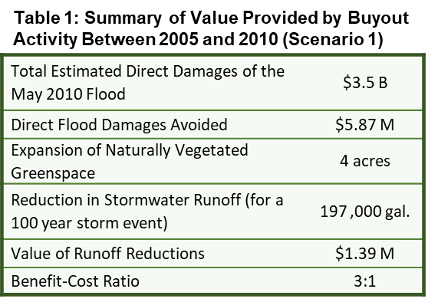
For each scenario, analysis was performed using the R statistical package and geographic information systems (GIS) software. The analysis focused on estimating damages that would have resulted under 2010 flood levels for each scenario, the amount of impervious area removed and reduction in runoff due to less impervious area, amount of public greenspace created through acquisition of the properties, etc. By comparing Scenarios 1, 3, and 4 with Scenario 2 the expected value of avoided damages and relative benefits were estimated for the buyout program expansion.
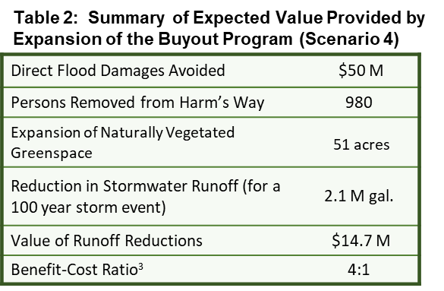
As shown in Table 1 the expected value provided by buyouts conducted between 2005 and 2010 in terms of actual damages avoided during the May 2010 flood is about $5.87 M. This dollar value refers to structural and contents damages for 33 bought-out properties and additional monetary losses from temporary relocation of property residents and labor costs related to clean-up and rebuilding efforts. We estimate that for every dollar spent on buyouts prior to 2010 about 80 cents in damages during the May2010 floods was avoided. Over a 75 year time horizon a 3:1 benefit-cost ratio for the buyout of these homes is expected. (More information can be obtained in the full report.)
In comparison, the expected value, in terms of damaged and losses avoided during the May 2010 flood, given the hypothetical scenario where all of the homes bought out by 2017 and all the homes currently under consideration for future buyouts are considered to have been bought out prior to 2010, is about $50 M. In this scenario for every dollar that would have been spent on buyouts an expected dollar in flood damages during the May 2010 floods would have been avoided. In addition, in this scenario about 398 homes and an estimated 980 residents of those homes would have not been exposed to or damaged by, the May 2010 floods. The long-term benefit-cost ratio for this scenario is about 4:1. This scenario highlights the relative advantages provided by pro-active adoption of an expanded buyout program.
In total, buyout program activities through the year 2016 removed about 314 properties from high-risk flood areas (at a cost of about $39 M and at an estimated long-term benefit cost ratio of at least 4:1) and also created about 195 acres of publicly-owned greenspace in the Metro area. In addition, the study found that without the four-foot freeboard requirement in place since 1979, increased inundation of structures with reported flood damage during 2010 would have resulted in about $2 B in additional damages across the county.
Overall, the buyout program seems to be well worth the investment with a positive reduction in damages and benefit to the community far outweighing the costs. On average, each home bought-out is expected to provide between $500,000 to $700,000 of value in damages avoided over a 75-year time horizon. Similarly, the freeboard requirement is doing just what was intended, preventing damages for properties. This business case can be used to aid the decision-making processes by providing an assessment of direct and indirect costs associated with mitigation/adaptation efforts already implemented, and estimates of future costs and/or savings associated with different scenarios of adaptation implementation.

Nashville has a fairly proactive and aggressive freeboard requirement which was established in 1979 that requires new development in the 100 year floodplain to have a finished floor elevation four feet above base flood elevation.
NIBS. 2017. “Natural Hazard Mitigation Saves: 2017 Interim Report.” National Institute of Building Sciences Multihazard Mitigation Council, December 2017.
Note: Several properties were purchased prior to the 2010 flood with FEMA and local mitigation funds, but only buyouts supported primarily by FEMA funds were considered in this evaluation. For properties purchased with FEMA mitigation funds, Metro only pays 12.5% of the total costs for acquisition, abatement, and demolition of the properties.

