How to Use My Media
My Media is located on the navbar of the Brightspace homepage. It can always be easily accessed by clicking the Vanderbilt logo or Home icon at the top of any Brightspace page. My Media is a repository for all of your videos, which can then be distributed to any of your courses.
1.) Click on the My Media tab. When accessing “My Media” for the first time, Brightspace will ask your permission to use Kaltura. Select the checkbox and then click Continue.
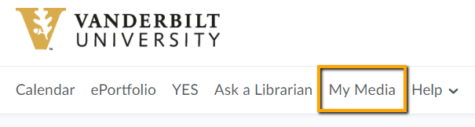

2) To begin adding media, click Add New
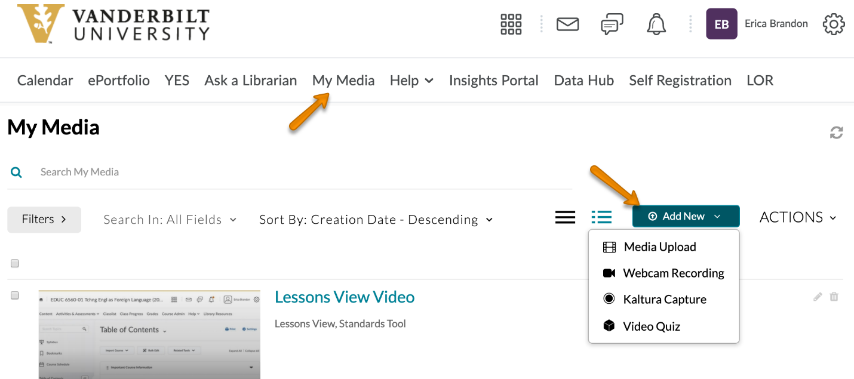
The options are:
- Media Upload – This allows a user to upload media from their local computer. Media that can be uploaded includes video, audio, and image files.
- Webcam Recording – This allows a user to record their webcam.
- Kaltura Capture – This allows a user to record their screen and add audio narration. Refer to the back of this page for more information on Kaltura Capture.
- Video Quiz – This allows users to embed questions within their videos. These questions are not connected to the grade book in any fashion. They remain only within the Kaltura video and are to be used as reflective questions for the viewer.
3) After adding media from one the above choices, a list of your available media will be presented.
4) From this page you can sort, search, view, edit, and delete media.

Kaltura Capture Basics
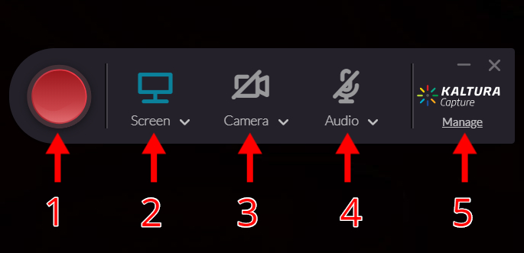

- Begin recording
- Select the screen you’d like to record
- Select the webcam you’d like to record
- Can also be used to select a second screen to record by selecting the v icon
- Enable/disable microphone
- Select the v icon next to Audio to choose a microphone
- Change settings and access previously recorded Kaltura videos
- Includes the option to record device audio which is useful if you’d like to show a video with sound during your recording

