How can I make my course active, so it is visible to students?
When your course is generated, it is inactive by default. This means that only those with Instructor access can see it on their dashboard. When you are ready for students to view your course, you will need to make the course active. This is a quick process.
Updated Spring 2020

Activating Your Course
1) First, log into Brightspace and enter the course.
2) In the NavBar, click Course Admin
3) Under Site Setup, click Course Offering Information
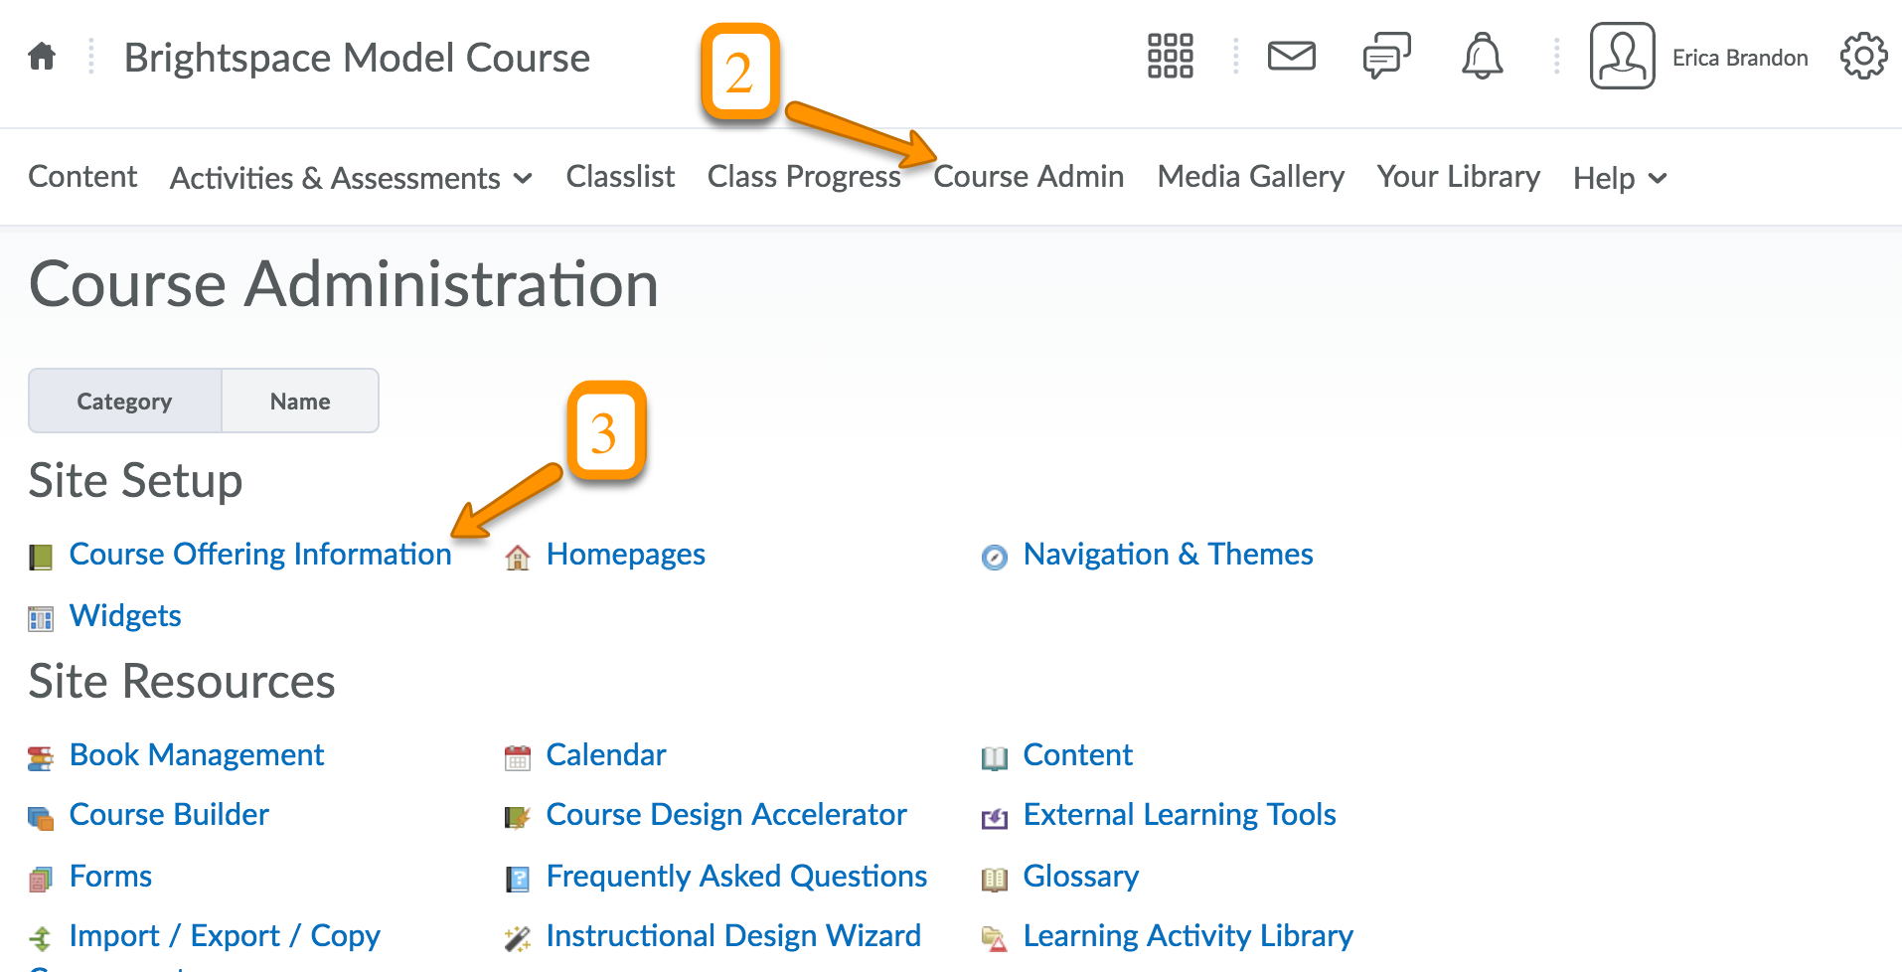

Continued on page 2

4) Click the box under Active, then Save.
