VANDERBILT STUDENT VOLUNTEERS FOR SCIENCE
http://studentorg.vanderbilt.edu/vsvs
Stratigraphy
Spring 2019

Goal: To introduce students to the geological time scale, fossils, sedimentary rock columns, index fossils, and column correlation methods.
Fits TN Standards 8.ESS.2.3

VSVSer Lesson Outline:
I. Sedimentary Rock Layers/Columns
_______ A. Sedimentary Rocks
_______ B. Creating a Model of Sedimentary Layers
_______ C. Explaining the Column
_______ D. Index Fossils and Radioactive Dating
_______ E. Finding the Ages of the Layers in Our Column
_______ II. Stratigraphy (Correlating Columns)
_______ IIB. Correlating Stratigraphic Columns
_______ III. Timeline of the Earth

LOOK AT THE VIDEO BEFORE YOU GO OUT TO YOUR CLASSROOM (https://studentorg.vanderbilt.edu/vsvs/lessons/)
USE THE PPT AND VIDEO TO VISUALIZE THE MATERIALS USED IN EACH SECTION.

1. Before the lesson:
In the car ride, read through this quiz together as a team. Make sure each team member has read the lesson and has a fundamental understanding of the material.
Stratigraphy Lesson Quiz
1. How do sedimentary rocks form?
2. What is the age of a fossil relative to the rock in which it is found?
3. Which layer in a stratigraphic column is the oldest?
4. Explain how you can compare two different stratigraphic columns from different parts of the world.
5. Give an example of an index fossil and explain why it is useful..

2. During the Lesson:
Here are some fun facts for the lesson
1. Nashville sits in a valley surrounded by limestone layers. Fossils can be seen embedded in the limestone.
2. Evidence for the asteroid that killed the dinosaurs is seen in various stratigraphic columns. There is a worldwide layer of iridium dating back to the time when the dinosaurs were wiped out. Iridium is more common in meteorites than it is on Earth.
4. Trilobites are commonly used as index fossils to determine the age of certain landmarks. They are great for determining the movement of plate tectonics. Scientists today are still unsure of why the trilobites went extinct.

Unpacking the Kit – What you will need for each section:
IB. Creating a Model of Sedimentary Layer
For demonstration:
- box containing materials for demonstrating the layering:
1 plate, 1 column container, 1 bottle of water
Jars 1-5 of sand, with different colors of sand representing different types of sedimentary rock and different stones representing fossils:
For students:
10 plates, 10 column containers (jars containing water), 10 bags containing jars of sand (to represent different types of rocks and fossils):
Jar 1: White sand containing black rocks
Jar 2: Orange sand containing white rocks
Jar 3: Black sand
Jar 4: White sand containing white rocks
Jar 5: Tan sand containing white rocks and tan/red rocks
36 observation sheets
20 Handouts with Column Diagram,
ID. Index Fossils and Radioactive Dating
10 models of rock layers/fossils encased in boxes
IIA. Stratigraphy (Correlating Columns)
20 sets of colored stratigraphic columns (National Park Sequences)
IIB. Correlating Stratigraphic Columns
20 sets of 3 stratigraphic sequences
For Part III. Timeline of the Earth
1 cylinder containing the string timeline

- Sedimentary Rock Layers/Columns
Learning Goals:
- Students understand how sedimentary rocks are formed.
- Students experiment with forming sedimentary layers and understand that fossils are deposited at the same time the as the sediment.
- Students understand that sediments are deposited in horizontal layers
- Students understand that older layers are at the bottom in a sedimentary layer, while younger layers are at the top

Why is the science in this lesson important?
An understanding of stratigraphy is useful for understanding when and how life originated on Earth, as well as for studying evolution and historical changes in Earth's ecosystems. Potential careers that benefit from an understanding of stratigraphy include paleontologists, archaeologists, and soil scientists.

A. Reviewing Sedimentary Rocks
- Q. Ask students what they know about sedimentary rocks. If these answers aren’t given, go over them briefly:
  - Most sedimentary rocks are formed from sediments deposited in oceans, lakes or rivers.
  - Sediments form layers that pile on top of each other, which compress over time to create rock.
  - Types of sedimentary rock include sandstone, limestone, and shale.

- Q. Ask for a show of hands of which students have seen rock layers on the sides of the highway while driving around Nashville – this is sedimentary rock! Ask if anyone knows what type of rock this is.
  - Limestone
- Tell students that we are going to create a model of sedimentary rock layers.

B. Creating a Model of Sedimentary Layers
- Set up at the front of the class the apparatus to create the sedimentary rock column demonstration
Materials for VSVS demo
- plate
- column container
- bottle of water
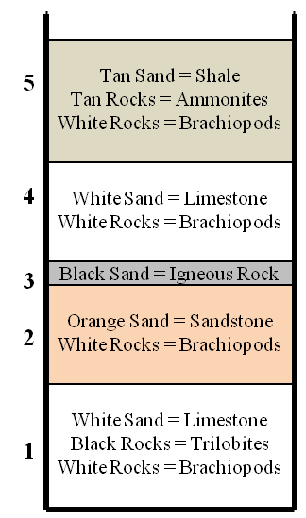
1 set of numbered jars of sand, with different colors of sand representing different types of sedimentary rock and different stones representing fossils:
    - Jar 1: White sand containing black and white stones.
    - Jar 2: Orange sand containing white stones.
    - Jar 3: Black sand.
    - Jar 4: White sand containing white stones.
    - Jar 5: Tan sand containing white and tan/red stones.
Materials for students, per group:
1 plate, 1 column containers (jars containing water), 1 set of jars of sand (1-5, to represent different types of rocks):
36 observation sheets
20 Handouts with Column Diagram,

- One VSVS member should draw a large diagram on the board to represent the column, based on the diagram on this page.
  - Do not draw the entire finished diagram. Start with the open-top rectangle representing the column (bolder lines). As each jar of sand is added, draw the layer line and write the color of the sand and rocks.
- The other VSVS members should hand out the columns (jar), jars of sand, water, and plates (1 per group of students).
Put the column on the plate to catch spills.

- Demonstrate how to create the column and have the students do each layer after you do.
- Pour the container of water into the column, reminding students that sedimentary rocks form when sediments settle out of water and form layers.

- Explain to students that we are using different colors of sand to represent different types of sedimentary rock, and different color stones to represent fossils. Point out that the fossils (stones) get deposited at the same time as the sand and rocks.

- Pour all of the sand and rocks from container #1 into the column. Wait until each layer settles (~30 seconds) before pouring the next layer. Make sure students are adding the jars of sand to the column in the correct order (#1 first ...)
- When settled, pour all of container #2’s contents into the column and wait for it to settle. Then container #3’s contents, and so forth until all 5 containers are used. Make sure to update the drawing on the board as new layers are added.
C. Explaining the Column
- Q. Ask students to describe what happened when they poured each layer of sand.
  - Sand settles through the water to make a flat layer at the bottom of the column.
  - This is similar to sediment settling out of water to form layers; over millions of years the sediment is compressed and turns into rock.
  - Explain that sediment is deposited in horizontal layers, and it stays that way unless something disturbs it.
  - Have students answer Question 1 on their observation sheet.
- Sediments settle and form rocks in ___horizontal_layers.

  - Fossils are deposited at the same time the rock material is deposited. Therefore the ages of the fossil and rock in which it is found are the same.
  - Have students answer Question 2 on their observation sheet.
- What is the age of a fossil relative to the rock in which it is found? The same_

- Tell students to imagine that the process of creating their sand columns took millions of years to occur.
- Tell students that different rock layers represent different periods of time.
  - Q. Ask students which layer is the oldest in the column.
    - The bottom layer; it was deposited first and other layers were deposited on top of it.
  - Q. Ask students which layer is the youngest in the column.
    - The top layer; it was deposited last, on top of all other layers.
  - How old are the middle layers? (You can’t tell for sure! But they are older than the top layer and younger than the bottom layer.)
  - Have students answer Question 3 on their observation sheet.
#3. Older layers are __at the bottom_ in a column of sedimentary layers, while younger layers __are at the top__.
  - Fossils succeed each other in a definite order – the oldest fossils in a series of layers will be in the lowest layer.

D. Index Fossils and Radioactive Dating
Learning goals:
- Students observe a model of a stratigraphic column that includes fossils.
- Students correlate the model with the sedimentary column that they created.
- Students learn what an index fossil is and realize that in the model, the ammonites and trilobites are index fossils. Index fossils are used for dating rock layers.
- Students learn that radioactive elements are used for dating rock layers.

Pass out 1 model of rock layers/fossils encased in boxes plus the “Column Analysis” worksheet to each group of students. Have them hold the model beside their sand column and tell them that the model has the same pattern of layers from the sand column. The fossils in the box model are real and are represented by different colored pebbles in their columns

- Explain that the second column (called Stratigraphic Column) on the worksheet is the way geologists would represent such a column and that the key on the bottom of the page shows what each symbol means.

- Tell students names of type of rock and fossils in each layer.
  - Top layer: ammonites and brachiopods in shale
  - Bottom layer: trilobites in limestone
  - Middle layers 2 and 4: brachiopods in limestone or sandstone
  - Middle #3: Igneous rocks
- Tell students that fossils are often incorporated into sedimentary rocks. The sediment that buries them later forms into rocks with the fossils inside.
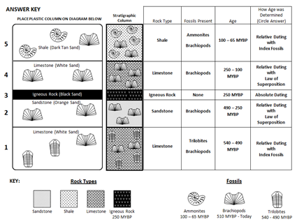
Using Index Fossils to find the Age of Rock Layers
- Tell students that in real sedimentary rocks, some fossils are found in many layers, while some are found in only one layer.
  - Q. Ask students which type of fossil, one found in many layers or one found in only one layer, would be more useful for identifying the age of a rock layer. (A tough question – give them hints and walk them to the answer if necessary!)
- Fossils found only in one rock layer can be used for identifying the age of the rock layer. If a fossil is found in many different layers, the age of the layers can’t be identified using fossils.

- Tell students that fossils that are only found in one layer, can be used for identification/rock dating purposes. These fossils are called index fossils.
- Have the students answer Question 4 on their observation sheet.
#4. __Index fossils__are fossils found in only 1 layer of sedimentary rock and can be used for identification/rock dating purposes.
- Q. Ask students which fossil(s) in their column would be considered index fossils, and which would not be considered index fossil(s)
A. Ammonites and trilobites are only found in one layer, so they would be considered index fossils; brachiopods are found in all layers, so the brachiopod is not an index fossil.
Using Absolute Dating with Radioactive Elements to find the Age of Rock Layers
Tell students to look at layer # 3 in their column – the thin black layer.
  - When there is a dark, skinny layer in a sedimentary rock column, it is usually the result of lava or volcanic ash interrupting a sedimentary rock layer – it is an igneous rock, not a sedimentary rock.
  - Igneous rocks contain radioactive elements like uranium, rubidium, thorium, and potassium – scientists can use these elements to determine the exact age of these rocks.

E. Finding the Ages of the Layers in our Column
Learning Goals: Students will determine the ages of the layers in the model.

- Tell students they are now going to use their model to determine the ages of the “rock” layers. As they go through the column, layer-by-layer, point out what rock types and fossils are represented in the columns. The answers for the rock types and fossils are already given on the worksheet. The students will be asked to determine the ages (relative or absolute) of each layer.

  - The black layer (third layer from the top) is an igneous rock.
How can we find the age of this layer?
By using absolute dating with radioactive elements.
In this hypothetical case, we will say that this layer is 250 million years old.
Tell students to enter this data on their worksheet.

- Ask students how an igneous rock might get into a sedimentary layer?
  - Answers should include volcanic ash settling out many miles away from an erupting volcano, lava flows above ground, or magma intruding into rock layers below the surface.
For VSVS Information only:
Most igneous rocks can be dated radiometrically because they contain unstable radioactive elements that decay.
Carbon-14, uranium-238, rubidium-87, thorium, potassium are the most common (isotopic) elements studied.
Igneous rocks can be given a numerical age by radiometric dating methods.

Two layers contain index fossils. Which layers are these?
The tan layer (on top) and the white layer on the bottom both contain fossils that aren’t found in
any other layers. Ammonites and Trilobites are index fossils and scientists know how old they are (over a range of time).

So how can we find the ages of these layers?
Ammonites (in the tan layer on top) lived from 100 million years ago until 65 million years ago – this is the range in which this rock was deposited in.
Tell students to enter this data for the top layer (100-65 MY old, and circle Relative dating with index fossils).
Trilobites (in the white layer on bottom) lived from 540 million years ago until 490 million years ago – this is the range in which this rock was deposited in.
Tell students to enter this data for the bottom layer (540 - 490 MY old, and circle Relative dating with index fossils).

How do we find the dates the other two layers were deposited in?
Relative dating.
We know that the white layer second from the top must have been deposited between the top layer (100 million years ago) and the third layer (250 million years ago)
The orange layer (fourth from the top) must have been deposited between the bottom layer (490 million years ago) and the third layer (250 million years ago).
Tell students to enter this data for layers 2 and 4.

II. Stratigraphy (Correlating Columns)
Learning Goals:
Students look at real life example of stratigraphic columns in 3 National Parks
Students learn how geologists can correlate sedimentary layers many miles apart.

- Tell students that sedimentary rock layers often stretch across entire continents. Sometimes these
layers are connected; however, often layers have been removed in some locations by erosion, and some are buried under other layers and can’t be seen by us yet.

A. National Park Rock Sequences
- Pass out a set of colored stratigraphic columns (paper-clipped together) to students.

- Tell students that these columns represent actual sedimentary layers taken from the National Parks (Graphic A); they have been cut from the stratigraphic columns in Graphic B, on Handout #1.)
  - Have students separate the columns and put them at their correct National Park locations on the map (Graphic A) in Handout #1. Tell them that although erosion has affected each location differently, they all still show some of the same layers. Have the students put them in stratigraphic order, then place them on the map.
  - Point out that columns can correlate over large distances.
  - Have them put the complete, paper-clipped columns back together and collect them from the students.
Map of National Parks (Graphic A)

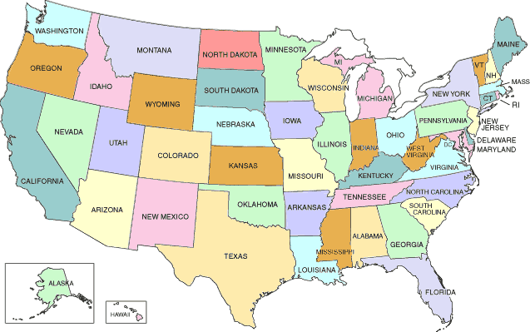
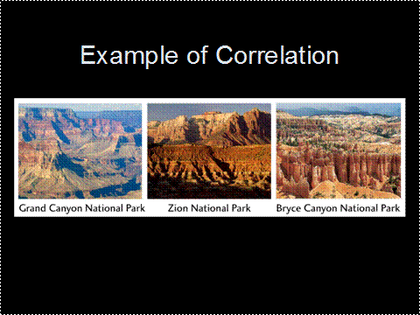

National Park Correlations (Graphic B)
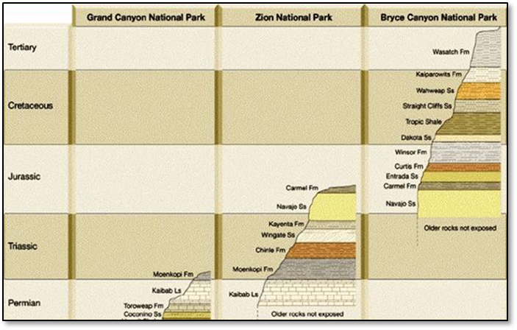

- Correlating Stratigraphic Columns
- Pass out the set of 3 stratigraphic sequences to each student. Tell students to imagine that these are 3 sequences of rocks found in different places around the US.
  - Tell students to find in sequences A and B at least 2 layers whose index fossils and rock types match.
  - Emphasize that the depth of the layers does not have to be the same.
  - Students should place the sequences side-by-side with matching layers touching.
  - Have them repeat the process with sequences B and C.
  - This can get tricky, so VSVS members should walk around and help students with the task.

- Pass out the longer laminated strip (1 per pair) and tell the students that this geological column is the one they have just compiled from their short sequences. This can tell us a lot more about the geologic history of the earth than the individual columns can.
- Q. Which short strip has the oldest rocks exposed and how do we know?
  - Location A, because it contains the oldest fossils and has the bottom layers in the geological columns.
  - These layers still exist at locations B and C, they just haven’t been exposed yet.
- Q. Which short strip has the youngest rocks exposed and how do we know?
  - Location C, because it has the top layers in the geological column.
  - These layers are missing at locations A and B because of erosion.

VSVS members should collect the columns and answer any questions the students have.

III. Timeline of the Earth (If time permits – do as much as time allows)
Learning Goals: Students can “see” the time scale of earth’s history from a model.

- Introduction
- Q. Ask the class if anyone knows how old the earth is.
  - 4.6 billion years old, or 4600 million years old. Write the number out in full on the board so they understand how much time this is (4,600,000,000).
- Tell students that the timeline of earth’s history is called the geologic time scale. We will show them a rope that represents, to scale, this timeline.
- It is divided into 4 major periods called eons, which are further divided into eras. The boundaries between geological times correlate with major changes on earth.
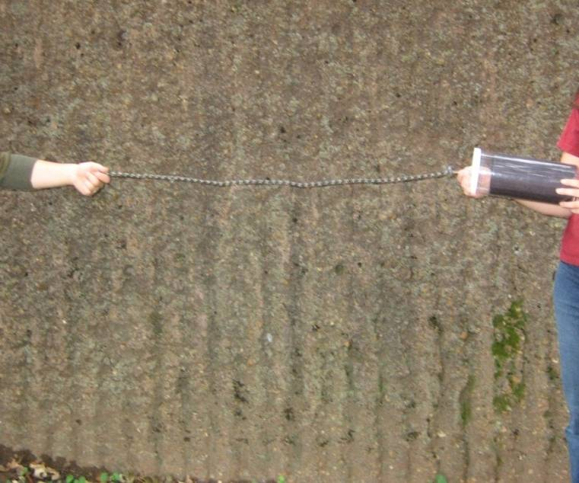
- Time Scale Model
Tell students to look at the timeline on the observation sheet
- Hold up the time scale model (the cylinder) with just a small piece of string pulled out so that all students can see it. Tell students:
  - The string represents the timeline of the earth’s history – the complete geologic time scale over its entire duration of 4.6 billion years.
  - The string is divided into the 4 eons, and the last eon is divided into eras.
Note – the string is 19 feet long, so make sure you have enough room to “spread”.
  - One VSVS member or student volunteer will hold the string and another will hold the container and walk to the right while removing each eon and stopping when a knot is reached.
  - A VSVS member will describe each eon to the students, while another writes the information regarding each eon and era on the board as they are introduced.
  - The string must be kept taught in a straight line so that the students get the concept of the length of time taken for each eon.

- Hadeon Eon
  - Pull the first (camouflage-colored) section of the string out, and stop as soon as you get to the first knot (between color changes). Tell students:
  - This is the Hadeon Eon, from 4.6-3.8 billion years ago.
  - No living organisms during this time, but the oldest known rocks existed (found in the Canadian Rocky Mountains).
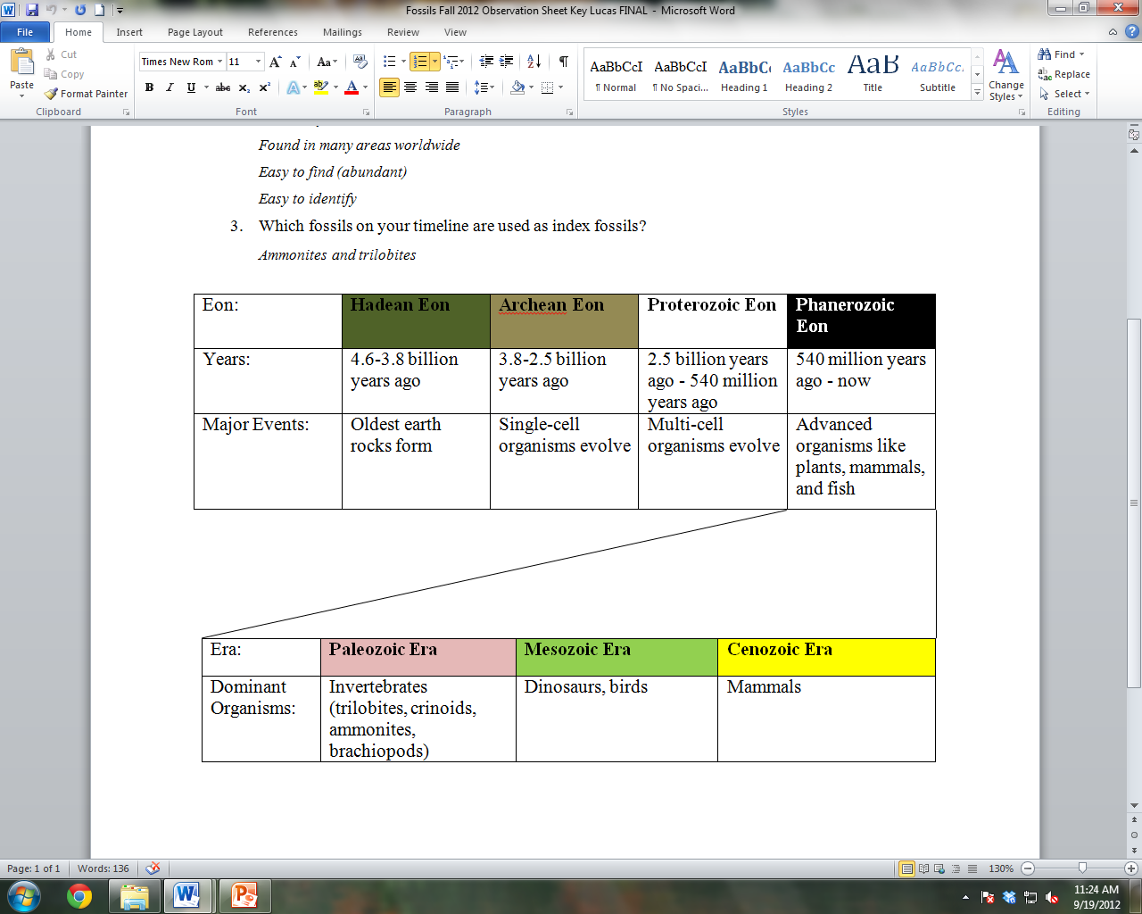

Archean Eon
- Pull the second (tan) segment of the string until the second knot is reached. Tell students:
  - This is the Archean Eon, from 3.8-2.5 billion years ago.
  - The first single-cellular organisms lived during this time (fossils found in Australia).
Proterozoic Eon
- Pull the third (white) segment of the string until the third knot is reached. Tell students:
  - This is the Proterozoic Eon, from 2.5 billion years ago to 540 million years ago.
  - The first multi-cellular organisms lived during this time (fossils found in Michigan)
Phanerozoic Eon,
- Pull out and display the black end of the string. Tell students:
  - This is the Phanerozoic Eon, from 540 million years ago to now.
  - Plants, fish, and animals came to exist as we know them today during this time.
  - This last eon is subdivided into 3 smaller time intervals called eras.

- Looking at the Phanerozoic Eon Timeline
- Tell students to look at the Phanerozoic Eon time line. Focus students’ attention on the black (Phanerozoic Eon) section of the rope.
  - The different colors (pink, green and yellow) show the different eras. The colored string twisted around the black cord corresponds with these eras on the placemat.
  - The organisms shown lived and thrived on earth during the time periods their boxes overlap with; both fossil and living pictures are displayed.

- Tell students that each era ends with the extinction of a large amount of animals on earth.
  - Q. Ask students if they know what extinction means.
    - When the last remaining members of a species have died out.

- Point to the pink section of the timescale, and identify it as the Paleozoic Era. Tell students:
  - Simple animals called invertebrates dominated the earth in this era. Pictures of different types of invertebrates (trilobites, ammonites, crinoids, and brachiopods) can be seen on the timeline; point them out to the students. Emphasize that the earliest trilobite is an index fossil.
  - Early fish, land plants, and reptiles develop but are not common yet.
  - 90% of all species of animals went extinct at the end of this era. (Emphasize to students the magnitude of this extinction – tell them to imagine 90% of animals on earth dying.) (If students ask why – scientists are still investigating!)

- Point to the green section of the timescale, and identify it as the Mesozoic Era. Tell students:
  - Dinosaurs and other reptiles dominated the earth in this era.
  - Small mammals, birds, flowering plants, and flies also were common

  - 50% of all species of animals went extinct at the end of this era. (If students ask why, tell them that most scientists agree that it was due to impact of a large meteorite near Mexico.)
  - The later ammonites are index fossils

- Point to the yellow section of the time scale as the Cenozoic Era. Tell students:
  - This era continues up until today

Mammals dominate the earth in this era.
  - Q. Ask students if they’ve thought about how long humans have existed in the geologic time scale. Humans have only existed in the very last knot of the rope (the dangling skeleton). This is an extremely short time in the history of the earth.
Lesson written by: Pat Tellinghuisen, Program Coordinator of VSVS1998-2018, Vanderbilt University
Courtney Luckabaugh, Lab Manager of VSVS, Vanderbilt University
Edited by: Kyle Broach, VSVS Training Committee, Vanderbilt University
Lucas Loffredo, VSVS Training Committee, Vanderbilt University
We gratefully acknowledge the assistance of Dr. Molly Miller, Professor Emeritus of Earth & Environmental Sciences, Vanderbilt University.
Reference:Chernicoff, S., & Whitney, D. (2007). Geology: An Introduction to Physical Geology. Upper Saddle River, New Jersey: Pearson

Stratigraphic Sequences
Geological Column
A
B
C

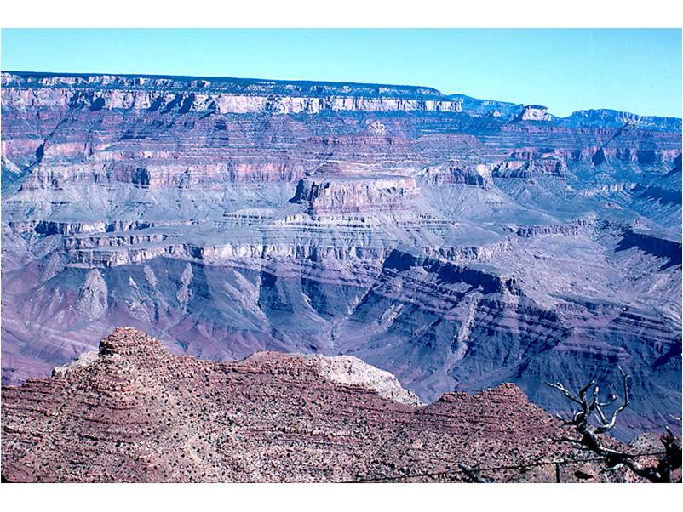
A
B
C

Grand Canyon

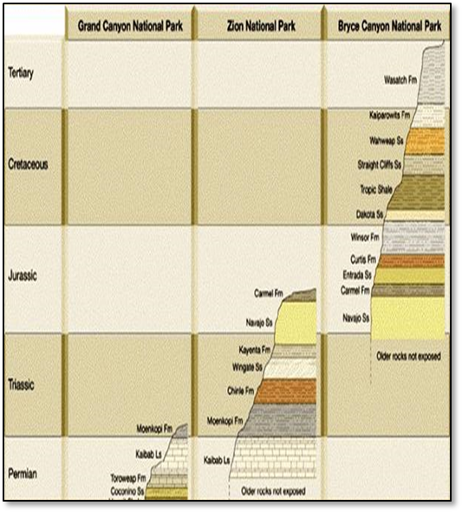
Match up columns to these maps:
Stratigraphy Observation Sheet

1. Sediments settle and form rocks in ___________________ layers.

2. What is the age of a fossil relative to the rock in which it is found? __________

3. Older layers are ______________________ in a column of sedimentary layers, while younger layers are _______________________.

4. _____________________ are fossils found in only 1 layer of sedimentary rock that is used for identification/rock dating purpose

Eon: | Hadean Eon | Archean Eon | Proterozoic Eon | Phanerozoic Eon
Years: | 4.6-3.8 billion years ago | 3.8-2.5 billion years ago | 2.5 billion years ago – million years ago | 540 million years ago – mow
Major Events:

Expansion of Phanerozoic Eon:

Era: | Paleozoic Era | Mesozoic Era | Cenozoic Era
Dominant Organisms:

Stratigraphy - Answers - Observation Sheet

1. Sediments settle and form rocks in _horizontal__________________ layers.

2. What is the age of a fossil relative to the rock in which it is found? The same.__________

3.Older layers are at the bottom in a column of sedimentary layers, while younger layers are at the top.

4.. __Index fossils__ are fossils found in only 1 layer of sedimentary rock that is used for identification/rock dating purpose

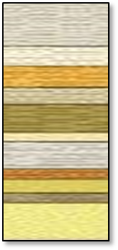
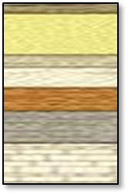
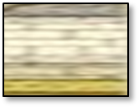

ANSWER KEY
Stratigraphic
Column
Rock Type | Fossils Present | Age | How Age was Determined  (Circle Answer)
Shale | Ammonites  Brachiopods | 100 – 65 MYBP | Relative Dating with  Index Fossils
Limestone | Brachiopods | 250 – 100 MYBP | Relative Dating
Igneous Rock | None | 250 MYBP | Absolute Dating
Sandstone | Brachiopods | 490 – 250 MYBP | Relative Dating
Limestone | Trilobites  Brachiopods | 540 – 490 MYBP | Relative Dating with  Index Fossils

PLACE PLASTIC COLUMN ON DIAGRAM BELOW

Limestone (White Sand)

Limestone (White Sand)

Igneous Rock (Black Sand)

5

4

3

2

1

Shale (Dark Tan Sand)

Sandstone (Orange Sand)

Ammonites
100 – 65 MYBP
Brachiopods
510 MYBP - Today
Rock Types
Sandstone
Shale
Limestone
Igneous Rock
250 MYBP
Fossils

KEY:

Name _______________________________________
Rock Type | Fossils Present | Age | How Age was Determined  (Circle Answer)
Shale | Ammonites  Brachiopods |  | Absolute Dating (Radiometric)  Relative Dating with  Index Fossils  Relative Dating
Limestone | Brachiopods |  | Absolute Dating (Radiometric)  Relative Dating with  Index Fossils  Relative Dating
Igneous Rock | None |  | Absolute Dating
Sandstone | Brachiopods |  | Absolute Dating (Radiometric)  Relative Dating with  Index Fossils  Relative Dating
Limestone | Trilobites  Brachiopods |  | Absolute Dating (Radiometric)  Relative Dating with  Index Fossils  Relative Dating
Stratigraphic
Column
PLACE PLASTIC COLUMN ON DIAGRAM BELOW

5

4

3

2

1

Ammonites
100 – 65 MYBP
Brachiopods
510 MYBP - Today
Trilobite
540-490 MYBP
KEY:

Rock Types
Sandstone
Shale
Limestone
Igneous Rock
250 MYBP
Fossils

