VANDERBILT STUDENT VOLUNTEERS FOR SCIENCE
http://studentorg.vanderbilt.edu/vsvs
Saltwater Density
Spring 2019
Goal: To demonstrate the concept of density using saltwater, and to share some information about the salinity of oceans.
Fits Tennessee standards 6.ESS2.1
VSVSer Lesson Outline:
________ I. Introduction - Saltwater in the Ocean:
The VSVS team will share some information about oceans with the students.
________ II. Density Information and Activities
- Density Background Information: VSVS team members will explain the concept of density.
- Density Demonstration: VSVS volunteers will show students how salt packs around water molecules using a jar of marbles and salt.
- Polydensity bottle
- Floating Solids Demonstration: Students will observe two vials: one with saltwater and one with freshwater. A plastic bead will float in the saltwater but not in the freshwater, this illustrates the concept of density and floating..
________ III. Separation Challenge: Students will separate a mixture of beads using the concept of density. There are four types of beads with differing densities. As students add salt to the water, the density changes, the beads will float according to their densities.
________ IV. Review

LOOK AT THE VIDEO BEFORE YOU GO OUT TO YOUR CLASSROOM (https://studentorg.vanderbilt.edu/vsvs/lessons/)
USE THE PPT AND VIDEO TO VISUALIZE THE MATERIALS USED IN EACH SECTION.

1. Before the lesson:
In the car ride, read through this quiz together as a team. Make sure each team member has read the lesson and has a fundamental understanding of the material.
1. What’s the difference between density and mass?
2. What region of the globe is home to densest salt water?

2. During the Lesson:
Here are some Fun Facts for the lesson
Density of salt water: 1020 kg/m³
Density of the human body: 1062 kg/m³
Density of the Dead Sea: 1240 kg/m³
Least dense? The universe: estimated at 10⁻²⁷ kg/m³
Most dense? A black hole; “infinitely” dense

Draw an analogy to a pinhole and a football field. If you compress a football field into the size of a pinhole, the football field would have a very high density. If you shrank the football field into a tiny, tiny space, just a little more than nothing, you’d have the density of the singularity of a black hole. A singularity of a black hole is a one-dimensional point that contains infinite mass in an infinitely small space (this example may be too advanced for the class, so share accordingly).
Refer to Disney’s Despicable Me. In Despicable Me: when Gru shrank the moon, he decreased the volume, without altering the composition of the moon (i.e. the mass did not change). So the density would have increased. So it would be impossible for Gru or a spaceship to lift the moon.

Unpacking the Kit – What you will need for each section:

For Part I: Introduction - Saltwater in the Ocean
32 Observation Sheets, 16 Instruction Sheets, 16 World Maps with Ocean Salinity and Density Graphs

For Part II. Density Information and Activities
- Density Activity
6oz container of salt, 1 6oz jar containing marbles
- 1 Polydensity bottle
- Floating/Sinking Beads
16 bags with1 vial of saltwater and a plastic bead (#1), 1vial of regular water and a plastic bead (#2)

For Part III: Separation Challenge – Changing the Density of Water to Make Beads Float
16 containers of kosher salt, 2L bottle of water, 16 100 mL plastic jars containing several beads of 4 different colors/shapes filled with water.
  - Ziploc bags containing:1 measuring spoon, 1 coffee stirrer, 16 plates

I. Introduction - Saltwater in the Ocean
Why is the science in this lesson important?
Learning Goals: Students learn about salinity differences in the ocean.
The density of saltwater can impact global currents that wildlife use to migrate around the ocean. Thus an understanding of saltwater density is relevant to oceanologists, fishermen, and anyone who relies on the sea for a living.

Tell students that:
- Oceans and seas contain considerably more salt than freshwater. Ask students why they think the sea contains so much salt but lakes, streams, and rivers have very little.
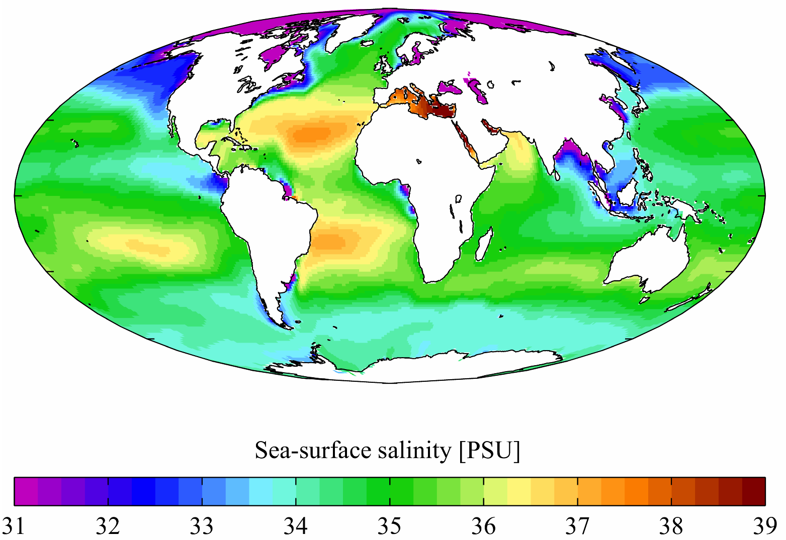
  - The salt in the ocean comes from the gradual process of weathering and erosion of the Earth’s crust, as well as the wearing down of mountains.
  - Salinity is the amount of dissolved salts in water.

Have students look at the map of the world handout.
  - As students can tell from the map, the oceans vary widely in salt concentration.
  - The numbers in the key (at the bottom) are measures
http://en.wikipedia.org/wiki/Salinity
of salinity. 35 means there are 35 grams of salt per 1000 grams (1 kilogram) of water. The higher the number, the more salt that ocean contains.
  - Ask students if they can point to the saltiest area. The saltiest water occurs in the Red Sea and the Persian Gulf.
  - The average salinity of water in the ocean is 35 PSU.

II. Density Information and Activities
Learning Goals:
Students learn the definition of density, and that density is a physical property of matter.
Students observe that solids (beads) of different densities float or sink depending on the density of the liquid they are in.
A. Density Background Information
- Ask the students to explain the property of density.
  - Density is a physical property of matter.
  - Each element and compound has a unique density associated with it.
- Ask students to give you some examples of high density objects and low density objects. Some examples might be:
  - Regular coke can vs. Diet coke (diet floats in water, regular sinks)
  - Oil (less dense) vs. water (more dense)
  - 1 golf ball (more dense) vs. 1 cotton ball (less)
- Sum up the difference between high density and low density with these generalizations:
  - High density means there is a lot of material in a given space (volume)
  - Low density means there is little material in a given space (volume).
- Have students look at the pictures on their Instruction Sheet. The circles represent material. Both pictures have the same space (area), but the high density picture has much more material (circles).

Since D = m/V, more mass (circles) in a given volume leads to an increase in density.
High Density Low Density
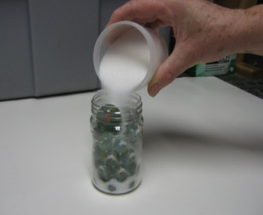
- Demonstration
Materials:
- 6oz container of salt
1 6oz jar containing marbles
- Show students the jar with marbles in it.
- Tell the students that the marbles represent water molecules.
- Pour the container of salt into the jar.
- Explain to the students that the salt packs around the marbles like it does around water in salt water.
- Ask students why they think saltwater is denser than regular water. Saltwater has a higher mass because of the added salt, and hence is denser.

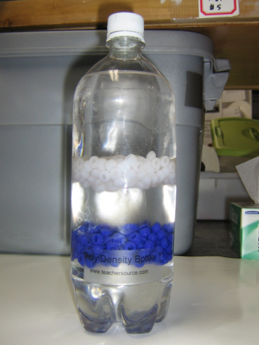
- Polydensity Bottle Demonstration
- Have students observe the polydensity bottle. Shake the bottle gently and let the students observe what happens (the 2 liquids gradually separate).
- Ask students what happened? First the white beads moved to the top and the blue beads moved to the bottom of the liquid (refer to background information). Then the white beads floated down and the blue beads floated up and met in the middle.
- Ask students why they think this happened?
  - The two liquids have different densities.
  - One of the liquids is denser salt water (lies below the beads on the bottom).
  - The other liquid is less dense rubbing alcohol (lies above the beads on the top).
  - These 2 liquids do not mix, they form layers (salt water on the bottom & rubbing alcohol on the top)

  - The beads also have different densities:
    - The blue beads are denser than the white beads and less dense than the salt water (they float on the salt water).
    - The white beads are less dense than the salt water and blue beads, but denser than the rubbing alcohol (they float on the blue beads but not on the rubbing alcohol).

For VSVS background information only: The bottle contains a mixture of isopropyl alcohol and saltwater. All of the liquids and beads have different densities. The rubbing alcohol is the least dense followed by the white beads, then the blue beads, with salt water being the densest. When the two liquids are forced to temporarily mix by shaking, the liquid formed has a density somewhere between those of rubbing alcohol and saltwater. As the two liquids separate once more (due to their different densities), the initial layering reoccurs: the blue beads float to the top of the saltwater layer because they are less dense than saltwater, and the white beads float to the bottom of the isopropyl alcohol layer because they are more dense than the isopropyl alcohol.

D. Floating/Sinking Beads
Learning Goals: Students observe how density of a liquid impacts beads’ ability to float.
Materials:
16 bags containing
1 vial with saltwater and a plastic bead (#1)
1vial with regular water and a plastic bead (#2)
Pass out the bags containing the vials with the beads to pairs of students. Make sure that students do not remove the tops of the vials. Tell students that the 2 liquids have different densities.
Explain to students that:
  - solids that are less dense than a liquid will float in that liquid.
  - solids that are denser than a liquid will sink in that liquid.
Tell students that the beads in all of the vials have the same density.

Ask students why the bead floats in vial 1 but not in vial 2.
  - Vial #1 has a liquid that is denser than the bead.
  - Vial #2 has a liquid that is less dense than the bead.
  - Tell students that the liquid in vial #1 is salt water and in vial #2 is regular water.

Point to the facts on the board:
Pure water has a density of 1g/ml.
Ocean water at the sea surface has a density of about 1.027 g/ml.
Saturated salt solution has a density of 1.202 g/ml.
Ask students why they think saltwater is denser than regular water.
Saltwater has a higher mass because of the added salt but still occupies the same amount of space in a container that regular water would, and hence is denser.
Ask students if the bead is more or less dense than regular water. More
Ask students if the bead is more or less dense than saltwater. Less

III. Separation Challenge – Changing the Density of Water to Make Beads Float
Learning Goals: Students observe how density of a liquid impacts beads’ ability to float.
Distribute to each pair of students:
1 plate
1 100mL jar containing water and several colored beads
1 measuring spoon (pink 1/4tsp)
1 Coffee Stirrer
1 container of salt
32 Density Graphs (Handouts)
Tell students to:
- Observe that there are 4 different beads. Tell students that the beads have different densities. They are (see student handout):
Bead | Approximate Density
#1, white, oval | < 1.00g/mL
#2, blue, cylindrical | 1.05-1.07g/mL
#3, yellow, cylindrical | 1.13-1.16g/mL
#4, clear, cylindrical | > 1.276g/mL

- Pure water has a density of 1g/mL
- A saturated salt solution has a density of 1.202 g/ml
- Ask students to explain why the white oval beads are floating? Their density is less than that of pure water.
Tell students that we can gradually change the density of the water by adding salt to it.
- Tell students to look at the Density of Salt Water graph and explain that the density of water increases as more salt is added.
- Ask students: What do you think will happen to the beads when salt is added to the water?
Since the beads have different densities, they will float in different densities of salt water.
- Ask students to predict the order that the beads will float.

For VSVS Information: The density of the salt water has been calculated using a mass of 1.63 g for one ¼ teaspoon of salt and 100mL for volume.
The density of regular (fresh) water is 1g/mL. 100mL = 100g
(Since D = m/V, the density of water is 100g/100mL, = 1g/mL)
The density of the saltwater is calculated using:
100g of water + (1.63 grams X # of 1/4-teaspoons of salt added) / 100mL

Tell students to:
- Stir the beads and water, using the coffee stirrer (not the spoon).
- Tap all of the floating beads gently to see which ones float and which beads sink to the bottom.
Share the following explanation with the students: some of the beads float initially because water has a high surface tension. This surface tension is mostly due to the high intermolecular forces between water molecules making it possible for some things that would normally sink to float. Tapping the bead exerts enough force to break the surface tension. Stirring the water may also break the surface tension.

- Record on their observation sheets, which beads are floating and which are at the bottom of the cup. The round whitish beads should be the only ones floating at this point.
- Fill the spoon with salt (do not overfill).
- Add one level spoon of salt and then stir the water until they can no longer see salt particles.
- Record what happens. Are any more beads floating on top?
There shouldn’t be any beads floating on top.
- Have students repeat this step. Record what happens after each spoon is added.
- Students can add several more spoons; but tell them not to go higher than 10 spoons of salt total.
- After 10 spoons, have students screw lid on jar. Make sure it cannot leak. Place jars in kit box so that NO water will leak into box – ie upright!
Note: In the lab, 3 or 4 1/4- teaspoons of salt were required for the blue beads to float and 7-9 spoons were necessary for the yellow beads to float. This may vary depending on students’ “level teaspoons”. The clear beads will not float at all. Their density is greater than that of a saturated salt solution. Students can add several more spoons; tell them not to go higher than 10 spoons of salt total. The salt solution eventually becomes saturated and no more salt will dissolve.

- Results
Ask students if their predictions were correct.
  - The white beads floated initially, because their density is less than one.
  - The beads floated in the order of their densities, white, then blue, then yellow.
  - The clear beads never floated. The students should have noticed that salt stops dissolving in the water. This is called a saturated solution.

- Ask students if they can think of a way to make the clear beads float.
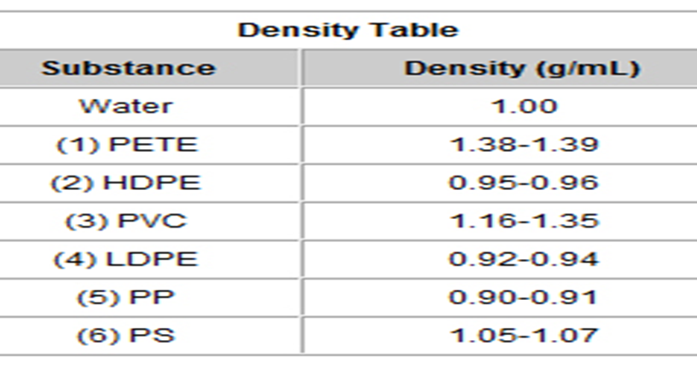
  - We could use liquids more dense than saltwater for the clear beads.
Tell students to look at the Density Table for Recyclable Plastics (on their Handout) and determine what kinds of plastics might have been used in this lesson.

IV. Review
- Ask students: If a solid floats in a liquid, is it denser or less dense than the liquid? – Less If it sinks -more
- Ask students why saltwater is more dense than freshwater? Saltwater has a higher mass than the same volume of freshwater.
- Ask students: what is one way to separate mixtures? Density

References: Educational Innovations Mixture Separation Challenge, and Polydensity Bottle.
Lesson written by: Patricia Tellinghuisen, Director of VSVS 1998-2018, Vanderbilt University
Michael Gootee, VSVS Lab Assistant

Observation Sheet - Saltwater Density

IIC. Floating/Sinking Beads in Vials
Is the bead more or less dense than freshwater? __________
Is the same bead more or less dense than saltwater? __________
III. Separation Challenge
Look at the table of bead densities and predict the order in which they will float as spoons of salt are added to the water.
1.___________________________________________________________________________

2. ___________________________________________________________________________

3. ___________________________________________________________________________

4. ___________________________________________________________________________

Bead | Approximate Density
#1, white, oval | < 1.00g/mL
#2, blue, cylindrical | 1.05-1.07g/mL
#3, yellow, ylindrical | 1.13-1.16g/mL
#4, clear, cylindrical | > 1.276g/mL

Write down what happens to the beads after each addition.
Number of Spoons Added | Density salt water | What Happened to the Beads?
0 | 1.00
1 | 1.0163
2 | 1.0326
3 | 1.0489
4 | 1.0652
5 | 1.0815
6 | 1.0978
7 | 1.114
8 | 1.1304
9 | 1.1467
10 | 1.163
Look at the Density Table for Recyclable Plastics (on your Handout) and determine what kinds of plastics might have been used in this lesson.
white, oval = ________________ blue, cylindrical = __________________ yellow, cylindrical = ________________ clear, cylindrical = __________________

Observation Sheet Answers - Saltwater Density

IC. Floating/Sinking Beads
Is the bead in the vial more or less dense than freshwater? More_____
Is the same bead in the vial more or less dense than saltwater? Less______

III. Separation Challenge
Look at the table of bead densities and predict the order in which they will float as spoons of salt are added to the water.
1.white, oval will float in pure water, since its density is less than the density of water
- blue, cylindrical
3. , yellow, cylindrical
4. clear, cylindrical
Bead | Approximate Density
#1, white, oval | < 1.00g/mL
#2, blue, cylindrical | 1.05-1.07g/mL
#3, yellow, cylindrical | 1.13-1.16g/mL
#4, clear, cylindrical | > 1.276g/mL

Write down what happens to the beads after each addition.
Number of Spoons Added | Density salt water | What Happened to the Beads?
0 | 1.00
1 | 1.0163
2 | 1.0326
3 | 1.0489
4 | 1.0652
5 | 1.0815
6 | 1.0978
7 | 1.114
8 | 1.1304
9 | 1.1467
10 | 1.163

Look at the Density Table for Recyclable Plastics (on your Handout) and determine what kinds of plastics might have been used in this lesson.
white, oval = HDPE, LDPE, PP blue, cylindrical = PS
yellow, cylindrical = PVC clear, cylindrical = PETE, PVC

Saltwater Density Instruction Sheet
Spring 2019
- Saltwater in the Ocean
Look at the world ocean map.
- Density Information and Activities
- Density Background Information

High Density Low Density
High density means there is a lot of material in a given space.
Low density means there is little material in a given space.
Demonstration
- Observe the salt & marble demonstration.
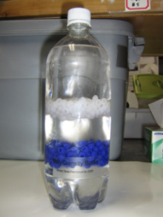
- Polydensity Bottle.
The white and blue beads in the next demonstration have different densities.
Watch as the polydensity bottle is shaken. What happened?
Look at the bottle again after a few minutes, and observe what has happened.

C. Floating/sinking Beads Activity
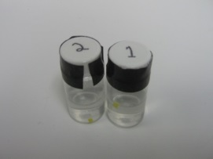
- Examine the 2 vials. (Do NOT remove the tops of the vials.)
- Note that the beads in all of the vials are the same and so have the same density.
- Why does the bead float in vial #1 but not in vial # 2?
- Is the bead more or less dense than regular water?
- Is the bead more or less dense than saltwater?

- Separation Challenge: Changing the Density of Water to Make Beads of Differing Densities Float

- There are 4 different beads. They are:
Bead | Approximate Density
#1, white, oval | < 1.00g/mL
#2, blue, cylindrical | 1.05-1.07g/mL
#3, yellow, cylindrical | 1.13-1.16g/mL
#4, clear, cylindrical | > 1.276g/mL

NOTE: Your jar has been filled with 100 mL water.

Pure water has a density of 1g/mL
A saturated salt solution has a density of 1.202 g/ml
- Why are the white beads floating?
- Predict the order that the beads will float as the density of water changes.
Experiment.
To change the density of the water, salt will be added:
- Stir and gently tap the beads with the coffee stirrer (not the spoon). Note on your observation sheet which beads float and which sink. Was your prediction correct?
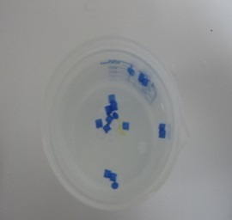
- Fill your ¼ teaspoon with salt.
- Add the spoon of salt to the jar of water and use the coffee stirrer to thoroughly stir in all the salt.
- Observe and record what happens to the beads.
- Repeat steps 4 and 5 (adding one spoon of salt at a time) making sure all the salt is dissolved each time.
- Observe what happens to the beads after every spoonful of salt is added.
- If some of the beads of one color sink and some don’t, tap them with your coffee stirrer to make sure there are no air bubbles.
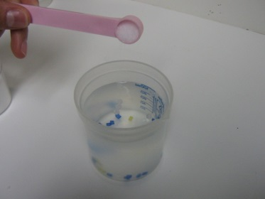
- Mark down all your observations in the table so you can use them for the next part of the lesson.

IV. Results
- Were your predictions were correct?
- Look at the Density Table for Recyclable Plastics (on your Handout) and determine what kinds of plastics might have been used in this lesson.

