VANDERBILT STUDENT VOLUNTEERS FOR SCIENCE
http://studentorg.vanderbilt.edu/vsvs
Igneous Rocks
Spring 2019
Goal: To introduce students to the types of igneous rocks, how they form, and what minerals combine to form them.
Fits Tennessee 8.ESS.2.3

VSVSer Lesson Plan
______ I. Introduction – What are Igneous Rocks?
- Definitions – How are igneous rocks formed?
- Lava versus Magma
______ II. Examining Igneous Rocks
- Intrusive vs. Extrusive Igneous Rocks
- Basaltic vs. Granitic Rocks
- Minerals of Igneous Rocks
- Examining Pegmatite
______ III. Where do these Igneous Rocks come from?
______ IV. Examining Volcanic Rock
- Stratovolcanoes vs. Shield Volcanoes
- Special Types of Volcanic Rock

LOOK AT THE VIDEO BEFORE YOU GO OUT TO YOUR CLASSROOM https://studentorg.vanderbilt.edu/vsvs/lessons/
USE THE PPT AND VIDEO TO VISUALIZE THE MATERIALS USED IN EACH SECTION

Divide class into 16 pairs. Hand out an Igneous Rock observation sheet to each student.

Unpacking the Kit:
VSVSers do this while 1 person is giving the Introduction. Note that students are put into pairs and should have their pencils ready
For Part II: Examining Igneous Rocks
- Plastic Cases containing one set of Igneous Rocks, 1 set of minerals and 1 piece of pegmatite.
32 Magnify Glasses
For Part IIB, IIC and IID and Part III: 16 laminated mats for igneous rocks and 16 Venn diagrams.
For Part IV. Examining Volcanic Rocks
16 Volcano diagrams in sheet protectors
Deep plastic box with lid containing:1 Margarine container, 2 Lids (1 with multiple small holes and 1 with no holes), 16oz of water, Small plastic plate, Small dropper bottle of detergent, Small container of dry ice, A pair of tongs, 2 goggles for VSVSers
For Part B. Special Types of Volcanic Rock
1 clear 16oz cup, 8 Plastic Cases containing two sets of Volcanic Rocks ( 2 pairs of students will share the case), 16 magnifying glasses from Part III

I. Introduction – What are Igneous Rocks?
Why is the science in this lesson important?
Igneous rocks are a rich source of minerals and ores Minerals are vital to our everyday lives: for example, minerals are an important component of iPhones, computer chips, and magnets. New processes are currently being developed to allow us to more efficiently extract the minerals that we are currently using, as well as extract completely new materials. Careers involving innovation in the mining and metallurgy industries are extremely important in ensuring that humans use our limited supply of resources sustainably.
Learning Goals: Students understand that igneous rocks are formed above and below the earth’s surface by cooling melted rock.

Write the following vocabulary on the board: magma, lava, intrusive igneous rock, extrusive igneous rock, granitic, basaltic, intermediate, mineral, shield volcano, stratovolcano, volcanic rock

A. Definitions – How are igneous rocks formed?
There are 3 types of rocks - sedimentary, metamorphic and igneous. This lesson focuses on igneous rocks.
Ask students if they know how igneous rocks are formed and what they are formed from.
- Igneous rocks form when the melted rock material from the Earth cools.
- Cooling and hardening of melted rock material can occur on or underneath Earth’s surface.

B. Lava Versus Magma
- Tell them that melted rock material is called magma when it is underneath the Earth’s surface. Igneous rocks made from magma form underneath the Earth’s surface and are called intrusive igneous rocks
- When the melted material is on or above the Earth’s surface, it is called lava. Igneous rocks formed from lava form on or above the Earth’s surface and are called extrusive igneous rocks.
Tell the students that they will:
- Look at different samples of igneous rocks
- Look for visible differences between intrusive and extrusive igneous rocks
- Learn about some of the different minerals that make up igneous rocks
- Examine some different types of volcanic rocks and relate them to the type of volcano they come from.

II. Examining Igneous Rocks
Learning Goals: Students identify the differences between different types of igneous rocks and how minerals impact the qualities of each igneous rock type.

Materials:
- Plastic Cases with one set of Igneous Rocks, 1 set of minerals and 1 piece of pegmatite.
32 Magnifying Glasses

A. Intrusive Versus Extrusive Igneous Rocks
Hand out igneous rock, minerals and pegmatite box to each pair and a magnifying glass to each student.
Tell students to remove the rocks (A-F) from the box. Leave the minerals and pegmatite in the box.
- Scientists can classify rocks as fine-grained or coarse-grained. Coarse-grained rocks have large crystals of different minerals, and fine-grained rocks have very small crystals that are difficult to see.
- Extrusive igneous rocks cool and harden much more quickly since they form at the Earth’s surface where the temperature is cooler. Since they cool quickly there is not as much time for large, visible crystals to form. Extrusive rocks are fine grained
- Intrusive igneous rocks form deep within the Earth where they cool much more slowly because the temperature is higher. Crystals have more time to grow larger. Intrusive rocks are coarse grained.

Tell students to sort the rocks into 2 sets - fine and course grained.
Ask students what rocks are fine grained and which are course grained.
A, B, C have no crystals and are fine-grained. D, E, F have large crystals and are course-grained.

B. Basaltic Versus Granitic Rocks
- The color of a rock depends on the elements in the minerals in the rock.
- Granitic (also called Felsic) rocks are light-colored because they contain minerals that have more silicon, sodium, aluminum and potassium (don’t emphasize elements, focus on the color).
  - Granite is the most common granitic rock.
- Basaltic (also called Mafic) rocks are dark-colored and contain minerals that have more calcium, iron and magnesium.
  - Basalt (buh-salt) is the most common Basaltic rock.

Tell students to sort the rocks into 2 sets - light-colored and dark-colored.
They might have trouble classifying rocks B and E. Tell the students that these rocks are called intermediate because they are made from a mix of Granitic and Basaltic lava.
Ask students which rocks they think are Granitic (A and D), Basaltic (C and F).

Pass out the laminated mats for igneous rocks AND the Venn diagram (1 per pair).
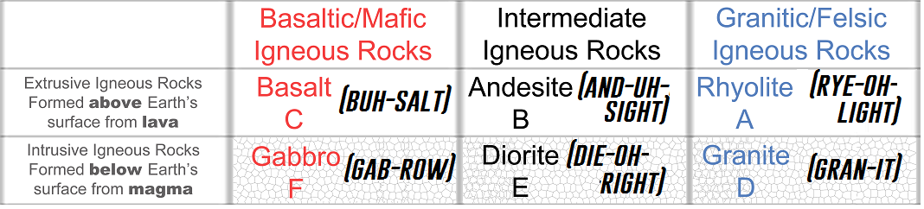

Refer to the images as you talk about key terms below
Tell students to place the rocks on the chart, matching the letters to the corresponding spaces.
Walk around and help them to do this as needed.

Explain that:
- The top row contains Extrusive Igneous Rocks that formed from lava on the Earth’s surface. These rocks are fine-grained.
- The bottom row of rocks contains Intrusive Igneous Rocks that formed from magma below the Earth’s surface. These rocks are coarser grained (“speckled”). Students may or may not know that the "specks" are crystals of minerals.
- The color gradually gets lighter from left to right.
- The rocks in the blue column are lighter in color and are Granitic
- The rocks in the red column are darker and are Basaltic.
Tell students that the reason for the difference in colors will be more obvious after they have examined the minerals that make up the rocks.

C. Minerals of Igneous Rocks
Learning Goal: Students remember that minerals are the building blocks of rocks

Tell students to place the Venn diagram below the igneous rock mat.
Have the students place the minerals on the diagram, matching the numbers to the corresponding spaces.
Remind students that minerals are the building blocks of rocks. The igneous rocks are different combinations of these minerals.
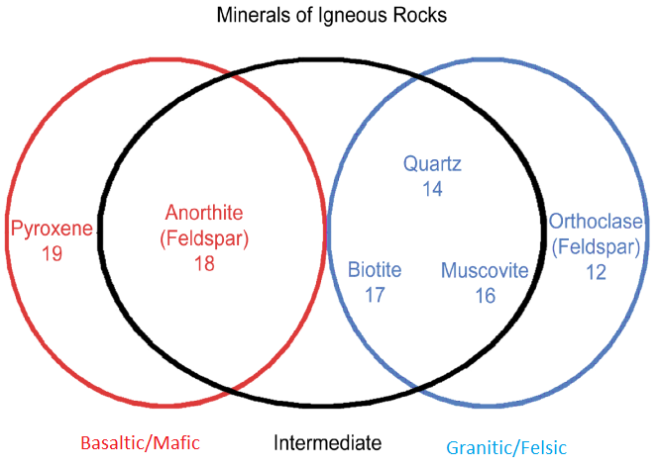
The colored circles/ovals in the Venn Diagram correspond to the three columns in the table:
- Any mineral in the blue circle can be found in a granitic/felsic rock.
- Any mineral in the black circle can be found in an intermediate rock.
- Any mineral in the red circle can be found in a basaltic/mafic rock.
- Minerals in overlapping ovals can be found in both corresponding rock types

Ask students:
- What difference do they see in the colors of the minerals?
The color gradually gets lighter from left to right.
- What is the relationship between the color in the minerals and rocks?
The color of the rock depends on the minerals that make up the rock. The minerals that make up the basaltic rocks tend to be darker than those that make up the granitic rocks. Intermediate rocks are made from some granitic minerals and some basaltic minerals.

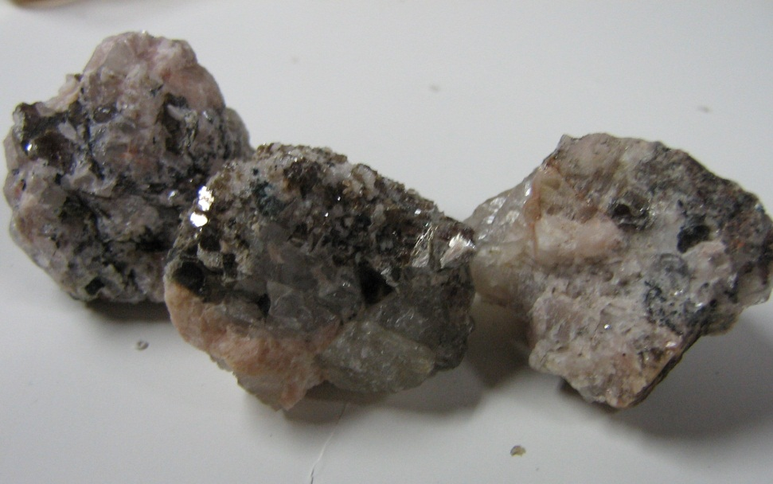
D. Examining Pegmatite
Tell students to look at the large-grained igneous rocks (D, E and F) and the pegmatite (H) with the magnifying glasses to observe the minerals in them.
Note: The name Pegmatite refers to an igneous rock with especially large mineral crystals. It does not have a specific mineral composition.
Walk through the minerals of the pegmatite with the students:
Using the minerals placed on the Venn diagram as a reference, ask students if they can see: Orthoclase feldspar, quartz, muscovite, and biotite.
Note: If the samples have a salmon/pink colored mineral, point out to students that it is a type of orthoclase feldspar (12) that has impurities that makes it pink instead of the white mineral they have in front of them.
Tell students that other minerals are present but that we have listed only the largest/easiest to see.

Based on the minerals listed, ask the students:
Is the pegmatite intrusive or extrusive? Intrusive because it has large crystals
Is the pegmatite granitic, intermediate, or basaltic? Granitic because it’s made of the minerals that are found in granitic rocks. It may also be lighter in color.

III. Where do these Igneous Rocks come from?
Learning Goals: Students identify the source of different igneous rock types.

Have the students place the rocks on their labels on the landscape diagram below the chart.
Tell students to notice where these rocks are forming.
- Darker basaltic rocks form from cooling of lava or magma from the ocean splitting apart at rifts, also called mid-ocean ridges.
- Lighter granitic rocks form from violent eruptions of volcanoes on land.
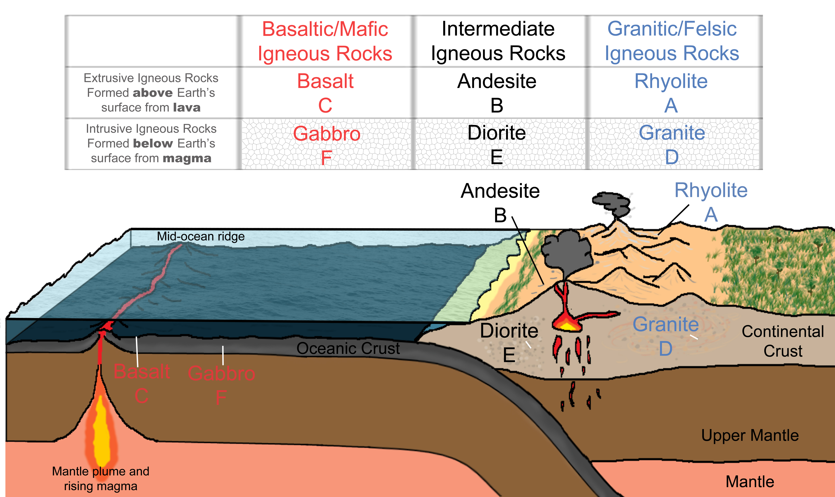

Ask the students to put their rocks and minerals back in their boxes so that VSVS volunteers can collect the boxes and the mats while setting up for the next part of the lesson.
VSVS volunteers MUST look at every box before they remove them from the table, to make sure all materials have been put back.

IV. Examining Volcanic Rocks
Learning Goals: Students observe demonstrations to understand how shield and stratovolcanoes can produce igneous rock.

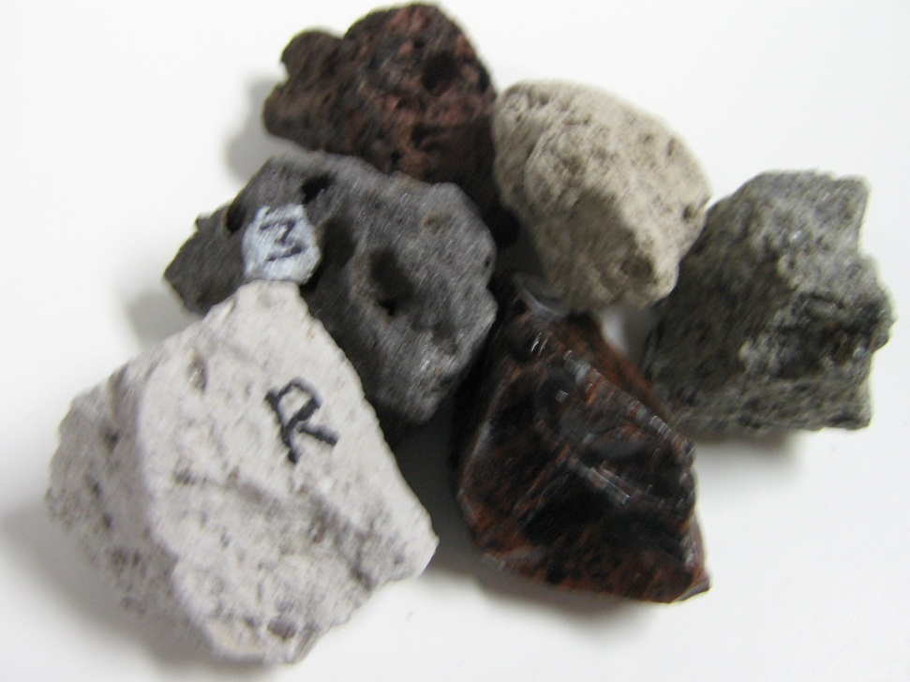
Pass out one volcano diagram to each pair.

Ask the students if they know the difference between a shield volcano and a stratovolcano (also known as Cinder Cone volcanoes).
Shield volcanoes are broad volcanoes that have slow moving lava flows.
Stratovolcanoes are tall, steep volcanoes that erupt explosively.

Tell students to look at the Volcano diagram handout and explain the difference between the 2 volcanoes

SHIELD VOLCANOES:
- Are named because they look like upside down shields.
- Are spread out over a wide area and are almost continuously erupting.
- Form as lava flows in all directions, cools, and builds up in layers over time.
- Can be found in Hawaii. Lava from Kilauea Volcano was in the news in 2015, as it flowed towards a shopping center.
- Tend to have basaltic lava, which flows easily.

STRATOVOLCANOES (Cinder Cone volcanoes):
- Are usually very tall and very steep.
- Erupt explosively all at once, sending out clouds of hot ash and gases as well as flows of lava.
- Mt. St. Helens and Vesuvius – the volcano that destroyed Pompeii – are both stratovolcanoes.
- Stratovolcanoes tend to have granitic lava, which flows slowly.

Additional Information for VSVS members:
Stratovolcanoes are more explosive in nature and deadlier. They are often found on shores because of plates moving underneath the Earth’s surface. These volcanoes are very dangerous because of ash clouds and pyroclastic flows that form when they erupt. Ash clouds can form a glassy layer inside the lungs, which end up suffocating the victim. Pyroclastic flows are extremely fast and large clouds of hot gas whose temperature can reach up to 300°F and can travel at speeds of 200 miles per hour.

A. Demonstration - Stratovolcanoes vs. Shield Volcanoes
Materials:
Deep plastic box with lid containing:
1 Margarine container
2 Lids – 1 with multiple small holes and 1 with no holes
16oz water
1 Small plastic plate
1 Small dropper bottle of detergent
1 Small container of dry ice
1 Pair of tongs

SAFETY GUIDELINES:
- VSVS VOLUNTEERS MUST WEAR SAFETY GOGGLES WHILE DOING THIS DEMONSTRATION.
- KEEP THE MARGARINE CONTAINER IN THE BOX FOR THE STRATOVOLCANO DEMONSTRATION.
- USE THE TONGS TO HANDLE DRY ICE

Tell students that we will be demonstrating shield volcano and stratovolcano eruptions.

For the shield volcano:
- Take the margarine container out of the box and place it on the small plastic plate so that the students can see the demonstration better.
- Fill the margarine container 2/3 of the way full with water.
- Add one squirt of laundry detergent to the water.
- Using the tongs, drop 2 pieces of dry ice into the container.
- Quickly place the lid with multiple small holes on top of the container, making sure to press it on fully.
The mixture should start to slowly ooze out of the holes in the lid. Explain that this is similar to how lava in a shield volcano eruption slowly leaves the volcano and slowly flows down around all sides.
For the stratovolcano:
- Put the margarine container back in the deep plastic box.
- Make sure the margarine container is 2/3 full of water.
- Using the tongs, drop 2 pieces of dry ice into the container.
- Quickly place the lid without holes on top of the container, making sure to press it on fully.
- Step back and watch the lid first bulge and then fly off.

Point out that lid bulges as gas builds up inside the margarine container– this didn’t happen with the shield volcano.
This is similar to how gas builds up in a stratovolcano just before it explosively erupts, sending material (and lava) outwards in all directions, just as the lid violently flew off.

Repeat the demonstrations, making sure to point out the slow oozing of the shield volcano demo and the lid bulging before the eruption in the stratovolcano demo.

B. Special Types of Volcanic Rock
Materials:
1 clear 16oz cup
8 Plastic Cases with two sets of Volcanic Rocks - (Box #4 – 2 pairs of students will share the case)
16 magnifying glasses from Part III

Pass out the cases of volcanic rocks labeled (M-T). Each group of four should get one case that contains two sets of rocks.

Tell students that these are special kinds of igneous rocks called volcanic rocks because they come from volcanoes. All of the rocks in the cases come from stratovolcanoes.

Have students work with their partner to make observations about each rock.
As they make observations, they should fill in the chart on the back of their observation sheets.
If time is short, discuss the differences between the rocks as a class and take notes on the board.

While the students are working, walk around and engage them in conversation about what they are observing and make sure that they are recording their observations on their observation sheet.
After a few minutes, have the students stop working, and ask them about their observations.
- Pronounce the name of each rock
- Ask them what they observed or what they think makes the rock unique
- Mention some (not all) of the fun facts provided for each rock below.

Volcanic Rock Fun Facts:
M. Vesicular Basalt (veh-sick-you-ler buh-salt)
- This rock is made of the same minerals as the basalt we looked at earlier.
- The word vesicular means it has small cavities or air pockets because the gas didn’t escape before the rock cooled.
N. Scoria (skur-ree-uh)
- It is made from lava that had a lot of gases trapped inside.
- These gases form large bubbles in the lava which remain as holes or cavities in the solid rock.
O. Pumice (pum-iss)
- When lava is extremely rich in gases, it can begin frothing or foaming.
- When this foam is violently ejected from the volcano and solidifies, pumice is formed.
- Pumice will float on water.
- Pumice is commonly used as scouring stones or in exfoliating creams.
Show students that pumice will float – use the 16 oz cup, add water, and add a piece of pumice.
P. Obsidian (ub-sid-dee-in)
- Obsidian is also known as volcanic glass, and has a smooth, glassy appearance.
- It is formed when lava from a volcano flows into water (a lake or ocean), which causes it to cool so quickly that no mineral crystals can form.
- The red streaks tell us how the lava was flowing when it cooled.
- In the past, obsidian was used to make arrowheads and other tools.
R&T. Ash Tuff (ash tough) & Vitric Tuff (vit-trick tough)
- Volcanic tuff is rock formed when debris from an explosive volcano piles up and is later compressed into a solid rock.
- Sample R is called ash tuff because it is mainly composed of volcanic ash pressed together to form a solid rock.
- The word vitric means glassy, and vitric tuff is made up of bits of volcanic glass (obsidian).

CLEAN UP:
- Collect all volcanic rocks and put into cases in their labeled positions.
- Collect the volcano diagrams and the magnifying glasses.
- Empty the liquid from the margarine container.
- Put all the demo materials back in the deep plastic box so they don’t spill.

Lesson written by: Pat Tellinghuisen, Progam Coordinator of VSVS 1998-2018, Vanderbilt University
Courtney Luckabaugh, Lab Manager of VSVS, Vanderbilt University
Edited by: Kyle H. Broach, VSVS Training Committee, Vanderbilt University
Lucas Loffredo, VSVS Training Committee, Vanderbilt University
Megan Covington, VSVS President, Vanderbilt University
Reference: Chernicoff, S., & Whitney, D. (2007). Geology: An Introduction to Physical Geology. Upper Saddle River, New Jersey: Pear

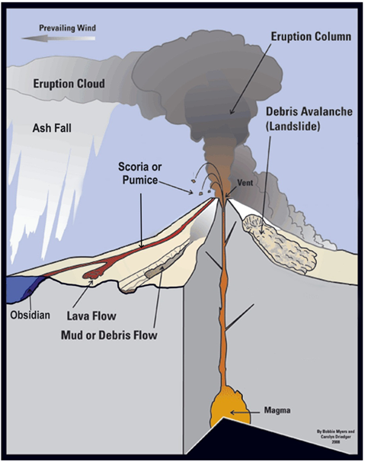
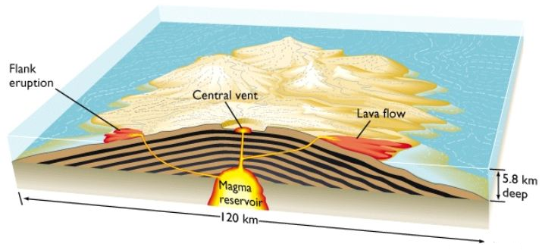
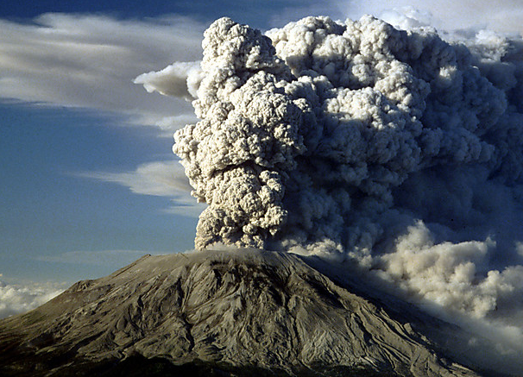
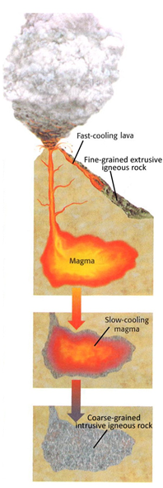
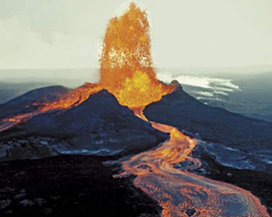
Mt. St. Helens, Washington
Kilauea volcano, Hawaii
Stratovolcanoes
Shield volcanoes

Igneous Rock Observation Sheet

Name _______________________________________

I. Introduction – What are Igneous Rocks? – Circle your answer

1. (Sedimentary, metamorphic, igneous) rocks form when melted rock material cools.

2. Igneous rocks formed from lava form on or above the Earth’s surface are called (intrusive, extrusive) igneous rocks.

3. Igneous rocks formed from magma underneath the Earth’s surface are called (intrusive, extrusive) igneous rocks.

II. Examining Igneous Rocks
4. Which kind of rock – Granitic or Basaltic – tends to be light in color? _______________________

5. In your chart, what differences do you notice between the extrusive igneous rocks in the top row and the intrusive igneous rocks in the bottom row?
____________________________________________________
____________________________________________________

6. Circle your answer: The color of an igneous rock is determined by (where it forms, what minerals it is made of, the temperature of the lava around it).

7. What minerals do you observe in the pegmatite sample?
____________________________________________________
____________________________________________________

8. Do you think pegmatite is intrusive or extrusive? Why?
____________________________________________________
____________________________________________________

IV. Examining Volcanic Rock

Volcanic Rock: | What do you observe? What makes this rock unique?
Vesicular Basalt (M)
Scoria (N)
Pumice (O)
Obsidian (P)
Ash Tuff (R)
Vitric Tuff (T)

Igneous Rock Observation Sheet Answers
I. Introduction – What are Igneous Rocks? – Circle your answer
1. (Sedimentary, metamorphic, igneous) rocks form when melted rock material cools.

2. Igneous rocks formed from lava form on or above the Earth’s surface are called (intrusive, extrusive) igneous rocks.

3. Igneous rocks formed from magma underneath the Earth’s surface are called (intrusive, extrusive) igneous rocks.

II. Examining Igneous Rocks
4. Which kind of rock – granitic or basaltic – tends to be light in color? Granitic

5. In your chart, what differences do you notice between the extrusive igneous rocks in the top row and the intrusive igneous rocks in the bottom row? The extrusive igneous rocks in the top row are fine-grained, whereas the intrusive igneous rocks in the bottom row are speckled/have visible crystals.

6. Circle your answer: The color of an igneous rock is determined by (where it forms, what minerals it is made of, the temperature of the lava around it).

7. What minerals do you observe in the pegmatite sample? Orthoclase feldspar, quartz, muscovite, and biotite

8. Do you think pegmatite is intrusive or extrusive? Why? Intrusive because it has large crystals

IV. Examining Volcanic Rock
For the chart, possible answers include the appearances of the rocks, how shiny they are, how heavy they are (pumice should be very light, for example), or anything else observable about the rocks.

