VANDERBILT STUDENT VOLUNTEERS FOR SCIENCE
http://studentorg.vanderbilt.edu/vsvs
Evidence of a Chemical Reaction
Spring 2019
Goal: To show students evidence of a chemical change.
Fits TN standards:7PS1.2, 7PS1.3, 7PS1.4

VSVSer Lesson Outline
______ I. Introduction
Question students about the difference between physical and chemical changes. Explain what constitutes evidence of chemical reactions.
______ II. Safety Concerns
Discuss safety issues. Demonstrate how students will use the small dispensing bottles and the 24-well culture plate.
______ III. Determining if a Chemical Change has Occurred
Tell students to follow the instructions on the instruction sheet. You will still need to guide them through the procedures, making sure they understand the instructions. Discuss results with students after they finish each row. Chemical equations for Rows A, B, C are given.
_______ Row A: Chemical Reactions That Give a Precipitate (solid)
Students should realize that if the solution turns cloudy, a solid (precipitate) is forming.
_______ Row B: Chemical Reactions That Involve a Color Change
Formation of complex ions cause color changes.
------------ Row C: Chemical Reactions That Produce a Gas
Students look carefully at the bubbles (CO₂) produced in solutions.
--------- IV. Analyzing Results
Emphasize the chemistry of carbonates and bicarbonates. Students predict the reaction
between marble and HCl.
-------- V. Identifying an Unknown
-------- VI. Review

LOOK AT THE VIDEO BEFORE YOU GO OUT TO YOUR CLASSROOM (https://studentorg.vanderbilt.edu/vsvs/lessons/)
USE THE PPT AND VIDEO TO VISUALIZE THE MATERIALS USED IN EACH SECTION.

1. In the car ride, read through this quiz together as a team. Make sure each team member has read the lesson and has a fundamental understanding of the material.
Lesson Quiz
- What are some basic differences between a physical and chemical change?
- What are signs of a chemical change?
- What are the major safety concerns in this lesson for students?
- What is important about the reaction between a carbonate/bicarbonate and an acid?
- What is a precipitate?
- Briefly describe the process students will use to “identify the unknown” at the end of the lesson
- If a reaction causes the solution to go from colored to clear, does it count as a color change?
- In all of the reactions in this lesson for which a gas is given off, what is the gas?

2. Use these fun facts during the lesson:
- Chemical changes constantly occur in living organisms. The human body is made up of proteins that help catalyze complex chemical reactions.
- The products of a chemical reaction have the same total mass as the reactants (law of conservation of mass).
Unpacking the Kit – What you will need for each section:
- VSVSers do this while 1 person is giving the Introduction. Note that students are put into pairs and should have their pencils ready
- While one team member starts the introduction, another should write the following vocabulary words on the board:
physical change, chemical change, chemical reaction, formula, solution, precipitate, compound, mixture

For Part III. Determining If a Chemical Change Has Occurred
34 safety goggles for students and VSVS members
16 24-well culture plates with lids
16 plastic plates
Instruction sheets, obs sheets
15 sets of dropper bottles of each:
1.0 M HCl hydrochloric acid
1 M Na₂CO₃ sodium carbonate
0.5 M NaHCO₃ sodium bicarbonate
0.1 M Cu(NO₃)₂ copper (II) nitrate
0.1 M Fe(NO₃)₃ iron (III) nitrate
0.1 M KSCN potassium thiocyanate
A. Demonstration Bag A – 2 oz bottle of 0.1 M CaCl₂, 2 oz bottle of 1 M Na₂CO₃, 2 10 oz clear cups
4 jars containing the products, with precipitate in bottom
B. Demonstration Bag B – 2 oz bottle of 0.05 M Na₂S₂O₃, 2 oz bottle of 0.01 M I₂ , 2 10 oz clear cups
C. Demonstration Bag C - 2 oz bottle of 1 M HCl, jar of Na₂CO₃, 1 teaspoon, and 1 10 oz clear cup

For Part IV. Analyzing Results
15 small pieces of marble CaCO₃ (in a small bag)

For Part V. Optional: Identifying an Unknown
5 sets of 1oz dropper bottles of each of the following unknowns: Unknown A: NaHCO₃ ₃, Unknown B HCl, Unknown C: KSCN.

I. Introduction
Learning Goals: Students can name the different indicators that a chemical reaction has occurred.
Ask students: What is the difference between a physical change and a chemical change?
Be sure to include the following information in the discussion:
- A physical change does not change the chemical properties of a substance.
  - No new substance is formed during a physical change.
  - Only the physical properties are changed.
  - Examples of physical changes include changes in the size, shape, or state of matter. For example, ice, liquid water, and steam. In each of these states, water has physically changed (from solid, liquid, gas) but not chemically.
- A chemical change does change the chemical properties of a substance.
  - One or more new substances are formed in a chemical change.
  - A chemical change cannot be easily reversed.
  - Examples include: burning paper, digestion of food, bananas browning
Ask students: How can you tell when a chemical change has occurred? Some answers may include: a gas given off, color change, precipitation, explosion, burning, etc.

Tell students what to look for to determine if a chemical change has occurred:
When solutions of two compounds are mixed, it is often possible to determine whether or not a chemical reaction has occurred through visual observation.
Evidence of a chemical change might be a color change, a gas given off (it may smell), the formation of a precipitate (a new solid), or an energy (temperature, light) change.

Write these observations on the board and share the following explanation with students.
- A color change occurs when two solutions are mixed and a new color is produced.
  - BUT, if the color of one solution becomes a paler shade, that change is caused by dilution from the other solution and does not qualify as a color change.
- Bubbles or fizz indicate that a gas is given off.
  - BUT, make sure that students understand that the bubbles given off in a soda pop drink is NOT evidence of a chemical change This is just excess gas that is released when the top is opened. Carbonated beverages contain carbon dioxide gas dissolved under pressure, and removing the top lowers the pressure and allows carbon dioxide bubbles to escape.
- A precipitate forms when two substances react to give a new solid compound that does not dissolve in water.
  - A precipitate will MOST LIKELY look like a cloudy solution, fine grains in a solution, a swirl, or a fluffy solid. The solution cannot be seen through.
Note: When two clear solutions are mixed and a white precipitate forms, this whitish color does not count as a color change. The change should be recorded only as the formation of a precipitate.
- An energy change (temperature or light) can be either a physical or chemical change. A chemical energy change occurs in a glow stick when chemicals mix to produces light. A physical energy change occurs when you freeze water.

Important: Scientists do not rely on just visual observations to determine if a chemical or physical change has occurred. The only real evidence is the formation of new substances with different chemical formulas from the reactants.

II. Safety Concerns
- Tell students they must put on safety goggles before mixing any solutions.
- Students should not directly smell any chemicals.
- If anyone gets any of the chemicals on their skin or in their eyes, they should flush immediately with water. Although the solutions are dilute, they could still cause eye damage, especially the 1.0 M HCl.
- Emphasize to students how important it is for them to follow directions.

Organize students in pairs and distribute the following materials to each pair of students:
2 safety goggles
1 24-well culture plate
1 plastic plate
6 dropper bottles of solutions
2 Instruction Sheets
2 Chemical Reactions Observation Sheets
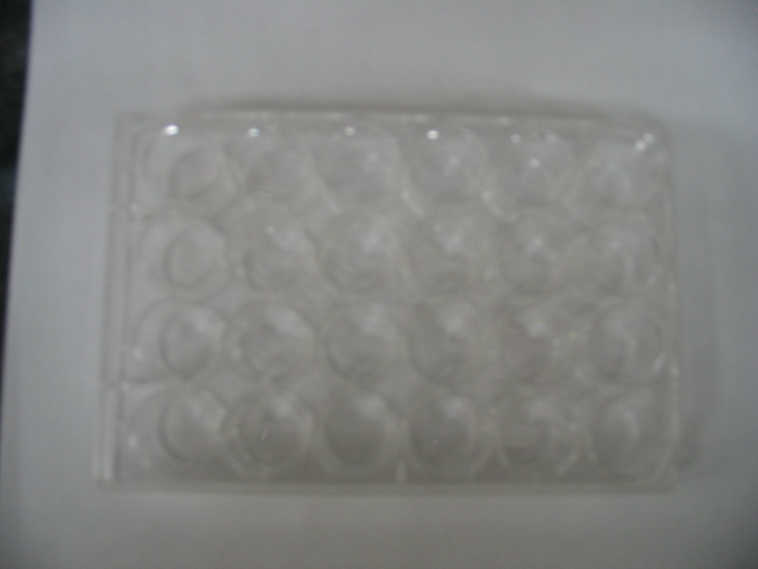
      - VSVS volunteers should put on their safety goggles and keep them on until students are finished mixing chemicals.
letters
- Have students look at the 24-well plate and the instructions at the top of the Chemical Reactions Lab Sheet.
- Show students how to find the letters A, B, C, D as well as the numbers 1 - 6 on the 24-well plate. (Letters are imprinted in the plastic along the right side; numbers are imprinted across the top and the bottom. These are tiny and may be difficult to see.)
numbers
- Show students how to match the grid on the lab sheet to the 24-well plate. Tell students to place the 24-well plate on the plastic plate.
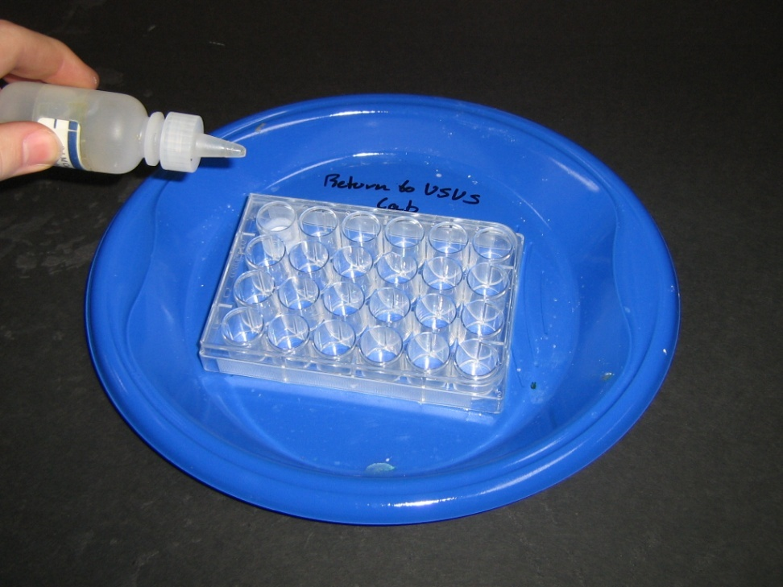
Give the following instructions to the students:
- The names and formulas of the compounds being used in this experiment are listed at the bottom of the observation sheet.
Have students look at these names and formulas while you pronounce them for the class.
The labels on the dropper bottles list both the name and formula.
of the compounds.
Show students how to be careful when matching the formulas (some of the formulas are very similar).

- Show students one of the bottles and demonstrate how to get drops out of the bottle. Dropper bottles are easy to use. Apply slow, gentle pressure. Do not remove the red cap from a bottle until it is to be used. Put the cap back on the bottle immediately after use.
When using two solutions, put a squirt of the first solution in the correct well so that it is one-fourth full (we do not want students to spend time counting drops). Then add one squirt of the second solution. The well should now be half full.

- Tell students they will perform the reactions for one row only then stop and discuss the results with the VSVS members. Tell the partners to take turns doing the experiments as they follow the grid on the lab sheet. Both students record their observations on the lab sheet. Students can record NR if No Reaction occurs. Otherwise, they will record color change, gas given off, or precipitate formed.

- Tell students to follow the instructions on the instruction sheet for mixing solutions. (The instruction sheet lists the same directions as are given below.)

III. Determining If a Chemical Change Has Occurred
One team member should draw a grid of the well plate on the board with all of the rows labeled. Write on this when discussing the results with the students.

Note: VSVS volunteers need to monitor the students closely to be sure contamination does not occur.
Ensure that students use the correct bottle.

Stop and discuss results with students after each row. This is preferable to waiting until students finish all of the experiment since some will finish very quickly and then be bored waiting for others to catch up.

The beginning of each reaction is given on the student observation sheet. Students and VSVSers should complete each equation on the board after the reactions in each row are completed.
Learning Goals:
- Students can name the different indicators that a chemical reaction has occurred.
- Students can identify the specific indicators of a reaction and explain how to look for them
A. Chemical Reactions that Give Precipitates - Row A
Demonstration: Show students what a precipitate looks like by doing the following demonstration.
Take the demonstration bag marked ROW A. Remove the 2 oz bottles of solutions and the two 10 oz clear cups. Empty each 2 oz bottles into separate cups. Hold the two cups up so the students can see what happens, and then pour one solution into the other. A white solid (precipitate) forms. Point this out
as an example of a chemical reaction in which a precipitate forms to the students.
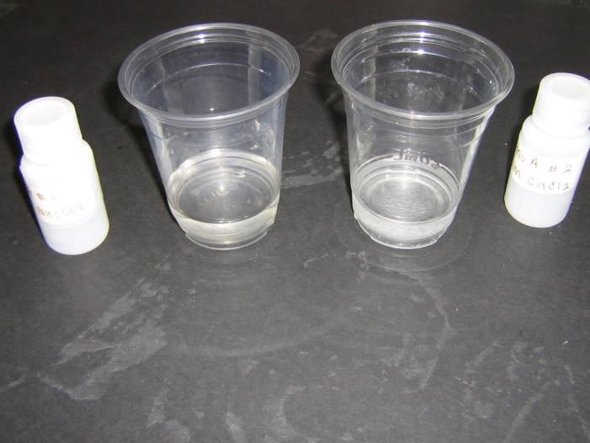
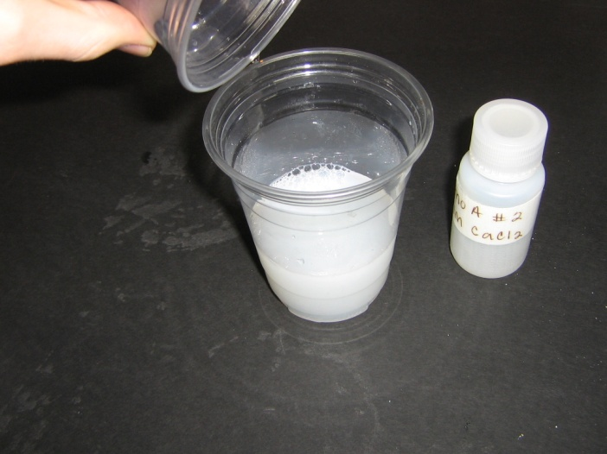

Show the students the jars with the clear liquid and precipitate in the bottom. Tell them that these are the products from the same reaction just done, but the products were allowed to stand for several hours. Shake the jar to show the students that the solution will become cloudy again.
Tell students to use the grid on their observation sheet to perform the experiments in Row A. Make sure that they correctly identify the formulas of the compounds being used in a reaction ( listed on the observation sheet).
Note: For each activity DO NOT record the results until the students have completed the experiments for the row since they may wait to copy the answers from the board.
Review and Equations:
- Ask students what evidence indicated that a chemical reaction occurred.
  - A precipitate formed in A1 and A2.
- Put the results on the board. A1: precipitate A2: precipitate
- Students can look at the equations on the observation sheet:
Demo: CaCl₂ + Na₂CO₃ → CaCO₃ + 2 NaCl
A1: 2 Fe(NO₃)₃ + 3 Na₂CO₃ → Fe₂(CO₃)₃ + 6 NaNO₃
A2: Cu(NO₃)₂ + Na₂CO₃ → CuCO₃ + 2 NaNO₃

B. Chemical Reactions that Involve a Color Change - Row B
Demonstration: Show students what a color change looks like by doing the following demonstration.
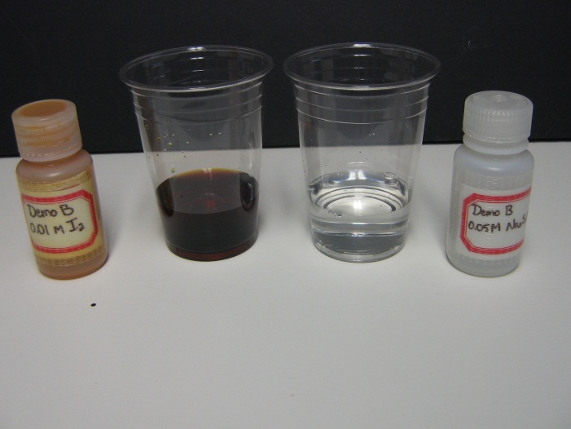
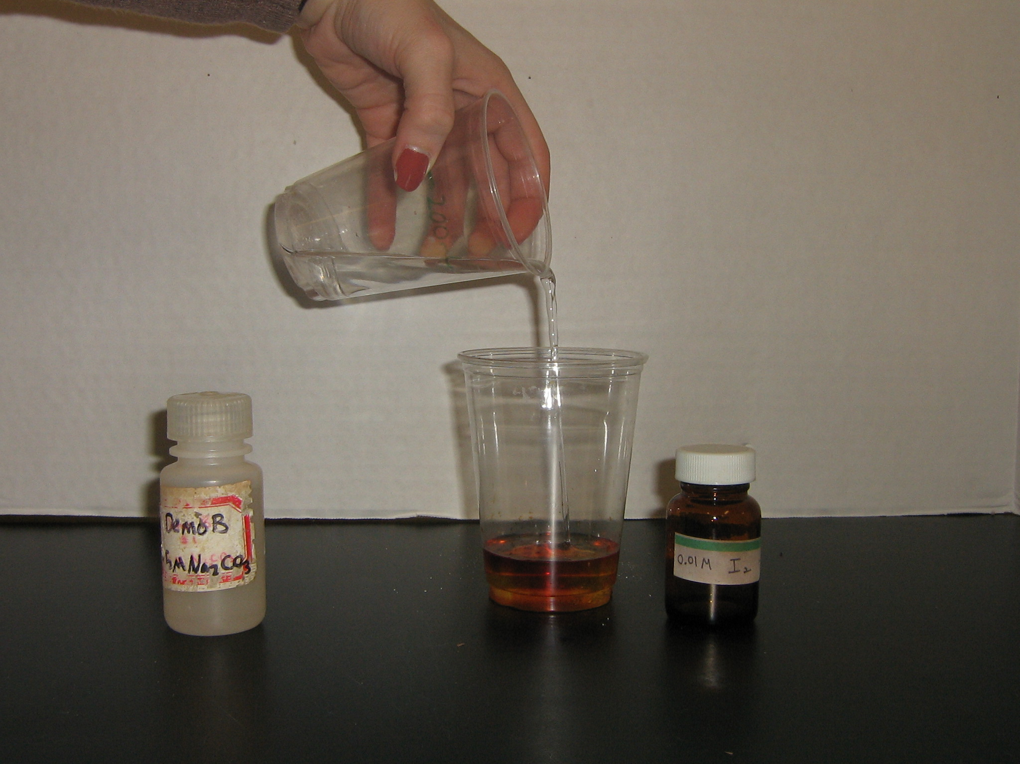
- Take the demonstration bag marked ROW B. Remove the 2 oz bottles of solutions and the two 10oz clear plastic cups. Empty each 2 oz bottles into separate cups. Hold the two clear containers up, and tell students to notice that one is a clear colorless solution and the other is a clear, brown solution. Pour the colorless solution into the brown solution, and ask students to describe what happens. The brown solution turns colorless, but it is still clear (i.e no precipitation). Explain to students that a chemical reaction has taken place because the brown solution turned colorless upon addition of the clear solution.
- Tell students to use the grid on the lab sheet to perform the experiments in Row B.
Background for VSVS Members Only: This is an oxidation-reduction reaction in which iodine is reduced to iodide ion, and thiosulfate ion, S₂O₄ ²⁻, is oxidized to tetrathionate ion, S₄O₆²⁻.

Review and Equations:
- Ask students what evidence indicated that a chemical reaction occurred.
  - A color change occurred.
- Put the results on the board. B1: color change to deep red B2: color change to pale green.

Students can look at the equations on their observation sheet.
Demo: I₂ + 2 Na₂S₂O₃ → 2 NaI + Na₂S₄O₆
B1: Fe(NO₃)₃ + KSCN → Fe(SCN)(NO₃)₂ + KNO₃
intense red color
B2: Cu(NO₃)₂ + KSCN → Cu(SCN)(NO₃) + KNO₃
pale green color
Background for VSVS Members Only: Color changes with metal ion solutions are caused by the formation of complex ions. In the present case, the SCN⁻ (thiocyanate) anion bonds strongly to the Fe³⁺ (iron) ion in solution to give an intense deep red color. The SCN⁻ anion also bonds to Cu(II) (copper) ion.

C. Chemical Reactions that Produce a Gas - Row C
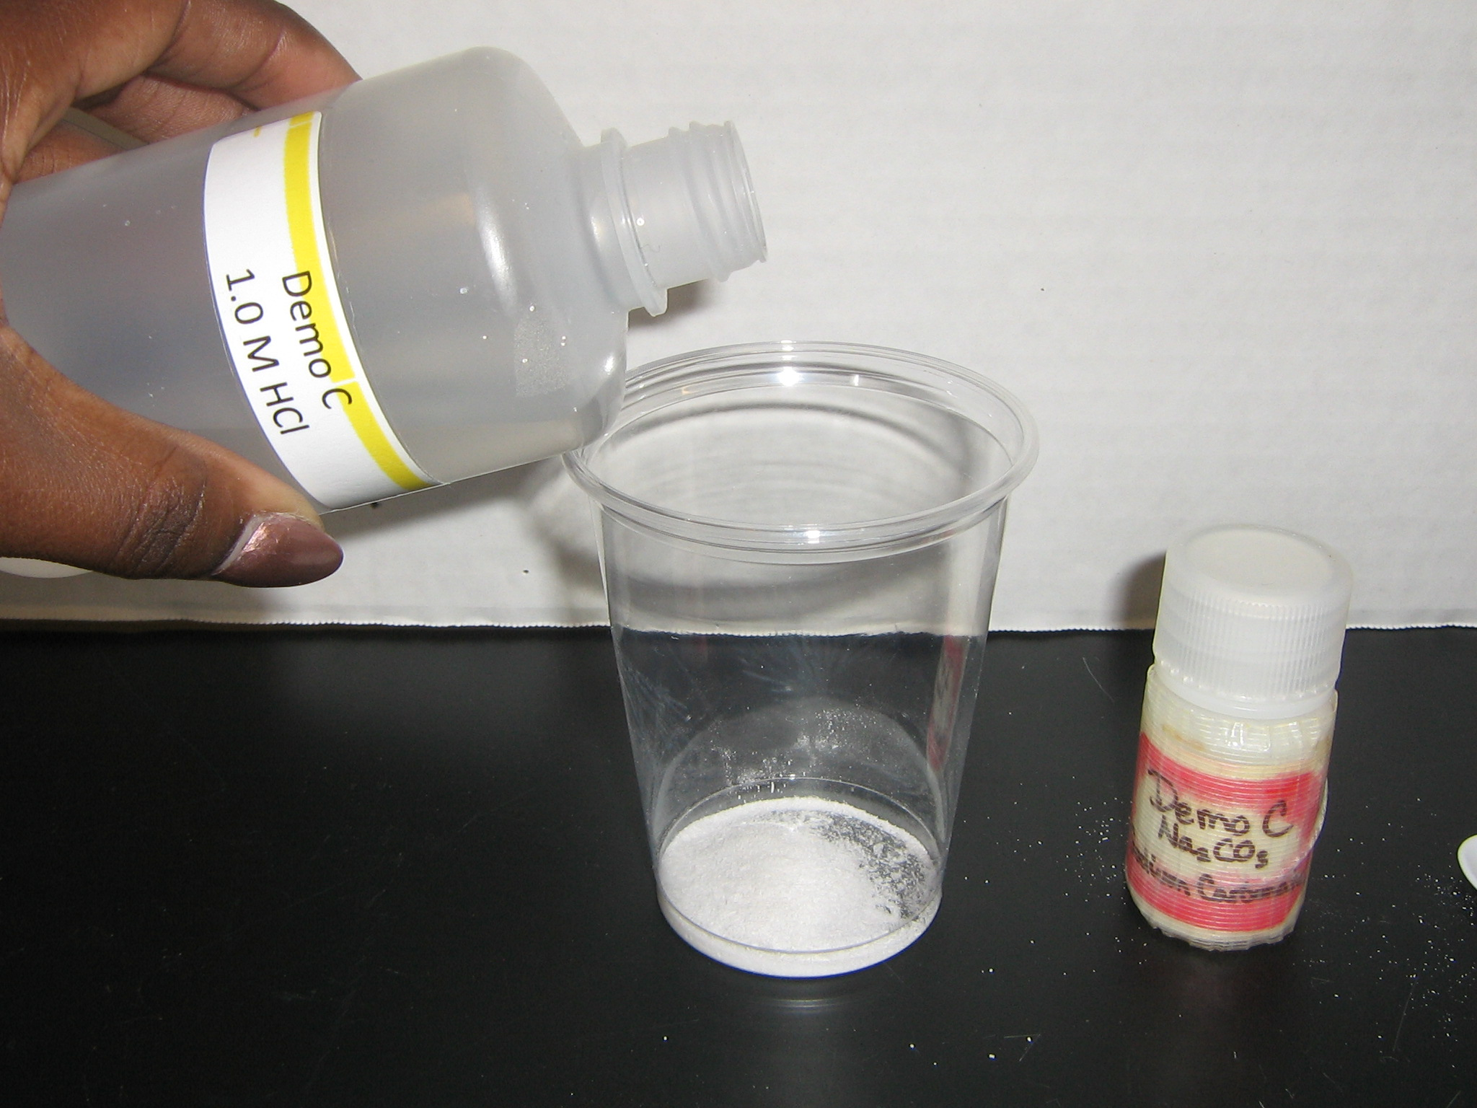
Demonstration: Show students what a chemical change that produces a gas looks like by performing the demonstration first.
Note: Tell students they will have to look very closely and quickly as soon as they add the second solution to the first solution. The bubbles of gas are small and come off as soon as the solutions are mixed.
Take the demonstration bag marked ROW C. Hold the cup up and ask students to watch very carefully what happens.
Put 1 tsp of the solid (Na₂CO₃) into the cup and empty the 2oz bottle (HCl) into it.
Ask students to describe what happens.
A bubbling up (slight foaming) which quickly subsides indicates a gas is given off. Tell students to watch very carefully for bubbles of gas when they are doing Row C because they may be difficult to see.
- Tell students to use the grid on the lab sheet to perform all the experiments in Row C.
Review and Equations:
- Ask students what evidence indicated that a chemical reaction occurred.
  - Bubbles/gas were given off.
- Put the results on the board. C1: bubbles/gas C2: bubbles/gas
- Students can look at the equations on the observation sheet.
Demo: Na₂CO₃ + 2HCl → 2NaCl + CO₂ + H₂O
C1: NaHCO₃ + HCl → NaCl + CO₂ (g) + H₂O
C2: Na₂CO₃ + 2HCl → 2NaCl + CO₂ (g) + H₂O

IV. Analyzing Results
Learning Goals: Students can analyze compounds’ reactions with one another and use that data to identify an unknown compound.
Carbonates:
- Write CO₃ on the board and tell students that formulas that include “CO₃” as part of the formula are called carbonates.
- One form of carbonate, sodium carbonate is commonly referred to as "washing soda." It is part of many laundry detergents and dish washing detergents.
- Tell students to look at the ingredients of the copy of a washing soda box on their Instruction sheet. Sodium carbonate is listed as an ingredient.

Bicarbonates:
- Write HCO₃ on the board and tell students that formulas that include “HCO₃” as part of the formula are called bicarbonates.
- A common source of bicarbonate is baking soda, whose scientific name is sodium bicarbonate. Sodium bicarbonate is used for baking and as a deodorizer. Tell students to look at the ingredient label on baking soda and notice it says sodium bicarbonate.
Reactions of Carbonates and Bicarbonates:
- Ask students to look at each box in row C and circle the formulas that have “CO₃” or “HCO₃” as part of the formula. .
- Write HCl on the board.
  - Tell students that HCl is an acid called hydrochloric acid.
  - Tell students to put boxes around all the HCl’s in Row C
- Ask students what happened in row C when an acid was added to a carbonate or bicarbonate.
  - A gas was given off.
  - Ask students if they have ever made a “volcano” at home or at school. Ask students if they remembered what they added to make the “lava”. Most likely, they used vinegar and baking soda. Vinegar is an acid, and when added to baking soda (sodium bicarbonate), it bubbles as it releases a gas.
- Ask students what happens when you add an acid to carbonate or bicarbonate. When an acid is added to a carbonate or bicarbonate a chemical reaction occurs. This is evidenced by the fact that a gas is given off.
- Tell students that the gas given off in these reactions is carbon dioxide.
Identifying Carbonates Using Chemical Reactions:
- Tell students that chalk, limestone and marble are all calcium carbonate. If the formula for calcium carbonate is CaCO_{3 ,} what might happen if an acid (HCl) is added to marble? It will bubble (give off a gas).
- Write the first half of the equation, CaCO₃ (s) + HCl (aq) → ...on the board, and ask students to hypothesize what will happen, and what the products will be. The gas will be CO_{2.}

The full equation is:
CaCO₃ + 2HCl → CaCl₂ + CO₂ + H₂O
- Have VSVS members hand out a piece of marble to each pair of students. Tell students that they are going to test their hypothesis to see if the marble will bubble when HCl is added.
- Have students add the marble to C5 and to squirt some HCl into the well. Ask students what happened. Was their hypothesis correct? Yes, it should bubble when HCl is added.
- Tell students that many statues are made of limestone and marble. Ask students what they think happens to statues when acid rain falls on them. The carbonate in the statue reacts with acid liberating a gas and causing the statue to decompose.
Background Information (in case students ask about acid rain): Acid rain is caused by the presence of varying amounts of sulfuric acid and nitric acid in rain drops. Fossil fuels, particularly coal and oil, contain sulfur as an impurity. When fossil fuels are burned, the sulfur combines with oxygen to form sulfur oxides that are gases released into the air. When it rains, the water reacts with these gases to form sulfuric acid. When vehicles burn gasoline or diesel fuel, nitrogen oxides are emitted into the air, and these react with water to produce nitric acid. The amount of sulfuric acid and nitric acid in acid rain depends on the location. The acid rain in Nashville is primarily caused by nitric acid from the high density of vehicles, while the acidity of rain in industrialized areas will be caused by the presence of both sulfuric and nitric acids. As a result of the Clean Air Act, industrial and power plants are emitting much lower amounts of sulfur oxides; however, the emission of nitric oxides from vehicle exhausts is still a problem.

V. Optional: Identifying an Unknown
Tell students they will be given a colorless solution that contains one of the following compounds dissolved in water
Unknown A: NaHCO₃
Unknown B: HCl
Unknown C: KSCN
These are the same colorless solutions that they have been doing the experiments wit.
Tell them that they will follow a plan, using the dropper bottles from the chemical reaction kit, to determine the identity of the unknown.
Students can work in pairs, groups, or as a class. There is a total of 15 dropper bottles.
Distribute the unknown dropper bottles throughout the class, so that pairs or groups of students have access to one unknown.
Tell students to:
- Follow the plan in Row D and add a squirt of their unknown to the 6 wells in Row D of the well plate.
- Add a few drops from their known dropper bottles, one well at a time.
- Write down the observation immediately after each addition.
- Look at the results in Rows A, B and C, to determine what the possible reactions are.

Ask students: What do you think your unknown is? _____________
If the students have trouble, tell them to compare what happened in their reactions to what happened in the earlier reactions. For example, if their unknown causes precipitates to form with iron nitrate and copper (II) nitrate, then it has to be sodium bicarbonate.
What is your proof for what you’ve listed in (a)?
The proof should be stated something like the answer response in the plans given above but specific for the unknown. For example, if the unknown was HCl, the proof statement could be: the unknown made the NaHCO₃ and Na₂CO₃ fizz.
Note: The students cannot distinguish between NaHCO₃ and Na₂CO₃ with the chemicals they have been given.

Write balanced chemical equations for the reactions you used to determine the identity of the unknown. (Refer to equations in lesson (Section VIII))

Optional: Answer these questions after finishing the chemical reactions observation sheet.
- Write complete, balanced equations for the following:
  - One reaction in Row A that gave a precipitate.
Refer to equations in lesson (Section VIII)
  - One reaction in Row B that gave a color change.
Refer to equations in lesson (Section VIII)
  - One reaction in Row C that gave a gas.
Refer to equations in lesson (Section VIII)

VI. Review Questions
Ask students:
- What is a physical change?
- What is a chemical change?
- What are the chemical changes we saw today?
- How do we know when a chemical change has occurred? (answer on p. 3)

VII. Clean-up
- Have students put the dropper bottles back in the Ziploc bag. Make sure that the bottles are all upright. Leaks make for nasty clean-up tasks.
- Collect the Ziploc bags and the goggles.
- Place the lids on the 24-well plates and carefully put them in the Rubbermaid container. Place the lid on the Rubbermaid container and put it in the bottom of the box. (If you can rinse them out at the school, do so, PLEASE)
- Place the ziploc bags and other materials in the box.
- Collect all instruction sheets in sheet protectors and put them in the box.

Lesson written by Dr. Melvin Joesten, Chemistry Department, Vanderbilt University
Pat Tellinghuisen, Program Coordinator of VSVS 1998-2018, Vanderbilt University

Class Activity Sheet – Extension Activity
NAME _________________________________________________________

1. You will be given an unknown colorless solution that contains one of the following compounds dissolved in water: KSCN, HCl, NaHCO₃. Follow Row D to determine the identity of your unknown.
- What do you think your unknown is? _____________ If there is more than one possibility, list both.

- What is your proof for what you’ve listed in (a)?

- Write balanced chemical equations for the reactions you used to determine the identity of the unknown.

- Write complete, balanced equations for the following (choose a correct equation from the list below):
  - One reaction in Row A that gave a precipitate.

  - One reaction in Row B that gave a color change.

  - One reaction in Row C that gave a gas.

Chemical Equations for Chemical Reactions in this Lesson
Abbreviations: s = solid, aq = aqueous, g = gas, l = liquid
CaCl₂ (aq) + Na₂CO₃ (aq) → CaCO₃ (s) + 2 NaCl (aq)

2 Fe(NO₃)₃ (aq) + 3 Na₂CO₃ (aq) →Fe₂(CO₃)₃ (s) + 6 NaNO₃ (aq)

Cu(NO₃)₂ (aq) + Na₂CO₃ (aq) → CuCO₃ (s) + 2 NaNO₃ (aq)

I₂(aq) + 2 Na₂S2O₃(aq) → 2 NaI(aq) + Na₂S₄O₆ (aq)

Fe(NO₃)₃ (aq) + KSCN (aq) → Fe(SCN)(NO₃)₂ (aq) + KNO₃ (aq)

Cu(NO₃)₂ (aq) + KSCN (aq) → Cu(SCN)(NO₃) (aq) + KNO₃ (aq)

Na₂CO₃ (s) + 2HCl (aq) → 2NaCl (aq) + CO₂ (g) + H₂O (l)

NaHCO₃ (aq) + HCl (aq) → NaCl (aq) + CO₂ (g) + H₂O (l)

Na₂CO₃ (aq) + 2HCl (aq) → 2NaCl (aq) + CO₂ (g) + H₂O (l)

CaCO₃ (s) + 2HCl (aq) → CaCl₂ (aq) + CO₂ (g) + H₂O (l)

Class Activity Sheet
ANSWER SHEET
Answer these questions after finishing the chemical reactions observation sheet.

- Write complete, balanced equations for the following:
  - One reaction in Row A that gave a precipitate.
Refer to equations on worksheet
One reaction in Row B that gave a color change.
Refer to equations on worksheet
One reaction in Row C that gave a gas.
Refer to equations in lesson (Section VIII)

2. 2. You will be given an unknown colorless solution that contains one of the following compounds dissolved in water: KSCN, HCl, NaHCO₃. Follow Row D to determine the identity of your unknown.

What do you think your unknown is? _____________

- What is your proof for what you’ve listed in (a)?
The proof should be stated something like the answer response in the plans given above, but specific for the unknown. For example, if the unknown was CaCl₂, the proof statement could be: A precipate formed when NaHCO₃solution was added. The CaCl₂ solution is the only one of the possible unknowns that will give a precipitate with NaHCO₃.

- Write balanced chemical equations for the reactions you used to determine the identity of the unknown.
Refer to equations below
Chemical Reactions Observation Sheet
Name________________________________
Vocabulary Words: physical change, chemical change, chemical reaction, formula, solution, precipitate, compound, mixture
In each box, use the following choices to record your observations: color change, precipitate formed, gas given off, NR (no reaction)
Add other observations if you wish. Ex: lots of bubbles, fizz, small or large bubbles, cloudy precipitate.
A1  Fe(NO₃)₃ + Na₂CO₃ | A2  Cu(NO₃)₂ + Na₂CO₃ | A3 | A4 | A5 | A6  Demonstration  CaCl₂ + Na₂CO₃ | CaCl₂ + Na₂CO₃ → CaCO₃ + 2NaCl  2 Fe(NO₃)₃ + 3 Na₂CO₃ →Fe₂(CO₃)₃ + 6 NaNO₃  Cu(NO₃)₂ + Na₂CO₃ → CuCO₃ + 2 NaNO₃
B1  Fe(NO₃)₃ +KSCN | B2  Cu(NO₃)₂ +KSCN | B3 | B4 | B5 | B6  Demonstration  I₂ + 2Na₂S2O₃ | I₂ + 2 Na₂S₂O₃ →2 NaI + Na₂S₄O₆  Fe(NO₃)₃ + KSCN → Fe(SCN)(NO₃)₂ + KNO₃  Cu(NO₃)₂ + KSCN (aq) →Cu(SCN)(NO₃) + KNO₃
C1  baking soda NaHCO₃ + HCl | C2  washing soda  Na₂CO₃ + HCl | C3 | C4 | C5  marble solid  CaCO₃ + HCl | C6  Demonstration  Na₂CO₃ + 2HCl | Na₂CO₃ + 2HCl →2NaCl + CO₂+ H₂O  NaHCO₃ + HCl → NaCl + CO₂ + H₂O  Na₂CO₃ + 2HCl → 2NaCl + CO₂ + H₂O  CaCO₃ + 2HCl → CaCl₂ + CO₂+ H₂O
D1  NaHCO₃  + unknown | D2  KSCN  + unknown | D3  Fe(NO₃)₃  + unknown | D4  Cu(NO₃)₂  + unknown | D5  HCl  + unknown | D6
HCl - hydrochloric acid Na₂CO₃ - sodium carbonate NaHCO₃ - sodium bicarbonate Cu(NO₃)₂ - copper (II) nitrate Fe(NO₃)₃ - iron (III) nitrate
KSCN - potassium thiocyanate CaCl₂ - calcium chloride
Chemical Reactions Lab Sheet
Answer Key
A1  Fe(NO₃)₃ + Na₂CO₃  precipitate | A2  Cu(NO₃)₂ + Na₂CO₃  precipitate | A3 | A4 | A5 | A6  Demonstration  CaCl₂ + Na₂CO₃  white precipitate
B1  Fe(NO₃)₃ +KSCN  color change-  deep red | B2  Cu(NO₃)₂ +KSCN  color change - pale green color | B3 | B4 | B5 | B6  Demonstration  I₂ + 2 Na₂S2O₃  color change – brown to colorless
C1  baking soda  NaHCO₃ + HCl  gas given off | C2  washing soda  Na₂CO₃ + HCl  gas given off | C3 | C4 | C5  marble solid  CaCO₃ + HCl  gas given off | C6  Demonstration  Na₂CO₃ + 2HCl  gas given off
Answers for unknowns on separate page |  |  |  |  | D6
HCl - hydrochloric acid Na₂CO₃ - sodium carbonate NaHCO₃ - sodium bicarbonate Cu(NO₃)₂ - copper (II) nitrate Fe(NO₃)₃ - iron (III) nitrate
KSCN - potassium thiocyanate CaCl₂ - calcium chloride
Answer Sheet for Unknown Solutions
baking soda  NaHCO₃ + unknown A ( NaHCO₃)  NR | potassium thiocyanate  KSCN+ unknown A ( NaHCO₃)  NR | iron nitrate  Fe(NO₃)₃+ unknown A ( NaHCO₃)  PPT | copper nitrate  Cu(NO₃)₂+ unknown A ( NaHCO₃)  PPT | hydrochloric acid  HCl + unknown A  A ( NaHCO₃)  Gas given off
baking soda  NaHCO₃  + unknown B (HCl)  Gas given off | potassium thiocyanate  KSCN + unknown B (HCl)  NR | iron nitrate  Fe(NO₃)₃ + unknown B (HCl)  Color change | copper nitrate  Cu(NO₃)₂ + unknown B (HCl)  Color change | hydrochloric acid  HCl + unknown B (HCl)  NR
baking soda  NaHCO₃ + unknown C (KSCN)  NR | potassium thiocyanate KSCN + unknown C (KSCN)  NR | iron nitrate  Fe(NO₃)₃ + unknown C (KSCN)  Color change | copper nitrate  Cu(NO₃)₂ + unknown C (KSCN)  Color change | hydrochloric acid  HCl + unknown C (KSCN)  NR

Instruction Sheet
Evidence of a Chemical Reaction 7th Grade
Important:
- Always wear safety goggles when dealing with chemicals
- Pay close attention to which solutions you are using
- To use dropper bottles apply slow, gentle pressure
- Don’t fill more than halfway full
- Record observations: NR = no reaction, PPT= precipitate, color change, gas formed

Chemical Name | Chemical Formula
1. Iron III Nitrate | Fe(NO₃)₃
2. Copper Nitrate | Cu (NO₃)₂
3. Sodium Carbonate | Na₂CO₃
4. Potassium Thiocyanate | KSCN
5. Sodium Bicarbonate | NaHCO₃
6. Hydrochloric Acid | HCl

- Setting Up
  - Receive and put on safety goggles
  - Materials
    - First set of solutions
    - 24 well plate
    - plastic plate (place well plate on plastic plate)
    - Observation Sheet
III A. Row A -Precipitate
  - Watch VSVS members complete Demo A
  - What you need:
    - Fe(NO₃)₃ ---> squirt into well A1, ¼ full
    - Cu(NO₃)₂ ---> squirt into well A2, ¼ full
    - Na₂CO₃ ----> squirt into both A1 and A2 until ½ full
C. Record your observations for each well on your observation chart.
D. Wait for instructions from VSVS member before moving on
III. B Row B – Color Change
- Watch VSVS members complete Demo B
- What you need
- Fe(NO₃)₃ ---> squirt into well B1, ¼ full
- Cu(NO₃)₂ ----> squirt into well B2, ¼ full
- KSCN ----> squirt into both B1 and B2 until ½ full
- Record your observations for each well on your observation chart.
- Wait for instructions from VSVS members before moving on

III. Row C – Produce a Gas
- Watch VSVS members perform Demo C
- What you need
- NaHCO₃ ---> squirt into well C1, ¼ full
- Na₂CO₃ ----> squirt into well C2, ¼ full
- HCL ---> squirt into both C1 and C2 until ½ full
C. Record your observations for each well on your observation chart
D. Wait for instructions from VSVS members before moving on.
IV. Analyzing the Results – Carbonates and Bicarbonates
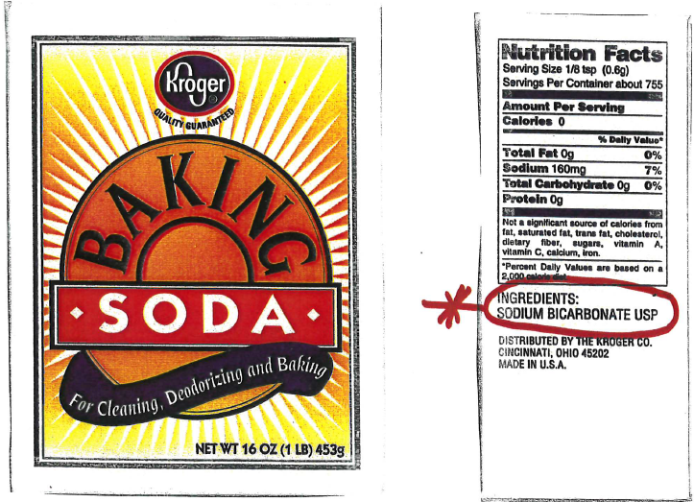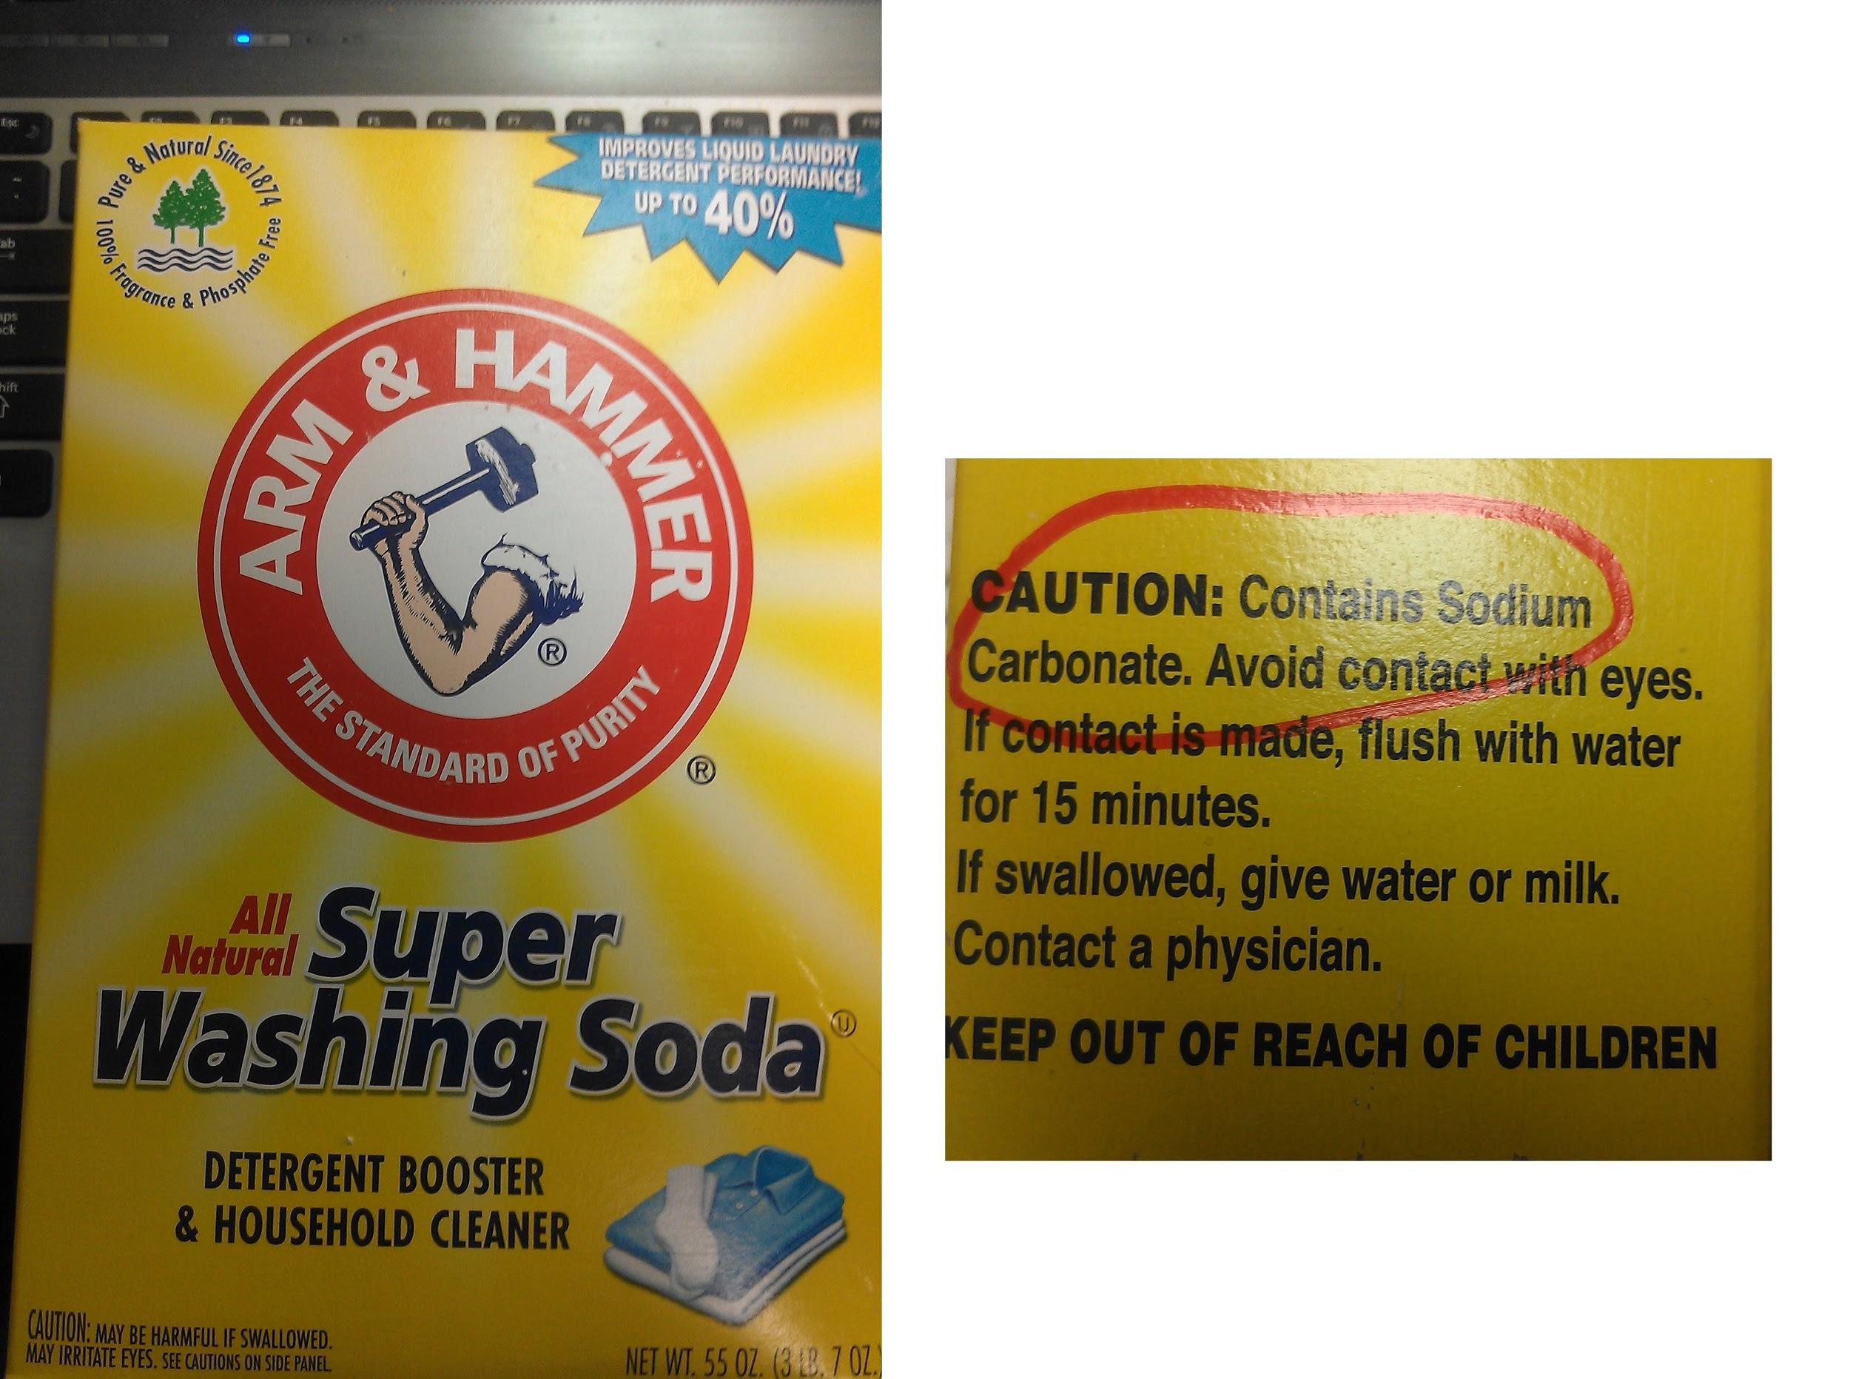
- Discuss results with the class or small groups
- Predict what will happen if marble and an acid interact?
- Receive a piece of marble from VSVS member
- Place marble in well C5
- Add a few drops of HCL
- Record observations
V. Optional – Identifying an Unknown
- Receive an unknown solution from VSVS member
- Record which unknown you are given on your observation sheet
- Squirt unknown into wells D1 - D6 until ¼ full
- D1 ---> squirt NaHCO₃, until ½ full
  - Record Observations for each cell immediately after addition.
- D2 ---> squirt Na₂CO₃, until ½ full
3. D3 --->squirt KSCN, until ½ full
4. D4 ---> squirt Fe(NO₃)₃, until ½ full
5. D5 ---> squirt Cu(NO₃)₂, until ½ full
6. D6 ---> squirt HCl, until ½ full

D. Determine which solution your unknown is (ask VSVS member if you need help
VII. Clean- Up
- Place red caps on all the dropper bottles
- Give goggles back to VSVS members
- Wash off the well plates if available

