VANDERBILT STUDENT VOLUNTEERS FOR SCIENCE
http://studentorg.vanderbilt.edu/vsvs
Effect of Carbon Dioxide on the Environment
Spring 2019

Goals: To understand the three states of matter and the six examples of changes of state.
To investigate the effect of carbon dioxide dissolved in “ocean” water.
To investigate the role of carbon dioxide in the formation of caves.
Fits TN Standards: 7PS1.6, 7ESS3.1, 7ESS3.2

Lesson Outline
_____ I. Introduction
A: Carbon Dioxide Facts
Give students some background information on CO₂.
B: Background Information about Dry Ice
- How is Dry Ice Made?
Students learn how dry ice is made, what it is used for and how cold it is.
- The States of Matter: Solids, Liquids, and Gases
Introduce the three states of matter and the six examples of changes of state.
_____ II. Comparing Dry Ice to H₂O Ice
Activity: Students observe a piece of dry ice and a piece of H₂O ice that have been placed in separate ziploc bags. The ziploc bag containing dry ice inflates from CO₂ gas given off when dry ice sublimes. Dry ice doesn’t leave behind a liquid when it melts because it sublimes.
What is the Greenhouse Effect?
Use the student handout to discuss the greenhouse effect.
_____ III. Effect of CO₂ in Oceans.
Universal Indicator is used as an indicator to show that carbon dioxide can make water more acidic. Students infer that natural rainwater is slightly acidic because of carbon dioxide.
_____ IV. Effect of CO₂ on Land.
Acid added to a Tums tablet illustrates how caves are formed, and show sthe effect of acidic water on seashells and corals.
_____ V. Review

LOOK AT THE VIDEO BEFORE YOU GO OUT TO YOUR CLASSROOM https://studentorg.vanderbilt.edu/vsvs/lessons/
USE THE PPT AND VIDEO TO VISUALIZE THE MATERIALS USED IN EACH SECTION.

1. In the car ride, read through this quiz together as a team. Make sure each team member has read the lesson and has a fundamental understanding of the material.
Lesson Quiz
- Name all six changes of state.
- Think of several basic “uses” of carbon dioxide in every-day life. (Hint: plants, carbonated drinks, air, Halloween, fire)
- What properties of dry ice distinguish it from regular ice?
- Why is rainwater slightly acidic?
- Why does dry ice bubble in water?
- Describe the reaction of carbon dioxide with water. How does this effect oceans? What happens when there is an increase in carbon dioxide in the atmosphere ?
- How is acid rain different from rainwater? What causes acid rain?

2. Use these fun facts during the lesson:
- The famous candy “Pop Rocks” are made by highly pressuring the candy with carbon dioxide. When you eat it, the candy dissolves and the carbon dioxide is released, which creates popping sounds.
- Dry ice cannot be stored in inflexible containers (like glass) because the buildup of sublimed gas would cause the container to explode.
Note: In this lesson use the words carbon dioxide and the term CO₂ interchangeably so the students will become familiar with both.

Materials:
1 trash bag for used cups
16 Thermometer diagram (in binder)
1 12oz styrofoam cup for H₂O ice
3 12oz styrofoam cups dry ice
32 ziploc snack bags
32 plates
5 tongs for volunteers to use
5 pairs work gloves for volunteers to use
16 dropper bottles of universal indicator
1 liter of ocean water
16 6oz. (squat) clear plastic cups (to be 1/3 filled with ocean water)
16 6 oz clear cups (to be 1/3 filled with dilute acid)
16 Tums tablets
1 liter water (tap)
2 500mL bottles 0.1M HCl
35 Observation Sheets
17 Instruction Sheets and thermometer diagram
17 Handouts containing Universal Indicator color charts, cave formation diagrams plus greenhouse effect
1 Answer Sheet for VSVS Team (in sheet protector )
1 box goggles (32 plus 5 for volunteers)

Unpacking the Kit:
Part 1: Distribute the Instruction sheets (containing thermometer diagram), plus Handout containing Universal Indicator chart, Greenhouse effect diagram, cave formation diagram to pairs of students.
Distribute an observation sheet to each student.
Part 1I: Distribute goggles to all students.
Give each PAIR a plate, 2 ziploc snack bags 1 tsp of H₂O ice, 1 piece of dry ice
Part 1II: Distribute 1 dropper bottle of universal indicator and 1 6oz. (squat) clear plastic cups 1/3 filled with ocean water,
Part 1V: Distribute 1 6 oz clear cups containing 1 Tums tablet. VSVSers will add dilute acid (0.1M HCL) .

While one team member starts the introduction, another should write the following vocabulary words on the board:
dry ice, change of state, sublimation, deposition, vaporization, freezing, melting, condensation, climate change, cave formation
Whenever possible, refer to vocabulary words throughout the lesson and during review.

IA. Carbon Dioxide Facts
For this lesson: One VSVS volunteer needs to 1/3rd fill 16 10 oz cups with “ocean” water for Part III
One VSVS volunteer needs to 1/3rd fill 16 10 oz cups with limewater for Part IV.
Divide the students into pairs.
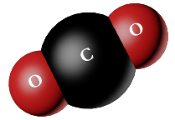
- Write and draw the CO₂ molecule on the board (it is on the instruction sheet as well)
- Write CO₂ on the board and ask students: What is CO₂? carbon dioxide
- Ask students: What do you know about CO₂?
Accept student responses and share the following information if it is not mentioned in the discussion.
  - Humans inhale oxygen and exhale CO₂.
  - Plants use CO₂ to carry out the process of photosynthesis. The photosynthesis reactions of plants convert carbon dioxide to oxygen.
  - CO₂ is solid at –108° F or –78° C.
  - CO₂ is a gas at room temperature.
  - CO₂ dissolves in water and is what gives fizz to carbonated drinks.
  - Carbon dioxide is a greenhouse gas in the atmosphere. It helps keep the atmosphere warm with the greenhouse effect.

Today we are going to use dry ice as a source of carbon dioxide.

1B. Background Information about Dry Ice
- How is Dry Ice made?
Dry Ice is made by collecting carbon dioxide gas that is formed as a by-product from industrial activities such as fermentation, oil refinery activities.
For VSVS information only: Then the carbon dioxide-rich gas is pressurized and refrigerated until it liquefies. Next, the pressure is reduced. When this occurs some liquid carbon dioxide vaporizes, causing a rapid lowering of temperature of the remaining liquid. As a result, the extreme cold causes the liquid to solidify into a snow-like consistency. Finally, the snow-like solid carbon dioxide is compressed into small pellets or larger blocks of dry ice

- Ask students: What is dry ice used for?
Accept student responses and share the following information if it is not mentioned in the discussion.
    - Dry Ice is used in meat lockers to keep meat frozen.
    - Dry Ice is used in the manufacturing of plastics, chemicals, beverages, pharmaceuticals.
    - It is used in theaters to create a fog effect.

- Discussion of Dry Ice Temperature
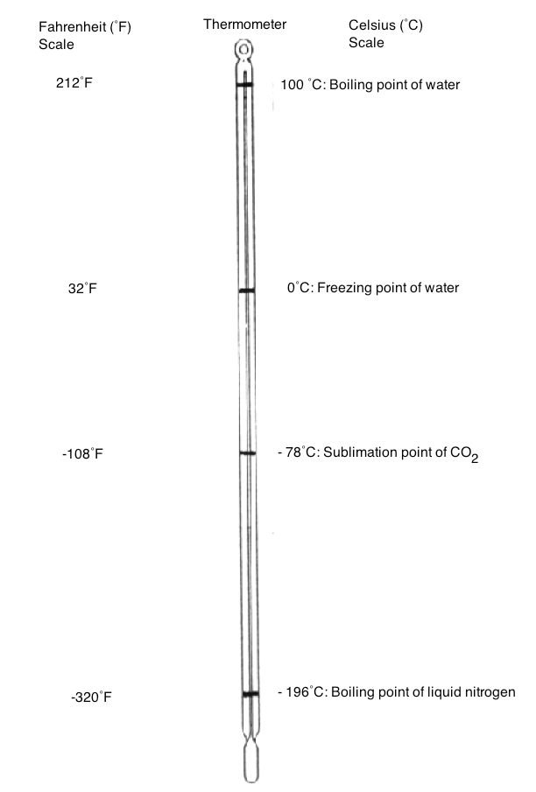
Use the thermometer diagram to help students understand the temperature of dry ice (how cold it is) by comparing the markings for the boiling point of water, freezing point of water. Note that there is no temperature given for the boiling point of liquid CO₂ because it does not exist at normal pressure.

- The States of Matter: Solids, Liquids, and Gases
- Most substances have three states of matter that are observable at normal conditions
(1 atmosphere of pressure and 20°C).
- Ask students what the 3 states of water are? Ice (solid), liquid, and water vapor (gas).
  - Tell students that carbon dioxide also has 3 states, but that only 2 exist at normal conditions: a solid (called dry ice) and gas.
- There are 6 processes that are involved in changes of state: freezing, melting, vaporization, condensation, deposition, and sublimation.
  - Draw the following diagram on the board, omitting the italicized processes.
  - Ask students to name the physical processes that lead to changes of state, and add them to the diagram. Be sure to include the following information in the discussion, and refer to the thermometer to show students where the various points are on the thermometer
Note: Write the different states on the board. Ask the students to identify the processes involved in each change of state, and add to diagram.

Solid (melts) →Liquid (vaporizes) →Gas

Gas (condenses) →Liquid (freezes) →Solid

Solid (sublimes) →Gas

Gas (deposits) →Solid

- Liquids can change to solids by freezing.
  - The freezing point of water is 32°F or 0°C.
- Solids can change to liquids by melting.
  - The temperature where a solid melts to a liquid is called the melting point.
- A liquid changes to a gas by vaporization (boiling).
  - When water boils, steam rises off the top. The steam is water vapor, which is water as a gas.
  - The vaporization point of water is 100°C or 212°F.
- A gas changes to a liquid via condensation.
  - This change of state is responsible for the droplets of water that form on a lid when a boiling pot of water is covered.
- Sublimation occurs when a solid changes state to a gas without going through a liquid phase.
  - Dry ice sublimes at -78°C or -108°F.
- Deposition is the change from gas to solid. (One example is snow that forms in clouds. Water vapor changes directly to ice without first becoming a liquid.)

II. Comparing Dry Ice to H₂O Ice
Safety Note: Students should not hold pieces of dry ice. The temperature of dry ice is -78° C, and students could get frostbite burns if their skin is in contact with dry ice for more than a few seconds.

Materials to be given to each PAIR:
2 goggles
1 plate
2 ziploc snack bags
- tsp of small pieces of H₂O ice
- piece of dry ice

- Distribute the materials to pairs.
- Tell students to put their goggles on and keep them on until the end of the lesson. VSVS members should also put on goggles.
- VSVSers place 1 tsp of H₂O ice in a bag and a piece of dry ice in the other ziploc bag. The bags are placed on the plate.
- Tell students to close the ziploc fastener on the bag.
- Remind students that they should not touch the dry ice.
- Ask students to observe both pieces of ice in the ziploc bags for a few minutes.
- Record their observations on the Observation Chart. Make sure that the students:
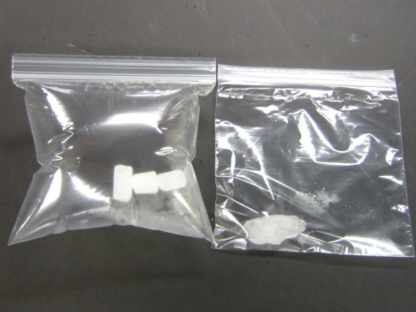
1. Describe what happens.
2. Record the changes of state that occur.

Observation 1: The dry ice ziploc bag will inflate whereas the water ice bag does not.
Explanation: Room temperature is around 20°C. Dry ice sublimes at -78°C so CO₂ gas is filling the bag.
Ask students: What changes of state have occurred? Dry ice solid to CO₂ gas by sublimation.
Water ice solid to liquid water by melting .
- Tell students to open the ziploc bags and carefully empty the pieces of dry ice and ice onto the plate.
- Tell students to leave the pieces of ice and dry ice on the plate, do not move them, but observe them periodically to see what happens over time.

Observation 2: Later when the two pieces have disappeared, the students will notice a puddle where the H₂O ice was and there will be no puddle where the dry ice was.
Explanation: Students should recall that dry ice sublimes (becomes a gas without passing through the liquid phase), thus it does not leave a puddle. Regular ice leaves a puddle because solid ice turns to a liquid at temperatures above 0°C.
Note: Share the following information with the class: carbon dioxide actually does have a liquid state which can be observed at room temperature and 5 atmospheres of pressure.

Observation 3: “Smoke” comes off the dry ice.
Explanation: This is caused by tiny ice particles that form because the cold carbon dioxide gas coming off dry ice is cooling the water vapor in the air enough to cause it to condense into tiny droplets.
Ask students what the changes of state are:
CO₂ gas sublimes from the solid dry ice, and is cold enough to condense water vapor (in the air) to liquid water droplets.
Emphasize that CO₂ gas is colorless and is invisible.
The white “smoke” is condensed water vapor.

Remind students that all these changes of state are physical changes, not chemical changes.

What is the Greenhouse Effect?
- Ask the students what they know about the effect of carbon dioxide on the atmosphere? Bring up these points if the students do not:
  - Carbon dioxide is a greenhouse gas and traps infrared radiation which can be converted to heat. Other molecules can also trap heat (e.g. water vapor and methane), but carbon dioxide is considered the main problem because it is being added to the atmosphere by human activity.
  - Air contains a very small amount of carbon dioxide (about 0.03%).
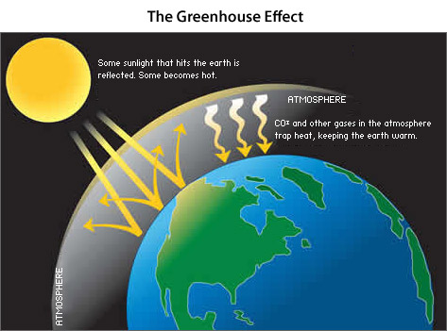
Background:
Up until the 1800s and the start of widespread use of fossil fuels, humans were a minimal contributor to global warming. The Earth itself (volcanic eruptions, deep sea rifts) was a bigger source of increased carbon dioxide.
Since the Industrial Age, people have contributed additional carbon dioxide to the atmosphere by burning fossil fuels like coal, oil, and natural gas.
Scientists believe that increased concentration of carbon dioxide in the atmosphere is causing global warming.
Explain what a greenhouse gas is: The sun’s rays pass through the atmosphere, hit the earth, and are reflected back as heat. This heat is absorbed by greenhouse gases, such as carbon dioxide, in the atmosphere.
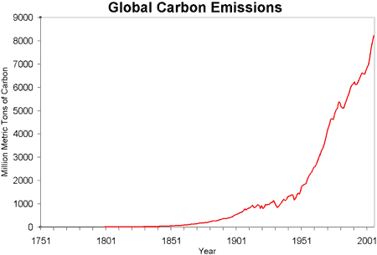
  - Tell students to look at the handout that has the diagram showing the greenhouse effect and the graph showing the increase in carbon dioxide since the Industrial Age.

III. The Effect of CO₂ in Oceans
Tell students that increasing amounts of CO₂ in the atmosphere also effects the oceans.
Write on the board: carbon dioxide sink, acidification
- Ask the students what they know about the effect of carbon dioxide on the oceans?
  - Ocean water is naturally slightly basic (tell students to look at the pH chart) because it contains dissolved minerals.
  - Oceans are called sinks for CO₂. Most of the CO₂ in the oceans becomes carbonic acid. Point to the equation on their Instruction sheet.
CO₂ + H₂O → H₂CO₃
Carbon dioxide water carbonic acid
  - Oceans have absorbed between 1/3rd and ½ of the carbon dioxide released by humans since 1850, and this has slowed the rate of climate change.
  - Oceans contain 50 times more carbon dioxide than air. Water in the oceans can remove CO₂ directly from the air. These natural mechanisms can remove 10 billion tons of CO₂ per year.
  - The amount of carbon dioxide in the oceans has also increased since the Industrial Age.
  - Burning of fossil fuels is putting about 25 billion tons into the air annually, so there is a net increase of 15 billion tons.

Distribute the following materials for each pair:
- 10 oz. clear plastic cup 1/3 full of “ocean” water
1 dropper bottle of universal indicator
1 Universal Indicator chart
1 piece of dry ice

Show the students the universal indicator and tell them that it is used to measure the acidity of liquids. Have them look at the Universal Indicator chart.
  - In neutral solutions, such as distilled water, the indicator is green.
  - In acidic conditions, it will turn yellow, then red.
  - In basic solutions it will be blue. Ocean water is naturally slightly basic.

NOTE: Acid rain is much more acidic, having a pH below 5.6.
Acid Rain is caused by acids formed when polluting gases NO₂, SO₂ and SO₃ gases react with water.

Tell the students to put a squirt of indicator into their cups.
Tell students to note the color It should be green. A more intense color is preferable.
Add a piece of dry ice to it.
Note color changes.

Observation: The indicator changes color.
Students should observe that the indicator changes color as the carbon dioxide dissolves in water. See color chart change. This is an example of a chemical change
Explanation: When dry ice is added to water, the warmer temperature of the water causes the dry ice to produce carbon dioxide gas bubbles, some of which dissolve in the water. When carbon dioxide dissolves in water it forms carbonic acid, a weak acid that acidifies the solution.

Tell students to look at the equation on their Instruction sheet:
CO₂ + H₂O → H₂CO₃
Carbon dioxide water carbonic acid (a weak acid)
Ask students if they can think of consequences of dissolving increasing amounts of carbon dioxide in ocean waters? It will make the oceans more acidic.
  - Acidification of the oceans has been occurring since the Industrial Revolution, over the same time span that an increase in CO₂ gas in the atmosphere has been noted.
  - The change in acidity so far is small, but greater changes are expected.
  - Acidification can adversely affect marine life. Increasing acidity can make it difficult for marine organisms to form skeletons and shells
There are other observations that students can make. Discuss these as a class and move on to the next section on cave formation.

Dry ice gives off bubbles when it is added to water.
Changes of State: Dry ice solid to CO₂ gas (sublimation)
Explanation: The water is warm enough (room temp. is approximately 20°C or 68°F) to cause the dry ice to sublime and produce carbon dioxide gas bubbles.

A white fog appears over the water in the top of the glass.
Changes of State: Water vapor (gas) to liquid water droplets (condensation).
Explanation: The air above the water (and in the room) contains water vapor. When the temperature of the air is lowered by the cold carbon dioxide gas, the water vapor condenses to small water droplets (a fog) or ice particles (smoke) that are suspended in the carbon dioxide gas. Point out that the fog is white even though the solution in the cup is colored. Emphasize that carbon dioxide gas is colorless.

The white fog stays in the top of the glass and any white fog that leaves the glass goes down along the side of the glass rather than up in the air.
Explanation: Carbon dioxide is heavier than air, water droplets are heavier than air, and cold air is heavier than warm air. Fog that went out of the glass went down rather than up into the air.
Tell students that dry ice is often used to create smoke and fog-like effects in movies and at concerts.

Fog that goes down along the glass disappears near the bottom of the glass.
Changes of State: Liquid water droplets vaporize to gaseous water vapor.
Explanation: The carbon dioxide fog has warmed up enough to vaporize the water, leaving only carbon dioxide which is colorless. The CO₂ warms up to the dew point temperature so the water droplets are converted to water vapor, causing the fog to disappear.

IV. Effects of CO₂ on Land
Tell students that CO₂ in water also affects the land.
Remind students that carbon dioxide dissolves in water to produce carbonic acid.
CO₂ + H₂O → H₂CO₃
Carbon dioxide water carbonic acid (a weak acid)
Tell students that rainwater seeps down through soils where CO₂ levels can be 10 to 100 times that of the atmosphere. This is because certain bacteria decompose organic material which releases CO₂ in the process. Since soil is not as open as the atmosphere, much of this CO₂ gets stuck, causing water trickling down to become much more acidic than the rainwater.

Ask them if they know of any examples of CO₂ affecting land. Answers may include:
Acidic rain (but incorrect -stress that normal rain is not strongly acidic, and not a result of CO_{2,} but instead is a result of acids formed when polluting gases NO₂, SO₂ and SO₃ gases react with water.), weathering of rocks.

If students don’t mention dissolving rocks, tell them that rainwater can dissolve certain types of rock.
Tell students that there is a rock called limestone that contains the mineral calcite. Ask them if they know where this rock can be found. Answer: It is common anywhere that used to be shallow ocean. Middle Tennessee has lots of limestone because it used to be a shallow ocean.
The mineral calcite is composed of calcium carbonate.
Experiment – Effect of Acid on Calcium Carbonate
Materials for each pair:
6 oz clear cup containing a Tums tablet
2 500mL bottles 0.1M HCl
Background Information: Calcium carbonate reacts with carbonic acid (carbon dioxide in water) to form soluble calcium bicarbonate. Corals and shells are composed of calcium carbonates.
The equation for this step is:
CaCO₃(s) + CO₂(g) + H₂O → Ca(HCO₃)₂ (aq)
Note: (s) = solid, (g) = gas, (aq) = dissolved in water

Tell students that the Tums tablet is a good model of the calcite mineral, since it is also made of calcium carbonate. Tums tablets are commonly used to aid acid indigestion, and heartburn, since they can help neutralize excess acids in the stomach.
Note: the acid used in this model to simulate the effect of carbonic acid on calcium carbonate is dilute hydrochloric acid.

Activity:
VSVSers will give each pair of students a cup containing a Tums tablet.
Other VSVSers will pour the dilute acid into the cups (about 1/3rd full)
Ask students what they observe? Students should see bubbling from the Tums tablet disintegrating.

Real world application
Tell students that what they have observed illustrates the process of how a cave is formed AND what can happen to shells and corals in acidic solutions.
Explain cave formation by asking the students to look at the drawing on their observation sheets and explaining what happens (without using chemical equations).

- Explain that the process of cave formation is very slow, taking many thousands of years depending on the size of the cave. Cave formation occurs as follows:
  - Rain dissolves some CO₂ from the air as it falls.
  - The rain water collects even more CO₂ as it percolates through soil (because of the concentrated amounts in the soil).
  - When the rain water hits limestone (calcium carbonate, the same as the Tums tablet), the acidified water begins to dissolve the rock. Ask students: Why? (If you explained it clearly they should respond that the carbonic acid in rain water reacts with calcium carbonate to form calcium bicarbonate, which is soluble).
  - As the limestone dissolves, the aqueous calcium bicarbonate is carried away by underground rivers. The contour of a cave is left behind.
  - Many times, caves have stalagmites and stalactites, which form on the floor and ceiling of the cave respectively. This occurs when water containing the dissolved calcium bicarbonate evaporates, causing calcium carbonate to precipitate (reverse of equation 2).
  - (For VSVS’ers: this is LeChatelier’s Principle at play).

V. Review
Review the changes of state and ask the students to give example from today’s experiments.

What does sublime mean? A solid goes directly to a gas state without becoming a liquid.
- What is dry ice? solid carbon dioxide
- How cold is dry ice? –78 ºC. Refer to the thermometer diagram.
- What happens when dry ice is dropped into water? Bubbles of CO₂ are given off, a cloud forms above the water, the cloud stays in the container instead of floating in the air, if any of the cloud falls out of the container it floats down and disappears.

Note about solutions used for “simulated” ocean water and “simulated” rain water

We are using a pH 10 solution for the “simulated” ocean water to lengthen the time needed for color changes for Universal Indicator. This allows students time to observe the color change from blue (basic) to green (neutral) to yellow (acidic) when a piece of Dry Ice is added to the solution. The average pH of ocean water is 8.1. When a solution with this pH is used in this activity, the addition of a piece of Dry Ice causes the Universal Indicator color changes to occur so fast that the green color for a neutral solution can’t be seen.

Lesson written by: Dr. Melvin Joesten, Chemistry Department, Vanderbilt University
Pat Tellinghuisen, Program Coordinator for VSVS1998-2018, Vanderbilt University
Susan Clendenen, Teacher Consultant, Vanderbilt University
Heather Day, Assistant for VSVS, Vanderbilt University
Effect of Carbon Dioxide on the Environment
Observation Sheet Student’s Name__________________________

Lesson Activity | Observations
II. Comparing Dry Ice to H₂O Ice
a) What happens to the dry ice in the bag? The regular ice?
b) What happened to the dry ice left on the plate? The regular ice?
III. Carbon Dioxide in Ocean Water
What color did the Universal Indicator solution turn when dry ice was added?
What does this tell you about the effect of carbon dioxide dissolved in ocean water?

IV. Cave Formation
What happens to the Tums when acid was added to it
What does this tell you about the effect of carbon dioxide dissolved in rain water on limestone, coral reefs and sea shells ?

Effect of Carbon Dioxide on the Environment
Observation Sheet
Answer Sheet

Lesson Activity | Observations | Change of State
II. Comparing Dry Ice to H₂O Ice in a bag  A What happens to the dry ice in the bag?  B The regular ice? | A Ziploc bag with dry ice fills with gas (CO₂).  B. Ziploc bag with ice doesn’t change in size | A. solid to gas (sublimes)  B. none
II. Comparing Dry Ice to H₂O Ice on the plate  A What happened to the dry ice left on the plate?  B the regular ice? | A1 Dry ice CO₂ changes from solid to gas  A2 Water vapor in air is cooled by dry ice to form tiny particles of ice water, seen as “smoke(water vapor).  B Water ice melts | A1. solid to gas (sublimes)  A2. gas to liquid to solid  B. solid to liquid
III. Carbon dioxide in Ocean Water  What color did the Universal Indicator solution turn when dry ice was added?  What does this tell you about the effect of carbon dioxide dissolved in ocean water? | From blue to green to yellow to red. | No change of state This is a chemical change
IV. Cave Formation  What happens to the Tums when acid was added to it  What does this tell you about the effect of carbon dioxide dissolved in rain water on limestone, coral reefs and sea shells ? | The Tums tablet fizzes in the acid and disintegrates. | No change of state This is a chemical change.

Instruction Sheet - Effect of Carbon Dioxide on the Environment
Do not touch the dry ice with your hands! Use your tongs.

- Discuss the temperature of dry ice.
- Discuss the different states of matter:
Solid →Liquid →Gas

Gas →Liquid →Solid

Solid →Gas

Gas →Solid

- Comparing Dry Ice with Regular Ice
- Put on your goggles.
Place a piece of dry ice and regular ice into your Ziploc bags. Be sure to close the fasteners.
- Describe the appearance of dry ice and of regular ice. How are they similar? How are they different?
- Observe both pieces of ice in the bag for a minute. What do you observe? Record your observations on the observation sheet.
- Empty both pieces of ice onto your plate. What do you observe?
- Leave both pieces on the plate and check on them periodically. What do you notice?
III. The Effect of CO₂ in Oceans.
Place a squirt of Universal indicator into your cup of “ocean” water. Record the color.
Add a piece of dry ice to the cup and observe changes in the color of the liquid.
Carbon dioxide gas dissolves in water to give carbonic acid.
CO₂ + H₂O → H₂CO₃
Carbon dioxide water carbonic acid

IV. The Role of CO₂ in Cave Formation
Observe what happens when acid is added to a Tums tablet.

Universal Indicator pH Chart
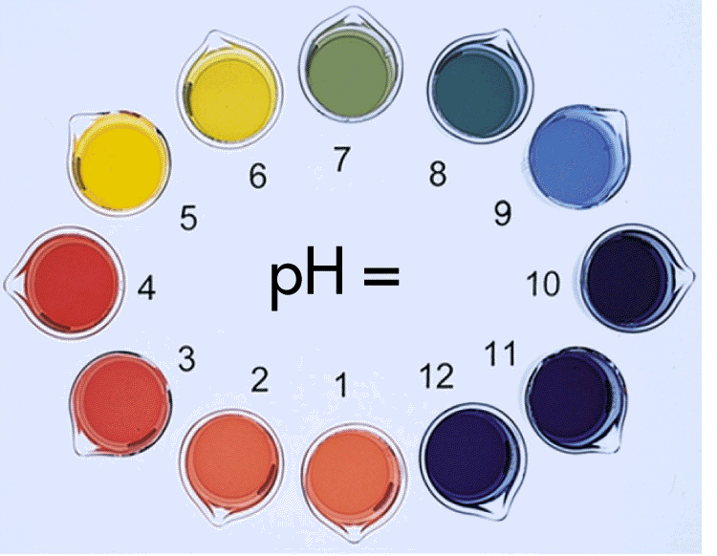

The Effect of CO₂ on the Environment Handout
