VANDERBILT STUDENT VOLUNTEERS FOR SCIENCE
http://studentorgs.vanderbilt.edu/vsvs/
Electrical Circuits
Spring 2017
(Adapted from Student Guide for Electric Snap Circuits by Elenco Electronic Inc.) by Matt Jackson, NSF Undergraduate Teaching Fellow, Vanderbilt University and David Harris, VSVS Co-President, Spring 2010)
Acknowledgement: We want to thank NASA and the Tennessee Space Consortium for funds to purchase the electric circuit kits.

Goal: To learn about series circuits and their properties through the use of Elenco Snap Circuit™ kits.
Fits Tennessee standards SPI 0607.12.1
Lesson Outline
I. Introduction
Discuss electric circuits and write the vocabulary on the board.
II. Activity – Making a Simple Circuit
Students work in pairs and build a simple circuit.
III. Activity - Using a Switch
Students place a switch in the circuit in part II.
V. Activity - Building Series and Parallel Circuits
Students build a series circuit and then a parallel circuit Then they compare brightness of bulbs VI. Summary
Review the results of the lesson and the vocabulary words.

Materials
7 ziploc bags containing materials for assembling circuits
7 sets of Instruction Sheets
observation sheets
1 Extra bag of 5 light bulb holders
1 Extra bag of 5 batteries

I. Introduction
Do not hand out materials until you have discussed the following background information.
Write the following vocabulary words on the board: electricity, current, simple circuit, series circuit,

Ask students to tell you what they know about electricity and currents:
Make sure the following is included in the responses:
There are 2 types of electricity, static and current.
Static electricity is the build-up of electrical charge. It does not flow. It can make your hair stand on end, or “zap” you when it is discharged. Lightning is another example of static electricity being discharged.
Current electricity is moving electrical charge, usually electrons.
Current electricity flows through a circuit. The electrons can flow only if the is complete.

Tell students they will be following diagrams on their instruction sheets to build a simple circuit.
Important Note: Divide students into pair
II. Activity: Making a Simple Circuit
Materials 7 ziploc bags containing materials for simple circuits, 7 sets of instruction sheets for building simple circuits, observation sheets
- Hand out one bag containing circuit materials to each pair.
- Tell the students to look at the grid and its components, and compare it with Diagram #1 on their Instruction sheets. They will need to replace the components in the same way when they are finished with the activities.
- Tell the students that the snap circuits we will use today contain flattened wires. Tell them to remove one of the #3 connectors and look at its underside. Point out the flattened wire connecting the two snaps.
- Have all pairs of students follow to build the simple circuit on their board.
- Tell them not to connect one of the #3 snaps until they are told to.
- Ask the students if the circuit is complete. No.
- How can they tell? The light bulb does not come on.
- What does it take to complete the circuit? Connect the last snap, as seen in Diagram #2.
- Tell the students to do this, and to note that the bulb now glows.
- This is called a closed circuit.
- Ask the students which way the electricity is flowing. Electrons flow from the negative end (the “flat” end of a battery) to the positive end (the end with the “knob”).

III. Activity - Using a Switch
Tell the students to replace one of the #3 snaps with the switch (Diagram #3).
Sliding the switch to the on position is the same as completing the circuit – the light bulb then glows.

IV. Activity - Making a series and parallel circuits
There are two ways that a circuit can be connected: series and parallel. The difference between the two is how the parts are connected. Each has properties that are unique to it. A normal circuit may have both types of circuit connections.
Tell the students to build the series circuit (Diagram #4)
- Ask students if the brightness of the bulbs is the same or changed?
Tell the students to build the parallel circuit (Diagram #5 )
- Ask students if the brightness of the bulbs is the same or changed?
Note: Students will observe the lights are dimmer in the series circuit

Series circuit Analogy
It can be helpful to use the following analogy to help your class understand why the bulbs in a series circuit are more dimly lit than those in a parallel circuit.
- Imagine that 5 people need to wash their hands, but there is only 1 sink. Since 5 people must share one sink, each person will get less water than if each person had access to their own sink. The more people using the sink simultaneously, the less water each person gets to wash their hands. This is analogous to a series circuit, where the brightness of bulb #1 is affected by the addition of another bulb in series. When this happens, both bulb #1 and bulb #2 become dimmer. The more bulbs you add in series, the dimmer each bulb will become. Similarly, the more people sharing one sink, the less water going to each person.

Lesson modifications by:
Dr. Mel Joesten, VSVS Faculty Advisor, Vanderbilt University
Pat Tellinghuisen, VSVS Coordinator, Vanderbilt University
Matt Majeika, NSF Undergraduate Teaching Fellow, Vanderbilt University
Observation Sheet
Electric Circuits

Name ________________________________________________

A. Series Circuits – Circle your answer.

- The light bulbs in the series circuit were (brighter, dimmer, the same brightness) as the bulb in the simple circuit.
- The light bulbs in the series circuit were (brighter, dimmer, the same brightness) as the bulb in the parallel circuit.

Observation Sheet
Electric Circuits

Name ________________________________________________

A. Series and Parallel Circuits – Circle your answer.

  - The light bulbs in the series circuit were (brighter, dimmer, the same brightness) than the one in the simple circuit.
  - The light bulbs in the series circuit were (brighter, dimmer, the same brightness) as the bulb in the parallel circuit.

Diagram # 1 – Grid and All Components Needed for Circuits
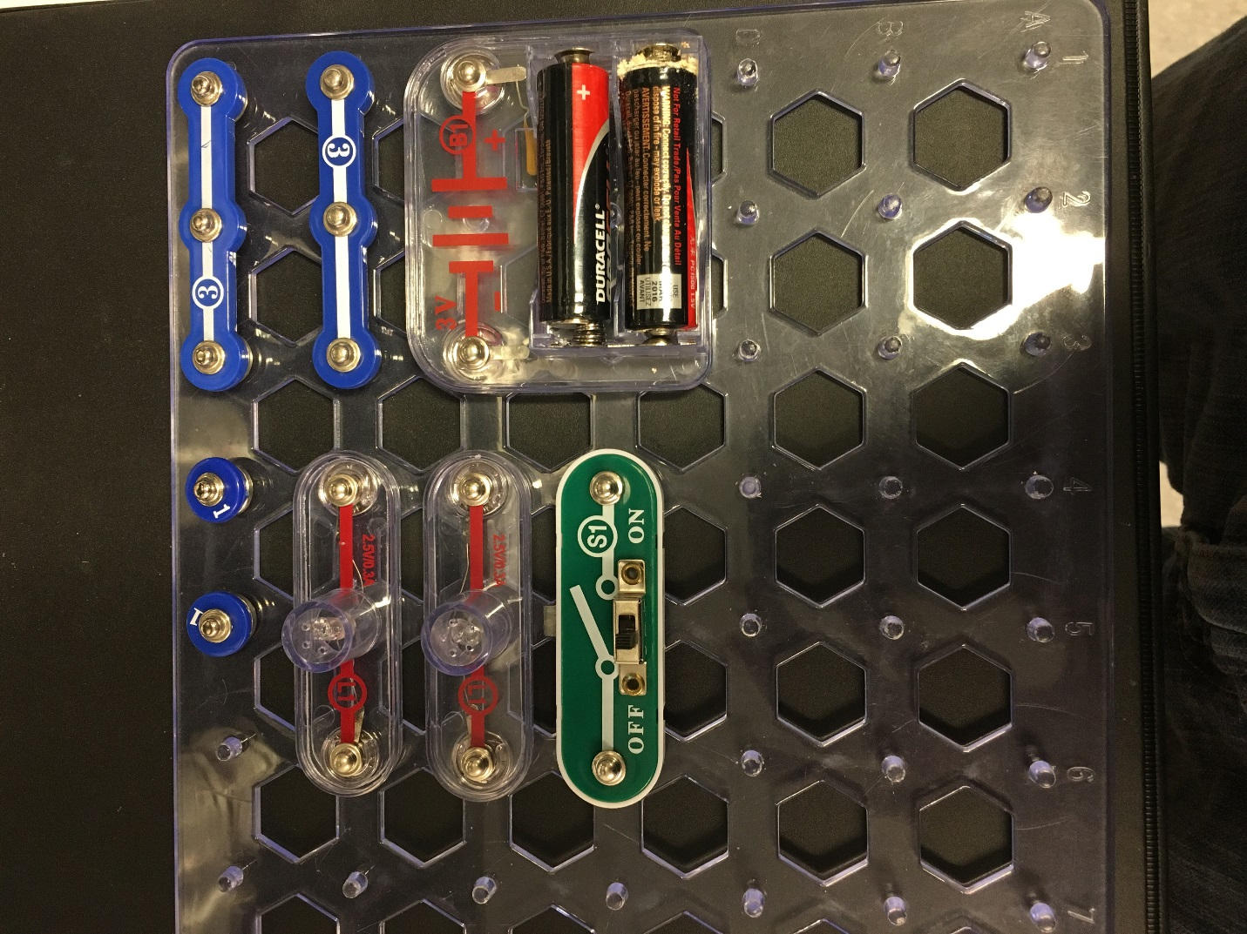
When you are finished with building the circuits in this lesson, please replace all the components to match this diagram.

Diagram #2 – Simple Circuit

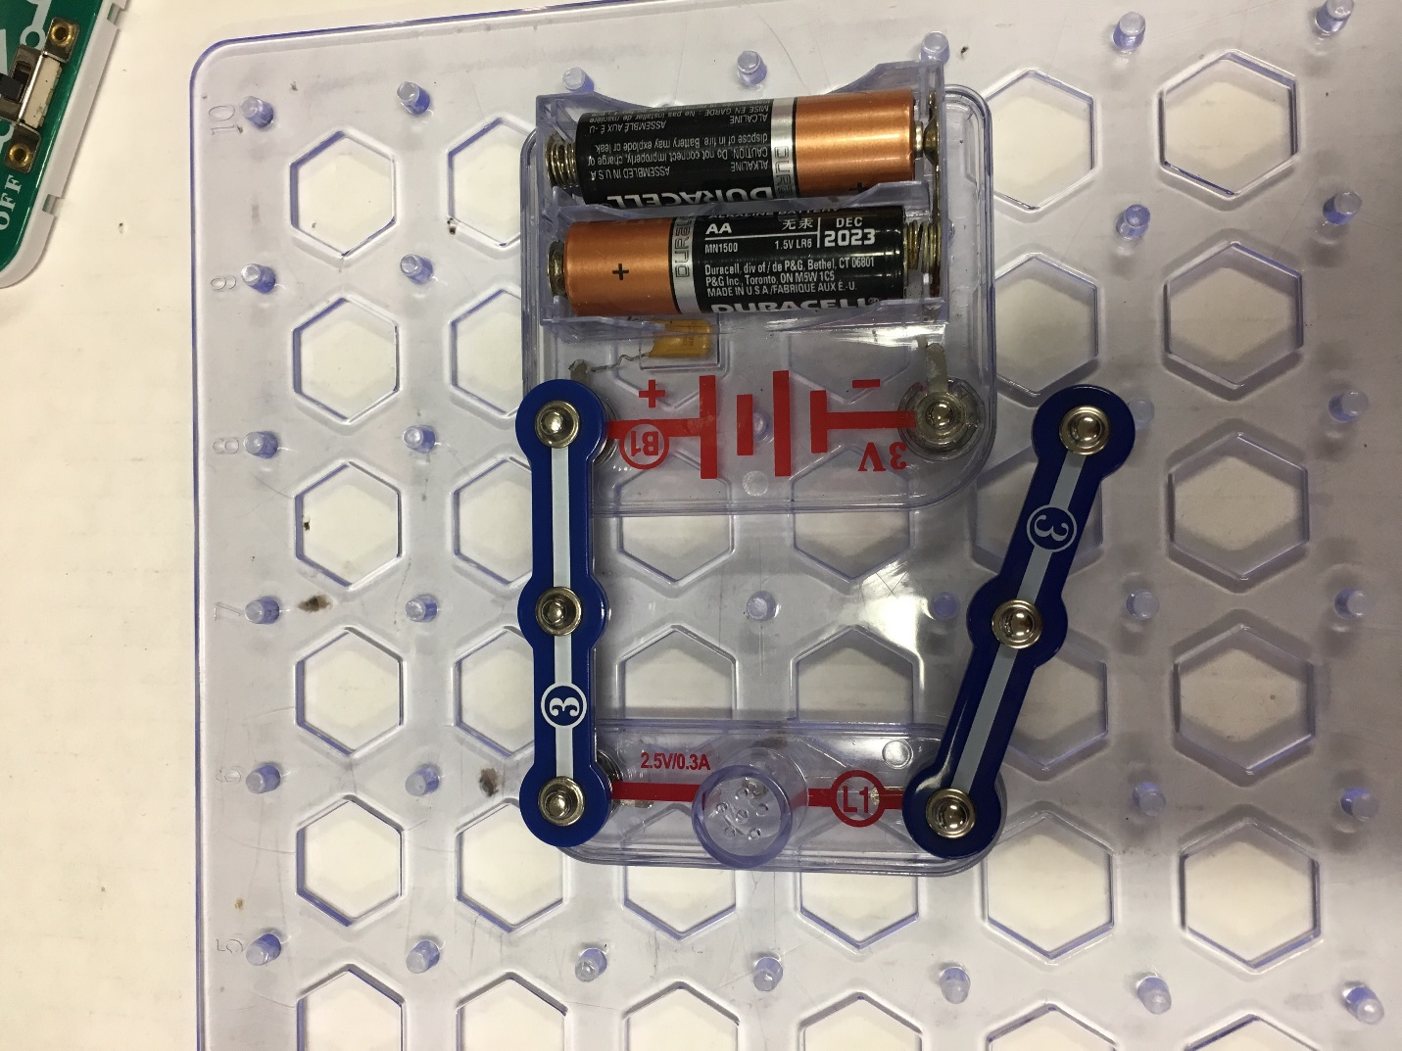

Follow the picture above to assemble the parts on your circuit board for a simple circuit. Leave the #3 connector unattached as in the picture above. Then snap it on the battery snap. What happens? Disconnect the #3 connector.
Diagram #3 – Simple Circuit with Switch
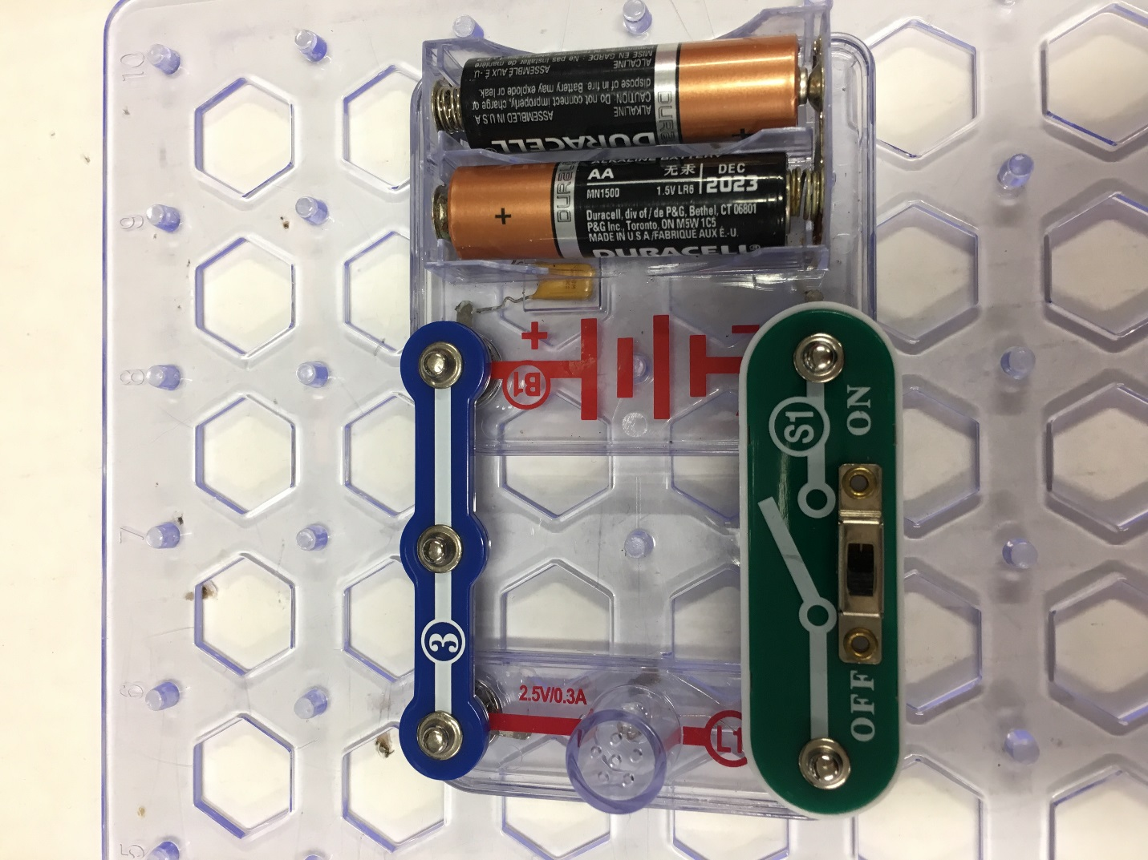
Replace the #3 connector with a switch and turn the switch on. What happens?
Turn the switch off.
Diagram #4 – Series Circuit

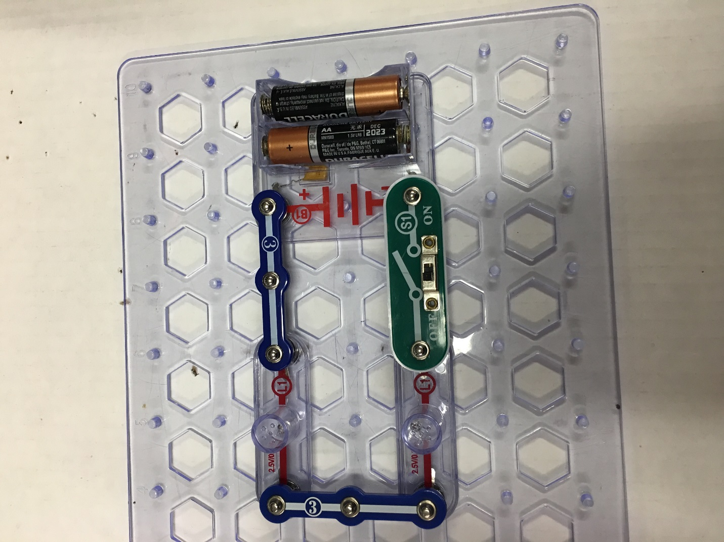

Follow the picture above to assemble a circuit with two light bulbs in series. Turn the switch on. Compare the brightness of your bulbs to those of your partners in the group who assembled the parallel circuit. How do they compare?

Diagram #6 Parallel Circuit

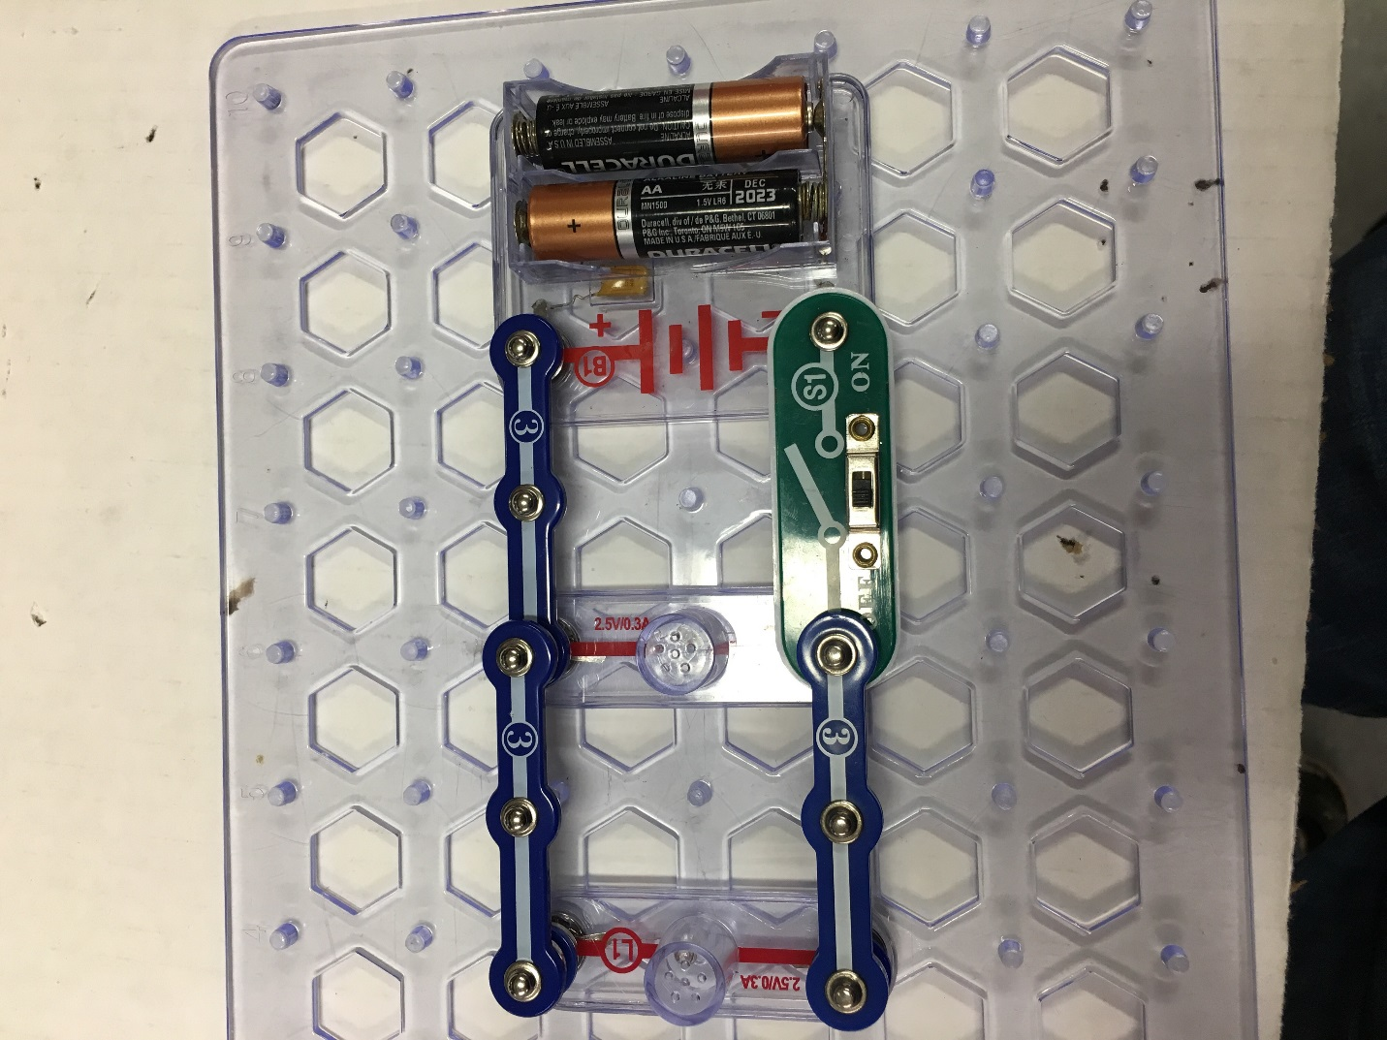
Follow the picture above to assemble a circuit with two light bulbs in parallel. Turn the switch on. Compare the brightness of your bulbs to those of your partners in the group who assembled the series circuit. How do they compare?

REPLACE ALL COMPONENTS ON YOUR GRID ACCORDING TO THE DIAGRAM #1

