VANDERBILT STUDENT VOLUNTEERS FOR SCIENCE
http://studentorgs.vanderbilt.edu/vsvs
BED OF NAILS
Fall 2016

Materials
Pairs of boards with 2 holes at ends
1 – board for TOP
1 – board with many holes drilled through (BOTTOM)
sets of 2 Wooden Support Rods with cm marks
Bags of Nails (6)
2 Bags of Nails (25)
30 7” or 9” Balloons
5 pieces of string to measure circumference of balloon (23 cm long)
4 balloon pumps
10 procedure sheets in sheet protectors
30 student worksheets

I. INTRODUCTION

While one VSVS team member is discussing the introductory material, two other VSVS team members should prepare the demonstration (Part II).

The purpose of this lesson is to demonstrate the physics of pressure and the difference between pressure and force.

In this experiment, force is the weight of the mass pushing down on the balloon and thus the nails. Pressure is the force per unit area.

Ask the students if they have heard of people lying on a bed of nails? Ask if they know why these people are not punctured by the nails?
A single nail has a sharp point – any force applied to this point is being concentrated onto a small area. Therefore the force per unit area (i.e., pressure) is large for a single nail. If the same force is spread out over several nail points, the force per unit area decreases (i.e., pressure decreases). The pressure on each nail point will decrease when more nails are added to the “bed”.

Ask the students if they can think of more common applications of this relationship between pressure and surface area.
Sharp knives cut easily because the thin surface area of the blade concentrates a
lot of force over a small area.
Snowshoes allow people to walk on top of snow because the large surface area of
the snowshoe spreads the force of the wearer over a large area.

Notes for VSVS Team:

As the number of nails is increased, the amount of pressure required to pop the balloon should increase.

A large factor in determining success for this lesson relates to how consistent students are with inflating their balloons to about equal sizes. For this reason, have them use the circumference string to get each inflated balloon to the same size.

The pattern of the nails is another important determinant in judging the accuracy of the data. For example, six nails arranged in a sporadic pattern will pop a balloon much easier than six nails in a tight, cubic pattern. This lesson is a great visual demonstration of force and pressure, and students should immediately comprehend the concepts at hand.

In this lesson the students will be testing how changing the pattern of six nails affects how much force it takes to break a balloon. Only one variable will change – the pattern of nails. The force is measured by how far the top board has to be pushed down before the balloon breaks. Before having them carry out these tests, the VSVS team should do the following demonstration so students have an idea of what happens when the variable is the number of nails.

Ask Students to Make a Prediction
After hearing the introduction, have the students predict what might happen when the number of nails is increased or decreased.
Ask the students: Which will require more force to break the balloon? If a balloon is placed on top of one nail in the center of the 25-nail board or if a balloon is placed on top of six nails in the center of the 25-nail board?

II. PREPARING FOR DEMONSTRATION BY VSVS TEAM
Materials for Demonstration
2 sets of boards
1- board TOP
1- board with many drilled holes, BOTTOM
1 set of 2 wood support rods
2 Bags of Nails (25)
5 7” Balloons
1 piece of string to measure circumference of balloon (23 cm long)
1 procedure sheet
1 balloon pump

One VSVS team member should take three of the blocks with holes in them and prepare as follows:
    - One block with 1 nail in the center
    - One block with all 25 nails.
Another VSVS team member should start doing the following:
Use the balloon pump to blow up two 7” balloons. Use 8 pumps - 1 pump is up and back. Before you tie off each balloon, put one of the circumference strings around each balloon and either add air or let out air until balloon has this circumference. Then tie off the balloon.

III. DOING THE DEMONSTRATION
- See Procedure Sheet. Place the bottom board on a level surface.
- Put one nail in the center of the bottom board.
- Insert the two dowel rods in the side holes
- When you are ready to do the demonstration, one person should carefully hold the balloon over the nail while another person places the top board on the two dowel rods.
- Have one person look at the marks on the dowel rods and note what mark is the starting point. (Top or bottom marks can be used – there is a 2 cm difference.)
- Then another person should slowly apply pressure by pushing down on the top
board until the balloon breaks.
7. Record the mark that was reached when balloon broke.
8. Use the block with 25 nails, and repeat steps 5 through 9.

Discuss the results of the demonstration with the students.

IV. STUDENT EXPERIMENTS
Divide the students into four groups and distribute the following materials to each group.
Materials for each group
Pairs of boards with 2 holes at ends
1 – board for TOP
1 – board with many holes drilled through (BOTTOM)
sets of 2 Wooden Support Rods with cm marks
1 Bag of Nails (6)
5 7” Balloons
1 piece of string to measure circumference of balloon (23 cm long)
1 balloon pump
2 procedure sheets
1 student worksheet for each student

One VSVS member should work with each group. Help them assemble the set-up (same as you used in the demonstration.)
1. Explain how to use the balloon pump to get 8 pumps in the 7” balloon. Be sure
they use the circumference string to get the balloon at the right circumference
before they tie it off.

2. Tell the group to try three different arrangements of six nails. Each time they
should draw the pattern of nails on the worksheet. They should label the successive
patterns on the worksheet with numbers.

3. For each pattern of nails they should record the reading on the dowel rod that
was reached when the balloon broke.

- DISCUSSION OF RESULTS

Ask a student from each group to explain the differences in the amount of force that was required for the patterns of six nails that they tried.

- OPTIONAL
If there is more time available, have groups try a few more patterns.

Lesson written by: Frank Merendino, Vanderbilt NSF Undergraduate Teaching Fellow, 2004
Dr. Mel Joesten, Department of Chemistry, Vanderbilt University

This lesson was adapted from “Bed of Nails” GAS camp, 2003 and from “Build a Bed of Nails”, author Martin Teachworth, in The Science Teacher, Sept. 1994.
PROCEDURE
Needs to be redrawn

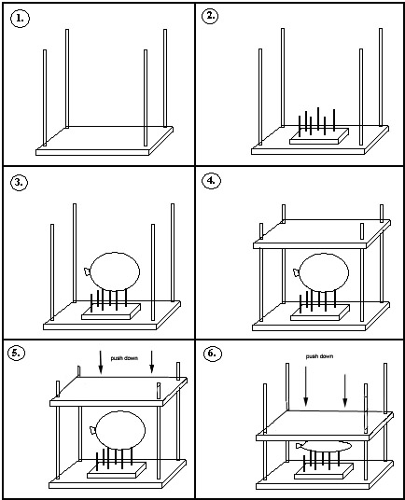

1. Place a supporting rod at each corner of the wood block labeled “Bottom.”

2. Add six nails to the block with 25 holes drilled into it, and place the block in the center of the “Bottom” board. Try a cluster of nails for your first experiment. Draw a diagram of where you placed the nails on the worksheet.

3. Inflate a balloon to the same circumference by measuring with the circumference string.

4. Carefully rest the balloon on the nails and place the block labeled “Top” over the balloon so that the apparatus is stable, confined completely within the support rods.

5. Note the cm mark on the front dowels, and gradually push down on the top board keeping it level as you do so. Another member of the group should be watching the cm marks and note the mark reached when the balloon breaks.
6. Record the cm mark reached on the worksheet under your diagram of nail placements.

7. Repeat the experiment, changing the arrangement of the six nails in the block each time.

Bed of Nails Student Worksheet

Student’s name __________________________________________

Diagram of Nail Placements (Reuse diagrams as needed.)
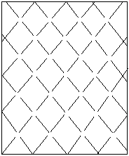
Cm reading __________ Cm reading ________ Cm reading _________

Cm reading _________ Cm reading _______ Cm reading ________

Questions

Did the placement of the nails affect how easily the balloon would pop?

What do you think would happen if the balloon were only partially inflated? Do you think it would have been easier or harder to pop?

What types of nail patterns worked best for holding the most mass? Which patterns held the least mass?

