VANDERBILT STUDENT VOLUNTEERS FOR SCIENCE
http://studentorgs.vanderbilt.edu/vsvs
Rusting
Fall 2009
GOALS
To introduce students to common metals and investigate their oxidation.
To investigate the rusting of iron.
TN Curriculum Alignment: GLE 0507.9.1 Observe and measure the simple chemical properties of common substances.

LESSON OUTLINE
1. What is a Metal?
Show students some different metals and discuss their uses.
2. Oxidation (rusting) of Iron.
A. Rusting of Iron Filings
Students investigate the conditions needed for rusting of iron. They use iron filings exposed to air, iron filings exposed to water, and iron filings exposed to salt and hydrogen peroxide.
B. Commercial Hothands Pack.
Students observe a commercial Hothands pack. They are told that the active ingredients in it include iron, salt and water. They can feel that the activated pack gets warm.
3. How Can We Protect Iron From Rusting?
Students discuss ways that are commonly used to prevent iron from rusting. They compare the rate of rusting of a regular, a galvanized (zinc coated), and a brass coated nail, and a ceramic coated screw put into salt and hydrogen peroxide.
4. Review
5. Optional: Do Other Metals Oxidize?
Students discuss oxidation of aluminum and copper. They put a dull penny into vinegar and notice the return of a copper color as the oxidized layer on it is removed.

Materials
9 plastic bags containing vials of copper, aluminum, zinc, and iron (1 for VSVS team).
8 Hothands
8 plastic bags containing:
1 6-well plate
1 container of iron filings
1 scoop
3 pieces of cotton
3 1 oz cups
1 container of salt with 1 taster spoon inside
8 dropper bottles of hydrogen peroxide
8 dropper bottles of water
8 plastic bags containing:
1 petri dish containing cotton
4 Nails or screws– Brass covered, galvanized, ceramic plated, steel (iron)
8 plastic bags containing:
1 1oz cup
1 dropper bottle vinegar
1 penny
1 Tomato sauce can
1 Soda Can
8 Observation sheets
16 Instruction sheets (with pictures on reverse side)
Set-up:
1. Tell the teacher to divide the class into 8 groups.
2. Write the Vocabulary words: Metal, Oxidation, Rusting, Iron.
3. Write the ingredients of the Hothands on the board (iron powder, water, salt, activated charcoal and vermiculite).
4. Students MUST wear GOGGLES for this lab!!!

1. What is a Metal?
Materials
9 plastic bags containing vials with copper, aluminum, zinc and iron metal pieces.
Give each group a set, and keep one set for VSVS team.

Tell students that metals are a group of chemicals that have similar properties.
They are usually shiny, good conductors of heat and electricity, and can be formed into
different shapes.
Tell students to look at the vials of the metal pieces and ask them how they are used around
the house and in the work place (1 example is included in each vial)?
Copper – outer coating of a penny, inner part of a dime, electrical wiring,
Aluminum – pie pans, soda pop cans, foil
Zinc – inner part of a penny, batteries
Iron - Nails, fences, steel wool scouring pad, cars
Other well-known metals are gold, silver, nickel

Ask students if they know what oxidation is? What are some things that oxidize?
Oxidation usually occurs when an element or compound combines with oxygen.
Cut fruits oxidize – apples turn brown after they have been cut and left exposed to air.
Copper oxidizes and becomes a dull color (new pennies are shiny; older ones are dull).
Silver becomes “tarnished” and black when it oxidizes.
Iron is oxidizing when it rusts and turns a reddish color.

Tell students we are going to investigate the oxidation of iron, commonly called rusting.
Rust is the common name for a very common compound, iron oxide.
Rusting is a very slow process which takes place over several weeks or months.

2. Oxidation (Rusting) of Iron
Ask students to name things that rust?
Anything made of iron, that is left outside (in the rain) will rust faster than things kept dry and inside.
Examples may include gardening tools, bicycles, anything with exposed iron.

Ask students if they have ever seen iron rust in a few seconds? Probably not!
Tell the students they are going to put some chemicals together that will cause rusting in just a few minutes.

Divide class into 8 groups.

2A. Experiment - Rusting of Iron Filings
Give the following to each group of 3-4 students:
1 Observation and Instruction sheet
1 plastic bag containing:
1 6-wellplate
1 container of iron filings
1 scoop
3 pieces of cotton
3 1 oz cups
1 container of salt with 1 taster spoon inside
1 dropper bottle of hydrogen peroxide
1 dropper bottle of water

Tell the students that the iron filings are still metallic iron, just in smaller pieces.

Tell students to:
- Place the cups in the top 3 wells of the well-plate, and place the well-plate on the observation sheet.
- Put 1 piece of cotton in each cup. Note – the reason for using the cotton is to make the
color change due to rusting more obvious.
- Sprinkle iron filings on top of the cotton in each cup (a small scattering is all that is
needed).

Each piece of cotton will now be treated differently. Tell students to follow the diagram on the observation sheet.
- Add NOTHING to the first cup. This is the control cup.
- Add a squirt of water on top of the filings in the 2nd cup.
- Add a sprinkle of salt and a squirt of hydrogen peroxide on top of filings in 3rd cup.

Have the students observe the 3 cups for one minute and then ask them what differences they can see. Have students answer question 1. (Answer: Cup 3 shows evidence of rusting)
After 1 minute:
- The cotton with just iron (cup 1) is unchanged.
- The cotton containing iron and water (cup 2) does not have orange coloring.
- The cotton containing the hydrogen peroxide and salt (cup 3) will have some orange color (rust).

Set aside to observe again later.

Ask students which of the 3 cups had the best conditions for rusting?
Cup 3, because the hydrogen peroxide could supply more oxygen than just air or water
(as in cups 1 and 2), and salt speeds up rusting.

Explanation:
For iron to rust & become iron oxide, 3 things are required: iron, water and oxygen.
The equation for oxidation of iron is: 4Fe + 3O₂ -----› 2Fe₂O₃
Tell students that hydrogen peroxide is a good source of oxygen.
Iron can rust without salt being present, but it will make rusting even faster (it is a catalyst). Iron objects close to the ocean rust faster. Cars rust faster when we salt the roads in the winter to melt ice.

B. Commercial Hothands Pack.
Show the students one of the commercial Hothands. Ask the students if anyone has used one?
Campers or hunters use these to keep their hands warm in cold weather.

Give each group a Hothands pack and tell them to remove the plastic covering and touch the pack so that they can feel that it is at room temperature.
Tell one member in the group to shake it to activate it and then set it aside until after the next experiment has been set up.

How do Hothands work?
- Record the ingredients on the board. (iron powder, water, salt, activated charcoal and vermiculite).
- Tell the class that the “missing ingredient” that is needed to make the hand warmer warm up is oxygen. When the plastic covering is removed, the inside pouch is porous enough to allow air to enter the pouch. The oxygen in air reacts with iron to form iron oxide with the release of heat.
- This is same reaction as rusting (iron + oxygen + water). The iron + oxygen + water reaction in the HotHands pack is 1000 times faster than normal rusting.
For VSVS information only:
Why did the temperature change? The chemical reaction producing the iron oxide is an exothermic reaction, which means that it gives off energy in the form of heat.
In everyday life, why don’t objects that rust get hot? Iron filings have a large surface area in contact with the water or salt, so the rusting occurs very rapidly. Most rusting objects in everyday life, such as cars, shovels, etc., have a smaller surface area that is rusting and thus will not rust nearly as fast and therefore will not generate the heat observed in your experiment.
How does rusting generate heat? Changes in the energy held by chemical bonds in the oxidation of iron yield a net loss of energy from the reactants, and this net loss escapes to the surroundings where it is felt as heat.
3. How Can We Protect Iron From Rusting?
Rusting costs billions of dollars each year.
According to one source (the NACE Foundation), “the effects of corrosion costs $276 billion dollars a year. That is $1000 per person living in the US each year. Natural disasters (hurricanes, tornadoes, flooding etc) cost only $17 billion each year.”

There are 3 main ways to slow down the rusting process. Have students look at the pictures on the Instruction sheet – they illustrate different ways iron can be protected from rusting by preventing water and oxygen from contacting the iron.

1. Cover the metal surface (with paint, oil, soap (steel wool pad), plastic, etc.)
Some screws are coated with plastic. Bicycles and cars are painted.

2. Coat the iron with another metal that will oxidize before the iron will.
Galvanized metal is an example of using a protective coat; iron or steel is coated with zinc.
- Show the students a can of tomato sauce and point out that the inside of the can is coated to protect the steel from the acid in the tomato sauce.
- Other examples include galvanized nails, and zinc coating on ships or boats.
- A water heater has a rod of magnesium, aluminum, or zinc inserted into the tank. This rod acts as a sacrificial metal to protect the steel case forming the tank. The rod made out of a more reactive metal that is preferentially oxidized, thus protecting the steel tank. (Refer to the image on the Instruction Sheet)

Other examples for VSVS information only:
- Zinc will oxidize before iron will. Oxidized zinc will form a tough, protective coating on the outside of the steel or iron, thus keeping the oxygen away from the iron.
- Oxidized iron does not make a protective coating because it flakes off, exposing new iron to be oxidized.

3. Combine iron and other metals to make an alloy (a chemical mixture of a metal with one or more other metals and/or nonmetals)
The more iron present in an object, the faster it will rust if exposed to oxygen.
When iron is alloyed with carbon, it makes steel, which is a strong metal that doesn’t rust quickly.
If iron is alloyed with carbon and chromium, it makes a stronger form of steel (stainless steel) that doesn’t corrode. Most kitchen utensils are made from stainless steel.

Experiment - Preventing Rusting.
Materials per group
1 plastic bag containing 1 petri dish containing cotton
4 Nails or screws– Brass covered, galvanized (zinc coated), ceramic plated, steel (iron)
1 container of salt containing a spoon (from previous experiment)
1 dropper bottle hydrogen peroxide (from previous experiment)

Tell them to:
- Look at the picture on the Instruction sheet so that they can identify each type of nail.
- Place the petri dish with cotton on the observation sheet.
- Add a spoonful of salt over the cotton.
- Place the nails and screws on the cotton in the same order as in the diagram on the Instruction sheet.
- Pour hydrogen peroxide over the cotton and nails.
- Record observations after 1 minute.

The steel nail will show some rusting (orange color on the cotton ball); none of the other nails should show signs of rusting.
Set aside for later observation if time permits.
Have the students answer questions 3 & 4.

Go back to the 1st experiment with iron filings on the cotton balls (2A - Rusting of Iron Filings) and note any more changes in the color on the cotton.
By now, the cotton with just iron (cup 1) is still unchanged.
The cotton containing iron and water (cup 2) may have an orange coloring.
The cotton containing the hydrogen peroxide and salt (cup 3) will have a lot of orange color (rust).
Have the students answer question 2.

Note: The students should now feel the commercial hot hands pack and note that it feels warmer than before.

Have the students answer question 5.

4. Review
- What is the chemical name of rust? Iron oxide
- What is the chemical name for the process of rusting? Oxidation.
- What is needed for rusting to occur? Iron, water and oxygen
- What can make iron rust faster? The presence of salt, more oxygen, as provided by hydrogen peroxide.
- How can rusting be prevented? Coating the iron with something (such as paint, plastic, zinc (galvanizing), chrome (chromium electroplated onto surface) or brass (alloy of copper & zinc)), making an alloy (steel, stainless steel).

5. Optional (if time permits): Do other Metals oxidize?
This activity can be done if all other experiments have been completed, including the review.
Materials for each group:
1 plastic bag containing:
1 1oz cup
1 dropper bottle of vinegar
1 penny
Copper can oxidize – old pennies have a dull grey color, while new pennies are a shiny copper color. The coating is copper oxide. Old pennies can have their shiny color restored by removing the oxide layer.
Tell students to:
1. Put the 1 oz cup into the last well in the well-plate
2. Pour vinegar over it to cover it
3. Observe what happens
The dull coating should disappear after about 5 minutes.
Have the students answer question 6.

Aluminum
Aluminum also oxidizes, but the aluminum oxide layer cannot be seen very easily. Soda cans have a plastic liner on the inside to prevent the carbonic acid in the liquid from reacting with the aluminum. Have students look at the picture on the Instruction sheet that shows this plastic coating and show them the actual can from the kit.

*Some materials adapted from cKit Experiments from the NACE Foundation

Lesson Written by Pat Tellinghuisen (Vanderbilt Student Volunteers for Science Director)
& Courtney Luckabaugh (Vanderbilt University Undergraduate Lab Assistant)
Rusting Instruction Sheet
1. What is a Metal?
1. Look at the vials of the metal pieces.
2. How they are used around the house and in the work place?
3. Discuss the definition of oxidation.

2. Oxidation (Rusting) of Iron
1. Place the cups in the top 3 wells of the well-plate, and place the well-plate on the observation sheet.
2. Put 1 piece of cotton into each cup.
3. Sprinkle a small scattering of iron filings on top of the cotton in each cup.

Each piece of cotton will now be treated differently. Follow the diagram on the observation sheet.

1. Add NOTHING to the first cup. This is the control cup.
2. Add a squirt of water on top of the filings in the 2nd cup.
3. Add a sprinkle of salt and a squirt of hydrogen peroxide on top of filings in 3rd cup.
4. Observe the 3 cups for one minute and record the differences you can see.
Set aside to observe again later.

Which of the 3 cups had the best conditions for rusting?

2B. Commercial Hothands Pack (1 for each group).
1. Remove the plastic covering and touch so you can feel that it is at room temperature.
2. One member in the group should shake it to activate it and then set it aside until after the next experiment has been set up.

3. How Can We Protect Iron From Rusting?
Discuss the 3 main ways to slow down the rusting process.

Experiment - Preventing Rusting.
1. Look at the picture on the other side of this Instruction sheet to identify each type of nail.
2. Place the petri dish with cotton on the observation sheet.
3. Add a spoonful of salt over the cotton.
4. Place the nails and screws on the cotton in the same order as in the diagram on the other side of this
Instruction sheet.
5. Pour hydrogen peroxide over the cotton and nails.
6. Record observations after 1 minute then set aside.
7. Go back to the 1st experiment with iron filings on the cotton balls and note any more changes in the
color on the cotton.

Commercial Hothands Pack
Members of your group should now feel the commercial hot hands pack and note the temperature change.

4. Review

5. Optional (if time permits): Do other Metals oxidize?
This activity will be done if all other experiments have been completed. It can also be done at home.
Other metals, including copper can oxidize – old pennies have a dull grey color, while new pennies are a shiny copper color. The coating is copper oxide. Old pennies can have their shiny color restored by removing the oxide layer with an acid.
1. Place a 1 oz cup into the labeled well in the well-plate and put a dull-looking penny into it.
2. Pour vinegar over it to cover it.
3. Observe what happens.
Preventing Rusting Experiment
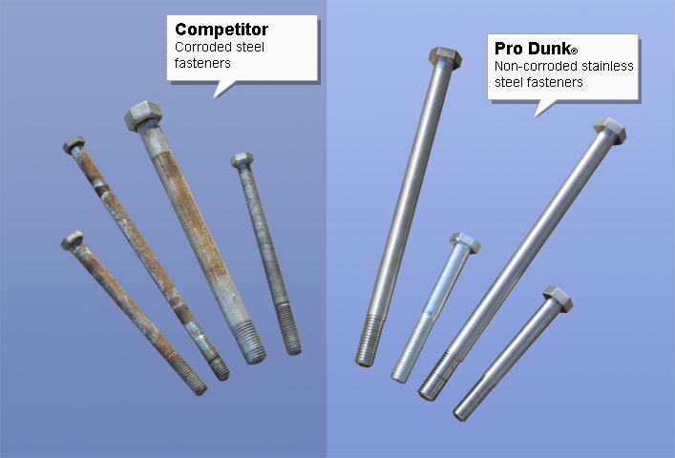
Without protection, iron products will be more likely to rust. The bolts on the left rusted because they had nothing preventing it.
The bolts on the right are made of stainless steel, so they are less likely to rust.
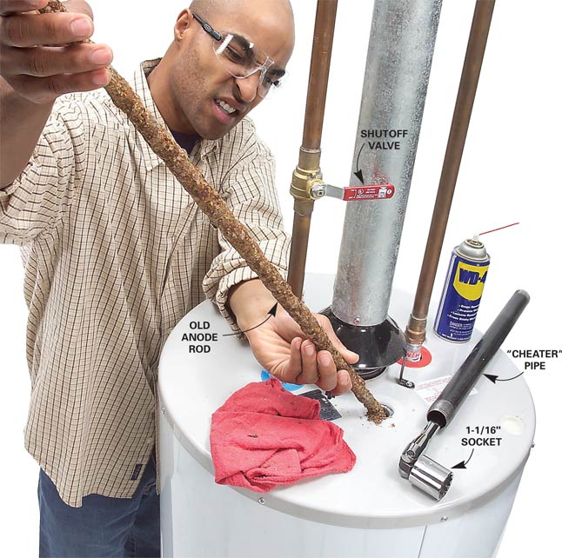
Water heaters contain a
rod of a non-iron metal,
like the one this man is
holding, so that instead
of the tank (steel/iron)
rusting, the metal rod
will become corroded.
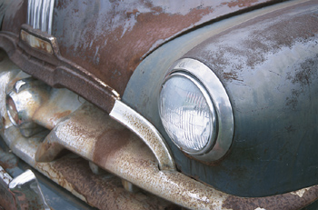
When the paint wears off
or chips, the car rusts.
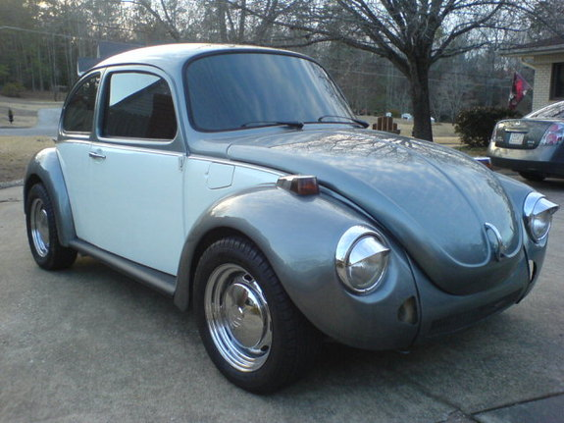
By painting cars and bicycles,
we protect them from rusting.
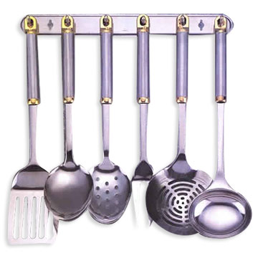
Stainless Steel Utensils
(Metal Alloy of Iron,
Carbon & Chromium)
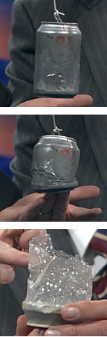
Like iron, aluminum also oxidizes. To prevent the carbonic acid in the soda from reacting with the aluminum, soda cans are lined with a thin layer of plastic on the inside as shown above.
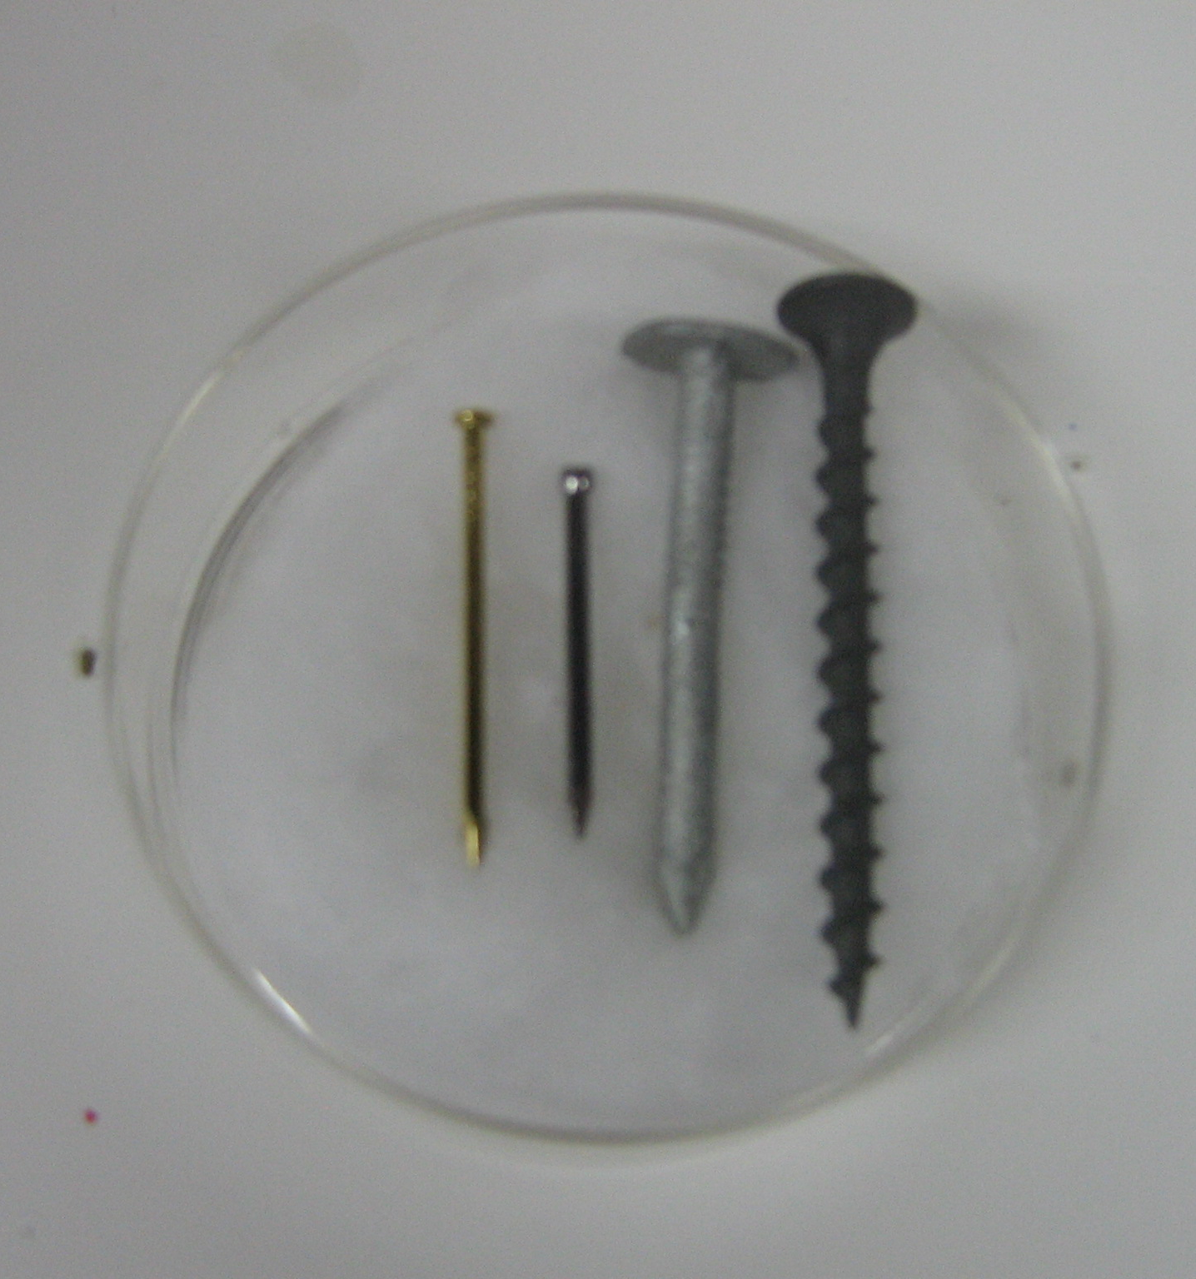
Placement of Nails
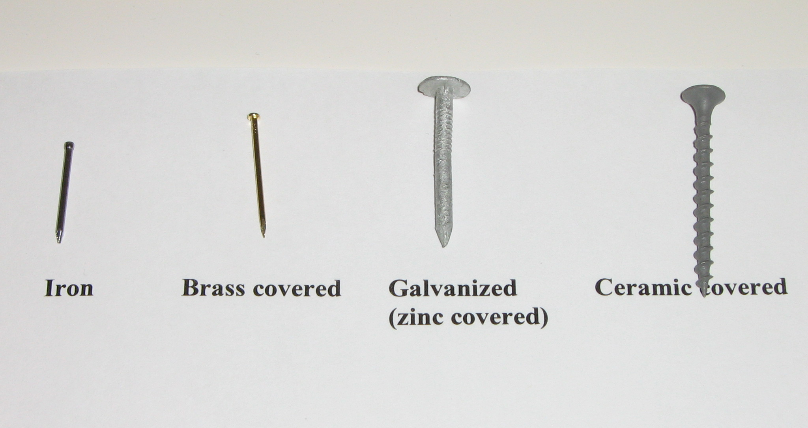
Nail Identification
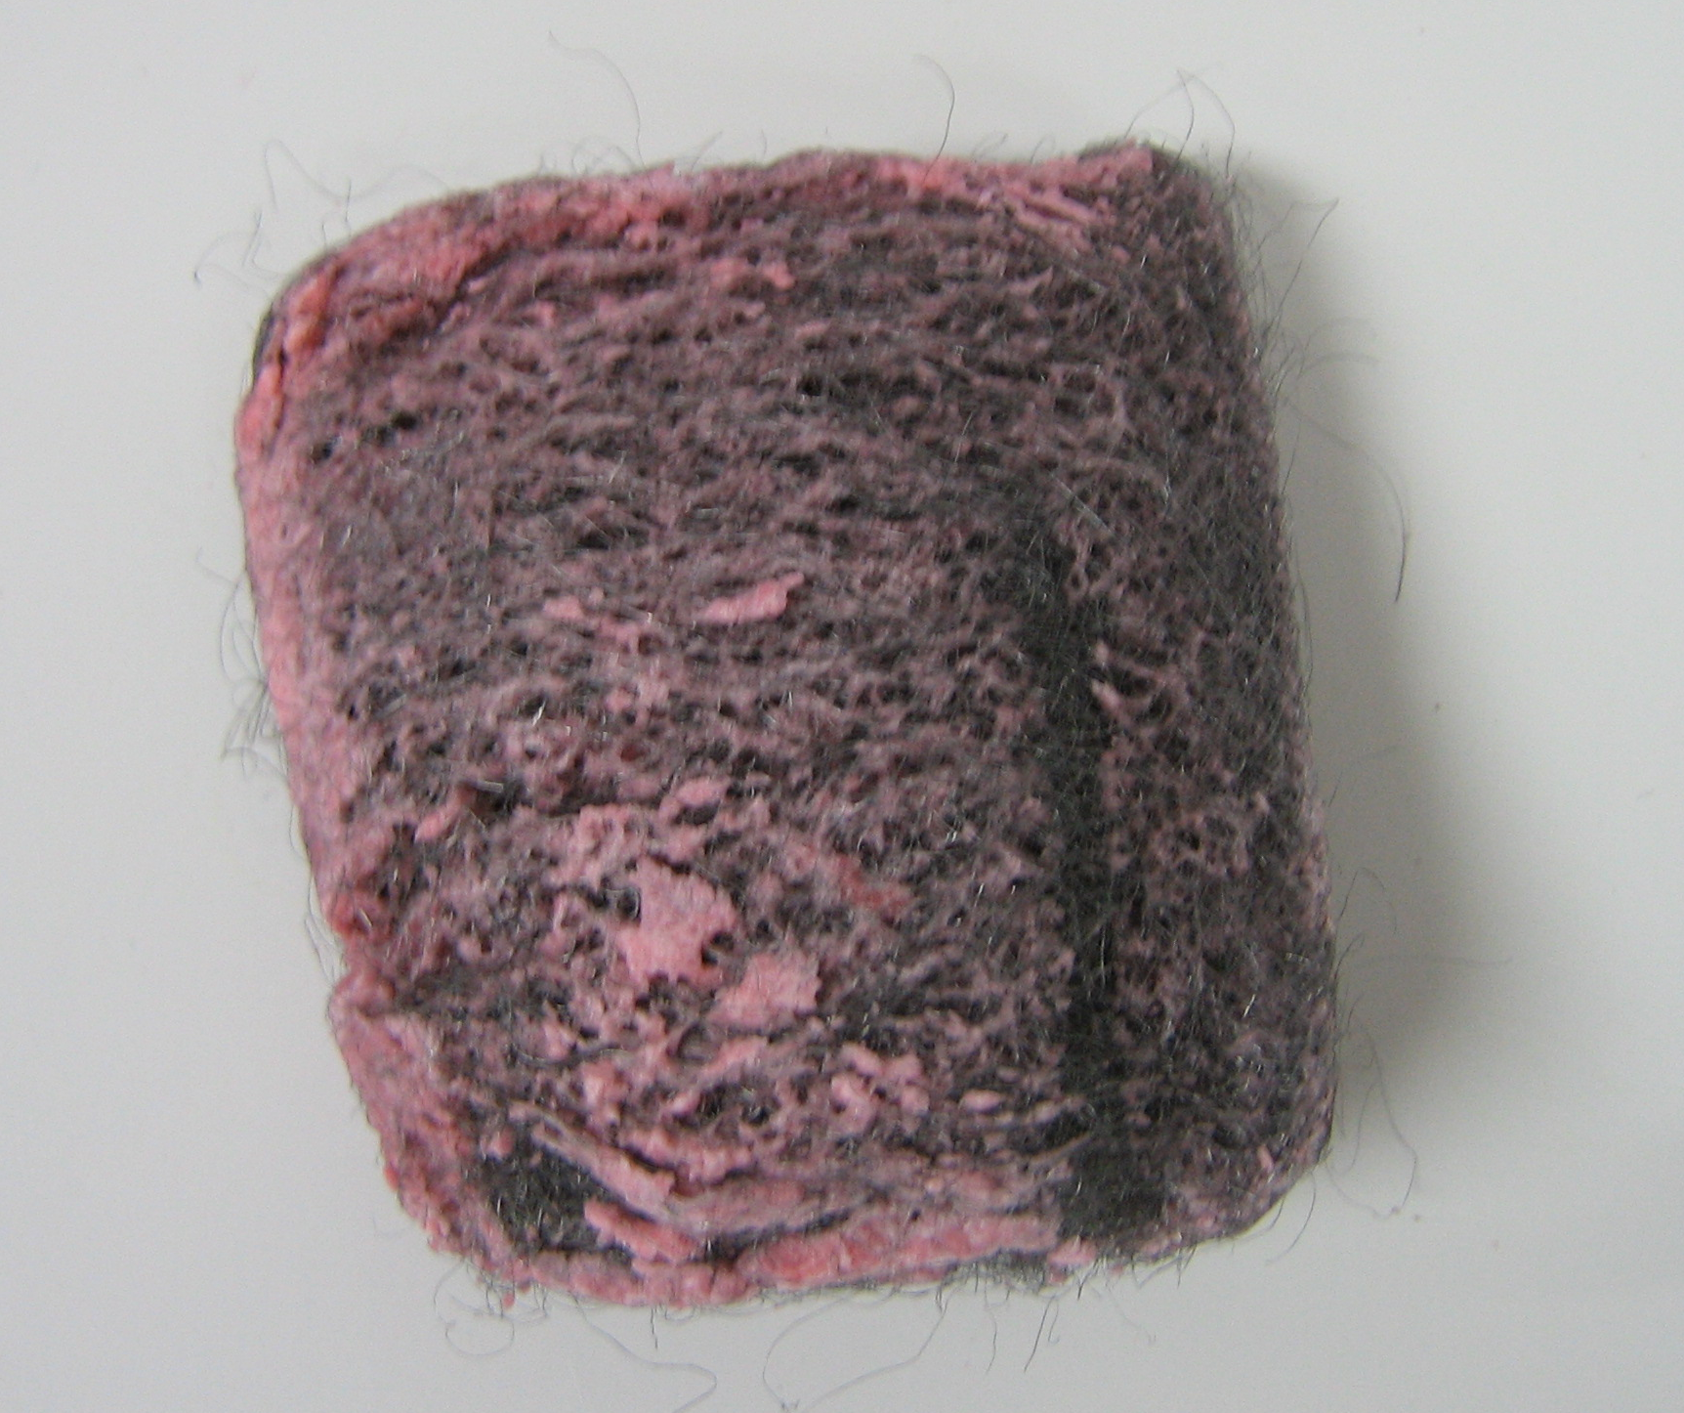
Steel wool pad
with soapy
coating (pink)
Ways to Protect Iron from Rusting
Name_______________________________

Rusting Observation Sheet
Iron Fillings
(Control)
Iron Fillings
Water
Iron Fillings
Salt & Hydrogen Peroxide
Dull Penny & Vinegar
1
2
4
6
5
4

1. Which cup showed rusting after 1 minute? ___________________________________
2. Which cup showed rusting after 20 minutes? __________________________________
3. Which nails rusted? ____________________________________________________________________
4. Which nails did not rust? _______________________________________________________________
5. What happened to the Hothands Pack after it was activated?
______________________________________________________________________________________
6. What happened to the dull penny when exposed to vinegar?
______________________________________________________________________________________
Name_______________________________

Rusting Observation Sheet (ANSWERS)
Iron Fillings
(Control)
Iron Fillings
Water
Iron Fillings
Salt & Hydrogen Peroxide
Dull Penny & Vinegar
1
2
3
6
5
4

1. Which cup showed rusting after 1 minute? Cup 3 shows evidence of rusting.
2. Which cup showed rusting after 20 minutes? Cup 3 shows lots of rust. Cup 2 shows some rusting.
3. Which nails rusted? The steel nail rusted.
4. Which nails did not rust? The brass covered, galvanized (zinc coated), and ceramic plated nails/screws did not rust.
5. What happened to the Hothands Pack after it was activated? It became warmer.
6. What happened to the dull penny when exposed to vinegar? It became shiny/looks new.

