VANDERBILT STUDENT VOLUNTEERS FOR SCIENCE
http://studentorgs.vanderbilt.edu/vsvs
pH
Spring 2016

Goal: To introduce students to acids, bases and the pH scale.
Fits Tennessee standards: SPI 0507.9.1: Distinguish between physical and chemical properties
SPI 0807.9.12 Identify the basic properties of acids and bases

Lesson Outline
I. Demonstration: Mystery Liquids.
Use litmus paper to test three “mystery” liquids, and note colors. Then add red cabbage juice to the
“mystery” liquids and note colors. Explain what indicators are. Do not identify the liquids in the glasses at this time, but set them aside for later.
II. Discussion of Acids and Bases.
Some general properties of acids and bases are discussed.

III. Explanation of the pH Scale.
Write the letters pH on the board, and give brief explanation. Give each pair one of the pH charts
and an instruction sheet. Point out the acid, neutral and base regions.
IV. Demonstration: Making a Color pH Scale Using Solutions of a Known pH.
One person from the VSVS team should put the “Colors of Known pH Solutions” Chart on the board. Students observe colors for 14 known pH solutions when red cabbage juice is added.
V. Testing the pH of Household Items.
One person from the VSVS team should put the Household Items Chart on the board. Students test
several household items with cabbage juice and record the colors they observe. Each group matches
these colors with the known solutions and records the pH for the known solution that gives the best
match.
VI. Analyzing Introductory Demonstration.
Ask students if they can identify the liquids in the glasses from Demonstration I as acids, bases, or
neutrals based on the colors.

VII. Demonstration, Magic Foam, AKA Cabbage Volcano
The demonstration uses milk of magnesia, red cabbage juice, sodium bisulfate, sodium carbonate.

VIII. Review.

Discuss review questions in the context of vocabulary words.
Materials:
2 8 oz bottles of red cabbage juice
1 plastic bag containing: (for introduction - Mystery Liquids)
3 10 oz. clear plastic glasses
1 4 oz. bottle white vinegar - labeled A
1 4 oz. bottle of water - labeled W
1 4 oz. bottle of window cleaner - labeled B
3 strips of red litmus paper
3 strips of blue litmus paper

1 set 4 oz jars containing pH 1-14 buffers (in plastic container) - labeled
14 dropper bottles of red cabbage juice (1 per pair)
14 24 well trays (with lids) in plastic container
7 plastic bags (pairs will share) containing
7 dropper bottles with sprite, window cleaner, tap water, vinegar, laundry detergent, lemon juice, rain water
For Magic Foam demonstration:
1 plastic bottle with the top cut off
1 large (8-oz) bottle of red cabbage juice
1 clear plastic container containing:
milk of magnesia, solution of sodium bisulfate, sodium carbonate solid, 1 plastic spoon
1 binder containing
32 pH observation sheets, 16 pH charts, laminated,16 Instruction Sheets (in sheet protectors)

1. In the car ride, read through this quiz together as a team. Make sure each team member has read the lesson and has a fundamental understanding of the material.
- What is the purpose of the cabbage juice and the litmus paper in this experiment? How can you analyze their effects?
- What does it mean to be acidic? What does it mean to be basic?
- Which of the following is NOT a property of a base?
  - Bitter
  - Corrosive
  - Slippery
  - More [OH⁻] than [H⁺]
- Label each substance as acidic, basic, or neutral:
  - Lemon juice
  - Vinegar
  - Window cleaner
  - Tap water
  - Rainwater
- A solution with a pH of 9 is how much more basic than a solution with a pH of 5?

2. Use these fun facts during the lesson:
- Stomach acid has pH of approximately 1.5 – 3.5
- Different plants grow the best in soils of different pHs. Thus, some people treat their soil to make it more or less acidic so that their plants can grow better.
- Similarly, different fish thrive in water of different pHs, and thus this pH must be monitored for a fish’s health.
- The pH of the water in a pool must be maintained at around 7.5 for optimal effectiveness of chlorine. The chlorine won’t destroy pathogens (germs) as well if the water is too basic, and it will escape too quickly if the water is too acidic.
- The pH of blood is about 7.35-7.45, making it slightly basic, while the pH of skin averages at about 5.5, making it acidic. The acidity of skin makes it an unfriendly environment for harmful bacteria and fungi.
Unpacking the Kit:
VSVSers do this while 1 person is giving the Introduction. Note that students are put into pairs and should have their pencils ready
Write the following vocabulary words on the board: acids, bases, neutral, pH, indicator
For Part I. Introductory Demonstration - Mystery Liquids 1 plastic bag containing: 1 8 oz bottle of red cabbage juice, 3 10 oz. clear plastic cups, 14 oz. bottle labeled A (vinegar), 1 4 oz. bottle labeled W (water), 1 4 oz. bottle labeled B (dilute ammonia), 3 strips red litmus paper, and 3strips blue litmus paper

For Part IV. Demonstration: Making a Color pH Scale Using Solutions of a Known pH
14 labeled 4oz jars containing pH 1-14 buffers, 1 8 oz. container of red cabbage juice, 16 pH charts

For Part V. Testing the pH of Household Items

7 bags containing: 1 dropper bottle each of: sprite, tap water, window cleaner, vinegar, lemon juice, laundry detergent, rain water
14 well plates (1 per pair), 14 dropper bottles of cabbage juice, 30 observation sheets (1 per student), 14 Instruction sheets

For Part VII. Demonstration: Magic Foam, AKA Cabbage Volcano
1 plastic bottle with the top cut off, 1 large (8-oz) bottle of red cabbage juice,
1clear plastic container containing: milk of magnesia, solution of sodium bisulfate, sodium carbonate solid, 1 plastic spoon

I. Introductory Demonstration
Materials:
1 8 oz bottle of red cabbage juice
3 10 oz. clear plastic glasses
1 4 oz. bottle labeled A (vinegar)
1 4 oz. bottle labeled W (water)
1 4 oz. bottle labeled B (window cleaner)
3 strips red litmus paper
3 strips blue litmus paper
Demonstration:
- Have 2 VSVS volunteers hold the 3 clear plastic glasses up so students can see them.
- Tell the students that you have some mystery liquids.
- Pour the contents of the bottle labeled A into the first glass.
- Pour the contents of the bottle labeled W into the second glass.
- Pour the contents of the bottle labeled B into the third glass.
- Have a student describe the three liquids they see.
N Note: Students should not be close enough to smell the liquids. Describe liquids based on visual cues only.
- Ask students if they have ever heard of litmus paper. If so, what is it used for? Litmus paper is used to test whether something is acidic or basic.
- Test each glass of clear liquid by dipping first the red and then the blue litmus paper into the liquid and noting what changes, if any, occur.
- Ask students to record the changes on their observation sheets.
- Then, one at a time, hold each glass of clear liquid up for the students to observe as you pour a little cabbage juice into each of the liquids until the color is strong enough for students to see.
- Ask students to record the color changes.
Note: Do not identify the liquids at this point. The vinegar should turn pink or red, the water should
dilute the cabbage juice to a lighter shade of purple, and the window cleaner should turn blue-green.

Explain to the students:
- Indicators are substances that change colors when mixed with an acid or base.
- Indicators are a safe way to help scientists identify whether a substance is an acid or a base.
- Litmus paper is an indicator that also identifies whether a substance is an acid or a base.
- In this experiment, the liquids turned different colors because one is an acid, one is a base, and one is a neutral (neither an acid nor a base).
- RED cabbage juice was the indicator used to cause this color change. Tell students it was made from red cabbage bought in the grocery store. It was blended with water and then strained.
- Tell the students that you will see if they can tell you what was in each of the glasses after they do the experiments in today’s lesson.

II. Discussion of Acids and Bases
- Ask students: Can you name some common acids?
  - Responses may include references to battery acid, acid indigestion, acid rain, citric acid.
- Ask students: Can you name some bases?
  - Most students know less about bases than acids. The most common response here is a reference to bases in softball or baseball.
  - Common bases include soaps, detergents,
Share the following information about acids and bases with the students. Select the information that is appropriate for the class you are teaching. Feel free to add other appropriate information, but keep this discussion brief.
- Acids:
  - Natural acids in food give foods a sour, sharp flavor (like lemons).
  - Strong acids can burn your skin.
  - Many acids are corrosive. They eat away metals and other substances.
  - Some acids can be helpful. The acid in your stomach aids in digestion.
  - Two acids (sulfuric acid and nitric acid) cause damage in acid rain.
- Bases:
  - Bases taste bitter and feel slippery.
  - Some bases are used to settle upset stomachs.
  - Detergents and many cleaning solutions are basic.
  - Strong bases can burn the skin.

III. Explanation of the pH Scale
- Ask students: How can scientists tell which solutions are more acidic or more basic than other solutions? Litmus paper can only tell you if a solution is an acid or a base. Other indicators can tell you how acidic or basic something is by different shades of color.

Refer to the letters pH on the board.
- Scientists developed a way to measure the acidity or basicity when small amounts of acids or
bases are present in water. This is called the pH scale.
- Give a pH chart to each pair and use your copy to briefly point to acid, neutral, and base regions on the chart as you explain the pH scale (acids 0-6, neutrals 7, bases 8-14).
- On the pH scale, 0 is the most acidic solution and 14 is the most basic solution.
- Students will be testing several common liquids found in the home that are examples of solutions that have pH values within this range.

IV. Demonstration: Making a Color pH Scale Using Solutions of a Known pH
For VSVS information only: A pH of 0 is a 1M solution of a strong acid such as hydrochloric acid. A
pH of 14 is a 1 M solution of a strong base such as sodium hydroxide. Like the Richter scale used to
measure the extent of ground movement in earthquakes, the pH scale is a logarithmic scale. This means
that a substance at pH 6 is ten times more acidic than a substance of pH 7, a substance at pH 5 is one
hundred times more acidic than a substance of pH 7 and so on.
The important concept at this grade level is to understand the 0-14 scale that identifies which
substances are acids and bases. It is not necessary to spend lots of time explaining the logarithmic aspect of the scale.
Important: More concentrated solutions of acids and bases exist that go beyond either end of this scale.

There is some debate as to what “pH” stands for. The “H” stands for hydrogen, but there is controversy as to what the “p” stands for. Some say it stands for “power of hydrogen”; others argue that it stands for the German word potenz or the French words puissance or pouvoir, which mean power. Yet others contend that it stands for the Latin terms pondus hydrogenii, potential hydrogenii, or potential hydrogen. Another theory is that the creator of the term, Sorensen, simply used the letter “p” to label the test solution and “q” for the reference solution. In modern chemistry, however, the “p” now means “decimal cologarithm of”.

Materials:

14 labeled 4 oz jars containing pH 1-14 buffers
1 8 oz container of red cabbage juice
- pH charts

- Scientists use indicators to determine the pH of substances. In this lesson, we will use red cabbage dye as an indicator.
- Put the “Colors of Known pH Solutions” table on the board (without answers entered). Write in the colors as you add cabbage juice to each pH buffer . (Accept other color names as long as they are similar to those on the chart.)

Colors of Known pH Solutions
pH Number | Answers:Color (after cabbage juice is added)
1 | Red
2 | Red
3 | reddish-pink
4 | pinkish-lavender
5 | pink-purple
6 | purple
7 | purple
8 | blue (blue-green)
9 | blue
10 | Green
11 | green-yellow
12 | Yellow
13 | Yellow
14 | Yellow

- Organize the jars in pH 1-14 order. Place them so that all students can see them.
  - Point out that all liquids are clear but are all different strengths of acidity or basicity.
  - Each labeled jar corresponds to a specific pH. Each of these will turn red cabbage juice a different color and these colors will be used later in the lesson to determine whether household items are acids or bases.
  - The colors should correspond to those on the student’s color chart.
Start with the pH 1 bottle and add cabbage juice until the color is strong enough for students to see. (Note: color should be red).
Continue adding cabbage juice to the other jars, moving from pH 2 to pH 14.
- After each addition, tell students you are using a solution that is 10X more acidic or basic.
- Ask students to check their pH chart to see what solution has a pH of 7 (neutral, as in distilled water).

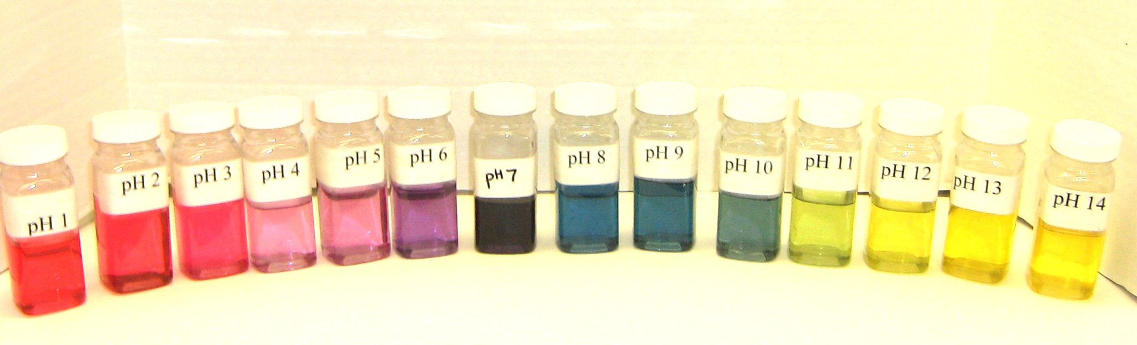
- Have them look at their chart to confirm the colors and record the colors on the table on the board.
- Point out the acidity/basicity of the household items listed on the chart.
Explain that the acidic solution in their stomach helps to break down the food they eat into forms
their body can use during the process of digestion.
- Tell students that the pH 1 and 14 are the extremes of the pH scale. For every pH between 1 and 14, there is a unique color of red cabbage juice indicator.
- The students now have a pH scale to use as a reference guide in determining the pH of their household solutions.
- Ask students:

When red cabbage juice is used as the indicator, what color do the acid solutions turn?

shades of pink or red.
When red cabbage juice is used as the indicator, what color do the basic solutions turn?
shades of blue or green. pH 12 and 14 then turn yellow.

V. Testing the pH of Household Items

Materials per group of 4:

1 bag containing: 1 dropper bottle each of: sprite, tap water, window cleaner, vinegar, lemon juice, laundry detergent, rain water
2 well plates (1 per pair)
2 dropper bottles of cabbage juice
4 observation sheets (1 per student)
2 Instruction sheets

Note: Organize the class into groups of 4. The students will do the experiment in pairs, but 2 pairs will share the household solutions. Give each pair one of the instruction sheets. A VSVS team member will still need to give instructions. You will still need to guide them through the procedures, making sure they understand the instructions.
- Tell students that they will test several household items to determine if they are acids, bases, or neutrals.
- Put the Testing Household Items chart on the board (not the answers - leave 2nd and 3rd column blank)
- Tell the students to place the well plate beside the Instruction sheet. The template on the bottom of the Instruction sheet tells which household item should be added to which well.
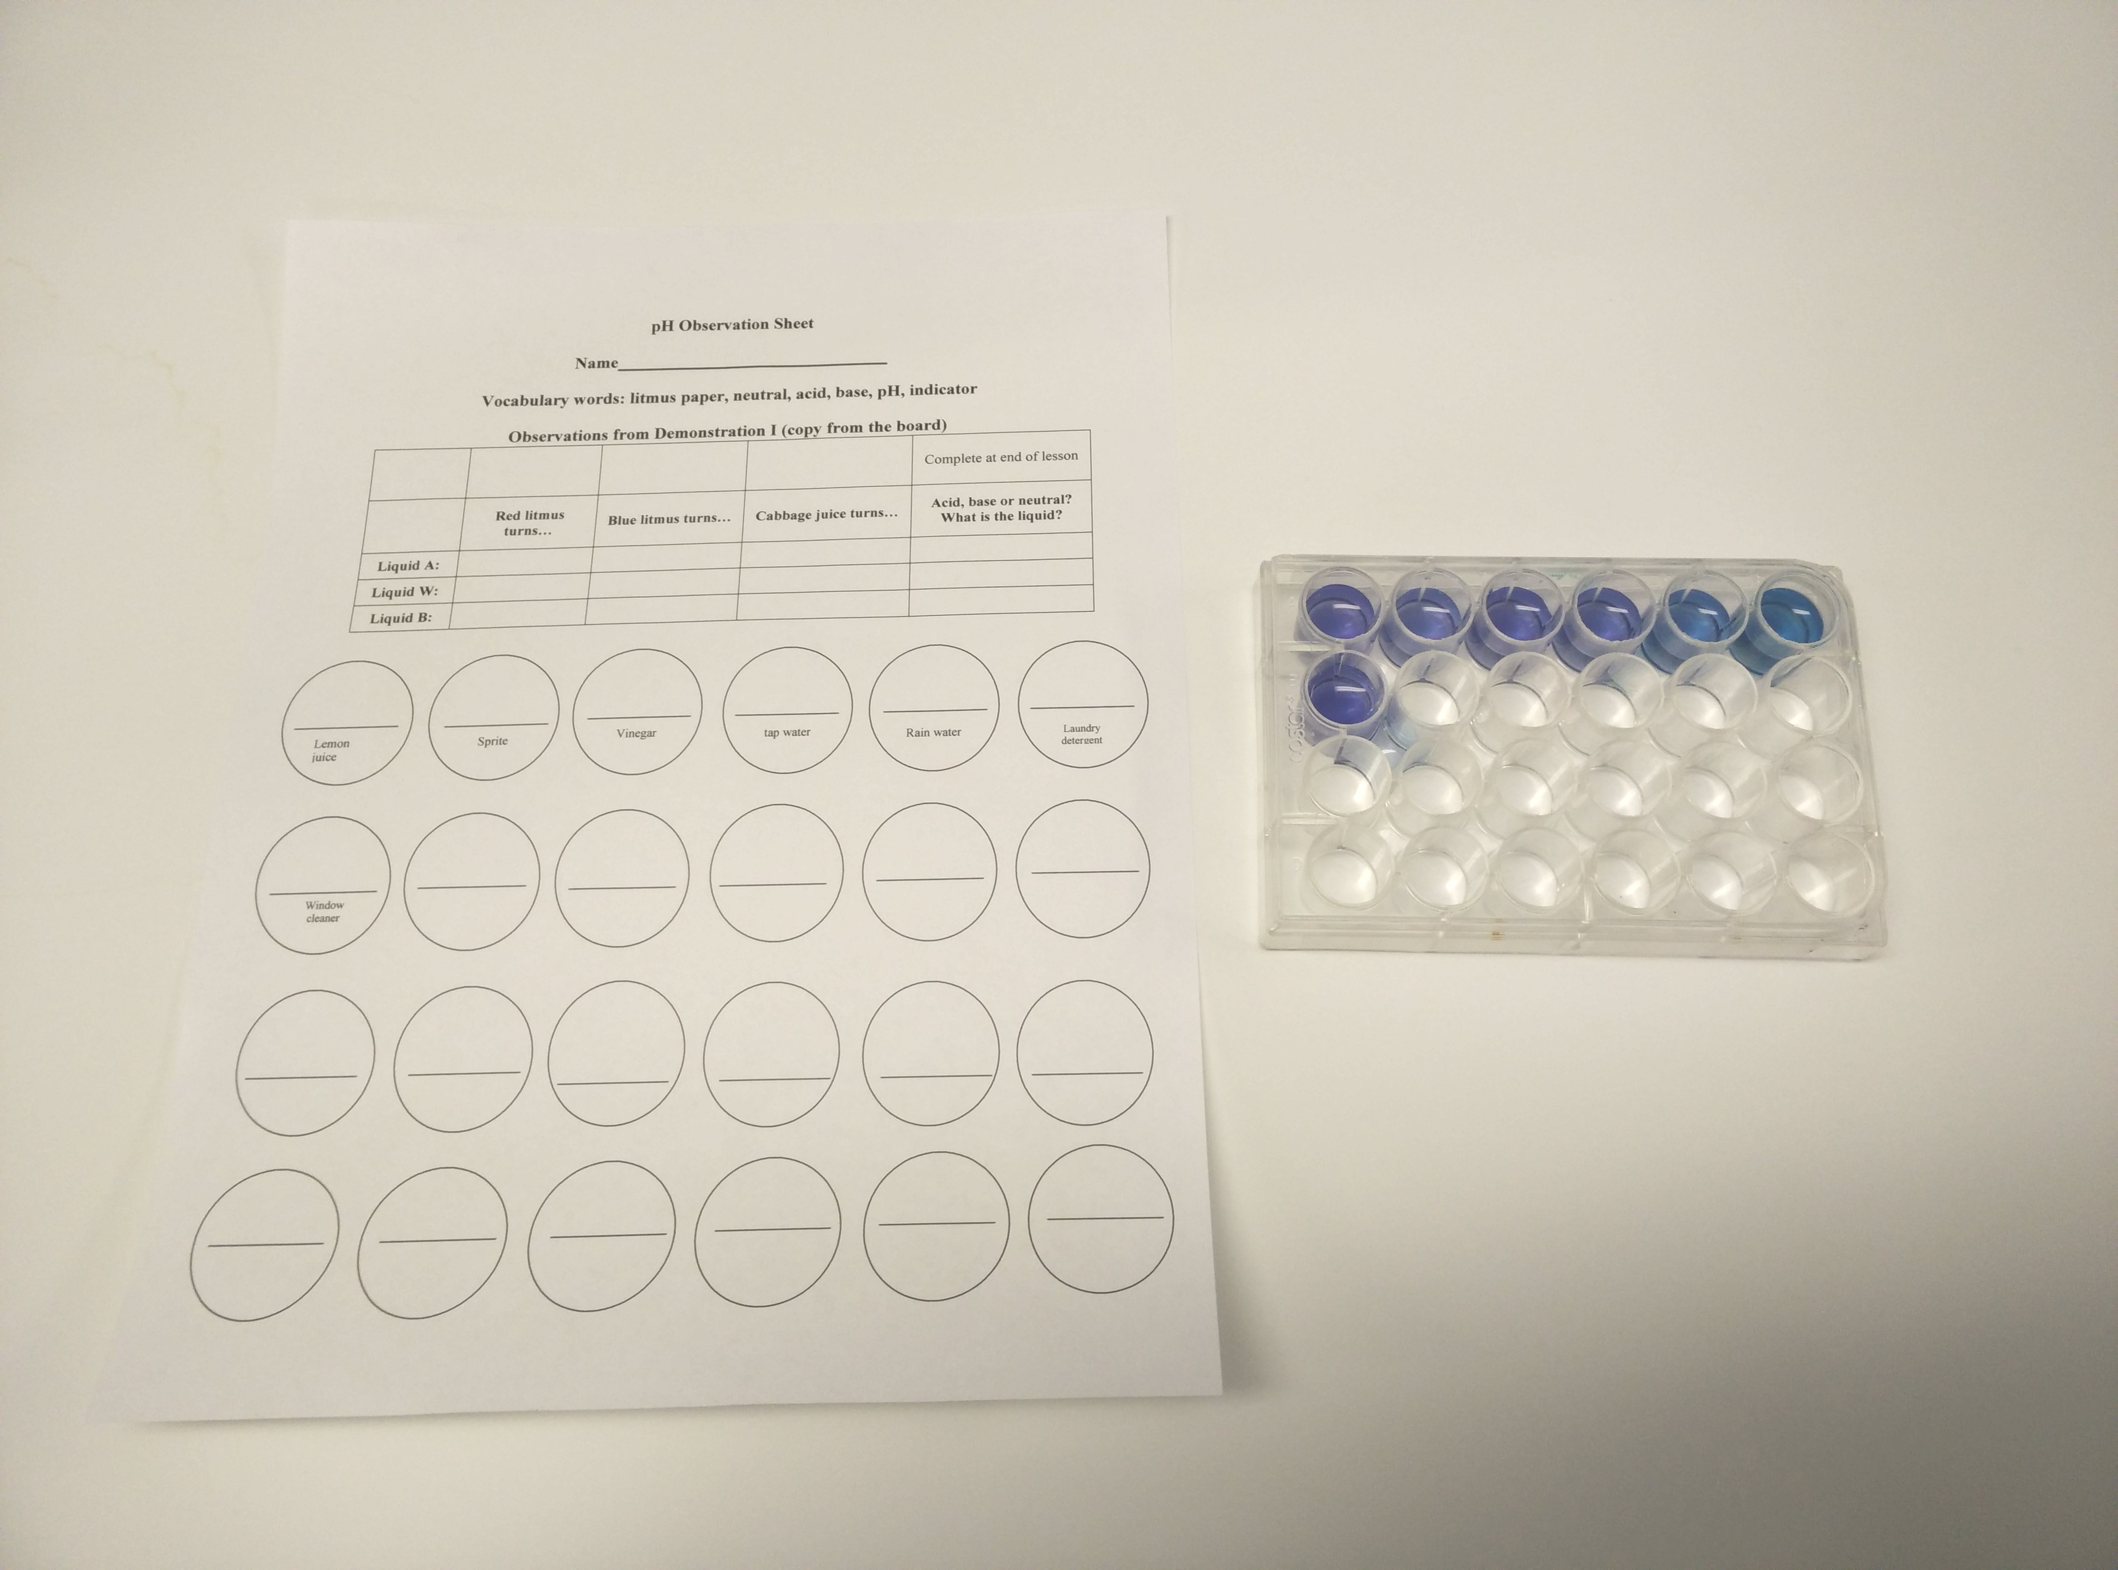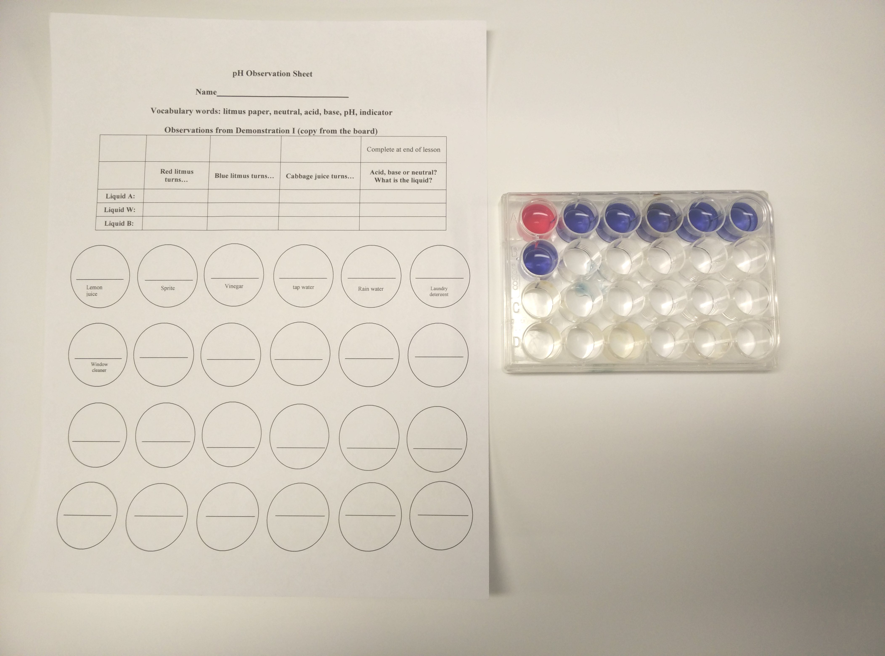

- Demonstrate how to squeeze the bottle to add several squirts of cabbage juice into the well. (The well should be about 1/2 full.) Do not fill the wells completely.
- Tell students to add several squirts of cabbage juice to the 6 wells in the 1st row of the well plate and the first well of the second row until the wells are about 1/2 full.
- Remind students that the dropper bottle should not touch the cabbage solution, since this would cause contamination.
- Tell students to add a squirt of the liquid household solution to the cabbage juice.
- Students should look at the color changes on the observation sheet, compare the color of the household solution with the known pH solutions and the pH color chart and decide on a pH value based on the closest match. Then they should record the pH for the known solution that most closely matches the household solution.

Testing Household Items - Answer Sheet
Item | Final Color | pH Result of Test
Item | (pink, red, purple, blue, green) | (acid, base, neutral,  and closest pH #)
lemon juice | Answer: red/pink | Answer: acid, 2
sprite | Answer: pinkish  lavender | Answer: acid, 4/5
vinegar | Answer: red or pink | Answer: acid, 3
tap water | Answer: blue | Answer: base, 8
rain water | Answer: purple | Answer: neutral or acid, 7/6/5
window cleaner | Answer: green | Answer: base, 10
laundry detergent | Answer: blue/green | Answer: base, 9/10

VI. Analyzing Introductory Demonstration
- Get the three glasses of mystery liquids from the introductory demonstration I.
- Ask students to use their observations from today’s experiment to determine
(1) whether the liquids are acid, base, or neutral, and
(2) what they think the identity of the liquids are.
- Have them record their predictions in the right column of the table at the top of the observation sheet
- After they have finished, review their predictions.
Liquid A is an acid (red color) and is vinegar.
Liquid W is neutral (purple color) and is tap water.
Liquid B is basic (blue-green color) and is window cleaner.

VII. Demonstration: Magic Foam – Cabbage Juice Volcano

Materials:
1 tall plastic bottle with the top cut off
1 clear plastic container (to catch overflow)
1 Ziploc bag with containers of red cabbage juice, milk of magnesia, sodium carbonate (solid), sodium bisulfate (solution) and one plastic spoon
Note: sodium hydrogen sulfate = NaHSO₄, also known as sodium bisulfate
sodium carbonate = Na₂CO₃
Note: Be sure to hold the container with the cut-off bottle level since foam will come over the top of the
bottle at various times during the demonstration.
Safety Note: Eye or skin contact with chemicals should be avoided. If contact occurs, immediately flush with water.

- Tell students to use their best powers of observation as they watch this demonstration.
- Place the cut-off bottle in the center of the clear plastic container.
- Pour all of 8-oz container of red cabbage juice into the cut-off bottle.
- Have another VSVS volunteer carefully hold the plastic container with the bottle in front of the class so all students can see the experiment as the chemicals are added.
- Shake up the milk of magnesia and add all the contents to the cabbage juice. Slowly swirl the bottle.
  - Ask students what color the cabbage juice is now. green
  - What would the pH of the milk of magnesia be? basic
- Add half of the acidic solution (sodium hydrogen sulfate) and swirl. Be sure students note the color change. (changes to red)

Be prepared for foaming and awe from the audience in the next step.

- Add two plastic spoons of the basic solid (sodium carbonate). The foam will form quickly, reach the top of the bottle, and probably overflow a little. The solution will change colors, showing blue, purple, and pink at different places in the foam.

- Add the remaining acidic solution and swirl. More foaming will occur.

- Ask students: Why does the solution foam?
The sodium carbonate, Na₂CO₃, reacts with acid (NaHSO₄ in this case) to form the gas, carbon dioxide, CO₂. This produces foam. This is similar to adding vinegar to baking soda.
The color changes in the foam are a result of the mixing of the acid and base to give different
colors as they neutralize each other.
Local colors of pink or blue are caused by a greater concentration of acid or base in that
region.
For VSVS Information Only: You can share this information with the class if time permits.
At the beginning of the magic foam experiment, milk of magnesia turned the cabbage juice green because it is a base. Milk of magnesia was then neutralized by the acid, sodium hydrogen sulfate, going through several colors to give a reddish-pink color because an excess of acid has been added. When the base, sodium carbonate was added, carbon dioxide gas was produced from the reaction with the acid, sodium hydrogen sulfate

VIII. Review

Discuss review questions in the context of the vocabulary words.
- What scale is used to determine how acidic or basic a dilute solution of an acid or base is? pH scale
- How is this scale useful to scientists? It provides a comparison that is universally recognized, not only by scientists but by the informed public.
- On the pH scale, what numbers represent acids? 0 – 6
- On the pH scale, what number represents a neutral? 7
- On the pH scale, what numbers represent bases? 8-14
- When using red cabbage juice as the indicator, what color do acidic solutions turn? shades of pink or red
- When using red cabbage juice as the indicator, what color do base solutions turn? shades of blue and green, except pH 13 and 14 which turns yellow
- Is there an advantage to using red cabbage juice instead of litmus paper to test acids and bases?
Yes, litmus paper only undergoes one color change to indicate whether something is acidic
or basic. Red cabbage juice has a range of color changes that indicate the range of acidity or basicity. For example, red cabbage juice will show that Sprite is not as acidic as vinegar, even though both are acids. Litmus paper would show that both were acids but would not distinguish which one was more acidic.
Cleanup: One of the VSVS volunteers should take the magic foam demonstration bottle to the nearest sink and pour the contents out. Wash down the drain with lots of water, and rinse out the bottle. Be sure
to return the bottle with the kit.

Reference: Fun with Chemistry, Vol. 2, 2nd edition; Sarquis, M; Sarquis, J. Eds., Publ. 91-005, Institute for Chemical Education, University of Wisconsin: Madison, 1991; pp. 53-62.
Lesson written by: Dr. Melvin Joesten, Chemistry Department, Vanderbilt University
Pat Tellinghuisen, Director of VSVS, Vanderbilt University
Susan Clendenen, Teacher Consultant, Vanderbilt University
Dr. Todd Gary, former Coordinator of VSVS, Vanderbilt University

pH Observation Sheet

Name_______________________________

Vocabulary words: litmus paper, neutral, acid, base, pH, indicator

Observations from Demonstration I (copy from the board)
 |  |  |  | Complete at end of lesson
 | Red litmus turns… | Blue litmus turns… | Cabbage juice turns… | Acid, base or neutral?  What is the liquid?
Liquid A:
Liquid W:
Liquid B:

Sprite

Lemon juice

Vinegar

tap water

Rain water

Laundry detergent

Window cleaner

