VANDERBILT STUDENT VOLUNTEERS FOR SCIENCE

http://studentorgs.vanderbilt.edu/vsvs

Ultraviolet Light

Mini Lesson for Fall 2017
Goal: To study the properties of ultraviolet light (UV light). To test the ability of various substances to protect skin against UV light.
Fits TN standards
GLE: 0707.11.6 and 0707.7.9 Investigate the types and fundamental properties of waves
GLE: 0707.1.6 Describe the function of different organ systems.

VSVSer Lesson Outline:

_______ I. Introduction

_______ A. The Integumentary System

Discuss the different parts of skin. Refer to the Ein-o skin model.

_______ B. Electromagnetic Spectrum
Briefly explain electromagnetic radiation and point out the different types - X rays, UV, visible light, IR, and radio waves. Mention that the difference in energy is because of their differences in wavelength.

_______ C. What is Ultraviolet light?
Show students where UV light occurs in the electromagnetic spectrum. Explain that there are 3 kinds of UV light, depending on the wavelength (UVA, UVB, UVC).

_______ II. Demonstrations

_______ A. How Is UV Light Useful?
Discuss how UV lights can be used. Examples are to kill bacteria, attract bugs, detect forgeries, detect bodily fluids in forensic work.
_______ B. How Can UV light Be Detected?
Some chemicals absorb UV light and then re-emit the energy as light that we can see (visible light). Fluorescent and blacklight bulbs contain mercury vapor that emits UV light when its excited electrons return to the ground state. Blacklights have a special glass bulb that absorbs most of the visible light.
_______ C. How is UV light dangerous?
Ultraviolet light has more energy than visible light, and can damage living cells. Discuss UV radiation and skin.

_______ III. Testing UV Blocking Materials.
Show the students the necklace made from UV beads and demonstrate the UV bead sensitivity to UV light by shining the black light on the necklace. Each group will use the purple UV-sensitive beads and a black light to test a variety of items. The items tested are a control bead, SPF 45 sunscreen, SPF 8 sunscreen, sunglass lens, a piece of T-shirt..

_______ IV. Review Results
Ask students to look at the observation sheets while you review the results with them.

_______ V. Making a UV-sensitive bead bracelet
Students make a bracelet from UV-sensitive beads that they get to keep. The beads will detect UV radiation.

_______ VI. Discuss Ozone Depletion

LOOK AT THE VIDEO BEFORE YOU GO OUT TO YOUR CLASSROOM https://studentorg.vanderbilt.edu/vsvs/lessons/
USE THE PPT AND VIDEO TO VISUALIZE THE MATERIALS USED IN EACH SECTION.

Complete teacher/school information on first page of manual.
- Make sure the teacher knows Pat’s home and office numbers (in front of manual).
- Exchange/agree on lesson dates and tell the teacher the lesson order (any changes from the given schedule need to be given to Pat in writing (email)).
- Since this is your first visit to the class, take a few minutes to introduce yourselves. Mention you will be coming three more times to teach them a science lesson.

1. Before the lesson:
In the car ride, read through this quiz together as a team. Make sure each team member has read the lesson and has a fundamental understanding of the material.
- What are the three categories of UV radiation and what are the main differences between them?
- What are some uses for UV light?
- What are some ways UV light can be blocked?
- Which items protected the bead from the UV light and which did not?
2. During the Lesson:
Here are some Fun Facts for the lesson
-Did you know that other animals can see parts of the spectrum that humans can’t? A large number of insects can actually see ultraviolet light!
-Ultraviolet light actually means “beyond light” because it is beyond the visible light that humans can see. The word “ultra” comes from Latin, as ultra means “beyond.”
-UV rays can be used to disinfect hospital and medical equipment. The radiation it gives off kills any living cells on the equipment. Useful for doctors and nurses!
-Bees can see UV light! They use it to see which flowers to pollinate when the UV radiation is reflected off of the flower petals.
-UV light can be used with special powder to find fingerprints and shoe prints that help forensic scientists solve crimes.
-Too much exposure to UV rays causes a person’s skin to wrinkle and sag faster than normal. This is why you should wear sunblock when going outside in the sun!

Unpacking the Kit – what you will need for each section

For Part I Introduction and Part II
- The Integumentary System
8 Skin models, 16 handouts - Electromagnetic Spectrum

For Part III. Testing UV Blocking Using UV Sensitive Beads
32 goggles for students and 5 for VSVS members
8 goggles for student testing
16 Black Lights, 16 1/2 sheets of white paper towels, 16 Instruction Sheets
1 necklace made from UV-sensitive beads
16 Ziploc bags containing:
6 UV-sensitive beads that turn purple in UV light (in mini bag), 1lens from a pair of sunglasses, 1 piece of T-shirt material, 11-oz wide-mouth bottle for SPF 45 sunscreen, 11-oz wide-mouth bottle for SPF 8 sunscreen, 1 paper towel, 2 pieces of acetate sheet, 2 Q-tips
For clean-up: 1 Ziploc bag marked for used acetate sheets, sunscreen coated UV beads and Q-tips

For Part V. Making a UV-sensitive bead bracelet
- pieces of braid for stringing beads - each one is tied off on one end with one UV bead
32 1oz cups, 1 jar beads (about 150, 5 per student)

Divide students into pairs

Introduction
Learning Goals:
- Students use a model to identify different layers of skin
- Students identify where UV light falls on the electromagnetic spectrum, and describe instances in which it is helpful and harmful.

One VSVS team member should write the following vocabulary words on the board while the others are giving each student an Electromagnetic Spectrum handout:

integumentary system, electromagnetic spectrum, visible light, ultraviolet light, SPF, ozone

fluorescence, phosphorescence

- The Integumentary System
Ask students if they know what the integumentary system is?
Skin, hair and nails make up the integumentary system.
The skin is the body's largest organ.
Pass out the skin models – 1 per group of 4.
Ask students to give some important functions of skin.
Its purpose is to protect the body from damage, infection and drying out.
It has two main layers: the inner layer, called the dermis, and the outer layer, called the epidermis.
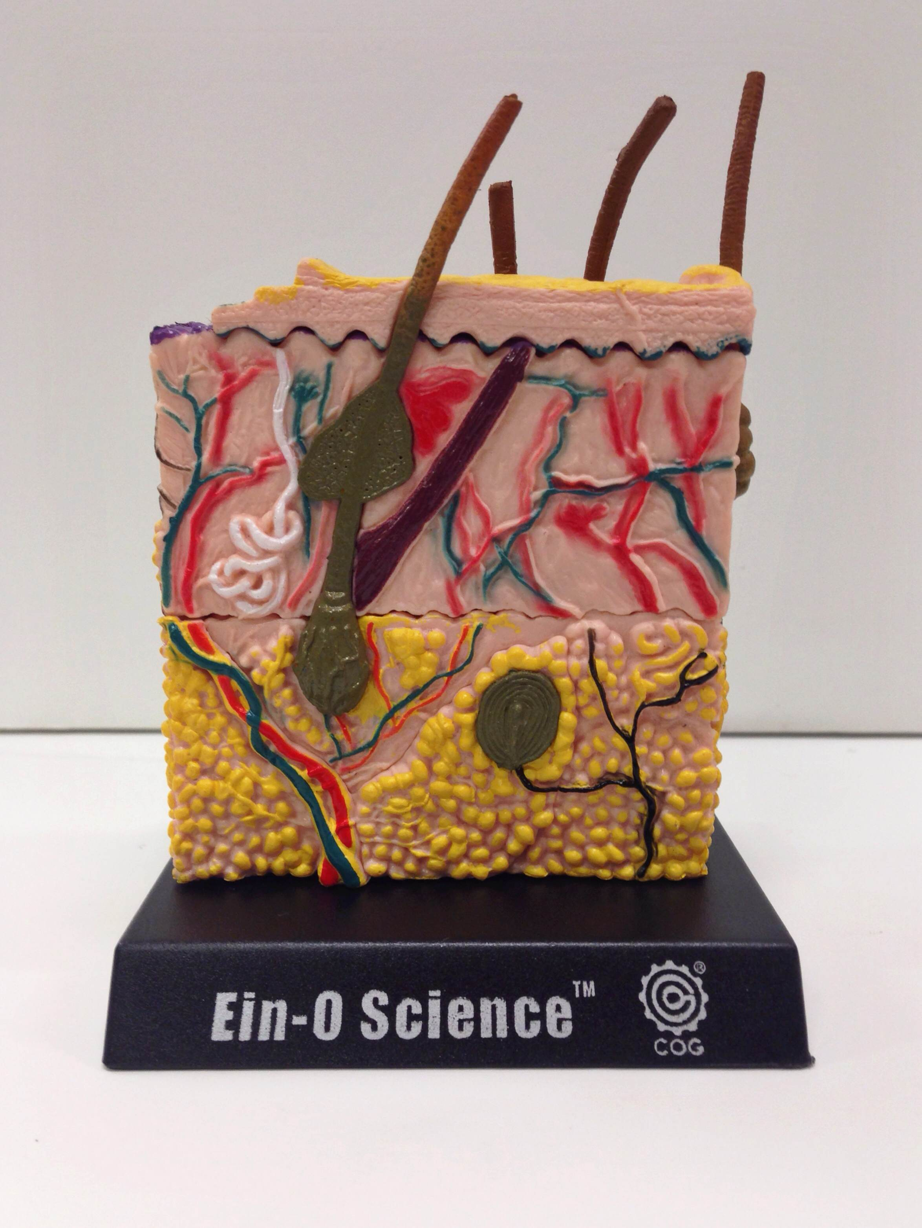
Point out the following layers in the model:
Epidermis

Dermis
- The epidermis:
  - Forms the protective, waterproof layer of the skin.
  - Makes new cells after old ones flake off.
  - Makes melanin, which is what gives skin its color. It also protects the skin from ultraviolet (UV) ray damage from the sun by absorbing and scattering the energy. People with more melanin have darker skin and better protection from UV light. People with lighter skin (less melanin) are more vulnerable to damage from UV light.
- The dermis:
  - contains sweat glands which help regulate body temperature
  - nerve fibers which help you feel things around you
  - hair follicles and blood vessels.

Fun Facts about skin:
Your body has about 19 million skin cells!
Your skin loses about 30,000 to 40,000 old skin cells a day. But don’t worry! Your skin keeps
making cells. New skin cells last for about a month before they fall off.
On 1 square inch of skin, we have 650 sweat glands!
Skin cells change shape. They start fat and square, but as they move to the top of the epidermis, they get flatter until they finally flake off!
All the dead skin cells are on top! You have about 18-23 thin layers of dead skin cells!

B. What is the Electromagnetic spectrum (EM Spectrum)?
Tell the students to look at the EM spectrum on the observation sheet.
- The electromagnetic spectrum is the arrangement of all the different types of electromagnetic waves.
- Discuss briefly (not more than 3 minutes) the different parts of the electromagnetic spectrum.
- Point out that there are several different types of waves – radio, microwave, infrared, visible, ultraviolet, x-rays and gamma rays. These waves have different wavelengths, frequencies and energies. Fun mnemonic: Raging Martians Invaded Venus Using X-ray Guns
- Tell students that the light we see is visible light. It appears to be white, but is made up of many colors.
- Point out that the wavelengths longer than the visible red are called infrared and the waves shorter than violet are called ultraviolet.
- Tell the students that today’s lesson will be focusing on ultraviolet light (UV light).

- Point out the region in the electromagnetic spectrum where ultraviolet light occurs.

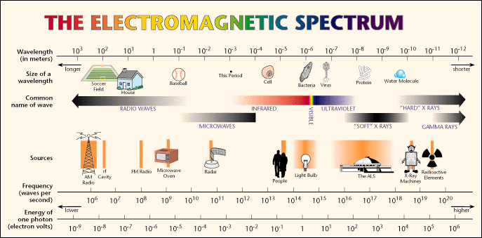

Source: http://www.lbl.gov/MicroWorlds/ALSTool/EMSpec/EMSpec2.html

- Tell students to look at the Visible Light/UV Light diagram (below) and point out:
  - Visible light has wavelengths ranging from 400 to 700 nanometers (1nm = 1 X 10-9 m).
  - These wavelengths are a small section of the full electromagnetic spectrum.

- Draw a wave on the board and show the students how a wavelength is measured.
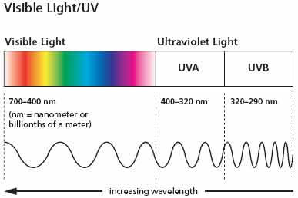
Long Wavelength Short wavelength
700 nm 400 nm

C. What is UV light?
- UV stands for Ultraviolet, a portion of the light spectrum that is beyond the violet light that we can see with our eyes.
  - Humans cannot see UV light.
  - UV waves have shorter wavelengths and higher energy than visible light.
  - Ultraviolet light is produced by the sun. What happens when it reaches the earth’s atmosphere? Most UV radiation is absorbed by the atmosphere or reflected back into space. This is the ozone layer, which we will discuss later on.

Activities and Demonstrations
A. How can UV light be useful?
Learning Goals:
- Students identify where UV light falls on the electromagnetic spectrum, and describe instances in which it is helpful and harmful
- Students use a model to identify which layers of skin can be damaged by UV light

Ask the students if they know any uses for UV lights.
- Ultraviolet lights are used by forensic scientists to detect bodily fluids.
  - They can also be used to kill bacteria.
  - Bug Zappers use UV light to attract insects.
  - UV lamps are used to detect fake dollar bills ($5 and up).
- Tell students to look at their handout sheet.
  - The bottom picture shows a copy of a $20 bill that has been exposed to UV light.
  - Notice the fluorescent strip. Some chemicals absorb UV light and then re-emit the energy as visible light – this is fluorescence
This strip can be seen on the bill in visible light, but fluoresces only under UV light.
Bills of different denominations have strips that fluoresce different colors and are at different positions on the bill.
The $1 bill does not have a strip.
For VSVS Information: Black lights work in the same way that fluorescent lights work. Both bulbs contain mercury vapor inside the bulb.
When the bulb is electrified, electrons of the mercury atoms are excited and when they return to the ground state, UV light is emitted.
In fluorescent bulbs, the UV light is absorbed by the white coating (the phosphor) and reemitted as white light.
In black lights, a different phosphor is used to produce the UV light, as well as a special glass for the bulb which blocks almost all of the visible light.
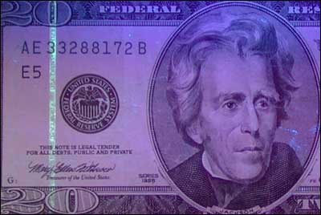

B. Since we cannot see ultraviolet light, how can it be detected?
- Show the students a small “black light” and turn it on.
  - Explain that the purple glow is light from the visible, not the ultraviolet part of the EM spectrum.
  - A black light emits UV radiation in the 300-400nm range plus some visible light.

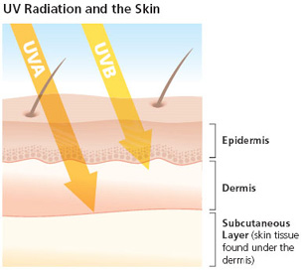
C. How is UV light dangerous?

Ultraviolet light has more energy than visible light, and can damage living cells. Skin cancer is the most common type of cancer in the US. It is estimated that 90% of non-melanoma skin cancers are associated with exposure to UV radiation from the sun.
Like visible light, Ultraviolet light has many different wavelengths. There are three categories of UV radiation: UVA, UVB, and UVC. .
UVA rays can age us and UVB rays can burn us. Overexposure to either can damage the skin.

Refer back to the skin model to show how deep the UV rays can penetrate.

UVA: (at 400-315nm) is the closest to the visible light
UVA rays penetrate deep into the dermis, the skin’s thickest layer. Unprotected exposure can lead to premature skin aging and suppression of the immune system. And when your skin’s defenses are down, you’re at risk for skin cancer.
However, recent studies show that UVA damages skin cells in the basal layer of the epidermis, where most skin cancers occur. UVA contributes to and may even initiate the development of skin cancers.

UVB: (315-290nm) is mostly absorbed by the ozone layer in the atmosphere. The amount of UVB light that reaches the ground depends on where the sun is in the sky, the amount of ozone in the atmosphere, and the cloudiness of the sky. On a clear summer day, the maximum amount of UVB radiation occurs around midday, and so the most intense sunburn radiation occurs between the hours of 10am - 4pm.

UVB rays will usually burn the superficial layers of your skin. Sunburned skin doesn’t just feel awful, it can cause permanent damage over time.
- When UVB light damages DNA, our cells might not work correctly. Sometimes this makes the cells grow uncontrollably, a condition called cancer.
- UVB light also damages the tissue in our eyes and can cause cataracts.

UVC: (290-220nm) is very dangerous, but it is all blocked by the earth’s atmosphere (the ozone layer).

How do you know if your skin has received too much UV light?
  - It turns red and becomes tender, i.e., you get a sunburn.

We should block as much UV light from our bodies as possible.
Ask students if they know ways we can block UV light. Answers should include:
- sunscreen, long sleeves and pants, wide brimmed hats, sunglasses, and staying in the shade.
- Glass in windows transmits less than 10% of sun-burning UV light.
- AVOID TANNING BEDS – THEY USE UV LIGHT
- Watch for the UV Index – it is issued daily for your zip code and predicts the level of solar UV radiation and indicates the risk of overexposure on a scale from 0 (low) to 11 or more (extremely high). A special UV Alert may be issued for a particular area, if the UV Index is forecasted to be higher than normal.
- AVOID TANNING LOTIONS – THEY DO NOT PROTECT YOUR SKIN.

Testing UV Blocking Using UV Sensitive Beads
Learning Goals:
- Students participate in a controlled experiment to test the effectiveness of different materials in blocking UV light.
- Students use evidence from experiments to draw conclusions about how to best prevent sunburns
- Divide the students into pairs and give each pair one of the UV lights.
- Show the students a string of UV detecting beads. Point out that all the beads are white.
- Expose the necklace to a portable UV light, until the beads have turned color.
- Explain that this color change is due to the presence of UV light. The beads contain a chemical that absorbs the UV light and reemits it as visible light.
- Point out the purple beads in the necklace and tell the students that they will be using just the purple beads for this experiment because these change to a more intense color than the others.
For VSVS information only: The color change involves a dye molecule absorbing UV energy to produce a different geometric isomer of the molecule. When the UV energy is removed, the color slowly fades as the dye molecule rotates back to the more stable form. Since the color fades slowly, this is an example of phosphorescence
What does sunscreen do?
- Since most students should be familiar with sunscreen and SPF, keep this discussion brief.
- Most students will probably answer that sunscreens keep you from getting sunburned.
- The only light waves affected by sunscreen are those in the UV range. There are special chemicals in sunscreens that absorb the UV light, preventing it from reaching your skin.

How do you know how well a sunscreen blocks UV light?
- All sunscreen is labeled with an SPF (Sun Protection Factor) number that indicates how well it absorbs UV light.
- For example, an SPF of 15 means that it should take 15 times longer for skin damage to occur as it would on unprotected skin.
- Doctors recommend that everyone (even those with dark skin) wear a sunscreen with an SPF of at least 15 whenever they are in the sun.
- Doctors recommend using sunscreen that is labelled as “broad spectrum”, since they protect your skin from both UVA and UVB rays. Show the students the picture of the different sunscreens and point out the SPF caption and if it is a broad spectrum sunscreen (protects you from both UVA AND UVB radiation)

Who should wear sunscreen?
- Everyone! “Although darkly pigmented persons develop skin cancer on sun-exposed sites at lower rates than lightly pigmented persons, UV exposure will still increase their risk for developing skin cancer.”

Distribute the following to each group:

The Ziploc bags of materials to be tested
1 blacklight
Distribute a pair of goggles to every student, and VSVS members. (The goggles will block any UV radiation from reaching eyes.)

A. Demonstrating the procedure:
- Tell the students they will be testing several items to see how well they block UV radiation. They will be using the UV-sensitive beads and observing their color change. This is phosphorescence, since the beads absorb the UV light but continue re-emit visible light even when not exposed to UV
- Tell them they need to have a control bead to compare the effect of the protection. The control bead will be completely exposed to the UV light, whereas the other beads will have some protection.
- Show the students the observation sheet, the positions to place the beads and materials to be tested. Demonstrate steps 1-3 and then tell the students to do the experiment.
  - Put 3 beads in the squares on the first row of the observation sheet, and cover with the lens of a sunglass, and the piece of T-shirt. Leave one bead uncovered – this is the control bead. Tell the students they will be exposing these items to UV light and will be observing the color changes that occur.
  - Hold the UV light about 1-2 inches above the beads (make sure all beads have UV light shining on them at the same time).
  - When the control bead has turned purple, turn the UV light off and remove the lens and material. Observe and record the color of the beads.

- Tell students to collect the sunglass lens and piece of T-shirt and beads and put them back into the Ziploc bag. Do this before moving on to the next experiment.
- Demonstrate steps 4-7 and the have students do the experiment.
- Place the remaining 3 beads in the squares on the 2nd row. Show the students the acetate sheets, Q-tips and the containers of SPF 45 and SPF 8 sunscreen.
- Dip a Q-tip in the sunscreen, spread a good amount on the acetate, and immediately put on top of the bead. (Tell them this is important to prevent the sunscreen from drying out.) Emphasize that they should try to avoid getting any sunscreen on the paper and beads, since it is difficult to wash off.
- Hold the UV light about 1-2 inches above the beads (make sure all beads have UV light shining on them at the same time).
- When the control bead has turned purple, turn the UV light off and remove the lens and material. Observe and record the color of the beads.
Tell the students to carefully remove the acetate sheets covered with sunscreen and place them on the paper towel with the Q-tips. Keep all sunscreen away from lens etc. A VSVS member will collect all materials with sunscreen on them and put them in the marked bag. We will wash beads for reuse.

Ask students how they could test if the goggles prevent UV light from damaging their eyes.
By placing a UV detecting bead inside up-turned goggles and holding the goggles over the black light.

If there is time, have the students perform this test with the extra goggles.

IV. Review

Note: Ask the students to look at the observation sheets while you review the results with them.
Learning Goals:
- Students participate in a controlled experiment to test the effectiveness of different materials in blocking UV light.
- Students use evidence from experiments to draw conclusions about how to best prevent sunburns
- Does sunscreen really work? Yes
- Is SPF 45 better than SPF 8? It should be but maybe not noticeable
- Do sunglasses block UV? Yes
- Does clothing protect you from UV light? Yes

Clean-Up and Return of the Kit:
- Students should place everything (except the acetate, paper towel and Q-tips used for sunscreen) in their plastic bags.
- A VSVS member will collect all materials with sunscreen on them and put them in the marked bag.
- VSVS members will collect and return everything to the VSVS lab.
Note: Be sure to collect all black lights. Count to make sure you have 16. Check that they are turned off and place them back in the kit box before you go on with the next sections.

V. Making a UV-Sensitive Bracelet
Give each student a cup of 5 UV beads and 1 piece of braid.
- Tell the students to string the beads onto the braid. After they have finished stringing the beads, they should make a bracelet by putting the untied end through the hole in the bead on the tied-off end and tying a knot.
- When they are finished, they should shine their black light on the beads. (The beads take a few minutes to develop the full color.) Notice that the beads continue to glow after the black light is removed.
- Tell the students they get to keep the bracelet and should use it to measure the amount of UV radiation on sunny days. They could keep a diary of their results – trying different times of the day and different times of the year – summer vs. winter.

VI. Discussion: Ozone Depletion
Ask the students if they know how the earth’s atmosphere is protected from too much UV radiation.
- In the upper atmosphere, ozone is a “good” gas, since it screens out dangerous UV rays. But close to ground it is a pollutant and can act as a greenhouse gas.
- Ozone is an essentially colorless gas (pale blue at high concentrations) that has a distinctively sharp and unpleasant smell.
- Ozone is naturally formed in the atmosphere when UV rays react with O₂ to make O₃.
- The amount of screening of UV radiation from ozone has decreased by about 3% over the last decade.
- An ozone hole forms over Antarctica every spring (this has happened since the late 1970s). Ozone loss in the polar regions during the winter and spring can be as great as 50-70 % of what is normally present.
- Ozone losses over the Antarctica may contribute to changes in ozone over the whole globe. This decrease causes an increase in UV rays reaching the earth’s surface.
- Ozone depletion is primarily caused by chlorine contained in chlorofluoro carbons (CFC’s). The production of CFC’s is now regulated, but it will be at least 50 years before the ozone level reverts to the level present before depletion began.
- Some countries announce a “time-to-burn” index (From: www.atm.ch.cam.ac.uk/tour/index.html)
Written by: Pat Tellinghuisen, Director of VSVS
Rachel Shevin, VSVS student volunteer
Dr. Mel Joesten, Emeritus Professor of Chemistry
Reference: “Putting UV-Sensitive Beads to the Test” by Terre Trupp, Journal of Chemical Education, Volume 78, Number 5, May 2001 p. 648a&b.
Additional Resources Consulted: American Academy of Dermatology
http://www.cdc.gov/mmwr/preview/mmwrhtml/rr5104a1.ht

UV Light and Skin Protectant Observation sheet
NAME __________________________________

Vocabulary words:
Integumentary system, Electromagnetic spectrum visible light ultraviolet light
fluorescence phosphorescence SPF ozone
Bead covered by t-shirt
CONTROL
(Un-covered Bead)

Bead covered by sunglasses

Bead covered by SPF 8 sunscreen
Bead covered by SPF 45 sunscreen

CONTROL
(Un-covered Bead)

Ultraviolet Light - Observation Sheet
 | No color change | Light purple | Darker Purple
Experiment 1.
Control UV Bead
UV bead covered with sunglass lens
UV bead covered with T-shirt
Experiment 2.
Control UV Bead
UV bead under SPF 8 sunscreen
UV bead under SPF 45 sunscreen

Review questions:
Note: If there is no change in the original color of the bead, then the bead has absorbed no UV light. If the color of the bead has changed to a dark purple, then it has absorbed a lot of UV light.

What SPF sunscreen should be worn when outside?
Does clothing protect your skin from UV light?

Ultra Violet Light Handout
Source: http://www.lbl.gov/MicroWorlds/ALSTool/EMSpec/EMSpec2.html
Long Wavelength Short wavelength
Blacklight 365nm
A $20 US bill exposed to UV light shows a blue strip with writing
embedded in it. Other bills (the $1 does not have a strip) have strips
in different places. At home, you can hold a bill up to a light and
see the strip

UV Index Forecast
The forecast map shows contour lines of predicted UV Index values during the solar noon hour. The map is created daily from National Weather Service forecast data.

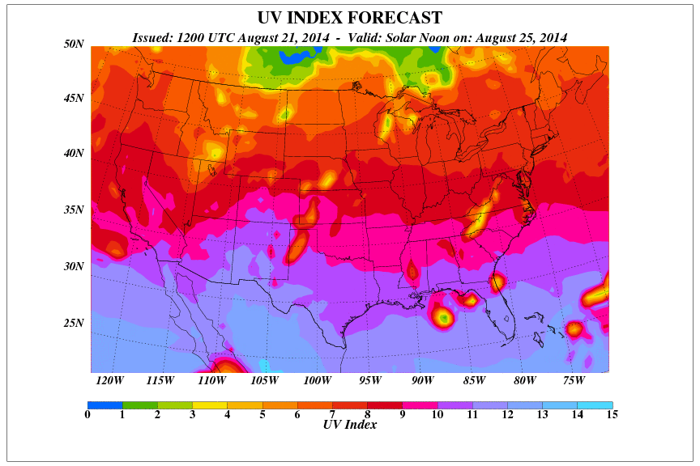
UV radiation changes, depending on the time of day, time of year, location, altitude, weather, reflection, ozone layer
http://www2.epa.gov/sunwise/uv-index

UV LIGHT - INSTRUCTION SHEET (FALL 2017)

I. INTRODUCTION
A. The Integumentary
- Look at model of skin. What are some important functions of skin? How does melanin protect the skin?
B. Electromagnetic Spectrum
- Look at the electromagnetic spectrum on the handout and locate the different types of radiation.
B. What is Ultraviolet light?
- Find where UV light wavelengths occur in the EM spectrum. There are 3 categories of UV light – UVA, UVB, and UVC.

II. ACTIVITIES AND DEMONSTRATIONS
- How is UV Light Helpful?
- Can be used to kill bacteria, to detect counterfeit bills, and to help forensic specialists solve crimes.
B. How Can UV Light be Detected?
- Some chemicals absorb UV light and reemit it as colored visible light.
C. Why is UV Light Dangerous?
- UV light has more energy than visible light. Refer back to the skin model to show how deep the UV rays can penetrate.

III. TESTING UV BLOCKING MATERIALS
A. Demonstration
B. Activity - Put on your goggles.
Look at the Observation sheet and notice the positions for the beads and materials to be tested.
  - Put 3 beads in the squares on the first row of the observation sheet, and cover with the lens of a sunglass, and the piece of T-shirt. Leave one bead uncovered – this is the control bead.
  - Hold the UV light about 1inch above the beads (make sure all beads have UV light shining on them at the same time).
  - When the control bead has turned purple, turn the UV light off and remove the lens and material. Observe and record the color of the beads.

Collect the sunglass lens and piece of T-shirt and beads and put them back into the Ziploc bag. Do this before moving on to the next experiment.
- Place the remaining 3 beads in the squares on the 2nd row.
- Dip a Q-tip in the sunscreen, spread a good amount on the acetate, and immediately put the clean side on top of the bead. The sunscreen is on the upper facing side of the acetate. Place the Q-tip on the paper towel.
Try to avoid getting any sunscreen on the paper and beads, since it is difficult to wash off.
- Record your observations on the observation sheet.

CLEAN-UP: REMOVE THE ACETATE SQUARE ON TOP OF THE BEADS AND PLACE THEM ON THE PAPER TOWEL. A VSVS MEMBER WILL COLLECT ALL.
V. MAKING A UV-SENSITIVE BEAD BRACELET
A VSVS team member will give you some beads and a piece of braid.
String the beads onto the braid and put the untied end through the hole in the last bead and tie a knot.
Shine the black light on the beads for 2 minutes and then remove the light.
Observe the colors in your UV-sensitive bracelet.
Take the UV bracelet home. Try using it to measure the amount of UV light by wearing it outside on sunny days to see if the UV beads develop color.
VI. DISCUSS THE OZONE HOLE.

