VANDERBILT STUDENT VOLUNTEERS FOR SCIENCE
http://studentorgs.vanderbilt.edu/vsvs
Properties of Carbon Dioxide
Spring 2016

Goal: To introduce students to various properties of CO₂. To illustrate that changes in states of matter are physical changes.
Fits Tennessee standards SPI 0507.9.1: Distinguish between physical and chemical properties
SPI 0507.9.2: Describe the differences between freezing and evaporation

LESSON OUTLINE
I. Introduction
A. Share some information about physical and chemical changes with students. Make sure to emphasize sublimation since that is the major change of state that the students will observe in this lesson.
B. Give students some background information about dry ice.
C. Use the given thermometers to help students understand different temperatures.
D. Students will see that water can be frozen using dry ice.
II. Comparing Dry Ice to H₂O Ice – Divide Students into Pairs
Students observe a piece of dry ice and a piece of H₂O ice that have been placed in separate Ziploc bags. The Ziploc bag containing dry ice inflates from CO₂ gas given off when dry ice sublimes. Dry ice doesn’t leave behind a liquid when it melts because it sublimes (changes from a solid to a gas).
III. Illustrating Physical Changes with Dry Ice
Students place a piece of dry ice in water and are told to record everything they observe. See diagram for possible observations. Emphasize that these are physical changes. The bubbles are produced from the sublimation of solid carbon dioxide to carbon dioxide gas because the water raises the temperature of solid carbon dioxide above its sublimation temperature.
IV. Illustrating Chemical Changes with Dry Ice
Bromothymol blue is used as an indicator to show that carbon dioxide can make water more acidic. Students infer that natural rainwater is slightly acidic because of carbon dioxide.
V. Finish Demonstration on Freezing Water with Dry ice
VI. CO₂ as a Fire Extinguisher - Demonstration
Use the CO₂ gas given off from dry ice to extinguish a candle.
VII. Review

1. In the car ride, read through this quiz together as a team. Make sure each team member has read the lesson and has a fundamental understanding of the material.
Lesson Quiz
- Explain the difference between a physical and chemical change.
- Name all six changes of state.
- Think of several basic “uses” of carbon dioxide in every-day life. (Hint: plants, carbonated drinks, air, Halloween, fire)
- What properties of dry ice distinguish it from regular ice?
- Why is rainwater slightly acidic?
- Why does dry ice bubble in water?
- Describe the reaction of carbon dioxide with water. How does this affect oceans? What happens when there is too much carbon dioxide in the atmosphere (in relation to the reaction)?
2. Use these fun facts during the lesson:
- Your blood cells transport oxygen throughout the body and carry carbon dioxide out of the body. Carbon dioxide has to be removed because it reacts with water in your body to form carbonic acid, which is poisonous in high amounts. Contrary to popular belief, you do not die from lack of oxygen but from carbon dioxide poisoning when you suffocate.
- The famous candy “Pop Rocks” are made by highly pressuring the candy with carbon dioxide. When you eat it, the candy dissolves and the carbon dioxide is released, which creates popping sounds.
- Scientists believe that increased concentration of carbon dioxide in the atmosphere is causing global warming. Carbon dioxide is a greenhouse gas and traps infrared radiation which can be converted to heat. Other molecules can also trap heat (e.g. water vapor and methane). But carbon dioxide is considered the main problem because it is being added to the atmosphere.
- Up until the 1800s and the start of widespread use of fossil fuels, humans were a minimal contributor to global warming. The Earth itself (volcanic eruptions, deep sea rifts) was a bigger source of increased carbon dioxide.
- Dry ice cannot be stored in inflexible containers (like glass) because the buildup of sublimed gas would cause the container to explode.
Materials:
1 trash bag for used cups
1 plastic homemade “dewar”
1 10 oz cup
1 plastic bag containing:
1 Styrofoam cup of H₂O ice
3 Styrofoam cups of dry ice
32 Ziploc snack bags
16 plates
1 plastic bag containing 4 pairs of work gloves for handling dry ice and 4 spoons
1 plastic bag containing:
1 small candle
1 box of matches
1 aluminum pan (small)
6 500 mL bottles of water
32 6 oz. short clear plastic cups
1 plastic bag containing:
3 dropper bottles of bromothymol blue indicator
16 laminated BTB color charts
1 Bag containing:
1 100 mL bottle labeled “rain” water (.001M HCl)
1 100mL bottle labeled distilled water
2 10oz cups

1 Training binder containing:
32 observation Sheets
17 instruction Sheets and thermometer diagrams (back to back). One for VSVS team, 1 for each
pair.)
1 answer sheet for VSVS team (in sheet protector)

Unpacking the Kit and Preparation for the Lesson:

VSVSers do this while 1 person is giving the Introduction. Note that students are put into pairs and should have their pencils ready.
One team member should write the following vocabulary words on the board: dry ice, sublimation, physical change, chemical change, changes of state. Whenever possible, refer to vocabulary words throughout the lesson and during review. Also copy the thermometer diagram onto the board.

For Part I. Introduction
32 observation Sheets, 16 Instruction Sheets and thermometer diagrams (back to back).
1 plastic homemade “dewar” and 1 10 oz cup, water and dry ice

For Part II. Comparing Dry Ice to H₂O Ice: Observing Melting and Sublimation.
32 Ziploc snack bags and 16 plates
1 plastic bag containing 4 pairs of work gloves for handling dry ice and 4 spoons
Dry Ice and regular ice
For Part III. Illustrating Physical Changes with Dry Ice
One VSVS volunteer will fill the 32 6 oz cups 1/3 full with water.
16 will be handed out (1 per pair) in Part III and the other 16 in Part IV.
6 500 mL bottles of water
16 6 oz. squat clear plastic cups to be 1/3 filled with water
16 pieces of dry ice

For Part IV. Chemical Changes Involving Carbon Dioxide and Water
16 6 oz. short clear plastic cups 1/3 full water
1 plastic bag containing 3 dropper bottles of bromothymol blue indicator and 16 laminated BTB color charts
1 Bag containing 1 100 mL bottle labeled “rain” water (.001M HCl), 1 100mL bottle labeled distilled water, 2 10oz cups

For Part VI. CO₂ as a Fire Extinguisher – Demonstration
1 plastic bag containing 1 small candle, 1 box of matches, 1 aluminum pan (small)
Note: Write the different states on the board but omit the phase change for now. Write the phase change that occurs between each state until the students are asked to name them.
Solid melts →Liquid vaporizes →Gas
Gas condenses →Liquid freezes →Solid
Solid sublimes →Gas
Gas deposits →Solid
Note: In this lesson use the words carbon dioxide and the term CO₂ interchangeably so the students will become familiar with both.

- Introduction
Give each pair an instruction sheet (contains thermometer diagram on back). This includes the procedures students need to follow for their hands-on activities. You will still need to guide them through the procedures and make sure they are completing the observation sheet.

A. The States of Matter: Solids, Liquids, and Gases
- Most substances have three states of matter that are observable at normal conditions.
- Ask students what the 3 states of water are? Ice (solid), liquid, and water vapor (gas).
- Tell students that carbon dioxide also has 3 states, but that only 2 exist at normal conditions: a solid (called dry ice) and gas.
- Substances change their states of matter by physical processes. Changes of state are also called phase changes.

Ask students if they can name the physical processes that lead to changes of state. Write the processes in between the states. Be sure to include the following information in the discussion, and refer to the thermometer to show students where the various points are on the thermometer.

- There are 6 changes of state: freezing, melting, vaporization, condensation, deposition and sublimation.
- Solids can change to liquids by melting. The temperature where a solid melts to a liquid is called the melting point. The melting point is also different for different substances.
- Liquids can change to solids by freezing. This occurs at the melting point as well, but the direction of the temperature change is different from that when solids change to liquids.
- A liquid changes to a gas by vaporization (boiling). The temperature at which this occurs is called the vaporization point. When water boils, steam rises off the top. The steam is water vapor, which is water as a gas. The vaporization point of water is 100°C or 212°F
- A gas changes to a liquid via condensation. This change of state is responsible for the droplets of water that form on a lid when a boiling pot of water is covered. This occurs at the vaporization point.
- Sublimation occurs when a solid changes state to a gas without going through a liquid phase. Dry Ice (solid CO₂), undergoes sublimation at normal conditions. Dry Ice sublimes at -78°C or -108°F.
- Deposition is the change from gas to solid. (One example is snow that forms in clouds. Water vapor changes directly to ice without first becoming a liquid.)

A. Physical and Chemical Changes
Ask students if they understand the difference between chemical changes and physical changes. Make sure to include the following information in the discussion.
- Physical changes change the state of the substance, not its chemical composition.
- The physical properties of the substance change, not its chemical structure.
An example of a physical change is in making peanut butter. Grinding peanuts is a physical change because the peanuts are still peanuts, even though they are ground up (in a different form) and have different texture (physical property change).

- Changes of state are physical changes: when liquid water is frozen, it changes from a liquid to a solid. Each state, however, is chemically the same (all H₂O).
- Sublimation is a change of state where a substance goes directly from a solid state to gas state without passing through the liquid state.

- In chemical changes, a new substance is formed due to a chemical reaction. For example, rusting of iron and burning paper are all chemical changes. The chemical properties of the starting and finished products are different.
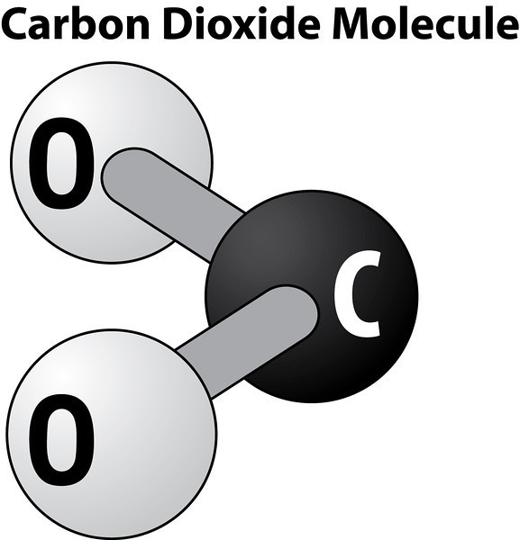

B. Background on CO₂
- Write and draw CO₂ on the board.
- Ask students: What is CO₂? Carbon dioxide
- Ask students: What do the C and the O stand for? C stands for carbon and O stands for oxygen
- Ask students: What does the ₂ stand for? "2" means 2 O’s for every 1 C
- Ask students: What do you know about CO₂?
Accept student responses and share the following information if it is not mentioned in the
discussion.
  - Air contains a very small amount of carbon dioxide (about 0.03%). Oceans contain 50 times more.
  - Humans inhale oxygen and exhale CO₂ (plus some oxygen as well).
  - Plants use CO₂ to carry out the process of photosynthesis. The photosynthesis reactions of plants convert carbon dioxide to oxygen.
  - CO₂ is solid at –108° F or –78° C.
  - CO₂ is a gas at room temperature.
  - CO₂ dissolves in water and is what gives fizz to carbonated drinks.
  - Carbon dioxide is a greenhouse gas in the atmosphere. It helps keep the atmosphere warm with the greenhouse effect.
  - Since the Industrial Age, people have added carbon dioxide to the atmosphere by burning fossil fuels like coal, oil, and natural gas.
- Ask students: What is dry ice?
Accept student responses and share the following information if it is not mentioned in the discussion.
  - Dry ice is solid CO₂.
  - Dry ice is called “dry” because it changes directly from a solid to a gas (sublimes) without passing through the liquid phase.

- C. Discussion of Dry Ice Temperature
Use the thermometer diagram to help students understand the temperature of dry ice (how cold it is) by comparing the
markings for the boiling point of water, freezing point of water, the sublimation temperature of dry ice, and the boiling point of liquid nitrogen (used in the Cryogenics lesson).
Note that there is no temperature given for the boiling point of liquid CO₂ because it does not exist at normal pressure.

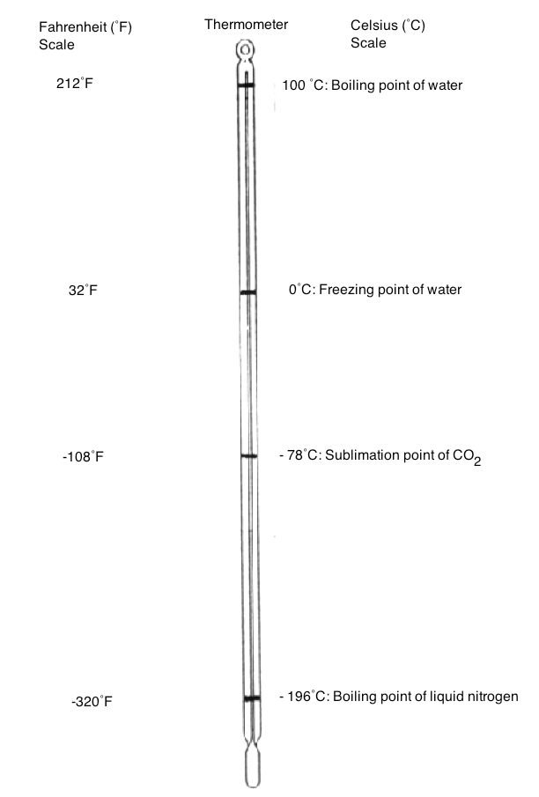

D. Demonstration: Freezing Water with Dry Ice
- Show students the 10 oz. cup with a small amount of water (not more than a centimeter deep from the bottom).
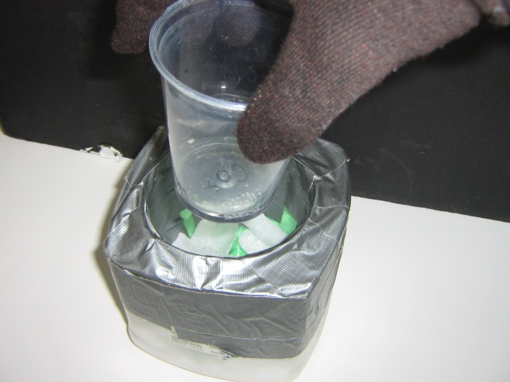
- Ask students to look at their thermometer diagram and predict what will happen to the water in the cup if you place it inside a container that contains of dry ice.
- Put some small pieces of dry ice in the bottom of the plastic dewar.
- Place the cup with a small amount of water in the plastic dewar on top of the dry ice. Pack a few pieces around the cup. Leave it for 10-15 minutes. (Wait until the end of the lesson to show students what happened. By this time the water should be completely frozen).

II. Comparing Dry Ice to H₂O Ice: Observing Melting and Sublimation.
Safety Note: Students should not hold pieces of dry ice. The temperature of dry ice is -78° C, and students could get frostbite burns if their skin is in contact with dry ice for more than a few seconds.

Materials per pair:
1 plate
1 piece of dry ice
1 small piece of H₂O ice
2 ziploc snack bags
2 observation sheets
Give each student an observation sheet and ask them to record their observations for each activity. After they record their observations, ask them to check the appropriate column on the right, indicating whether what they have observed is a physical change or a chemical change.
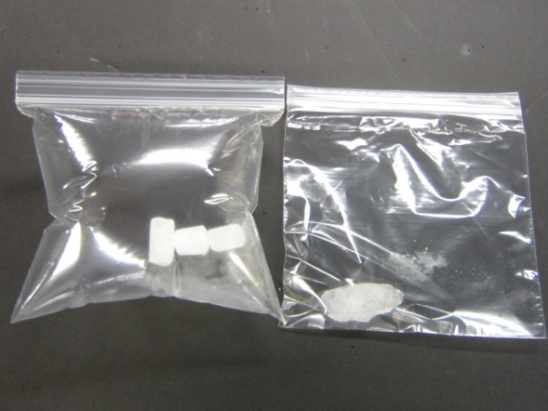
- Using gloves, a VSVS volunteer should place a piece of dry ice in the ziploc bag for each pair and close the ziploc fastener.
- Also, place a piece of H₂O ice (use spoons) in the other ziploc bag for each pair and close the ziploc fastener.
- Remind students that they should not touch the dry ice.
- Ask the students to describe the appearance of the two types of ice.
- Ask students to observe both pieces of ice in the ziploc bags for a few minutes.
- Have students describe what happens and record observations on the Observation Chart.

Observation 1: The dry ice ziploc bag will inflate whereas the water ice bag does not.
Explanation: Room temperature is around 20°C. Dry ice sublimes at -78°C so CO₂ gas is filling the bag.
Ask students: is this a chemical or physical change? Physical
Ask students to note the (absence of) color of the CO₂ gas – the gas is not visible.
- Tell students to open the ziploc bags and carefully empty the pieces of dry ice and ice onto the plate.
- Have students describe what happens and record observations on the observation sheet.
- Have one student in each group push the H₂O ice around with a pencil.
- Have students describe what happens and record observations on the observation sheet.
- Compare the dry ice with the H₂O ice.
- Tell the students to leave the two pieces of ice on the plate, to not move them, and to observe them periodically to see what happens to the dry ice and the H₂O ice over time.

Observation 2: “Smoke” comes off the dry ice.
Explanation: This is caused by tiny ice particles that form because the cold carbon dioxide gas coming off dry ice cools the water vapor in the air around the dry ice, causing it to first condense into tiny droplets and then to form tiny particles of ice. Emphasize that students are NOT seeing CO₂ gas (it is colorless).
Ask students: Is this a physical or chemical change? Physical

Observation 3: The dry ice moves around the plate and sometimes buzzes.
Explanation: The carbon dioxide gas being given off propels the piece of dry ice, often causing a vibration or buzzing.

Observation 4: Later when the two pieces have disappeared, the students will notice a puddle where the H₂O ice was and there will be no puddle where the dry ice was.
Explanation: Students should recall that dry ice sublimes (becomes a gas without passing through the liquid phase), thus it does not leave a puddle. Regular ice leaves a puddle because solid ice turns to a liquid at temperatures above 0°C.
Ask students if these are physical or chemical changes? Physical changes
Background for VSVS students only: Dry ice actually does have a liquid state which can be observed at room temperature and 5 atmospheres of pressure.

III. Illustrating Physical Changes with Dry Ice
Materials:
16 6 oz. squat clear plastic cups which are 1/3 full water
16 pieces of dry ice (VSVS volunteer distributes when needed)
- Tell the students to start observing and recording their observations as soon as the dry ice is added to the cup. Tell them to record everything they observe.
- Give each group a clear plastic cup that is about one-third full of water.
- Using gloves, a VSVS volunteer should place a small piece of dry ice into each group’s cup.
- After a few minutes of observation time, have a VSVS volunteer ask each group to share something they observed. Draw a picture of the cup (shown below) on the board and record the different observations from the groups near the drawing.
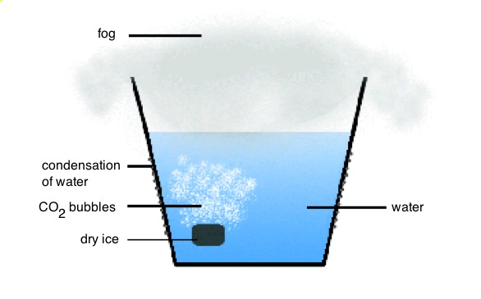
Notes: Condensation occurs on the outside of the cup. This is from outside water vapor and fog that escapes.

Use the following list and explanations to check the observations. (There may be other valid observations that are not listed here. Accept those as well.)

The following are all physical changes:
Observation 1: Dry ice gives off bubbles when it is added to water.
Explanation: The water is warm enough (room temp. is approximately 20°C or 68°F) to cause the dry ice to sublime and give off carbon dioxide bubbles.

Observation 2: A white fog appears over the water in the top of the glass.
Explanation: The air above the water (and in the room) contains water vapor. When the temperature of the air is lowered by the cold carbon dioxide gas, the water vapor condenses to small water droplets (a fog) or ice particles (smoke) that are suspended in the carbon dioxide gas. Again, emphasize that carbon dioxide gas is colorless.
Regular fog occurs when the temperature of the air drops below the dew point temperature, which is the temperature when water vapor in the air condenses to water droplets. Regular fog is heavier than air because it contains water droplets. This is why fog is close to the ground. Fog “burns off” after the sun comes up and the temperature increases.

Observation 3: The white fog stays in the top of the glass and any white fog that leaves the glass goes down along the side of the glass rather than up in the air.
Explanation: Carbon dioxide is colder and heavier than air. The fog that went out of the glass was carried down rather than up into the air.
Tell students that dry ice is often used to create smoke and fog-like effects in the movies & concerts.

Observation 4: Fog that goes down along the glass disappears near the bottom of the glass.
Explanation: The fog has warmed up enough (to its dew point) to vaporize the water, leaving only carbon dioxide which is colorless.

IV. Chemical Changes Involving Carbon Dioxide and Water
Tell students that carbon dioxide gas can make water more acidic.

Brief Discussion of Acids and Bases and Indicators
- Ask students for examples of some common acids and bases:
Since some students will not understand the term “pH”, the terms “acid, base and neutral” should be used.
For VSVS information only:
- Distilled water is neutral and has a pH of 7.
- Normal rainwater is slightly acidic, with a pH between 7 and 5.6 (because of the presence of dissolved carbon dioxide).
CO₂ + H₂O → H₂CO₃
Carbon dioxide water carbonic acid
- Acid rain is much more acidic, having a pH below 5.6.
  - Some common acids are vinegar, carbonated drinks, lemon juice.
  - Some common bases are milk, soap, window cleaner

- Scientists can use indicators to test if something is acidic, basic, or neutral. Tell the students that we are going to use an indicator called bromothymol blue (BTB) for our tests.
Color of bromothymol blue indicator Acid or base?
Blue base
Green neutral
Yellow acid
- Hand out the 16 bromothymol blue color charts (pairs will share) and tell the students to look at it. Point out the different colors of the solutions and the correlation with the acidity.
- Give each pair another 6 oz clear cup half filled with water.
- Add a squirt of the indicator to the each of the cups of water until the color is intense.
- Refer to the chart and make sure the students can tell you whether the water in their cup is acidic, neutral or basic. It should be basic (blue) but maybe more green (closer to neutral). Tap water naturally contains minerals that make tap water slightly basic.
- Tell the students they need to observe what happens to the color of the BTB after the dry ice is added to the cup.
- VSVS members place a small piece of dry ice to the cup of water/indicator mixture.
- Ask students if the water became more acidic or basic as the dry ice bubbled in the water? (More acidic, as shown by the change to a yellow color.)

Explanation: When dry ice is added to water, carbon dioxide gas bubbles are produced. As some of the carbon dioxide dissolves in the water it forms carbonic acid, a weak acid that acidifies the solution.
Note: students may not understand that gases can dissolve in water.
Students should observe a color change as the carbon dioxide dissolves in water - from blue to green to yellow (occurs at pH 6 and below).
Demonstration – pH of Rain Water Compared with Distilled Water.
Materials
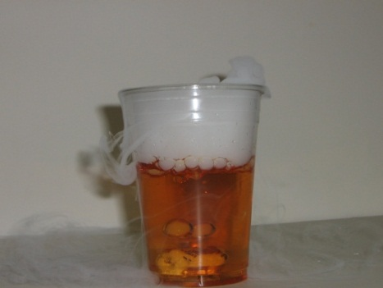
2 10 oz cups
2 bottles of water (1 rain water and1 distilled water)
1 dropper bottle BTB
Tell the students you have bottles of water that are examples of rain water and distilled water.
Pour the waters into the 2 labeled cups and add several drops of BTB indicator until there is an obvious color.
Ask students to look at the BTB color charts and label the waters as acidic, basic or neutral.
Point out that distilled water is always neutral.
Rain water is usually slightly acidic.
Ask the students: Given that the dry ice bubbled through water made the water more acidic, can they infer why rainwater is more acidic than distilled water?
Carbon dioxide in the atmosphere naturally dissolves in the rain water and makes it more acidic. Remind the students that carbonated drinks are also more acidic than drinking water.

V. Finish Demonstration of Freezing Water with Dry Ice
Remove the cup of water from the container of dry ice and have the students observe that the water is frozen.
Explanation: Tell students to look at their thermometer diagram to see that the temperature of dry ice is much colder (-78°C or -108°F) than H₂O ice (0°C or 32°F). So dry ice can freeze liquid water.

Clean-up: All the cups can be emptied in a sink and washed down with water. Put all used cups in the trash bag and return with the kit. This is important to avoid getting the kit box wet.

VI. Optional (if time permits) Demonstration: CO₂ as a Fire Extinguisher
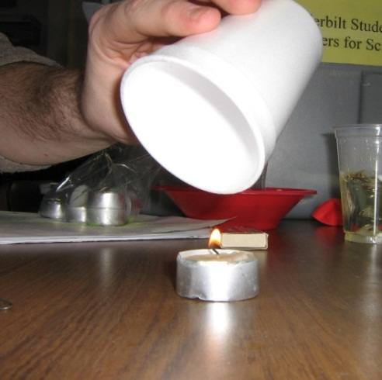
Materials:
1 plastic bag containing:
1 small candle
1 box of matches
1 aluminum pan (small)
- Place a small candle on a safe surface (aluminum pan) and light the candle. You may need to place a chair on a table so the candle will be visible to students.
- Ask students to predict what will happen when CO₂ from the dry ice reaches the candle.
- Accept logical responses and ask students to give reasons for their predictions.
- Ask students: Why did the flame go out? CO₂ is heavier than air and flows down over the candle. CO₂ is a good fire extinguisher because CO₂ deprives the candle of the oxygen needed to keep it burning. This causes the flame to be extinguished.
- Have students record observations on their observation chart.

VII. Review
Make a column on the board for physical changes and for chemical changes. Ask students to give you examples for each column from their observation chart. Summarize the physical and chemical changes and ask the following questions. Tell students to add information to their charts as needed. Whenever possible, call attention to the vocabulary words on the board as they come up in your discussion.
- What is CO₂? carbon dioxide
- What does CO₂ look like? It is not visible as a gas.
- What does sublimation mean? A solid goes directly to a gas state without becoming a liquid.
- Is CO₂ heavier or lighter than air? heavier
- What is dry ice? solid carbon dioxide
- How cold is dry ice? –78 ºC. Refer to the thermometer diagram.
- What happens when dry ice is dropped into water? Bubbles of CO₂ are given off, a cloud forms above the water, and the cloud stays in the container instead of floating in the air. If any of the cloud falls out of the container it floats down and disappears.
Lesson written by Dr. Melvin Joesten, Emeritus Professor, Vanderbilt University
Pat Tellinghuisen, Director of VSVS, Vanderbilt University
Vanessa Arredondo, Lab Assistant, Vanderbilt University

Properties of CO₂ - Observation Sheet (5th grade)
Name________________________________________________________________
Make observations for the different activities and write “yes” or “no” if the changes are physical or chemical.

Lesson Activity | Observations | Physical  Change | Chemical  Change
IIa. Comparing dry ice to water ice in a bag
A. What happens to the dry ice in the bag?
B. The regular ice?
IIb. Comparing dry ice to water ice on the plate
A. What happens to the dry ice on the plate?
B. The regular ice?
III. Dry ice in water – physical changes
What happens when dry ice is added to the water in the cup?

Draw a picture on the back of the paper to note the observations
IV. Dry ice in water - chemical changes
What happens to the color of BTB in water when carbon dioxide is bubbled through it?
V. Freezing H₂O
What changes occur when the cup of water is put in the dry ice container?
VI. CO₂ as a Fire Extinguisher
What changes occur when CO₂ gas is “poured” over flame?

Properties of CO₂ - Answer Sheet (5th grade)
Names________________________________________________________________

Lesson Activity | Observations | Physical  Change | Chemical  Change
II. Comparing Dry ice to water ice in a bag  A. What happens to the Dry ice in the bag?  B. The regular ice? | A Ziploc bag with Dry ice fills with gas (CO₂).  B. Ziploc bag with ice doesn’t change in size | yes | no
II. Comparing Dry ice to water ice on the plate  A. What happens to the Dry ice on the plate?  B. The regular ice? | A1 Dry ice changes from solid to gas and disappears.  A2 Water vapor in air is cooled by Dry ice to form tiny particles of ice water that look like smoke.  B Water ice melts and leaves a puddle. | yes  yes  yes | no  no  no
III. Dry ice in water – physical changes  What happens when dry ice is added to the water in the cup?  Draw a picture on the back of the paper to note the observations | 1. Dry ice (solid CO₂) changes to CO₂ gas (sublimes) to give gas bubbles in the water.  2. The cold CO₂ gas coming off the top looks like fog because the cold temperature above the cup has condensed water droplets which are suspended in the gas.  3. Fog disappears at the bottom of the glass - it has warmed up enough to be above the dew point and the water is vaporized.  4. The fog goes down over the side of the cup rather than up because CO₂ is denser and colder than air. | yes  yes  yes  yes | no  no  no  no
IV. Dry ice in water - chemical changes  What happens to the color of BTB in water when carbon dioxide is bubbled through it? | The color changes from blue/green to yellow. | no | yes
V. Freezing H₂O  What changes occur when the cup of water is put in the dry ice container? | Water in the cup froze after 10 min. | yes | no
VI. CO₂ as a Fire Extinguisher  What changes occur when CO₂ gas is “poured” over flame? | CO₂ is heavier than air and does not support combustion, so it put out the flame. | yes | no

