VANDERBILT STUDENT VOLUNTEERS FOR SCIENCE
http://studentorgs.vanderbilt.edu/vsvs
Minerals
Spring 2016
Goal: To introduce students to some of the tests that geologists use to determine the properties of minerals.
Fits TN State standards: GLE 0707.7.1 Describe the physical properties of minerals

LESSON OUTLINE
I. Introduction
Discuss the difference between "rocks” and "minerals.” Although some rocks contain just one mineral, most rocks are mixtures of two or more minerals. Give the class a Popcorn rock kit.
II. Learning the Tests That Help Distinguish Minerals
Organize the students into pairs. Explain that they will be learning how to do all the tests on hematite. Lead the students through each test using hematite.
The five tests they will use are the streak test, hardness test, cleavage/luster test, and magnetism.
Student pairs repeat the tests learned with hematite on their 2 minerals, record the results, and identify their minerals. Students also perform the acid test.
III. Other Properties of Minerals
Explain the property of fluorescence that some minerals exhibit. Also share some of the information about colored minerals.
SAFETY NOTE Students must wear goggles when performing the Acid Test. If goggles are not available for all students, the VSVS volunteers must perform the acid test for the students. Be sure you wear the goggles!

1. In the car ride, read through this quiz together as a team. Make sure each team member has read the lesson and has a fundamental understanding of the material.
Lesson Quiz
1) Most rocks are made up of how many minerals?
2) What is a streak?
3) What is the Mohs scale?
4) What is the difference between cleavage and fractures?
5) What is luster?
6) How can you tell if a mineral is magnetic?
7) What carbonate mineral makes up limestone?

2. Use these fun facts during the lesson:
- Diamond is the hardest natural material.
- Gemstones like sapphires and rubies are minerals that are cut and polished.
- Minerals account for about 5% of the weight of a human body.
- The most abundant mineral in the body is calcium, and 99% of this is in the bones and teeth.
Materials:
1 bag of materials for VSVS members:
3 types of calcite (yellow, blue and green)
1 piece of hematite
1 piece of muscovite
1 Mineral investigation kit (see below for contents)
1 bag (for demos) containing:
a piece of aluminum foil
a block of wood
a piece of glass
a sealed vial of ‘pearly’ beads
1 sample set of 11 minerals for the VSVS volunteers (includes labels and information)
1 bag containing 16 pieces of muscovite
1 bag containing 16 pieces of hematite
16 plastic bags containing 2 mineral samples (unknowns)
16 Mineral Investigation Kits containing:
1 hand lens
1 piece of copper
1 piece of iron
1 piece of glass
1 black streak plate
1 white streak plate
1 magnet
16 plates
16 dropper bottles of 0.5 M hydrochloric acid solution
1 jar containing 16 pieces of marble plus 4 large pieces of calcite
1 clear box with 12 samples of colored minerals
1 crystal kit (popcorn rocks) to be left in class, plus a bottle of vinegar.
16 Properties of Minerals AND Everyday Uses of Minerals in sheet protectors
32 Observation sheets
1 Answer Sheet in sheet protector
1 Box of Goggles

Unpacking the Kit:
VSVSers do this while 1 person is giving the Introduction. Note that students are put into pairs and should have their pencils ready

For Part II for students Learning the Tests for Minerals
1 bag containing 16 pieces of muscovite,
1 bag containing 16 pieces of hematite
16 plastic bags containing 2 mineral samples (unknowns)
16 Mineral Investigation Kits containing:1 hand lens,1 piece of copper, 1 piece of iron, 1 piece of glass,
1 black streak plate, 1white streak plate and 1 magnet
32 observation sheets
For Part II for VSVS Demonstrations:
1 bag of materials for VSVS members containing
3 types of calcite (yellow, blue and green)
1 piece of hematite
1 piece of muscovite
1 Mineral investigation kit (see below for contents)
1 bag (for demos) containing:
a piece of aluminum foil
a block of wood
a piece of glass
a sealed vial of ‘pearly’ beads
For Part F. Determination of the Unknown Minerals.

For Part G. Acid Test
For students: 16 plates, 16 dropper bottles of 0.5 M hydrochloric acid solution, 1jar containing 16 pieces of marble, GOGGLES for all
For Demonstration: plus 4 large pieces of calcite
For Part III. Optional Other Properties: Color and Uses of Minerals
1 clear box with 12 samples of colored minerals, 16 Everyday Uses of Minerals handouts

I. Introduction – What are minerals?
Write the following vocabulary words on the board: mineral, luster test, streak test, hardness test, Moh’s scale (moe’s), and cleavage test

Ask students, "What makes up rocks?”
- If students don’t mention minerals, tell students that all rocks are made up of minerals.
- If you look at any piece of rock closely, you will see that it is rarely completely smooth like plastic or metal. Instead it is made up of different grains or crystals.
- These crystals, which are sometimes minute and sometimes quite large, are called “minerals.”
- Minerals are inorganic compounds that form naturally in the earth.
- A mineral has a definite composition, is a solid element or compound, and has a crystal shape.
- There are more than 4,900 different kinds of minerals, but only 30 or so common ones.
- Some rocks contain just one mineral. Most rocks are mixtures of two or more minerals.

- The basic structure of a mineral is called a crystal.
  - A crystal is a solid in which the atoms are arranged in orderly, repeating patterns.
  - Crystals can come in different shapes and sizes. They can be rough, smooth, or in between. They can be very large, or very small. The size of the crystal depends on how fast the magma from which is came cooled.
Tell students that you are leaving a crystal growing kit. They can watch the crystals grow. Tell the teacher to follow the instructions included in the kit. Vinegar is supplied as well.

Popcorn Rocks
Dolomite is very similar in composition to calcite. As we know, calcite dissolves and fizzes when it is added to hydrochloric acid, or any acid, like vinegar. What is occurring with our dolomite sample is very similar to what occurs when we put the hydrochloric acid on calcite. The dolomite dissolves into the vinegar. Over time, the vinegar will evaporate. but the dissolved dolomite will remain in the solution. This dissolved dolomite will then have to recrystallize onto the solid rock. Interestingly, the dolomite does not recrystallize into dolomite, but actually into a chemically similar mineral called aragonite. This aragonite appears very fuzzy because there is not much mineral dissolved at a given time, so only a small amount can crystallize.

Ask students if they know where we get minerals.
- “If it can’t be grown, it must be mined.”
- Answers include from the earth, from mines, mining, from mountains. Tell students that we extract minerals from the earth through mining.
Tell students that minerals have properties that make them useful, including:
- They can be melted and mixed to form new materials (e.g., steel)
- They can be used as a source of metals like iron
- They can be used by themselves (gemstones are one common example)

Write the name hematite (he-mah-tight) on the board and tell the students that this is one of the most important minerals mined. It is the most abundant and important ore of iron. It is used to make steel which, in turn, is used in everything from automobiles to flatware to the very machinery used to make almost everything else we use.
- Tell students they will explore some of uses for the other minerals at the end of the lesson

Ask students: How do scientists tell these minerals apart from each other?
Scientists can identify minerals through several tests. Tell students they will learn how to do the tests using hematite, and then use the tests to identify an unknown mineral.

Write the names of the “unknown” minerals (talc, rose quartz, smoky quartz, halite, galena,( guh-lee-nuh] magnetite, graphite, feldspar, calcite, gypsum) on the board, and tell the students that today, as geologists, they will investigate the 2 minerals assigned to each pair, record data about their properties and then be able to identify their minerals.

Note: Do not pass out acid dropper bottles and goggles until test E(b).
Do not pass out Properties of Minerals handout until after all tests have been done.

1. Distribute the following materials to each pair:
1 Mineral Investigation Kit 2 observation sheets
1 set of 2 numbered minerals (unknowns) and 1 piece of hematite
2. VSVS members will lead the students through each test on the mineral hematite and have them record the results on their investigation sheets.
3. After each test is done on hematite, the students will immediately do the same test on their 2 unknown minerals and record the results on their sheets.
When student groups are working independently, VSVS volunteers should circulate to monitor and help groups as needed.
4. After the pairs are finished with all the tests on their minerals, tell them to name their 2 minerals using the information on the Properties of Minerals Handout, which should only be handed out after all tests and observations are completed. Discuss the results and emphasize similarities and differences.

II. Learning the Tests for Minerals
A. Streak Test
Materials for VSVS members
1 hematite mineral
1 bag containing 3 types of Calcite (yellow, green and blue) and black and white streak plates
Explain the Streak Test.
- A "streak” is the color of a mineral when it is ground down to a powder.
- A streak test is a test that you do by pushing a mineral across a plate.
- This crushes up the mineral, allowing you to see a diagnostic color that a specific mineral has. The color of the mark left on the tile is the mineral’s streak.
- Show the students the three minerals (from the VSVS plastic bag) that are all calcite and emphasize their different colors. The different colors are from different impurities.
- Explain that a particular mineral can have several colors depending on impurities. While the color of a mineral may change, its powder and streak will usually stay the same.

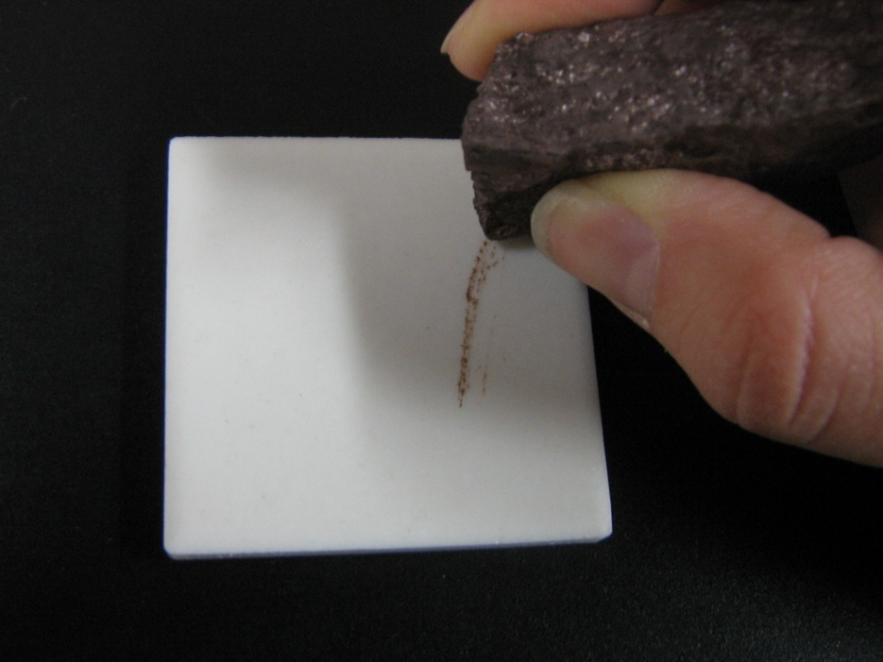
Tell the students that the calcite minerals will have the same STREAK test result. Show this by doing the streak test on the black streak plate. Keep the plate flat on the table like the image here.

Testing the hematite. Tell the students to:
1. Gently stroke the edge of the hematite across the white streak plate.
Note: Ask students to make only one streak per mineral since the tiles and minerals are needed for other classes.
2. Record the color that the streak produces. Hematite has a red to brown streak
- Repeat the test on their unknown minerals using the black streak plate with light colored
minerals and the white streak plate with the dark-colored minerals.
- Record the results on their observation sheet.
If no streak is visible on either plate, the students should record "not visible”. (Note that “not visible” actually means that the mineral is harder than the streak plate).
Make sure that the students have the following results, but do NOT tell the students the name of the mineral:
Mineral Streak
#1 Hematite red, brown
#2 white
#3 black
#4 white
#5 colorless, white
#6 black
#7 black, gray
#8 white
#9 white
#10 white
#11 colorless, white
B. Hardness Test
Another clue to a mineral’s identity is its hardness - that is, what will it or will it not scratch?
Diamond is the hardest mineral to scratch, and has the highest rating (a 10).
Talc (with a rating of 1) is one of the easiest to scratch.
A mineral’s hardness reflects how strong the mineral structure is.
Explain Mohs Scale before performing this test.
- Geologists have devised a set of common materials that are used to scratch a mineral to find where it lies on the hardness scale.
- Think about it – geologists often travel into outback areas and need to carry all their materials into the field with them. Carrying an electron microscope is not an option!
- The following everyday materials are sufficient for geologists to identify the hardness of minerals.

These materials are:
Hardness Testers (Everyday Equivalent Objects)
1 no everyday equivalent
2 Fingernail
3 Copper coin or piece of copper
4 Iron nail/piece of iron
5 Glass
6 Penknife Blade
7 Steel File
8 Sandpaper
9 no everyday equivalent
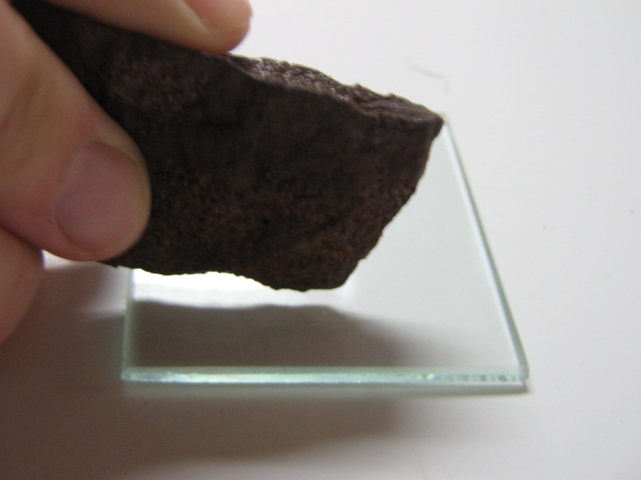
10 no everyday equivalent

- Tell students we will be using just four of the everyday equivalents (“testers”) in this lesson. Since several classes will be using the minerals, the students will scratch the testers with the mineral.

NOTE: Ensure that all testers, especially the glass plate, are flat on the table surface while scratching (like the image). If held aloft, the glass will snap in half.

Testing the hardness of hematite.
Tell the students to:
- Determine the Mohs hardness of hematite by finding the HARDEST tester that the mineral will scratch.
Once a mineral scratches a tester, do not continue to try to scratch softer testers (because it will!). Remember these testers and minerals will be used by other classes.
2. Find the hardness of hematite by scratching the testers with the hematite, in the following order (from hardest to softest):

1. piece of glass (hardest)
2. piece of iron
3. piece of copper
4. fingernail (softest)

- Circle the first tester the hematite scratches, along with the Moh’s number that is with it.
If the hematite scratches the glass, its hardness is greater than 5 (>5).
If the hematite scratches the iron, its hardness is 4-5.
If the hematite scratches the copper, its hardness is 3-4.
If the hematite scratches your fingernail, its hardness is 2-3.
If the hematite does not scratch your fingernail, its hardness is 1-2.
Make sure that the students have the following results for Hematite = 4-5 or >5
- Repeat the test on the 2 unknown minerals and record the results.
Hardness Test Results.
Make sure that the students have the following results (Some students may get slightly different results. The following ranges are acceptable. Use the number on the mineral to determine if the students have the correct results.):
Mineral What is the 1st item it scratches? Hardness
#1 Hematite glass or iron >5 or 4-5
#2 none 1-2
#3 glass or iron >5 or 4-5
#4 copper 3-4
#5 glass or iron >5 or 4-5
#6 copper or fingernail 3-4 or 2-3
#7 none 1-2
#8 none 1-2
#9 glass or iron (fine scratches) >5 or 4-5
#10 fingernail or none 2-3 or 1-2
#11 glass >5

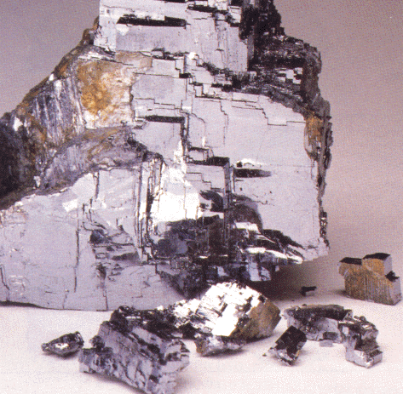
C. Cleavage and Fracture Test (Breakage Test)
Materials:
1 bag containing 16 pieces of muscovite

Minerals can break in different ways, depending on how strong the bonds are between the atoms in the mineral. They will break along the planes that are the weakest. They can break by either cleaving or fracturing.
Above: Notice the sharp angles produced by breaking the mineral.
NOTE: Do not break the minerals!! Cleavages will already be apparent as smooth surfaces.

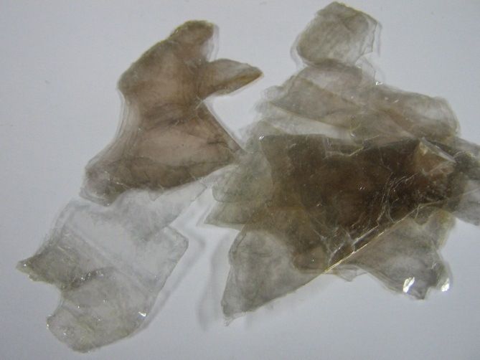
Tell the students that if the mineral cleaves, they will see flat surfaces.
Some minerals can break into sheets (cleavage in one direction).
Distribute the samples of muscovite around the class and point out the sheets.
Tell them that the pioneers used muscovite for windows.
Others minerals can cleave in several directions (diamonds cleave in 4 directions).
If a mineral fractures, it breaks unevenly along curved or irregular surfaces.
Above: The mineral muscovite cleaves into thin sheets.
Testing the hematite for cleavage/fractures.
- Have the students look at their hematite tell them that it has no cleavage.
- Help them determine if their unknown minerals cleave into planes or fracture. The answers are given on their Instruction sheet. Point out the cleavage planes or fracture pattern.
Cleavage And Fracture Test (Breakage) Results.
Tell the students to look at their minerals and make sure they circle the correct answer on their observation sheet.
Mineral Cleavage/Fracture
#1 Hematite no cleavage, fractures
#2 cleaves - 1 direction, look for layers
#3 no cleavage, fractures
#4 cleaves - 3 directions
#5 no cleavage, fractures
#6 cleaves - cubic
#7 cleaves - (scales)
#8 cleaves
#9 cleaves - 2 planes
#10 cleaves - cubic
#11 no cleavage, fractures

D. Luster (Shininess) Test
Materials:
1 bag containing aluminum foil, wood, glass, and a container with a pearly substance.

- The way a mineral reflects light is called luster.
- Show the students the aluminum foil, the glass and the wooden block.
- Explain the terms metallic luster and nonmetallic luster by showing the following examples:
  - The aluminum foil has a metallic luster – it reflects light well. It is shiny and looks like a metal. Ask students for other examples that illustrate metallic luster (stainless steel pots, etc).
  - If the mineral does not look like a metal, it is classified as having a non-metallic luster.
    - These minerals can be further classified as being:
dull – show the students the wood
glassy – show the students the glass
pearly – show the students the vial of pearly beads

Testing the hematite for luster.
- Tell the students to examine their hematite to determine its luster (it has a non-metallic luster).
- Students may need to hold the mineral up to a light or look through the magnifying glass, to see “specks” of metallic luster.
- Have them record the result on their investigation sheets.
- Then have the students do the same test on the other minerals and record the results.
Make sure the students have the following results (but do not tell them the name of the minerals):

Luster (Shininess) Test Results.
Mineral Luster
#1 Hematite non-metallic – dull
#2 non-metallic – pearly
#3 metallic
#4 non-metallic – glassy or pearly
#5 non-metallic – glassy
#6 metallic
#7 metallic
#8 non-metallic – glassy
#9 non-metallic – dull or pearly
#10 non-metallic – glassy
#11 non-metallic – glassy

E. Magnetism Test
Explain that some minerals are magnetic. These minerals will be attracted to a magnet.
If the mineral is attracted to a magnet, the mineral is magnetic.
If there is an attraction, the students circle yes; if not, circle no.

1. Have the students do this test on hematite by touching the magnet to the mineral.
- it is not magnetic
2. Repeat on their unknown minerals. # 3 is the only mineral that attracts a magnet
3. Take out your sample #3, DO NOT say its name, and show the students that some minerals do actually attract a magnet (only a few students will have this sample).

F. Determination of the Unknown Minerals.
Pass out the Properties of Minerals Handout and tell students to use it to help them determine the names of their minerals. Circulate around the room while the students are working and help them as needed.

G. Acid Test
Explain the acid test:
There is an important group of minerals called "carbonates” which contain carbon and oxygen. Most tend to be fairly soft and whitish in appearance. Acid makes carbonates fizz and bubble. Geologists use dilute hydrochloric acid when they perform an acid test.
Demonstration
Show students the acid test on Calcite.
Place the calcite pieces on plates and take them to groups to show them what happens when drops of acid are put onto the mineral. Use magnifiers if needed.

Student experiment:
CAUTION: This acid must be used with care. The mixture contains only 0.5 M acid, but students should not be allowed to play around or squirt this on anything but the mineral. If the class tends to be unruly or if enough goggles are not available for the students, the VSVS volunteers should take the acid to the groups and put it on the marble pieces for them. Then the students can observe and record their observations.
Before any student touches the acid dropper bottle, make sure ALL students are wearing their goggles and continue to do so until the acid is removed from their tables!!!

Pass out the Goggles, acid, plates, and piece of marble.
Explain to the students that marble is a type of rock, NOT a mineral. Explain that they will be testing the marble to see if it reacts with acid.
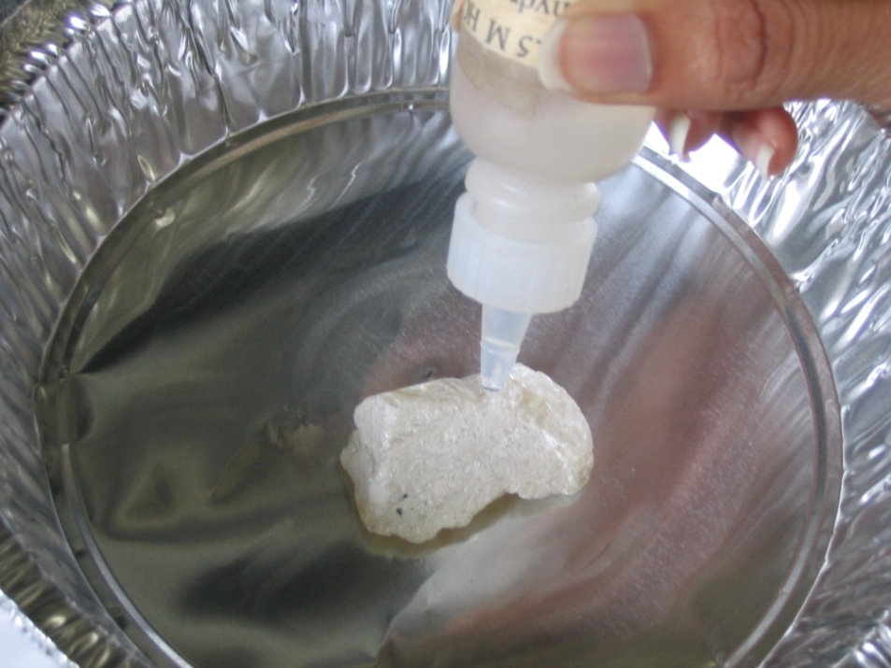
Tell the students to:
- Put the marble on their plate.
- Use the dropper bottle to carefully put a few drops of acid
on the marble.
- Use the hand lens to examine the marble to see if there is any sign of a fizzing or bubbling reaction.
Students should see a bubbling reaction. Walk around the room to make sure everyone sees this reaction. Have them record their results on their observation sheet.
- Tell them to use their Properties of Minerals Handout and see if they can determine what mineral is in the rock marble. The answer is calcite.
- Have them record their answer on their observation sheet.

Ask the students:
Do you know of any other rock, which is common to Tennessee, that “fizzes” when acid is added? limestone
What mineral do you suppose is in limestone? calcite

III. Optional
Everyday Uses of Minerals
Tell students to look at the Everyday Uses of Minerals Handout. As each mineral is discussed, have a VSVS member hold up the mineral from the VSVS mineral box).
Other Properties: Color (If there is enough time)
A team member can take the box of sample colored minerals around to each group while some of the information about colored minerals is shared from the next page.

Lesson written by Pat Tellinghuisen, Coordinator of VSVS, Vanderbilt University
Dr. Melvin Joesten, Chemistry Department, Vanderbilt University Courtney Luckabaugh, VSVS Lab Assistant, Undergraduate, Vanderbilt University
We gratefully acknowledge the assistance of Professors Molly and Calvin Miller, Vanderbilt University.

Mineral Color Kit Information Sheet
How Minerals Are Colored
Share some of this information with the student groups as you show them the 12 mineral samples in the kit.

BACKGROUND INFORMATION ONLY: When light strikes the surface of a mineral, some wavelengths will be absorbed and some will be reflected. The color we see results from the combination of reflected wavelengths of light. Minerals that are colorless or white reflect the total spectrum of light.
For some minerals, color is a fundamental characteristic of its chemical composition. These minerals are termed idiochromatic, meaning that they will always display the same color. (Minerals 1, 2, 3 and 9.)

Certain metallic minerals with similar compositions but differing states of oxidation will exhibit different colors. (Minerals 5, 6, 7 and 10)
Many minerals contain trace elements in their composition which control their color. These trace elements are called chromophores. (Minerals 4 and 8)
Some minerals will display a range of colors due to the mixing of impurities. These impurities may be combinations of minerals or organic compounds.

Mineral Color Formula Reason for color
1. Sulfur yellow S chemical composition
2. Pyrite brass-yellow FeS₂ chemical composition
3. Fluorite pink CaF₂ chemical composition
4. Beryl green Be₃Al₂(Si₆O₁₈) contain trace elements
5. Magnetite black Fe₃O₄ oxidation state
6. Olivine green (Fe, Mg)₂SiO₄ chemical composition
7. Hematite red Fe₂O₃ oxidation state
8. Quartz pink SiO₂ contain trace elements
var. Rose (Titanium)
9. Malachite green Cu₂CO₃(OH)₂ chemical composition
10. Limonite yellow-brown (Fe₂O₃H₂O) chemical composition
11. Gypsum var. Selenite colorless CaSO₄.H₂O chemical composition
12. Halite pink NaCl mixing of impurities

Name__________________________________________

Minerals Observation Sheet

Sample # | 1
Streak
What color is the streak when the mineral is rubbed on the tile?
Hardness  Start by trying to scratch the top item and stop when an item is scratched by the mineral. Circle the first item that is scratched and the number from the Mohs’ scale that goes with it. | Glass >5  Iron Nail 4-5  Copper 3-4  Fingernail 2-3  Nothing 1-2 |  | Glass >5  Iron Nail 4-5  Copper 3-4  Fingernail 2-3  Nothing 1-2 |  | Glass >5  Iron Nail 4-5  Copper 3-4  Fingernail 2-3  Nothing 1-2
Cleavage or Fracture?  Breakage Patterns  Does it appear to break/cleave in specific directions/shapes (breaks off in sheets, cubes, etc) or does it fracture/just break randomly/roughly? | Cleavage  Shape/# of directions:  _________________  OR  Fracture |  | Cleavage  Shape/# of directions:  _________________  OR  Fracture |  | Cleavage  Shape/# of directions:  _________________  OR  Fracture
Luster  Is it metallic or nonmetallic? If nonmetallic, is it dull, pearly or glassy?  Circle answers. | Metallic | Nonmetallic | Metallic | Nonmetallic | Metallic | Nonmetallic
 |  | Dull  Pearly  Glassy |  | Dull  Pearly  Glassy |  | Dull  Pearly  Glassy
Magnetic?  Is it attracted to a magnet? Circle. | Yes  OR  No |  | Yes  OR  No |  | Yes  OR  No
Mineral Name | Hematite

1. What happened when you put drops of acid on the marble? _____________________
2. What mineral is in marble? ___________________________
3. What other rock commonly found in Tennessee reacts like marble with acid?
________________________
4. What mineral is in this rock? _________________________

Properties of Minerals

Streak | Red, Brown | White | Colorless/White | Black | White | White | Colorless/White | Black, Gray | White | White | Black
Hardness | Glass >5  OR  Iron 4-5 | Fingernail 2-3  OR  None  1-2 | Glass >5  OR  Iron 4-5 | Glass >5  OR  Iron 4-5 | None  1-2 | None  1-2 | Glass >5  OR  Iron 4-5 | None  1-2 | Copper 3-4 | Glass >5  OR  Iron 4-5  (fine scratches) | Copper 3-4  OR  Fingernail 2-3
Cleave or Fracture?  Breakage Patterns | Fracture | Cleavage  Cubic | Fracture | Fracture | Cleavage | Cleavage  one direction – look for layers | Fracture | Cleavage (Scales)  [note the lines going across the surface] | Cleavage  3 directions | Cleavage  2 planes | Cubic Cleavage
Luster | Nonmetallic  Dull | Nonmetallic  Glassy | Nonmetallic  Glassy | Metallic | Nonmetallic  Glassy | Nonmetallic  Pearly | Nonmetallic  Glassy | Metallic | Nonmetallic  Glassy or Pearly | Nonmetallic  Dull or Pearly | Metallic
Attracted to Magnet? | No | No | No | Yes | No | No | No | No | No | No | No
Reacts with Acid? | No | No | No | No | No | No | No | No | Yes | No | No
Mineral Name | Hematite | Halite | Rose Quartz | Magnetite | Gypsum | Talc | Smoky Quartz | Graphite | Calcite | Feldspar | Galena

Properties of Minerals ANSWER Sheet

Sample Number | 1 | 10 | 5 | 3 | 8 | 2 | 11 | 7 | 4 | 9 | 6
Streak | Red, Brown | White | Colorless/White | Black | White | White | Colorless/White | Black, Gray | White | White | Black
Hardness | Glass >5  OR  Iron 4-5 | Fingernail 2-3  OR  None  1-2 | Glass >5  OR  Iron 4-5 | Glass >5  OR  Iron 4-5 | None  1-2 | None  1-2 | Glass >5  OR  Iron 4-5 | None  1-2 | Copper 3-4 | Glass >5  OR  Iron 4-5  (fine scratches) | Copper 3-4  OR  Fingernail 2-3
Cleave or Fracture?  Breakage Patterns | Fracture | Cleavage  Cubic | Fracture | Fracture | Cleavage | Cleavage  one direction – look for layers | Fracture | Cleavage (Scales)  [note the lines going across the surface] | Cleavage  3 directions | Cleavage  2 planes | Cubic Cleavage
Luster | Nonmetallic  Dull | Nonmetallic  Glassy | Nonmetallic  Glassy | Metallic | Nonmetallic  Glassy | Nonmetallic  Pearly | Nonmetallic  Glassy | Metallic | Nonmetallic  Glassy or Pearly | Nonmetallic  Dull or Pearly | Metallic
Attracted to Magnet? | No | No | No | Yes | No | No | No | No | No | No | No
Reacts with Acid? | No | No | No | No | No | No | No | No | Yes | No | No
Mineral Name | Hematite | Halite | Rose Quartz | Magnetite | Gypsum | Talc | Smoky Quartz | Graphite | Calcite | Feldspar | Galena
1. What happened when you put drops of acid on the marble? It fizzes
2. What mineral is in marble? Calcite
3. What other rock commonly found in Tennessee reacts like marble with acid? Limestone
4. What mineral is in this rock? Calcite
Minerals Instruction sheet

I. Introduction
II. Tests for Minerals
A. Streak Test
1. Gently stroke the edge of your mineral across a streak plate
ONCE (use black for light minerals and white for dark ones).
2. Record the results on the observation sheet.
If no streak is visible on either plate, you should record "not visible”.

B. Hardness Test
- Find the hardness of your minerals by scratching the testers with the minerals, in the following order (from hardest to softest):
1. piece of glass (hardest)
2. piece of iron
3. piece of copper
4. fingernail (softest)
KEEP GLASS PLATES FLAT ON THE TABLE.
- Determine the Mohs hardness of your mineral by finding the
HARDEST tester that the mineral will scratch.
Once a mineral scratches a tester, do not continue to try to scratch softer testers (it will scratch them!).
- Circle the first tester the mineral scratches along with the Mohs number.
If it scratches the glass, its hardness is greater than 5 (>5).
If it scratches the iron, its hardness is 4-5.
If it scratches the copper, its hardness is 3-4.
If it scratches your fingernail, its hardness is 2-3.
If it does not scratch your fingernail, its hardness is 1-2.

C. Cleavage and Fracture Test
Minerals can break in different ways, depending on how strong the bonds are between the atoms in the mineral. NOTE: Do not break the minerals!! Cleavages will already be apparent as smooth surfaces.
- Look for smooth surfaces and regular shapes (cubes, long rectangles) that indicate a clean break along the mineral. This is a cleavage. It can be in one direction or 3 directions, like a cube.
- If only rough surfaces are present, these are caused by fracturing. Hematite fractures while muscovite cleaves.
- Look at your minerals and see if you can find smooth surfaces and angles, or if you can only find roughness. The table below gives you the answer for your mineral.

Mineral Cleavage or Fracture? Mineral Cleavage or Fracture?
#1 Hematite no cleavage, fracture #2 cleaves in 1 direction, look for layers
#3 no cleavage, fractures #4 cleaves in 3 directions
#5 no cleavage, fractures #6 cleaves - cubic
#7 cleaves - (scales #8 cleaves
#9 cleaves - 2 planes #10 cleaves - cubic
#11 no cleavage, fractures

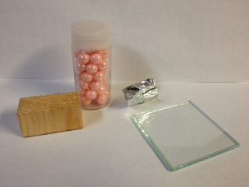
D. Luster Test
The way a mineral reflects light is called luster. Compare your mineral to the four different luster types provided in the bag (see image at right).
- The aluminum foil has a metallic luster – it reflects light well. It is shiny and looks like a metal.
- If the mineral does not look like a metal, it is classified as having a non-metallic luster.
These minerals can be further classified as being:
dull – the wooden block is dull
glassy – the glass has a glassy look to it; some minerals do, too.
pearly –the beads have a pearly look just like some minerals.
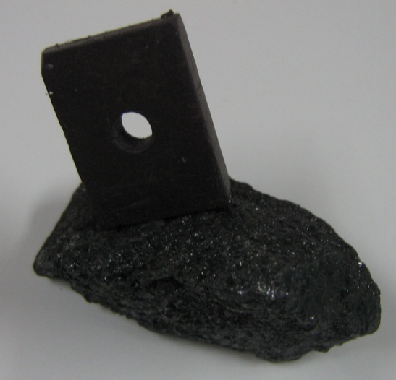
- Wright down your results on your observation sheet.

E. Magnetism Test
Some minerals are magnetic. These minerals will be attracted to a magnet like the image here.
- If the mineral is attracted to a magnet, the mineral is magnetic.
- Do this test on hematite by touching the magnet to the mineral.
- If there is an attraction, circle yes; if not, circle no.

F. Determination of Unknown Mineral
Now that you have done all of these tests on your minerals, use the Properties of Minerals Handout to help you identify them. Look for a mineral that has all of the properties you have discovered.

G. Acid Test
There is an important group of minerals called "carbonates” which contain carbon and oxygen. Most tend to be fairly soft and whitish in appearance. Acid makes carbonates fizz and bubble

CAUTION: NEVER play around or squirt acid on anything but the mineral. You MUST wear goggles and continue to do so until the VSVS members collect your acid bottles.
A VSVS member will show you the test on the mineral calcite.
You will try this test on a type of rock (marble) instead of a mineral.
- Put the marble in your plate.
- Use the dropper bottle to carefully put a few drops of acid
on the marble.
- Use the hand lens to examine the marble to see if there is
any sign of a fizzing or bubbling reaction.
- Cap the acid for the VSVS member.
- Record your observations on your sheet.

III. Other Properties: Everyday Uses of Minerals and Color

