VANDERBILT STUDENT VOLUNTEERS FOR SCIENCE
http://studentorgs.vanderbilt.edu/vsvs
Electrolysis of Water and Fuel Cells
Mini Lesson for Fall 2016

Goal: To learn about the energy conversion from electrical energy to chemical energy through the electrolysis of water and to become familiar with fuel cells.

I. Introduction
Discuss different forms of energy.
II. Electrolysis of Water: Electrical Energy → Chemical Energy
A. Distilled Water Experiment
Students use two nichrome electrodes and a 9-volt battery to test whether any reaction occurs in distilled water. Nothing happens because distilled water doesn’t conduct electricity.
B. Salt Water Experiment
Students then add a small scoop of sodium sulfate to the distilled water, stir with a
toothpick, and then place the nichrome electrodes in the water. This time they should see bubbles - more at one electrode than the other (approximately twice as many hydrogen bubbles)
C. Fuel Cell Experiment
Students will work with a VSVS member. There are 4 sets of materials, so divide the class accordingly
A. Examining the Fuel Cell
Students examine the various parts of the fuel cell, and identify what they are used for.
B. Hydrogen Production
Students use the hand crank to produce hydrogen and oxygen gas, and observe the different volume each gas holds.
C. Fuel Cell Car
Students learn how the fuel cell car operates, and observe how the hydrogen is converted back to water.

Fun Facts
- Electrolysis was first studied in 1833 by the English physicist and chemist Michael Faraday.
- Hydrogen fuel for hydrogen fuel cells can be made from many sources like wind energy, solar energy, and even garbage.
- A fuel cell for a hydrogen fuel cell car lasts up to 150,000 miles before it needs to be replaced.
- Fuel cells were discovered in 1838 by two European physicists.
- Iceland has committed to eventually having every vehicle in the country hydrogen fuel cell-based.
- Fuel cell are generally considered better for the environment than most commercial vehicles.

Complete teacher/school information on first page of manual.
- Make sure the teacher knows the VSVS Director’s (Pat Tellinghuisen) home and office numbers (in front of manual).
- Exchange/agree on lesson dates and tell the teacher the lesson order (any changes from the given schedule need to be given to Pat in writing (email)).
- Since this is your first visit to the class, take a few minutes to introduce yourselves. Mention you will be coming three more times to teach them a science lesson.
- Do the experiment with the classroom, and leave 10 minutes at the end to discuss aspects of college life with them. Some topics that could be included are on page 5 of the manual.

Unpacking the Kit
For Part II. Electrolysis of Water
Students will work in pairs for this part. There are 16 sets of materials, so divide the class into enough groups to use all the materials.
1 Demonstration ziploc bag containing:
1 9-volt battery with wire leads
1 set of nichrome electrodes mounted in Styrofoam
1 plastic container with 16 sets of nichrome electrodes mounted in Styrofoam
16 ziploc bags containing the following items:
1 9-volt battery with wire leads clipped to popsicle stick
1 small container of sodium sulfate
1 small plastic scoop
1 toothpick
1 hand magnifying lens
1 plastic container with 17 2oz. jars of distilled water
10 paper towels in plastic bag
16 plates

For Part III. Fuel Cells These are distributed to VSVS members only, who will conduct the experiment with the students (the class needs to be divided into as many groups as there are VSVS team members)
4 plastic containers with
1 reversible fuel cell
1 model car
1 3oz. bottle of distilled water
1 hand crank with built in patch cables
4 6 oz cups
4 plastic plates
16 student handouts showing fuel cell car and handcrank
4 VSVS handouts

I. Introduction
Ask students if they can name any conversions of electrical energy to other forms of energy. Ask for examples for each conversion.

Answers should include:
- Electrical to Mechanical – motors
- Electrical to Thermal (heat) – heaters, toasters, ovens
- Electrical to Light - light bulbs
- Electrical to Chemical – electrolysis of water
- Electrical to Sound – doorbells

Ask students if they know the formula for water? H₂O.
Write this formula on the board. Explain that this formula shows that water is made up of two parts hydrogen and one part oxygen.
Ask students if they know what will happen if an electrical current is passed through water?
The water decomposes into 2 gases, oxygen and hydrogen.
Write the formula for these gases on the board – O₂ and H₂.
Tell students that they are going to use electrical current from a 9-volt battery to decompose (break down) water.

II. Electrolysis of Water: Electrical Energy → Chemical Energy
Materials
1 Demonstration ziploc bag containing:
1 9-volt battery with wire leads
1 set of nichrome electrodes mounted in Styrofoam
1 plastic container with 16 sets of nichrome electrodes mounted in Styrofoam
16 ziploc bags containing the following items:
1 9-volt battery with wire leads
1 small container of sodium sulfate
1 small plastic scoop
1 toothpick
1 hand magnifying lens
- plastic container with 17 2oz. jars of distilled water
10 paper towels in plastic bag
16 plates

Perform the following demonstration before you pass out materials:
- Take the 9-volt battery, wire leads, and the set of nichrome electrodes from the demonstration bag.
- Take one of the jars with distilled water from the plastic container.
- Follow the diagram below and show the students how to hook up the set of nichrome electrodes to each wire by attaching the alligator clip to the short end of the electrode. Explain that the nichrome is an electrode because nichrome conducts electricity.
- Show them how the electrodes are placed in the jar. Emphasize to students that the nichrome electrodes and their mount should be handled with care. Refer them to the picture on the instruction sheet (also given below) for the correct hookup and placement of the nichrome electrodes. Note that the alligator clips are connected to the short end of the nichrome electrodes.

Give each group a bag of materials, a jar with distilled water, and a set of nichrome electrodes.

A. Distilled Water Experiment
- Have students place the electrodes connected to the 9-volt battery in the jar that contains distilled water so that the electrodes are in the water.
- Tell the students to see if any bubbles are forming around the end of the electrodes in the water.
- Record observations on the board. (Students should observe that nothing happens.)

For the next experiment, students should remove the electrodes from the water before adding salt.

B. Salt Water Experiment
- Tell students to use the small plastic scoop to get a small amount of sodium sulfate from the container.
- Add one scoop of sodium sulfate to the distilled water in the jar.
- Stir the water and sodium sulfate with the toothpick.
- Follow the same procedure as before and place the electrodes back into the jar.
- Tell students to look through the side of the jar to see if any bubbles are forming around the end of the electrodes in the water. They may have to use the hand lens.
- Record observations on the board.
- Ask students to notice which electrode (black connection or red connection) has the most bubbles. Answer: Black connection.
Note: Students should observe tiny bubbles of gas at both electrodes.
One electrode should have twice as many bubbles as the other. This is the negative electrode (the black wire). The students may have difficulty seeing this because this is where the hydrogen bubbles are emitted. Hydrogen bubbles are smaller than the oxygen bubbles.

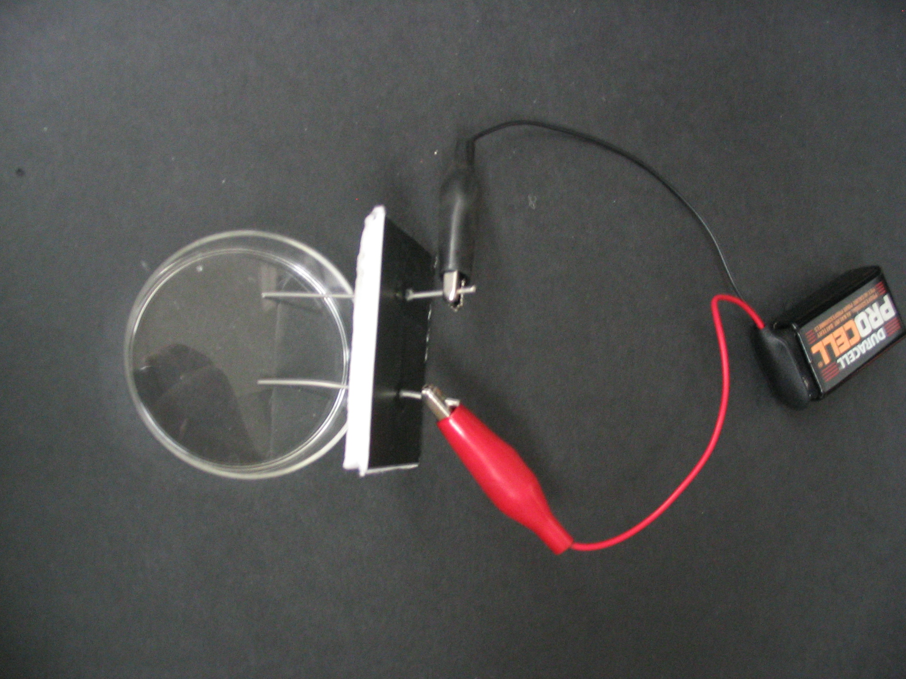

Ask the students the following questions:
- Where is the electrical energy coming from? The battery.
- What kind of bubbles are forming in the jar? Hydrogen and Oxygen gas
- Which electrodes had the most bubbles? The electrode connected to the black (negative) alligator clip. It may be difficult to notice, but the ratio is 2:1.
- Based on the formula for water, which bubbles are being produced in larger amounts: hydrogen or oxygen? The formula for water shows that water has twice as many hydrogen atoms as oxygen atoms. There are more bubbles around one electrode. Those are the hydrogen bubbles.

Explanation:
Important point - the electrical energy in the battery was converted to chemical energy when water (H₂O) was broken into hydrogen and oxygen gas.

The decomposition of water is a chemical change.

The decomposition of water requires energy, and this case, electrical energy is being used to cause the reaction to occur.

The electrolytic solution contains a small amount of sodium sulfate, which conducted the electric current through the solution. Pure water does not conduct electricity so water was not broken down in the pure or distilled water.
For VSVS Information only:
In the water at the negatively charged cathode, a reduction reaction takes place, with electrons (e⁻) from the cathode being given to hydrogen cations to form hydrogen gas
Cathode (reduction): 4 H₂O(l) + 4e⁻ → 2H₂(g) + 4 OH⁻(aq)

At the positively charged anode, an oxidation reaction occurs, generating oxygen gas and giving electrons to the cathode to complete the circuit:
Anode (oxidation): 2 H₂O(l) → O₂(g) + 4 H⁺(aq) + 4e⁻

Overall reaction: 2 H₂O(l) → 2 H₂(g) + O₂(g)The number of hydrogen molecules produced is thus twice the number of oxygen molecules.

Clean – up:
Tell students to clip the alligator clips back on to the popsicle stick. This is to prevent the clips touching each other, which could create a short-circuit and drain the battery or cause the battery to become very hot.
Collect the nichrome electrode sets; place them back in their plastic container.
Collect the jars and make sure the lids are screwed on tightly. Return them to their plastic container.
Have students put the other materials in their bag.
VSVS volunteers should collect the bags of materials and place them back in
the kit box.

III. Fuel Cells
Materials
4 reversible fuel cells
4 model cars
1 plastic container with 4 3oz. bottles of distilled water
4 hand cranks with built in patch cables
4 6 oz cups
4 plastic plates
10 paper towels in plastic bag
16 student handouts showing fuel cell car and handcrank
4 VSVS handouts showing fuel cell

Give each VSVS member a fuel cell and a jar with distilled water

A. Examining the fuel cell
- Pass out the provided handout.
- Have students look at the fuel cell and the handout. Help students identify all parts of the cell.***There is a student version of the handout and a volunteer version. The volunteer version has descriptions of what each component does. The student version merely has them numbered, but not described***
- Place the fuel cell upside down (number facing down) on a plastic plate placed on a flat surface.
- Remove the stoppers on fuel cell (two).
- Pour distilled water into both storage cylinders (be careful to pour it around the outside of the cylinder, not into the small tube in the middle) until the water reaches the tops of the small tubes in the center of the cylinders.
- Tap the fuel cell lightly to help water flow into the area surrounding the membrane and metal current-collecting plates.
- Add more water until it starts to overflow into the tubes in the cylinders.
- Place the stoppers back onto the cylinders. Make sure no air is trapped inside the cylinder. Small air bubbles will not cause problems.
- Turn the fuel cell right side up.
Give each group a hand crank.
B. Hydrogen production
- Attach the red patch cable from the hand crank to the banana jack positive terminal (red) (2 in the following diagram). Then attach the black patch cable from the hand crank to the banana jack negative terminal (black) (1 in the following diagram).
- Begin to turn the hand crank to cause the water to begin being converted to hydrogen. Students should observe water displacing out of the outlet tube and into the open container above as gas bubbles form and collect in the storage cylinders. Water is displaced because the gas coming into the storage cylinders takes up more volume than the water which was there to begin with, and so the water must go into the overflow channel.
- Turn the hand crank in complete circles, about 50 times. Students should now see a small bubble in the hydrogen tank.

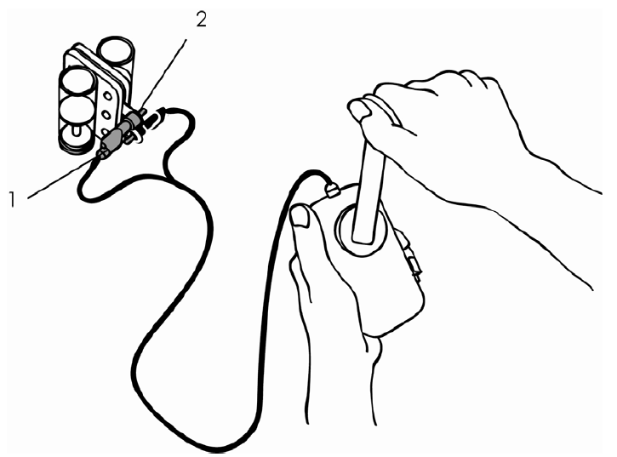
Ask the students the following questions:
- Ask students to notice which side (O₂ side or H₂ side) has the greater volume of gas. Answer: Hydrogen side
- Based on the formula for water, which bubbles are being produced in larger amounts: hydrogen or oxygen? The formula for water shows that water has twice as many hydrogen atoms as oxygen atoms. There is a larger bubble in the hydrogen tank, so it is hydrogen.
- Where is the electrical energy coming from? The hand crank is turned by the student, turning an electromagnet inside of a wire coil which generates electricity. The electrical energy is used to put a current through the membrane in the fuel cell, which is used to split water into hydrogen and oxygen. Splitting it in this way converts the electrical energy into chemical energy, since the stored hydrogen acts as a battery. So, the final energy pathway is mechanical energy going to electrical energy going to chemical energy. When the car runs, this pathway reverses. The gas is consumed into electricity, which powers the fuel cell car.

Give each group a fuel cell car and a 6 oz cup

  - Fuel Cell Car

- Detach the patch cables from the fuel cell.
- Being careful not to spill the overflow water, clip the fuel cell into the notches on the car.
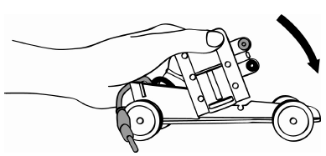
- Place the car on the cup so that the wheels are touching neither the cup nor the ground.
- Plug the patch cables from the car into the cell (red cable to red banana jack and black cable to black banana jack). The car will begin running as soon as both cables are plugged in.
- Let the car run all the way down until it runs out of the H₂/O₂ gases.
- Once the energy is discharged, have the students examine the two water storage tanks.
- Did the water return to the original level?

Explanation:
Important point - the energy from the hand crank (mechanical) was converted immediately to electrical energy before travelling through the wires to the electrolyzer, where the electrical energy was converted to chemical energy when water (H₂O) was broken into hydrogen and oxygen gas.

In the case of the Fuel Cell, only distilled water was used. The electrolyzer is a plastic-like film (called a polymer) which has tiny amounts of platinum and iridium (another metal) imbedded in it. This allows the water to be split without salt or other electrolytes needing to be added.

The hydrogen was stored and therefore became a sort of battery, and the energy stored was able to be used to power the car.

Discuss the importance of going to College and answer students’ questions.

Lesson written by
Kristen Engerer, Vanderbilt University Graduate Student
Pat Tellinghuisen, VSVS Program Coordinator

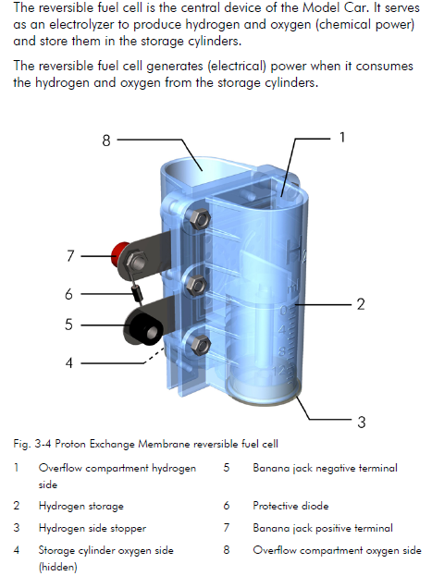
- Overflow compartments are needed to compensate for the increase in volume when the water undergoes electrolysis. Since the gases take up more volume, some of the water is displaced into this compartment.
- The tank that holds water that is electrolyzed into hydrogen gas.
- The stopper used to hold the gas and water in the cell.
- The tank that holds water that is electrolyzed into oxygen gas.
- The negative terminal used to connect the patch cables to provide electricity for the reaction.
- The diode used to prevent high current levels from damaging the fuel cell membranes.
- The positive terminal used to connect the patch cables to provide electricity for the reaction.
- See point 1
Not shown: Electrolyzer membrane. This is a plastic-like film (called a polymer) which has tiny amounts of platinum and iridium (another metal) imbedded in it. This allows the water to be split without the addition of salt or other electrolytes.
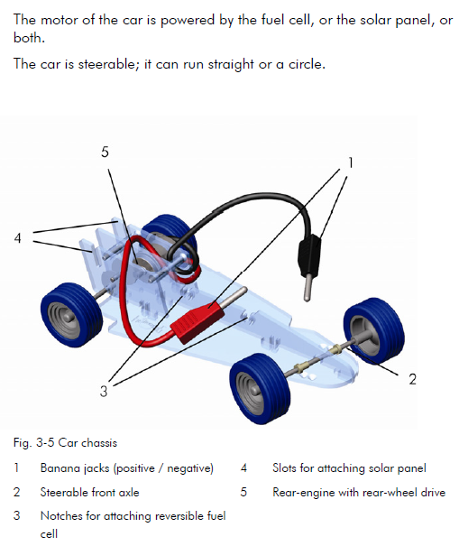
- Cables used to connect the car to the fuel cell supplying the car with power
- Allows the car to be set to drive straight or in a circle
- Place where the fuel cell can attach securely
- Place to have the solar panel attached to the car to allow for continuous energy generation and car running, rather than using stored energy from the fuel cell. This will not be used in this lesson
- Uses the energy provided to drive the car

