VANDERBILT STUDENT VOLUNTEERS FOR SCIENCE
http://studentorgs.vanderbilt.edu/vsvs
Electrical Conductivity
Fall 2016
(Adapted from Student Guide for Electric Snap Circuits by Elenco Electronic Inc.)
Acknowledgement: We want to thank NASA and the Tennessee Space Consortium for funds to purchase the Elenco Snap Circuit™ kits.

Goal: To measure the conductivity of solids and solutions using an LED in a circuit.
TN Curriculum Alignment:
GLE 0607.12.1 Describe how simple circuits are associated with the transfer of electrical energy.
GLE 0607.12.2 Explain how simple electrical circuits can be used to determine which
materials conduct electricity.
Lesson Outline
I. Introduction
Explain Static and Current electricity. Write the vocabulary words on the board and explain conductors and nonconductors. Explain that all materials can be described as conductors, insulators, or semi-conductors.
II. Explaining the Circuit – Demonstration
Explain the circuit and LED and demonstrate how the students will use the red and black lead wires to test conductivity.
III. Conductivity of Solids
Students will work in pairs. Hand out one grid and one bag of solids to each pair. Make sure all groups have a correctly assembled the circuit by having them touch the ends of the black and red lead wires together and noting the red LED glows brightly. Explain what conductors and insulators are. Students then test the solids and record their results on the Observation Sheet.
IV. Conductivity of Solutions
Explain that some solutions are conductors while others are nonconductors. Students will test a number of solutions. Make sure they understand the importance of rinsing off the metal leads of the red and black wires in distilled water between each conductivity test.
V. Optional Activity
If time permits, have students test one of the solutions: (the bag may contain Gatorade, Sprite, rubbing alcohol, lemon juice, bottled water).
VI. Optional Activity #2 - Demonstration
Why use LED’s?
VII. Review
Review the results of the lesson and the vocabulary words.

1. In the car ride, read through this quiz together as a team. Make sure each team member has read the lesson and has a fundamental understanding of the material.
Lesson Quiz
1. What is the difference between static electricity and current electricity?
2. How can you tell the difference between a good conductor and a poor conductor through a conductivity test?
3. Will an electrolyte solution or a non-electrolyte solution conduct electricity? Why?
4. Is sugar solution a conductor? Why or why not?
5. At the conclusion of the lesson should the leads be snapped together before they are placed back in the kit?

2. Use these fun facts during the lesson:
- Copper is commonly used as a conductor for electrical wiring but silver is actually a better conductor. Silver is not widely used in industrial applications because it is too expensive.
- Damp wood is a better conductor than dry wood. Although wood is generally considered to be an insulator, it is able to conduct sufficiently strong currents, which is why it is not recommended to stand under a tree during a thunderstorm.
- In the food service/production industry, cooking equipment may be sanitized with harsh chemicals that have high concentrations of ions. A conductivity test can be used to determine if the cleaning agent has been sufficiently rinsed away. If there is still significant conductivity when pure water is in contact with the equipment, then the equipment should be further rinsed to remove the cleaning agent.
- Public water facilities often monitor the conductivity of their output water to determine how much material is dissolved in the water (total dissolved solids). It is important to note that this test only accounts for the dissolved solids that are conductive. However, this method would be useful to determine if water has been demineralized, that is, if hard water has been effectively treated to remove some of the contaminating ions. As another example, conductivity tests can be used to determine if desalination processes have removed all of the salt from ocean water so that it becomes fit for human consumption.

Materials
1 conductivity demonstration grid with assembled circuit, plus a bag with a nail and a bottle cap.
16 sets of grids with assembled circuit
16 bags of solid materials for checking conductivity (paper clip, aluminum foil, copper strip, golf pencil sharpened on both ends, paper
1 plastic box containing:
6 jars labeled and containing: distilled water, tap water, vinegar, 0.1 M hydrochloric acid,
distilled water for sugar to be added, distilled water for salt to be added.
8 bags containing:
1oz wide-mouth bottle of sugar
1oz wide-mouth bottle of salt
2 taster spoon
1 chemwipe tissue
2 toothpicks
1 bag containing wide mouth bottles of Gatorade, Sprite, rubbing alcohol, bottled water, and lemon juice
1 quart distilled water
16 6oz cups for distilled water for rinsing leads
16 sets of Instruction Sheets
32 observation sheets
1 bag of 5 AA batteries (extras)
1 light bulb holder plus bulb

Unpacking the Kit:
Do not hand out materials until you have discussed the following background information.
For Part I. Introduction
While 1 person is giving the Introduction, another VSVS member writes the following vocabulary words on the board: conductors, insulators (liquids are referred to as nonconductors), semiconductors.
For Part II. Explaining the Circuit – Demonstration
1 grid with assembled circuit, plus a bag with a nail and a bottle cap for demonstrating conductivity.
For Part III: Conductivity Tests of Solids
Students will do this activity in pairs.
16 sets of grids with assembled circuit, 16 bags of solids (paper clip, aluminum foil, copper strip, golf pencil sharpened on both ends, paper), 16 sets of instruction sheets, 32 observation sheets
For Part IV. Conductivity of Solutions
16 6oz cups for distilled water for rinsing leads, 8 set of jars labeled and containing: distilled water, tap water, vinegar, 0.1 M hydrochloric acid, distilled water for sugar to be added, distilled water for salt to be added.
8 bags containing: 1oz wide-mouth bottle of sugar, 1oz wide-mouth bottle of salt, 2 taster spoons, 1 chemwipe tissue, 2 toothpicks
For Part V: Optional Activity #1
1 container with wide mouth bottles of Gatorade, Sprite, rubbing alcohol, bottled water and lemon juice

Introduction
Materials
1 grid with assembled circuit, plus a bag with a nail and a bottle cap for demonstrating conductivity.

Ask students if they know what the 2 types of electricity are.
1. Static electricity is the build-up of electrical charge. It does not flow. Lightning is an example of static electricity being “discharged” after having been built up.
2. Current electricity is moving electrical charge, usually electrons. Some materials have
more “free” electrons than others. Current electricity flows through a completed circuit.
Tell the students that electricity flows through some materials better than others. All materials can be classified as conductors, insulators / nonconductors or semiconductors.

- Conductors are materials that allow the movement of electrons through them. Metals have many “free” electrons that can easily move, and therefore are good conductors. “Free” electrons are those not strongly held by the atom’s nucleus. Since they are not strongly held, they are able to “jump” from one atom to another. Wires used for electric circuits are usually made out copper wire, but other materials also conduct electricity.
- Insulators resist the flow of electricity, meaning electrons do not flow through them. Some examples of insulators are Styrofoam, plastic (e.g., the casing around electrical wires), and glass.

- Semiconductors allow small currents to flow. Sometimes they are conductors and sometimes they are insulators. Silicon is the material most often used in making semiconductors.
Background information for VSVS members:
Insulators generally cause static charge to build up. Insulators do not allow the flow of electricity so the charge that builds up is not able to dissipate; it is only able to discharge. An example of discharge would be when a person rubs their feet on a carpet while wearing socks and then touches another person causing a small shock.

Tell the students that the snap circuits we will use today contain flattened wires. Remove one of the #2 connectors (blue bar with a 2 on it) and hold it up so that the students can see the metal underside. Tell the students that this metal is a good conductor of electricity.
- Explaining the Circuit – Demonstration
VSVS team members should hold up the demonstration circuit to show the students.
Tell the students to look at Diagram 1 and tell them it is a picture of this circuit. Point out the different parts – batteries, circuit connectors, black and red leads, resistor and LED light.

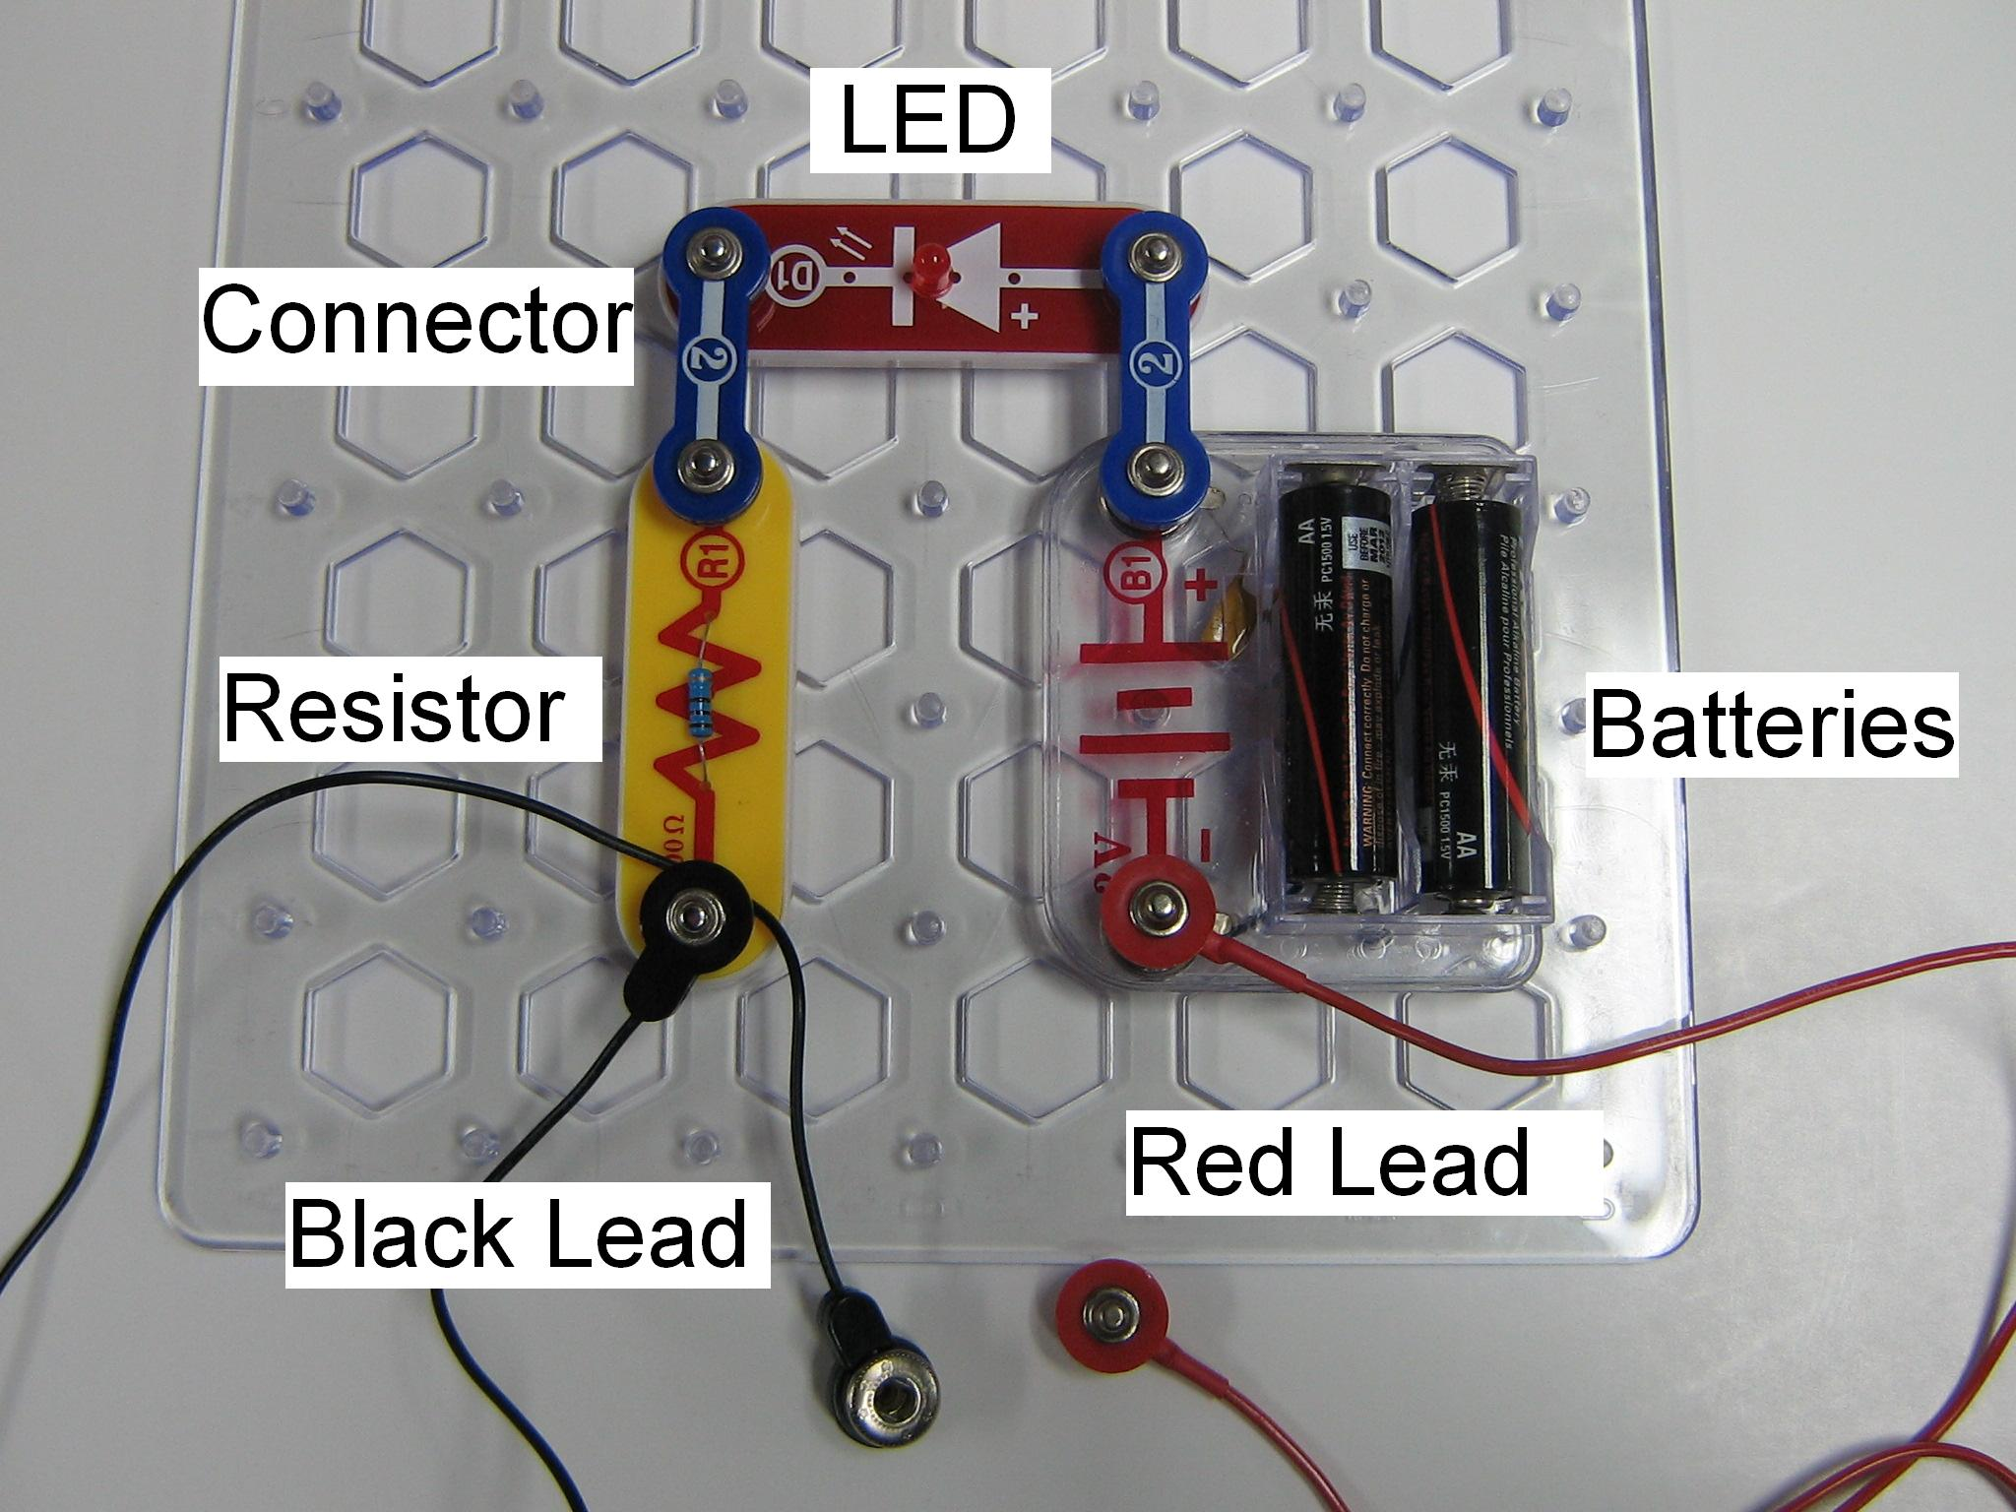
Diagram 1

Explain LED’s to the students: LED’s (Light Emitting Diodes) are more sensitive than light bulbs and glow brightly with small currents. They are made from semiconductors. They can be damaged by high currents and so are used with resistors to limit the current. Do NOT allow the students to remove the resistor.

Ask the students what you should do to make the LED glow. Touch the black and red lead together to complete the circuit.
Show the students that this is correct and that the LED emits light. Tell the students that the circuit is closed when the red and black leads are touching.
Now touch the end of one lead wire to the head of the nail and the end of the other lead to the point of the nail. The LED again lights up indicating that the circuit is closed. The metal nail is a good conductor of electricity and completes the circuit.
Repeat with the bottle cap, putting the ends of the leads on opposite sides of the bottle cap. The LED will not light up, indicating the plastic bottle cap is not a conductor, it is an insulator.

Tell the students that in the first activity they will determine whether a solid is a conductor by testing whether it completes the circuit and causes the LED to light up.

- Conductivity Tests of Solids
Students will do this activity in pairs.
Materials
16 sets of grids with assembled circuit
16 bags of solid materials for checking conductivity (paper clip, aluminum foil, copper strip, golf pencil sharpened on both ends, paper)
16 sets of instruction sheets
32 observation sheets
- Hand out one grid and one bag of solid conductivity materials to each pair.
- Tell them they will be testing several materials to see if they are conductors.
  - A good conductor will complete the circuit and the LED will glow brightly.
  - An insulator will prevent completion of the circuit, and the LED will not glow at all.
  - A poor conductor will make the LED light glow dimly.
- Have them assemble the circuit as demonstrated in Diagram 1. Make sure all groups have a correctly assembled circuit by having them touch the ends of the black and red wires together and noting the brightness of the LED.
- Tell the students to follow the instruction sheet and to record their results.
Explain that although pencils are referred to as “lead” pencils, the core of the pencil is actually graphite. In ancient Rome, the scribes wrote with a stylus made from lead. A large deposit of graphite was discovered in the 16th century in England, and found to be very useful for marking sheep! The early chemists mistook it for lead.
- Conductivity of Solutions
Materials per pair
1 6oz cup for distilled water for rinsing leads
1 set of jars labeled and containing: distilled water, tap water, vinegar, 0.1 M hydrochloric acid, distilled water for sugar to be added, distilled water for salt to be added.
8 bags containing:
1oz wide-mouth bottle of sugar
1oz wide-mouth bottle of salt
2 taster spoons
1 chemwipe tissue
2 toothpicks
Note: One VSVS member should fill 6oz cups about 1/3 full of distilled water. Each pair will use one of these to rinse the metal ends of lead wires.
Hand out the jars of solutions, salt and sugar containers etc, and a cup with distilled water to each group. The pairs will share the jars. Make sure that only 1 jar is open at a time to avoid contamination.

Background Information to tell the students:
Solids are not the only materials that can conduct electricity. In fact, liquids have electrical properties as well. Some liquids are conductors while other liquids are nonconductors.
Background information for VSVS members only:
Conducting liquids are called electrolytes. An electrolyte contains electrically charged ions that can conduct electricity. Some examples of electrolytic solutions are acids and bases and salt solutions such as sodium chloride (table salt) in water.
A non-electrolyte does not allow the flow of electric current because it does not have electrically charged ions that can conduct electricity. Some examples of non-electrolytic solutions are distilled water, sugar water.
Electrolytes are important to humans because they are necessary for proper cellular function, muscle function, and neurological function. A greater level of electrolytes is needed during strenuous muscular activity because more electrolytes are lost due to increased sweating. This is the reason why Gatorade and other sports drinks advertise that they replenish electrolytes.

Tell students to:
- Rinse the metal ends of the black and red lead wires by dipping them into the cup of distilled water. Tell the students they will need to do this in between each test, to avoid contaminating the next test sample with the one just tested (make sure that the students know what contamination means). They should then place the leads into the first jar containing distilled water to check that the leads are clean. The LED will not light up if the leads are clean. Note the rinse water will be contaminated enough after the HCl is tested so that the LED will be dimly lit. However, the test in the distilled water well should give a negative result (no glow).
- Place the labeled jars on top of the diagram on the instruction sheet. Make sure that the students have the order correct. Students must remove only 1 lid at a time, and replace it after both pairs have tested the liquid.
- Students MUST test the solutions in the order given, 1-6. The non-conducting solutions are tested first, followed by conducting solutions.
1. Testing distilled water:
Remove the lid of the first jar (contains distilled water).
Put the metal ends of both lead wires in the jar, as far apart as possible, and note if the LED is glowing. (It should not).
Remove the leads.
The lid can remain off, since this jar will be used again in steps 4 and 5.

2. Testing sugar water:
Use the tissue to wipe off the small spoon.
Remove the lid of the 2nd jar (distilled water) and add a small amount of sugar (just a little on the tip of the spoon is enough). Stir with a toothpick. Break toothpick so that it will not be used again.
Repeat the conductivity test. Record your results.
Rinse the metal ends of the lead wires in the rinse cup.
Replace the lid.
3. Testing tap water:
Remove the lid of the 3rd jar (tap water). Repeat the conductivity test. Record your results. Rinse the metal ends of the lead wires in the rinse cup. Replace the lid.
4. Testing vinegar:
Remove the lid of the 4th jar (vinegar) and repeat the conductivity test. Record your results. Rinse the metal ends of the lead wires in the rinse cup. Test that the leads are clean by putting them in the distilled water in jar 1. The LED should not glow. Replace the lid.
5. Testing hydrochloric acid:
Remove the lid of the 5th jar (hydrochloric acid, HCl) and repeat the conductivity test. Record your results. Rinse the metal ends of the lead wires in the rinse cup.
Test that the leads are clean by putting them in the distilled water in jar 1. The LED should not glow. If it does, rinse the leads in distilled water again. Replace the lid
6. Testing salt solution
Remove the lid of jar 6 (distilled water).
Use the small spoon to add a small amount of the salt into the same well (just a little salt on the tip of the spoon is enough). Stir with a toothpick. Break toothpick so that it will not be used again. Repeat the conductivity test Record your results. Rinse the metal ends of the lead wires in the rinse cup. Replace the lid.

Explanation of results:
- Distilled water does not contain ions and thus does not conduct electrical currents.
- Sugar molecules do not dissociate (split up) into ions in water, and so is a nonconductor.
- Tap water comes from wells, lakes, or rivers, and so it often contains small amounts of dissolved mineral compounds that can be ionic. The LED did not light up very brightly, but tap water can conduct enough current to stop a person’s heart.
- Vinegar is a weak conductor of electric current– the LED glows dimly. Only a few of the vinegar molecules ionize.
- Hydrochloric acid is a conductor of electric current - the LED glows brightly. All of the molecules ionize to H⁺ and Cl⁻ ions.
- Solid salt will not conduct electricity because the sodium and chloride ions are not free to move around. However, when salt is dissolved in water, it dissociates completely into ions, and so is a strong conductor of electric current.

- Optional Activity #1
Materials:
1 bag containing wide mouth bottles of Gatorade, Sprite, rubbing alcohol, bottled water and lemon juice
If time permits, ask the students to choose one of the solutions.
Ask the students to predict if they think the solution will conduct an electrical current. Test it.
- Gatorade caused the light to shine very brightly indicating that it is a strong conductor. The ingredients list citric acid, salt, sodium citrate, potassium phosphate.
- Sprite contains citric acid, potassium citrate and other salts which make it a good conductor.
- Rubbing alcohol does not conduct electricity.
- Bottled water may or may not contain minerals, depending on how it is “processed”.
- Lemon juice contains citric acid which conducts electricity.

- Optional Activity #2 - Demonstration
Why use LED’s?
In a light bulb, electricity is converted into light energy. The brightness depends on the amount of electricity flowing through it. Regular light bulbs need a high current to be bright. Repeat Experiment III using the nail and using a regular light bulb instead of the LED in the circuit. It will not light up.
LED’s Light Emitting Diodes are more sensitive than light bulbs and glow brightly with small currents. They are made from semiconductors and can be damaged by high currents and so are used with resistors to limit the current. Do NOT allow the students to remove the resistor.

Electrical current can flow through them in one direction only.
Ask the students which way the electricity is flowing. Show the students the direction of flow.
Current flows from the positive end (“knob”) of the battery to the negative (“flat”) end.
Demonstration only: change the direction of the LED piece by unsnapping it, turning it around and snapping it back in to place.
What happens? The LED does not light up.

- Review
- Go over the observation sheet with the students. Make sure they understand the chemistry behind conductivity and non-conductivity.

Lesson modifications by:
Dr. Mel Joesten, Emeritus Professor of Chemistry, Vanderbilt University
Pat Tellinghuisen, VSVS Director, Vanderbilt University
Michael Gootee, Undergraduate student, Vanderbilt University

Conductivity Observation Sheet

Name ________________________________________________

A. Testing the Circuit.
What happens when you touch the ends of the red and black lead wires together? ______________________________________________

Explain__________________________________________________________________

B. Conductivity Tests with Solids
Which of the following materials makes the LED glow brightly, dimly, or not at all?
Circle your answer.
1. copper strip no light, dim light, bright light
2. paper clip no light, dim light, bright light
3. paper no light, dim light, bright light
4. pencil wood (only) no light, dim light, bright light
5. “lead” in pencil no light, dim light, bright light
6. aluminum foil no light, dim light, bright light
On the basis of your tests, which ones are conductors of electricity?
___________________________________________________

C. Conductivity Tests with Solutions
Which of the following solutions makes the LED glow brightly, dimly, or not at all?
Circle your answer.

1. distilled water no light, dim light, bright light
2. sugar water no light, dim light, bright light
3. tap water no light, dim light, bright light
4. vinegar no light, dim light, bright light
5. hydrochloric acid no light, dim light, bright light
6. salt water no light, dim light, bright light
D. Optional Activity
Which solution did you test? ________________

Circle your answer. no light, dim light, bright light
Conductivity Answer Sheet

A. Testing the Circuit.
1. What happens when you touch the ends of the jumper cables together?
The LED lights up.
Explain: Touching the ends of the leads together completes the circuit.

B. Conductivity Tests with Solids
Which of the following materials cause the speaker to produce sound?
Circle your answer.
1. copper strip bright light
2. paper clip bright light
3. paper no light
4. pencil wood(only) no light
5. “lead” in pencil bright light
6. aluminum foil bright light
On the basis of your tests, which ones conduct electricity?
Copper strip, paper clip, “lead” in golf pencil, aluminum foil

C. Conductivity Tests with Solutions
Which of the following solutions makes the LED glow brightly, dimly, or not at all?
Circle your answer.
1. distilled water no light
2. sugar water no light
3. tap water dim light
4. vinegar dim light
5. hydrochloric acid bright light
6. salt water bright light

D, Optional Activity
The following are good conductors: Gatorade, Sprite, and lemon juice.
Rubbing alcohol does not conduct electricity. Bottled water may.

Electrical Conductivity Instruction Sheet

Place the jars on top of the diagram. Make sure that the labels match. Do not remove lids until you are ready to test the liquid.

Distilled Water Distilled Water (add sugar) Tap Water

Vinegar Hydrochloric Acid Distilled Water (add
salt)

