VANDERBILT STUDENT VOLUNTEERS FOR SCIENCE
http://studentorgs.vanderbilt.edu/vsvs
Chemical Energy Conversions
Spring 2016

Goal: To help students understand the energy conversions from chemical to light, sound, mechanical and thermal energy.
TN Curriculum Alignment: SPI 0607.10.3 Recognize that energy can be transformed from one type to another.
Lesson Outline
- Introduction.
Discuss different forms of energy and note that energy can be neither created nor destroyed.
- Chemical Energy → Thermal, Light, Sound, Mechanical Energy
Spray flammable Lycopodium powder into a can with a lit tea candle. There are many energy conversions taking place. Students are told that this demonstration will be repeated at the end of the lesson, when they will be asked to name the conversions.
- Chemical Energy → Light energy
The conversion of chemical energy to light energy is demonstrated with a lightstick.
- A. Chemical Energy → Thermal Energy.
The Recyclable Hand Warmer contains a supersaturated solution of sodium acetate that crystallizes when disturbed, demonstrating the conversion of chemical energy to thermal energy.
- Thermal Energy → Chemical Energy.
Potassium chloride is dissolved in water – students will observe a decrease in temperature. Thermal energy in the water provides the energy needed to dissolve potassium chloride. Show students the cold pack and explain that ammonium nitrate is the chemical in commercial cold packs.
- Chemical Energy → Thermal, Light, Sound, Mechanical Energy
The dust can explosion is repeated, and students will name all the conversions taking place.
- Review Questions

1. In the car ride, read through this quiz together as a team. Make sure each team member has read the lesson and has a fundamental understanding of the material.
Lesson Quiz
- What forms of energy are discussed in the lesson?
- How is chemical energy stored?
- What energy conversions are part of the “dust can” experiment?
- How is energy converted in the lightstick demonstration?
- In which demonstration(s) is a phase change used to give off heat?
- Why does water become cooler when potassium chloride is added to it?
2. Use these fun facts during the lesson:
- If a person yelled for 8 years, 7 months, and 6 days, he or she would produce enough energy to heat one cup of coffee.
- A hurricane releases 50 trillion to 200 trillion watts of heat energy. This is as much energy as a 10-megaton nuclear bomb exploding every 20 minutes.
- Just 1/3 of the energy in burning coal reaches the consumer as electricity. The rest is converted to unusable forms of energy, e.g. heat, chemical, light energy.
- Heating and cooling rooms is the greatest source of energy usage in American homes today.
- The amount of energy produced by the sun in 2 weeks equals the combined stored energy of all the coal, iron, and natural gas reserves known to man.
Materials
- large lightstick
8 small lightsticks
16 plates
8 4 oz jars of potassium chloride
16 thermometers
8 recyclable hand warmers (sodium acetate solution in plastic pouch)
1 Cold pack
16 50 mL measuring cylinders
16 spoons
16 8 oz Styrofoam cups
1 trash bag for used Styrofoam cups
1 large funnel
1 waste container (64 oz)
8 bottles filled with water
32 observation sheets
16 instruction sheets backed with picture of oranges with ice on them in sheet protectors
10 paper towels in plastic bag
1 box of goggles
1 plastic bag containing materials for exploding can demonstration:
1 aluminum pie plate
1 coffee can with hole in side and lid lined with foil
1 tea candle
1 box matches and 1 lighter
1 container lycopodium powder
1 pipette
Unpacking the Kit:
VSVSers do this while one person is giving the Introduction and another is writing the following on the board: Note that students are put into 8 groups of 3-4 and should have their pencils ready.
Thermal Energy

Light Energy
Chemical Energy
Sound Energy

Mechanical Energy

During the lesson, use this diagram to emphasize the energy conversions taking place.

For Part I. Introduction
Give each student an observation sheet and goggles.
Give each pair an instruction sheet (inside a page protector).

For Part II. Introducing Chemical Energy Conversions: Dust Can Explosion
1 plastic bag containing materials for exploding can demonstration:
1 aluminum pie plate, 1 coffee can with hole in side and lid lined with foil, 1 tea candle, 1 box matches and 1 lighter
1 container lycopodium powder and 1 pipette

For Part III. Chemical energy → Light energy: Lightstick Demonstration
8 small lightsticks, 1 large lightstick

For Part IV. Chemical Energy → Thermal Energy: Hand warmer demonstration

8 Recyclable hand warmers (plastic pouch maybe green, blue or colorless, and contains a liquid inside)

For Part V. Thermal Energy → Chemical Energy: Dissolving Potassium Chloride in Water
Students do this activity in pairs. Two pairs will share the potassium chloride and water.
16 Styrofoam cups, 16 thermometers, 16 50 mL measuring cylinders, 8 water bottles (shared by two pairs)
1 instruction sheet in a protector

For Part VI. Chemical Energy to Thermal, Light, Sound, and Mechanical Energy: Dust Can Explosion
Same as Part II.

- Introduction
Ask students: What are the different forms of energy?
Possibilities include: electrical, chemical, mechanical, thermal, light (electromagnetic), sound, and nuclear. (Note that Potential Energy and Kinetic Energy are states of energy, not forms.)

Tell the students that this lesson will be emphasizing chemical energy and conversions of this form to and from other energy forms. Students can use the depiction that you drew on the board as a reference in determining what chemical energy is converted to in each experiment.
Explain to students that chemical energy is the energy stored in the chemical bonds that hold the chemical together.
Since it is a stored energy, it is a type of potential energy.
When the atoms or molecules in a chemical are rearranged, chemical energy is released or absorbed.
Point out that several types of energy may be produced in a chemical energy conversion; for example, when wood burns, chemical energy is converted to thermal, light, and sound energy.
Ask students: what are some other examples of chemical energy being converted to other forms?
- Food being eaten (chemical to thermal and mechanical).
- Batteries used in flashlights (chemical to light and thermal).
Ask students: What happens to energy when we use it? Be sure to include the following points in the discussion.
- Energy is neither created nor destroyed.
- The total amount of energy stays the same. It only changes from one form to another.
In this lesson, students will study the following energy conversions
• chemical energy → light energy
• chemical energy → thermal energy
• thermal energy → chemical energy
• chemical energy → sound energy
• chemical energy → mechanical energy
Organize students into eight groups of three or four students.
- Give each student an observation sheet.
- Give each pair an instruction sheet (inside a page protector).

II. Introducing Chemical Energy Conversions: Dust Can Explosion
Caution: This experiment is loud and sometimes propels the lid of the coffee can in the air.
Be sure the can is some distance away from the nearest students before you do this experiment!
Note: If the explosion does not happen on the first try, please try again. Some groups have to try this several times to achieve the desired results. The students love to see this more than once, and it shows them that perseverance pays off.
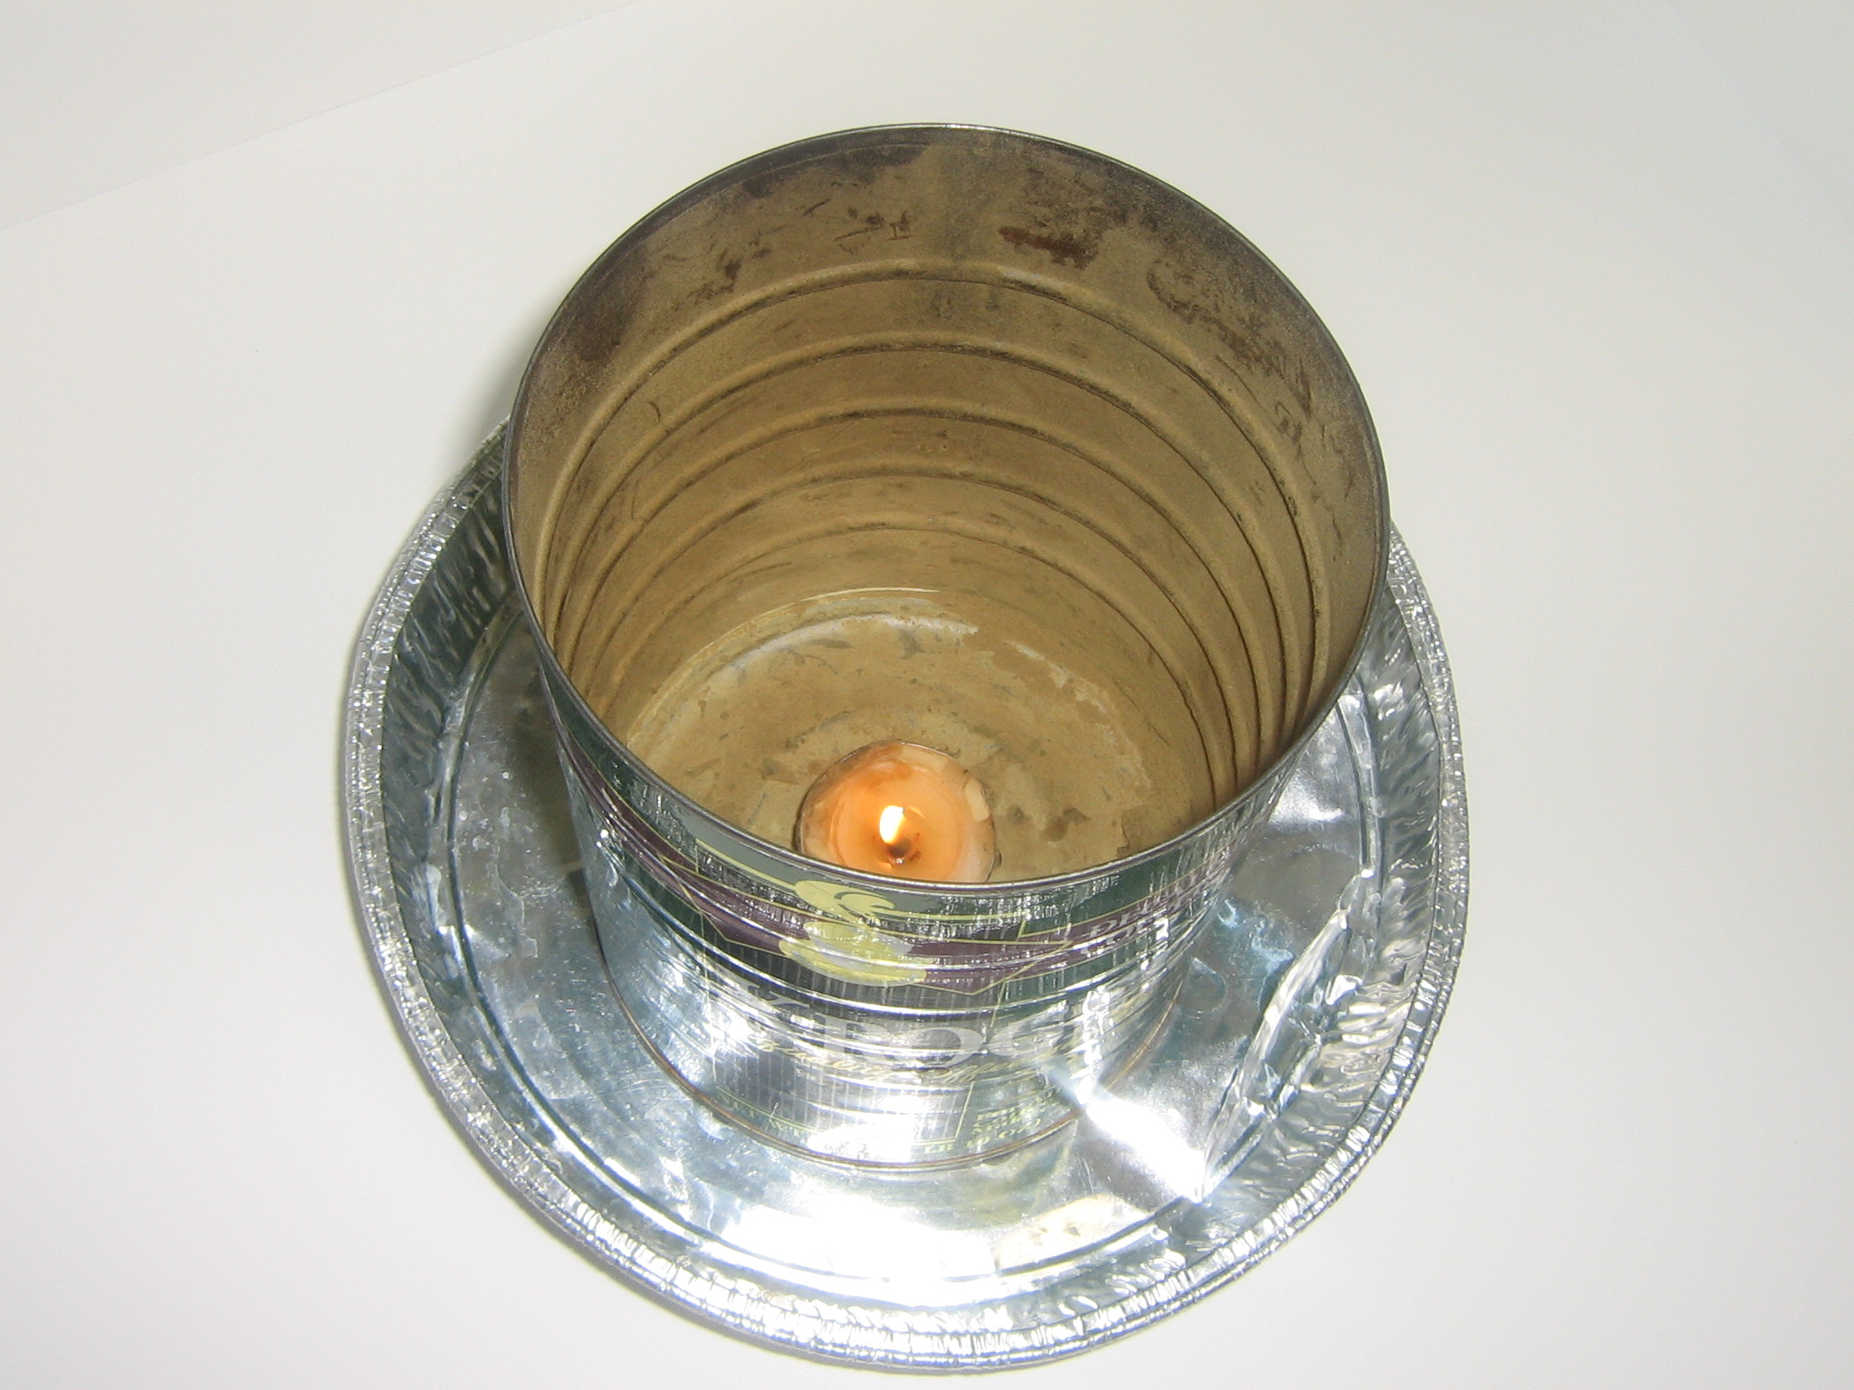
Tell students that the next demonstration will illustrate at least 4 chemical energy conversions. Students will observe so that they can name the conversions at the end of the lesson.
Put on Goggles
- Show students the "dust can”.
- Light the tea light candle and place it in the coffee can. Do not place it too far away from the hole in the side of the can.
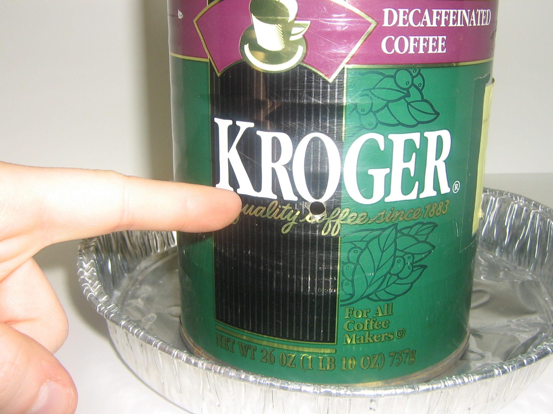
- Load the pipette with enough lycopodium powder to fill the tip. DO NOT turn the pipette upside down, it will fall out of the pipette. There must be a good amount of powder at the tip of the pipette for this to work.
- Show the students the hole in the side of the can.
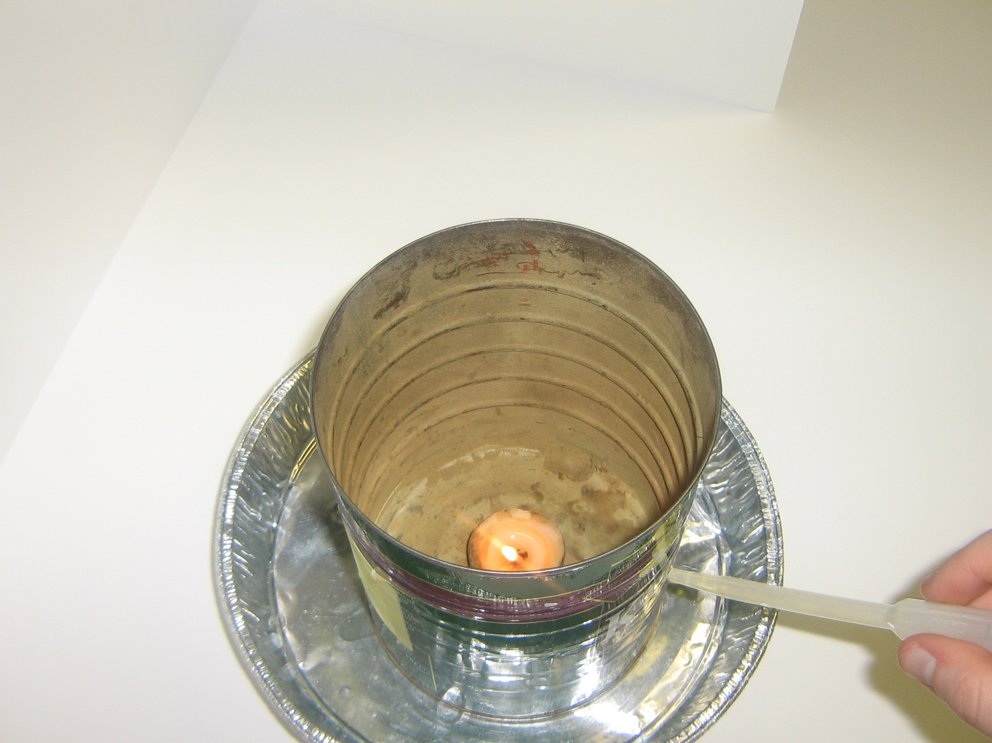
- Holding the pipette at an angle (aiming down with about a 30° angle from the horizontal), place the pipette in the hole (make sure the pipette is snug) and angle it toward the flame.
- Place the lid on the can. Wait until now to do this, as the flame will quickly go out after the lid is secured.
- Immediately after securing the lid, firmly squeeze the pipette. Leave the pipette in the hole after squeezing.
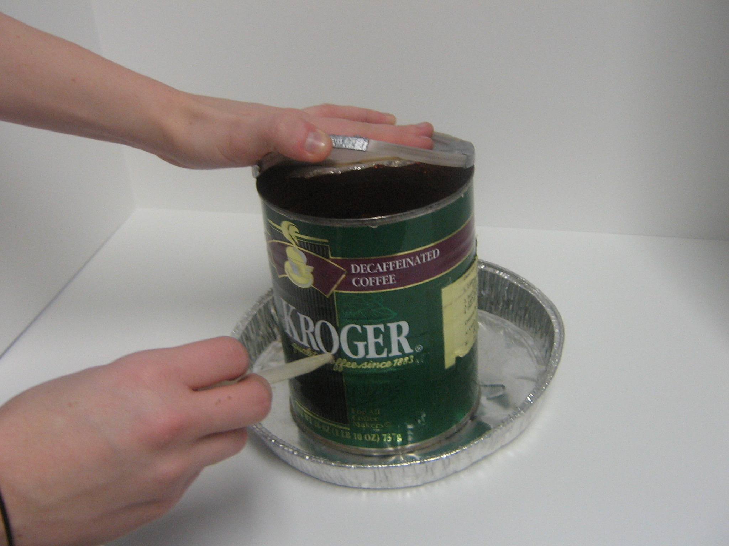
- There will be a flash of fire and a loud explosion, and the lid will blow off the can.
- Tell students that you will do this again at the end of the lesson and that they will need to name the different chemical reactions taking place
The large volume of combustion gases created (carbon dioxide and water vapor) causes the lid of the can to blow off.
Background Information for VSVS members only: The dust can explosion is a dramatic illustration of the effect of surface area on the rate of reaction. The chemical reaction is the same as any combustion reaction of an organic fuel - wood, coal, gasoline, natural gas. These fuels all contain carbon which can react with oxygen to create water and carbon dioxide. If these gases are confined, an explosion will occur because the gases take up a larger volume than the fuel.
Explosions can be useful. For example, the internal combustion engine in a car works by small explosions set off by sparks from the spark plugs in each cylinder which drives the pistons. Other explosions can be disastrous. The dust can explosion is a safe, small scale illustration of what happens in a flour mill explosion. The dust can explosion illustrates why workers in grain elevators, saw mills, and flour mills have to be very careful about sparks. A spark can ignite flammable dust in the air to produce a large explosion.

III. Chemical energy → Light energy: Lightstick Demonstration
Materials
8 small lightsticks, 1 large lightstick

Lightstick Demonstration
- Give groups a lightstick to do the experiment along with you.
- Hold up the lightstick.
- Ask the teacher if it’s fine to turn off the lights for the demonstration. If not, continue with lights on.
- Bend the plastic tube to break the thin vial inside. The lightstick may need to be bent using the edge of a table.
- Shake the lightstick.
- Tell the students to do the same.
- Hold the lightstick up and walk around the room to give the students a closer look at the lightstick.
Explanation:
- There are two chemicals in the lightstick, one encased in a vial. When the lightstick is bent, the vial breaks and two chemicals mix and react.
- Ask them what kind of energy they think chemical energy was converted to in this demonstration:
Light Energy
- Ask students if they know of any other energy conversions from chemical energy to light energy.
Some examples are burning wood in fireplaces, a lit match, and fireworks. Another example in nature is the glow of the firefly or lightning bug (light is produced through the action of an enzyme, luciferase, on luciferin). This is called bioluminescence.
- The students can now answer question #1 on their observation sheet.

Note: The lightstick is an example of a chemiluminescent reaction. Chemiluminescence occurs when a chemical reaction produces a molecule in an excited state. When this excited molecule changes to a more stable form, it emits light. Bioluminescence is an example of chemiluminescence in a biological system, generally an animal or bacterium.
IV. Chemical Energy → Thermal Energy: Hand Warmer Demonstration

Materials : 8 Recyclable hand warmers (plastic pouch maybe green, blue or colorless, and contains a liquid inside)

Recyclable Hand-Warmer - Show the class a hand warmer and explain that it contains a supersaturated sodium acetate solution.
- Give each group a hand warmer.
- One student in each group should use a fingertip to firmly press and release the metal activation button. Some handwarmers have a piece of metal that needs to be bent.
- Students should see white solid beginning to form around the button/metal disc. If they don’t, they need to press the button again/bend metal disc. (Try using the tip of a finger to press down on the button.)
- Ask the students what they observed. A change of state from liquid to a solid has occurred, and the pouch became warmer.

When finished, collect all hand warmers and return them to the kit box. They are rejuvenated by heating in boiling water.

Explanation: Tell the students that there is more chemical energy in the bonds of liquids than in solids. When liquids change to solids, excess chemical energy is given off. This energy can be converted to another form. This is an excellent reminder that energy is not lost; it merely changes form.
Ask the students what form of energy they think the chemical energy was converted to:
Thermal Energy (because heat was released in the reaction)
- In this activity, the liquid to solid change occurs when the sodium acetate crystallizes (precipitates) out of solution. Thermal energy is given off.
- Students can now answer question #2 on their observation sheet.
- Point out that the hand warmer can be recycled by placing it in a pan of hot water for several minutes (directions are given on the hand warmer). This returns the energy that was lost during crystallization.
- Ask the students to explain how the recyclable hand warmer illustrates the law of conservation of energy. Pushing the button causes the solution to crystallize (turn solid) and thermal energy to be released. The opposite reaction occurs when the pouch is placed in hot water. This input of thermal energy restores the sodium acetate solid to its original liquid state.
For VSVS Information only:
1. Saturated solutions contain the maximum amount of solid that can be dissolved in a liquid at a given temperature. Usually, more solid can be dissolved if the solution is heated to a higher temperature; however, when this solution is cooled, the excess solid crystallizes. This is the normal process for purifying a solid (by recrystallizing it from solution).
2. Supersaturated solutions are unstable because they contain more dissolved solid than normally can be dissolved at that temperature. The difference between a supersaturated solution and a saturated solution is that the excess solid doesn’t crystallize when the solution is cooled. The excess solid will only crystallize with the addition of a seed crystal of the same substance, or in the case of the recyclable hand warmer, when the solution is disturbed by pressing the activation button. Only a few solids are capable of forming supersaturated solutions. Sodium acetate trihydrate is one of them.

Everyday Applications:
- Liquid to Solid Phase change gives off thermal energy:
Tell students to look at the picture of ice on oranges hanging from a branch of an orange tree on their handouts. Explain that farmers spray water on fruit trees when a light freeze is expected. The water freezes on the outside of the fruit. When it freezes, it releases enough heat to keep the fruit from freezing. (This is another phase change from liquid to solid that releases thermal energy, it just happens more slowly than in the hand warmer). This only works if the temperature doesn't drop below 28º F.

- Liquid to Gas uses thermal energy (Thermal to chemical)
This is especially important for humans – when we sweat, the evaporation of water from our skin absorbs heat from our skin. This helps maintain our body temperature. This is why a fan feels so cool after running around outside (it is a phenomenon called evaporative cooling).

V. Thermal Energy → Chemical Energy: Dissolving KCl in Water
Materials: (Students do this activity in pairs. Two pairs will share the potassium chloride and water. )
Give each pair the following:
1 Styrofoam cup
1 thermometer
1 50 mL measuring cylinder
1 water bottle (shared by two pairs)
1 instruction sheet in a protector

  - Distribute one jar of potassium chloride and 2 plastic spoons to each group of two pairs.
  - Give each student safety goggles and instruct them to wear them while they are doing this experiment.
- Tell the students that in each activity thus far, chemical energy has been converted to another form of energy.
- Let them know that in this activity, the opposite will occur. One form of energy will be converted to chemical energy.
Background: When dissolving a solid in a liquid, energy is required to break the bonds that hold the solid together. This energy is supplied by thermal energy from the liquid, and thus when most solids dissolve, the temperature of the liquid drops.

In this experiment, potassium chloride is dissolved in water, and thermal energy from the water is absorbed. The temperature change will be measured to show that thermal energy is used.
Ask students how they will be able to tell if thermal energy is being used. The water will be cooler.

Make sure students know how to read a thermometer:
- Ask students to look at the diagram of the thermometer on their Observation Sheet.
- Explain that:
  - This diagram is a copy of their thermometer.
  - Each line represents a temperature degree.
  - The temperature is read by observing where the top of the red liquid is.

Tell them to:
- Find the lines that represent 20ºC and 30ºC (the temperature will be between these 2 values).
- Mark on their diagram, the height to which the red liquid has reached on the thermometer.
- Determine which black line it matches up with on the thermometer diagram. The degree that the black line represents is the temperature the thermometer senses. Record this temperature.
- The temperature represented by their mark should be about 24ºC. (Answer question #4 on the Observation Sheet).
Note: While students are starting the experiment, VSVS members should circulate among the students and check their observations to see if their reading is about 24ºC.
Note: The instruction sheet also tells the students to mark the thermometer diagram when they measure the temperature of the water and the temperature of the potassium chloride solution. Continue checking their Observation Sheets throughout the activity to make sure they have recorded temperatures which correspond to their marks on the thermometer diagram.

- Students and VSVS members should put on their safety goggles.
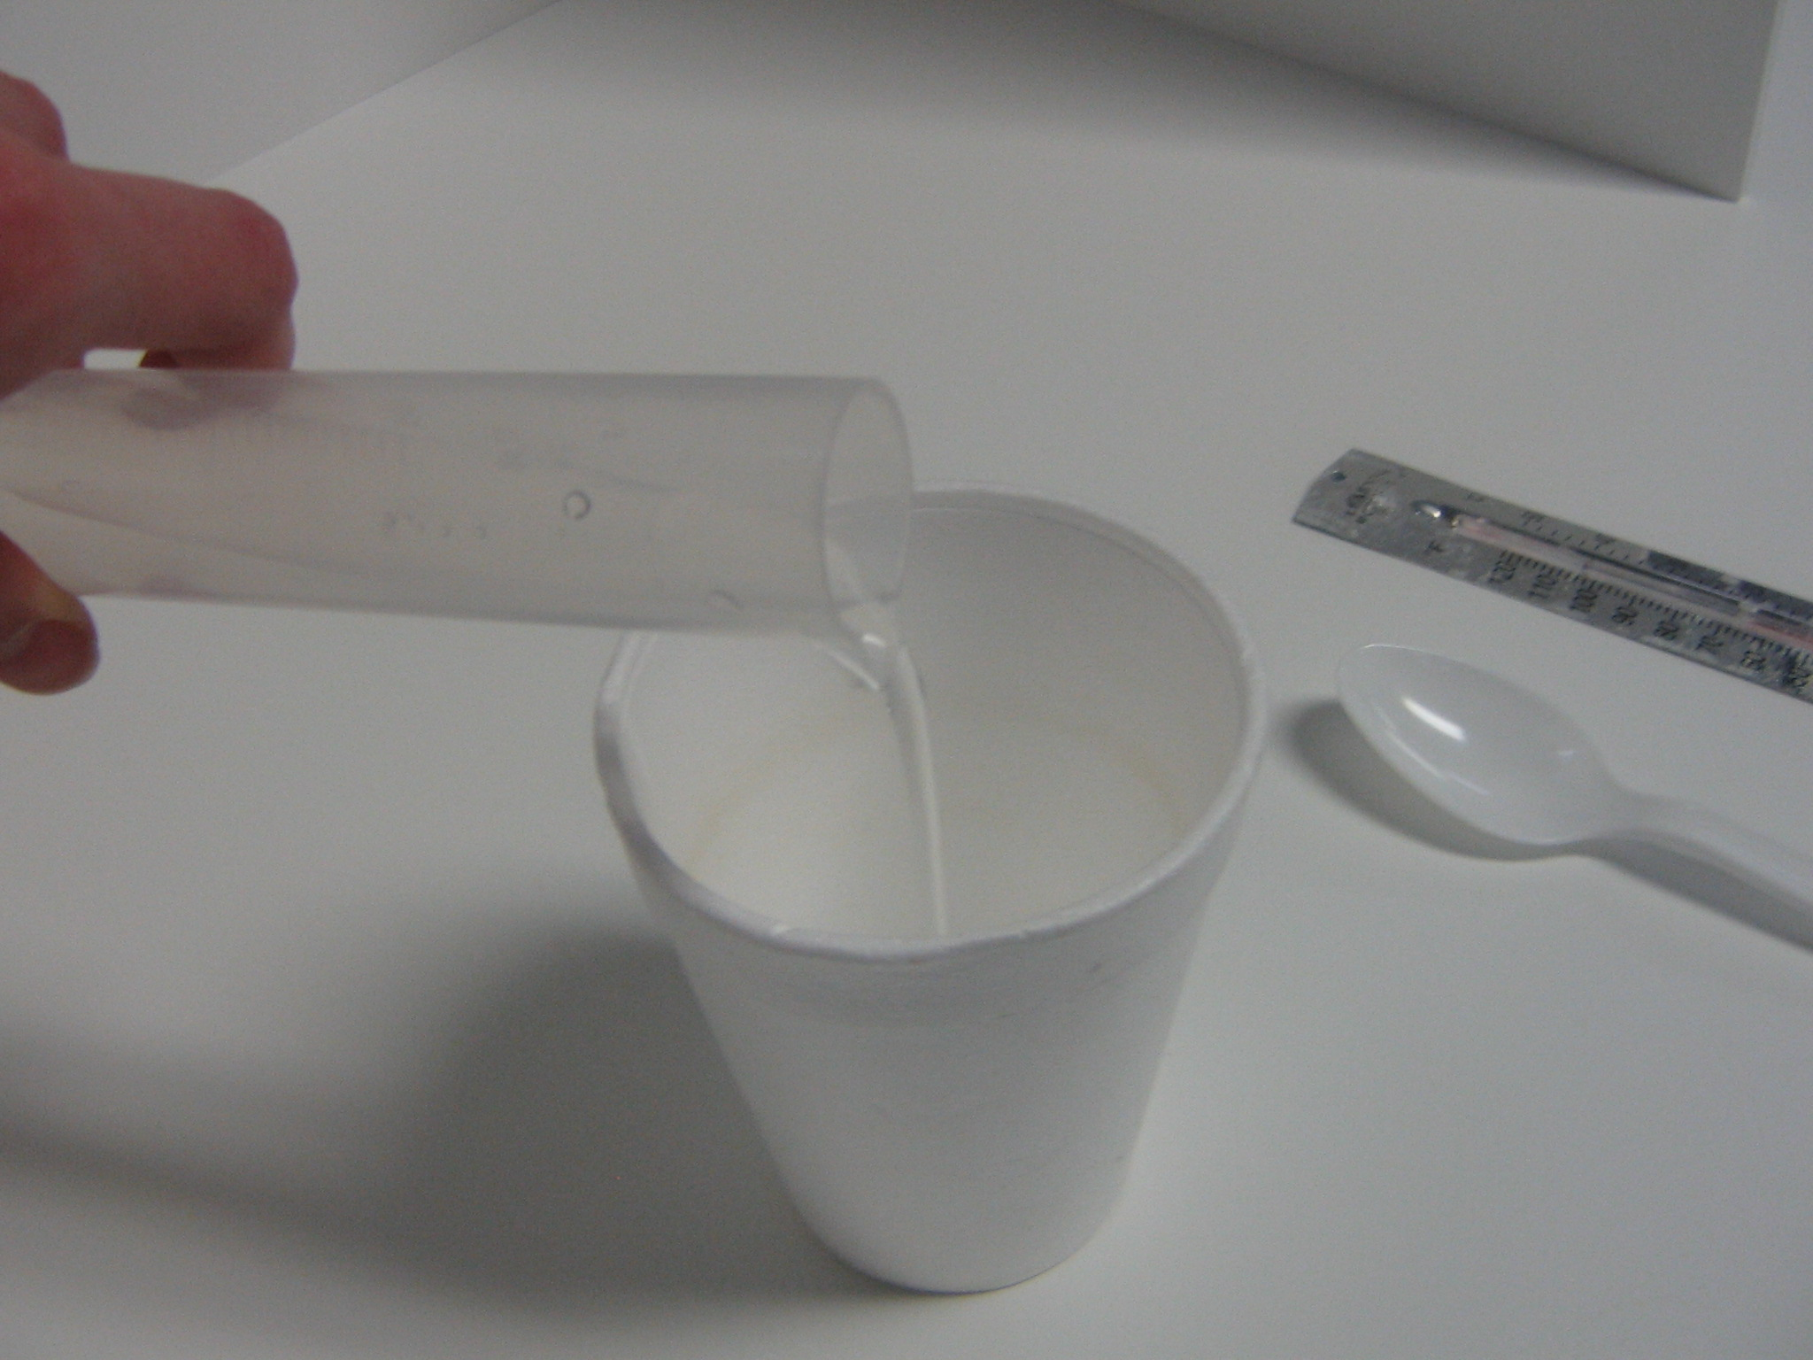
- The following instructions are given on their instruction sheet – make sure they are following this procedure while you are circulating and checking Observation Sheets.
- Tell each pair to:
  - Fill the 50 mL cylinders to the mark with water and add it to the Styrofoam cup.
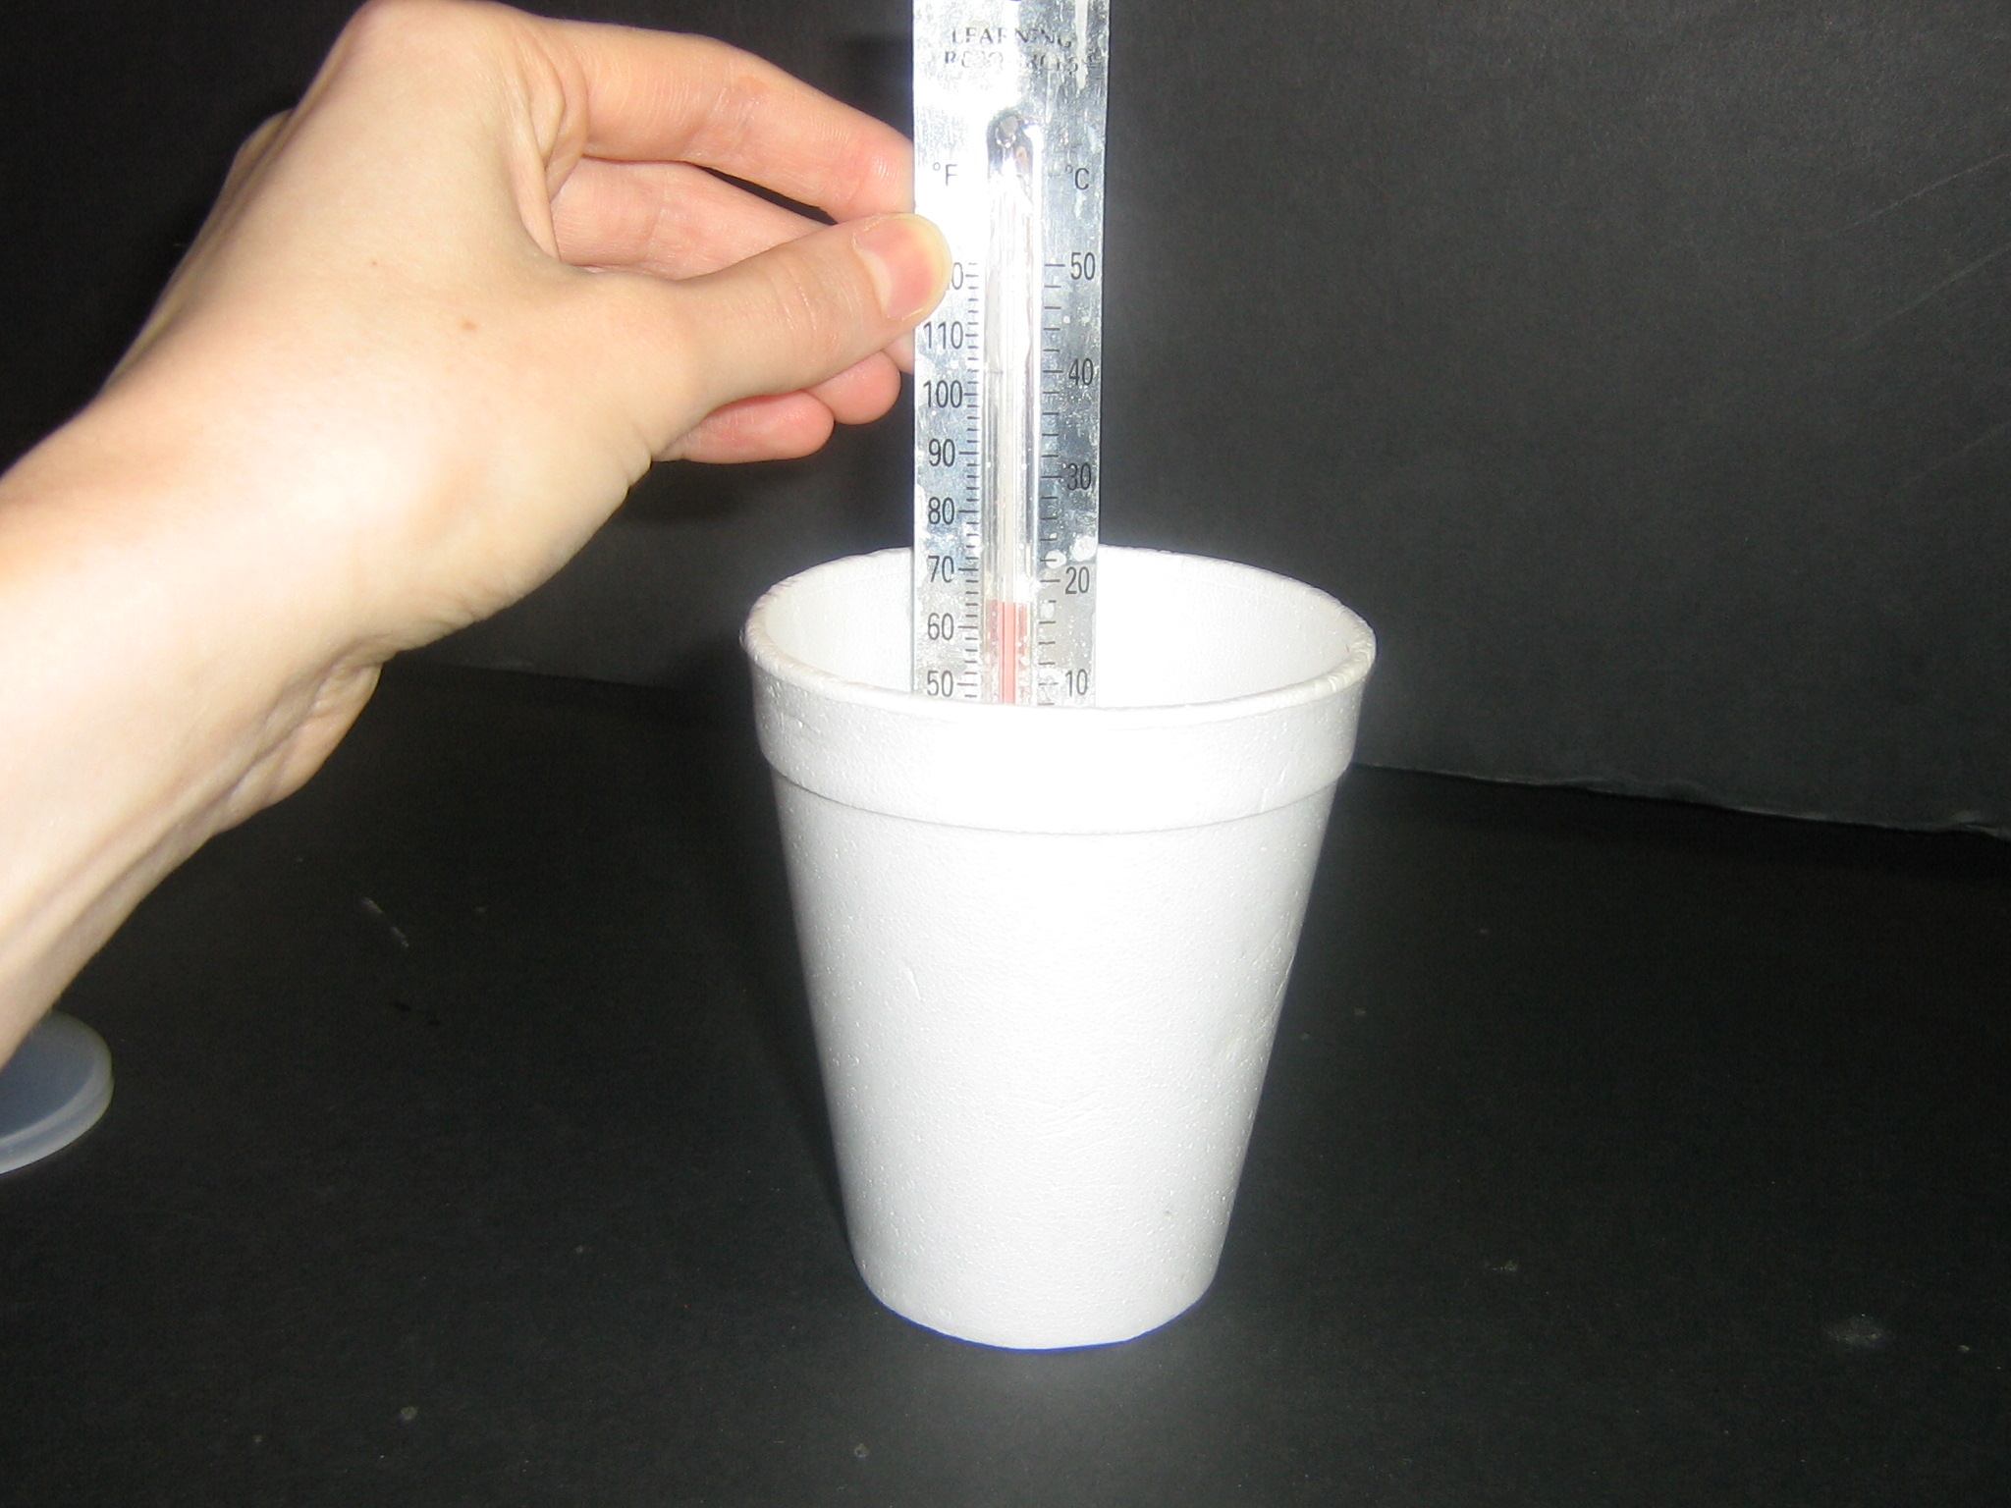
  - Place the thermometer in the water and (after about 1 minute) measure the temperature of the water.
  - They should mark the temperature they think the water is and answer question #5A on the observation sheet.
  - Add two spoonfuls of potassium chloride and stir with the thermometer. It takes about two minutes for the solid to dissolve.
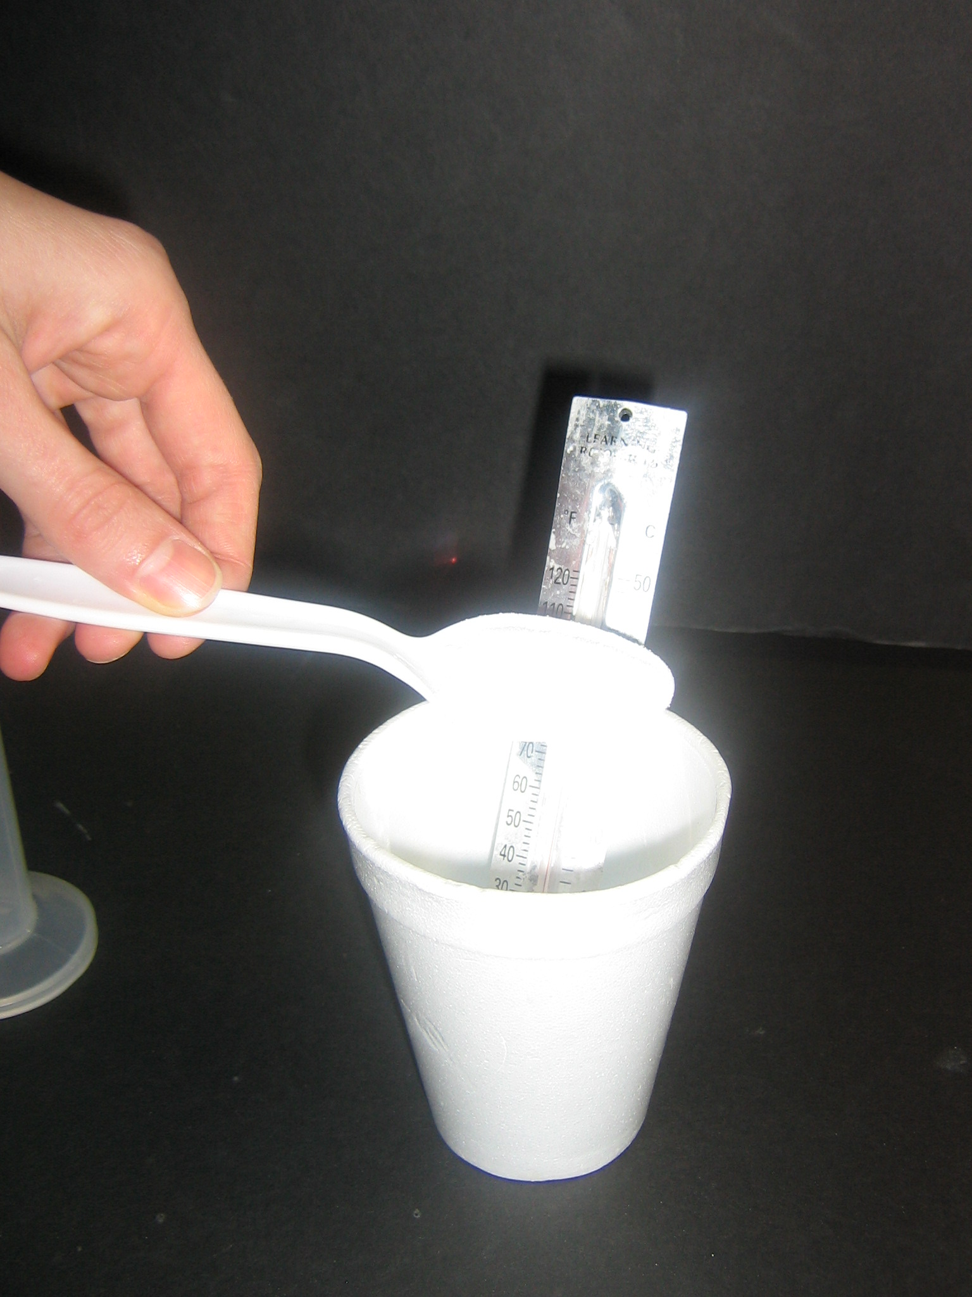
  - Find where the red liquid has moved to, read the temperature, mark the temperature on the thermometer diagram, and write in the temperature on the blank for #5B (water plus potassium chloride).
  - Subtract the two temperatures and record this value.

- Ask the students what they noticed after they added potassium chloride to the water: The water got colder.
- Ask students: What was the temperature difference they observed? Write these values on the board. Students should observe a decrease in the range of 10-14 degrees.
- Ask students what type of energy was converted to chemical energy in the experiment: Thermal Energy
- It is often difficult for students to see this. Remind them that in the activities with hand warmers, chemical energy was converted to thermal energy, so heat was released. In this activity, heat was used (the solution got colder), so it is a thermal energy to chemical energy reaction/conversion
Ask students if they know what a cold pack is. When is it used? Show the students a cold pack. Activate it and pass it around the room for the students to feel. (Make sure it is returned to the VSVS lab.)
Share the following information with the students:
Commercial cold packs contain separate bags of ammonium nitrate and water. The cold pack is activated by squeezing to break the plastic divider between the water and ammonium nitrate so ammonium nitrate mixes with the water. Just as in the experiment above, when ammonium nitrate is dissolved in water, thermal energy from the water is absorbed.
Disposal: Pour the solutions from the Styrofoam cups down a sink or, using the large funnel, into the waste bottle provided. Make sure the waste bottle lid is screwed on tightly and placed UPRIGHT in the kit box. Put used Styrofoam cups in the trash bag before putting them back in the kit box.
VI. Chemical Energy to Thermal, Light, Sound, and Mechanical Energy (The Return of the Dust Can Explosion).

A. Dust Can Explosion: Flame Demonstration
Materials needed for the Dust in a Flame Demonstration are in the Coffee Can which contains:
1 box of matches 1 container of lycopodium "dust” powder
1 pipette (jumbo size) 1 tea light candle
1 aluminum pan

- Show the students the lycopodium "dust” powder.
- Light the tea candle and place it on the aluminum pan.
- Load the pipette with enough dust powder to fill the tip. Do not turn the pipette upside down. There must be powder at the tip of the pipette for this to work.
- Hold the pipette so the tip is about 10 inches above the flame and squeeze the pipette bulb to release the lycopodium powder into the flame.
- There will be a flash of fire.
Ask students: Why was there a flash of fire?
It was caused by the rapid burning (combustion) of the lycopodium powder.

Ask the students if they can name the chemical energy conversion involved?
Burning involves chemical energy to light and thermal energy.

Explanation for VSVS members: If the powder is put in a pile, it will not light. Oxygen cannot get inside the pile to react with enough particles of powder; it can only react with the particles on the outside of the pile. When the powder is suspended in the air, it has more surface area than when it was in a pile. This is because the particles are extremely small. When they are sprayed into the air near the flame, the particles are spread out so the oxygen in the air reaches more particles at the same instant – hence more particles are burning at the same time, and you see a big flash of flame. (Lycopodium powder is a dried-up moss. It is used for this type of demonstration because the powder has extremely small particles.)

B Dust Can Explosion: Whole Demonstration
The dust can explosion is repeated (see Part 1 for instructions). Students will need to observe and name the conversions.
Ask students: What chemical energy conversions are involved? Write the answers on the board and tell them to then complete question #6 on their observation sheets.
Chemical to thermal
Chemical to light
Chemical to mechanical
Chemical to sound

VII. Review Questions
Go over the observation sheet with the students, and ask them to answer the review questions. Discuss the review questions, including reference to vocabulary words whenever possible.

What are the different forms of energy? Different forms of energy covered in this lesson include chemical, light, and thermal, mechanical. Other forms include, electrical, nuclear.

Can energy ever be created or destroyed?
No, energy is always conserved. It only changes form. This is the Law of Conservation of Energy

What type of energy conversions does the following represent?
- Turning on a flashlight: chemical energy to electrical energy to light energy

What are some other types of energy conversions that we have not discussed today?
Examples include: nuclear to electrical, electrical to thermal, electrical to mechanical (electric cars).

Lesson written by Dr. Melvin Joesten, Chemistry Department, Vanderbilt University
Pat Tellinghuisen, Coordinator of VSVS, Vanderbilt University
Susan Clendenen, Teacher Consultant, Vanderbilt University

CHEMICAL ENERGY CONVERSIONS OBSERVATION SHEET

Name ___________________________________________
Circle the correct energy conversion for the following questions:
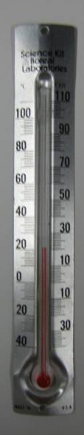
1. When the light stick was activated, chemical energy was converted to:
a. thermal energy b. light energy c. electrical energy
What evidence do you have for this conversion? __________________________

2. When the button was pushed/disc bent in the recyclable hand warmer, chemical energy
was converted to:
a. electrical energy b. thermal energy c. light energy
What evidence do you have for this energy conversion? ____________________

3. Activity: Reading the Thermometer
Look at your thermometer. Mark the height to which the red liquid has reached. This is the temperature the thermometer senses. Record this temperature below.
Initial temperature reading of the thermometer diagram: ______ °C

4. Potassium Chloride Activity
Repeat temperature reading after the thermometer has been in the water.
Determine what the temperature the water is and record below:
Temperature of water (A): ______ °C

Repeat temperature reading after potassium chloride has been added and dissolved, and record below:
Temperature of water + potassium chloride (B): ______ °C
Temperature change (A-B): ______ °C
In this activity, _____________energy was converted to chemical energy

5. Exploding Can Demonstration.
When the powder was ignited in the coffee can, chemical energy was converted to several
other forms. Circle all the conversions and give the evidence for the conversion:
Chemical to light ______________________________________________
Chemical to sound ______________________________________________
Chemical to mechanical ______________________________________________
Chemical to nuclear ______________________________________________
Chemical to thermal ______________________________________________
Chemical to electrical _________________________________________
Where did the chemical energy come from? _________________________________________________________________________

ANSWER SHEET
CHEMICAL ENERGY CONVERSIONS OBSERVATION SHEET

1. When the light stick was activated, chemical energy was converted to:
a. thermal energy b. light energy c. electrical energy
What evidence do you have for this conversion? _____lightstick lit up________

2. When the button was pushed/disc bent in the recyclable hand warmer, chemical
energy was converted to:
a. electrical energy b. thermal energy c. light energy
What evidence do you have for this energy conversion?__It felt warmer________

3. Activity: Reading the Thermometer
Put a mark next to the line on the thermometer diagram that is even with the top
of the black line in the middle of the thermometer. Record the temperature
represented by this mark on the blank below.
Temperature reading of the thermometer diagram: __24__ °C

4. Potassium Chloride Activity
Draw a line on the picture of the thermometer that matches where the top of the
red line is on your thermometer in the water. Determine what the temperature
the water is and record below:
Temperature of water (A): _21 (varies)_ °C
After potassium chloride has been added and dissolved, measure the
temperature of the water using the same method as before and record below:
Temperature of water + potassium chloride (B): 14 (varies)_ °C
Temperature change (A-B): -10 to -14_ °C
In this activity, ___thermal___energy was converted to chemical energy

6. When the powder was ignited in the coffee can, chemical energy was converted to several other forms. Circle all the conversions and give the evidence for the conversion:
Chemical to light Observed a yellow flame
Chemical to sound Heard a loud noise
Chemical to mechanical The lid blew off.
Chemical to nuclear none
Chemical to thermal The lid and can felt warm
Chemical to electrical none
Where did the chemical energy come from? Stored in the chemical bonds of the
powder. The energy was released when the powder burned.

Instruction Sheet
Chemical Energy Conversions
I. Introduction.
Thermal Energy

Chemical Energy Light Energy

Sound Energy

Mechanical Energy

II. Introducing Chemical Energy Conversions – Dust Can Explosion

III. Chemical Energy→ Light Energy
Activate the lightstick.
Answer question #1 on your observation sheet.

IV. Chemical Energy → Thermal Energy
Recyclable Hand Warmer
1. Press firmly and release the metal activation button. Or bend the metal disc.
2. You should see white solid beginning to form around the button. If you don’t, try again. (Try using tip of finger to press down on button.)
3. What happens? Answer question #2 on your observation sheet.

V. Thermal Energy → Chemical Energy
Reading the Thermometer
1. Find the lines that represent 20 degrees Celsius and 30 degrees Celsius. Mark the height to which the red liquid has reached on your thermometer and see which black line it matches up with on the thermometer diagram. The degree that the black line represents is the temperature the thermometer senses.
2. Record the temperature represented by this mark on the blank in question #3, Temperature Reading of Thermometer Diagram.
Measuring Temperatures of water and water with added potassium chloride
1. Put on your safety goggles.
2. Fill the measuring cylinder to the 50 mL mark with water and pour it in a Styrofoam cup.
3. Put the thermometer in the water, wait 1 minute and measure the temperature.
4. Record this temperature on your observation sheet in question #4A (temperature of water).
5. Add two spoonfuls of potassium chloride and stir carefully with the thermometer for about 2 minutes.
6. Stir carefully with the thermometer for two minutes or until the potassium chloride is dissolved.
7. Record the lowest temperatures reached.
8. Subtract the 2 temperatures and complete question #4.

VI. Revisiting the Exploding Can Demonstration.
Observe and circle all the conversions in the exploding can in question # 5.

