VANDERBILT STUDENT VOLUNTEERS FOR SCIENCE
http://studentorgs.vanderbilt.edu/vsvs
Stream Pollution
Fall 2013
Idea for lesson taken from a SEPUP Activity

Thanks to Professor Kaye Savage, Department of Geology, Vanderbilt University for providing information about acid runoff from gold mines and coal mines. She also provided the sample of solid tailings from the Jamestown lode in California, which is a mixture of iron(II) and iron(III) sulfates with other mineral particle impurities.

Goal: To learn how pollution runoff can cause a fish kill by affecting the pH of different locations on “Town” River.
Fits Tn state standards: Embedded Inquiry for all grades
Materials:
1 model of “Harrodsburg”
8 plastic containers containing 1 layer of marbles and 1 sponge.
8 bottles of water
8 5-oz plastic cup with small holes in the bottom
1 dropper bottle red food coloring
For demonstration, part 6B;
pH paper and 3 dropper bottles of solutions: pH = 4,7,11
Solids from mine tailings and solution of iron (III) sulfate
8 sets of dropper bottles labeled A-S (13 dropper bottles)
1 map answer sheet and sample/pH answer sheet in a sheet protector
32 map/observation sheets of the town
32 tables of Effect of pH on Marine Life (in sheet protectors)
32 Information Sheet on the Water Cycle
16 containers of pH Hydrion paper (2 per group)
8 samples of iron pyrite (fools gold)
- Strainer

- Introduction:
A fish kill has occurred in Harrodsburg River and the nearby lake, and the city’s Mayor has brought in a special team of scientists to determine the cause of the fish kill.

II. Explanation of Map and Model:
- Give students a copy of the map observation sheet and hold model so that all of the
students can see it.
2. Orientate the map and the model so that students understand where everything on the
map is in relation to the location on the model.
- Explain the direction of runoff from the different sources (downhill) and how it would reach the river.
Note: It is important that they understand the significance of the slope of the land, and
how it dictates the direction of water flow into the river.
4. Explain that polluted water flows in the same way that clean water flows.
5. Point out that the lettered positions on the model and map represent sources of water,
and the type of source (ie wells, ponds, lakes, or streams).
Note that wells D, H, I, J, K, R, have been removed from testing. They are not listed on the observation sheet, but are still on the model.
III. The Water Cycle
Hand students a copy (in sheet protectors) of the water cycle and explain the important steps.
Tell them the water cycle is also called the hydrologic cycle.
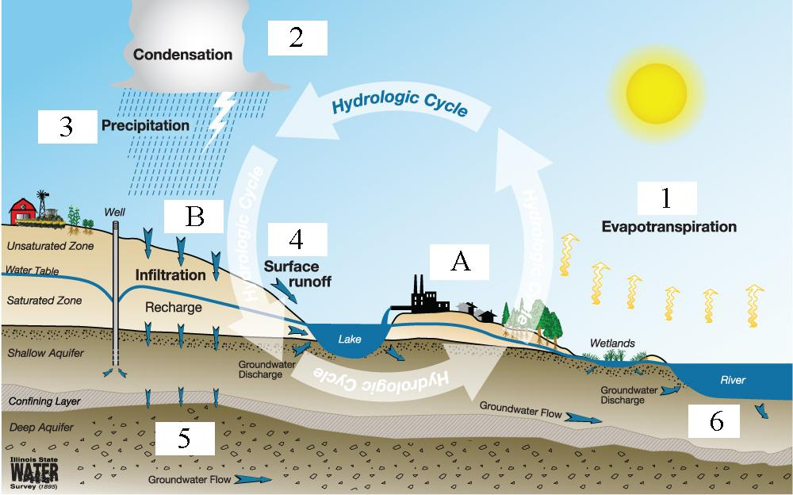
Illustration courtesy of Illinois State Water Survey, http://www.isws.illinois.edu/docs/watercycle/.

The Water Cycle:
Point out the numbers and letters in the diagram and explain the meaning of each:
#1. Water in lakes, rivers, and oceans evaporates due to the heat from the ground or
radiation from the sun.
#2. Air currents (wind) carry the water vapor over land where it cools and condenses into cloud.
#3. The condensed water vapor the precipitates and falls (in the form of rain, snow, sleet,
etc.) to the Earth.
#4. A large portion of the water runs along the surface and collects in rivers and lakes. This is called surface runoff.
#5. Percolation occurs when the water from rain or snow begins to move through the soil
and rocks. The water is now referred to as groundwater.
#6. All the precipitation that falls to earth eventually collects in the same rivers, lakes, and
oceans and the cycle begins again.
Key Terms:
- Wastewater Discharge (A): The release of waste products and contaminants into surface runoff and river drainage systems
- Leaching (B): This occurs when chemicals that are soluble in water are carried away by moving water and washed into lower layers of soil.

IV. Movement of Polluted Water into Lakes and Groundwater
Materials
8 plastic containers containing 1 layer of marbles and 1 sponge.
8 bottles of water
8 5-oz plastic cup with small holes in the bottom
1 dropper bottle red food coloring
1 styrofoam block
Divide students into 8 groups.
Tell students to:
- Place one end of the container on the styrofoam block so that it is tilted.
- Pour enough water into the plastic container so that the marbles are covered.

Explain: the water in the marbles represents ground water.
- Pour enough water over the sponge so that it is damp (it may already be damp from previous use).
  - The sponge represents top soil. Underneath the sponge, the water in the marbles represents an aquifer. Beside the sponge, the water becomes a lake.
  - Look at the water level in the lake and see how it corresponds to the water level in the gravel. It is the same level.
- A VSVS member will add 1 drop of red food coloring to the top of the sponge, near the edge of the container so that you can see the diffusion of the color. The food coloring represents a point source of pollution.
- Hold the cup with the holes in the bottom over the sponge (close to the red spot is ideal.)
- Add water to the cup with holes so that it drips onto the sponge above the spot. Observe what happens to the coloring.
The pollutant (red coloring) diffuses down through the sponge and into the
ground water. This in turn flows into the lake and pollutes it.

This demonstrates how pollutants can move from soil (represented by the sponge) into the groundwater (water beneath the sponge), and in turn, to streams and lakes.

V. How Can Polluted water Affect Stream Life?
There are many sources of water pollution. Ask students to name some water pollutants.
Answers may include soil run-off, oil, animal waste, chemicals from factories, mines,
fertilizers, pesticides, acid rain.
A more complete list is below, for VSVS members only.
Do not spend too much time on the answers.
For VSVS Member Information Only
Types of pollution:
- Sediments – soil, sand, clay and minerals in runoff from eroding land, and
construction sites
- Petroleum products – Oil, grease, gasoline from ships, oil refineries, gas
stations, and streets
- Animal wastes in runoff from feedlots, human wastes that are not properly
treated at a waste treatment plant and then released to river or lake.
(4) Organic wastes – released from food processing plants, paper mills
(5) Inorganic chemicals – mining and manufacturing industries, mines
(6) Fertilizers – source of phosphates and nitrates. Excess phosphates and nitrates
enhance the growth of algae. When these algae die, the decomposition process
uses up the dissolved oxygen in the lake or stream and fish die.
(7) Heated or cooled water – reduces level of dissolved oxygen in stream or lake and
can cause fish kills. Heated water may be discharged from nuclear plants or
manufacturing plants. Cooled water may be discharged from heat exchange units
in manufacturing plants.
(8) Pesticides, herbicides, fungicides – toxic substances that may be in agricultural
runoff from farms, parks, lawns, and golf courses
(9) Acid precipitation - Acid rain (or snow) results from the mixing of rainwater with
exhaust gases from burning fossil fuels – primarily nitrogen oxides from vehicles
and sulfur oxides from power plants and industries. Nitrogen oxides and sulfur
oxides dissolve in the rainwater to give nitric acid and sulfuric acid, respectively.
Tell students that many types of pollution can affect marine life in streams and lakes. Several types of testing are used to determine the quality of water in the stream or lake.
In today’s lesson, pH is the only test being done.

Note for VSVS team: To gain a more accurate picture of the water quality of a stream or lake, it would be necessary to also analyze for dissolved oxygen.
A. Quick review of the definition of pH
Write the letters pH on the board.
Tell students that the pH scale ranges from 0 to 14.
acids 0-6, (0 is the most acidic solution)
neutrals 7,
bases 8-14 (14 is the most basic solution).

Tell students that:
- The normal pH range for natural waters is between 5.0 and 8.5.
- Areas where limestone is found will be on the high end (pH7-8.5).
- The pH (acidity) of normal rainwater is 5.5 to 6.5 because of dissolved carbon dioxide. Any rain with a pH below 5.5 is called acid rain.
- Acid runoff from mines or factories can lower the pH below pH 7
- Rapidly growing algae can raise the pH above ph7 by removing carbon dioxide from the water during photosynthesis.
For VSVS information only:
More concentrated solutions of acids and bases exist that go beyond either end of this scale.
Like the Richter scale used to measure the extent of ground movement in earthquakes,
the pH scale is a logarithmic scale. This means that a substance at pH 6 is ten times
more acidic than a substance of pH 7, a substance at pH 5 is one hundred times more
acidic than a substance of pH 7 and so on.
Note: The important concept at this grade level is to understand the 0-14 scale that identifies which substances are acids and bases. It is not necessary to spend any time explaining the logarithmic aspect of the scale.

B. What conditions Harm Marine Life?
A range of pH from 6.5 to 8.2 is the best range for most marine life.
Tell students to look at the handout that shows the effect of pH on marine life. Point out the conditions where a fish kill can be expected (pH’s 4 (acid) and pH 10.5).
pH Effect
3.0 – 3.5 Fish cannot survive more than a few hours
3.5 – 4.0 Lethal to salmon
4.0 – 4.5 All fish, most frogs, and insects are not present.
4.5 – 5.0 Many insects are absent. Fish eggs won’t hatch.
5.0 – 5.5 Bottom-dwelling bacteria begin to die. Plankton start to disappear. Snails and clams are absent.
6.0 – 6.5 Freshwater shrimp are absent.
6.5 – 8.2 Optimal for most marine life.
8.2 – 9.0 Not directly harmful to fish, but any ammonia that is present is toxic to fish
9.0 – 10.5 Harmful to salmon and perch if present for long periods.
10.5 – 11.0 Lethal to salmonids. Prolonged exposure is lethal to carp, perch
11.0 – 11.5 Lethal to all species of fish.

C. Using pH Hydrion paper
Show students:
  - The container of pH Hydrion paper and the color chart on the side.
  - The 3 dropper bottles with different pH’s (4,7,11).
  - How to put a drop of the solution onto the pH paper.
  - Determine the pH of the solution by matching the color of the paper with the color chart.
  - Tell them that they will be doing the same tests on their water samples.

VI. Experiment – Testing the pH of the water in wells and stream
Students can do this experiment in pairs – the groups will share dropper bottles.

1. Distribute the dropper bottles so that all 8 groups have bottles A-S.
2. Tell students that the letters on the dropper bottles correspond to the letters on the
map.
3. Tell each group to:
a. Put the dropper bottles in alphabetical order.
b. Take the top off the first dropper bottle (A) and squirt a drop onto a piece of
pH Hydrion paper. Students need to take turns in testing the water samples.
c. Compare the color to that on the chart on the side of the vial.
d. Record the pH on the map by the line that corresponds to the letter on the
dropper bottle.
e. Repeat with the second dropper bottle (B). Make sure to tell them to use a
different piece of pH paper for each water sample that they test.
f. Repeat the same steps with the remaining samples.
4. After students have finished testing the samples, tabulate the results on the board.

VII. Results
1. Discuss any differences in the students recorded values – point out that differences of 1 pH unit are within experimental error, but any values that differ from the average value by more than 1 pH unit should be re-measured.
2. Look at the chart on the board and ask students: which pH is most common and why?
Samples A, F, G, L, N, Q, S, are all pH 7. A pH of 6 to 7 is common for water
that has not been contaminated.
3. Discuss the samples that are different from pH 7.
Sample B is pH 9
Samples C and E are pH 9
Sample M is pH 2
Samples O and P are pH 4.
4. Start upstream, and discuss how the pH changes as the water travels downstream (at
B).

Ask the students:
Why does sample B have a pH of 9?
The rock quarry is limestone (calcium carbonate), Run-off from the quarry will be a basic pH.
Why is the runoff from the farm (samples C and E) a pH of 9?
Fertilizers and runoff from cattle feed lots are generally basic –both contain ammonia. Lime is also present in some fertilizers, is basic.

Have students gather round the model and look at their observation sheet.
(The teacher should look at the Map Answer sheet in the sheet protector. For your convenience the reverse side of the Answer map in the sheet protector lists the well samples with their pH values.)

5. Have students look at the pH sheet that shows the effects of pH on marine life and determine which samples are causing the fish kill. (The acidic pH samples)

6. Ask students to figure out what caused the fish kill by determining where the pollution started. Answer - at position M on the side of the hill where the mine is.
Note that well N is not polluted and therefore pollution doesn’t come from runoff on that side.
M is contaminated by the mine

Discuss with the students:

Acid runoff from coalmines:
- Ten percent of the streams fed by groundwater springs in the northern Appalachians are acidic due to acid mine drainage.
- This is primarily caused by the pyrite, iron disulfide, found in coal.
- Iron pyrite, known as “fool’s gold” because of its shiny appearance, is FeS₂, iron disulfide.
- The pH of the river near the coal mine can be as low as 2 from acid drainage runoff from the mine.

7. After students have determined that it is probably runoff from the mine that has
Background information for VSVS members: When iron pyrite comes into contact with air, the disulfide ion, S₂²⁻ is oxidized by oxygen and reacts with water to give sulfuric acid. The overall equation is:
4 FeS₂ + 15 O₂ + 2 H₂O → 2 Fe₂(SO₄)₃ + 2 H₂SO₄
caused the low pH of sample M, give each group a piece of iron pyrite, “fools gold”
to look at. Make sure all the pieces are collected back.

8. Show the students the vial of solid mine tailings, which is a mixture of iron (II)
sulfate, iron (III) sulfate, and other mineral impurities.

9. Show the students the vial of a yellow solution of iron (III) sulfate, the oxidation
production of iron pyrite. Unscrew the lid, dip in a piece of pH paper and show them the result (tests for pH 2).

10. Help them understand why samples O and P are pH 4. The water in the stream
dilutes the acid runoff from the mine at sample M.

11. The spillway sample S is pH 7 and thus contaminated water in M, O and P has now
been diluted sufficiently to cause the spillway water to be a neutral pH of 7.

VIII. Review
- Review the causes of the different values of pH and how runoff from these sources affects the pH.
- Students may wonder why the well water (sample Q) near the mine isn’t a lower pH. Point out that the depth of the well allows for dilution – both by the filtering process through 100 feet of ground and from dilution from the underground aquifer where the bottom of the well is located.
- Mention again that pH is only one measurement that can provide information about the quality of water in the stream or lake. To gain a true picture, other tests, such as dissolved oxygen analysis, would be necessary.

Lesson written by:
Ryan Kirkland, Undergraduate NSF Fellow, Vanderbilt University
Pat Tellinghuisen Director, VSVS, Vanderbilt University
Professor Emeritus Dr. Mel Joesten, Vanderbilt University
Stuart Mitchell, Undergraduate board member, Vanderbilt University

Answer Sheet
Sample pH
A 7
B 9
C 9
E 9
F 7
G 7
L 7
M 2
N 7
O 4
P 4
Q 7
S 7

Effect of pH on Marine Life - Handout

pH Effect

3.0 – 3.5 Fish cannot survive more than a few hours

3.5 – 4.0 Lethal to salmon

4.0 – 4.5 All fish, most frogs, and insects are not present.

4.5 – 5.0 Many insects are absent. Fish eggs won’t hatch.

5.0 – 5.5 Bottom-dwelling bacteria begin to die. Plankton
start to disappear. Snails and clams are absent.

6.0 – 6.5 Freshwater shrimp are absent.

6.5 – 8.2 Optimal for most marine life.

8.2 – 9.0 Not directly harmful to fish, but any ammonia that
is present is toxic to fish

9.0 – 10.5 Harmful to salmon and perch if present for long
periods.

10.5 – 11.0 Lethal to salmonids. Prolonged exposure is lethal
to carp, perch

11.0 – 11.5 Lethal to all species of fish.

The Water (Hydrologic) Cycle
Stream Pollution: Informational Handout

Illustration courtesy of Illinois State Water Survey, http://www.isws.illinois.edu/docs/watercycle/.

The Water Cycle:
- Water in lakes, rivers, and oceans evaporates due to the heat from the ground or radiation from the sun.
- Air currents (wind) carry the water vapor over land where it cools and condenses into cloud.
- The condensed water vapor the precipitates and falls (in the form of rain, snow, sleet, etc.) to the Earth.
- A large portion of the water runs along the surface and collects in rivers and lakes. This is called surface runoff.
- Percolation occurs when the water from rain or snow begins to move through the soil and rocks. The water is now referred to as groundwater.
- All the precipitation that falls to earth eventually collects in the same rivers, lakes, and oceans and the cycle begins again.
Key Terms:
- Wastewater Discharge (A): The release of waste products and contaminants into surface runoff and river drainage systems.
- Leaching (B): This occurs when chemicals that are soluble in water are carried away by moving water and washed into lower layers of soil

