VANDERBILT STUDENT VOLUNTEERS FOR SCIENCE
http://studentorgs.vanderbilt.edu/vsvs
Light: Refraction & Absorption
Spring 2013

Goal: To introduce the concepts of refraction and absorption. Compliments Chapter 17.
Fits Metro Davidson County schools Science Academic Standards for grade 6.

This lesson was written with support from Dr Tobias Hertel, Vanderbilt University. Funds were provided from NSF grant # DMR-0619789.

Lesson Outline:
I. Introduction: Wave Demonstration
Introduce some properties of light.
II. Refraction
Refraction will be demonstrated in part (A) using a jar of water and a straw. In part B, students will use red lasers to study cases where light does or does not refract.
- (A) Water Refracts Light
- (B) What is needed for refraction to occur?
III. The Appearing Coin
Students will learn a “magic” trick using the concept of refraction.
IV. Absorption and Colors
Students will use differently colored filters and laser pointers to study the absorption of light.

Materials:
8 4-oz jars containing water and a straw
8 bags containing:
1 D-shaped refraction cup
1 popsicle stick
1 red laser pointer
1 red pen
8 rulers
1 green laser pointer
1 red laser pointer (larger size)
8 laminated green filters
8 laminated red filters
8 laminated filters, assorted colors
8 observation sheets
16 Instruction sheets
8 styrofoam cups with penny taped inside
8 16 oz bottles of water

I. Introduction
Pass out the Instruction and Observation sheets..
Have a VSVS member write the following words on the board: refraction, visible light, electromagnetic spectrum, laser, absorption

Ask students: What is light?
Be sure to include the following in the discussion:
- Light is a type of energy.
- Light is an electromagnetic (EM) wave which can be produced by vibrating, electrically charged particles.
- EM waves are transverse waves.
- Light is the only wave that can travel in a vacuum. Sound waves cannot travel in a vacuum which is why you cannot hear sound in outer space.
- Electromagnetic waves are classified according to wavelength – the distance from crest to crest. Some examples include: radiowaves, microwaves, infrared, visible light, ultra violet, Xrays, Gamma ray. Their wavelengths and frequencies are different.

Light waves can be reflected, refracted, absorbed, scattered, and diffracted.
Tell the students that today’s lesson is going to focus on refraction and absorption.

Divide the class into 8 groups.

II. Refraction

Materials
8 4-oz jars containing water and a straw

A. Water Refracts Light

- Give each group a jar containing water and a straw lying at an angle in the jar.
- Tell the students to rotate the jar while looking at the straw. Ask them what they observe. The straw will appear to be bent at the point where it emerges from the water.
- Tell the students to unscrew the lid and to hold the straw vertically in the center of the jar, so that half is in/out of the water. Look at the straw “straight on” at the center point, and then slowly move it to the side of the glass (do not move your head with the straw). Ask them what they observe.

Explanation:
- The bending of light or refraction occurs when light waves pass from one medium (or substance) to another.
- The speed of a wave depends on the substance that it is traveling through. Since light is a wave, its speed changes when it changes medium. In this example, the speed of light is slower in water than in air.
- As the wave slows down, it also changes its direction. So the light wave “bends” as it enters the water.
- Refraction only occurs when light waves pass into a different medium, at an angle.
- The straw did not appear to be “broken” when viewed in the center of the jar. (When you look at it “straight-on”.)
- The straw becomes more “broken” as it moves across the jar. (When you look at it from different angles.)

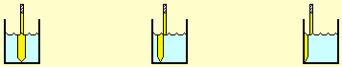

Reference: http://www.physicsclassroom.com/mmedia/optics/bp.html

B. What is needed for Refraction to Occur?

Materials (per group)
1 500 mL bottle of water
1 D-shaped refraction cup
1 popsicle stick
1 red laser pointer
1 ruler
1 red pen
1 observation sheet

While one VSVS member begins the explanation, have another pass out the materials.

Tell the students that they are going to investigate refraction of light using a laser.
Warn them that the lasers are NOT to be shone at any person as they can damage eyes.

i. Light travels in a straight line
- Center the groove of the ruler on the 0° line on the observation sheet, and place the laser in the groove on the ruler.
- Turn on the laser and trace the path of the beam with the popsicle stick. Have the students note that the beam travels in a straight line, along the 0° line.
- Tell one student to hold the laser in its place while another slides the empty refraction cup into its position on the observation sheet (it fits the half circle). Make sure the markings line up with the center line and the edges with the drawing.
- Tell the students to again center the groove of the ruler along the 0° line on the observation sheet, place the red laser in the groove, Turn on the laser and repeat the experiment.
- Make sure the students notice that the beam comes out along the same line again.
Note: It is important that the students aim the laser so that the beam enters the refraction cup along the straight line, at the mid point of the cup (marked with a black dot). Make sure the students notice that the beam comes out along the same line; i.e. no refraction has occurred.

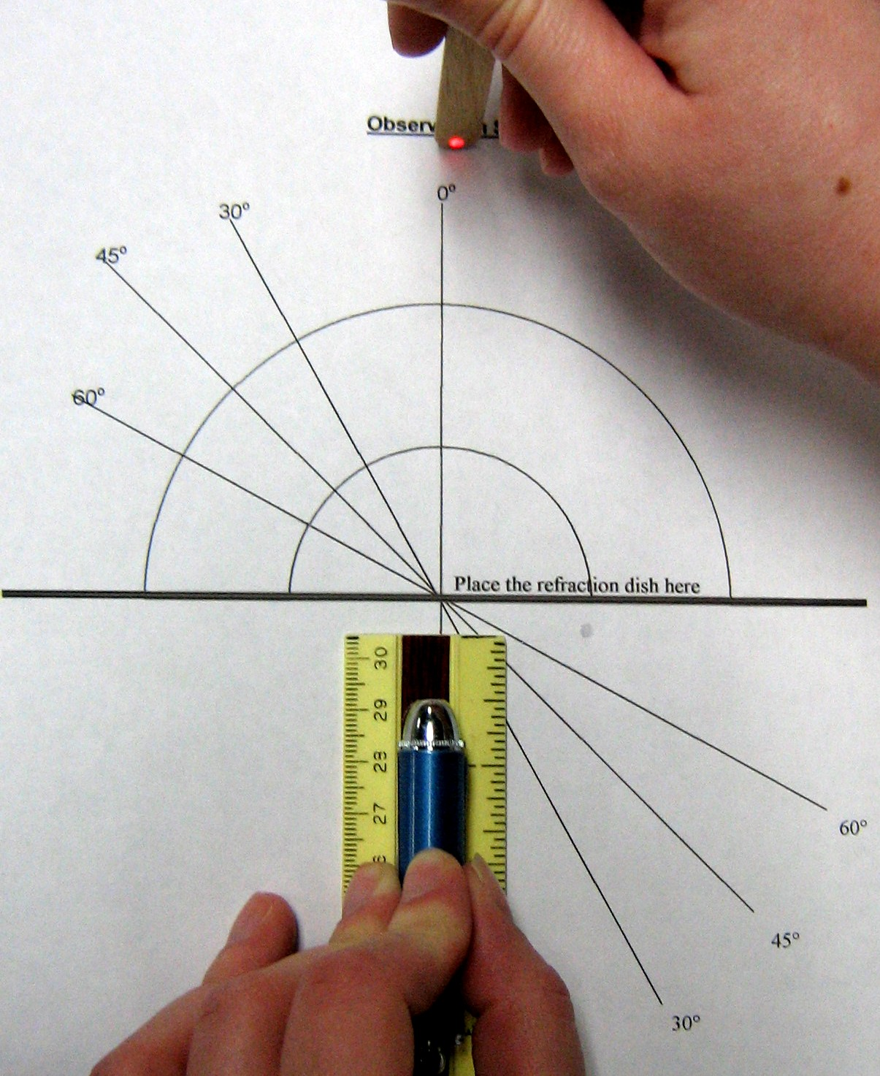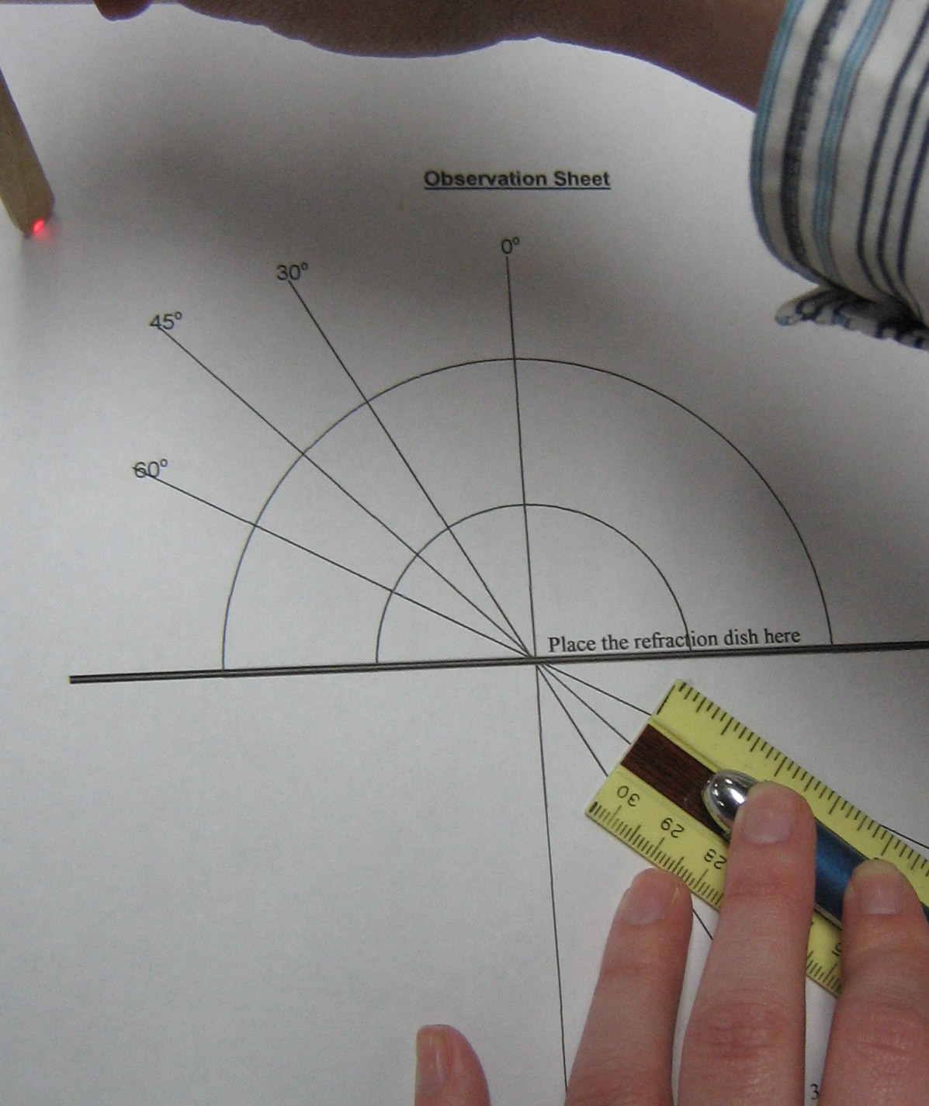

- Tell the students to remove the refraction cup and center the ruler and laser along the 45º line and repeat steps 3 and 4. Have the students note that the beam exits the refraction cup along the 45º line.

ii. Light is refracted when the medium changes AND the light wave enters at an
angle.
- Tell one of the students in each group to pour water in the D-shaped refraction cup.
- Re-center the groove of the ruler on the 0º line and place the laser in the groove. Turn the laser on to make sure the beam follows the straight line.
- Tell one student in each group to keep the laser in its place while another slides the water-filled refraction cup into its position. Again, make sure the markings line up with the center line and the edges with the drawing.
- Find where the laser beam exits the cup (this should still be along the same 0º line).
- Ask students: Why do you think the path of the beam has NOT changed? The medium has changed from air to water, but the beam is going through the cup “straight on”.
- Remove the refraction cup.
- Place the ruler and laser on the 45º angled line and trace the beam along the line to make sure that the laser beam follows the straight line.
- Keep the laser and ruler in the same position and slide the water-filled refraction cup into its position.
- Mark the exit position with the red pen.
- Ask students: Why does this beam not come out along the 45º line? The red laser light has been refracted because it entered the refraction cup at an angle, and the medium changed from air to water.
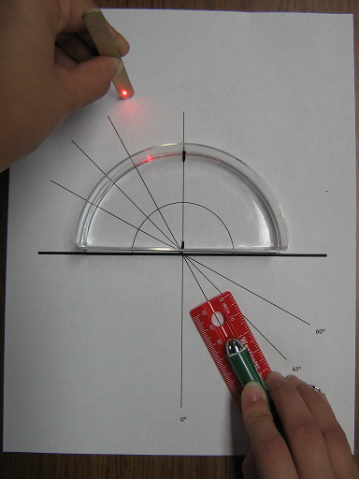

III. The Appearing Coin

Materials:
8 styrofoam cups with a penny taped in the center

Tell students that the next activity involves the property of refraction and may be used as a magic trick to try on their family.

Have students in each group do the following:
- Place the styrofoam cup with the penny on the desk.
- Select one student in each group to pour the water.
- Have the students in the group stand so they can easily see the coin.
- Now have the students back up slowly and stop when the coin has just disappeared from sight. (Tell the students that they may not stop at the same point as other students because they are different heights and have different lines of vision. They should stop just as soon as the coin disappears from sight and should not go back too far.)
- Tell the designated student to slowly pour water in the cup. The other students should raise their hands as soon as they can see the coin again.
- Continue to pour the water into the cup until all the students raise their hands. (If they cannot see the coin, they went back too far.)

Explanation: Refraction causes this effect. When water is added, the light is bent so that the coin becomes visible. This experiment shows that light is bent as it travels at an angle through one medium (water) into another (air). As light rays from the coin cross the water/air boundary, they speed up and bend. Our brains are programmed to assume that light rays travel straight from an object to our eyes. Therefore we see the coin straight in front of our eyes.

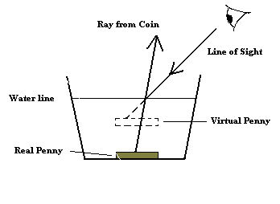

IV. Absorption and Colors
Safety Note: The green lasers are expensive and very bright. Please do not allow the students to play with the lasers!
- Pass out the red and green filters.
- Have one student hold the red filter horizontally and another shine the red laser from above, pointing towards the desk or floor. Have the students verify that the red laser light passes through the red filter (they will see a red dot on the floor or desk).
- Have the students repeat with the green filter.
- Ask students: What do you think will happen if a green laser is shone through the green filter? And the red filter?
- Show students that the green laser light passes through the green filter, but not through the red filter. (One VSVS member should go to each group and shine the green laser onto the green and red filters.)

Explanation:
When white light hits an object, some wavelengths are absorbed by the object, and other wavelengths are reflected or transmitted. The eye sees only wavelengths that are not absorbed.
For example:
- A piece of blue paper appears blue because only the blue wavelengths are reflected back to your eye, and all the other wavelengths in white light are absorbed.
- A piece of blue glass appears blue because the blue wavelengths have been transmitted and all others absorbed.

In this experiment, we use lasers that operate at single wavelengths, either red (about 700nm) or green (about 500nm) light (instead of white light which has all wavelengths).

The red filter appears red because it transmits only red wavelengths, and absorbs all others, (including green wavelengths). Therefore, the red laser light passes through this filter, but the green laser light does not.
The green filter appears green because it transmits only green wavelengths and absorbs all others, including red wavelengths. Therefore the green laser light passes through, but the red laser light does not.

Collect all materials. Make sure that all lasers have been returned.
Optional: If time permits, have the students choose another color of filter (blue, aqua, yellow, or pink). Ask the students to predict if the light will be absorbed by the filter. Have them repeat the above experiment with their new filter. Was their prediction correct? The differently colored filters will not block the laser entirely, however, students should notice that the laser light dims when passing through some of the filters (the filter is absorbing some, but not all, of the laser light).

Lesson written by: Pat Tellinghuisen, Director of VSVS, Vanderbilt University
Heather Day, Program Assistant for VSVS, Vanderbilt University
Jessica Thompson, Undergraduate student, Vanderbilt University,
Supported from NSF grant # DMR-0619789

Observation Sheet

Name: __________________________

0º
30º
30°

45°

60°

0°
Place the refraction dish here

45º

60º

Absorption
Did the red filter absorb red laser light? ________ Did the red filter absorb green laser light? ________

Did the green filter absorb red laser light? _______ Did the green filter absorb green laser light? _______

What color of filter did you choose? (circle one) aqua yellow pink blue

Did your filter absorb red laser light? ________ Did your filter absorb green laser light? __________

