VANDERBILT STUDENT VOLUNTEERS FOR SCIENCE
http://studentorgs.vanderbilt.edu/vsvs
Powers of Ten

Goals

The main objective of this lesson is to introduce students to the concept of scale, specifically, the powers of ten. Students will learn, through hands on activities to look at things different ways. They will understand that the same object can appear differently by simply changing the perspective or scale. After completing the activities, they will have a better understanding and be able to conceptualize what it means for an object to be magnified or reduced by a power of ten. The concept of multiple dimensions will also be introduced.

Materials

- Handouts:
“Powers of Ten in One Dimension”
Coloring book drawing with grid (2 cm²)
Grid sheet (20cm²)
“Power s of Ten in Pictures”
- Meter stick
- Rulers (students use their own)
- Scissors (students use their own)
- 30 notecard rulers (2 cm² hole in middle)
- 60 notecards
- 10² millimeter cube (100 millimeter cube)
- 10 millimeter cube
- 1 meter cardboard pieces (to demonstrate 10³ millimeter cube)
- “Powers of Ten” book

Introduction

- Ask students what they know about scale. For example, what does it mean for an object to be the same size as another? One-half the size? Double the size? Ten times the size?
Accept logical responses.

- Ask students if they know the difference between one-dimension, two-dimensions, and three-dimensions.
Accept logical responses.
- Examples:
One-dimension: lines, etc.
Two-dimensions: graphs, pictures, etc.
Three-dimensions: cubes, boxes, almost all matter, etc.

- Ask students what they know about exponents and scientific notation.
Accept logical responses.

If students still have questions, explain that the scientific notation is a way of expressing how many times 10 must be multiplied by itself to reach an intended number. For example, 10 x 10 equals 10², or 100; and 10 x 10 x 10 equals 10³, or 1000. Multiplying a number by itself produces a power of that number: 10³ is read out loud as “ten to the third power,” and is another way to say one thousand. The positive powers of ten are easy to understand, however, the negative powers may be more difficult. Since exponents tell how many times the 10 is to be multiplied by itself, negative exponents signal division by 10 a certain number of times. For example, 10⁻¹ equals 1 divided by 10, or 0.1, one-tenth; 10⁻² equals 1 divided by 10² (100), or 0.01, one-hundredth.

One-Dimensional Activity

- Pass out the handout labeled “Powers of Ten in One Dimension.”
- Show students the difference between 10⁻¹ millimeter, 10 millimeters, and 10² millimeters.
- Have students estimate how long they think a meter will be.
- Show students the meter stick and explain that it is 10³ millimeters.

Note: When explaining the difference between the lines, be sure to point out the scientific notation and relate the exponents back to the introductory discussion.

Two-Dimensional Activity

- Pass out the coloring book drawing with grid, one note card ruler, the 20 cm² grid sheet (as many as needed – if 25 students, each student will need 4, if 20 students, each student will need 5), and 2 plain note cards to each of the students.
- Depending upon the number students in the class, designate each student 2, 3, 4, or 5 squares from the coloring book drawing to enlarge (if 25 students, each student will have 4 squares; if 20 students, each student will have 5 squares). Note: it may help to number the squares before hand to assist in the assembly later on.
- Demonstrate for the students how to use the note card ruler. Note: Students do not have to use the note card ruler, but it makes this task easier.
  - Place the note card on the coloring book drawing so that your designated square is seen through the hole.
  - The numbers on the note card ruler correspond to the numbers on the grid sheet.
  - You can block of even more of your square to focus on a certain area by using the 2 extra note cards.
- Have students draw their designated smaller squares (from the divided drawing) onto the grid sheet. Notice here that the new drawings will be larger (100 times [10²] – due to the 2d – 10 x 10 times).
- When each of the students have finished drawing their squares onto the blank paper, have them cut out their drawings, choose a large open space in the room and combine the students drawings to form the larger version of the coloring book drawing.
- A discussion will surely abound. Ask students questions and accept logical responses. Be sure to tie the activity into the previous discussion on exponents, etc. Does it appear that this transformation seems more significant than that of the single dimension?
- Explain why the transformation ends up being 100 times larger than 10 times larger due to the 2d.
Three-Dimensional Activity

- Show students the 10² millimeter cube.
- Ask students what they think a 10 millimeter box would look like. It should be easier to explain and visualize using the markings on the box.
- Show students the smaller box (10 mm cube) and explain that it is one-thousandth of the size, due to its 3d – 10 x 10 x 10 times smaller.
- Discuss this in comparison to the students’ expectations. Is it smaller than they expected?
- Ask students what they think a 10³ millimeter box would look like. Are there any objects in the room that can be pointed out as examples (e.g. a refrigerator, etc.).
- Show students the cardboard pieces. Explain that the pieces themselves are two-dimensional, but combine to make a three dimensional cube.
- Choose a few students to help assemble (hold together) the cube.
- Discuss the results with the students. Is it larger than they expected? Is it smaller?
- Now ask students to think about what a 10⁴ millimeter box would look like. Would it be the size of the room, etc.? Does it appear that this transformation seems more significant than that of the two dimensional activity?

Supplemental Activities

- Give each of the students the handout entitled “Powers of Ten in Pictures.” Ask if they understand what the difference is between the photos.
- Explain how the pictures are related by powers of ten and the perspective of each photo progressively changes by zooming in ten times each interval.
- Show students the different maps. The maps with scales of 40 miles and 400 miles best reflect the lessons taught here.

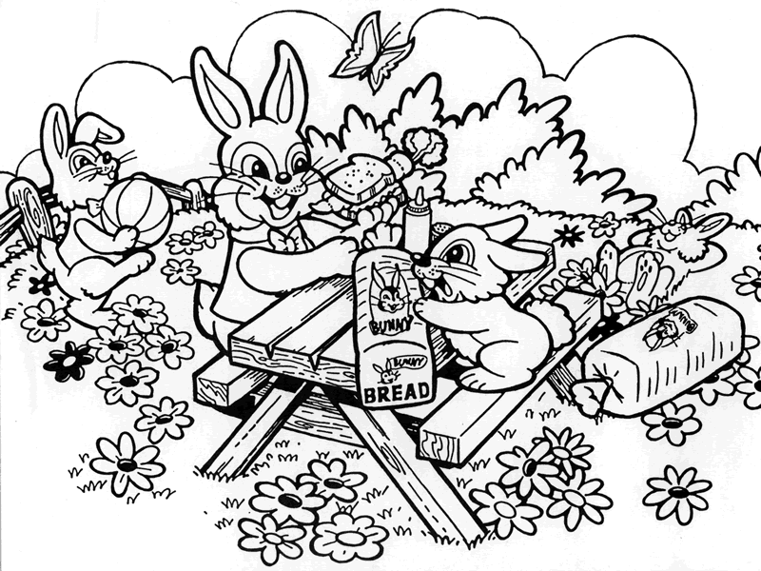
Powers of 10 in Pictures

The Western Hemisphere Southeastern United States Leon, Wakulla, and Franklin
of the Earth Counties in Florida
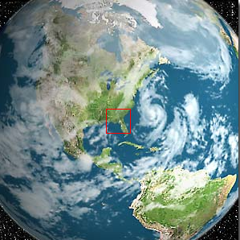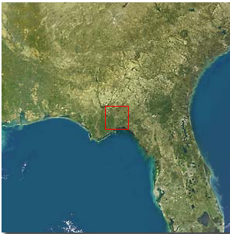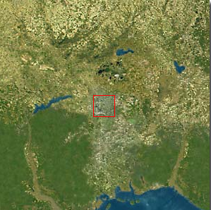
10⁺⁷ meters = 10,000 kilometers 10⁺⁶ meters = 1,000 kilometers 10⁺⁵ meters = 100 kilometers

Southwest Tallahassee, The National High Magnetic Nearby Trees, the Lake,
Florida Field Laboratory and the Laboratory Roof
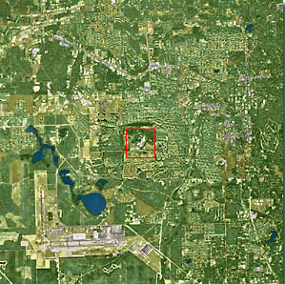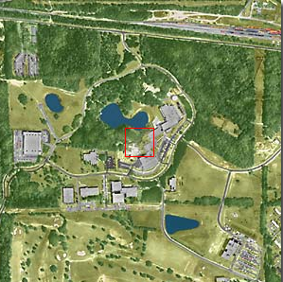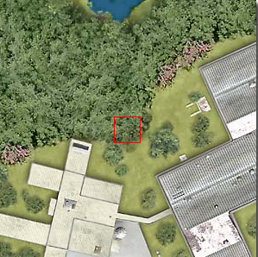
10⁺⁴ meters = 10 kilometers 10⁺³ meters = 1 kilometer 10⁺² meters = 100 meters

Top of Large Oak Tree Oak Tree Branch Oak Tree Leaves
With Leaves at Actual Size
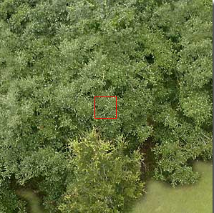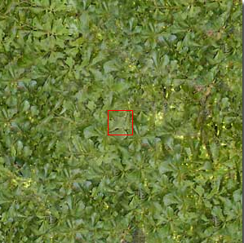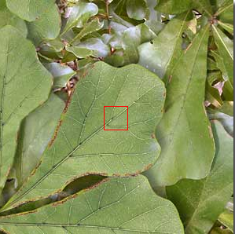
10⁺¹ meters = 10 meters 10⁺⁰ meters = 1 meter 10⁻¹ meters = 10 centimeters

Surface of an Oak Leaf Surface of an Oak Leaf Cells on the Leaf Surface
Magnified 10 Times Magnified 100 Times
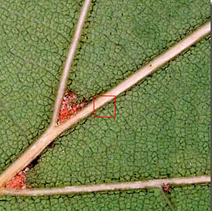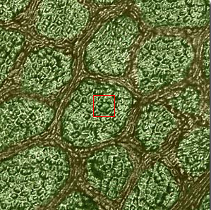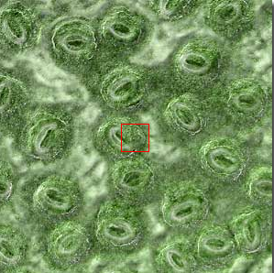
10⁻² meters = 1 centimeter 10⁻³ meters = 1 millimeter 10⁻⁴ meters = 100 micrometer

Powers of Ten in One Dimension

1 millimeter = 1.0 x 10⁻³ meters = 0.001 meter
10 millimeters = 1.0 x 10⁻² meters = 0.01 meter
100 millimeters = 1.0 x 10⁻¹ meters = 0.1 meter
1000 millimeters = 1.0 x 10⁰ meters = 1 meter

…

