VANDERBILT STUDENT VOLUNTEERS FOR SCIENCE
http://studentorgs.vanderbilt.edu/vsvs
Potato Power
(Electrical Energy sources)
Mini Lesson for Spring 2015

Goal: To learn about the energy conversion from chemical energy to electrical energy.
To understand how a battery is made.

Lesson Outline
I. Introduction
Discuss different sources of electrical energy.
II. Chemical Energy → Electrical Energy – Potato Battery Demonstration
Use a potato clock to demonstrate that potatoes and 2 different electrodes can provide enough electrical current to run a digital clock. This current is produced by the difference in activity of the copper and zinc electrodes that are inserted in the potatoes. This provides an example of chemical energy being converted to electrical energy.
III. Making a Battery
Demonstrates how a wet cell battery produces electricity
IV. Review

Students will work in groups of 3 or 4. There are 10 sets of materials, so divide the class into enough groups to use all the materials.

Fun Facts!
- Lightning is a potent example of electrical energy being discharged. Bolts can travel up to 130,000mph and can reach 30,000ºC!
- Electricity travels at the speed of light – more than 186,000 miles per second! If you traveled as fast as electricity, you could go around the world 8 times in the time it takes to turn on a light switch.
- Electrical energy powers your microwave, helps light your house, and lets you watch TV.
- When you scuff your feet against carpet the electrons travel through your bloodstream and collect in your finger, where they form a spark between another conductor.
- Electric eels can produce strong electric shocks for both self-defense and hunting.
- Electricity can be made from wind, water, the sun, and even animal poop!

Complete teacher/school information on first page of manual.
- Make sure the teacher knows the VSVS Director’s (Pat Tellinghuisen) home and office numbers (in front of manual).
- Exchange/agree on lesson dates and tell the teacher the lesson order (any changes from the given schedule need to be given to Pat in writing (email)).
- Since this is your first visit to the class, take a few minutes to introduce yourselves. Mention you will be coming three more times to teach them a science lesson.
- Do the experiment with the classroom, and leave 10 minutes at the end to discuss aspects of college life with them. Some topics that could be included are in the manual.
- While one team member starts the Introduction, another should write the following vocabulary words on the board:
fossil fuels turbine generator voltage amperage
solar energy wind energy battery LED

Materials
1potato "battery” clock
2potatoes
10 green liquid battery holders
10 containers of distilled water.
10 containers sodium bisulfate (containing mini spoon)
10 stirrers
10 M6 meters
10 green snap wires and 10 yellow snap wires

I. INTRODUCTION
A. Sources of Electricity
Where does electricity come from?
Ask students if they can tell you some different ways that electrical energy can be generated?

- Power plants burn fossil fuels such as coal, oil, and gas. The burning of these fuels is used to create heat to convert water to steam. The steam turns a turbine which acts to convert mechanical energy into electrical energy.
- Nuclear power plants produce heat energy by splitting apart atoms such as uranium and plutonium. The heat energy is used in the same way as in Fossil fuel plants.
- Hydroelectric power plants use the force of falling water to turn a water turbine which powers a generator.
- Solar: The light of the sun can be used to convert light energy to electrical energy via solar panels made up of thousands of solar cells.
- Wind: Wind turns large blades on a windmill to produce mechanical energy which drives an electric generator.
- Batteries: Batteries store energy and convert chemical energy to electrical energy: A battery is also known as an electrochemical cell.

This lesson will demonstrate the use of a chemical battery as a source of electrical energy.

II. Chemical energy → Electrical energy: Potato Battery Demonstration
Materials
1 potato "battery” clock
2 potatoes

Hold the potato battery clock so that students can see that it is working. (If it’s not working, make sure each potato has a copper and a zinc electrode inserted in it.)

- Ask students: What is causing the clock to run? Some students might say a battery.
- Ask students if they see a battery. There is no traditional battery.
- Show students the clock and point out the parts. Have them look at the picture of the clock on their handout. :
  - There are 4 metal probes, 2 zinc and 2 copper. These are called electrodes. Electrodes are electrical conductors that can carry a current. Point out the 2 different metals (zinc is silver-colored, copper is orangish).
  - The electrodes have wires attached to them. The wires carry the electric current.
  - The potato provides the acid (phosphoric acid) which reacts with the zinc electrode to produce excess electrons. There is no electricity in the potatoes.
  - The electrons flow from the zinc to the copper metal. The flow of electrons produces electricity.
  - The electricity powers the digital clock.
- Tell the students that the digital clock needs 2 potatoes and 2 sets of electrodes to make it work well:
  - Pull one of the metal electrodes out of one potato to show that this causes the clock to stop working (the circuit is broken).
  - Put the 2 electrodes connected to the clock into 1 potato – the clock may work faintly, or not at all. 1 set of electrodes does not produce enough electricity to power the clock.
- Tell the students that the digital clock will also work with fruits such as apples, oranges, lemons, limes.
- Ask the students to decide which energy they believe the chemical energy was converted to. Answer: Electrical Energy
For VSVS Information Only: Although the chemistry is too advanced for middle school students, this is an oxidation-reduction reaction in which the zinc metal is being oxidized, the phosphoric acid solution in the potatoes is acting as the electrolyte, water is being reduced around the zinc electrode to give hydrogen gas (very small amounts which aren't visible), and the potato matter is serving as a membrane for ion flow between the electrodes

III. Making a Battery

Tell students that are going to make a wet cell. It is similar to the one first created by Alessando Volta in 1880.

Divide the class into 10 groups, and give each group a set of materials:
1 green container outfitted with copper and zinc electrodes
1 M6 meter
2 connecting wires (1 yellow and 1 green)
- container of sodium bisulfate powder plus mini spoon
- bottle distilled water
1 stirrer

Explain that the M6 meter can measure both voltage and current. Point out the 3 different settings and tell students to turn the switch to the left, for the 5V setting.

The voltage measurement (V) tells you how much pressure is present to move the electrons being pushed through the circuit.
The electric current measurement (A or mA) tells you how much electricity is flowing through the wires each second.

Experiment:
Tell students to fill each compartment of the green container with distilled water (about 1/2 full).

Tell them that the green container is now a liquid battery, with zinc and copper electrodes. Help students identify the copper (orange colored) and zinc (silver colored) electrodes. Point out the arrangement of the electrodes – the metals alternate.

- Orient the green container so that the zinc electrode is on the left and the copper electrode is on the right.
- Place the M6 meter below the green container. Tell students to follow the diagrams to connect the cables, meters and green container.
- Connect the green jumper cable from the RHS (+) terminal of the M6 meter, to the RHS of the container (the end that has the orange-colored copper electrode) and the yellow jumper cable from the LHS (-) terminal of the M6 meter to the lighter zinc electrode on the LHS end of the green container.
- Make sure the black switch on the M6 meter is to the left for the 5V setting, and then measure and record the voltage.
Since the liquid used is distilled water, there should be no or little voltage recorded. Distilled water does not contain ions and thus does not conduct electrical currents.
- Tell students to add 2 scoops of the sodium bisulfate powder to each compartment. Stir with a coffee stirrer. Students should see the voltage increasing as the sodium bisulfate is added and stirred.
- Record the voltage. The voltage should read around 3V
- Now change the green jumper cable from the right end of the green box to the copper electrode at the end of the 1st compartment and measure the voltage (0.75V)
- Repeat by changing the green jumper cable from right end of the green box to the copper electrode at the end of the 2nd and then 3rd compartments. Record the voltage for both arrangements (1.5V and 2.3V).

Discussion:
Ask students what arrangement gave the highest voltage?
How did the voltage change with fewer compartments?
Each compartment produces about 0.75V. The 4 compartments are connected in series, so the voltages add together.

What could this battery power do?
Is this battery strong enough to make a digital clock run, as did the potatoes in the potato clock apparatus?
Remove the jumper wire snaps from the meter and set the meter aside. Leave the wires attached to the battery tank.
Place the LED in front of the battery tank so that the arrow is pointing from right to left (words are upside down). Snap the leads into the LED, connecting the red jumper cable to the positive end and the black jumper cable to the negative end.
Does the LED light? Repeat the steps 7 and 8 above to find out how many compartments in the battery tank are needed to make the LED glow. (At least 2 are needed).
Replace the LED with the digital clock and check to see how many compartments are required to make it work.
Tell students that both these devices require very little voltage to work.
Note: but not all LED’s will light up.

Household Batteries.
Tell students: The most common household battery is a dry cell battery:
It has 2 electrodes : zinc and carbon. Zinc likes to give up its electrons.
The electrolyte is ammonium chloride or zinc chloride.
Electrolytes move or conduct an electric current.
An alkaline battery has manganese dioxide and zinc powder as the electrodes and potassium hydroxide as the electrolyte.

Ask: What kind of battery have we produced (nuclear, biofuel, chemical)?

Voltage Measurements:
Voltage measurement from 1 compartment | Voltage measurement from 2 compartments | Voltage measurement from 3 compartments | Voltage measurement from 4 compartments

Clean – up: Empty green boxes into the sink, making sure the electrodes do not fall out. Collect all snap circuit pieces, sodium bisulfate powder, coffee stirrers and mini spoons and return them to the kit.

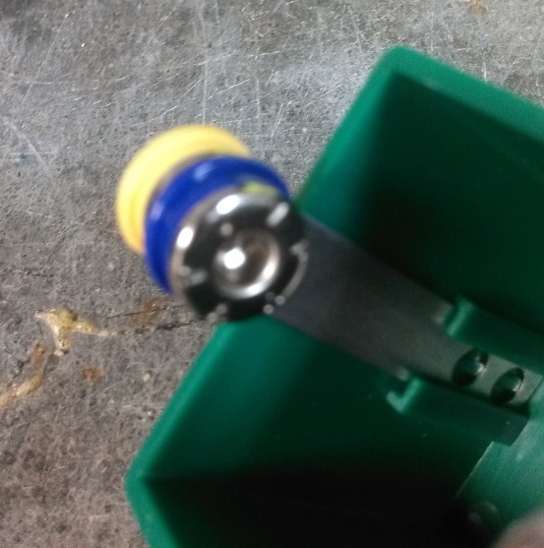
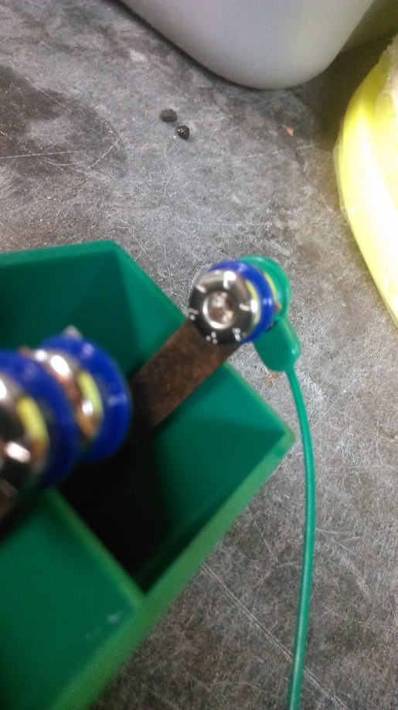
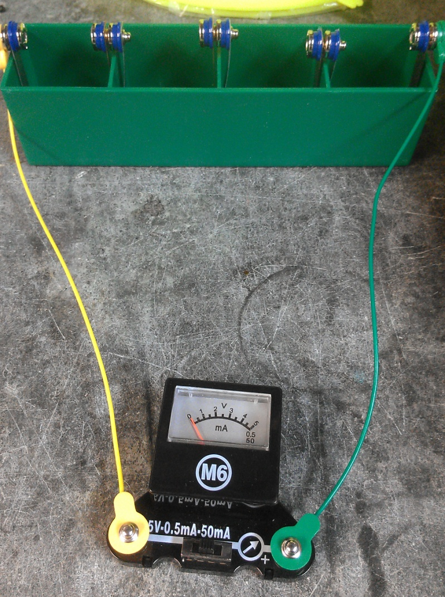
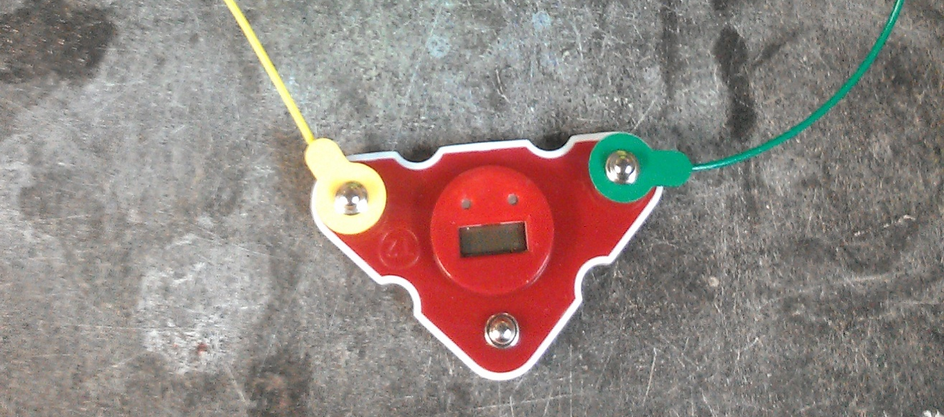
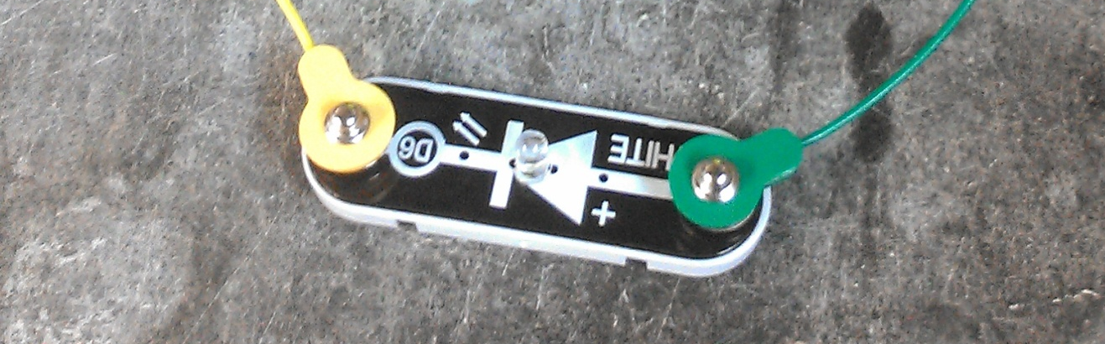
Yellow wire attached to zinc electrode (silver)
Green wire attached to copper electrode (color of a penny)
+
-
+
+
-
-

