VANDERBILT STUDENT VOLUNTEERS FOR SCIENCE
http://studentorgs.vanderbilt.edu/vsvs

Oil Spill
Fall 2013

Goal: For students to find the quickest and most cost effective method of cleaning an oil spill.
Fits Tn State goals: Embedded Inquiry for all grades

Lesson Outline

I. Introduction and Background
This section explains the dangers of an oil spill to the environment and the difficulties of fully removing oil from an ecosystem.

II. Investigating Materials Used to Clean Up Oil Spills

III. Cleaning the Spill

IV. Discussion
The students will talk about which methods were both cost effective and successful, and which methods were expensive and harmful.

Materials:
12 jars of water (colored)/oil
2 stopwatches
12 plastic containers (size?)
12 small plastic plates
24 2oz cups for collecting removed oil (“waste water”)
1 bottle of mineral oil, colored with cocoa powder, 1 pipette
12 bags containing items for mechanical removal: 1 pipette, 1 spoon, 3 popsicle sticks, 3 10” pieces of string, 3 pairs of tweezers
12 bags containing “natural” materials used to absorb oil: 2 cotton balls, 2 2 x 2 in. paper towel strips, , 1 jar of clay kitty litter, 1 jar of vermiculite 2 spoons
1 bag of straw (teachers distribute to students)
12 bags containing manmade materials used to absorb oil: 1 jar of oil absorbent powder, 1 snack bag containing 1 1”x2” absorbent pad material
1 12oz jar for detergent demonstration
1 dropper bottle detergent
2 L water
1 roll paper towels
1 large trash bag for waste
32 Observation Sheets
32 Handouts (pictures)

I. Introduction
Tell the students that there has been a catastrophic oil spill in the ocean.
Tell the students that they are going to be environmental engineers and that their task is to find the most efficient and least expensive way to clean up an oil spill.

Oil spills can occur on water or land.
Marine oil spills can occur when tankers or offshore drilling platforms discharge crude oil or spill refined petroleum products (such as gasoline or diesel fuel).
Land oil spills occur around oil wells, refineries, gas stations and occasionally from ruptured oil pipes.
Oil can also spoil the environment from natural oil seeps.

What happens when oil is spilled onto/into water?
Materials
12 oil/water bottles (1 per 3-4 students)
16 Handouts (pictures) 1 per pair

Pass out the oil/water bottles. Tell students that the water was colored blue to make the layers easier to see.
Tell students to shake the bottle and observe what happens. (Oil settles back on the top.)
Explain: oil is less dense than water and so it floats on top of the water.

What Happens after an Oil Spill Occurs?
When oil spills onto water, it:
- First 10 minutes: Spreads out to form a thin layer, called an oil slick. This layer is 0.1 mm thick. It can spread even thinner to a sheen. You can see sheens in puddles in parking lots – they have a rainbow or silver appearance.
Show students the picture of the oil sheen on their handout.
- After Day 1: Oil begins to break down. The warmer the water temperature and the more sun exposure, the faster the oil breaks down.
30-40% oil evaporates in the first few days, leaving the more viscous compounds that are slower to spread across the water.
- After several days: Oil clumps form. These clumps can exist from months to years in enclosed seas and for years in the open ocean and on beaches. Eventually, they degrade.
Storms and rough water can speed up the spread of the oil and also help degrade the oil.
Between 10 and 30 percent of the oil is absorbed by sediments and suspended materials and deposited on the bottom of the sea. Once at the bottom the decomposition rate of the oil halts almost completely because of lack of oxygen, and heavy oil fragments can be preserved inside sediments for years.
Reference: How Oil Breaks Down in Water http://www.popularmechanics.com/science/energy/coal-oil-gas/oil-spill-water-chemistry

What is the Environmental Impact of an Oil spill?
- Floating oil can easily move to shore and harm animals such as birds, fish, and other sea creatures that reside on or near the shoreline.
- Ask the students how oil can be detrimental to the health of animals and plants.
Some answers could include:
  - Oil can destroy the insulating ability of fur-bearing mammals such as seals and otters, exposing them to harsher temperatures.
  - Oil can destroy the water-repelling abilities of a bird's feathers, hampering its ability to fly to find food or escape predators.
  - Birds and animals could ingest oil when they try to clean themselves, which can poison them.
- Another problem associated with oil spills is the high expense of removing the oil from the ecosystem; it is not a cheap process.
- Tell the students they will be testing various methods of removing oil from water as well as considering the cost effectiveness.

Cleaning up Oil Spills
Response teams have several options to try to contain the oil. Tell students to look at the handout containing pictures that show the different methods used for oil removal.
- Mechanical skimming after the spill is surrounded with booms. The removal can be done with skimmers, suction devices, buckets. This method requires calm waters and does little harm to the environment. But there are problems with disposing of the oil after it has been collected.
- Sorbents can be spread on the surface of the oil. Examples of sorbents include natural materials like straw, hair, vermiculite, or manmade ones such absorbent powder or absorbent maps.
- Dispersants such as detergents break up oil into smaller clusters. The oil sinks deeper into the water column. Burying the oil a little deeper means that surface slicks won't float toward shorelines as readily. However, mixing these chemicals into water has long been a controversial process, as they have proved toxic to some marine organisms.

Tell students that these will be the 3 methods they will be investigating. Other options, not being investigated today, include:

- Burning: is very efficient but creates toxic smoke. It has to be done on a fresh spill.
- Highpressure hosing: on the shoreline can often drive oil deeper into the beach and can kill all living things on the shore.
- Bioremediation: using microorganisms or biological agents to break down or remove oil. Oil-eating bacteria numbers can be increased by adding fertilizer.
- Dredging: some oils are actually denser than water, and would sink. These would require cleaning below the surface of the impacted water.
- Do Nothing. Sometimes this is more effective!

II. Investigating Materials Used to Clean Up Oil Spills
Tell the students to examine the materials list on the observation sheet, and discuss which items should be the best at soaking up the oil on the water from the model environment. VSVS members should write the ideas on the board.

Here are brief descriptions of the items on the materials list:
Paper Towel Strips: Cut into approximately 2” x 2” pieces. They can absorb water, but are not as effective in absorbing oil.
Absorbent clay (kitty litter): Can absorb oil, but is denser than water, so will sink. If the sinking is not anticipated, groups may end up may paying a fine and spending more money attempting to remove the sunken debris.
Often used to absorb oil on driveways.
Cotton balls: The cotton is somewhat absorbent; students may need more than one.
Detergent: Liquid laundry detergent. Many commercials will state that detergent will remove grease from clothes and dishes. However, they do so by dissipating the grease. Interaction of detergent with the oil will “break apart” the oil, thus diluting out the amount of oil over the entire surface of water. This has its own environmental implications.
String: Natural fibers. It can float on water and oil. Can soak up oil.
Straw/Hay: Oil can adhere to the surface of the straw. Can float on water, is economical, easy to get, biodegradable, and easily removed
Oil mat: Absorbs oil and repels water. Floats.
Oil absorbent Powder: Can be sprinkled on top of oil. Absorbs oil and forms a solid with it. Repels water. Solid can be easily removed.
Vermiculite: Absorbs liquids. Natural, environmentally friendly.
Spoons: Can be used to scoop up oil. Reusable. Scoops up water too.
Popsicle sticks: Can be used as a skimmer.
Tweezers: Metal. Must be used to manipulate other tools (so that fingers don’t get greasy, but also as somewhat of a mechanical handicap)

III. Cleaning the Spill

Materials
12 plastic containers ½ filled with water with 1 drop green food coloring and oil/cocoa powder
24 2oz cups for collecting removed oil
12 small plastic plates

The students should work in groups of 2-3 members so that very student in a group will experiment with one of the methods per category. Students will pool their results on a group observation sheet so they can report the final results to the class.

Pour water into the plastic containers, about 2/3rd full and add 1 drop food coloring (green is good).
Shake the oil/cocoa mix well.
A VSVS member will make an “oil slick” on top of the water, by pouring a small amount of oil/cocoa mix, so that a 2 inch slick forms.

Method A: Mechanical skimming methods
- Give the students the first set of materials (spoon, pipette, Popsicle sticks, string, and tweezers).
Tell students the string, tweezers and popsicle sticks are used as aids in any way, such as forming booms, or skimming…
Tell students they will use the spoon on ONE slick, the pipette on another. The spoon represents a “bucket”. Students should attempt to remove as much oil as they can, while removing as little water as possible. Students will spoon the oil/water mixture into a 2oz cup. Estimate how much water was removed as well as the amount of oil, by looking at the ratio of water to oil collected (is it about the same, less, more?).
- A VSVS member will add another oil slick. Again, students should attempt to remove as much oil as they can using a pipette, while removing as little water as possible. The pipette represents suction devices. Students will pipette the oil/water mixture into the 2oz cup.
- Tell students to give each item a score, based on the ease of removal of oil, materials absorbency (of oil), etc (see table). A low scoring number (0) is BAD, Higher scoring (2 or 3) BETTER.

Method B. Using “Natural” Sorbents
- There are 5 different materials to be tested, so each group of 2-3 students will initially choose 2 materials to test and can test more if there is time.
- If needed, VSVS members will empty water/oil from plastic container into a waste container and add fresh water plus a drop of green food coloring. Add “oil slicks”.
- Give students the 2nd plastic bag containing “natural” absorbents. Show students how to use the materials:
  - Place the cotton on top of 1 slick. It may be moved around to absorb all the oil in 1 slick (use tweezers)
  - Place the paper strips on top of a slick.
  - Spread the straw over a slick.
  - Spread 1 -2 teaspoons of the kitty litter over a slick.
  - Spread 1 -2 teaspoons vermiculite over a slick.
- Remove the material plus any oil it has absorbed with tweezers, spoon…students choice.
- Score the materials, using the rubric provided.

Method C. Using Manmade Sorbents
- There are 2 different materials to be tested.
- If necessary, empty water/oil from plastic containers. Add fresh water, green food coloring and oil. The students may keep the string, popsicle stick and tweezers to use again.
- Give students the 3rd plastic bag containing manmade absorbents.
- Show students how to:
  - Spread an absorbent powder over the slick.
  - Spread the absorbent pad material over another slick.
- Remove the material plus any oil it has absorbed with tweezers, spoon…students choice.
- Score the materials, using the rubric provided.

Method D. Using Detergents – DEMONSTRATION ONLY
Materials
1 8 oz jar containing water (half filled)
Mineral oil
A VSVS member will demonstrate this. Please do not let students add detergent to their containers. Any residual detergent will be difficult to remove.

- Add a few drop of the mineral oil to the water.
- Hold up the jar so that the students can see that the oil and water are separated

- Add a squirt of detergent to the bottle and cap. Shake the jar (this simulates rough seas) and let the liquids settle.
- Show students the jar and have them describe what has happened

IV. Discussion
Ask students what was the BEST method for removing oil?
What materials make things worse? (those that sink)?
What material was the worst?
Ask students what they think are the top 4 methods for removing oil.
Notes for VSVS members:
The paper towel strips are extremely poor in absorbing the oil directly from the top of the water. Once the paper towel strips are completely wet, they are nearly worthless.

The cotton balls are somewhat oil-absorbent but absorb water as well. They can be reused.

The string is one of the most effective tools for removing the oil. It can hold nearly five times its weight in oil. With the reuse rule, the students can squeegee the oil from the string fairly quickly to remove the entire spill. Before students catch on to its highly absorbent nature, they will most likely try to use it as a way to rope off the spill.

While the string and cotton swabs have worked the best in previous trials, students may be able to come up with novel techniques to soaking up the oil. Encourage students to be creative, but as in real life, creativity is often constrained by economics.

The laundry detergent causes a disaster; it forces the oil to spread and re-compartmentalize into many tiny globules. Typically, when detergent is added, the oil would disperse outward and head straight to the shore to contaminate the sand. This phenomenon occurs because the molecules of liquid detergent contain both hydrophobic and hydrophilic parts. The detergent compartmentalizes oil into small globs (micelles), as the hydrophobic parts interact with the oil. It may appear as if the detergent somewhat dissolves the oil, but it does not - the volume of oil is exactly the same before and after adding the soap. You can also have a discussion about whether it is better to have a lot of detergent that is also introduced into the environment.

Lesson modified by Pat Tellinghuisen, Director of VSVS
Jason Wong, Vanderbilt Undergraduate, 2013
from protocols written by:
Frank Merendino, NSF Undergraduate Teaching Fellow at Vanderbilt University
Dr. Joe Lopez, Vanderbilt University Center for Science Outreach
Dr Joshua Schwartz, Vanderbilt University Center for Science Outreach
References:
Office of Response and Restoration, National Oceanic and Atmospheric Administration http://response.restoration.noaa.gov/index.php
Tryengineering.org Oil Spill Basics.htm
How Oil Breaks Down in Water http://www.popularmechanics.com/science/energy/coal-oil-gas/oil-spill-water-chemistry
Links to Related stories in Popular Mechanics:
10 Biggest Oil Spills in History
5 Lingering Questions from the BP Oil Spill
Techno-Sponge "ShamWows" Oil Spills
The State of Oil Spill Cleaning Technology
5 Wild Technologies Being Used Now to Clean Up the BP Oil Spill
Grading the Deepwater Horizon Oil Spill Improvised Cleanup Tech

Oil sheen
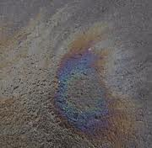

1a. Mechanical skimming - Booms 1b. Mechanical Skimming
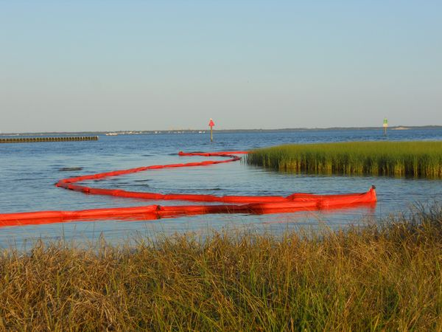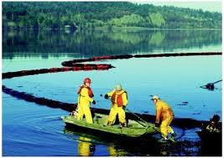

2a. Absorbent Pads (and boom) 2b. Chemical Absorbent Powders
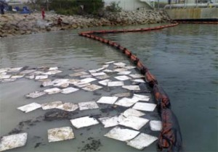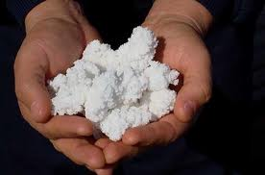

- Dispersants (can also be done by boat)
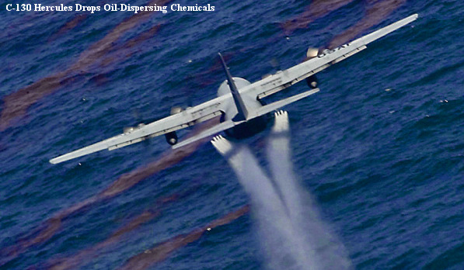

- Burning 5. High Pressure hosing
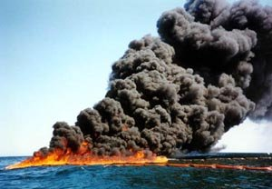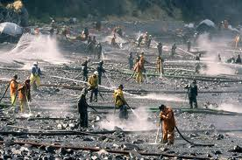
- Biodegradation
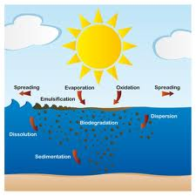

Information Sheet
- Spoons: Can be used to scoop up oil. Reusable. Scoops up water too.

- Pipettes: Simulate suction tools. Reusable. Sucks up water too.

- Popsicle sticks: Can be used as a skimmer.

- Paper Towel Strips: Cut into approximately 2” x 2” pieces.

- Absorbent clay (kitty litter): Can absorb oil. Is denser than water. Often used to absorb oil on driveways.

- Cotton balls: The cotton is somewhat absorbent.

- String: It can float on water and oil. Can soak up oil.

- Straw/Hay: Oil can adhere to the surface of the straw. Can float on water, is cheap, easy to get, biodegradable, and easily removed.

- Oil mat: Absorbs oil and repels water. Floats. Expensive.

- Oil absorbent Powder: Can be sprinkled on top of oil. Absorbs oil and forms a solid with it. Repels water. Solid can be removed.

- Vermiculite: Absorbs liquids. Natural, environmentally friendly.

- Tweezers: Metal. Can be used to manipulate other tools (so that fingers don’t get greasy, but also as somewhat of a mechanical handicap).

- Detergent: Liquid laundry detergent. Many commercials will state that detergent will remove grease from clothes and dishes. However, they do so by dissipating the grease. Interaction of detergent with the oil will “break apart” the oil, thus diluting out the amount of oil over the entire surface of water. This has its own environmental implications.

 |  |  |  | Paper | Straw/ | Kitty | Vermi- | Absorbent | Absorbent
 | Spoon | Pipette | Cotton | Strips | Hay | Litter | culite | powder | pad
Is Material Reusable?
0 - One use
1 - Few Uses
2 - Multiple Uses
Materials Absorb/Remove Oil
0- Fails at removing/absorbing the oil
1- Absorbs/Removes the oil relatively well
2 - Absorb/Removes oil well
Labor Required to remove oil
0 - A lot of effort required
1- Moderate Effort Required
2 - Little to no effort required
Amount of Material Used/Cost
0 - Way too expensive
1- Moderately Expensive | 3 | 2 | 2 | 3 | 3 | 3 | 1 | 0 | 0
2- Moderately Cheap
3 - Cheap
Did the Material Sink/Float? (Environment Friendly)
0 - Sank to the bottom
1 - Some floated/sank to the bottom
2- All of it stayed afloat
Is the material safe to use? (to Workers)
0 - Very harmful
1 - May or Can be Harmful
2 - Not Harmful at all
How much water was with the oil in the waste?
0 - Enormous amounts of Water
1 - Moderate Amounts of Water
2 - Little to no water
Total Score

