VANDERBILT STUDENT VOLUNTEERS FOR SCIENCE
http://studentorgs.vanderbilt.edu/vsvs

Oh, Deer!
FALL 2004

GOAL

To help students understand the importance of suitable habitat for animal populations and
recognize factors that may affect wildlife populations in changing ecosystems.

Objectives:
Students will:

1. identify and describe food, water, and shelter as three essential components of habitat;
2.recognize that a good habitat is the key to wildlife survival
3.see that a population will continue to increase in size until some "limiting factors” cause
fluctuations in wildlife populations
4.understand that nature is never in "balance," but is constantly changing.

MATERIALS

Note: Be sure you have all necessary materials before you leave the lab.

* Materials are not in boxes! They can be found in Vanderbilt bags.
large area - either outdoors or indoors where students have room to move around
chalkboard or chart tablet
pencil
data record sheet
clipboard
64 blue cards
64 brown cards
64 green cards
6 small buckets or containers

Note: This lesson requires good classroom management. If you can, talk to
the teacher about the game before you start so he/she can help keep the
class organized and focused. Establish a signal that the students will
recognize as the signal for them to stop moving, get quiet, and look to
you for further instructions. (Use a raised hand, a whistle, clapping, or
a signal that the classroom teacher uses for a "Stop and get quiet” signal.)

BACKGROUND

The most fundamental of life's necessities for any animal are food, water, shelter and space in a suitable arrangement. Without these essential components, animals cannot survive. A variety of factors affect the ability of wildlife to successfully reproduce and to maintain their population over time. Disease, predator/prey relationships, varying impacts of weather conditions from season to season (e.g., early freezing, heavy snows, flooding, drought), accidents, environmental pollution and habitat destruction and degradation are among these factors.
This activity is intended to be a simple but powerful way for students to grasp some basic concepts: that everything in natural systems is interrelated; that populations of organisms are continuously affected by elements of their environment; and that populations of animals do not stay at the same static number year after year in their environment, but rather are continually changing in a process of maintaining dynamic equilibria in natural systems.
Wildlife populations are not static. They continuously fluctuate in response to a variety of stimulating and limiting factors. We tend to speak of limiting factors as applying to a single species, although one factor may affect many species. Natural limiting factors, or those modeled after factors in natural systems, tend to maintain populations of species at levels within predictable ranges. This kind of “balance in nature” is more like a teeter-totter than a balance. Some species fluctuate or cycle annually. Quail, for example, may start with a population of 100 pairs in early spring; grow to a population of 1200 birds by late spring; and decline slowly to a winter population of 100 pairs again. This cycle appears to be almost totally controlled by the habitat components of food, water, shelter and space, which are also limiting factors. Habitat components are the most fundamental and thereby the most critical of limiting factors in most natural settings.

PLAYING THE GAME

I. Introduce Habitats and their Characteristics
Tell students that they are about to participate in an activity that emphasizes the most
essential things that animals need in order to survive.
Ask: What are the essential components of habitats for deer to survive?
food, water, shelter and space in a suitable environment
For the purposes of this activity, we will assume that deer have enough space in
which to live. Since we are emphasizing food, water, and shelter, the deer need to
find food, water, or shelter in each round in order to survive.

II. Set up the Game
Choose one student or VSVS volunteer to collect data.
Have the rest of the students count off in fours.
Have all the ones stand in one area and have the twos, threes and fours stand in
another area.
Designate two parallel lines on the ground or floor 10 to 20 yards apart.

Have all the ones line up behind one line; the rest of the students line up
behind the other line.
The ones will be the deer for round one.
The twos, threes and fours become resources of their choice (food, water,
shelter).

Instructions for the Deer

Explain and demonstrate these instructions for the deer:
When looking for food, you should hold a green card and clamp your hands
over your stomach.
When looking for water, you should hold a blue card and put your hands in
front of your mouth.
When looking for shelter, you should hold a brown card and put your hands
together over your head. Hold your hands in a point over your head to resemble a pointed roof.
A deer may choose to look for any one of its needs during each round.

A deer may not change what it is looking for until the beginning of the next
round.

Note: The VSVS volunteers should hold 3 small buckets or containers behind each line.
There will be three containers for the deer to choose from and three for the resources.
One bucket will contain 32 blue cards representing water, one will hold 32 brown
cards representing shelter, and one will hold 32 green cards representing food.
At the end of each round the students can drop the cards in the appropriate bucket
and select another card for the next round. It is permissible to keep the same card
for more than one round. Caution students to be careful with the cards so that
students in the other line will not see what they are choosing. IF the students are
standing with their backs to the other line as they have been instructed to do, the
other students should not be able to see their selections.

Instructions for the Resources (the rest of the students):

Explain and demonstrate the same instructions given to the deer to the students who
are resources:
Each student can choose at the beginning of the round which resource they want to
be.
Students depict their resource by holding the same color card and by using the same
signs that the deer use.
A resource may not change what it is until the beginning of the next round.
Tell the resources that they will not move from the line unless a deer comes to get
them.

III. Play the Game

The activity starts with all players lined up in their respective lines (deer on one
side; resources on the other) --with their backs to the students at the other line.
Begin the round by asking all of the students to select their cards and make their
signs--each deer deciding what it is looking for, each resource deciding what to
become --still with their backs to the students at the other line.
When you see that the students are ready, count: "One...two...three." At the count
of three, each deer and each resource turns to face the opposite group, continuing
to hold the cards and signs in clear view.
When the deer see the resource they match, they walk quickly to the resource they
need. Each deer must hold the resource sign chosen until reaching a resource with the
same sign.
Note: Resources DO NOT move. They wait for a deer to come to get them. Resources or
habitat components stay in place on their line until a deer needs them. If no deer
needs a particular habitat component during a round, the habitat component just
stays where it is in the habitat. The resource person can change which component
it is at the beginning of each round.
Each deer that reaches its necessary habitat resource person takes the "food”,
"water”, or "shelter” back to the deer side of the line. This represents the deer
successfully meeting its needs. So all surviving deer and the resources they "used”
return to the deer line for the next round.
By meeting its needs, a deer "reproduces”, and the resource person becomes
another deer for the next round.
Any deer that fails to find its food, water, or shelter dies and becomes part of the
habitat. That is, a deer who dies becomes a resource person in the next round.

Note: When more than one deer reaches a resource, the deer that gets there first
survives and the other deer dies. If the two deer arrive at the same time, you can
decide whether you want to let both live or whether you want to let the resource
tell you who arrived first. If you let the resource decide, be careful to avoid
arguments since students will tend to side with a friend.

Play 12 rounds. The data recorder should record how many deer are alive at the
beginning of the game and at the end of each round.

Note: Sometimes students confer and all make the same sign. That is okay, but don’t
encourage this. For example, all the resources could decide to be shelter. This could
represent a drought year with no available food or water and will have a definite impact
on the deer population. This idea is in the optional activities at the end of the lesson.

IV. Analyze the Game

Ask: What did you notice about the deer population as we played the game?
For example, the students may have seen a small herd of deer (seven students in a class of 28) find its habitat needs and expand rapidly in population over two to three rounds until the habitat did not contain sufficient food, water, and shelter for all the members of the herd. At that point, some deer starved or died of thirst or lack of shelter, and they returned as part of the habitat.

Post the data recorded during the activity. Each round represents one year. The number of deerat the beginning of the activity and at the end of each round represent 12 years.

Example:
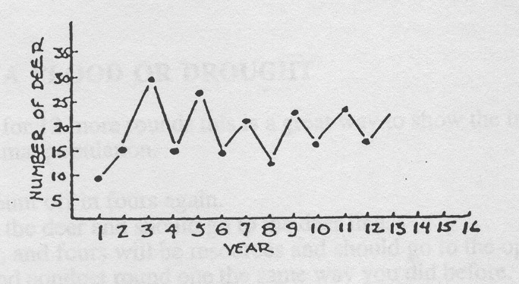
The students will see a visual reminder of what they experienced during the activity: the deer population fluctuated over a period of years. This is a natural process as long as the factors which limit the population do not become excessive, to the point where the animals cannot successfully reproduce. The wildlife populations will tend to peak, decline, and rebuild, peak, decline, and rebuild--as long as there is a good habitat and sufficient numbers of animals to successfully reproduce.

QUESTIONS FOR REVIEW
What do animals need to survive?
food, water, shelter, and space in a suitable arrangement

What are some "limiting factors” that affect their survival?
disease, predator/prey relationships, impacts of weather conditions, accidents,
pollution, habitat destruction

Are wildlife populations static, or do they tend to fluctuate, as part of an overall"balance of nature”?
tend to fluctuate

Is nature ever really in "balance” or are ecological systems involved in a process of constant change?
may be in balance for a brief time but usually are in a process of constant change
OPTIONAL ACTIVITIES
Choose from these activities as time permits:

EFFECTS OF A FLOOD OR DROUGHT

If you have time for 12 more rounds this is a great way to show the impact that a disaster has on an animal population.

Have students count off in fours again.
The ones will be the deer and should go to the deer line.
The twos, threes, and fours will be resources and should go to the opposite line.
Start the game and conduct round one the same way you did before.
On round two, have one of the VSVS volunteers quietly tell all the resources to become water for round two since there is a flood predicted for that year.
OR
On round two, have one of the VSVS volunteers quietly tell all the resources to be shelter for
round two. There is no food or water available due to a drought that is occurring in year two.
Continue rounds 3-12 as normal, allowing the resources to choose to be food, water, or shelter
as they did in Game #1.

When the graph is constructed after round 12, note the effects of the drought or the flood on the
deer population. Use the graph to see how long it took for the deer population to recover -
if they did recover.

PREDATOR and PREY
After the students have played several rounds of "Oh Deer!,” introduce a predator such as a mountain lion or a wolf into the situation.
The predator starts in a designated "predator den” area off to the side.
The predator has to skip or hop. This reduces the possibility of violent collisions between deer and predators.
The predators can only tag deer when they are going towards the habitat and are between the habitat and deer lines.
Once a deer is tagged, the predator escorts the deer back to the predator den. This simulates the time it takes the predator to eat the deer. The "eaten” deer is now a predator.
Predators that fail to tag someone die and become a resource. That is, in the next round, the predators that died join the habitat line. They will become available to surviving deer as either food, water, or shelter.
During each round, keep track of the predators as well as the deer.
Incorporate the data into the graphs.

STORY OF THE HUDSON BAY TRAPPERS
There are records of the activities of Hudson Bay trappers for a period of a hundred years or more.
In those records are some interesting data. These data refer to pelts shipped from America to Europe, particularly the pelts of the snowshoe hares and the lynx. Researchers have found that snowshoe hare populations seem to peak about every seven to nine years and then crash, repeating the process over each comparable time period. So, a snowshoe hare population graph would look like this:
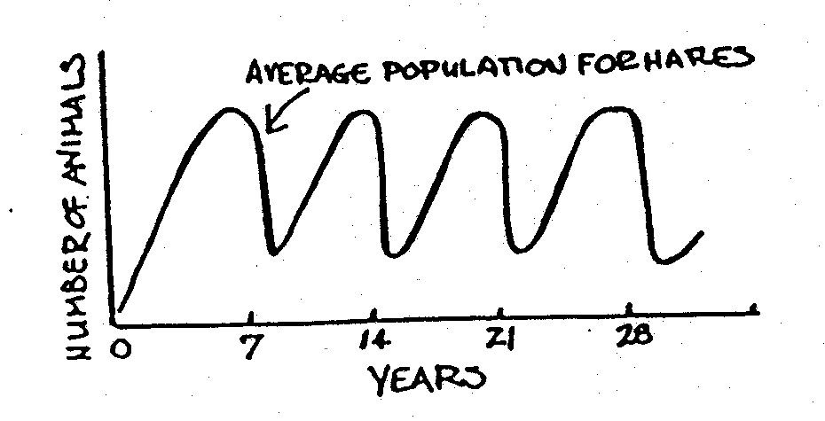
It has also been discovered that lynx populations do the same thing--except that they do it one year behind the hare populations. The combined graphs would look like this:
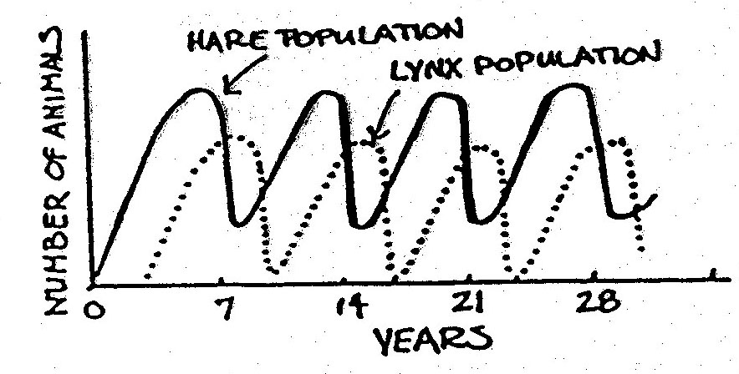
Graph this over the deer graph you made, adding first the hares, and then the lynx.

Ask: Which animal is the predator? Which is the prey?
Are predators controlling the prey, or are the prey controlling the predators?
(We have been brought up to "know" that predators control the prey--and are now discovering that this is not so. The number of prey animals available tells us how many predators can live in the area.)
Is this like the deer habitat activity we just played? Who controls?
(Sometimes the habitat--when the deer population "gets on top of it" and destroys the vegetative food and cover.)

Some recent research has added a new dimension to the story of the snowshoe hares and the lynx. It has been found that a major winter food of the hare is a small willow. As hare populations grow, the use of the willow plants grows too. But, when the willow plant has been "hedged" or eaten back so far, the plant generates a toxin (poison) which precludes use by the hare. That is when the hare population crashes, followed by the crash of the lynx population about a year later. Then the willow, relieved of pressure, begins to grow again. The hare population begins to grow in response, and last of all, within a year or so, the lynx population follows. And the cycle has begun again - over and over - every seven to nine years.

Discuss the "balance of nature." Is nature ever in "balance?"

Round | # of deer | Round | # of deer | Round | # of deer
0 |  | 0 |  | 0
1 |  | 1 |  | 1
2 |  | 2 (flood) |  | 2 (drought)
3 |  | 3 |  | 3
4 |  | 4 |  | 4
5 |  | 5 |  | 5
6 |  | 6 |  | 6
7 |  | 7 |  | 7
8 |  | 8 |  | 8
9 |  | 9 |  | 9
10 |  | 10 |  | 10
11 |  | 11 |  | 11
12 |  | 12 |  | 12

Round | # of deer at end | # of predators at end
0
1
2
3
4
5
6
7
8
9
10
11
12

