VANDERBILT STUDENT VOLUNTEERS FOR SCIENCE
http://studentorgs.vanderbilt.edu/vsvs
Light
Fall 2011

Goal: To demonstrate scattering, reflection of light, and diffraction.
Lesson Outline:
I. Introduction
Students discuss the properties of light.
II. Scattering
A VSVS member shines a laser pen through a stream of flour to illustrate scattering. Students use a laser
pen to observe the different paths the red laser light takes when it is shone through a vial of clear water and then a vial of cloudy milk of magnesia solution.
III. Reflection
Students use a laser pen, a mirror, and a popsicle stick to trace the path of the red laser beam when the pen is shone onto the mirror. Students observe that the angle of reflection is the same as the angle of incidence.
IV. Diffraction
A. Diffraction Gratings - Students hold up what looks like a blank slide and look at room lights or outside light through a window and see separation of white light into several rainbows. The slide actually contains about 1500 lines per centimeter. Each space between two grooves acts as a slit through which light can pass. When illuminated with white light, the diffraction grating has the same effect as a prism.
B. CD - Students hold the CD in a way that produces “rainbow” patterns. CD’s have many parallel grooves so the CD acts like a diffraction grating.
C. Lasers and Diffraction Gratings: Demonstration
Use the red laser pointer and the diffraction grating to show that the red laser produces 3 red dots when
the laser light shines through a diffraction grating. Repeat with a green laser, and have students note that
the green dots are spread further out than the red ones.
V. Total Internal Reflection and Fiber Optics
A. Light Pipe: Demonstration
A VSVS member shines a red laser pen through one end of a “light pipe to demonstrate total internal reflection.
B. Fiber Optics Cables
Students observe total internal reflection in the fiber optic cable attached to a flashlight.

Materials:
1 plastic bag containing:
1 2oz dropper bottle containing flour
1 aluminum pie pan
16 #1 bags (for Reflection and Scattering experiments) containing:
1 mirror mounted on a block of wood
1 popsicle stick
1 vial containing water
1 vial containing water and milk of magnesia
1 red laser pointer in plastic case
16 plastic rulers
1 plastic bag containing 32 CDs and 32 diffraction gratings
1 demo bag containing
1 red laser pointer
1 green laser pointer
1 diffraction grating
1 acrylic light pipe
Fiber optic cables (Bag #3)
8 fiber optic flashlights
32 Observation sheets
16 Instruction sheets (in page protectors)

I. Introduction
Write the following vocabulary words on the board: reflection, scattering, diffraction, laser
Ask students to tell what they know about light.
These points may come up in the discussion or you may choose to add them to the discussion. Remember to keep this discussion short.

- Light is energy that is emitted by vibrating electric charges.
- Light is an electromagnetic wave.
- The light we see is visible light.
  - Visible light is made up of many colors.
  - All of these colors put together make light appear to be white.
  - Visible light has wavelengths ranging from 400-700 nanometers (1nm = 1 X 10⁻⁹ m).
  - These wavelengths are a small section of the full electromagnetic spectrum.
- Light comes from the sun and from artificial sources.
  - Electricity can produce light.
  - Some animals produce their own light - fireflies, certain fish.
- Light can pass through some substances, but is blocked by other substances.
- Visible light consists of red, orange, yellow, green, blue, indigo, and violet and ranges in wavelength from 400 to 700 nm. (A nanometer is 1.00 x 10⁻⁹ meters. A meter is about the distance from the floor to a door knob. )

II. Scattering
A. Laser Light
Materials for Demonstration:
1 laser pen
1 pie pan
1 2oz dropper bottle of flour
Safety Note: CAUTION – Be careful not to point the laser at anyone and to keep it pointed away from your eyes.
The term "laser” is an acronym for Light Amplification by Stimulated Emission of Radiation (l.a.s.e.r). Lasers emit a single wavelength of light. The wavelength of light emitted by the red laser pointer is 670 nanometers.

- Shine the laser perpendicular to the direction the students are facing. Ask them whether or not they can see the path of the laser beam. The answer should be no, but they will be able to see the red dot on a wall at the end of the beam.
- Tell the students that you are going to use the flour to help you see the beam.
- Using the pie pan to catch the flour, continue to shine the laser perpendicular to the students and squirt the flour in small portions onto the beam from above. If you watch carefully, you should be able to see the path of the laser light before it reaches its final destination.
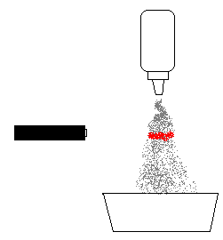
- Ask the students why you are able to see the beam with the flour, but cannot see the beam without it.
In order for the laser beam to be seen, it must be intercepted and scattered to your eye. The particles of powder allow this to happen.
- This phenomenon can be very useful. For example, some home security and protection systems operate on the concept of invisible laser beams, such as in the movie Mission: Impossible. The use of a powder or a fine mist of liquid can allow you to see the path of the laser.

Divide the class into pairs.
Safety Note: Tell the students that they will be using lasers to study some properties of light waves, and that there are several rules that must be followed:
Be very careful with the laser pointer.
Never aim it at anyone.
When turning it on, always have it pointed away from your eyes and from other persons. Eye damage can occur with direct eye exposure to some laser beams.

B. Observing Light Scattering
- Distribute the following materials to each pair:
  - 2 observation sheets
  - 1 Instruction sheet
  - 1 plastic bag containing:
    - 1 mirror mounted on a block of wood
    - 1 popsicle stick
    - 1 vial containing water
    - 1 vial containing water and milk of magnesia
    - 1 red laser pointer in plastic case
- Tell the students to take the laser pointer and the 2 vials of liquids out of the bag. Tell them to set the vials upright on the desk. They can look at the Instruction sheets for clarification.
- Have one student be responsible for turning the laser on. Tell the student to hold the laser to the side of the vial with clear liquid, and point down towards the desk. They should observe what happens when the laser is turned on. (The students may see the laser beam enter and exit the vial at the glass edges, and will see the red beam hit the table. They will not be able to see the ray traveling through the water (or at the most, they will see a very faint line).
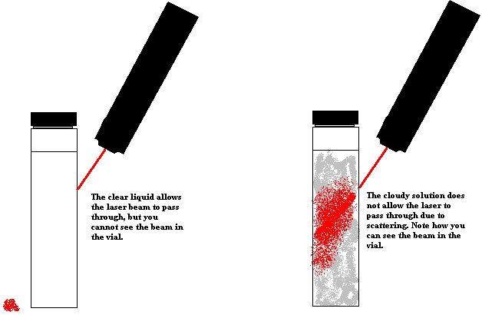
- Tell students to gently shake the second vial containing a few drops of Milk of Magnesia, so that the liquid is cloudy and repeat step 3. Now they will be able to see the laser beam passing through the liquid, but it will not exit the vial.
- Light cannot be seen as it travels, unless the beam is intercepted and scattered to the eye. The white milky substance added to the second vial is milk of magnesia, which is made of very small white particles. These particles scatter the light to your eye so you can see it.
- Tell the students to turn the vial so that it is horizontal, and to shine the laser pointer through the glass bottom. What happens to the laser beam?
- The beam does not go all the way to the other end. It gets weaker the further across the vial it travels because all of the light has been scattered.

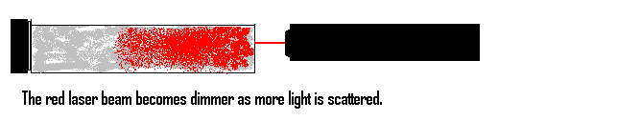

III. Reflection
Materials – each pair needs:
2 Observation sheets
1 Instruction sheet
1 Mirror mounted on a wooden block
1 grooved ruler
1 popsicle stick
1 laser pointer

- Tell the students to put the vials back in the bag and take out the mirror, and the popsicle stick. Distribute a grooved ruler to each pair.
- Ask students what happens to light when it strikes a surface?
  - When light strikes an object, it is either transmitted (allowed to pass through), or reflected (bounced back to your eyes so that you can see the object).
  - When light hits a smooth surface, such as a mirror, regular reflection occurs. Ask students what we call the image that we see in the mirror. A reflection.

- Tell students that they are going to experiment with reflecting light in a mirror.
- Tell students to place the block of wood with the mirror on the marked line on the observation sheet.

1. 2.
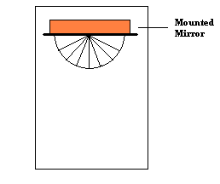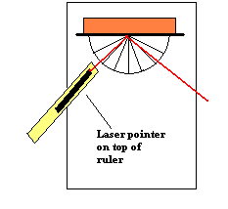

- Designate one student to hold the laser pointer. Remind the students to NEVER look directly into a laser beam.
- Tell the students to place the laser in the groove of the ruler and place the ruler and pointer so that the beam shines along the solid 45° line and is pointed to the “X”
- Designate another student to hold the popsicle stick in the path of the laser beam, so that the red dot is visible on the stick. Have the students “trace” the laser beam along the 45° line in towards the mirror. Adjust the position of the laser if necessary. (The laser can be tilted down so that the beam shines on the paper.)
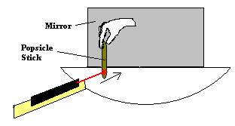
- Now tell the students to trace the reflected beam with the popsicle stick and to note which line the stick moves along. (It should be close to the dotted 45° line.)
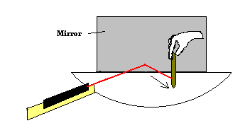
- Tell the students that the light from the laser to the mirror is called the incident ray and the light from the mirror is the reflected ray.
- Explain that when light goes in at an angle on one side (left or right) it comes out at the same angle on the other side. (It is helpful to some students if you draw this on the board or relate it to balls on a pool table.)

Note: The concept the students should learn is that light can bounce or reflect. Light goes in at one angle and comes out on the opposite side at an equal angle.
- Allow the students to try other angles (moving the ruler and laser) to see what happens. Remind students to aim for the “X” in the center.
- After a brief time of experimentation with other angles, ask the students what they can conclude about the reflection of light.
  - Light can be reflected by using a mirror.
  - When you shine a light straight into a mirror, it comes straight back.
  - When you shine a light into a mirror at an angle, it will come out at an equal angle on the opposite side of the mirror.
  - Incoming light is reflected at the same angle as the outgoing light.

Important. Collect all laser pointers and count them to make sure you have them all. Do not continue with the lesson until you have placed the laser pointers in the VSVS box. Also, make sure the laser pointers are not left on in the cases. If one is on in the case, open it and rotate the pointer so the button is to one side, not straight up, as this will cause the lid of the case to press the button.

IV. Diffraction
Materials:
32 CDs
32 diffraction gratings

Ask students if they know what diffraction is?
- All waves can be bent when they move around a barrier or through an opening, this is called diffraction.
- For light to be diffracted, it must pass through a slit that is very narrow.

A. Diffraction Gratings

- A VSVS volunteer should show students how to hold the diffraction grating.
  - Hold the slide by the cardboard only.
  - Do not touch the clear film in the cardboard holder.
  - Hold the diffraction grating close to (but not touching) the eye and look at any lights or windows in the room.
  - Several rainbows should appear.

Hand out a diffraction grating and CD to each student.
CAUTION: Do not look directly at the sun with a diffraction grating.

Explanation:
- Diffraction grating slides consist of many equally spaced parallel grooves -- typically about 1500 lines per centimeter.
- Each space between two grooves acts as a slit through which light can pass.
- The light bends around the edges of the grooves.
- When illuminated with white light, the diffraction grating has the same effect as a prism in that it separates white light into a spectrum of colors.
- However, the order of the colors is opposite from that seen in a spectrum made by a prism.

B. CD
- Tell the students to pick up the CD and notice the “rainbow” pattern from the room lights.

- CDs have many parallel grooves so the CD acts as a diffraction grating.
- The different colors in white light are bent different amounts, so a full spectrum of color can be seen when light is shone onto a CD.

C. Lasers and Diffraction Gratings: Demonstration
Materials
1 demo bag containing
1 red laser pointer
1 green laser pointer
2 diffraction gratings

This activity requires 2 VSVS volunteers. Tell students that you will shine the red laser light through a diffraction grating to see what happens.
Safety Note: Be very careful with the green laser pointer. Never aim it at anyone. When turning it on, always have it pointed away from your eyes and from other persons. DO NOT let students handle the green laser pointer. Eye damage can occur with direct eye exposure to the green laser beam. (It is illegal for Metro students to have laser pointers at school.)
- Hold the laser light close to the diffraction grating slide.
- Shine the red laser light through the diffraction grating to show three red points of light on the wall. The red dots will be in a horizontal, vertical, or diagonal line depending on the way you hold the diffraction grating slide. Rotate the slide to see the dots change position.
- Hold the second grating directly above the first grating.
- Now shine the green laser through the grating so that the center green and red dots overlap.
- Have students note that the green dots are spread further out than the red ones. The green wavelength is diffracted more than the red wavelength.
- All wavelengths are diffracted at different rates, so diffracted visible light is split into a rainbow of colors.

V. Total Internal Reflection and Fiber Optics
For VSVS Background Information Only: The center dot is the original laser beam that has been diffracted. The side dots are a result of interference.
A. Light Pipe: Demonstration
Materials:
1 acrylic light pipe
1 laser pointer

- Show the students the acrylic light pipe.
- Hold the light pipe so that the long part is vertical and the small horizontal part is pointing towards the class (but not directly at any person’s eyes).
- Turn off the classroom lights.
- Ask students what they think they will see when the red laser is shone through the long end of the pipe.
- Show students that the red light can be seen at the horizontal end, and that no light escapes to the ceiling. If the room is dark enough, the red light can be seen traveling around the tube.

Explanation: When the angle of incidence is high enough (above a critical angle characteristic of the substance; 42° for glass), the incident light is totally reflected inside the medium.

B. Fiber Optics Cables
Materials:
Demonstration materials from Bag #3
8 fiber optic flashlights

- Show students a piece of covered fiber optic cable.
- Tell students that fiber optics are often referred to as "light pipes”. Note that the fibers are solid, not hollow. Light remains inside of the transparent fibers by means of total internal reflection.
- Bundles of these fiber optic cables can be put together to make a cable capable of carrying images (cable TV, computer networking) or optically transmitted telephone messages.
- Shine the laser light through the fiber optic cable to show that the red laser light can be transmitted by fiber optic cable. Be careful not to let anyone directly view the laser light coming through the fiber optic cable.

Explanation: Because of total internal reflection, light can be "piped” from one location to another in glass, plastic rods, or other fiber optic material. On entering the "light pipe” at an angle greater than the critical angle of pipe material, the light undergoes repeated internal reflections and follows the contour of the pipe.

- Give each group a fiber optics flashlight.
- Have one student in each group turn on the fiber optic flashlight so the students can observe fiber optics cables for themselves.
- Tell students to handle the flashlights carefully so the fibers do not break.
- Tell them to notice that the light can be seen only at the ends of each fiber.
- Some students may see different colors – this is because there are colored filters inside the bowl of a few of the flashlights.

Lesson written by: Pat Tellinghuisen, Director of VSVS, Vanderbilt University
Susan Clendenen, Teacher Consultant, Vanderbilt University
Dr. Melvin Joesten, Chemistry Department, Vanderbilt University
Emily Culver, Past-President of VSVS, Vanderbilt University
John Kidd, NSF Undergraduate Teaching Fellow, Vanderbilt University
Frank Merendino, Undergraduate Teaching Fellow, Vanderbilt University

OBSERVATION SHEET

X
Place mirror along line

60°
I
60°
R

45°
I
45°
R

30°
I
30°
R

0°

IIb. Light Scattering Sketches
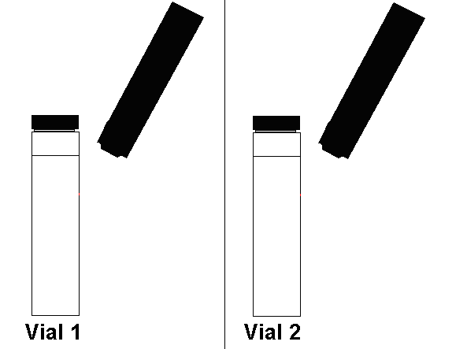



Light Instruction sheet

NEVER aim the laser pointer at anyone.

1. Discussion

2. Scattering
1. Take the laser pointer and the 2 vials of liquids out of the bag.
2. Place the two vials upright on the desk.
3. Designate one person in your group to be in charge of using the laser.
4. Hold the laser to the side of the vial with clear liquid and point down towards the desk (see diagram 1).
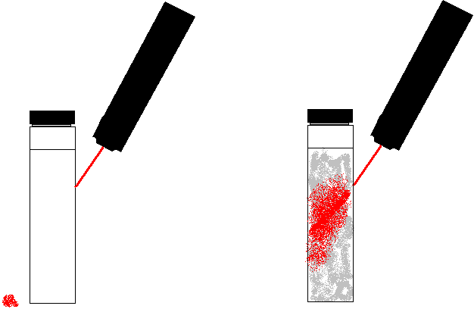
Diagram 1. Diagram 2.
5. Record what you see.
6. Gently shake the second vial containing a few drops of Milk of Magnesia, so that the liquid is
cloudy and repeat step 4.
7. Record what you see.
8. Turn the vial so that it is horizontal, and shine the laser pointer through the glass bottom towards the lid (see diagram 2).
9. Record what you see.

3. Reflection
1. Place the block of wood with the mirror on the marked line on the laminated observation sheet.
2. Designate one student in your group to hold the laser pointer.
Look at diagrams 3-6 and follow steps 3-6.
3. Place the laser in the groove of the ruler and place the ruler and pen so that the beam shines
along the solid 45° line and is pointed to the “X”
Diagram 3. Diagram 4.

4. Designate another student in your group to hold the popsicle stick in the path of the laser beam,
so that the red dot is visible on the stick. This is called the incident ray.
5. “Trace” the laser beam along the 45° line in towards the mirror. Adjust the position of the
laser if necessary. (The laser can be tilted down so that the beam shines on the paper.)
6. Now trace the reflected beam with the popsicle stick and note which line the stick moves
along. This is the reflected ray.

Diagram 5. Diagram 6.

7. Try other angles (moving the ruler and laser) to see what happens. Record your answers.

TURN IN YOUR LASER POINTERS.

4. Diffraction
A. Diffraction Gratings
- Hold the slide by the cardboard only.
- Do not touch the clear film in the cardboard holder
- Hold the diffraction grating close to (but not touching) your eye and look at any lights or windows in the room.
- A rainbow should appear.

B. CD
- Pick up the CD and notice the rainbow pattern from the lights.

C. Lasers and Diffraction Gratings: Demonstration

5. Total Internal Reflection and Fiber Optics
A. Light Pipe: Demonstration

B. Fiber Optics Cables
1. One student in your group turns on the fiber optic flashlight so that the other students can observe fiber
optics cables for themselves.
2. Handle the flashlights carefully so the fibers do not break.
3. Notice that the light can be seen only at the ends of each fiber.

