VANDERBILT STUDENT VOLUNTEERS FOR SCIENCE
http://studentorgs.vanderbilt.edu/vsvs
Discovering Inheritance Patterns
SPRING 2006

GOAL: To introduce students to the fundamentals of genetics and probability.

MATERIALS
30 parent cards for inheritance game
35 Punnett square worksheets (may need to print more, depending on how much practice is needed)
35 individual trait tables
35 blank face worksheets
35 observation sheets
30 pennies
35 booklets for data collection sheets and traits (optional take-home activity)

I. PROBABILITY AND GENETICS

Ask: What do we mean when we say something is probable? certain? impossible?
Accept student responses.

Each of these terms refers to the probability or the chance that something might occur.
A probability is a measure of how likely it is that something will happen.
Probabilities can be shown using percents, fractions or decimals.

Ask: What are some everyday situations in which probabilities are used?
Accept student responses.

Weather persons use probabilities in the weather forecast when they say that there is a 60% chance of thunder showers.
Probabilities are also used in medicine, sports, and science.
Genetics and inheritance involve probabilities.

II. INHERITANCE PATTERNS

Ask: What are traits?
A trait is a characteristic of an organism.

Ask: What kind of traits do humans possess?
Hair color, eye color, height, and many others

To discover some of their traits, ask students to stand if they have the trait you name:
curly hair
straight hair
freckles
blue eyes

taller than the average person their age

Ask students to try to roll their tongue. Have students stand if they can roll their tongue.
Ask students to clasp their hands with fingers intertwined - similar to a praying clasp.
It is important that they do this quickly and without thinking about it.
Tell students to see which thumb is on top -- that thumb shows the dominant hand.
Ask students to try to clasp their hands with the other thumb on top -- many will
find this uncomfortable.
Tell students that these are just a few of the many traits they possess. Today they will
learn more about how they received these traits.

Write these words on the board:
DNA ~ chromosome ~ gene expression ~ individual traits

Use the following information to explain to students the way our traits are determined:
Our genetic code is contained in DNA.
DNA is condensed into bodies called chromosomes.
We inherit half of our chromosomes from each of our parents.
Genes are the areas on a chromosome that dictate a certain trait.
When this gene is expressed it becomes part of the phenotype, or physical appearance.

III. GENOTYPE AND PHENOTYPE

Explain these terms to students:
genotype - genetic traits that are coded in our DNA
phenotype - physical traits that are shown in our physical person

Ask: Can a person’s genotype, or genetic traits, be different from their phenotype, or physical traits?

Yes, because not all genes are expressed. Genes for one trait can interfere with another. For example, you can inherit one gene for blue eyes from your mother and one gene for brown eyes from your father. Because the gene for brown can mask the blue, you have brown eyes. The gene for brown is called a dominant gene. The blue one is called a recessive gene because it is only expressed when there are two such genes present. Our genotype may have two of the same genes or two different ones. The one inherited can be expressed in different ways. So our genotypes and phenotypes may indeed differ. We can use Punnett (PUH-nit) squares to determine the probability of inheritance.

Two examples of recessive and dominant genes are eye color in humans and coat color of tigers at the Nashville Zoo.

IV. PUNNETT SQUARES
Write down the traits of each parent and the four children on the board.
A brown-eyed mother and father have four children, three have brown eyes and one has blue eyes.

Ask: Where did the blue eyes come from?

Explain:
The physical trait is called the phenotype.
The phenotype is either brown eyes or blue eyes.
The genetic makeup or genotype for brown eyes is Bb or BB.
The B is the dominant gene for brown eyes and the b is the recessive gene for blue eyes.
The genotype for blue eyes is bb.
If both genes are the same BB or bb this is called homozygous.
If both genes are different in the same person this is called heterozygous.

Ask: What is the probability of inheriting each genotype?

The father’s genes (Bb—heterozygous dominant) are placed on top
 | B_{father} | b_{father}
B_{mother} | BB | Bb
b_{mother} | Bb | bb
of the Punnett square with each gene situated over one column. The mother’s genes (also Bb) are placed to the side with each gene next to its own row.

The father’s dominant B gene is written in each square below it;
similarly, the recessive b gene is placed in the squares below it.
The mother’s dominant B gene is written in both squares to the right
of it, as is the recessive b gene.

This process is a simulation of what genotypes four children will inherit. In other words, there is a 75% chance a child will be brown-eyed (3 of 4 squares are either BB or Bb) and a 25% chance a child will be blue-eyed (1 of the 4 squares is bb).

Pass out the Punnett Square worksheets and genotype/phenotype table for practice.

Point out the table on the right, which is on the Punnett square practice sheet. The students will be able to refer to it while doing the next activity. Also point out that the letters assigned to the genotypes are arbitrary and are just used for this lesson. (Eye color and hair color are optional.)

Dominant | genotype | Recessive | genotype | Other
brown hair | BB | red hair | bb | Bb = blond hair *
brown eyes | BB | blue eyes | bb | Bb = hazel eyes *
freckles | FF, Ff | no freckles | ff
free earlobe | AA, Aa | attached earlobe | aa
tongue rolling | RR, Rr | no tongue rolling | rr
curly hair | CC | straight hair | cc | Cc = wavy hair *

* Optional info: In these cases, the heterozygous genotype expresses a phenotype that is neither dominant nor recessive. From above, the genotype BB (hair) results in brown hair and bb results in red hair. The heterozygote genotype of Bb results in blond hair. When the heterozygote has a different, intermediate phenotype compared to the homozygous dominant or homozygous recessive individuals, this is said to be incomplete dominance. Interestingly, the intermediate phenotype is expressed in F1 (the first generation), but parental phenotypes reappear in F2 (subsequent generation).

V. INHERITANCE GAME
- Organize the class into partners.
- Pass out an observation sheet, two parent cards, and a penny to each pair of two students.
- Have one student flip the penny while the other records the data.
- Have each student do Punnett squares to predict the phenotype of the offspring using the genotypes that are written on the parent cards.
- The students will flip a coin twice for each phenotype: once for the maternal gene and the second for the paternal gene.
  - If it lands on heads, they are to record the gene on the right.
  - If it lands on tails, they are to take the gene on the left.
- Do this for each parent and each trait.
- Have some students present their data and the phenotype of their offspring to the rest of the class.

Example: The students are determining the child’s phenotype for earlobe attachment. The maternal genes are Aa and the paternal genes are AA. The first coin flip is heads. The student will then write “a” in the box corresponding to earlobe genotype from mother. The second coin flip is tails (note that this is irrelevant; the father will always contribute an “A” gene). The student will write “A” in the box corresponding to earlobe genotype from father. Since the genotype for the child is Aa, the phenotype is unattached (the dominant trait).

VI. INDIVIDUAL GAME
Pass out a blank face worksheet and an individual traits worksheet (the one with various facial features and their genotypes) to each pair of students.
Tell students to flip the coin for each trait, starting with hair.
Tell them that for this activity, heads = dominant and tails = recessive.
Suggest that they write down the genotype that is obtained by the coin flip.
After determining the genotype of each trait, tell the students to draw in the corresponding phenotype (from the individual traits worksheet) on the blank face.

Example: For length of eyelashes, students flip the coin twice and obtain one tails and one heads (one dominant gene and one recessive gene). When they refer to their individual traits chart, they see that the genotype is Ll. This genotype corresponds to a long eyelash length phenotype. They then draw long eyelashes on their blank face worksheet.

If time permits, allow a few students to present their faces to the class.

VII. DISCOVERING YOUR GENOTYPE (OPTIONAL)

Ask: How would you discover your genotype?
You would have to look at your parents, or maybe your grandparents to see if you have the same features.

Give each student a trait booklet (6 half sheets that are stapled).These trait sheets show some common features and whether they are dominant or recessive. Look over these sheets and see if you have any of these traits. Take these sheets home and look at your parents to see who passed these traits on to you. If you show a recessive trait, you may need to check your grandparents or great-grandparents to see who had that trait.

OPTIONAL ACTIVITIES - White Tigers at the Nashville Zoo
Share the information about the white tigers at the Nashville Zoo.

Most Siberian tigers are orange. In 1951, the first white tiger, Mohan, was found in India. Since then all white tigers in zoos throughout the world are descendants of Mohan. In the wild a white tiger cannot hide in the jungle as well as an orange tiger.

The recessive gene is for a white coat in tigers. The genotype is ww.
The dominant gene is orange. The orange phenotype can have two possible genotypes WW or Ww.
The Nashville Zoo has a large male white tiger genotype (ww) and an orange female with the genotype (Ww). Last spring four baby cubs were born and can be seen in the nursery at the zoo. 3 were white and 1 was orange. If you did a Punnett square of these two tigers (ww x Ww), half of the offspring would be wW and half ww. The zookeepers expected in a litter of four cubs to find 2 white cubs and 2 orange cubs.

White Tigers and Family Pedigrees

In the dry season of 1951, hunters found four tiger cubs playing in the hunting preserve of the Maharajah of Rewa, in central India. Although the hunters were looking for bigger game, one of the cubs caused great excitement: Instead of the normal orange-and-black-striped coat, it had a pure white pelt! Lured into a cage by a bowl of water, the young tiger was brought to the Maharajah’s palace and named Mohan, meaning "Enchanter.” Mohan grew into a magnificent creature, larger than most tigers, strong, and healthy. But he lacked the usual rich orange and jet black pigments of normal tigers; his coat was nearly pure white, with ashen gray stripes. What’s more, his nose and paw pads were pink instead of black, and his eyes were ice blue with a tendency to cross.

Was Mohan just a fluke of nature, or a unique occurrence? Or were his special traits hereditary, that is, capable of begin passed to offspring and through them to future generations?

Mohan was mated with Begum, a normal tiger, but the results were disappointing: None of the cubs had Mohan’s sparkling white coat, and it seemed that Mohan was a once-only occurrence, never to be repeated, but Mohan was kept in a cage with one of his daughters, Radha. You can imagine the surprise of his keepers when they saw the offspring from the mating of the two. Some of the cubs in the second generation had beautiful white coats. To the Maharajah’s joy, the trait was hereditary. Although it appeared to have skipped Radha’s generation, it had remained intact (though hidden) and had reappeared in the next generation. What could cause a hereditary trait to behave in this hit-and-skip fashion? And what was the relationship of the white pelt to the crossed blue eyes?

Punnett square explanation:
 | w_{father} | w_{father}
W_{mother} | Ww | Ww
W_{mother} | Ww | Ww
Because Mohan was mated with a normal tiger, Begum, it is safe to assume that Begum’s genotype was for a dominant tiger: WW or Ww. Because the white coat phenotype was hidden in the first generation, it is safe to assume that Begum’s genotype is WW. Because the dominant allele masks the recessive allele, no white coat offspring are observed for the first generation.

Because Radha was the daughter of Mohan, she possessed the recessive allele, w. When mated with her father, there is the probability that a recessive allele from Mohan will pair with a recessive allele with Radha. Therefore, the white coat phenotype appears in the 2nd generation after skipping the first generation.

 | w_{father} | w_{father}
W_{daughterr} | Ww | Ww
w_{daughter} | ww | ww

PUNNETT SQUARE PRACTICE

 | B_{father} | b_{father}
B_{mother} | BB | Bb
b_{mother} | Bb | bb
Example on the right: father is Bb (heterozygous dominant for B), mother is
Bb (also heterozygous dominant for B)

MOTHER’S GENES

FATHER’S GENES

MOTHER’S GENES

FATHER’S GENES

MOTHER’S GENES

FATHER’S GENES

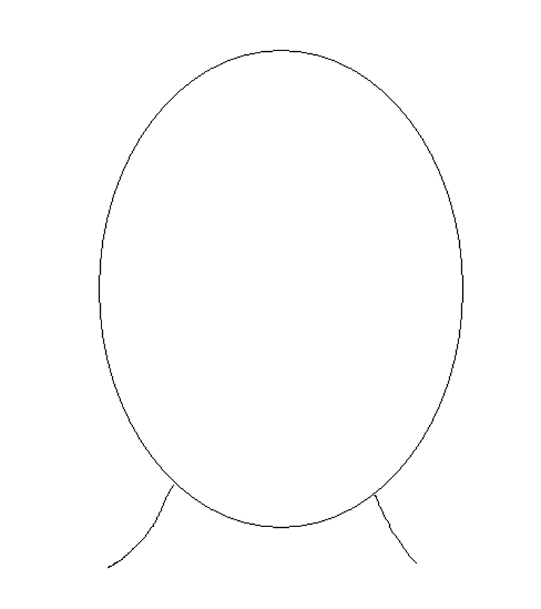
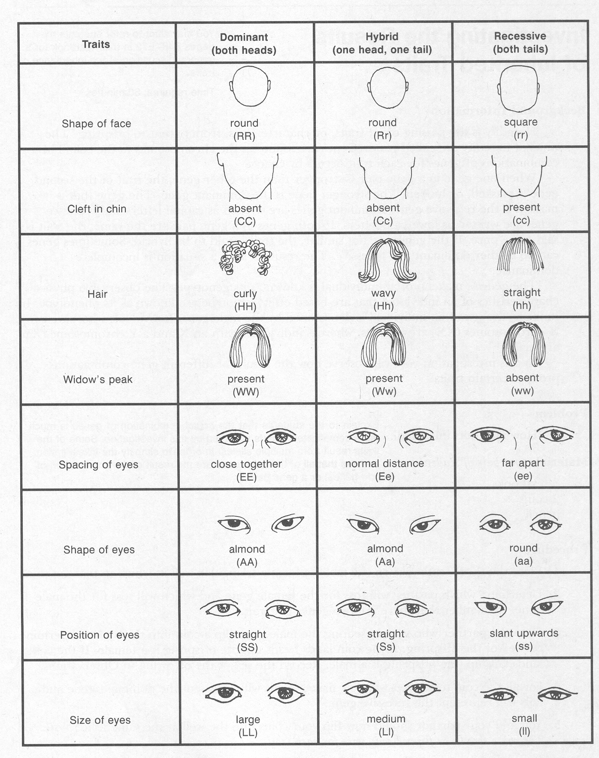

Dominant | genotype | Recessive | genotype | Incomplete dominant phenotype
brown hair | BB | red hair | bb | Bb = blond hair
brown eyes | BB | blue eyes | bb | Bb = hazel eyes
freckles | FF, Ff | no freckles | ff
free earlobe | AA, Aa | attached earlobe | aa
tongue rolling | RR, Rr | no tongue rolling | rr
curly hair | CC | straight hair | cc | Cc = wavy hair

