VANDERBILT STUDENT VOLUNTEERS FOR SCIENCE
http://studentorgs.vanderbilt.edu/vsvs
Electrolysis of Water
Mini Lesson for Fall 2012

Goal: To learn about the energy conversion from electrical energy to chemical energy through the electrolysis of water.

I. Introduction
Discuss different forms of energy.
II. Electrolysis of Water: Electrical Energy → Chemical Energy
A. Distilled Water Experiment
Students use two nickel electrodes and a 9-volt battery to test whether any reaction occurs in distilled water. Nothing happens because distilled water doesn’t conduct electricity.
B. Salt Water Experiment
Students then add a small scoop of sodium sulfate to the distilled water, stir with a
toothpick, and then place the nickel electrodes in the water. This time they should see bubbles - more at one electrode than the other.
C. Add Universal Indicator to the Salt solution
Students add a few drops of universal indicator to their salt solution and observe
color changes (corresponding to pH changes) at the electrodes.

Students will work in groups of 3’s or 4’s. There are 8 sets of materials, so divide the class into enough groups to use all the materials.

Complete teacher/school information on first page of manual.
- Make sure the teacher knows the VSVS Director’s (Pat Tellinghuisen) home and office numbers (in front of manual).
- Exchange/agree on lesson dates and tell the teacher the lesson order (any changes from the given schedule need to be given to Pat in writing (email)).
- Since this is your first visit to the class, take a few minutes to introduce yourselves. Mention you will be coming three more times to teach them a science lesson.
- Do the experiment with the classroom, and leave 10 minutes at the end to discuss aspects of college life with them. Some topics that could be included are on page 5 of the manual.

I. Introduction
Ask students if they can name any conversions of electrical energy to other forms of
energy? Ask for examples for each conversion.
Answers should include:
- Electrical to Mechanical – motors
- Electrical to Thermal (heat) – heaters, toasters, ovens
- Electrical to Light - light bulbs
- Electrical to Chemical – electrolysis of water
- Electrical to Sound – doorbells

Ask students if they know the formula for water?
H₂O. Write this formula on the board. Explain that this formula shows that
water is made up of two parts hydrogen and one part oxygen.
Ask students if they know what will happen if an electrical current is passed through water?
The water decomposes into 2 gases, oxygen and hydrogen. Write the formula for these gases on the board – O₂ and H₂.
Tell students that they are going to use electrical current from a 9-volt battery to
decompose water.

II. Electrolysis of Water: Electrical Energy → Chemical Energy
Materials
1 Demonstration ziploc bag containing:
1 9-volt battery with wire leads
1 set of nickel electrodes mounted in styrofoam
1 plastic container with 8 sets of nickel electrodes mounted in styrofoam
8 ziploc bags containing the following items:
1 9-volt battery with wire leads
1 small container of sodium sulfate
1 small plastic scoop
1 toothpick
1 hand magnifying lens
1 plastic container with 9 2oz. jars of distilled water
2 universal indicator dropper bottles
1 roll of paper towels

Perform the following demonstration before you pass out materials:
- Take the 9-volt battery, wire leads and the set of nickel electrodes from the demonstration bag.
- Take one of the jars with distilled water from the plastic container.
- Follow the diagram below and show the students how to hook up the set of nickel electrodes to each wire by attaching the alligator clip to the short end of the electrode. Explain that the nickel is an electrode because nickel conducts electricity.
- Show them how the electrodes are placed in the jar. Emphasize to students that the nickel electrodes and their mount should be handled with care. Refer them to the picture on the instruction sheet (also given below) for the correct hookup and placement of the nickel electrodes. Note that the alligator clips are connected to the short end of the nickel electrodes.

Give each group a bag of materials, a jar with distilled water, and a set of nickel electrodes.

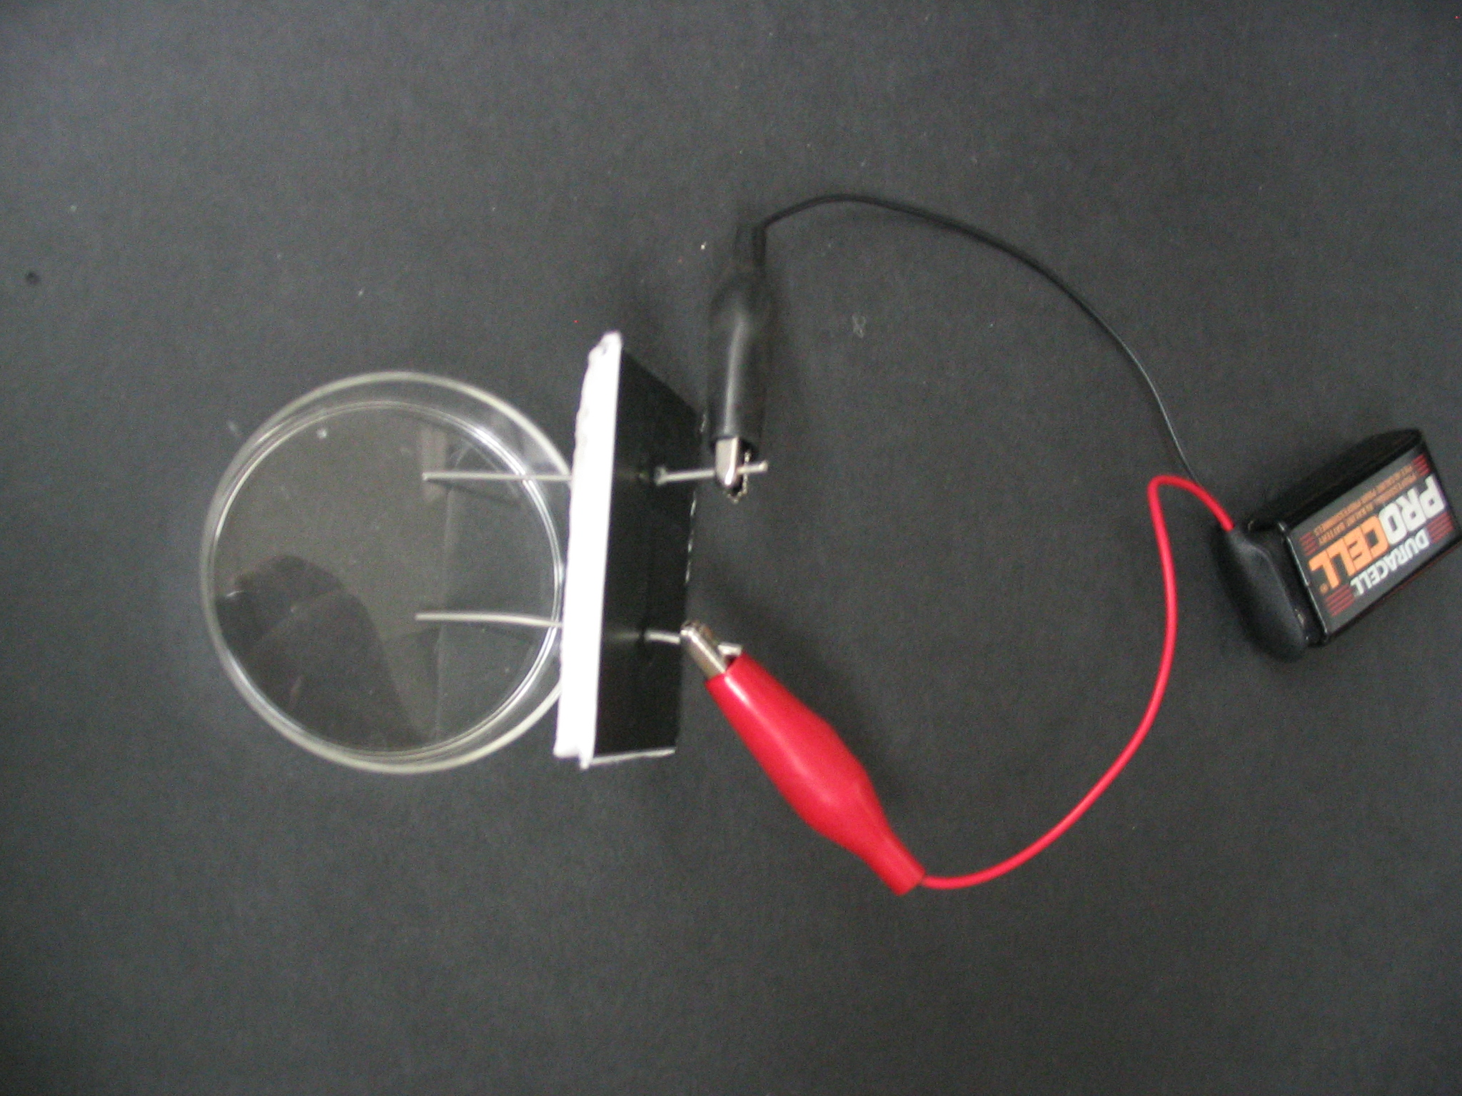
A. Distilled Water Experiment
- Have students place the electrodes connected to the 9-volt battery in the jar that contains distilled water so that the electrodes are in the water.
- Tell the students to see if any bubbles are forming around the end of the electrodes in the water. They may have to use the hand lens.
- Record observations on the board. (Students should observe that nothing happens.)
For the next experiment, students should remove the electrodes before adding in salt.

B. Salt Water Experiment
- Tell students to use the small plastic scoop to get a small amount of sodium sulfate from the container.
- Add one scoop of sodium sulfate to the distilled water in the jar..
- Stir the water and sodium sulfate with the toothpick.
- Follow the same procedure as before and place the electrodes back into the jar.
- Tell students to look through the side of the jar to see if any bubbles are forming around the end of the electrodes in the water. Then tell students to pass the lens around so each student can look at the bubbles.
- Record observations on the board.
- Ask students to notice which electrode (black connection or red connection) has the most bubbles. Answer: Black connection.
Note: Students should observe tiny bubbles of gas at both electrodes.
One electrode should have twice as many bubbles as the other. This is the negative
electrode (the black wire). The students may have difficulty seeing this because this is
where the hydrogen bubbles are emitted. Hydrogen bubbles are smaller than the
oxygen bubbles.

Ask the students the following questions:
- Where is the electrical energy coming from? The battery.
- What kind of bubbles are forming in the jar? Hydrogen and Oxygen gas
- Which electrodes had the most bubbles? The electrode connected to the black (negative) alligator clip. It may be difficult to notice, but the ratio is 2:1.
- Based on the formula for water, which bubbles are being produced in larger amounts: hydrogen or oxygen? The formula for water shows that water has twice as many hydrogen atoms as oxygen atoms. There are more bubbles around one electrode. Those are the hydrogen bubbles.
  - Add Universal Indicator to Salt Solution

- Tell students to remove the electrodes. VSVS members will add enough drops of
Universal Indicator to give a light green solution. (Observations will not be possible if the solution is too dark.)
- Put the electrodes back into the jar and observe the color changes at the
electrodes.
- A purple color will develop at one electrode (the cathode) and a yellow to orange color will develop at the other (anode).
- Tell students that the universal indicator is detecting changes in the acidity of the water. The water starts with a pH of neutral and is green colored.
- Its pH becomes acidic at the anode where oxygen is given off. The Universal Indicator turns red in acid.
- Its pH becomes basic at the cathode where hydrogen is given off. The Universal Indicator turns purple in basic solutions.

Explanation:
Important point - the electrical energy in the battery was converted to chemical energy when water (H₂O) was broken into hydrogen and oxygen gas.

The decomposition of water is a chemical change.

The decomposition of water requires energy, and this case, electrical energy is being used to cause the reaction to occur.

The electrolytic solution contains a small amount of sodium sulfate, which conducted the electric current through the solution. Pure water does not conduct electricity so water was not broken down in the pure or distilled water.
For VSVS Information only:
In the water at the negatively charged cathode, a reduction reaction takes place, with electrons (e⁻) from the cathode being given to hydrogen cations to form hydrogen gas
Cathode (reduction): 4 H₂O(l) + 4e⁻ → 2H₂(g) + 4 OH⁻(aq)

At the positively charged anode, an oxidation reaction occurs, generating oxygen gas and giving electrons to the cathode to complete the circuit:
Anode (oxidation): 2 H₂O(l) → O₂(g) + 4 H⁺(aq) + 4e⁻

Overall reaction: 2 H₂O(l) → 2 H₂(g) + O₂(g)The number of hydrogen molecules produced is thus twice the number of oxygen molecules.

Discuss the importance of going to College and answer students questions.
See page 5 in manual for possible topics.

Clean – up:
Collect the nickel electrode sets; place them back in their plastic container.
Collect the jars and make sure the lids are screwed on tightly. Return them to their plastic container.
Have students put the other materials in their bag.
VSVS volunteers should collect the bags of materials and place them back in
the kit box.

