VANDERBILT STUDENT VOLUNTEERS FOR SCIENCE
http://studentorgs.vanderbilt.edu/vsvs
Electrical Conductivity
Elementary Grades
Fall 2012
(Adapted from Student Guide for Electric Snap Circuits by Elenco Electronic Inc.)

Acknowledgement: We want to thank NASA and the Tennessee Space Consortium for funds to purchase the Elenco Snap Circuit™ kits.
Goal: To measure the conductivity of solids.
TN Curriculum Alignment:

Lesson Outline
I. Introduction
Explain Static and Current electricity. Write the vocabulary words on the board and explain conductors and nonconductors.
II. Demonstration – Explaining the circuit
Explain the circuit and demonstrate how the students will use the red and black lead wires to test conductivity.
III. Activity 1. Conductivity of Solids
Students will work in pairs. Hand out one grid and one bag of solids to each pair. Make sure all groups have a correctly assembled circuit by having them touch the ends of the black and red lead wires together and noting the bulb glows brightly. Explain what conductors and nonconductors are. Students then test the solids and record their results on the Observation Sheet.
VII. Review
Review the results of the lesson and the vocabulary words.

Materials
1 demonstration grid with assembled circuit, plus a bag with a nail and a bottle cap for demonstrating conductivity
10 sets of grids with assembled circuit
10 bags of solid materials for checking conductivity (paper clip, aluminum foil, copper strip, golf pencil sharpened on both ends, paper, popsicle stick, plastic spoon, and cork)
10 sets of Instruction Sheets
20 observation sheets
1 bag of 5 AA batteries (extras)

Write the following vocabulary words on the board: conductors, insulators, semiconductors.
Do not hand out materials until you have discussed the following background information.

Introduction
Materials
- grid with assembled circuit, plus a bag with a nail and a bottle cap for demonstrating conductivity.

Ask students if they know what the 2 types of electricity are.
1. Static electricity is the build-up of electrical charge. It does not flow.
2. Current electricity is moving electrical charge, usually electrons. Some materials have
more “free” electrons than others. Current electricity flows through a circuit.

Tell the students that electricity flows through some materials better than others. All materials can be classified as conductors, insulators / nonconductors or semiconductors.

- Conductors are materials that allow the movement of electrons through them. Metals have many “free” electrons that can easily move, and therefore are good conductors. By “free” electrons, it means that the electrons in the metal atom are not strongly held by the atom’s nucleus. Since they are not strongly held, they are able to “jump” from one atom to another. Wires used for electric circuits are usually made out copper wire, but other materials also conduct electricity.

- Insulators resist the flow of electricity, so do not allow electricity to flow through them. Some examples of insulators are Styrofoam, plastic (e.g., the casing around electrical wires), and glass.
- Semiconductors allow small currents to flow. Sometimes they are conductors and sometimes they are insulators. Silicon is the material most often used in making semiconductors.
Background information for VSVS members:
Insulators generally cause static charge to build up since static charge is not able to flow. Insulators do not all the flow of electricity so the charge that builds up is not able to dissipate; it is only able to discharge. An example of discharge would be when a person rubs their feet on a carpet while wearing socks and then touches another person causing a small shock.

Tell the students that the snap circuits we will use today contain flattened wires. Remove one of the #2 connectors (blue bar with a 2 on it) and hold it up so that the students can see the metal underside. Tell the students that this metal is a good conductor of electricity.

- Demonstration – explaining the circuit
VSVS team members should hold up the demonstration circuit to show the students.
Tell the students to look at Diagram 1 and tell them it is a picture of this circuit. Point out the different parts – batteries, circuit connectors, black and red leads, and light bulb.
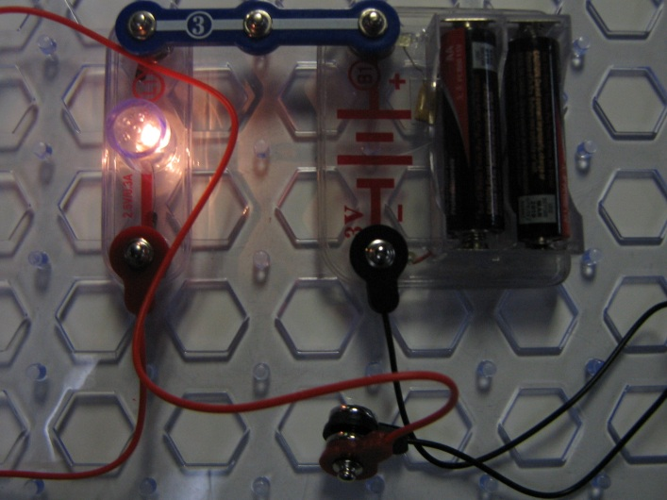
Diagram 1

Ask the students what you should do to make the light bulb glow. Touch the black and red lead together.
Show the students that this is correct and that the bulb emits light. Tell the students that the circuit is now closed.

Now touch the end of one lead wire to the head of the nail and the end of the other lead to the point of the nail. The bulb again lights up indicating that the circuit is closed. The metal nail is a good conductor of electricity and completes the circuit.
Repeat with the plastic bottle cap, putting the ends of the leads on opposite sides of the bottle cap. The bulb will not light up, indicating the plastic bottle cap is not a conductor, it is an insulator.

Tell the students that in the activity they will determine whether a solid is a conductor by testing whether it completes the circuit and causes the bulb to light up.

- Activity 1. Conductivity Tests of Solids
Students will do this activity in pairs.
Materials
10 sets of grids with assembled circuit
10 bags of solid materials for checking conductivity (paper clip, aluminum foil, copper strip, golf pencil sharpened on both ends, paper, popsicle stick, plastic spoon, and cork)
10 sets of instruction sheets
20 observation sheets

- Hand out one grid and one bag of solid conductivity materials to each pair.
- Tell them they will be testing several materials to see if they are conductors.
  - A good conductor will complete the circuit and the bulb will glow brightly.
  - An insulator will prevent completion of the circuit, and the bulb will not glow at all.
  - A poor conductor will make the bulb light glow dimly.
- Make sure all groups have a correctly assembled circuit by having them touch the ends of the black and red wires together and noting the brightness of the bulb.

Lesson modifications by:
Dr. Mel Joesten, Emeritus Professor of Chemistry, Vanderbilt University
Pat Tellinghuisen, VSVS Director, Vanderbilt University
Conductivity Observation Sheet

Name ________________________________________________

A. Testing the Circuit.
What happens when you touch the ends of the red and black lead wires together? ______________________________________________

Explain__________________________________________________________________

B. Conductivity Tests with solid materials
Which of the following materials makes the light bulb glow brightly, dimly, or not at all?
Circle your answer.
1. copper strip no light, dim light, bright light
2. paper clip no light, dim light, bright light
3. paper no light, dim light, bright light
4. pencil wood (only) no light, dim light, bright light
5. “lead” in pencil no light, dim light, bright light
6. aluminum foil no light, dim light, bright light
7. cork no light, dim light, bright light
8. popsicle stick no light, dim light, bright light
9. plastic spoon no light, dim light, bright light

On the basis of your tests, which ones are conductors of electricity?
___________________________________________________

Conductivity Answer Sheet

A. Testing the Circuit.
1. What happens when you touch the ends of the jumper cables together?
The bulb lights up.
Explain: Touching the ends of the leads together completes the circuit.
B. Conductivity Tests with Solids
Which of the following materials cause the light bulb to light up?
Circle your answer.
1. copper strip bright light
2. paper clip bright light
3. paper no light
4. pencil wood(only) no light
5. “lead” in pencil bright light
6. aluminum foil bright light
7. cork no light
8. popsicle stick no light
9. plastic spoon no light

On the basis of your tests, which ones conduct electricity?
Copper strip, paper clip, “lead” in golf pencil, aluminum foil

Electrical Conductivity - Instruction Sheet

Vocabulary words: conductors, insulators, semiconductors.
I. Introduction
Look at Diagram 1 (it is a picture of this circuit).
Point to the different parts – batteries, circuit connectors, black and red leads, light bulb.

II. Demonstrations by VSVS team.

III. Activity 1. Conductivity of Solids
- Testing the Circuit.
Touch the ends of the red and black lead wires together. What happens? (Write your answer on the observation sheet.)
- Conductivity Tests using solid materials
Test the following materials. Record if the light bulb glows brightly, dimly, or not at all.
  - Touch the ends of the black and red wires to opposite sides of the copper strip.
  - Touch the ends of the black and red wires to the paper clip.
  - Touch the ends of the black and red wires to the piece of paper.
  - Touch the ends of the black and red wires to the wood part of the golf pencil.
  - Touch the end of the black wire to one sharpened end of the golf pencil and the red wire to the other end of the sharpened pencil.
  - Touch the ends of the black and red wires to opposite sides of the aluminum foil.

On the basis of your tests, record which ones are conductors of electricity.

