VANDERBILT STUDENT VOLUNTEERS FOR SCIENCE
http://studentorgs.vanderbilt.edu/vsvs
Chemistry in a Ziploc Bag
Spring 2014

GOAL: To have students react several chemicals and observe changes during the chemical reaction.
Fits Tn standards GLE 0507.9.1: Observe and measure the simple chemical properties of common substances

LESSON OUTLINE
I. Introduction: Explanation about the importance of observations in science experiments.
This lesson aims to teach students how to make observations like a scientist.
II. Experiment: Students work in pairs. Students study the reaction when phenol red in water
solution is added to baking soda and record all observations. They then record
what happens when calcium chloride is added to the mixture.
III. Observations and Explanations
Review the observations students make. Explain what observations show that
a chemical change has occurred.

IV. VSVS Background Information on Chemical Equations

1. In the car ride, read through this quiz together as a team. Make sure each team member has read the lesson and has a fundamental understanding of the material.
Lesson Quiz
- Why are scientific observations important? Why do they need to be recorded?
- What is a hypothesis?
- How was the phenol red indicator made?
- What needs to be prepared during the initial explanation?
- When do students need to record observations?
- What are some of the possible student observations? How can they be explained?
- What are some signs of a chemical change?

2. Use these fun facts during the lesson:
- Some types of fire extinguishers use baking soda to put out fires
- Why is baking soda used in baking? Baking soda reacts with acids in cake or cookie mixes to create carbon dioxide (similar to this experiment!) which creates bubbles that make the batter to expand (“rise”).
- Baking soda is sodium bicarbonate, and is used for neutralizing both acids and bases. It is also used to treat indigestion, heartburn, and burns.
- Some kinds of toothpaste have baking soda to improve whitening and plaque removal.
- Phenol Red is used to monitor the pH of cells in cell culture. An excess of waste or bacterial contamination will cause acidification of the media and the phenol red will turn yellow.
- Calcium chloride is put on roads in winter because it lowers the freezing point of water, preventing ice from forming.

MATERIALS
15 plates
15 2 oz cups marked with line at 15 mL
2 250 mL containers of phenol red solution
4 spoons
15 Ziploc sandwich bags containing one spoonful of baking soda
4 containers of anhydrous calcium chloride
25 paper towels
1 trash bag
students use their own pencils and paper to record observations

I. Introduction

Organize students in pairs.
While one VSVS member gives the following explanation, other VSVS members should add phenol red solution to the 15 2oz cups marked with a line.

Explain to the students about the importance of making careful observations and recording them. This is how scientists do experiments. New discoveries and advances in science depend on having a careful and accurate record of observations made while doing an experiment. After the experiment is over, scientists think about the observations and data they have collected and try to come up with an explanation of what happened (an hypothesis).

NOTE: Phenol red indicator solution was made by dissolving a small amount of phenol red powder in water; so when you add the phenol red solution you also have to consider the effect of the water on the reactions.

II. Experiment
Give each pair one ziploc bag containing baking soda, one 2 oz cup containing 15 mL of phenol red solution, and one plate. Tell students to have a piece of paper to write down their observations.

Instruct the students that one person will be holding the bag while the other will write down all observations possible. Students should write down:
A. Everything they observe after the phenol red is added to the ziploc bag containing baking soda. B. Everything they observe after the calcium chloride is added to the Ziploc bag

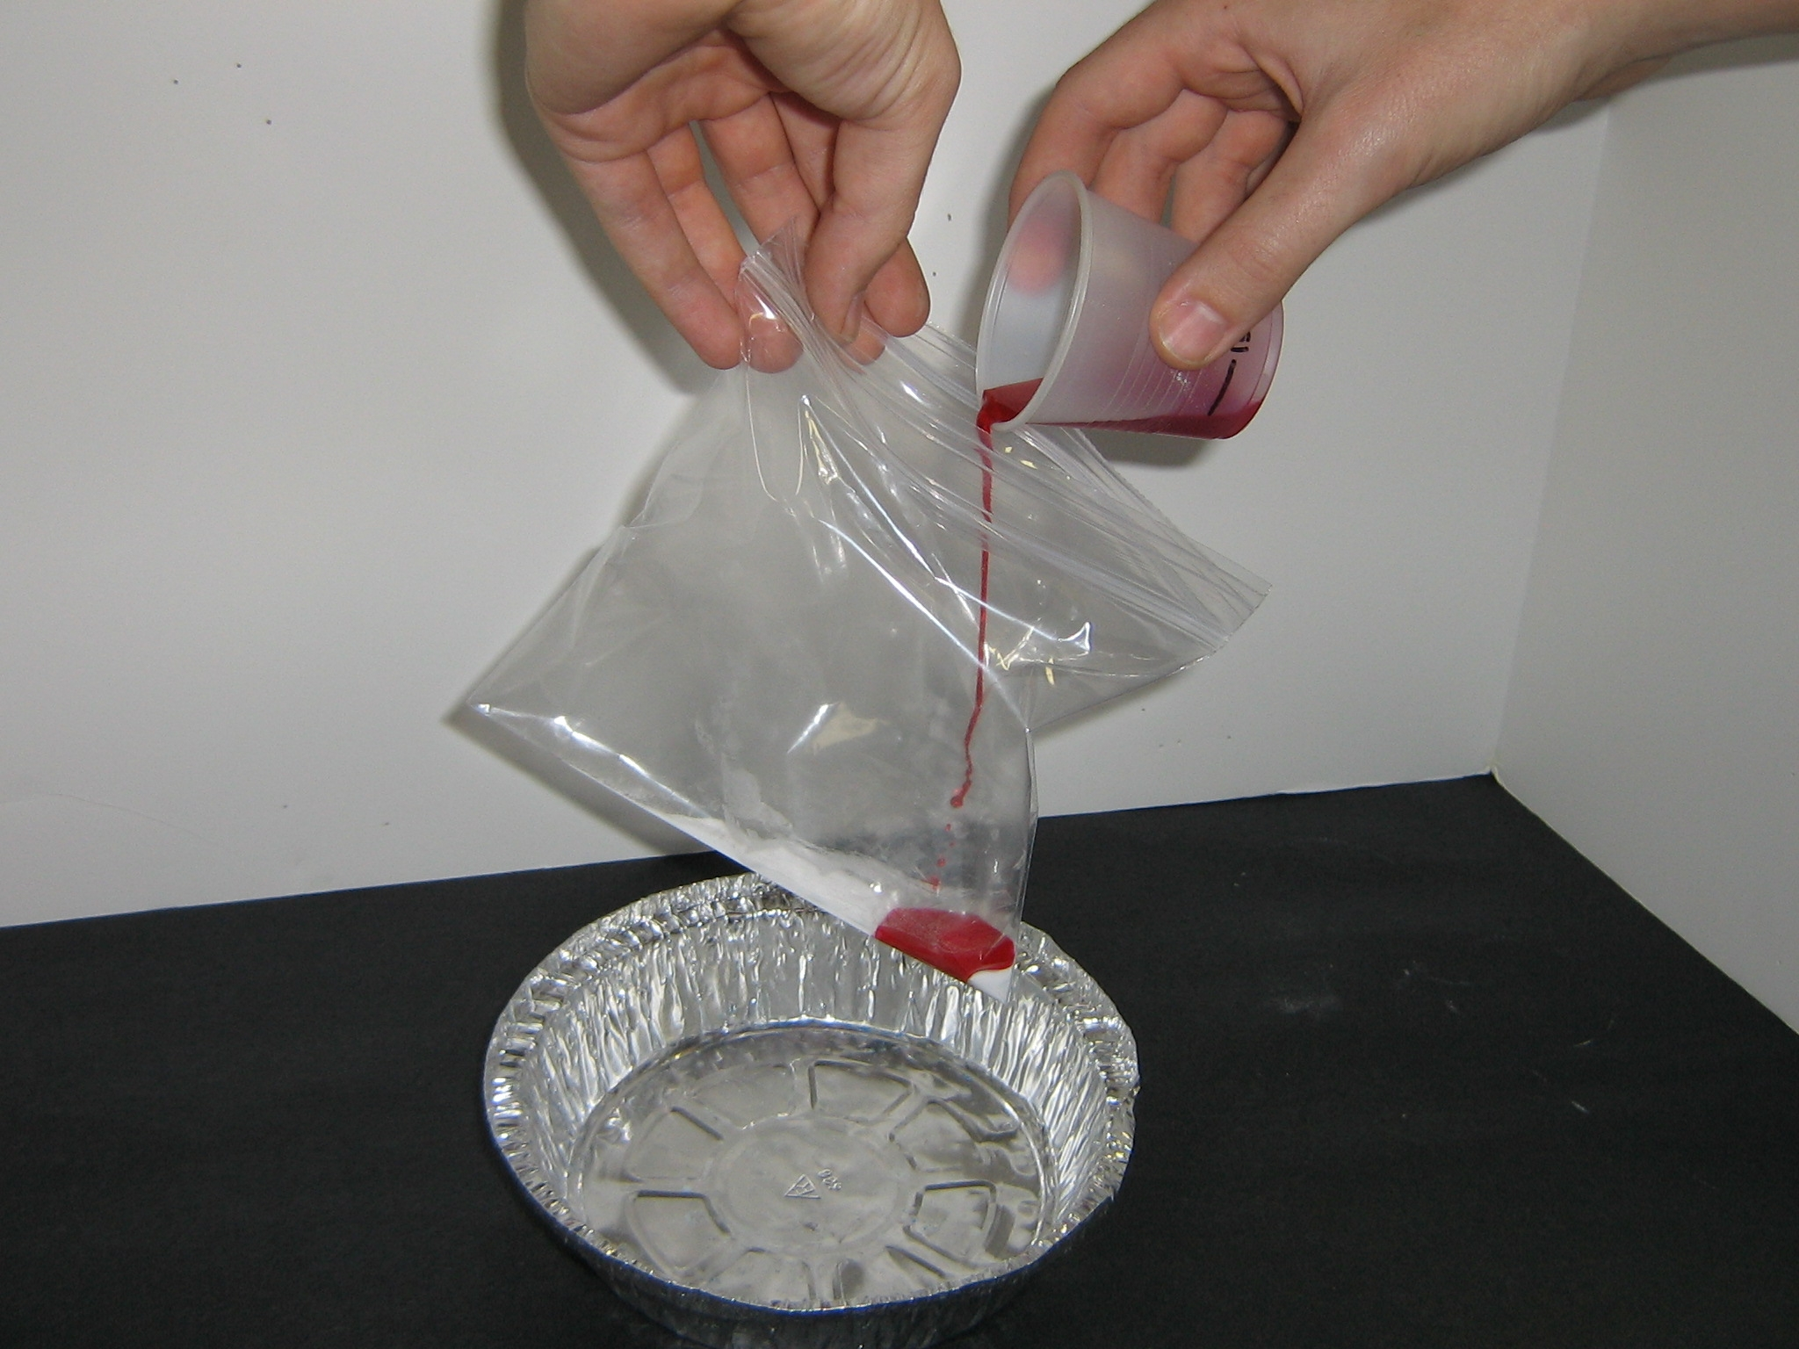
Tell students to:
- Hold the bag upright over the plate and add the 15 mL of phenol red solution to it.
- Seal the bag.
- Feel the bag (while keeping it upright) and record ALL observations about the color of the mixture and the temperature of the bag.
- Be ready to open the bag when a VSVS member comes to add a spoonful of anhydrous calcium chloride to the mixture.
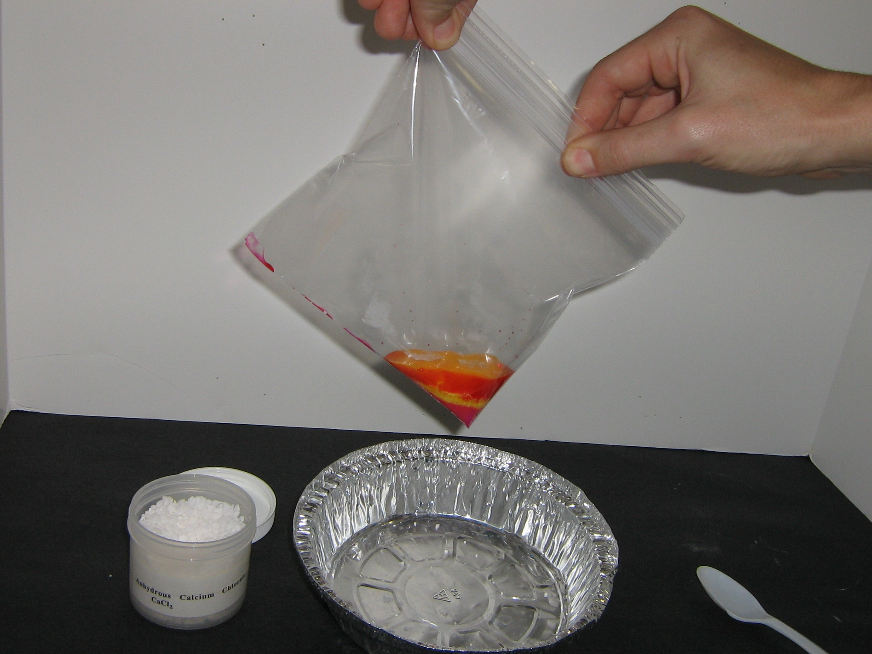
- Seal the bag as quickly as possible after the calcium chloride is added.
Keep the bag upright and sealed while gently shaking the bag back and forth to mix the contents.
- Observe what happens after the calcium chloride was
added – color changes, whether the bag is cold or warm (or both since there can be localized heating), foaming, gas given off, change in bag size, ...
- The reaction takes about three to five minutes.
During this time the student not holding the bag should write down any observations that the pair has made.

NOTE: There is no danger of the bag exploding if the correct amounts of chemicals are used. Since everything is pre-measured, you should have no problems. In the event one does explode or leak, use paper towels to clean up any mess. Assure the students that the chemicals are safe.

III. Observations and Explanations

Write student’s observations on the board. Possible student observations:
(1) When phenol red solution is added to the baking soda bag, it remains red.
(2) The bag feels cold.
(3) When the calcium chloride is added, the phenol red turns yellow. Students may feel a short-lasting warming while the anhydrous calcium chloride dissolves in water.
(4) The bag fills up with gas and continues to feel cold.

Explanation for students:
For purposes of your classroom discussion, you can mention the following points (Equations for the chemical reactions are for VSVS team information only.)
NOTE: This explanation is too complicated for the chemistry level of 5th grade students. Baking soda is sodium bicarbonate (NaHCO₃) and is weakly basic (pH of 8.4), and so the solution of phenol red indicator remains red when it is added to the baking soda.
HCO₃⁻ (aq) + HOH(l) → H₂CO₃ (aq) + OH⁻ (aq)
(Equilibrium reaction which produces 0.00025% OH⁻)
- Phenol red is an acid-base indicator which turns red in basic solution and yellow in acidic solution.
- The bag feels cold because baking soda absorbs heat when it dissolves in water.
- When the anhydrous calcium chloride is added to the ziploc bag, the mixture becomes warm at first because anhydrous calcium chloride gives off heat when it dissolves in water. (This may not be noticed because the bag is warm for a very short time.)
- The phenol red solution turns yellow which indicates an acidic solution. This happens because the calcium ion (Ca²⁺) reacts with the bicarbonate ion (HCO₃⁻) to form insoluble calcium carbonate and hydrogen ion (H⁺).
Ca²⁺ (aq) + HCO₃⁻ (aq) → CaCO₃ (s) + H⁺ (aq)
- The bag fills with carbon dioxide gas because the hydrogen ion formed in the reaction of calcium ion and bicarbonate reacts with remaining bicarbonate ion to give carbon dioxide gas. H⁺ (aq) + HCO₃⁻ (aq) → CO₂ (g) + H₂O (l)
This is similar to the reaction that happens when vinegar is added to baking soda.
- The bag continues to feel cold because heat is being absorbed.

Ask students: How can you tell when a chemical change has occurred?

Possibilities include: a gas given off, color change, temperature change, explosion, burning

Note: The 5th graders may not have covered this topic.
In that case, tell students what evidence to look for to determine if a chemical reaction occurs: a color change, a gas given off, temperature change, or the formation of a precipitate.

Ask the students what evidence for chemical changes did they observe in today’s experiment?

Answers: A color change; a gas given off; a temperature change.
Clean-up: The VSVS team should collect all ziploc bags and used cups and put them in the trash bag. Make sure the ziploc bags containing the reaction mixture are sealed before you put them in the trash bag. Return trash bag and kit to the VSVS lab.

IV. VSVS Background Information On Chemical Equations
The equations for the reactions that occur when anhydrous calcium chloride is added to the sodium bicarbonate solution are given below.

The bicarbonate ion (HCO₃⁻) is a weak acid and partially ionizes in solution.
HCO₃⁻ (aq) → H⁺ (aq) + CO₃ ²⁻ (aq) (1)

Calcium ion (Ca²⁺) from calcium chloride reacts with sodium bicarbonate to give insoluble calcium carbonate.
Ca²⁺ (aq) + CO₃ ²⁻ (aq) ↔ CaCO₃ (s) (2)

The removal of the carbonate ion from solution shifts the bicarbonate equilibrium (1) to the right, releasing more H⁺, which reacts with more HCO₃⁻ to produce CO₂ gas and H₂O.
H⁺ (aq) + HCO₃⁻ (aq) → CO₂ (g) + H₂O (l) (3)

The indicator changes color because the carbon dioxide dissolves in water to produce an acidic solution.
CO₂ (g) + H₂O (l) → H₂CO₃⁻ (aq) → H⁺ (aq) + HCO₃⁻ (aq) (4)

Reference: Fun With Chemistry, Vol. 1, 2nd ed.; Sarquis M., Sarquis, J., Eds.; Publ. 91-005; Institute for Chemical Education, University of Wisconsin: Madison, 1991; pp 147-153.

Adapted by: Dr. Melvin D. Joesten, Department of Chemistry, Vanderbilt University
Pat Tellinghuisen, Director of VSVS

