VANDERBILT STUDENT VOLUNTEERS FOR SCIENCE
http://studentorgs.vanderbilt.edu/vsvs
Beanie Baby™ Mystery
Spring 2006

Reference: “Beanie Baby™ Mystery” by Joe Neilly, Senior Microscopist at Abbott Laboratories. http://www.msa.microscopy.com/ProjectMicro/BeanieBabyMystery.html

Lesson adapted by Joe Lopez, Ph.D., Vanderbilt University

GOAL: To introduce younger students to the use of a microscope.

LESSON OUTLINE
I. Introduction
Tell the story of the missing Beanie Babies.
II. Explanation of Microscopy
Discuss how a microscope works and how it can be used to solve the mystery. Explain the proper use of a microscope and its parts.
III. Examining the Reference Slides
Give each student one of the instruction sheets. A VSVS team member will still need to give instructions, but the students can refer back to the instruction sheet as they are doing the experiments. You will still need to guide them through the procedures, making sure they understand the instructions.
Distribute reference slides and guide students through instruction sheets.
IV. Examining the Beanie Babies Students examine the Beanie Babies and compare their observations to their references.
V. Analysis and Wrap-Up
A representative from each group explains what they observed and how they solved their mystery.

Set-Up:
Make sure that each of the Beanie Babies has a sufficient amount of detergent sprinkled on its back. The students should be able to lift some of the detergent off the Beanie Baby using a piece of tape. If there is not enough detergent, sprinkle some of the detergent in 1 oz. cups onto the back of the Beanie Baby.
MATERIALS:
8 slide holders containing:
5 reference slides (oregano, flour, salt and pepper, sand, powdered laundry detergent) and 1 empty slide
16 handheld microscopes
8 30x microscopes
8 100x microscopes with stands
8 #1 ziploc bags containing
Beanie Baby™ with “mystery powder” on its back
1 bag containing
2 1 oz. containers of laundry detergent
8 rolls of Scotch tape
1 pencil per student (in class)
35 microscope sheets
35 observation sheets

I. INTRODUCTION
This lesson introduces students to the use of a low power microscope, as well as how to compare and classify materials. They will examine an unknown powder on the back of a Beanie Baby® and use their references to solve the mystery of “who borrowed the Beanie Baby.”

Who Borrowed the Beanie Baby™? by Joe Neilly, Senior Microscopist at Abbott Laboratories

Five Beanie Babies® that belonged to a second grade class mysteriously disappeared two nights ago. This morning they were returned but had some strange spots on them. All of the students like the Beanies. However, five students stayed in class after school the night the Beanies disappeared. They are suspects and might have borrowed the Beanie Babies®®. This is what the five students did after they left the classroom

The Clues by Joe Neilly, Senior Microscopist at Abbott Laboratories

- Mary helped her mom make spaghetti last night. Her mom uses lots of oregano in her spaghetti sauce.
- It was hot last night and Billy got to go to Nashville Shores with his friends.
- Sarah went to a restaurant with her parents. She likes the fancy salt and pepper shakers.
- Bobby’s brother was having a birthday last night so Bobby went to the bakery with his mom to pick up a special cake. There was lots of flour on the counters in the bakery.
- Jenny’s family’s washing machine was broken, so Jenny helped her sister take the laundry to the Laundromat.

II. INTRODUCTION TO MICROSCOPY
The microscope is a tool that many scientists use to observe and analyze things smaller than the human eye can see. There are different types of microscopes that are designed to view distinct specimens and at higher powers. For the purpose of this activity, the students will use hand-held microscopes to analyze their data. These are obviously different from microscopes used in laboratories and even in their classrooms. However, the purpose of this activity is to familiarize the students with how small things can be magnified with the use of a tool like this.

A. THE MICROSCOPE
The microscope used in this activity is different from those found in laboratories and
even those found in school classrooms. However, using these microscopes provides a good introduction for future use of more “professional” microscopes. The microscopes used in this activity differ from others in two ways:
1. There is no way to change objectives (go from one magnification to another). Students will use two different microscopes with different magnifications to learn the differences in the magnifications.
2. An 8x magnifying lens is attached to the 100x microscope.

The 100x magnifying glass has a stand to which slides can be attached. The 30x microscope does not; slides can just be placed on the desk with the microscope placed directly on top of it for viewing.

Distribute the microscope diagram handouts. Point out the following parts of the microscopes to the students:

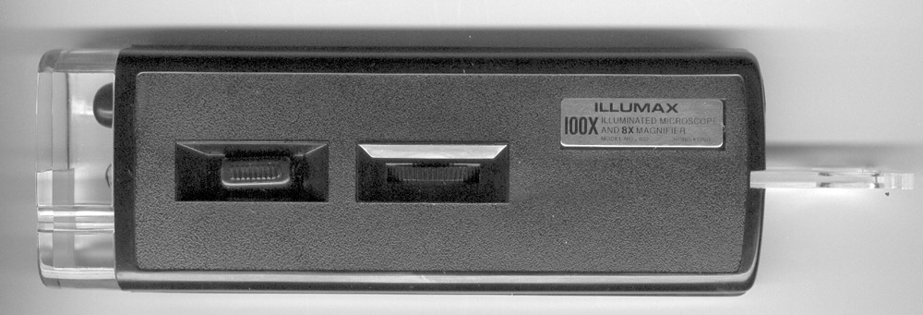
ocular
8x magnifier

light switch
focus adjustment knob

Ocular (eyepiece): opening through which objects are viewed; contains a lens that helps to magnify objects

Objective lens: located at the bottom of the microscope at the opening through which objects are viewed; together with the ocular lens, the objective lens magnifies what is being viewed

Light (point out the switch just below the focus adjustment knob): the light helps to view the magnified image of the object better; it is focused on the object with the help of the mirror just below the stand (when it is used)

Focus adjustment knob: this wheel can be adjusted on either side of the microscope; this focuses the image that is being magnified by raising and lowering the objective lens—in other microscopes, the adjustment functions by raising or lowering the stage
On laboratory microscopes, there are two knobs to adjust the focus: one for coarse adjustment (for large changes of focus) and one for find adjustment (for more precise changes of focus).

Stand (only on 100x microscope): this is comparable to a stage on other microscopes; the stand has stage clips that hold a slide in place under the objective

Point out the “100x” on the side of the microscope. Say that the 100x tells the magnification of the microscope (or the objective of a microscope). This means that an object viewed through the microscope will look 100 times larger than when it is viewed by the eyes alone.

B. USING THE MICROSCOPE
NOTE: When using the microscope, remember that the object that is being viewed
appears upside down.
1. Place the slide under the metal stage clips on the microscope stand.
2. Slide the light switch to turn on the light.
3. Look through the ocular lens and turn the focus adjustment knob until the object can be seen clearly.

C. USING THE 8x MAGNIFIER (only on the 100x microscope)
This magnifier functions like a hand lens; no additional light is needed.

The magnifier is located next to the ocular on the top of the microscope. Grasp both sides of the magnifier and slide the magnifier out of the case. Replace the magnifier by pushing it back into the case when finished.

III. SOLVING THE MYSTERY

REMIND THE STUDENTS TO TAKE CARE IN NOT DROPPING THE MICROSCOPE OR SLIDES AND TO KEEP THE MICROSCOPE AWAY FROM DUST OR DIRT.

TELL THE STUDENTS TO KEEP THEIR FINGERS AWAY FROM THE OCULAR LENS.

1. Divide the class into eight groups of four (3-5 are acceptable).

2. Pass out one set of reference slides to each group.

3. Pass out a lab sheet to every student.

4. Tell the students that they will be using their microscopes to make observations about the reference powders. They are to look for and describe the shape, size and color of the powders and note their observations on the lab sheet. There is also space on the lab sheet for them to draw a picture of what they see through the microscope.

The students should start looking at the powders using the 8x magnifier first. They can then use the 30x and 100x microscopes to see the differences in magnification of the powders. When they make their observations, also tell them to write down which magnification they used (8x, 30x, or 100x) when they drew their picture.

The students will probably get the most information from using the 30x microscope. The point of using the 100x microscope is to familiarize the students with using the microscope and also to show that the 100x objective is stronger than the 30x.

The powders are more easily examined with the slides tape-side down.

5. Tell the students that this part of the activity will help them to solve the mystery.

6. After they have finished filling out their worksheets, give the groups a Beanie Baby® with the mystery powder on its back. Tell them that they will use the microscope to identify the powder and solve the mystery.

7. Tell the students to take a piece of tape and carefully lift off some of the mystery powder off the Beanie Baby with the sticky side of the tape. They should be careful not to touch the sticky side, as doing so may leave fingerprints on the tape.

8. Tell the students to then place the tape onto the empty slide with the powder over the clear circle of the slide. This will allow them to better analyze the sample under the microscope.

IV. DISCUSSION

The powder on the Beanie Babies’ backs is powdered laundry detergent. Jenny thought that the Beanie Babies needed to see the world outside the classroom and took them out for a night on the town.

Remind the students about the parts of the microscopes that they used. Ask how differently the powders appeared when they viewed them using different magnifications.

Beanie Baby™ Mystery Student Lab Worksheet

Name _______________________________________________

Name of Beanie Baby: __________________

Powder:  Which microscope did you use?  What does it look like? | Draw Picture Here
Powder:  Which microscope did you use?  What does it look like? | Draw Picture Here
Powder:  Which microscope did you use?  What does it look like? | Draw Picture Here
Powder:  Which microscope did you use?  What does it look like? | Draw Picture Here
Powder:  Which microscope did you use?  What does it look like? | Draw Picture Here
Powder:  Which microscope did you use?  What does it look like? | Draw Picture Here

What is the mystery powder on the Beanie Baby? ____________________

Who borrowed this Beanie Baby? ______________________

Microscopes

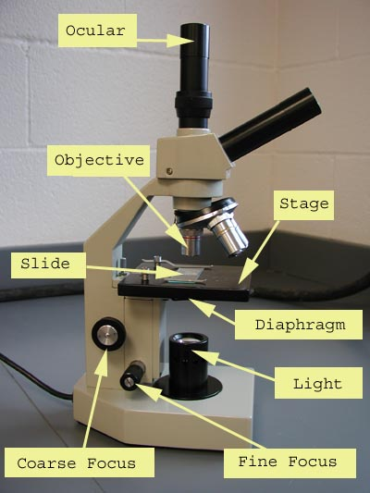

A typical microscope used in a laboratory or classroom

ocular
8x
magnifier
light switch
focus
adjustment
knob

Microscope used to solve the Beanie Baby™ Mystery
ANSWER SHEET
Beanie Baby Mystery™ Student Lab Worksheet

Name of Beanie Baby:

Powder: Salt and pepper  Which microscope did you use? 30x  What does it look like? Small, clear cubic crystals (salt), dark square-like pieces (pepper) | Draw Picture Here  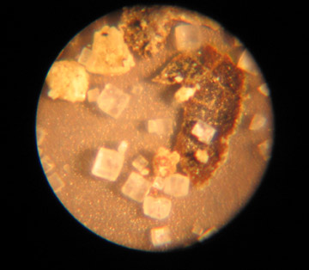
Powder: Flour  Which microscope did you use? 30x  What does it look like? Very small white grains,  almost “fluffy” in appearance | Draw Picture Here  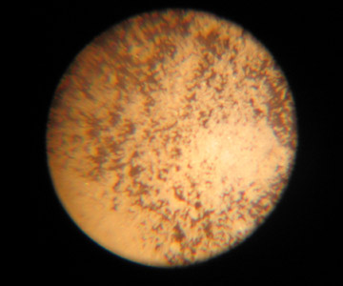
Powder: Oregano  Which microscope did you use? 30x  What does it look like? Plant-like, irregularly  shaped; has many small hairs | Draw Picture Here  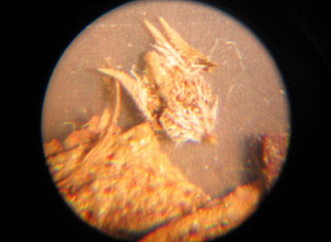
Powder: Laundry detergent  Which microscope did you use? 30x  What does it look like? Small white rocks, although  not as crystal-like as the salt. Larger than  the flour. Whiter than the sand. | Draw Picture Here  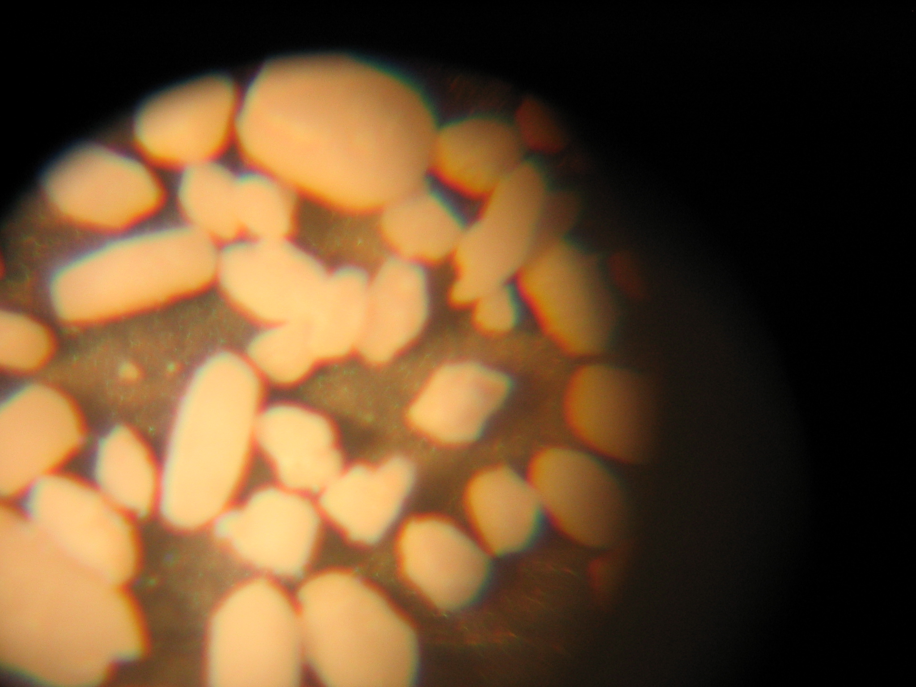
Powder: Sand  Which microscope did you use? 30x  What does it look like? Larger clear crystals,  somewhat brown in appearance | Draw Picture Here  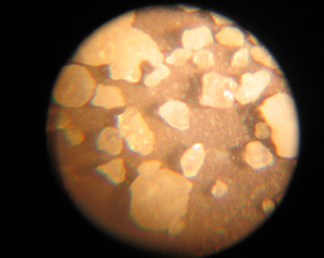
Powder:  Which microscope did you use?  What does it look like? | Draw Picture Here

What is the mystery powder on the Beanie Baby? Laundry detergent

Who borrowed this Beanie Baby? Jennie

