19 Shares
FacebookTweetParlerEmail
RELATED
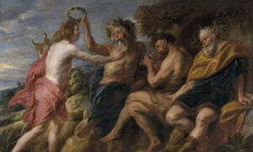
The Asses’ Ears of Modernism and Post-Modernism
4
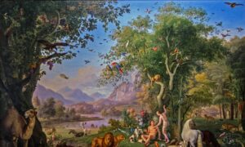
All Good in the Garden
8
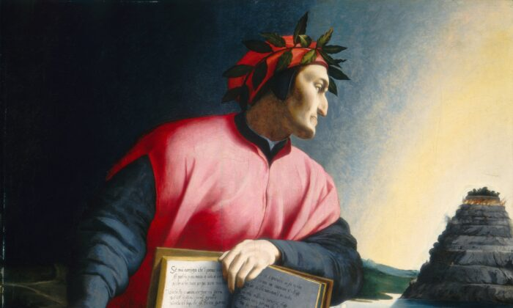
Dante shows us a way beyond hell to purgatory. Detail from an allegorical portrait of Dante Alighieri, late 16th century, by an unknown master. National Gallery of Art. (Public Domain)
TRADITIONAL CULTURE

More Dante Now, Please! (Part 1): How Dante Provokes Thinking
BY JAMES SALE

October 19, 2020 Updated: October 19, 2020

Print
Recently, a top American academic at a highly prestigious American university dropped me a line and said, “The universities are dying.” I wouldn’t know personally whether this is true, since I have never attended an American university, and I don’t live in the United States. But his words resonated with me, because it is certainly true in the UK.
Perhaps the science, the technology, and the medical faculties are swimming along swimmingly in their own self-congratulatory way—very happy with themselves as they still attract grants and support, and most importantly, as they are led to believe what clever boys and girls they are—the cream of intellectual achievement, in fact. But this is really a serious distortion of what education is about.
Science, for example, tells us “how” things are but not so much about the “what” and, preeminently, the “why.” The “why things” are far more important than “how” they are; this is not to say that “how” is not important, but “why” encompasses ultimate questions such as our purpose. Science and technology, without true purpose, are not beneficial to humanity but dangerous.
To find out about the why, we need to revisit the humanities and their various faculties, which is, of course, where the dying is happening.
Here’s an insight: Between the ages of 7 and 10, my youngest son, Joseph, was a Harry Potter fanatic; and through “Harry Potter,” his reading skills and his imaginative capabilities advanced immensely. But it was a bit of a surprise when he was 18 (in 2011), and he looked at prospective universities and found one in the UK offering an English degree—with “Harry Potter” studies as a key component! How proud the university was of its right-on, contemporary, non-elitist approach to literature. And how sad it must be for that university now when the only proper response, apparently, to a J.K. Rowling book is to burn it for its author’s insensitive view that being a woman means being a woman.
J.K. Rowling accepting a 2019 Robert F. Kennedy Human Rights award in New York City. She has since returned the award. (Bennett Raglin/Getty Images for Robert F. Kennedy Human Rights)
All this brings me to the basic point that unless we get serious about understanding what great thinking looks like—found in works by theologians, philosophers, writers, and poets—we as a civilization are going to fall. The falling will be into the stealth ideologies—equality, diversity, woke-ism—all underpinned by a virulent form of Marxism, and the end of all true values as we know and love them.

What Great Thinking Looks Like
If we narrow great thinking down to an area that I am personally excited by, it would be to say: Every child should be exposed at continual points in their education to good, great, and the greatest literature. Indeed, as adults, the need to experience more than just bestsellers and pap is also of paramount importance if we are to continue to grow as human beings and as citizens.
What constitutes great literature is not contemporary books full of politically correct, woke memes and themes with all their self-congratulating virtue signaling and superiority. These are the equivalent of fast food, only less nutritious. Classic texts are not defined by patriarchal, white, middle-class males; on the contrary, they emerge from cultures because the people in a culture have thought long and hard about the text and have found that whenever they return to it, there is more value to be had: more entertainment, more ideas, more learning, more beauty, and—dare I say it?—more transcendence. The great classic speaks to the deepest parts of human nature and usually points to some divinity beyond it.
A great example of the literature I have in mind would be Dante’s “Divine Comedy,” a work of overarching genius. As far as the Western canon is concerned, only half a dozen works or so might be compared with it.
Let’s be clear too. There’s nothing wrong with a Western canon, especially if it be subject to lively debate and revision. It was English writer Dr. Samuel Johnson writing in his “Preface” to “The Plays of William Shakespeare” who put the matter most succinctly: “What mankind have long possessed they have often examined and compared, and if they persist to value the possession, it is because frequent comparisons have confirmed opinion in its favor. As among the works of nature no man can properly call a river deep or a mountain high, without the knowledge of many mountains and many rivers; so in the productions of genius, nothing can be styled excellent till it has been compared with other works of the same kind … What has been longest known has been most considered, and what is most considered is best understood.”
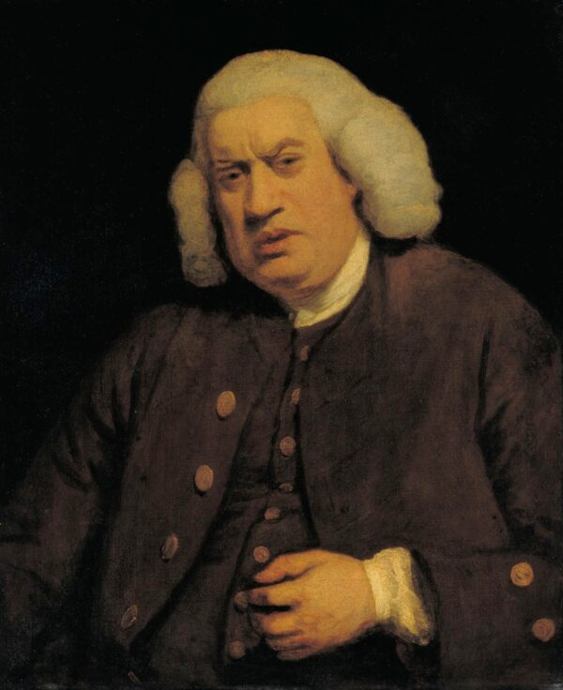A portrait of man of letters Samuel Johnson, circa 1772, by Sir Joshua Reynolds. (Public Domain)
And the thing is, Dante’s “Divine Comedy” is not a dry-as-dust, academic book that we might politely applaud for its scholarship, or some politically correct parable extolling utopian virtues fit for utopian futures that will never be. (But, heck! Why not indoctrinate children with it anyway?) Rather, “The Divine Comedy” is as gripping a story as one could ever read: a journey down to Hell, up through Purgatory, and pressing on to Heaven itself. Even one canto of the 100 that constitute the whole poem is full of surprise, mystery, emotion, mythology, philosophy, and much more, including, especially, what we all want to know about—people, their predicaments, and their conditions, all sorts of them.
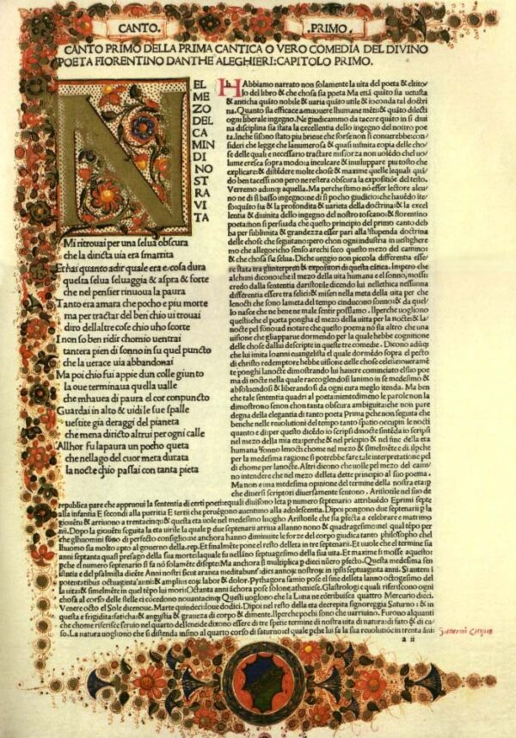Even just one canto from Dante’s masterpiece the “Divine Comedy” is full of mystery and emotion. Canto I from the “Inferno,” the first part of the “Divine Comedy.” (Public Domain)

The Nature of Reality
The “Divine Comedy” is a work that explores the very nature of reality. As professor William Franke observes in his brilliant book “Dante’s Interpretive Journey,” understanding reality is never easy; it is something that each person must struggle with. The “Divine Comedy” is not some work of Catholic propaganda. Dante is constantly inviting the reader to interpret the meaning of what is going on for him or herself. And it’s not: Here’s the truth; take it or leave it. On the contrary, the text questions itself and invites you, the reader, to do exactly the same. How stimulating might that be for a late secondary school student, never mind an adult?
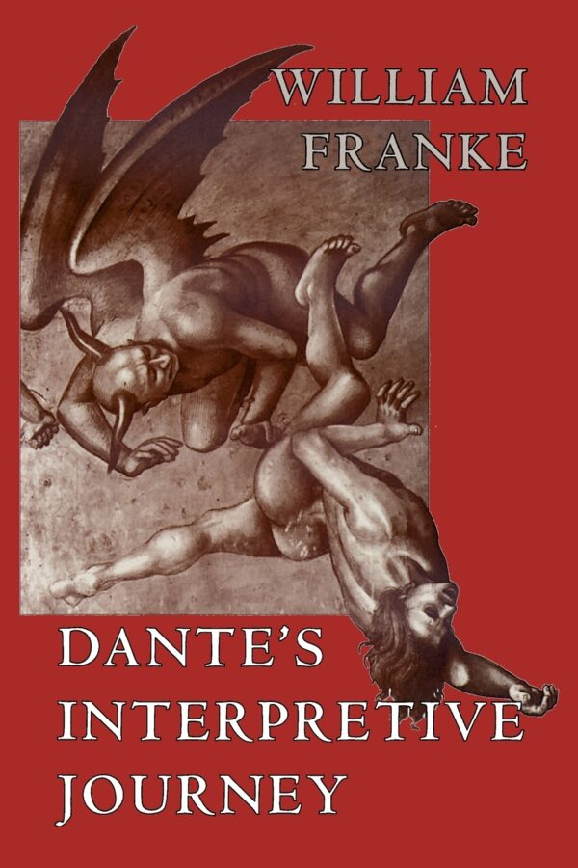Professor William Franke’s book offers illuminating insights into Dante’s work.
A couple of examples might help clarify what I mean here. The primary problem of the whole poem is whether it is literally true, for Dante claims it is. What are we to make of this work: Is it just a work of art—of artifice—or did Dante really go to hell and beyond, as he claims? Is he a visionary or a prophet of God? How can we know how to decide these claims?
Or take another example that I am particularly fond of, and which Franke explores in his book: How is it that Dante, on the one hand, refers to and dismisses the ancient and pagan gods as lying and false, and on the other, invokes Calliope and Apollo as his muses to inspire him on his journey?
With these questions, we come down to exploring the fundamental question of what truth is, and how true this account of Dante’s journey is.
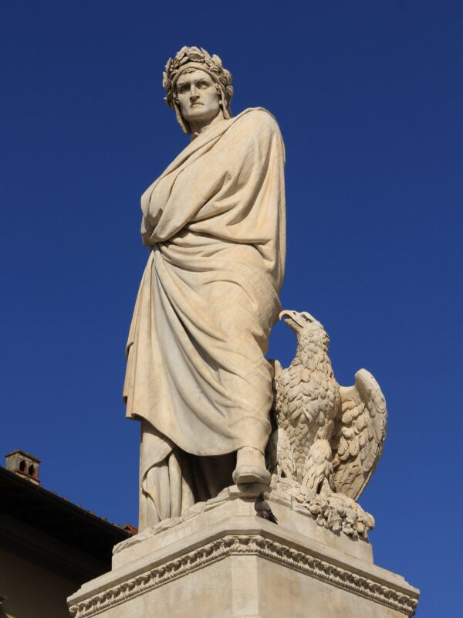A statue of Dante Alighieri, 1865, by Enrico Pazzi, next to Santa Croce church in Florence, Italy. (Jörg Bittner (Unna) / CC BY-SA 3.0)

Big Topics Versus Virtue-Signaling Memes
These are big topics, but young people like big topics, don’t they? Surely, this is the kind of book to inspire curiosity, engender wonder and amazement, and provide intellectual ballast for the rest of one’s life! But I hope, too, it is obvious that this mode of thinking is a million light-years away from the certain certainties of woke thinking and political correctness.
In woke culture, the truth is always black and white, quite literally: black people good, white people bad; women good, men bad; freedom (aka: license) good, authority bad; liberal good, conservative bad; and so on. These self-evident truths are of course far from self-evident, but clearly so many people have now lost their ability to think—that is, to “discriminate” in the true meaning of that word—that they fall in with these mindless memes.
We are now literally in the 700th year since the passing of Dante Alighieri. He died on Sept.13, 1321, and so next year we need to celebrate this giant in the world of poetry and philosophy. What, however, in the meantime might be the biggest single contribution of Dante’s poetry to our world now?
The answer, I think, is the issue of the freedom of the will and its fatal opposite, determinism. We’ll be looking at this in part 2 of this article and seeing how this is explored in Dante’s three worlds, and how in our society now, we are experiencing the disbelief in free will being worked out—disastrously.
James Sale is an English businessman whose company, Motivational Maps Ltd., operates in 14 countries. He is the author of over 40 books on management and education from major international publishers including Macmillan, Pearson, and Routledge. As a poet, he won the first prize in The Society of Classical Poets’ 2017 competition and spoke in June 2019 at the group’s first symposium held at New York’s Princeton Club.

