Supplemental Appendix 1. Technical details regarding prior choices for the Bayesian SEM.

Regression effects. For all regression effects relating predictors to IQUAL2, priors were Normal distributions. The center of the distribution was chosen according to findings from past research. Dispersion was chosen following the recommendation of Smid et al. (2018) to define the impossible parameter space – parameter values that cannot occur given the scales of the variables. The indicators of the dependent variable, IQUAL2, ranged from 1-7, meaning it was impossible for the effect of any predictor to be <–6 or >6. We thus specified a standard deviation of 2 for these priors. Therefore, 99.7% of the distribution (i.e., +/– 3 standard deviations) lay between -6 and 6, the bounds of the possible parameter space for all regression effects. The chosen prior for the effect of experimental condition on IQUAL2 was Normal(0, 2).
We followed a similar approach in specifying priors for the effects of the covariates on IQUAL2. We expected IQUAL1 to exert a strong positive effect on IQUAL2, given past findings that parent-child interaction quality tends to persist across time (Hoff, 2006; Hoff-Ginsberg, 1991); therefore, we chose a center of d = 0.6 for this prior. For parents’ perception of play, as well as perceived role in child development, we expected weak positive effects based on prior research (Fogle & Mendez, 2006; Hembacher & Frank, 2020; Strouse et al., 2019; Wooldridge & Shapka, 2012), and centered these priors at d = 0.1. We expected parent’s perception of co-use with digital media and overall positive perception of digital media to have moderate positive effects based on past work (Nathanson, 2001; Strouse et al., 2019; Vaala & Takeuchi, 2012; Wood et al., 2016), and therefore centered these priors at d = 0.3.
Factor loadings. For the factor loadings relating IQUAL1 and IQUAL2 to their indicators, we also specified informative priors. We again used Normal distributions, which are recommended for factor loadings (Merkle et al., 2020). Each prior was centered at 1 to reflect our expectation of strong correspondence between each indicator and the latent variable; previous studies have reported strong relationships between various pairings of the indicators (Ensor et al., 2011; Hindman & Morrison, 2012; Hirsh-Pasek et al., 2015; Mathis & Bierman, 2015; Romeo et al., 2018). Given the consistency of these results, we set the standard deviation of each prior to 5 (rather than the default 10 in blavaan) to reflect greater certainty that factor loadings would be strong.
Other parameters. We maintained the default priors in blavaan for all latent variable intercepts (N(0,10)), observed variable intercepts (N(0,32)), covariances (Beta(1,1)), and variances (Gamma(1, 0.5)).

Supplemental Table 1. Demographic Details by Condition Group.
 | Control  M (SD) | Experimental  M (SD)
Age in years  Parent  Child  Parent-child dyads  Gender (Male/Female)  Parent  Child  Recruitment location  Southern US  Midwestern US  Western US  Northeast US  Canada | 36.15 (7.07)  4.45 (0.34)  N (%)  39  4/35  20/19  33 (84.6%)  2 (5.1%)  3 (7.7%)  1 (2.6%)  0 (0.0%) | 35.45 (6.74)  4.31 (0.31)  N (%)  38  2/36  20/18  25 (65.8%)  8 (22.2%)  4 (10.5%)  0 (0.0%)  1 (2.6%)
Parent Education Level  Less than a 4-year degree  4-year College Degree  Professional or Graduate Degree  Did not report | 4 (10.3%)  14 (35.9%)  21 (53.8%)  0 (0.0%) | 4 (10.5%)  13 (34.2%)  20 (52.6%)  1 (2.6%)
Child Racial/Ethnic Identity  European American  African American  Hispanic/Latino  Asian  Other Race (not listed)  Multiple races reported  Did not report | 29 (74.4%)  0 (0.0%)  0 (0.0%)  0 (0.0%)  1 (2.6%)  9 (23.1%)  0 (0.0%) | 29 (76.3%)  1 (2.6%)  1 (2.6%)  2 (5.3%)  0 (0.0%)  4 (10.5%)  1 (2.6%)
Household Income  Under $15,000-$45,000  $45,000-$75,000  $75,000-$105,000  $105,000-$150,000  Above $150,000 | 0 (0.0%)  8 (20.5%)  3 (7.7%)  15 (38.5%)  13 (33.3%) | 2 (5.3%)  4 (10.5%)  11 (28.9%)  12 (31.6%)  9 (23.7%)

Supplemental Table 2. OK Play Activity Descriptions.
Activity type | Example Activity | General Activity Format | Is co-play prompted during the activity?
Drawing | Grow a Flower, Submarine, Ice Cream, Dance, Hug, etc. | Taking pictures, using different colors to fill in shapes, to produce a story | Yes ("Pass it to a partner.") However, not required to complete the activity
How to | How to Make an Angry Emergency, Tell a Tale, Bust A Move, etc. | How-to guides for crafts and other activities | Yes. Parents must read the instructions
Stories | Doggy Art Show, Treehouse Club,  Haha Haircuts, I ♥ Candy, etc. | Create own story with drawings, pictures, songs | No
Scavenger Hunt | Give a Gift, Museum of Emotions, Fruit Emergency, etc. | Taking pictures of objects on a list | No
Book Maker | Animal Babysitter, Hero vs. Villain, Plan a Party, etc. | Recording sounds/words (similar to Mad libs) | No
Movie Maker | Question Time, Cooking Up!, Emotion Update, etc. | Recording videos | No
Music Maker | Hand Washing Song, Angry Song, Sound Bath, etc. | Recording singing and sounds | No
Sparks | Silly Word Club, Spread Joy, Mapa's Circle-Pizza, Goodnight Hike, etc. | Stories that can be paused for conversation about the reading | No
Breathing Toys | Birthday Cake, Balloons, Sunrise, Ferris Wheel, etc. | Themed breathing exercises | No

Supplemental Table 3. Prior distributions chosen for the Bayesian SEM.
Parameter | Prior | Description
Regressions
IQUAL2 on Experimental Group | Normal(0, 2) | Informative
IQUAL2 on IQUAL1 | Normal(0.6, 2) | Informative
IQUAL2 on Digital Media Involvement | Normal(0.3, 2) | Informative
IQUAL2 on Play as Learning | Normal(0.1, 2) | Informative
IQUAL2 on Role in Child Development | Normal(0.1, 2) | Informative
IQUAL2 on Positive Digital Media Beliefs | Normal(0, 2) | Informative
IQUAL2 on Time Spent with App Nudges* | Normal(0.1, 2) | Informative
Factor Loadings
All | Normal(1, 5) | Informative
Covariances
All | Beta(1, 1) | blavaan default (weakly informative)
Latent Variable Intercepts
All | Normal(0, 10) | blavaan default (weakly informative)
Observed Variable Intercepts
All | Normal(0, 32) | blavaan default (weakly informative)
Variances
All | Gamma(1, 0.5) | blavaan default (weakly informative)
Note. Normal distribution is described as N(Mean, SD).
*Time spent with app nudges was included as a predictor in a separate model run only on participants in the experimental group.
Supplemental Table 4. Prior distributions used in sensitivity analysis.
Parameter | Informative (used in original model) | Weakly informative (blavaan defaults) | Noninformative/ diffuse
Regressions
IQUAL2 on Experimental Group | Normal(0, 2) | Normal(0, 10) | Normal(0, 1000)
IQUAL2 on IQUAL1 | Normal(0.6, 2) | Normal(0, 10) | Normal(0, 1000)
IQUAL2 on Digital Media Involvement | Normal(0.3, 2) | Normal(0, 10) | Normal(0, 1000)
IQUAL2 on Play as Learning | Normal(0.1, 2) | Normal(0, 10) | Normal(0, 1000)
IQUAL2 on Role in Child Development | Normal(0.1, 2) | Normal(0, 10) | Normal(0, 1000)
IQUAL2 on Positive Digital Media Beliefs | Normal(0, 2) | Normal(0, 10) | Normal(0, 1000)
IQUAL2 on Time Spent with App Nudges* | Normal(0.1, 2) | Normal(0, 10) | Normal(0, 1000)
Factor Loadings
All | Normal(1, 5) | Normal(0, 10) | Normal(0, 1000)

Note. In all models, weakly informative (blavaan default) priors were used for all covariances (Beta(1, 1)), latent variable intercepts (Normal(0, 10)), observed variable intercepts (Normal(0, 32)), and variances (Gamma(1, 0.5)).

Supplemental Table 5. Full results from the Bayesian SEM.
Parameter | Posterior mean | Posterior SD | HPDI | Gelman-Rubin Statistic
Regressions
IQUAL2 on Experimental Group | 0.015 | 0.096 | [-0.174, 0.205] | 1.000
IQUAL2 on IQUAL1 | 0.699 | 0.097 | [0.528, 0.887] | 1.002
IQUAL2 on Digital Media Involvement | 0.067 | 0.038 | [-0.007, 0.142] | 1.000
IQUAL2 on Play as Learning | 0.015 | 0.133 | [-0.245, 0.281] | 0.999
IQUAL2 on Role in Child Development | -0.022 | 0.171 | [-0.345, 0.319] | 0.999
IQUAL2 on Positive Digital Media Beliefs | -0.068 | 0.044 | [-0.158, 0.018] | 1.001
Factor Loadings
IQUAL2 to Positivity Composite (t2) | 1.000 | -- | -- | --
IQUAL2 to Conversation Connectedness (t2) | 1.116 | 0.163 | [0.819, 1.462] | 1.001
IQUAL2 to Coordinated Joint Engagement (t2) | 0.956 | 0.173 | [0.628, 1.333] | 1.002
IQUAL2 to Mutuality Composite (t2) | 1.093 | 0.113 | [0.888, 1.334] | 1.003
IQUAL1 to Positivity Composite (t1) | 1.000 | -- | -- | --
IQUAL1 to Conversation Connectedness (t1) | 0.829 | 0.144 | [0.551, 1.110] | 0.999
IQUAL1 to Coordinated Joint Engagement (t1) | 0.725 | 0.145 | [0.435, 1.012] | 1.001
IQUAL1 to Mutuality Composite (t1) | 1.022 | 0.069 | [0.896, 1.162] | 1.000
Covariances
IQUAL1 with Dig Med Inv  IQUAL1 with Play as Learning | 0.065  0.072 | 0.123  0.036 | [-0.179, 0.312]  [0.007, 0.148] | 1.002  1.000
IQUAL1 with Role in Child Dev | 0.045 | 0.026 | [-0.002, 0.100] | 1.000
IQUAL1 with Pos Dig Med Beliefs | 0.105 | 0.108 | [-0.104, 0.329] | 1.001
Dig Med Inv with Play as Learning | 0.241 | 0.095 | [0.072, 0.441] | 1.002
Dig Med Inv with Role in Child Dev | 0.029 | 0.066 | [-0.101, 0.158] | 1.002
Dig Med Inv with Pos Dig Med Beliefs | 1.462 | 0.327 | [0.887, 2.173] | 1.001
Play as Learning with Role in Child Dev | 0.074 | 0.021 | [0.038, 0.119] | 1.001
Play as Learning with Pos Dig Med Beliefs | 0.182 | 0.078 | [0.043, 0.352] | 1.003
Role in Child Dev with Pos Dig Med Beliefs | 0.038 | 0.055 | [-0.069, 0.147] | 1.001
Variances
IQUAL1 | 0.393 | 0.083 | [0.260, 0.583] | 1.002
IQUAL2 (residual) | 0.142 | 0.035 | [0.085, 0.219] | 1.001
Pos Dig Med Beliefs | 2.160 | 0.352 | [1.559, 2.945] | 1.000
Role in Child Dev | 0.114 | 0.020 | [0.082, 0.160] | 1.001
Play as Learning | 0.217 | 0.037 | [0.158, 0.301] | 1.002
Dig Med Inv | 2.994 | 0.481 | [2.188, 4.050] | 1.000
Mutuality T1 (residual) | 0.011 | 0.012 | [0.000, 0.044] | 1.000
Coordinated T1 (residual) | 0.520 | 0.088 | [0.376, 0.713] | 0.999
Connectedness T1 (residual) | 0.577 | 0.102 | [0.416, 0.816] | 1.000
Positivity T1 (residual) | 0.098 | 0.020 | [0.059, 0.142] | 1.001
Mutuality T2 (residual) | 0.078 | 0.029 | [0.025, 0.142] | 1.001
Coordinated T2 (residual) | 0.048 | 0.084 | [0.342, 0.672] | 0.999
Connectedness T2 (residual) | 0.405 | 0.080 | [0.273, 0.582] | 1.000
Positivity T2 (residual) | 0.157 | 0.034 | [0.100, 0.234] | 0.999

Supplemental Table 6. Results from sensitivity analysis.
Parameter | Estimate [HPDI] from original model (informative) | Estimate [HPDI] using blavaan defaults  (weakly informative) | Estimate [HPDI] using diffuse priors (noninformative)
Regressions
IQUAL2 on Experimental Group | 0.015 [-0.174, 0.205] | 0.014 [-0.171, 0.197] | 0.016 [-0.174, 0.206]
IQUAL2 on IQUAL1 | 0.699 [0.528, 0.887] | 0.697 [0.510, 0.895] | 0.698 [0.519, 0.879]
IQUAL2 on Digital Media Involvement | 0.067 [-0.007, 0.142] | 0.066 [-0.003, 0.141] | 0.065 [-0.007, 0.139]
IQUAL2 on Play as Learning | 0.015 [-0.245, 0.281] | 0.017 [-0.239, 0.267] | 0.019 [-0.242. 0.285]
IQUAL2 on Role in Child Development | -0.022 [-0.345, 0.319] | -0.012 [-0.347, 0.351] | -0.025 [-0.371, 0.329]
IQUAL2 on Positive Digital Media Beliefs | -0.068 [-0.158, 0.018] | -0.067 [-0.153, 0.020] | -0.066 [-0.153, 0.020]
Factor Loadings
IQUAL2 to Positivity Composite (t2) | 1.000 | 1.000 | 1.000
IQUAL2 to Conversation Connectedness (t2) | 1.116 [0.819, 1.462] | 1.117 [0.809, 1.455] | 1.120 [0.826, 1.459]
IQUAL2 to Coordinated Joint Engagement (t2) | 0.956 [0.628, 1.333] | 0.958 [0.643, 1.306] | 0.9645 [0.636, 1.308]
IQUAL2 to Mutuality Composite (t2) | 1.093 [0.888, 1.334] | 1.098 [0.887, 1.330] | 1.095 [0.888, 1.342]
IQUAL1 to Positivity Composite (t1) | 1.000 | 1.000 | 1.000
IQUAL1 to Conversation Connectedness (t1) | 0.829 [0.551, 1.110] | 0.833 [0.552, 1.124] | 0.832 [0.548. 1.119]
IQUAL1 to Coordinated Joint Engagement (t1) | 0.725 [0.435, 1.012] | 0.728 [0.459, 1.027] | 0.732 [0.464, 1.023]
IQUAL1 to Mutuality Composite (t1) | 1.022 [0.896, 1.162] | 1.023 [0.890, 1.166] | 1.026 [0.893, 1.174]
Note. All estimates are unstandardized. HPDI = Highest Posterior Density Interval.

Supplemental Table 7. Results from Regression Analysis Predicting Time Spent with Nudges.

Predictor | Beta | S.E. | t | p-value
Intercept | 6.01 | 17.67 | 0.34 | 0.74
Digital Media Positive Beliefs | 0.09 | 0.84 | 0.11 | 0.91
Perceived Parent Role | 2.73 | 2.91 | 0.94 | 0.35
Play as Learning | -3.09 | 2.39 | -1.29 | 0.21
Digital Media Parent Involvement | 0.44 | 0.67 | 0.66 | 0.51

Supplemental Figure 1. Presence of co-play across games and experimental groups at pre- and post-test.
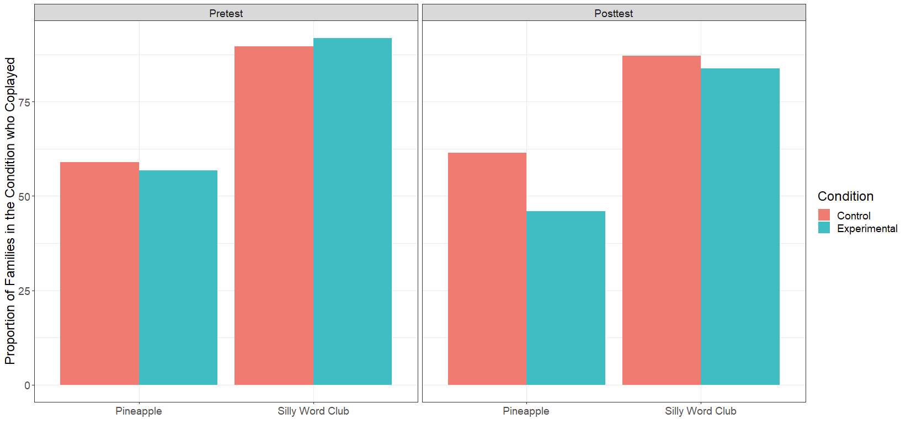

Supplemental Figure 2. Posterior density plots for regression estimates from full Bayesian SEM.

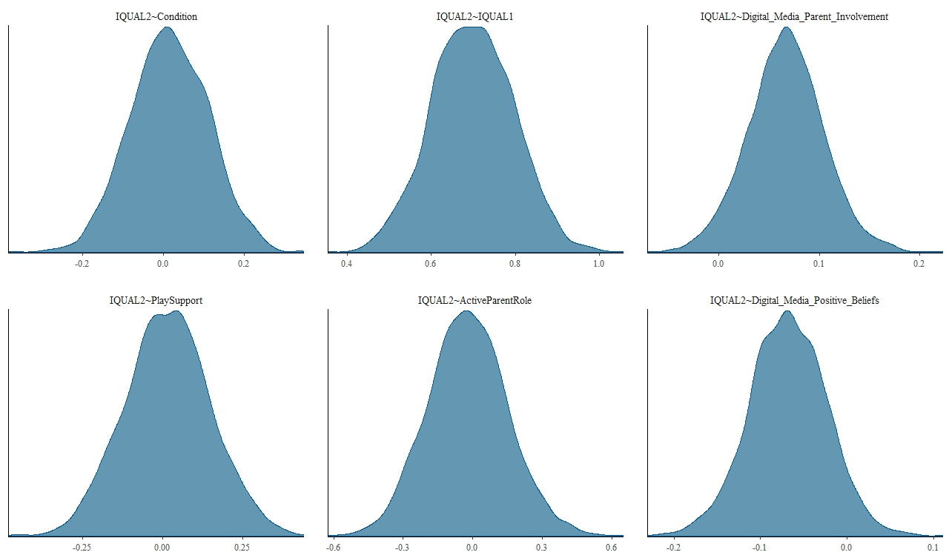

Supplemental Figure 3. Trace plots for regression estimates from full Bayesian SEM.

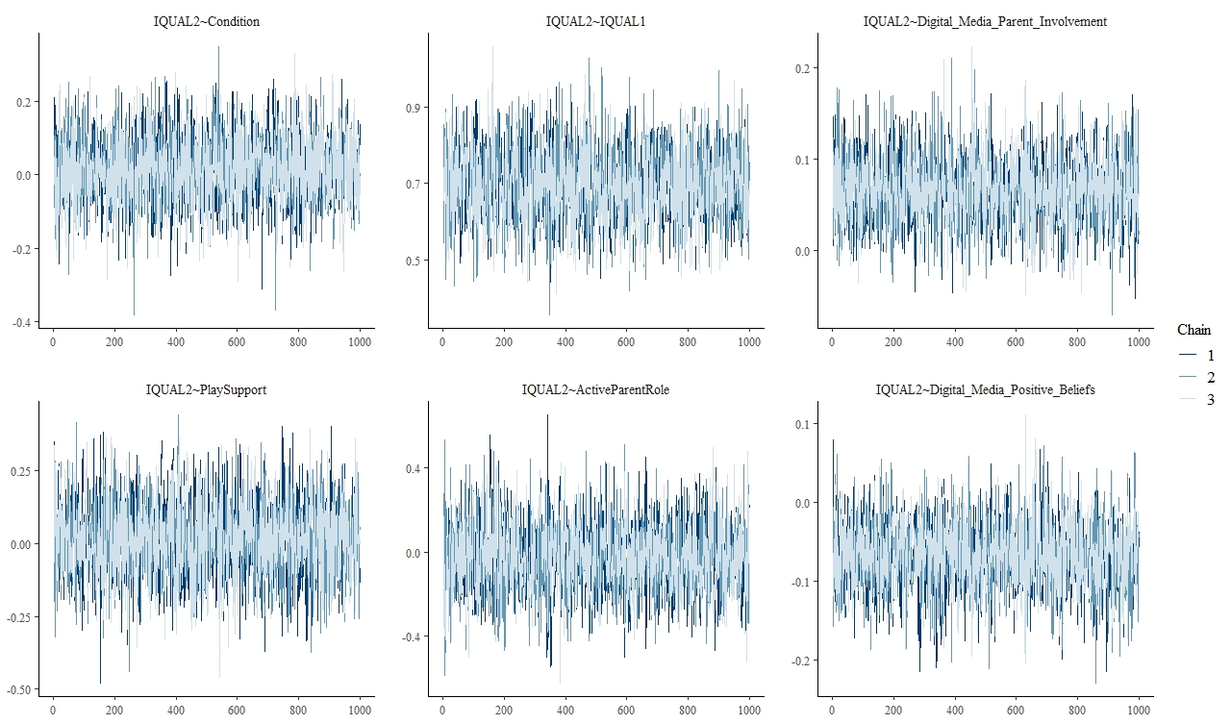

Supplemental Figure 4. Results from parent feedback survey.

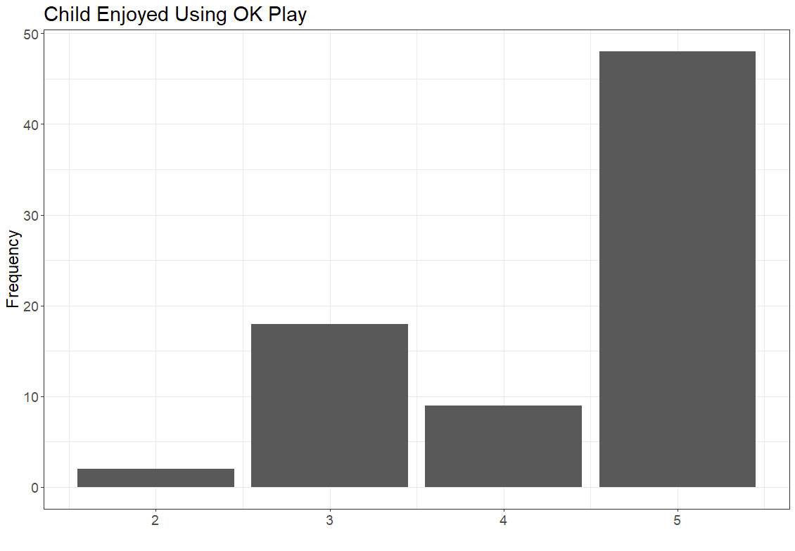

Note. 1=Never, 2=Almost never, 3=Sometimes, 4=Almost always, 5=Always.

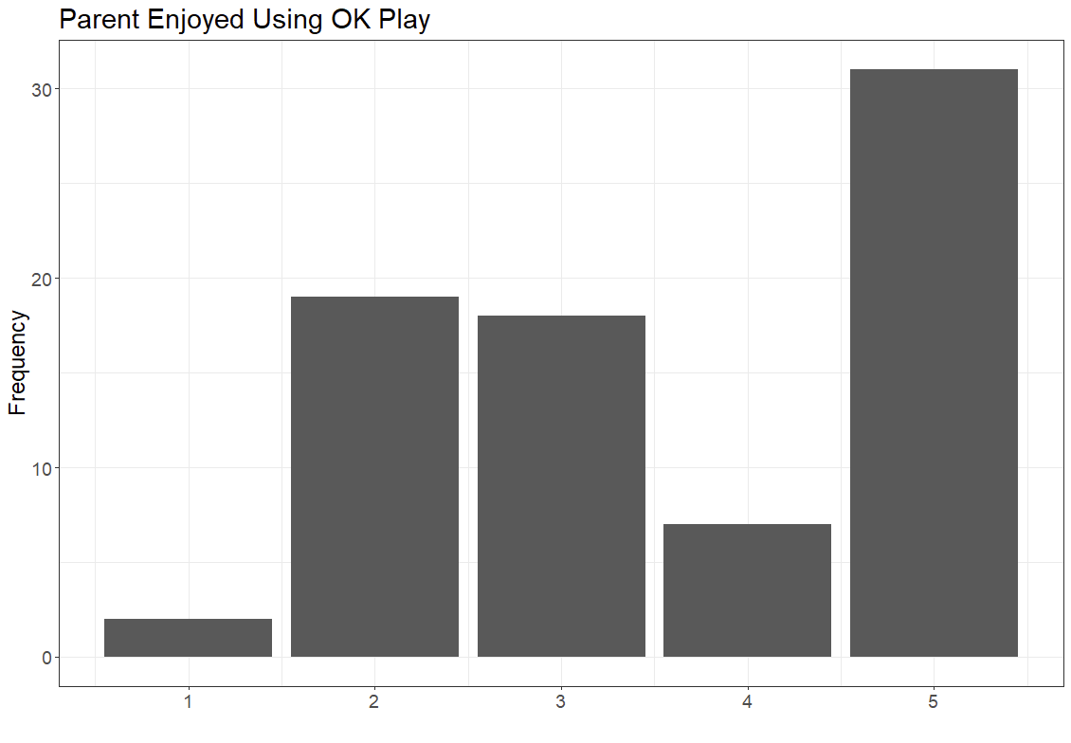
Note. 1=Never, 2=Almost never, 3=Sometimes, 4=Almost always, 5=Always.

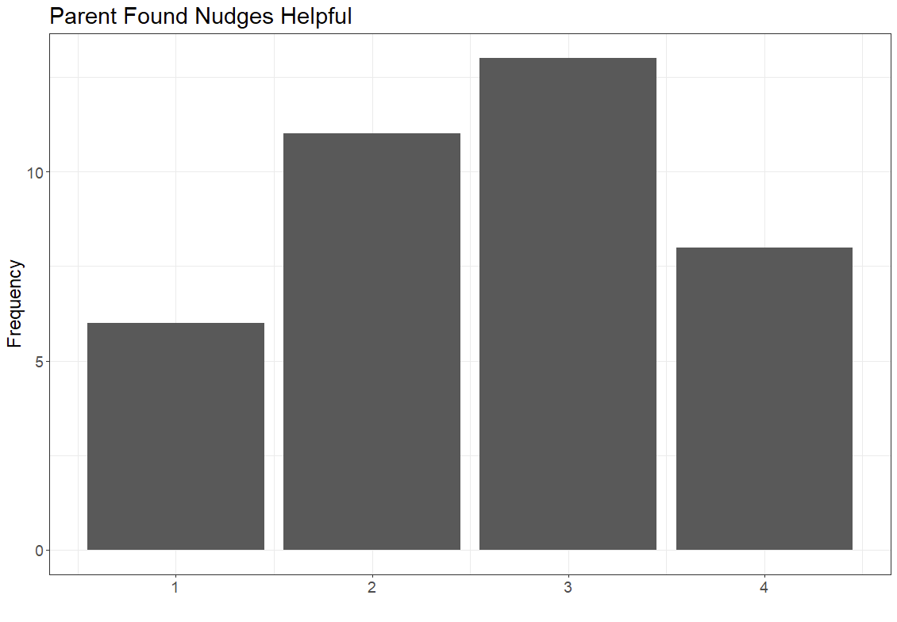
Note. 1=Never, 2=Almost never, 3=Sometimes, 4=Almost always, 5=Always.

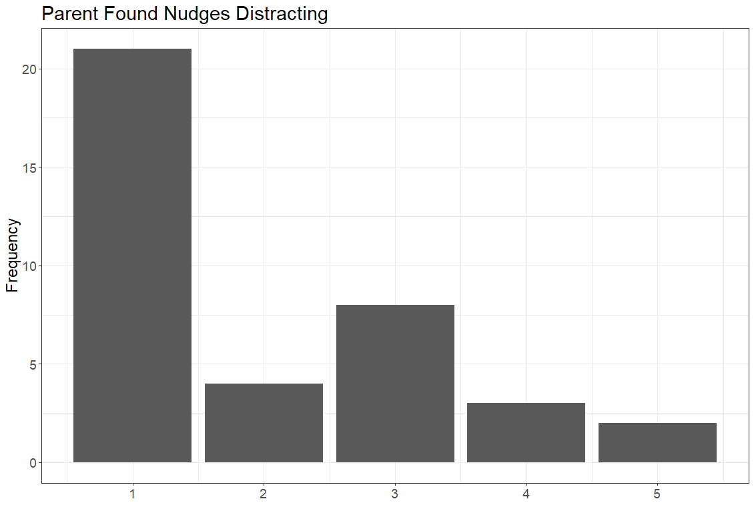
Note. 1=Never, 2=Almost never, 3=Sometimes, 4=Almost always, 5=Always.

