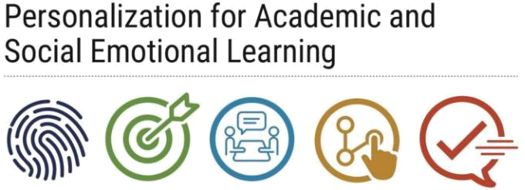
Student Interest and Learning Survey

Overview:
- A student feedback survey can help educators understand students’ interests and learning preferences.

Purpose:
- This tool provides teachers with the opportunity to gather data on students’ interests and learning needs.
- It can also serve as a reference to use during rapid check-ins with students, as well as when planning lessons, classroom activities, and assignments.

Implementation:
- It is suggested that this survey be distributed to students during the first week of the semester or school year, either during a content course or during a PASL study hall period.
- The survey should take no more than 20 minutes for students to complete.

Details:
- Teachers are advised to distribute this survey to students at the beginning of the course or period.
- The survey may delivered in paper format or online based on the preferences of the school.
- Once completed, teachers may be able to use the responses from this survey to build rapport with students during rapid check-ins.
- Teachers may also use survey responses to plan lessons that merge students’ interests and goals with the content being taught.

Connections to Other Components:
- This student survey will help teachers to understand their students’ learning styles and interests, and by extension, facilitate educators’ creation of lessons and classroom activities that meet the needs of their students.
- The information gathered from this survey may also be used during rapid check-ins with students to build rapport and facilitate adult-student connections.

Materials:
- Student Interest and Learning Survey
Student Interest and Learning Survey

Student Instructions: Please read the following questions. Circle your responses and provide written answers on the lines provided.

Name: ____________________________________________

- When you grow up, what would you like to be? (i.e. lawyer, doctor, teacher, etc.) Explanation: _______________________________________________________________

- What are your hobbies? What do you like to do for fun?

Explanation: _______________________________________________________________

3) Are you involved in any after-school activities or sports? If so, what are they?

No Yes

Explanation: _______________________________________________________________

- What is your favorite …

Movie? ___________________________________________________________________

Book? ____________________________________________________________________

TV Show? _________________________________________________________________

Band or Music Artist? ________________________________________________________

5) If you could travel anywhere in the world, where would you go?

Explanation: _______________________________________________________________

6) What is your favorite subject in school? Why?

Explanation: _______________________________________________________________

7) What is your least favorite subject in school? Why?

Explanation: _______________________________________________________________

8) What academic or personal goals would you like to accomplish this school year?
Explanation: _______________________________________________________________

- When I am learning something new, I prefer to…

- Have someone show me how to do it

- Have someone tell me how to do it.

- Figure it out myself

- Other: _______________________________

- I remember things best when I…

- Write them down

- Say them over and over

- Move around and use hand gestures while repeating them in my head.

- Other: ________________________________

- I prefer to work….

- Individually

- With a group

Explanation: _______________________________________________________________

- I work best in classrooms that are…

Quiet Noisy Have Music Playing

Explanation: _______________________________________________________________

- When I finish my work early, I usually…

- Distract myself by reading, going on my phone, etc.

- Talk to others around me

- Fidget a my desk, move around the room, or ask to leave the classroom

- Other: _______________________________

14) My teachers can help me learn by …

Explanation: _______________________________________________________________
__________________________________________________________________________

