Earth Science | Published: 16 October 2018 | News Story
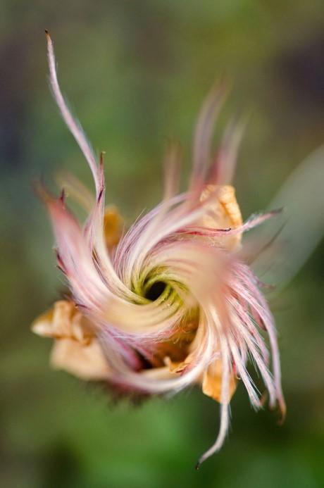
Credit: Press Release
https://www.eurekalert.org/pub_releases/2018-09/uoe-tpm092518.php

Higher Heights Recorded for Artic Plant Life May Be Due to Global Warming

Elizabeth Ojo

In parts of the world dominated by ice and snow, the plants in the arctic tundra are growing taller in reaction to rising global warming levels, according to a new study.

Isla Myers-Smith, a field ecologist at the University of Edinburgh in Scotland, and her team compiled data stretching decades on tundra vegetation and published their findings in Nature in September 2018.

The tundra is warming faster than any other ecosystem on Earth, and the potential consequences are crucial because of global feedback effects between vegetation and climate. These effects have been more apparent in the last thirty years. The feedback system includes the melting of icecaps and rising water levels due to greenhouse gases. Implications would affect ecosystem functions such as soil temperature, decomposition, and carbon cycling in the plants.

Myers-Smith’s team expanded their study to include sites in the Italian Alps and Sweden. They plotted surveys of the land sites from collections spanning from 1989 to 2015. Surveys were conducted of 117 sites within 38 regions totaling more than 60,000 observations. She said "this is the first time that a biome-scale study has been carried out to get to the root of the critical role that plants play in this rapidly-warming part of the planet". They monitored the traits and function of the tundra ecosystem to evaluate how plants adapt to changing environments. They compared summer temperatures and winter ones against World Climate temperatures to find correlation between elevation of plants and temperature. There was a 0.005 °C temperature increase per meter of elevation increase meaning that the plants have the potential to release more greenhouse gases.

There are many species of low shrubs, grass, and plants that help maintain Earth’s climate change. Most are native to the northern climates, but species like vernal sweetgrass, which are from lowland England, have emerged at sites in Sweden and Iceland. The permafrost under the northern plants contain up to fifty percent of the world’s soil carbon. Shorter plants trap more snow, insulating more soil and saves it from freezing too quickly. Taller plants mean that the frozen carbon will thaw faster and there will be an increase in the release of greenhouses gases.

Not all studies have similar results. Steve Oberbauer, an ecophysiologist at Florida International University was part of a study in 2012 in PLOS ONE that considered a long term and short term observation collection of artic plants from 1994 to 2012. They focused on the response of artic plants to global warming. “While some plant characteristics like height, leaf length, and day of flower emergence had minor changes, the average response of plants to warming varies over time and had diminished overall in recent years”, reported Oberbauer on his team’s research.

Further study by ecologists needs to be done based on the effect of precipitation on plant growth. The timing of snow melting, soil drainage, and permafrost also plays a role in the accuracy of the data collected. This could affect soil moisture on spatial temperature based on water availability.

While Redwoods in National parks are historical landmark destinations, plants in the tundra play an important role in the long term effects of climate change. Their rising heights could be Earth’s indicator of the future of global warming.

