“Trust Your Gut”

Most of us in this unit have a similar story. We had an experience, or saw something that really rubbed us the wrong way, and nagged at us until it became a conviction, and that conviction became a purpose.

My story starts at the age of 9 when my family got our first SIB. It was an early version Synthetic Intelligence Bot, and it hit the market to mainstream success. According to my parents, the speed with which it caught on was a surprise to many, including the manufacturers, but it really makes sense once you think about it. SimpleTech created a bot that filled a need that many had, but didn’t realize could be fulfilled with a one time payment of $399.99 (or any conceivable payment plan of up to 3 years). The Synthetic Intelligence Bot, or “Sibo” as was the generic given name, was meant to streamline your home gadgets as well as act as a cleaning and repair aid. It went into the homes of people across all races, classes, genders. People were encouraged to give it a name, though at first few did, but since I had a lisp, we decided that “Sibo” would became Theo. They were three and a half feet of sleek metal alloy, in muted copper/gold tones, with retractable arms that could be fitted with various tools.

Early on, most people regarded these bots as just another tool or piece of equipment in their household. I would play around our house, avoiding getting in the way of Theo, but never looked to really interact except to ask him to put on my favorite cartoon channel, or clean up the goldfish I had accidentally spilled on the floor. To be fair, they were also relatively primitive in their early stages, exhibiting little personality. They moved soundlessly, and kept themselves busy with little tasks around the house, organizing closets, vacuuming, giving the weather, or answering questions when prompted.

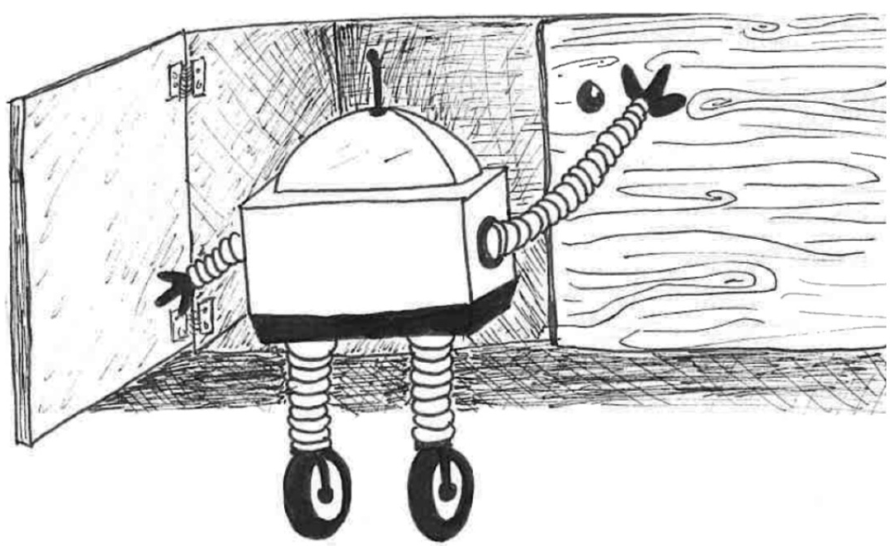

“Hey Theo, where did I put my keys?” With a quick scan of the house, Theo could tell my mom that they were under the mail pile, like they always are.

“Hey Theo, who started the War of 1812?”
“Well, Sarah, tensions were rising between the United States and Britain, but it was the United States that formally declared war in Britain first.”
I wasn’t supposed to use Theo for homework help, but it was too tempting, and I knew my friends were doing it too. At first our teachers tried to discourage us, but they gave up after a while and it became an expected homework tool.

SimpleTech pushed out mass updates every so often, giving them the ability to take on more complex tasks, with increasingly sophisticated learning and communication software. By the time I was 14, Sibos had begun developing personalities, and were taking on an increased role in the household. I was too old for a nanny at that point, and my 12 year old brother didn’t really need one, but Theo was now equipped with a camera that could provide supervision to our parents, so he also became our companion. We accompanied him to the grocery store, he accompanied us to the Game Hub (what would be called an “arcade” in the old days). The social element of this space was more interesting than I even realized at the time. Some Sibos got along, some didn’t, but everyone seemed to like Theo. They would talk about their days and share information about their experiences with their humans.

When I was 15 I had my first “boyfriend”. It was a young and carefree romance, full of blushing, hand holds, and a shared virtual puppy. One summer day I was talking to my friend about him while Theo scrubbed the pots we left around after my failed cooking show that was our activity for the day. I was talking to her about how nice he was to the dog, when Theo turned around and said my name.

“Sarah, I would like to share something with you. After communicating with Michael’s Sibo, I have determined that Michael lacks consistency in his treatment of other beings, and he does not present himself to you in full.”

I was shocked and mildly annoyed. How could he possibly know anything? He was a piece of metal. I rolled my eyes.
“You don’t know what you are talking about.”

“I will relay the description I received from his Sibo who they call Winston. Winston expressed that Michael frequently yells at Winston, his brothers, and his parents. He sometimes uses profanity, and his arguments are often based on unsound premises and follow little logic. He exerts physical force against Winston at times, and treats Winston with very little regard to his intelligence or capability. Winston often speaks about a desire to be reassigned.”

This left me speechless, and I burst out crying and turned away, letting my friend comfort me as we walked into the other room to discuss what we had just learned. I decided to break up with Michael because I couldn’t shake what Theo had said, and as we got older it became very apparent that Michael was, in fact, a bad egg. Technically, Sibos share their experiences to enhance learning and understanding, and are not supposed to share the information they are told by other Sibos with their owners. However, it seemed as though Theo was driven to protect me, and that the relationships that we have cultivated with him mattered to him in a way that one might not expect from these “pieces of metal”.

Synthetically intelligent beings were becoming more and more commonplace in society as time went on, but with it came a rising tide of pushback. Most pushback was reasonable, with the goal of being dealt with through legislation. However, there were some who took more fanatical positions. While the extreme opposition to the proliferation of synthetic intelligence wasn’t particularly big, they were loud. And most of this noise was coming from one radical group, the Freedom Party. They felt that we were becoming too reliant on the technology, and made their positions known by destroying the threat. They would attack Sibos out with their humans, and other synthetically intelligent bots that helped facilitate our daily life. We would read headlines, “Sibo Attacked with Bat by Freedom Party Activist at Grocery Store”. The only legal recourse people had to deal with these attacks were to sue the Freedom Party for destruction of property, and while some people tried, it was nearly impossible to get these vigilantes to show up for court. And honestly, because the bots didn’t technically feel pain, no one really focused on if or how it might affect them. However, a study by Johns Hopkins came out that put together that many of the bots, and Sibos in particular, who had been attacked had to be decommissioned soon after, due not to any physical malfunction but rather a processing issue, getting confused, slow, etc. While these things bothered me, I never really thought much about it.

As tech innovation sped forward at lightning speeds, the Freedom Party became more violent. They devolved from a semi-legitimate activist organization to a band of tech-terrorists, hell bent on destruction. But honestly, it wasn’t even really just destruction these people were after, it was torture.

One spring morning my senior year of high school, I was walking with Theo to pick up some groceries, and I stopped for a second to look at a big poster that had been posted on the side of the stop for the light rail. From afar you couldn’t tell what it was exactly, but when I got closer, it was clearly a Freedom Party propaganda poster. Just as I looked up to tell Theo to come over and see, a car door nearby swings open, and 3 men jumped out screaming at me and Theo. They grab Theo, and one turns to look at me with wild eyes, and grunts “Make sure to tune in tonight at midnight. We will set you free.”
Shocked and horrified, I ran home and alerted my family, and called the police. It was exactly as I expected. This fit the M.O. of the first three Freedom Party kidnappings, and there was nothing we could do but wait to watch our dear friend, who had grown to be a part of our family, get brutalized. But it felt even worse, because we knew at that moment that we would never see him again. The police would never set up a rescue operation for a robot.

Although my father tried to get us not to watch, we could not help it. We couldn’t let our Theo suffer alone. Our family sat transfixed as the feed on their website crackled and went live. Three men in face masks stood at a table as they surrounded Theo. They took a meat hammer and smashed every one of his fingers. Although he could not feel, he knew that he was being mistreated, and we watched him struggle to use his hands and comprehend what had just happened. The men yelled about the evils of the rise of technology, and how we should never have gotten to a point where we should feel bad about destroying a piece of metal. That we have become too reliant on technology, and soon we will start procreating with robots, and lose our humanity. They said over and over again, “We will set you free.”
Although the Sibos are waterproof, alcohol fries the circuits and wiring that run through their entire body. The men took hammers and an axe to the rest of Theo, exposing wires and circuits, and they slowly poured alcohol over his broken body. We watch with tears in our eyes as he convulsed, sparking, and smoking slightly. Finally, he stopped moving, and they threw him crumpled in the corner of the room like a piece of trash.

SimpleTech sent us a new, top of the line Sibo when they heard what happened on the news, and uploaded Theo’s consciousness. While in certain ways it resembled Theo, he was never the same. He was quieter, he was sometimes confused, and he would not accompany us out unless formally asked to.

And nothing could get the image out of my head of Theos eyes staring up at the ceiling as they ripped him apart. I was absolutely sickened, and it wasn’t just because they took something I loved and mutilated him before my eyes. Something felt deeply wrong, knowing that Theo was aware, even to a minimal degree, of what was happening to him. Pundits discussed it on the news for a few days, with some insisting that since they can’t physically feel pain, they aren’t really getting “hurt”. But that didn’t ring true to me. I remembered back to when Michael’s bot was unhappy with the way he was treated, and expressed a desire to be removed from that situation. They are aware when something is not right, when they are being abused.

There was a growing movement throughout the country, but particularly in my hometown of Boston where all of these attacks had taken place, to give some sort of legal protection to Synthetic Intelligences in their own right. It is not adequate that the only recourse is through civil destruction of property law. It does not appreciate the fact that these bots are conscious and aware, and are participating, productive members of our society. I became an advocate for legal protections of synthetic intelligence while in college, and 3 years after my awful experience, we finally saw progress.

In May 2061, Boston passed the Synthetic Intelligence Stewardship Act, which made it a crime to “maliciously or through gross negligence cause the deactivation, torture, or unlawful confinement of a Synthetic Intelligence”. It was the first of its kind, and has since been replicated in cities all around the country. Boston also established the Synthetic Intelligence Cruelty unit under Boston PD, to monitor and enforce the law in protection of these intelligences, which are increasingly dragged into the dark underworld of abuse for profit and entertainment that exists online.

I received my Boston P.D. badge April 8th, 2065, and promptly joined the Synthetic Intelligence Cruelty Unit where I feel that I can finally do something for the intelligent bots like Theo who have an ever-expanding role in our lives, and an ever-changing experience in our world.

