Haptic Hysteroscopic Surgery Simulator with Quantitative Feedback

Aditya Karhade
J.R. Peacock
Madeline Tolish
Fletcher Young

Abstract
Hysteroscopy is a branch of laparoscopic surgery that plays a major role in OBGYN practice. However, hysteroscopic procedures are plagued by high rates of complications. Hysteroscopy simulators have been developed in an effort to improve the training of medical residents, but currently available models do not incorporate haptic feedback with quantitative measurements of the surgeon’s competence. Our design team has identified and defined the major needs for:
- a haptic hysteroscopic surgery simulator with quantitative feedback
- positive assessment and improved surgery results from medical students and residents at Vanderbilt Medical Center
- a publishable paper to share our findings with other medical centers to improve hysteroscopic surgery skills
A vision for design is introduced, and the design steps that have already been completed are outlined. Our team members and advisors are introduced along with their relevant skills that will contribute to the success of this project. Local academic institutions are identified as a possible early market for our product, with plans for expansion both nationally and globally. Finally, a timeline for future work that encompasses all major steps in the design process is proposed, including plans for sustainability.
Introduction
While hysteroscopy simulations exist, no system exists that incorporates haptic feedback with a quantitative means for measuring competency of surgical skills. With the problem defined as such, our team defined three major needs for the design of a new hysteroscopy simulator. The first need mandated that the system must be able to provide quantitative and qualitative summaries to the persons assessing the students learning the hysteroscopy techniques. The second need illustrated the requirement for the system to be fully immersive, especially regarding touch feedback, or haptics. The final need required the system to be able to be modified to perform different procedures or accommodate future changes.

History and Context
Hysteroscopy is a branch of laparoscopic surgery used in obstetrics and gynecology. Diagnostic and operative hysteroscopies range from visualizing the uterus without the need for abdominal incisions to extracting malignant polyps. Hysteroscopy has evolved from the 1965 introduction of the contact hysteroscope by Marleschki to play a major role for OBGYN training. For example, female sterilization, undergone by 345,000 women every year in the U.S., is increasingly dependent on hysteroscopy.
Hysteroscopy complications are more common for operative procedures than diagnostic ones. “The most common complications of operative hysteroscopy are perforation of the uterus, fluid overload syndrome, bladder or bowel injury and intra-operative hemorrhage.” ¹ Operator error and inexperience accounts for the vast majority of the errors in comparison to mechanical failures.¹ A Harvard Medical Practice study demonstrated that surgical operative adverse events account for 48% of all adverse clinical events and 74% of these operative adverse events were preventable.² Recent studies have found that dedicated hysteroscopy simulation training of first and second year residents improved their surgical skills and dry-lab performance skills, as assessed by the Objective Structured Assessment of Technical Skills (OSATS), to the level or above the level of third and fourth year residents.³
Thus far, we have:
1. Researched the need for a haptic hysteroscopy simulator
2. Created a needs assessment
3. Analyzed hysteroscopy videos
4. Consulted advisors Dr. Anderson and Dr. Thomassee
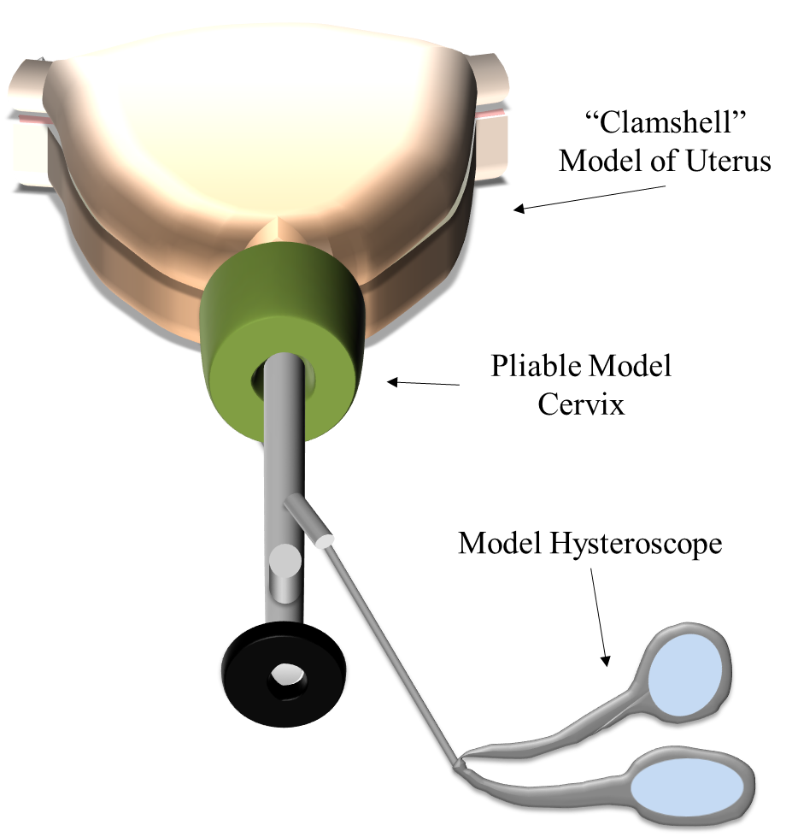
5. Obtained conceptual framework for physical design
Drs. Anderson and Thomassee have provided our team with a visual representation of a Hysteroscopic Training Model (HTM) that would fit their needs. The three main components of the model include a uterus, cervix, and hysteroscope. This drawing illustrates the need for a non-virtual environment which can provide haptic feedback. The inside of the uterus can be modified to measure different aspects of a surgeon’s competence.
Our early customers will be medical schools and hospitals that teach gynecology residents hysteroscopy. Potential institutions include Vanderbilt and other hospitals in the Middle Tennessee area. Once our surgery simulator gains traction with these early customers, expansion into a national or global market could be considered.

Team
Aditya Karhade is a Biomedical Engineering and Neuroscience senior at Vanderbilt University. Aditya has research experience at University of Leipzig in Germany as a Max Kade Foundation Research Fellow and at the Shade Tree Clinic and in the Vanderbilt Laboratory for Bionanotechnology and Nanomedicine and the Vanderbilt University Medical Center Functional Neurosurgery as a Research Assistant. His skills include scientific writing, poster presentations, data analysis, leadership, service and mentoring.
J.R. Peacock is a senior biomedical engineering student at Vanderbilt University. He has been involved in biomedical research since his freshman year, and has been a member of a mechanobiology laboratory at Vanderbilt since his sophomore year. J.R.’s experience with biomechanics will aid the team in achieving an accurate representation of haptic feedback in the surgery simulator. In addition, he has several years of personal experience with electronics design as well as fabrication with a variety of materials.
Madeline Tolish is a senior at Vanderbilt University majoring in biomedical engineering and minoring in engineering management. She has used these skills in experiences varying from research positions to a consulting internship. Due to her love of planning, she has even pursued and achieved the credential of a Certified Associate in Project Management from the Project Management Institute. Madeline will use these skills to aid the team in staying on schedule and facilitating communication between the team and the project advisors.
Fletcher Young is a senior at Vanderbilt University studying biomedical and electrical engineering. In addition to work in the classroom, he has been involved with numerous campus organizations and spent the summer as an intern at the Institute of Space and Defense Electronics creating diagnostic programs for circuit boards. He will be contributing experience in circuitry, biomechanics, and material fabrication.
Dr. Ted Anderson is a Professor of Obstetrics & Gynecology and the Director, Division of Gynecology, at Vanderbilt University Medical Center in Nashville, Tennessee. He is affiliated with multiple hospitals in the area, including Northcrest Medical Center and Vanderbilt Hospital and Clinics. He received his medical degree from Vanderbilt University School of Medicine, his PhD in Anatomy/Cell Biology and Residency Training in Obstetrics and Gynecology from Vanderbilt University and has been in practice for 21 years.
Dr. May Thomassee is an Assistant Professor of Obstetrics & Gynecology at the Vanderbilt Center for Women’s Health in Nashville, Tennessee.
Dr. Matthew Walker holds the full time faculty Position of Associate Professor of the Practice of Biotechnology/Bioengineering at Vanderbilt University. Dr. Walker teaches, develops and implements an innovative biotech design curriculum. Dr. Walker works across departments within the Schools of Engineering and Medicine, across schools within Vanderbilt University, and between Vanderbilt and the biotechnology/medical device industry. Dr. Walker's research includes unveiling systems level orthogonal biomarkers at the structure/function interface of disease. He and his teams blur the lines between engineering and medicine by using novel 2D-3D-4D-imaging and other technologies to discover/deliver new medicines/devices (Phases I-IIB, IV). Dr. Matthew Walker III is a Principal and President of Strategic Imaging Biomarkers Consulting, LLC (CRO). Dr. Walker was a mechanical/biomedical engineer with NASA-Houston, TX , prior to receiving his doctorate in Cardiovascular Biophysics and pharmacology from Tulane University School of Medicine. At Tulane medical, he worked under the direction of the world renowned cardio-renal researcher Dr. L. Gabriel Navar (Past President of the Am. Physiological Society). Dr. Walker continued his post-doctoral education and early faculty appointment at Harvard Medical School and MIT in the Division of Health Science and Technology, under the brilliant "Cardiovascular Engineer" Elazer R. Edelman, M.D. Ph.D. Dr. Walker then joined, (while retaining his adjunct faculty position at Harvard-MIT) Merck Research Laboratories where he led a team of pharmacology and biomarker development imaging scientists in cardiovascular, diabetes, cancer, and obesity related drug discovery campaigns.

Work Plan and Outcomes
Current testing protocols for hysteroscopic surgery are an insufficient representation of a resident’s ability to perform a successful operation without complications. Revised testing with detailed metrics and qualifications for success will shorten operation times, increase surgical dexterity, and reduce the amount of tissue deformation that results from accidental hysteroscope contact with the uterine wall. Patients will benefit from the Hysteroscopic Training Module through a reduction of pain, recovery time, and stress related to surgical intervention. In addition to patient benefits, surgeons providing guidance for hysteroscopic training will benefit from a detailed protocol that provides a more accurate representation of a resident’s performance than current testing protocols.
A standardized hysteroscopic surgery module that adequately tests surgical performance under a definitive protocol does not currently exist on the market. The HTM will fill this opening in the market by selling directly to medical schools across the country. Medical schools continually implement innovative testing procedures to stay competitive with peer institutions, maintain prestige, and sustain student intake. Use of 3D printed components and standard hardware supplies allow the HTM to be manufactured cheaply (~$1,000). A low price coupled with the demand for innovative testing procedures will incentivize medical schools to purchase the HTM and drive its commercial viability.
Our design process has already begun with ideation sessions, including brainstorming with our advisors. From these sessions, we have been able to generate several major tasks in our design process. The first task will be building an accurate 3D-printed model of the uterus and cervix. This model must be compatible with hysteroscope models that are currently in use. The next major task will be generating tasks for students to complete within the uterine model, as well as designing quantitative feedback measurements for those tasks in order to assess student competence. At every step along the way, we will be gaining feedback from our advisors and medical residents. This feedback will be integral in refining our design in an iterative fashion. Lastly, we plan on keeping excellent documentation throughout the entire design process.
Our goal by the end of the grant period is to have produced a functioning surgery simulator that has been tested with medical residents at Vanderbilt. With more time and user feedback, our product would improve throughout several iterations of design. If possible, we would like to publish the results of this early implementation. A peer-reviewed publication would give our work the opportunity to make an impact in the academic community. If we chose to pursue a commercial route at the end of the grant period, such a publication would provide important proof of concept for our initial investors and customers.
We believe our project will succeed because we have gathered a strong team to tackle a project within our unique skillsets. Our backgrounds in engineering, research, and industry have given us the tools to tackle this difficult problem, and we are motivated by the need for such a device in the field of gynecology. With the help of our accomplished advisors, we will be able to produce important deliverables by the end of the grant period.

Gantt Chart
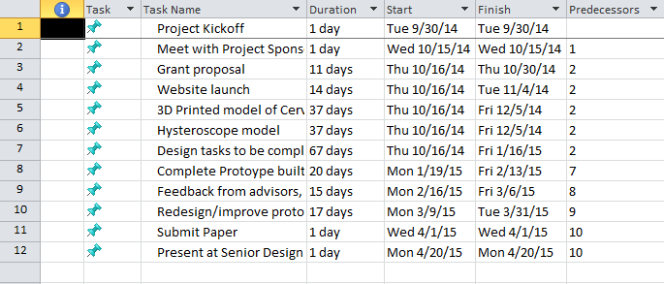
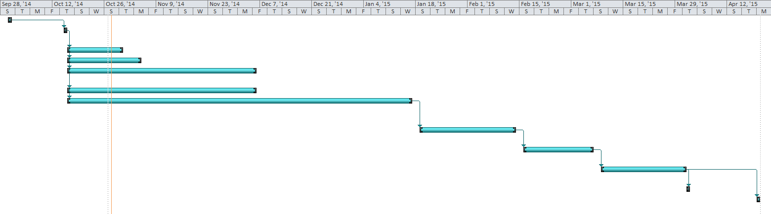
Evaluation and Sustainability Plan
It is vital to establish a set of post-implementation criteria that evaluates the efficacy of the HTM in order to understand its impacts on surgical performance. First, a significant change in testing results gathered from medical residents will determine whether the HTM has an effect on key testing parameters (dexterity, speed, reduction of tissue deformation, etc.). Using the data gathered from these tests, the team will work to publish a paper on the protocol, informing potential users and medical schools on the performance metrics and efficacy of the procedure. The primary indicator of success will be the implementation of the HTM in Vanderbilt’s medical center with the ultimate goal of having at least one other peer institution adopting the HTM for resident training.
Creating a sustainable product that can be developed over time requires forethought into different device aspects such as longevity, ease of use, and future applications. A list of components required to fabricate the HTM is important for future innovators to create and test residents. This will open the device up to future iterations with the possibility of location specific touch response or an LED-viewing screen. It is possible that as the device becomes commercially viable, it will garner attention from larger medical supply companies who may decide to purchase the produce for future development.

Citations
1. Aydeniz B et al. A multicenter survey of complications associated with 21 676 operative hysteroscopies. European Journal of Obstetrics & Gynecology and Reproductive Biology. 104(2002): 160–164.
2. Rassweiler et al. Classification and Detection of Errors in Minimally Invasive Surgery. JOURNAL OF ENDOUROLOGY. 2011. 25(11): 1713–1721
3. Rackow et al. Deliberate Practice Improves Obstetrics and Gynecology Residents' Hysteroscopy Skills. Journal of Graduate Medial Education. 2012. 4(3): 329–334.

Appendices
Budget
Category | Item Totals | Sub-Totals | Justification
Direct Expenses
Hysteroscope Materials |  |  | Vanderbilt's Gynecology Department is providing us with a used hysteroscope. Imaging materials such as fiber-optic camera, light, and monitor are required to view inside the uterus. Instrumentation materials such as a gyroscope will provide user feedback.
Hysteroscope | provided
Imaging Materials | $300
Instrumentation materials | $100
Subtotal |  | $400
Surgical Instruments |  |  | Vanderbilt's Gynecology Department is providing us with used surgical probe models. Electronics will be needed and used to adapt the instruments to be able to gather and report feedback data.
Models | provided
Electronics | $50
Subtotal |  | $50
Model Uterus |  |  | The shell of the model uterus will be 3D printed using the 3D printer and materials in the Vanderbilt BME Senior Design loft. Electronic circuitry and widgets will be needed to create the tasks for the user to complete.
Shell | free
Circuitry/task widgets | $150
Subtotal |  | $150
Feedback Data Storage |  |  | A data processor and storage such as an arduino or rasberry pi is needed to collect and store user feedback data.
Instrument and circuitry | $50
Subtotal |  | $50
Total Expense |  | $650

