Supplemental Information

Decoupling the Influence of Sorption and Diffusion on Membrane Permselectivity in Pervaporation

Sk Md Ali Zaker Shawonª, Longqian Xu^{b}, Ruoyu Wang^{b}, Penelope Friesª, G. Kane Jenningsª, Shihong Lin^{a b}*

ª Department of Chemical and Bimolecular Engineering, Vanderbilt University, Nashville, TN, 37235-1604, USA
^{b} Department of Civil and Environmental Engineering, Vanderbilt University, Nashville, TN, 37235-1831, USA

Appendix
S1 Calibration Curve for Concentration Measurement
In this study, we employed a density-based method to characterize the concentrations of sorbed components (ethanol and water) by measuring concentration changes in the bulk solution before and after sorption equilibrium. Sorption experiments were conducted using a high-resolution density meter (Anton Paar, DMA 4500M) with measurement precision up to 10⁻⁵ g mL⁻¹. To ensure measurable density changes, a large mass of PVA membranes (~7 g) was immersed in a minimal volume of feed solution (50 g). This optimized membrane-to-solution ratio maximizes compositional changes in the bulk solution, enabling accurate density measurements. Sorption experiments were performed in septum-sealed bottles to prevent evaporation and maintain constant composition throughout the equilibration period. Following sorption equilibrium, bulk solution samples were withdrawn using syringes and immediately analyzed for density at a standardized temperature of 20°C using the instrument's internal temperature control. A calibration curve correlating solution density with ethanol mass percentage was established across the experimental composition range of 50-95 wt% ethanol (Figure S1). The instrument's internal temperature control ensures calibration validity regardless of the sorption operating temperature.
The membrane-sorbed concentrations were calculated using mass balance. From the measured feed solution concentrations before and after sorption, combined with total membrane weight gain, individual component masses sorbed in the membrane were determined using:
$$(M_{0,w}-M_{m,w})/(M_{0,e}-M_{m,e})=M_{f,w}/M_{f,e}$$ | (1)
and,
$$M_{m,w}+M_{m,e}=M_{s}-M_{d}$$ | (2)
where, $M_{0,w}$, and $M_{0,e}$ represent the initial masses of water and ethanol in the feed mixture before sorption; $M_{f,w}$, and $M_{f,e}$ are the final masses of water and ethanol in the bulk solution after sorption (determined from density measurements); $M_{d}$, and $M_{s}$ are the masses of dry and swollen membranes, respectively; and $M_{m,w}$, and $M_{m,e}$ are the calculated masses of water and ethanol sorbed within the membrane at equilibrium.
Figure S1: Calibration curve, correlating feed solution densities with the ethanol mass content (weight percent). All density measurements were performed at a standardized temperature of 20°C using the instrument's internal temperature control.

S2 SEM
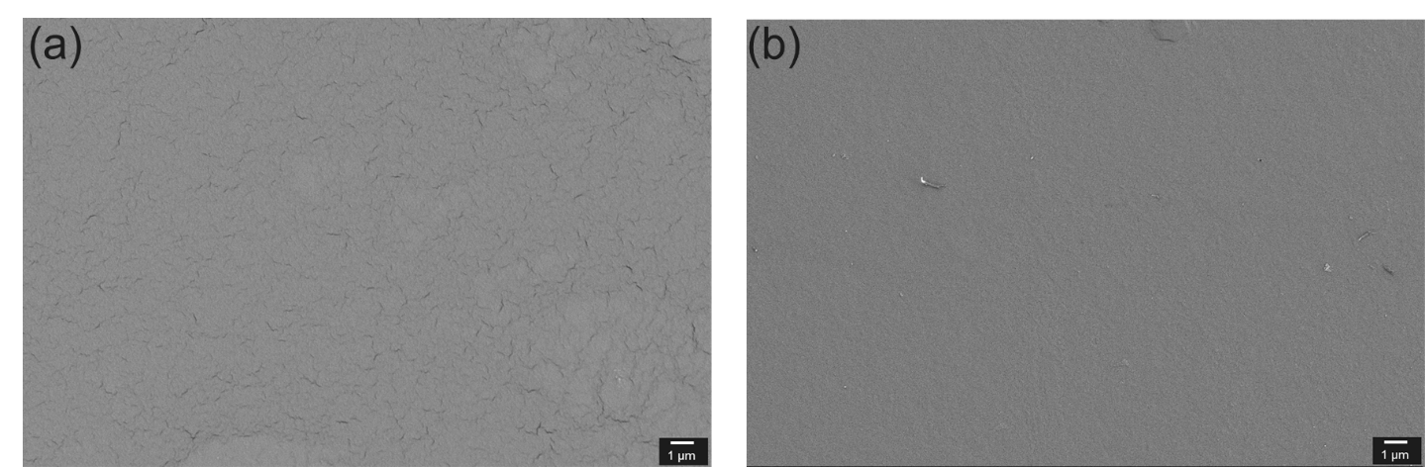
Figure S2: (a) SEM images of the surface of uncrosslinked PVA and (b) crosslinked PVA with glutaraldehyde.
The SEM micrographs demonstrate a notable morphological transformation following glutaraldehyde crosslinking of PVA membranes. The uncrosslinked PVA surface (Fig. S2a) shows a heterogeneous, coarse topography with dispersed micro-cracking reflecting a loosely packed polymer network maintained by hydrogen bonding interactions alone. This disordered structure indicates high water swelling propensity and reduced mechanical stability. Conversely, the glutaraldehyde-crosslinked PVA membrane (Fig. S2b) presents a considerably smoother and more uniform surface morphology, where the crosslinking process has substantially reduced the surface defects present in the uncrosslinked sample. The formation of covalent bonds between glutaraldehyde and PVA hydroxyl groups establishes a more stable, densely packed network structure that enhances surface homogeneity [1]. This morphological improvement corresponds with enhanced mechanical properties and decreased water uptake, highlighting the importance of chemical crosslinking in optimizing PVA membrane performance for practical applications.

S3 Temperature Influence
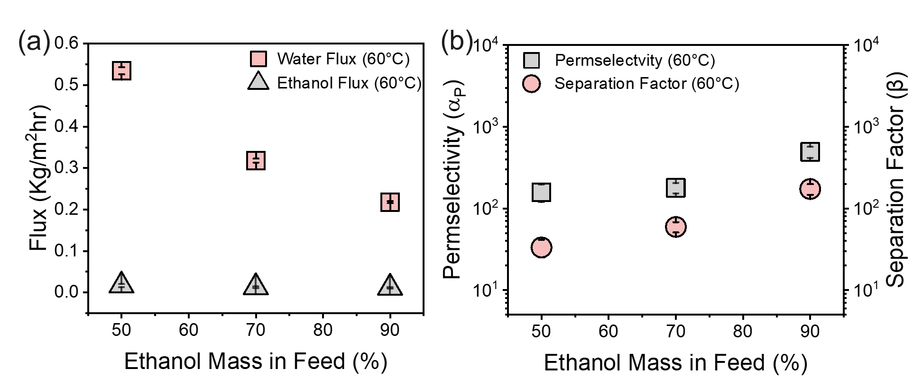
Figure S3: (a) Total flux, water flux, and ethanol flux obtained from the PV experiments at 60°C at various feed concentrations. (b) Permselectivity (α) and separation factor (β) of the membrane at 60°C at various feed concentrations.

Crosslinked PVA membranes used to obtain flux data at 60°C along with the permselectivity and separation factor (Fig. S2). Alike the performance trend obtained at 50°C (Fig. 6), water flux was found to decline (~73%), and ethanol flux moderately increased (~30%) for ethanol concentration increased from 50 to 90% in the feed mixture. This compositional dependence reconfirms the membrane's hydrophilic nature and the influence of water activity in the feed solution on the overall transport behavior even at this elevated temperature. However, in our PV experiment at this elevated temperature, the flux data exhibits a moderate increase from 50°C to 60°C, despite the fact that the vapor pressure of water and ethanol, which is the key driving forces for PV, nearly doubles in this range. In PV, with a near-zero permeate pressure, the driving force is largely determined by the saturated vapor pressure of the component in the feed solution. It is well-established that the saturated vapor pressure increases exponentially with temperature. Therefore, an increase in feed temperature from 50°C to 60°C indeed leads to a substantial increase in this thermodynamic driving force for both water and ethanol. This exponential relationship between temperature and vapor pressure forms the basis for the expectation of a more significant increase in flux as temperature rises.
However, this phenomenon has been already reported in the literature and explained with the help of resistance-in-series model. In PV the overall mass transfer follows a resistance in series model:
$$1/{J_{total}}=1/{J_{feed}}+1/{J_{membrane}}+1/{J_{permeate}}$$ | (S1)
Here, $J_{feed}$, $J_{membrane}$, and $J_{permeate}$ is the mass transfer from bulk feed to membrane surface, transport through the membrane itself, and desorption from the membrane to the permeate side, respectively. At elevated temperature it is very much possible that the membrane resistance becomes the rate limiting rather than the thermodynamic driving force [2]. Here, Liu et al. found that crosslinked PVA membranes exhibit solubility-controlled transport behavior rather than diffusion-controlled mechanisms at elevated temperatures, demonstrating that water permeance generally decreased when operational temperature increased, indicating a solubility-controlled transport behavior. This counterintuitive behavior occurs because the heat of sorption for both water and ethanol remains constant across the temperature range, while the membrane resistance becomes rate-limiting rather than thermodynamic driving force. In crosslinked PVA systems, the solution-diffusion mechanism transitions from diffusion-controlled to sorption-controlled transport as temperature increases, particularly evident in dense crosslinked polymer matrices, where the structure creates a tortuous, restricted pathway that doesn't significantly expand with modest temperature increases, as polymer chains have limited mobility due to chemical crosslinking [3]. Liu et al. also stated that below the identified sorption-induced glass transition (70-80°C) temperature, membranes are still largely in a glassy state. In a glassy polymer, polymer chain mobility is restricted, and the diffusion of penetrants is typically more limited compared to a rubbery state. In such conditions, while diffusivity does increase with temperature, in a glassy state, the rate of increase might be less pronounced or less sensitive to temperature changes than if the polymer were in a rubbery state. This inherent resistance to diffusion due to the rigid glassy structure further constrains the overall flux increase, even with an increasing driving force, contributing to the moderate rather than significant flux observation. The ethanol flux remains non-significant compared to the total flux across all compositions and temperatures, reflecting the significant steric hindrance imposed by the crosslinked PVA structure on larger ethanol molecules [4]. This behavior indicates that the free volume available for molecular transport doesn't increase proportionally with temperature in dense crosslinked systems, making membrane resistance the dominant factor controlling permeation rates rather than the increased molecular kinetic energy [2].
At elevated temperature as well permselectivity ($α_{P}$) and separation factor ($β$) increases with increasing temperature, reconfirming the feed composition impacts on these performance metrices as discussed in Fig. 5. Specifically, the temperature effects on $α_{P}$ and $β$ exhibit composition-dependent behavior. At high ethanol concentrations (70-90 wt%), both $α_{P}$ and $β$ decrease with increasing temperature from 50°C to 60°C. This reduction occurs because higher temperatures enhance molecular mobility in the crosslinked matrix, allowing larger ethanol molecules to permeate more readily through the dense polymer network [2]. Conversely, at 50 wt% ethanol composition, selectivity shows an increase at 60°C compared to 50°C, suggesting that the interplay between membrane swelling, molecular mobility, and transport resistance creates different dominant mechanisms depending on feed composition and water content [2]. The relationship between flux and selectivity demonstrates the inherent characteristics of crosslinked PVA membranes, where the dense polymer network provides excellent selectivity but at the expense of permeation rates.
S4 Performance of PVA-based membranes from literature
Table S1: Performance of PVA-based membranes and their comparison with this study
Description of the membrane | Crosslinking agent(s) | Feed composition | Feed condition | Performance | Reference
PVA cast on PAN | Glutaraldehyde | EtOH-80 wt%  H2O-20 wt% | 60 °C, <0.1 kPa. | Total Flux: ~1050 g/m²h.  β: ~140 | [5]
PVA modified with LiBr | Glutaraldehyde | EtOH-90 wt%  H2O-10 wt% | 40 °C, ~0.67 kPa. | Total Flux: ~127 g/m²h.  β: ~44 | [6]
Double Network-PVA | Thermally crosslinked at 120 °C | EtOH-85 wt%  H2O-15 wt% | 40 °C, ~0.54 kPa. | Total Flux: ~80 g/m²h.  β: ~225 | [7]
Multilayer composite of PAH/PVA/BTA | Thermally crosslinked at 100 °C | EtOH-90 wt%  H2O-10 wt% | 70 °C, ~0.1 kPa. | Total Flux: ~1460 g/m²h.  β: ~3300 | [8]
PVA/ZIF-8 MMM | Glutaraldehyde | EtOH-90 wt%  H2O-10 wt% | 25 °C | Total Flux: ~685 g/m²h.  β: ~4821 | [9]
PVA-PTES hybrid membrane | Phenyl-triethoxysilane | EtOH-85 wt%  H2O-15 wt% | 40 °C, ~0.3 kPa. | Total Flux: ~145 g/m²h.  β: ~1026 | [10]
PVA/Fumed silica | Glutaraldehyde | EtOH-90 wt%  H2O-10 wt% | 30 °C, ~1.6 kPa. | Total Flux: ~50 g/m²h.  β: ~180 | [11]
PVA | Glutaraldehyde | EtOH-90 wt%  H2O-10 wt% | 40 °C, ~0.1 kPa. | Total Flux: ~280 g/m²h.  β: ~104 | [12]
PVA | Glutaraldehyde | EtOH-90 wt%  H2O-10 wt% | 50 °C, ~3 kPa. | Total Flux: ~198 g/m²h.  β: ~232 | This study

References
[1] Z. Zhang, Y. Liu, S. Lin, Q. Wang, Journal of Polymer Research, 27 (2020) 228.
[2] L. Liu, S.E. Kentish, Journal of Membrane Science, 553 (2018) 63-69.
[3] R. Huang, P. Shao, C. Burns, X.-s. Feng, Journal of applied polymer science, 82 (2001) 2651-2660.
[4] X. Feng, R.Y. Huang, Industrial & Engineering Chemistry Research, 36 (1997) 1048-1066.
[5] H. Le Tran, M.N.D. Vuu, Q.M. Hoang, N.T. Nguyen, P.T. Mai, Journal of Science and Technology Development, 19 (2016) 97-106.
[6] A. Selim, A.J. Toth, D. Fozer, E. Haaz, N. Valentínyi, T. Nagy, O. Keri, L.P. Bakos, I.M. Szilágyi, P. Mizsey, Chinese Journal of Chemical Engineering, 27 (2019) 1595-1607.
[7] A. Selim, N. Valentínyi, P. Mizsey, Chemical Papers, 73 (2019) 1069-1081.
[8] Z. Zhao, G. Zhao, G. Tang, Y. Liu, P. Li, Advanced Membranes, 3 (2023) 100073.
[9] G.-S. Lin, Y.-R. Chen, T.-H. Chang, T.-C. Huang, G.-L. Zhuang, W.-Z. Huang, Y.-C. Liu, H. Matsuyama, K.C.-W. Wu, K.-L. Tung, Journal of Membrane Science, 621 (2021) 118935.
[10] L.L. Xia, C.L. Li, Y. Wang, Journal of Membrane Science, 498 (2016) 263-275.
[11] M. Samei, M. Iravaninia, T. Mohammadi, A.A. Asadi, Chemical Engineering and Processing-Process Intensification, 109 (2016) 11-19.
[12] V.S. Praptowidodo, Journal of molecular structure, 739 (2005) 207-212.

